# E-Learning tools for contrasting contexts

Moodley, K., van Wyk, M.

The historical background in South Africa has played a significant role in creating large gaps in the integration of technology in higher education institutions. Students from historically disadvantaged communities often remain marginalised with limited opportunities for online learning. In this chapter we unpack the different contexts within the country, describe their living circumstances and how this impacts on their exposure to online learning. We provide suitable intervention strategies that can be used to demonstrate how lessons can be adapted to achieve outcomes by adapting pedagogies and e-learning tools. The basis of these proposed interventions are governed by the SAMR technology integration model, ideas around humanising pedagogies and the reflective practice of our student feedback from different contexts.

## Introduction

In South Africa, the digital divide (Davids, 2020) has become more visible during the recent COVID-19 pandemic (Dube 2020; Myers, 2020). Even though many online learning platforms offered their online material for free in an attempt to provide flexible, accessible online learning opportunities, previously disadvantaged students remain marginalised (Paterson, 2021; UNESCO, 2020). According to Le Grange (2020) and Devakumar et al. (2020), a pandemic accelerates racism, discrimination and can become a driver of racism. This has been exposed in countries like the UK, USA and South Africa. Furthermore, socio-economic factors such as poverty and unemployment magnified inequalities among young adults, people of colour, and those without a tertiary education (Perry et al., 2021). Access to healthcare, green spaces, education and technology was limited to the more affluent groups of the population, mostly residing in urban areas (Myers, 2020).

## Urban and rural contexts

The historical context of South Africa where colonialism and apartheid laws have resulted in separate societies created multiple inequalities (McGregor, 2011). For example, zoned living areas, homelands, separate education and health services existed for black, coloured and indian people (McGregor, 2011). Although the apartheid laws changed more than 27 years ago, with the new dispensation, contrasting societies still exist with many complexities within each context (Paterson, 2021).

South Africa is highly differentiated geographically and is known for its alarming high levels of inequality (Masindi & Roux, 2020). The South African urban context is similar to other developing world cities in which basic requirements, good resources and employment opportunities are available. The suburban context is seen as the smaller towns, with lower population, limited resources and employment, accessible basic requirements and limited education opportunities. The rural contextconsists of small communities that cannot consistently access basic requirements for living such as electricity, running water and sanitation (Ellis, 2020). These areas are poverty stricken, have high unemployment rates and the community has little to no resources for effective school education. The population from these rural areas are highly disadvantaged and many still suffer the repercussions of the apartheid era. Like the rural areas, South Africa is also known for its “townships'' (Howell & Shearing, 2017; Swartz et al., 2013). Although these are mostly located near urban areas and have a high population density, basic services and communications infrastructure are irregularly supplied, and high unemployment and poverty contribute to crime. These areas are underdeveloped and racially segregated as they were previously reserved for the non-whites during apartheid. Although universities in South Africa are mainly situated in the urban and “township” areas, many of the students reside in the suburban and rural areas. For the purpose of this chapter, we will refer to the two contrasting contexts as urban (urban and suburban) and rural (rural and townships).

## University landscape in South Africa

South Africa has 26 public universities (Universities South Africa, 2021) and over 30 private universities (Kamerpower, 2021). While the University of South Africa is a distance learning university with its footprint all over the country, the remaining twenty-five universities are predominantly contact universities (Universities South Africa, 2021). The geographical reach of the 25 primarily contact universities is illustrated in Figure 1. Three of these universities have equal footprints in the urban, rural and/or township spaces.

Figure 1

Geographical reach of South African universities (Note: Information collated from UniRank (n.d.)

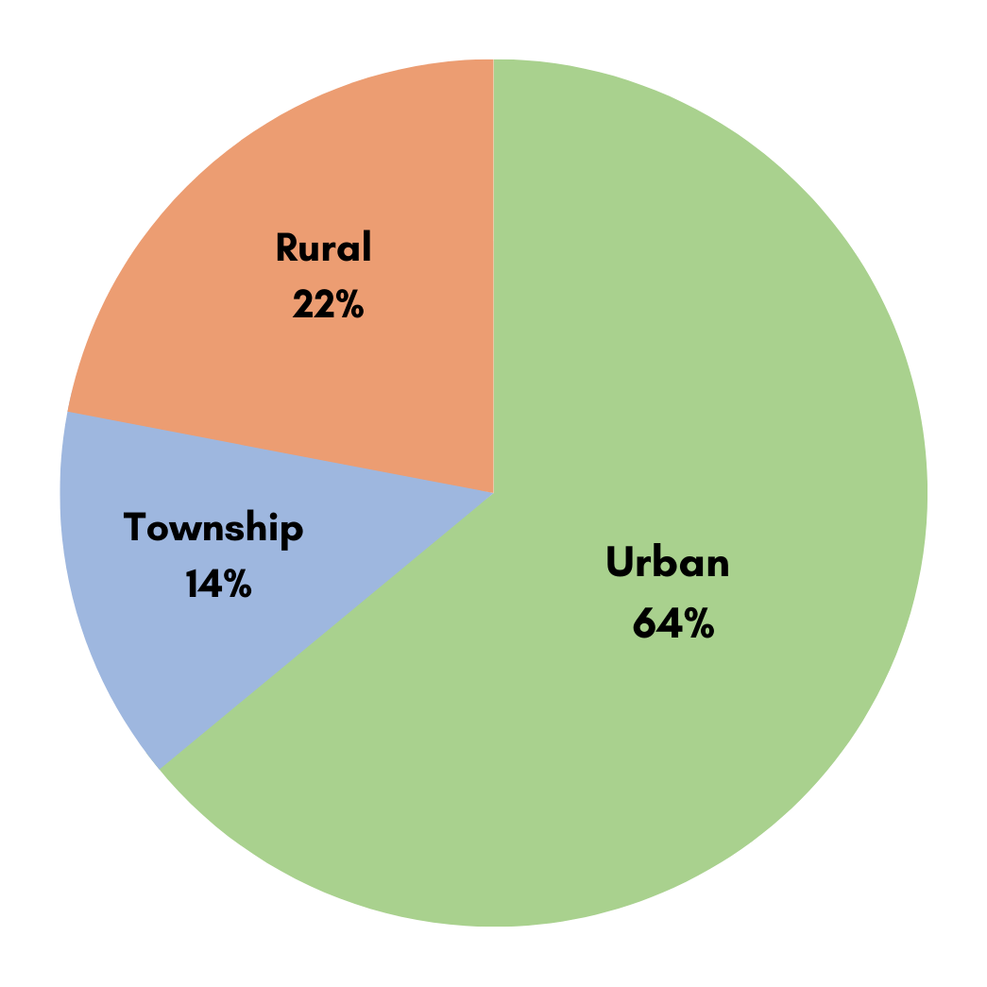

## Access to devices and infrastructure

All 25 of the contact universities offer some form of remote or online learning, and in some cases, following the hard lockdowns, made provision for their students to access computer labs on campus. Additionally, some universities provided some students with tablets or laptops either for free (based on certain criteria), subsidised or included in their course fees (Boikanyo, 2020; Thapeli, 2020; Vermeulen, 2020), while the National Student Financial Aid Scheme (NSFAS) pledged to deliver laptops to all their beneficiaries (Macupe, 2021). Although university websites which include the Learning Management System (LMS) were zero-rated during the COVID-19 pandemic (Gedye, 2020; South African Government, 2020), universities still provided their students with free internet access on campus or offered subsidised mobile data. Based on the accommodations and arrangements identified above, one might assume that all university students would have had access to a device either on campus or at home. Indeed, in some instances, lecturers and learning designers developed remote and online learning activities with exactly this assumption in mind. Thus, lecturers and learning designers felt they had the freedom to use applications and tools without being entirely restricted by concerns about data or bandwidth.

However, this promising picture is far from reality. The results of Jordaan (2020) agree with a survey done by 48,981 students from 18 of the 26 public universities in South Africa, 96% of the students indicated they have access to a smart device, such as laptops, tablets or smartphones. Although students have access to devices, they prefer using laptops for their online activities. Only 50-60% of the students mentioned that they have access to a laptop while 37% of the students said that they need to make plans (borrow or buy) to make sure they have enough data to do their online activities (DHET, 2020).  Although all university lecturers and students have some access to technology while on campus, universities are very differently resourced (Gedye, 2020). This contrast between urban and rural universities is explained by Gedye (2020) who stated:

An academic from a Gauteng university spoke about uploading video and audio files to the university’s website and using Skype and WhatsApp for teaching, while an academic from a regional university said he doesn’t think his university has the capacity for uploading and downloading content.

Not only are technology resources lacking but also food, accommodation, and transport. Students' plea for technological support is echoed by the South African Union of Students (SAUS) which reported to the Committee of Higher Education, Science and Technology that not all students are able to study online because poorer students lack the resources to access study material and activities (Mafolo, 2020).

## Learning design challenges

As learning designers, we find ourselves in a challenging situation as we design content and activities based on guidelines and best practices of published research, while students often come from peripheral, marginal or liminal contexts. This is coupled with several external factors such as lack of infrastructure, connectivity, devices and technical skills which limit access to high-end data intensive technology tools. Contributing to the problem is the rapid pace of change in educational technology (Hamilton et al., 2016). As the rise and demand for online schooling (UCT Online High School, TENEO) and online tertiary education (UPOnline, WITSOnline) continues, finding e-learning tools that can be used and are suitable for all contexts remains a challenge. To bridge the gap, learning designers need to find alternative methods to deliver the same content by using innovative pedagogy combined with different e-learning tools. Current literature on learning design caters largely for the urban context with good resources. However, due to the large gap between urban and rural contexts, and the historical background in South Africa, the challenge to cater for both can be seen as more complex (Le Grange, 2020; World Bank Organization, 2020).

This chapter aims to present alternative tools for contrasting contexts (urban vs rural) to meet the demand for education in unprecedented times where learning needs to take place in an online, blended or hybrid mode. Online learning is often used interchangeably with e-learning, virtual learning, network learning, web-based learning, mobile learning and distance learning (Muljana & Luo, 2019), because online learning encompasses a wide variety of technology tools, devices and media for educational purposes (Muljana & Luo, 2019). The fourth industrial revolution (Masindi & Roux, 2020) and the remote online teaching resulting from COVID-19 (Huma et al., 2021; Maharaj, 2021) magnified the benefits of hybrid or blended learning (Paterson, 2021). Blended learning, also referred to as hybrid learning, refers to the combination of face-to-face classes and e-learning (Picciano et al., 2014). Research has shown that blended learning has a positive effect on learning and teaching (Hung et al., 2020; Kamble et al., 2022). During the COVID-19 pandemic, more opportunities to use technology arose and necessitated a focus on how to design for technology integrated teaching and learning while considering contrasting contexts.

Accordingly, the question arises – how do we design technology integrated, student-centred online activities for urban and rural contexts? To guide us in addressing this question, we used a humanistic approach together with the SAMR model (Puentedura, 2012) to build online activities and select tools.

## Rural student feedback when studying at higher education

South Africa’s Higher Education, Science and Innovation Minister, Dr Blade Nzimande, declared at the start of the COVID-19 pandemic: “No student will be left behind” (SAnews, 2020). However, students from rural areas or who are studying at rural universities have a contrary experience to that advocated for by Dr Nzimande (Alex, 2022; Landa et al., 2021; Moodley et al., 2015; Walker & Mathebula, 2019).

In a study with 274 undergraduate students from a South African rural higher education institution (HEI), students’ feedback with regards to educational technology emphasises that for students studying in rural areas, internet access and cell phone reception is an issue when they need to access online platforms or use technology from home (Alex, 2022). Although students confirmed that they do know the basics of navigating online platforms, Alex (2022) reiterates that students and staff lack technical knowledge and this impacts their use of technology, more specifically online learning, in a negative way. Alex suggests that already available or known technology needs to be used, otherwise extensive training and support for both students and lecturers are needed (2022).

Landa et al. (2021) collected data using a questionnaire completed by 15 educators and 30 students from two South African universities and found it was evident in student feedback that all students don’t have access to high-end smartphones. As a result, students are not able to access content from LMSs because their mobile device is not designed to display content in a readable and mobile friendly format. However, students have access to WhatsApp, which is why they prefer to use this messaging application as an alternative technology to the preferred university LMS (Landa et al., 2021).

In another study, researchers sampled a total of 380 second and third-year students at a rural university (Moodley et al., 2015). Students’ feedback revealed that social media platforms are technologies that students can relate to, with students believing that these technologies enhance their participation and engagement, make the learning activities more interesting and can assist in building and strengthening a sense of community (Moodley et al., 2015). Students further suggest that when technology such as LMSs are used, it needs to be accessible in all university buildings and residences. Also, sufficient computers coupled with strong internet access need to be available throughout the campus for students’ access.

It is not only students at rural universities that experience these obstacles. Thirty students studying at three large urban universities emphasised that if lecturers want to use technology whether it is the LMS or applications during a lecture, they should not assume that all students have equal access to that technology. Students coming from poorer backgrounds might not have the necessary access to devices, data and internet access (Walker & Mathebula, 2019).

## Theoretical foundations

### Humanistic learning

Born from the work of Maslow, Rogers and Erickson (Khatib et al., 2013), humanistic learning theory focuses on the student. Humanistic learning approaches to teaching and learning is a student-centred approach (Khatib et al., 2013). When participating in learning activities, students need to have the freedom to choose their learning path (Brown, 2007). Engagement needs to be encouraged so that students are inspired and motivated to learn. Students also need to evaluate themselves and not only rely on the feedback of peers and lecturers (Goldenburg & Dietrich, 2002). This humanistic, student-centred learning approach opens up opportunities to create activities that stimulate both the affective and cognitive domain (Khatib et al., 2013).

Although the emphasis of this chapter is on the learning design and use of educational technologies in two contrasting contexts, it is also important to pay attention to humanising the learning of our students (Bartolomé, 1994). It will be foolish to replicate instructional design techniques that work in one context directly into the other (Bartolomé, 1994). In contrasting contexts, it is important to know that marginalised students learn in different ways (Huerta, 2011), and therefore questions such as those below should be engaged:

* “Who are we designing for?”
* “What are their living circumstances?”
* “What access do they have to the internet, devices, data and electricity?”
* “From what locations will students access the university's tools?”
* “What is their language proficiency?”
* “How and in what ways are students digitally literate?”

It is important to decide what culture you want to cultivate in your classes because that will influence your design, facilitation, kind of activities and technology tools to be used. In addition, learning is focused on what the students already know while at the same time respecting differences and showing care (Huerta, 2011). Humanising learning is more than learning, literacies, identities, cultural differences and participation, it also challenges the current approach to teaching (Fataar, 2016). Therefore, technology integration needs to assist in dealing with these inequalities and make provision for diversity and contrasts in personality, learning preferences and language proficiency.

### The SAMR model

The SAMR model, developed by Dr Puentedura in 2012, provides a guiding framework to evaluate technology-based activities and can improve integration of these emerging technologies into everyday teaching (Hilton, 2015). As teachers and learning designers adopt technologies, it is important that they understand how the technology can be used to enhance or transform learning. This model facilitates e-learning activities and supports the transformation of learning. Cummings (2014) infers that SAMR should facilitate the selection of suitable software and modern consumer technologies that cater for staff and students and promote 21st century skills.

Figure 2

The SAMR model (Puentedura, 2012)

We provide examples based on one topic, to demonstrate how this topic can be taught with e-learning tools at the 4 different levels of SAMR and how these learning activities are adapted for two contrasting contexts. As learning designers we are aware that in adapting activities, we need to maintain the standard and quality of the activity but also keep our students, their contextual challenges and user experience in mind. For this to happen, selecting the appropriate e-learning tools plays a pivotal role. Emphasis is placed on student engagement, sound educational principles, and the alignment of learning outcomes, assessment and activities (Biggs & Tang, 2007). Designing for urban and rural contexts is an enormous challenge since educational outcomes should be equitable.

However, you cannot design student-centred learning activities without considering a learning and assessment taxonomy such as Bloom’s taxonomy. Created by Benjamin Bloom in the 1950s, this taxonomy has been used for years as a basis for educational achievement, being seen as a lens through which we assess different levels of learning (Krathwohl, 2002). Bloom’s taxonomy gives an indication of “gaps” in constructing learning outcomes at different cognitive levels to create assessments that will align with these outcomes. In addition, the emphasis is on moving from what you are learning (factual knowledge) progressively to the how and why (metacognitive knowledge) (Cochran & Conklin, 2007; Krathwohl, 2002).

E-learning tools can be used at all levels of cognitive development.  The technology does not have to be complex, but the task for which the technology is used could be of a high cognitive level. It is necessary to pay attention to the learning outcome and how the technology supports the learning activity to achieve the outcome (Moodley, 2017).

We have chosen the topic “Blood flow through the heart” to illustrate how this can be taught in two contrasting contexts at different cognitive levels (Bloom’s taxonomy) using a variety of different e-learning tools such as videos, animations, learning management systems, student response systems and interactive presentations to create technology integrated activities at different levels (SAMR). Our experience as learning designers informed our practice of how to develop content for contrasting contexts. In this chapter, we attempt to share our experience and provide solutions in terms of designing activities using different pedagogical approaches and e-learning tools to cater for students in contrasting contexts because activities can be designed for all levels of learning, but the integration of technology at different levels provides a different learning experience and is dependent largely on contextual factors. Also, we explore student feedback on their experiences of learning with e-learning tools and some of the challenges and successes that contributed to their learning journey. Taking this into consideration, we illustrate how lessons can be adapted by using different e-learning tools to cater for contrasting contexts.

### Selecting e-learning tools

True to a humanistic approach, the learning designer needs to know the contextual background of their students before designing learning activities or integrating technology for that matter. However, taking the contrasting contexts of the student into consideration, the focus should be to design technology integrated, student-centred, online activities with appropriate e-learning tools.

Before selecting the e-learning tools, it is important to decide what needs to be taught (Blood flow through the heart) and align the pedagogical approaches and e-learning tools to the levels of the SAMR framework. Once this is done, outcomes, assessments and activities can be aligned. This can be tricky as there are several aspects to consider such as (i) designing the learning outcome; (ii) ensuring that the assessment activity is pitched at the appropriate level of Bloom's taxonomy; (iii) selecting e-learning tools that can be used in different contexts but will ensure the same learning outcome is achieved; (iv) ensuring that the tools selected enhance or transform the learning experience within the context. This is apart from the several external factors mentioned earlier that may shape the process. Incorporating the challenges and experiences described from the student feedback, we propose the following example using e-learning tools for contrasting contexts. Each level described provides an activity with an intervention strategy with possible hyperlinks and examples of e-learning tools that can be used.  For the purpose of illustrating this intervention, we provide examples of how content can be presented using different levels of Bloom’s taxonomy and at different levels of SAMR.

## Substitution

The first level of SAMR, substitution is regarded as the easiest and simplest way to integrate technology (Hockly, 2013). An activity can be classified as substitution if it was possible to do the activity without the use of technology (Hilton, 2015; Kirkland, 2014). While in this example the activities will fall under the first two levels of Blooms’ taxonomy: remember and/or understand, this does not imply that the substitution of technology can only be associated with the first two levels of Blooms’ taxonomy.

### Urban

In the urban context, students can be given a link to a YouTube video about . This would replace the explanation given by a teacher with an explanation that enhances learning through audio and visual learning stimulation (I can see the heart), drawing on humanising pedagogies, such as personalised learning experiences, multimodal learning, culturally responsive teaching, collaborative learning and inquiry-based learning. The students can then summarise what they have watched and this summary would demonstrate their ability to remember and understand the process of blood flowing through the heart. The activity can also serve as assessment of or for learning.

### Rural

In the rural context, not all students have devices and not all lecture halls have strong stable Wi-Fi. All students cannot work online at once unless they are in hotspot areas like the computer labs. The teacher can download the video and show it to the class (I can see the heart), use labelled images that have been saved on his/her device and explain (or play a prerecorded voice note). Alternatively, he/she can create a PowerPoint with the images and voiceover, save it as an MP4 video and play it to the class. This way, students still get the audio (teacher) and visual (illustration) stimulation. The teacher can use Bluetooth or , a cross-platform, Bluetooth-based, file sharing application, to provide the learning material. The students can summarise what they have learned and would achieve the same outcome.

## Augmentation

Augmentation goes beyond the level of substitution as it involves some type of functional improvement over what could have been achieved by traditional methods (Hilton, 2015; Kirkland, 2014). In this example, the technology allows for further improvement to the task that would not be possible if the technology was not used.

### Urban

In an urban setting, the teacher can create an interactive PowerPoint that acts as a branching scenario or include a branching scenario that can plug into the LMS. In this case, the student can click on different icons on the home screen (Figure 3) and choose their learning path, personalising the teaching approach. Each icon will take them through a different interactive activity thus enhancing the lesson by creating opportunities for choice.

Figure 3

Illustration of a possible home screen for interactive PowerPoint

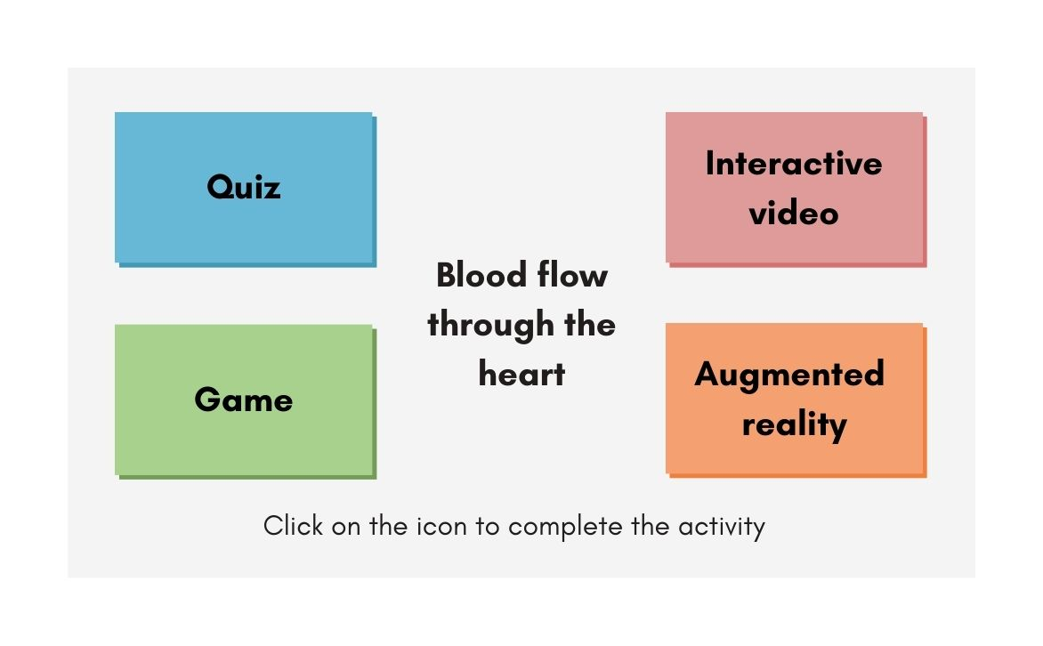

### Rural

In the rural context, the possible limitation of technical skills, stable Wi-Fi and devices require the lesson to be adapted. The pedagogical approach of using learning stations with devices set up with different activities where students can complete the activities at each station allows freedom of choice. However, should devices and stable Wi-Fi still remain a problem, each activity can be completed by the teacher presenting the activities one at a time and using [Plickers](https://www.plickers.com/) (Quiz) to engage with the students and scan their answers. Plickers is a classroom response system that allows teachers to gather real-time formative assessment data without requiring students to use digital devices. Instead, Plickers uses paper cards with unique codes printed on them to enable teachers to quickly and easily assess students' understanding of concepts by scanning the codes indicating their response (Mshayisa, 2020). Alternatively, the teacher can create learning stations and allow students to play the interactive presentation in teams. In this case, the outcomes are still achieved but the time taken to complete the activities increases.

## Modification

Modification is taking pre-existing tasks and altering them significantly so that they will not be achieved without technology (Hilton, 2015; Kirkland, 2014). The focus is on visual, audio and textual tools to share knowledge. Studies by Wang et al. (2013) and Cornelius et al. (2011) support the usefulness of technology at the modification level. Other examples of this would be when students create voice recordings (cellphone), online group discussions (Facebook, Twitter) and interactive text tools (Thinglink, Padlet, Google forms).

### Urban

In the urban context, students can create a presentation with narration of how blood flows through the heart. To do this, they can use PowerPoint or animation software such as  [Powtoon](https://www.powtoon.com/) to create animated videos. Powtoon is a cloud-based software application used for creating animated videos and presentations. It allows teachers to create engaging videos and presentations without the need for specialised skills or technical knowledge. This will require the students to research and evaluate images to create a “story” and then order the images so that they can add a voiceover that explains the logical flow of blood through the heart. They can then share their videos with the rest of the class on a virtual wall such as [Padlet](https://padlet.com/) and watch or comment on their peers' videos. Padlet is a digital tool that allows teachers to create online or virtual "walls" that can be shared and collaborated on by multiple students. Padlet can be used to create a variety of visual displays, including brainstorming sessions, mind maps, infographics, and photos. This activity transforms the lesson through group cohesion, technology integration and the opportunity of choice and multiple learning styles to create a humanising pedagogical environment.

### Rural

In the rural context, a teacher can provide printed images and ask students to order images in such a way that it tells the story of how blood flows through the heart. They can then insert those images on a PowerPoint slide, use PowerPoint animations and add voiceover to the slide explaining the process of blood flow through the heart and save that PowerPoint as an MP4 video. They can then submit the presentations to the teacher who can present a few in the class, reducing the online activity and data usage. Students are limited by the images provided and by creativity. The group activity becomes a whole class discussion. They still evaluate the images provided and apply their knowledge to achieve the outcome.  Alternatively, students can take photos and use the movie function on their phone gallery or a free app such as [Filmigo](https://www.google.com/aclk?sa=l&amp;ai=DChcSEwi_y9-lwY_zAhX_bG8EHQAqBCcYABAAGgJqZg&amp;ae=2&amp;ei=MoVJYYGxOrbV1sQP_dm26AQ&amp;sig=AOD64_3fD623IjBoid7tM6sq5QlWQvP1gw&amp;q&amp;sqi=2&amp;adurl&amp;ved=2ahUKEwiBktOlwY_zAhW2qpUCHf2sDU0Q0Qx6BAgDEAE) and create a video. They can share this with their peers via [WhatsApp](https://www.whatsapp.com/) or Shareit.

## Redefinition

Redefinition is the creation of a new task that would not be possible without the use of technology (Hilton, 2015; Kirkland, 2014). The focus is on the visualisation of narrative aspects found in texts (Puentedura, 2012; 2014). This is the hardest level to achieve in a rural context as it is dependent on the use of technology for new ways of thinking, creating, and collaborating. For example, virtual reality of historical sites, interactive simulations for complex scientific concepts and/or collaboration with peers in real-time from other parts of the world.

### Urban

In this activity, the students will work in groups to create their own online quiz games after they have viewed the blood flow through the heart on a virtual reality app. To create the quiz, they will be using gaming software like [Kahoot](https://create.kahoot.it/). They can invite other group members of the class to play their game. They will team up in groups and see the leaderboard as they progress. This quiz will require them to develop questions at varying levels of difficulty related to the flow of blood through the heart.  The lesson is transformed by including online immersion in the content, online gaming elements, collaboration, social interaction and audio, visual and textual stimulation. This diversely structured activity will resonate with different kinds of learning preferences.

### Rural

In a rural context, the lecturer will share (Shareit) a video which they need to watch. To create the quiz game, they would need to use PowerPoint with hyperlinks in the computer labs. The students can again work in groups to create the game and then post the game on social media (WhatsApp, Facebook). The other groups can then engage and share their game answers on the social media group. The group that manages to complete the quiz in the shortest time with all correct answers will be the winners. This will reduce data usage, include technology, collaboration and social interaction and still achieve the outcome. The gaming nature is still present but approached differently ensuring audio, visual and textual stimulation.

 Alex (2022) and Landa et al. (2021) claim that students prefer to work with applications that they know such as WhatsApp and social media tools and from which they have easy access on campus. Pedagogical approaches and e-learning tools need to be adapted to cater for a context of low technical skills and lack of devices and connectivity (Alex, 2022; Landa et al., 2021). Since students have mobile phones (Landa et al., 2021; Moodley et al., 2015), the content needs to be mobile friendly and be created to have a suitable mobile interface where they can use free applications. However, using mobile devices for education relies on reliable networks and access to low data. This issue is partially addressed since 24 (of the 25) public higher education institutions subscribe to [Eduroam](https://eduroam.ac.za/participants), a secure connection of hotspots on campuses globally ; students have access to Wi-Fi in designated areas and shared student spaces such as libraries, cafeteria, hostel and lecturing halls. Pedagogical approaches need to be adapted to supplement the less advanced technology (Alex, 2022) to create a meaningful, relevant and engaging learning experience, for example, through combining devices and apps (download a video on one device, share with others) and learning stations (setup stations where students can rotate). Careful thought, planning and evaluation of e-learning tools must be done to understand the educational value of the tool and how it can be used to support learning. It is important to note that although learning is always at the centre of an activity, this chapter focused on the level of technology integration (SAMR) and not the level of learning (Bloom’s taxonomy) because activities can be designed for all levels of learning, but the integration of technology at different levels provides a different learning experience and is dependent largely on contextual factors.  However, technology integration and humanising pedagogies can be used at all levels of Bloom's taxonomy.

## Conclusion

As learning designers, we need to think creatively and innovatively to package our learning material to include freedom of choice in the learning path, multiple learning opportunities and a wide range of e-learning tools. We need to demonstrate flexibility to cater for the diversity of students. We need to think of intervention strategies to manage inequalities across contexts and within contexts taking into consideration students’ feedback. This can be done by bringing in a human touch to our design, catering for different personalities, learning preferences and language and technical proficiency. To do this, we need to use different e-learning tools for contrasting contexts to customise or personalise our learning design. Integrating technology can be done in both rural and urban contexts and at various different levels of integration as demonstrated using the SAMR model. In this example, the rural context is limited to synchronous interactions on campus and sharing technology in computer labs. However, this is not always the case and depends on the extent of network connectivity available to students. Bloom’s taxonomy provides a guideline on how activities can be designed to be more complex while keeping the technology integration simple. E-learning tools that are best suited for the context need to be used and lessons need to be adapted to suit the needs of students. As learning designers, it is our duty to ensure that no student is left behind.

## References

Alex, J. K. (2022). Impact of the COVID-19 Pandemic on the academic life of higher education students: A rural South African perspective from a global study. South African Journal of Higher Education, 36(1), 20–40.<https://doi.org/10.20853/36-1-4303>

Bartolomé, L. I. (1994). Beyond the methods fetish: Toward a humanising pedagogy. Harvard Educational Review, 64(2), 173–194. <https://doi.org/10.17763/haer.64.2.58q5m5744t325730>

Biggs, J., & Tang, C. (2007). Teaching for quality learning at university(3rd edition). Open University Press.

Boikanyo, M. (2020, May 06). UP welcomes donation of 600 tablet devices from Aspen Pharmacare for students’ online learning. University of Pretoria<https://www.up.ac.za/faculty-of-health-sciences/news/post_2893123-up-welcomes-donation-of-600-tablet-devices-from-aspen-pharmacare-for-students-online-learning>

Brown, H. D. (2007). Principles of language learning and teaching (5th edition). Pearson Education.

Cochran, D., & Conklin, J. (2007). A new Bloom: Transforming learning. Learning & Leading with Technology, 34(5), 22–25. <https://eric.ed.gov/?id=EJ779824>

Cornelius, S., Marston, P., & Gemmell, A. (2011). SMS text messaging for real-time simulations in higher education. In J. Traxler & J. Wishart (Eds.), Making mobile learning work: Case studies for practice(pp. 13–17). ESCalate.

Cummings, C. (2014). Teacher created perspective interactive content (TCPIC), SAMR, and modernizing remediation in social science education. In W. B. Russell (Ed.),Proceedings from ISSS '14The Annual Conference of the International Society forthe Social Studies(pp. 37–39). Orlando, FL.

Davids, N. (2020, March 7). Maybe the coronavirus will set SA on a path to a more equitable education system. News24.<https://m.news24.com/Columnists/GuestColumn/opinionmaybethe-coronavirus-willset-south-africa-on-the-path-to-a-more-equitable-education-system-20200327>

Devakumar, D., Shannon, G., Bhopal, S. S., & Abubakar, I. (2020). Racism and discrimination in COVID-19 responses. The Lancet, 395(10231), 11–17. <https://doi.org/10.1016/S0140-6736(20)30792-3>

DHET, (2020).  Students' access to and use of learning materials Survey Report 2020. <https://www.usaf.ac.za/wp-content/uploads/2021/02/DHET_SAULM-Report-2020.pdf>

Dube, B. (2020). Rural online learning in the context of COVID-19 in South Africa: Evoking an inclusive education approach. REMIE - Multidisciplinary Journal of Educational Research, 10(2), 135–157. http://doi:10.4471/remie.2020.5607

Ellis, E. (2020, May 14). COVID-19: Exposing a water crisis in the making. Daily Maverick.<https://www.dailymaverick.co.za/article/2020-05-14-covid-19-exposing-a-water-crisis-in-the-making/>

Fataar, A. (2016). Towards a humanising pedagogy through an engagement with the social–subjective in educational theorising in South Africa. Educational Research for Social Change, 5(1), 10–21. <http://dx.doi.org/10.17159/2221-4070/2016/v5i1a1>

Gedye, L. (2020, April 2). COVID-19 turns learning into costly data exercise. Newframe. <https://www.newframe.com/covid-19-turns-learning-into-costly-data-exercise/>

Goldenberg, D., & Dietrich, D. (2002). A humanistic-educative approach to evaluation in nursing education. Nurse Education Today, 22(4), 301–310. <https://doi.org/10.1054/nedt.2001.0707>

Hamilton, E. R., Rosenberg, J. M., & Akcaoglu, M. (2016). The substitution augmentation modification redefinition (SAMR) model: A critical review and suggestions for its use. TechTrends, 60, 433–441. <https://doi.org/10.1007/s11528-016-0091-y>

Hilton, J. T. (2015). A case study of the application of SAMR and TPACK for reflection on technology integration into two social studies classrooms. The Social Studies, 107(2), 68–73. <https://eric.ed.gov/?id=EJ1091182>

Hockly, N. (2013). Technology for the language teacher: Mobile learning. ELT Journal, 67(1), 80–84. https://doi:10.1093/elt/ccs064

Howell, S., & Shearing, C. (2017). Prisons, tourism, and symbolism: Reflecting (on) the past, present, and future of South Africa. In J. Wilson, S. Hodgkinson, J. Piché, & K. Walby (Eds.), The Palgrave Handbook of prison tourism(pp. 277–294). Palgrave Macmillan.

Huerta, T. M. (2011). Humanising pedagogy: Beliefs and practices on the teaching of Latino children. Bilingual Research Journal, 34(1), 38–57. <https://eric.ed.gov/?id=EJ924661>

Huma, A., Yang, Y., Ahmad, S. A., & Ali, A. (2021). Technology Integration in higher education during COVID-19: An assessment of online teaching competencies through technological pedagogical content knowledge model. Frontiers in Psychology, 12, 1-11. <https://doi.org/10.3389/fpsyg.2021.736522n>

Hung, T. T., Tuyet, N. T., Long, N. T., & Hanh, N. V. (2020). The effect of positive learning culture in students’ blended learning process. Journal of E-Learning and Knowledge Society,16(3), 68-75. <https://doi.org/10.20368/1971-8829/1135218>

Jone, T. (2016, October 4). Reimagining Bloom’s taxonomy – with an eye on technology. NLN.<https://nursingedge.nln.org/2016/10/04/reimagining-blooms-Taxonomy-with-an-eyeon-technology/>

Jordaan, N. (2020, August 18). Half of university students don’t have resources such as laptops and data to study from home. Timeslive. <https://www.timeslive.co.za/news/south-africa/2020-08-18-half-of-university-students-dont-have-resources-such-as-laptops-and-data-to-study-from-home/>

Kamble, N.K, Hassan, A. M. M., Mishra, P., Asnate-Salazar, E., & Agathian, R. (2022). Role of blended teaching enhancing effectiveness of quality of teaching-learning process: An empirical study. Journal of Positive School Psychology, 6(2), 948–955. <http://journalppw.com>

Kamerpower. (2021). 20 Best private universities in South Africa 2021. <https://kamerpower.com/20-best-private-universities-in-south-africa-2021-registered/>

Khatib, M., Sarem, S. N., & Hamidi, H. (2013). Humanistic education: Concerns, implications and applications. Journal of Language Teaching and Research, 4(1), 45-51. http://10.4304/jltr.4.1.45-51

Kirkland, A. B. (2014). Models for technology integration in the learning commons. School Libraries in Canada, 32(1), 14-18. <https://journal.canadianschoollibraries.ca/wp-content/uploads/2017/04/SLiCv32n1.pdf>

Krathwohl, D. R. (2002). A Revision of Bloom's taxonomy: An Overview. Theory Into Practice, 41(4), 212–218.<https://doi.org/10.1207/s15430421tip4104_2>

Le Grange, L. (2020). COVID-19 pandemic and the prospects of education in South Africa. Prospects, 51, 425–436. <https://doi.org/10.1007/s11125-020-09514-w>

Landa, N., Zhou, S., & Marongwe, N. (2021). Education in emergencies: Lessons from COVID-19 in South Africa. International Review of Education, 67, 167–183. <https://doi.org/10.1007/s11159-021-09903-z>

Lawrence, G., Cole, C., & Johnston, K. P. (2020). Not more technology but more effective technology: Examining the state of technology integration in EAP Programmes. RELC Journal, 51(1), 101–116. <https://doi.org/10.1177/0033688220907199>

Macupe, B. (2021, January 19). Students to receive NSFAS laptops by March. Mail & Guardian.<https://mg.co.za/education/2021-01-19-students-to-receive-nsfas-laptops-by-march/>

Mafolo, K. (2020, June 25). The poor at universities left behind in lockdown, says student union.

Maharaj, S. (2021, March 9). Engineering faculties perfectly placed to be at forefront of expanding on lessons learned during COVID-19 pandemic. University of Pretoria.<https://www.up.ac.za/coronavirus-updates/news/post_2957066-expert-opinion-engineering-faculties-perfectly-placed-to-be-at-forefront-of-expanding-on-lessons-learned-during-covid-19-pandemic-says-up-dean>

Masindi, M., & Roux, P. A. (2020). Transforming South Africa’s universities of technology: A roadmap through 4IR lenses. Journal of Construction Project Management and Innovation, 10(2), 30–50. <https://doi.org/10.36615/jcpmi.v10i2.405>

McGregor, M. (2011). Judicial notice: Discrimination and disadvantage in the context of affirmative action in South African workplaces.De Jure Law Journal, 4(1), 111-125.[http://www.scielo.org.za/scielo.php?script=sci_arttext&pid=S2225-71602011000100008&lng=en&nrm=iso](http://www.scielo.org.za/scielo.php?script=sci_arttext&amp;pid=S2225-71602011000100008&amp;lng=en&amp;nrm=iso)

Mitchell, R. (2012). Technology is not enough. The Journal of Environment & Development, 21, 24–27. <https://doi.org/10.1177/107049651143567>

Moodley, K. (2017). Mobile learning: A professional teacher technical identity development framework [Doctoral dissertation, University of Pretoria]. UPSpace Institutional Repository. <http://hdl.handle.net/2263/67413>

Moodley, P., Singh, R. J., & Cloete, J. (2015). Exploring student perceptions of using the learning management system and social media for blended learning at a rural university. Progressio, 37(1), 68–82. <https://doi.org/10.25159/0256-8853/573>

Mshayisa, V. V. (2020). Students’ perceptions of Plickers and crossword puzzles in undergraduate studies. Journal of Food Science Education,19, 49–58. <https://doi.org/10.1111/1541-4329.12179>

Muljana, P. S., & Luo, T. (2019). Factors contributing to student retention in online learning and recommended strategies for improvement: A systematic literature review. Journal of Information Technology Education: Research, 18, 19–57. <https://doi.org/10.28945/4182>

Myers, J. (2020, August 18). 5 things COVID-19 has taught us about inequality. World Economic Forum. <https://www.weforum.org/agenda/2020/08/5-things-covid-19-has-taught-us-about-inequality/>

Paterson, M. (2021, February 11). COVID-19 and higher education: Damage done, lessons learnt. University World News. <https://www.universityworldnews.com/post.php?story=20210211103422612>

Perry, B. L., Aronson, B., & Pescosolidoa, B. A. (2021). Pandemic precarity: COVID-19 is exposing and exacerbating inequalities in the American heartland. PNAS, 118(8), 1–6. <https://doi.org/10.1073/pnas.2020685118>

Picciano, A. G., Dziuban, C. D., & Graham, C.R. (2014). Blended learning research Perspectives, Volume 2. Routledge.

Puentedura, R. R. (2012, August 23). The SAMR model: Background and exemplars[PowerPoint slides]. <http://www.hippasus.com/rrpweblog/archives/2012/08/23/SAMR_BackgroundExemplars.pdf>

Puentedura, R. R. (2014, December 11).SAMR and TPACK: A hands-on approach to classroom practice [PowerPoint slides]. <https://www.academia.edu/33751148/SAMR_and_TPCK_A_Hands-On_Approach_to_Classroom_Practice>

Qin, L. (2007). EFL teachers’ factors and students’ affect. US-China Education Review, 4(3), 60–67. <https://eric.ed.gov/?id=ED497391>

SAnews. (2020, April 30). Higher education vows to leave no student behind. <https://www.sanews.gov.za/south-africa/higher-education-vows-leave-no-student-behind>

South African Government. (2020, June 9).Minister Blade Nzimande: Progress in implementation of Coronavirus Covid-19 measures by Post School Education and Training Sector. <https://www.gov.za/speeches/minister-blade-nzimande-progress-implementation-coronavirus-covid-19-measures-post-school>

Swartz, S., Tyler, R., & Versfeld, A. (2013). Emotion as opportunity: Reflections on multiple concurrent partnerships among young men in South Africa. Gender & Behaviour, 11, 5197–5207.

Thapeli, N. (2020, October 2). Laptop handover.<https://www.vut.ac.za/laptop-handover>

UniRank. (n.d.). Top public universities in South Africa. <https://www.4icu.org/za/public/>

United Nations Educational Scientific and Cultural Organization (UNESCO). (2020). Global education monitoring report 2020: Inclusion and education: All means all.<https://www.unesco.org/gem-report/en/inclusion>

University of Pretoria (2021). UP welcomes donation of 600 tablet devices from Aspen Pharmacare for students’ online learning. <https://www.up.ac.za/faculty-of-health-sciences/news/post_2893123-up-welcomes-donation-of-600-tablet-devices-from-aspen-pharmacare-for-students-online-learning>

Universities South Africa (2021). Public universities in South Africa. <https://www.usaf.ac.za/public-universities-in-south-africa/>

Vermeulen, J. (2020, April 22). Free data for university students in South Africa. MyBroadband. [https://mybroadband.co.za/news/cellular/349109-free-data-for-](https://mybroadband.co.za/news/cellular/349109-free-data-for-university-students-in-south-africa.html)

Walker, M., & Mathebula, M. (2019). Low-income rural youth migrating to urban universities in South Africa: Opportunities and inequalities. COMPARE, 50(8), 1193–1209.

Wang, J., Yu, W. C. W., & Wu, E. (2013). Empowering mobile assisted social e-learning: Students' expectations and perceptions. World Journal of Education, 3(2), 59–70. http://doi:10.5430/wje.v3n2p59

World Bank. (2020). Remote Learning and COVID-19: The use of educational technologies at scale across an education system as a result of massive school closings in response to the COVID-19 pandemic to enable distance education and online learning.<https://www.worldbank.org/en/topic/edutech>

Read this online at <https://edtechbooks.org/ldvoices/elearning_tools_contexts>