# New Technologies Deliver on the Promise of HyFlex

Hinck, G., Burke, L.

The University of St. Thomas offered its first fully HyFlex course during the summer of 2017, in an initiative called “Take St. Thomas Home for the Summer.”  Business school leaders were interested in supporting instructional innovation and new course delivery models, and a finance instructor agreed to try the HyFlex model in his undergraduate course.

Working in conjunction with staff from STELAR (the “St. Thomas eLearning and Research” center), the instructor developed an undergraduate finance course that supported traditional classroom-based student participation as well as equivalent activities for online participants, using new online technologies (including Canvas, Panopto, Proctorio, and Zoom) and a new active learning classroom space with multiple displays and a smartboard.  Student response to this offering was positive with an additional section added each term to accommodate students on the waitlist.

Due to this successful initiative, the university is expanding HyFlex course delivery and variations of this model to additional courses and programs.  This chapter will describe our journey from our first introduction to the model at an online learning conference through current adoption status.

## History of Online Learning at the University of St.Thomas

The University of St. Thomas, Minnesota’s largest private university, has been a very traditional liberal arts institution for most of its 135 years, with campuses in St. Paul, Minneapolis and Rome.  While blended programs were offered at the graduate level starting in the 1990s, it wasn’t until 2012 that the first fully online program, an M.A. in Special Education, was developed in partnership with an online program management company, Bisk.

In 2016 the St. Thomas eLearning and Research group (STELAR) was created in order to provide internal instructional design and online course design and development services as we phased out our relationship with the OPM.  In addition to migrating those special education courses into the university’s instructional technology environment, during the summer of 2017, STELAR staff worked with faculty to develop a portfolio of online courses in an initiative called Take St. Thomas home for the Summer.  Through this initiative, we developed and offered FINC 321 in the HyFlex model of course delivery as a proof of concept.

## Faculty Development for Online and HyFlex Learning

The university’s Center for Faculty Development and STELAR work in partnership to support faculty, with STELAR providing the bulk of faculty training on topics related to online teaching and learning.  Initially, faculty training was offered through ad hoc on-campus instructional designer consultations, an annual multi-day on-campus workshop for blended teaching, and through faculty registrations in online Quality Matters and Online Learning Consortium workshops.  As STELAR expanded its training offerings, three 5-week online certificate courses were developed by instructional design staff in order to better assure that full time and adjunct faculty had the knowledge needed to design and facilitate online courses, with some training bootcamps for specific departments and programs to prepare them for teaching blended, online and HyFlex courses.

This chapter describes our journey from our initial offering of a HyFlex course as part of the Take St. Thomas Home for the Summer initiative to our current expansion of the HyFlex model into the School of Education.

## Why?

Our development of HyFlex courses started in the Opus College of Business, where the academic leadership team wanted to better use technology to support instructional innovation and new attendance models. At the 2016 OLC Innovate conference, several attendees from the business college attended a panel, “Hybrid Flexible Course and Program Design: Models for Student-Directed Hybrids,” and liked how HyFlex maximized student choice. Discussions ensued about offering HyFlex graduate courses in a new business analytics program.  One instructor in the program taught his courses using the classroom and web-conferencing components of this model as a proof of concept during the 2016-17 academic year and found that students liked the ability to choose their attendance modality from week-to-week. He was surprised to find that the group of students who attended online changed from week to week. He also reported that one student -- who was typically in class – experienced a minor car accident on her way to class one evening, and was able to attend class remotely online from the crash site while waiting for the police.

There was spirited discussion around converting the entire M.S. in Business Analytics program to HyFlex, but because enrollment in the on-campus courses was robust, and because course content was changing dramatically from term to term, few of the faculty were interested in adopting the HyFlex model as there was concern about the asynchronous online material requiring significant rework with each new term.

While enrollment in those courses was growing, student enrollment in on-campus undergraduate summer school courses was stagnant, and undergrads were often taking summer courses online elsewhere and then transferring the credits to St. Thomas.  As part of the effort to increase summer course enrollment (and revenue), business faculty were given the option of offering online or HyFlex courses in summer 2017. The premise behind developing a good HyFlex course allows us to create a single course that accommodates different learning preferences, decreases the need for multiple sections offered in a single modality, and meets the needs of both undergraduate and graduate students who have work or other commitments that might prevent them from attending class on campus. That said, it is also seen as a lot of work and we have had few faculty who have been willing to do that work to date.

## What?

Our approach is still evolving and is fragmented at times as we work to apply the model to various courses and programs.  While STELAR has shared information about HyFlex in various university communications and conference presentations, no formal goals or directives have been developed by the Office of the Provost other than promoting this as an instructional innovation through funding faculty course development grants.

In the 2018-19 academic year, a grant was offered for the “development of a co-located or hyflex course that allows students to participate on-campus or remotely within the same course section on a session-to-session basis.” Further explanation of the model suggested that “the course may be created in one of two formats: 1) the Co-Location model, which allows students to choose from two participation methods: regularly scheduled in-person sessions or interaction via Zoom webconferencing, or 2) the HyFlex model, which provides students the choice of three participation methods: in-person, through Zoom webconferencing, or asynchronously through Canvas.” That seems to have gained some new faculty interest, and we have several new programs engaged in offering either co-located or HyFlex courses in the 2019-20 academic year.

For the purposes of this chapter, we will focus on our first official HyFlex course, FINC 321, as it served as a proof of concept both for the use of online and classroom technologies, and will describe how this is informing subsequent courses and programs.

## **FINC 321 Financial Management**

Our first official HyFlex offering involved a core summer undergraduate business course in which students could choose to participate in one of three tracks for each of the bi-weekly class periods:

* Face-to-face in an active learning classroom
* Synchronously online through web-conferencing with Zoom Rooms
* Asynchronously online using Canvas and viewing classroom recordings

### Initial HyFlex Technologies

The course relied heavily on cloud-based and other technologies including:

* The Canvas learning management system, together with Proctorio for online test proctoring and VoiceThread for media-rich online asynchronous discussions
* A classroom computer and cameras optimized for live Zoom broadcasting, and Panopto recording for playback later
* A KappIQ Smartboard to support and capture whiteboard activities
* SHARP SVSI video distribution and the Axis streaming assistant
* An iPad to control the Zoom Room software
* A Catch Box throwable microphone and instructor lavalier mic.

One to two students were paid to assist during each class period, helping with set-up, monitoring the Zoom chat and reminding students to use the Catch Box microphone when speaking. They also controlled the wall-mounted classroom camera with a joystick to improve the quality of the video capture when the instructor moved around.  One of these student assistants was enrolled in the course and their salaries were paid out of the business school’s workstudy budget.

The video and images below help to illustrate how these technologies worked together.

**Figure 1**

Explanation of HyFlex Technologies: Video

**Figure 2**

Classroom Technologies

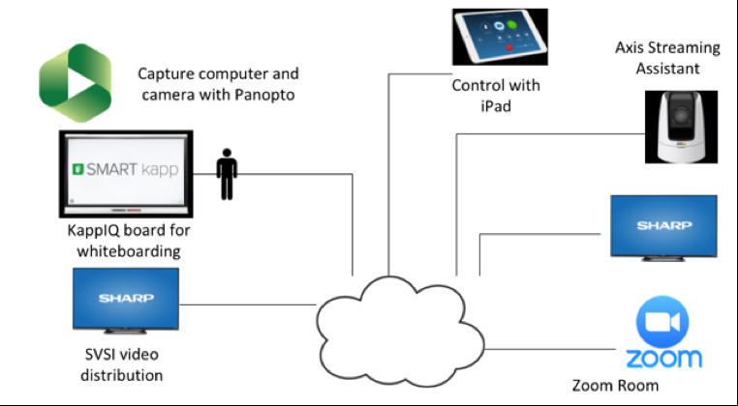

**Figure 3**

Instructor Technologies

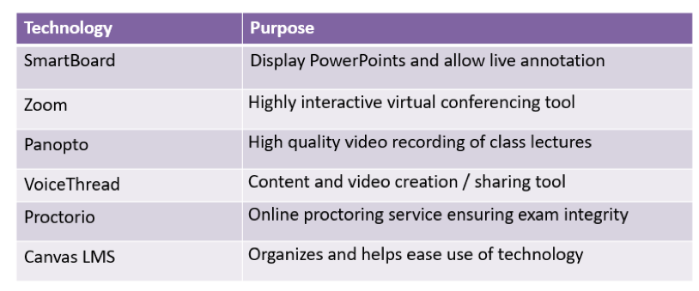

**Figure 4**

The HyFlex FINC 321 Active Learning Classroom

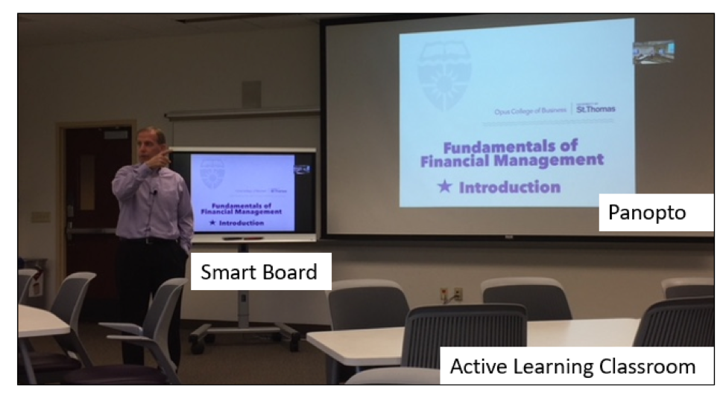

The technology we use to support HyFlex delivery continues to evolve.  Technologies used with each course are evaluated at least yearly and on an individual course-by-course basis.  Key technologies for most courses are a reliable web-conferencing system, SmartBoard, and high quality camera and audio.

### HyFlex FINC 321 Pedagogy

The on-campus and Zoom (synchronous online) students engage with each other and the instructor in the classroom and their interactions are captured in a Panopto video recording for viewing by the asynchronous students.  These videos, along with additional course materials, are available to all students on Canvas.  Students in all tracks complete the same readings, assignments and exams, with online students taking exams on the same day as in-class students through Proctorio. Daily participation points are assigned based on active classroom participation for on-campus and Zoom students and in the first year, asynchronous students submitted a written response to a discussion board prompt.

### Pedagogical Continuous Quality Improvement

Several pedagogical changes were made during the second FINC 321 offering.  VoiceThread is a supported tool on our campus.  Rather than participating in a text-based discussion board for participation points, asynchronous students were required to create a short VoiceThread video presentation in response to instructor prompts.

This change was made to more closely model the classroom pedagogy which required students to verbally support their positions in response to instructor prompts and questions. Per the instructor, this change resulted in a “dramatic improvement in engaging online students”.  Changes made in classroom delivery included a deliberate effort to increase engagement of synchronous students in the lecture and discussion through better integration of Zoom.  The instructor also worked to improve the quality of the videos through increased use of the Smartboard annotation tool to make recordings more dynamic allowing the students to better see and hear how an analysis was built. In addition, he tried to improve camera angles so that the video viewing experience of the asynchronous student was closer to a classroom experience. However, this was not as effective as hoped.  In part, because the student assistants often did not change the angles based on the classroom activities.  In fact, in the third year, the camera view will be static and positioned to directly face the instructor rather than mobile and following the classroom ‘action’. Students are required to view the videos, but this is not tracked or documented.

**Figure 5**

Learner Choice

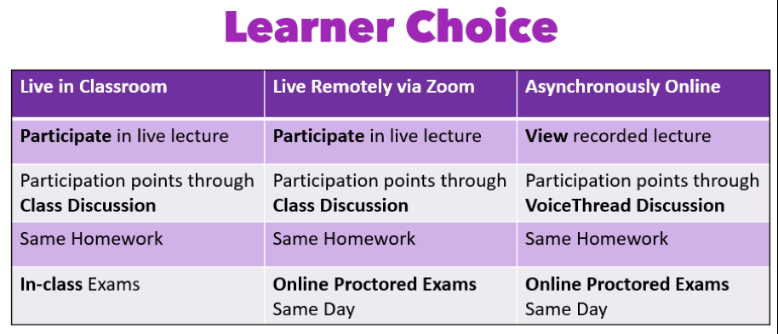

**Figure 6**

Canvas Modules

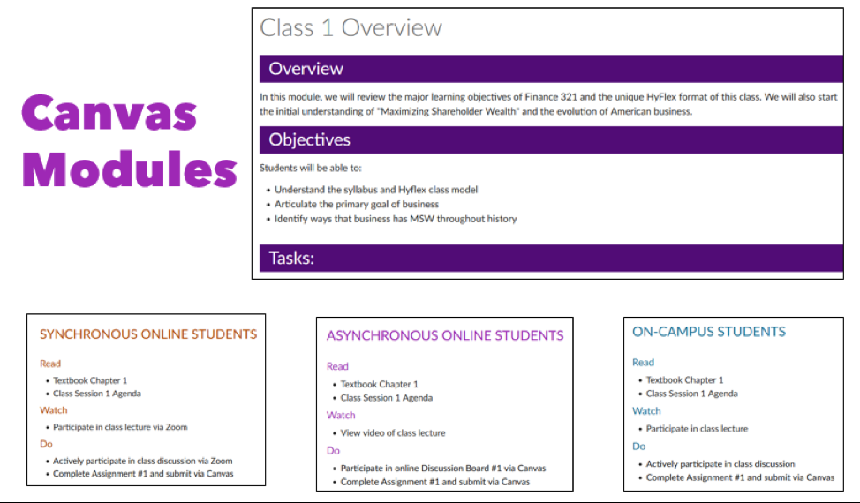

## How?

### Business Leads the Way

The initial discussions in support of HyFlex adoption involved the business college and appeal of HyFlex as a way to maximize course enrollments. Faculty aptitude, interest, and skill set figured heavily in choosing an instructor for our first pilot of a true HyFlex course.  It is important to note the short timeline (~3 months) between spring planning and summer delivery had a significant impact on initial HyFlex adoption.

The business college leadership supported and encouraged HyFlex delivery and paid the faculty grant awards while ITS/STELAR, working closely with the instructor, managed the project including classroom equipment, AV and classroom support, and instructional design services.  A partnership with university leadership and the Registrar was also essential.  Information about HyFlex as a course delivery option has been communicated through the STELAR website including blog posts such as [Interest Building Around the HyFlex Model of Course Delivery](https://www.stthomas.edu/stelar/showcase/id/hyflex/interest-building-around-the-hyflex-model-of-course-delivery.html).

## Implementation Issues

### Structure of the Model

The most significant implementation issue was simply determining how our HyFlex model would be structured, and what resources were needed to make it successful.  In our first HyFlex offering, the time from the initial decision to delivery of the course was less than 3 months, putting a heavy workload on faculty and staff alike. The heavy faculty workload was addressed by awarding faculty course development grants, limiting enrollment in sections, and paying faculty to facilitate any additional sections.

### Technology

Overall there have been few significant technology issues.  However, we did have equipment failure at a key point (last day of class) and not all students liked using the catch box for audio.  We are exploring other audio options but have not yet identified an acceptable replacement.

### Communication with Registrar

There were initial challenges with communicating this model to the registrar and HyFlex classes were not correctly represented in the university course catalog.   The registrar’s office has since created an official new course type category called HyFlexin our student information system that more accurately describes the student experience:

“Instruction is delivered concurrently via in-person class meetings, synchronous online class meetings, and asynchronous methods. Learners choose how they participate and engage each week.”

However, there is a delay between the time a course type is created and when it can be utilized and during the summer term 2019 the course description still included two sections, one online and one in-class and only the online section accurately described the model.  Interestingly, student enrollment in the online section was 42 students with a waitlist of 10 while the face-to-face section had only 9 students with no waitlist.

### Equivalency

In FINC 321 we realize we need to better address equivalency and improve student-student interaction in the asynchronous online mode of delivery.  As described previously, per the instructor, switching to VoiceThread helped to address this and we will continue to evaluate and make improvements.

### Data Collection

We would like to collect more data related to comparison of student outcomes but the required IRB process for online informed consents has so far prevented collecting meaningful outcomes data.  Moving forward, we will either streamline our online informed consent process through the use of online tools or will collect the data for institutional use only.

## Impact

### Increased Enrollment

Our initial goal was simply to successfully deliver a HyFlex course for the first time with approximately equivalent student learning outcomes while increasing summer term enrollment.  This goal was met and enrollments greatly exceeded expectations.   Enrollment in our first HyFlex finance course more than doubled the previous typical summer enrollment from 16 students to 39.  During the second summer, the enrollment cap was increased with 48 students enrolled.  In year 3 there are 51 students enrolled with a wait list of 10 and the instructor reports multiple additional emails from students requesting entry into the course. While typical enrollment caps are 40 students per section, our HyFlex sections are capped at 25 with instructors receiving course credit for additional sections.

#### Student Satisfaction with HyFlex FINC 321

Anecdotally per instructor, course evaluations and student outcomes were approximately the same as previous summer traditional offerings for the same course.  In the video below, Instructor Jim Shovein discusses student satisfaction.

**Figure 7**

Student Satisfaction

#### 2018 FINC 321 Student Survey Results

19/48 (40%) Response Rate

The majority of students reported participating asynchronously online and this was also reported as the preferred mode of participation.

**Figure 8**

Mode of Participation

**Figure 9**

Preferred Mode of Participation

Both online and face-to-face instruction were considered useful and students felt they learned as much or more than expected in the class.

**Figure 10**

Usefulness of Online and Face-to-Face Instruction

Consistent with the instructor report, technical glitches were few with more than half of the students reporting no glitches and only one student reporting many.

**Figure 11**

Number of Technical Glitches

#### Expansion of HyFlex to Other Programs

The success of the HyFlex model in our pilot has garnered the attention of other programs and we are currently expanding hyflex delivery as well as a variation termed ‘co-location’ into the college of education.

##### M.A. in Educational Leadership

The Master’s and Doctoral programs in Educational Leadership have recently adopted the co-location model which combines F2F and Zoom options with a robust Canvas site rather than a fully asynchronous online option, as is true for HyFlex courses.

##### M.A. in Special Education (SPED)

In contrast to educational leadership, the SPED program is adopting the full HyFlex version of course delivery as a way to integrate online and face-to-face course sections, increase enrollments, and boost revenues.  Previously, the program offered separate online and on-campus sections and found it difficult to maintain adequate enrollments in multiple sections.  Hyflex offers them the opportunity to combine sections and decrease teaching load or adjunct contracts, while still honoring student learning preferences.  The graduate SPED program is taking a very similar approach to FINC 321, but rather than adapting an existing F2F course, this program is starting with a fully online course and reworking it to include the F2F and Zoom options.  The combined sections share the same Canvas course site, and one evening per week students choose to come to campus for class or they can attend online via Zoom and interact with the class remotely. If they aren’t available to attend during class time, they can watch the recorded lectures and provide a summary of what they learned. Similar to FINC 321, students choose their attendance option each class period.

Increasing student enrollment is a goal shared by both faculty and administrators.  However, to-date the CoB has focused on offering traditional online courses as a way to increase enrollments rather than expanding HyFlex offerings while the SPED program has fully embraced the model and will be offering the entire program as HyFlex starting Fall 2020.

### University Recognition

Our adoption of HyFlex courses and technologies allowed us to help market the University of St. Thomas through multiple local and international conference presentations as well as an invitation to be interviewed for an Inside Higher Ed article (Lieberman, 2018).

## Conclusion

Instructor Quote:  “The critical thing to remember is that the technology is just a more effective and efficient means to our same desired end - a great educational experience, not in any way a replacement for engaged faculty with a well thought-out pedagogy”

Our HyFlex experience has been successful above and beyond our initial expectations.  With the right support, a dedicated and talented instructor can deliver a course that meets students where they are and how they learn. The HyFlex FINC 321 pilot served as a proof of concept that allowed us to build and adapt on this model so that it can be integrated into other courses and programs.  Both interest and implementation of HyFlex and its variants are growing with our first full program converting to this model and other programs   We now have an entire program that will convert all of their courses to HyFlex and other programs that will initially use a variation of the model.  We expect further growth due to student interest and initial successes.

Our greatest challenge will be finding and developing faculty to support this model across an entire curriculum or degree program.  What we have found is that as more instructors become comfortable with online delivery, they have fewer concerns with implementing HyFlex.  However, we need to continue to increase our online teaching talent pool and offer robust faculty training and support to adequately support this delivery model.  The College of Education will likely lead the way with mentoring and peer support as co-located and HyFlex become the future norm.

Efforts are still fragmented around how HyFlex is being applied to various programs but we are working to standardize systems for HyFlex delivery across the university.

## References

Lieberman, M. (2018, January 24). Introducing a new(-ish) learning mode: Blendflex/hyflex. Inside Higher Ed.Retrieved from [https://edtechbooks.org/-pww](https://www.insidehighered.com/digital-learning/article/2018/01/24/blendflex-lets-students-toggle-between-online-or-face-face?mc_cid=d423ee5bc8&amp;mc_eid=d2ce1b0fe2)

Read this online at <https://edtechbooks.org/hyflex/hyflex-UST>