# HyFlex Learning: Starting from where you are

Tan, S., Loh, G H

Introduction

During the COVID-19 pandemic, many higher education lecturers found it challenging to teach via videoconferencing due to their discomfort in teaching online and lack of competencies in thoroughly engaging students (Rapanta *et al.*, 2020). Likewise, it has not been easy for lecturers in Singapore to teach online and sustain online classroom engagement. Within the School of Applied Science (ASC) in Temasek Polytechnic, Singapore, students have had their fair share of cognitive and social struggles during this time.

Temasek Polytechnic (TP) is one of the five polytechnics that offers post-secondary education in Singapore. While Singapore is a city-state with high internet connectivity, learners and academic staff were taken by surprise when the country pivoted to a fully online Home-Based Learning (HBL) with the COVID-19 circuit breaker lockdown in April 2020. Faculties within TP are required to comply with the institution’s COVID-19 Safe Management Measures (SMM) advisory in terms of percent footfall on campus while ensuring that there is no learner left behind. While academic staff remained stoic throughout all the reopening phases, they had to adjust their teaching and learning practices to comply with rapidly changing SMM. As such, the ASC school within TP employed HyFlex Learning to address their needs to pandemic-proof teaching and learning practices during reopening phases of COVID-19. Hyflex learning can be defined as a way of learning whereby students have the flexibility in the modes of participation; enabling them to choose either face-to-face class sessions in-person or via online without physically attending class (Beatty, 2019).

The ASC School’s HyFlex Learning was the first reported use-case of HyFlex in TP. The ASC team employed innovative strategies to pivot the school’s Teaching and Learning practices with active and sustained HyFlex class engagement during the COVID-19 pandemic while fostering strong buy-in from academic staff and learners.

Inclusion and Equity

ASC School aims to “pandemic-proof” its teaching and learning practices and not leave any learner behind during the COVID-19 reopening phases. During the reopening phases, schools in TP needed to align to several safe management measures such as small group sizes (e.g., not more than 5 students per group), safe distancing between groups, as well as not more than 50 students per venue from May 2021 until October 2021. Although the initial objective for HyFlex Learning was to manage percent footfall on campus, the purpose of HyFlex Learning organically evolved into one that gives students autonomy, flexibility, and equity for learning. HyFlex Learning made provision for learners, who were well but were missing classes because of “Stay Home Notice”. Up to 25% of the tutorial sessions are HyFlex, and ASC encourages all staff to be HyFlex-ready for all tutorial sessions. Thus, the School of ASC was able to support academically “at-risk” learners, and those learners without an optimal learning environment at home (e.g., unstable Wi-Fi, space constraints, etc.) through HyFlex Learning (onsite). This could have impacted their learning if HyFlex Learning had not been an option.

**From Simple Tech to High Tech: Starting from where you are**

The School of ASC took a “whole of faculty” approach by starting where people are. Technology adoption has always been problematic and rarely straightforward in terms of implementation. The ASC management also considered the fact that not everyone may be on the same page regarding technology adoption and readiness. As such, ASC got “buy-in” from academic staff by taking a stance of personal readiness and individual progression. Staff could start from simple technology to more advanced technology; learning from the process as they progressed. Moreover, there was also a lot of knowledge sharing of practices to enable them to learn from one another.

The initial cost of Hyflex enabling technology was also kept low so that everyone within the faculty could participate in Hyflex Learning. Simple hybrid-flexible classes were trialed using wireless earpieces (US$30) (Figure 1) to affordable “Plug and Play” devices which allowed zooming in of content on a whiteboard (US$90) (Figure 2) to more advanced devices displaying 360 conferencing capability (US$1000) (Figure 3 and 4). The School of ASC is currently experimenting with building special user-friendly classrooms with various audio and visual components (see Figure 5). The idea has always been about encouraging staff to dabble and try out so that they could conduct HyFlex classes smoothly and at their own pace. The approach enabled staff to work within a sweet spot of their comfort zone without sacrificing the quality of teaching.

**Figure 1**

*Wireless headset*



**Figure 2** *Sessions conducted using a “Plug and Play” device*

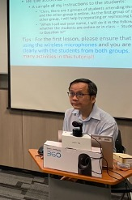

**Figure 3**

*A HyFlex Learning experience using 360 cameras with mic*

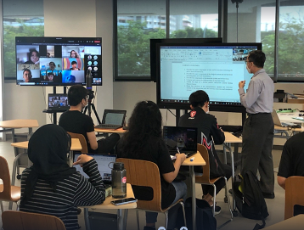

**Figure 4**  
*Capture of Student’s screen from home in the HyFlex Learning session*

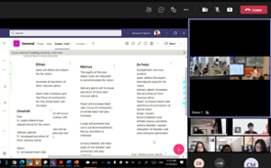

**Figure 5**

*An impression of the “user-friendly” classroom as envisioned by the lecturers*

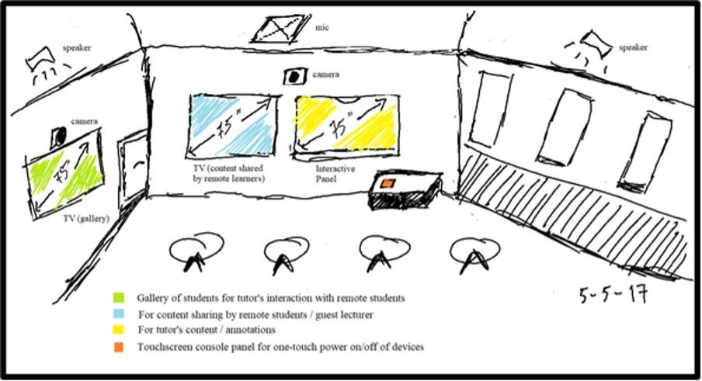

*(Source: TP’s HyFlex Learning Space Team – C.K. Boey, M. Kong, M. Yap, K. Goh, M. Fadlin,  M.K. Goh, S. Tan-Ong, G.H. Loh)*

**Learning and relearning (On-going Data Collection)**

The approach has been about starting where staff are in terms of readiness and allowing time for staff to learn and find their footing in the new technology. However, the journey in HyFlex would only be meaningful if all the stakeholders’ voices were heard. It was necessary to find out from the students whether they were fully engaged during the HyFlex session or not. Our hypothesis was that students would be fully engaged in the HyFlex session, but we wanted to verify this with students.

*Student Engagement*

            The HyFlex learning journey concerns users and the only way to learn about their experience is to hear directly from them. In this case, the users include the lecturers and the students. The HyFlex Learning team at TP piloted a study on students’ engagement (emotional, physical, cognitive) in a HyFlex learning environment. The data collection consisted of two parts: a student engagement survey and student focus groups.

Part 1: A survey on student engagement about their HyFlex learning experiences was conducted twice; once at the mid-point and again at the end of the HyFlex learning intervention to confirm the hypothesis that there would be significant student engagement in learning within the HyFlex environment. The BESS (Burch Engagement Survey for Students) (Burch et al., 2015) instrument was used. (See Appendix A.) The following definitions of engagement were used for the study.

Physical engagement

This relates to the extent to which people expend their efforts, both physical and mental, as they go about their jobs.

Emotional engagement

Emotional engagement encompasses positive and negative reactions to teachers, classmates, academics, and school, and is presumed to create ties to an institution and influence willingness to do the work. It refers to students’ affective reactions in the classroom, including interest, boredom, happiness, sadness, and anxiety.

Cognitive engagement

Cognitive engagement draws on the idea of investment; it incorporates thoughtfulness and willingness to exert the effort necessary to comprehend complex ideas and master difficult skills.

Part 2: Two focus groups, comprising five participants each, were conducted with students from the HyFlex session. (See Appendix B.) Students were interviewed after the end of the HyFlex learning experience to provide an in-depth understanding of their experience. The following are some of the findings.

**Findings**

Figure 6 describes the Student Engagement Study Survey conducted at two points: Physical Engagement Survey 1 represented by PE_1 (at the mid-point of the HyFlex class) and the second survey is represented by PE_2 (at the end of the HyFlex class). Similarly for Emotional Engagement Survey 1 and 2, EE_1 and EE_2 and Cognitive Engagement Survey 1 and 2 represented by CE_1 and CE_2. The results showed that there was an increase in student engagement; specifically, physical engagement, emotional engagement, and cognitive engagement.

**Figure 6**

*Student Engagement Survey Results*

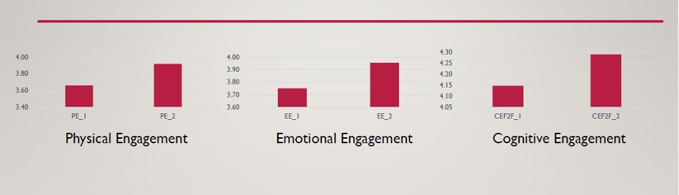

Note: Mean score for PE_1 = Physical Engagement Survey 1; PE_2 = Physical Engagement Survey 2; EE_1 = Emotional Engagement Survey 1; EE_2 = Emotional Engagement Survey 2; CEF2F_1 = Cognitive Engagement, Face 2 Face Survey 1; CEF2F_2 = Cognitive Engagement, Face 2 Face Survey 2.

Themes arising from the focus group part of the study include the following:

·       **Challenges:** The students found that it was hard to work around that “new-found” freedom where they need to monitor their own learning. Most students recognized that the online part of HL needed different strategies but were uncertain about the right type to use. They also claimed that it was harder for them to “speak-up” when they are dialing in from home. Straddling between face-to-face and online classes also brought about some confusion in timetabling (scheduling).

·       **Benefits:** Most students liked the flexibility in HL. Most of the HL lessons are also recorded, as such, they found it easier to review the lessons. In the home-based part of HL, they also liked the fact that they can get up late for class and yet, be on time.

·       **Social Interactions:** Students found that in the “face-to-face” aspect of HL it was easier for them to connect with their lecturer and fellow classmates. Student S mentioned that "face-to-face makes me feel more of a sense of belonging…".  Student E, “ Face-to-face session in HL, the concentration level is a lot higher because there is this atmosphere where everyone is paying attention, and then it also gives a little bit of peer pressure...”

“ For online aspect of HL, you are just staring at a screen, then there is not much interaction between the teacher and student. So, like, there's just something different about human-to-human interactions," as expressed by student A.

·       **Technical challenges:** They were unfamiliar with the platform when they started using the collaborative platform as it was new to them. Some technical issues, such as frozen screens while the lecturer was talking, made following the class very difficult. When the home Wi-Fi was weak, the experience was also detrimental to learning. In some instances, students were unable to see the lecturer’s slides during the session.

·       **Learning Strategies:** Students realized that different approaches were needed in the two formats of HL. Taking notes, peer discussion, and asking lecturers questions were the key learning strategies they applied in the face-to-face environment. However, these learning strategies were not easily transferred to the online environment. The students had a routine way of doing self-study in the face-to-face environment but found it hard to keep up with their old routine in the online environment.

·       **Self-regulation:** Students found that they procrastinated a lot in the online aspect of HL. They found that they were easily distracted and did not find "the urgency of learning" as the recorded sessions would always be available to them. They were also not sure of what kind of learning strategies to use in order to help themselves to persist in their learning. Some of the students tried out new learning strategies, others used old strategies that worked well in the face-to-face environment but did not work well in the online environment.

Data was also collected from the academic teaching staff in interviews. The following are some of the findings from the analysis of the interview data.

*Staff sentiments*

The academic staff members interviewed felt that they can engage onsite and remote learners cognitively and socially in their HyFlex classes through carefully crafted lessons. Furthermore, they also found the sharing of use cases of HL helpful, especially for those who are new to HL. Generally, the provision of affordable basic equipment such as wireless earpieces to academic staff enabled them to better engage onsite learners in HL.

Just like the common phrase, “it takes a whole village to raise a child”, it took a “whole faculty” approach for HyFlex Learning to be implemented across the ASC school. The learning, designing, implementing, and finally, sharing was an iterative cycle (Figure 7) where everyone benefited from the experience. Before embarking on the further design of engagement with a different configuration of the technology, the team learned from their experience, then implemented a revised approach with the knowledge learned.

**Figure 7**

*Iterative cycle: Learn, Design, Implement, Share*

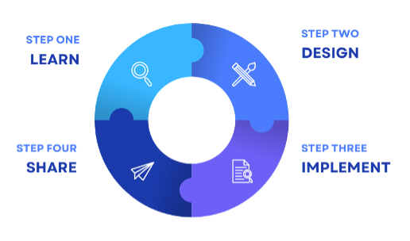

Limitations

There are some limitations to this pilot study as it only provided a snapshot of the phenomenon and only a small group of learners were surveyed and interviewed.

**Conclusion**

There is a place for further investment and investigation into HyFlex Learning Spaces as the School of ASC implement the next round of technology improvement. We’ve learned to “start from where you are and learn from the challenges”. If anything, the COVID-19 pandemic has helped us develop the ability to rise above challenges through learning and re-learning.

## References

Akkoyunlu, Buket & Yilmaz Soylu, Meryem. (2008). A Study of Student's Perceptions  
in a Blended Learning Environment Based on Different Learning Styles.  
*Educational Technology & Society.* 11. 183-193.

Beatty, B. J. (2019). Designing a Hybrid-Flexible Course: Creating an Effective Learning Environment for All Students. In B. J. Beatty, Hybrid-Flexible Course Design: Implementing student-directed hybrid classes. EdTech Books. Retrieved from https://edtechbooks.org/hyflex/hyflex_design

Burch, G.F., Heller, N.A., Burch, J.J.; Freed, R. & Steed, S.A.; (2015) Student Engagement: Developing a Conceptual Framework and Survey Instrument, *Journal of Education for Business,* 90:4, 224-229, https://doi:

Rapanta C, Botturi L, Goodyear P, Guàrdia L, Koole M. (2020). Online University  
Teaching During and After the Covid-19 Crisis: Refocusing Teacher Presence and Learning Activity. *Postdigital Science Education,*2(3):923–45. https://doi: 10.1007/s42438-020-00155-y. Epub 2020 Jul 7. PMCID: PMC7339092.

Staker, H., Chan, E., Clayton, M., Hernandez, A., Horn, M.B., and Mackey, K.     
(2011). *The Rise of K–12 Blended Learning: Profiles of emerging models.*  
Innosight Institute. https://www.christenseninstitute.org/wp-content/uploads/2013/04/The-rise-of-K-12-blended-learning.emerging-  
models.pdf

**Appendix A**

Burch Engagement Survey for Students (BESS) G. F. BURCH ET AL.

**Emotional engagement**

1.     I am enthusiastic about this class/course.

2.     I feel energetic when I am in this class/course.

3.     I am interested in material I learn in this class/course.

4.     I am proud of assignments I complete in this class/course.

5.     I feel positive about the assignment I complete in this class/course.

6.     I am excited about coming to this class/course.

**Physical engagement**

7.     I work with intensity on assignments for this class/course.

8.     I exert my full efforts toward this class/course.

9.     I devote a lot of energy toward this class/course.

10. I try my hardest to perform well for this class/course.

11. I strive as hard as I can to complete assignments for this class/course.

12. I exert a lot of energy for this class/course.

**Cognitive engagement: In class**

13. When I am in the classroom for this class/course, my mind is focused on class discussion and activities.

14. When I am in the classroom for this class/course, I pay a lot of attention to class discussion and activities.

15. When I am in the classroom for this class/course, I focus a great deal of attention on class discussion and activities.

16. When I am in the classroom for this class/course, I am absorbed by class discussion and activities.

17. When I am in the classroom for this class/course, I concentrate on class discussion and activities.

18. When I am in the classroom for this class/course, I devote a lot of attention to class discussion and activities.

**Cognitive engagement: Out of class**

19. When I am reading or studying material related to this class/course, my mind is focused on class discussion and activities.

20. When I am reading or studying material related to this class/course, I pay a lot of attention to class discussion and activities.

21. When I am reading or studying material related to this class/course, I focus a great deal of attention on class discussion and activities.

22. When I am reading or studying material related to this class/course, I am absorbed by class discussion and activities.

23. When I am reading or studying material related to this class/course, I concentrate on class discussion and activities.

24. When I am reading or studying material related to this class/course, I devote a lot of attention to class discussion and activities.

**Appendix B**

Hybrid Learning Research

Guide for Focus Group Interview

1.     EMOTIONAL ENGAGEMENT

·       Like or dislike (e.g., video lectures, in-class learning activities)

·       Interest or boredom

·       Sense of belonging (e.g., individual pre-class learning, peer interaction)

2.     PHYSCIAL ENGAGEMENT

·       Tasks intensity (e.g., online learning tasks, homework, classwork)

·       Effort towards learning

·       Persistence and concentration (e.g., face-to-face lessons)

3.     COGNITIVE ENGAGEMENT (IN & OUT of class)

·       Self-regulation (e.g., strategies to plan, monitor, and evaluate)

·       Investment in learning (e.g., go beyond requirements, prefer challenge)

·       Coping strategies (e.g., facing failure or challenge)

**Inclusion and Equity**

Read this online at <https://edtechbooks.org/hyflex/hyflex_starting>