# Complex Sentences Part 2

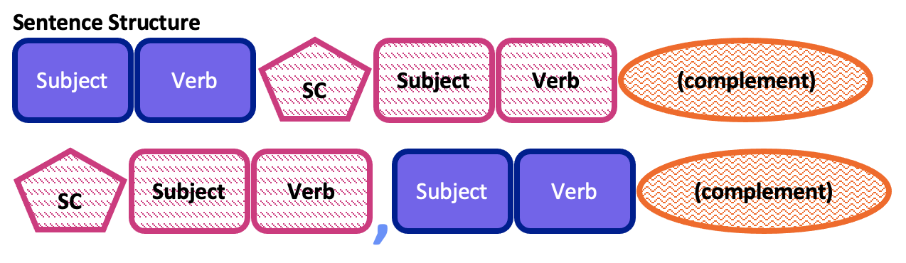

## Subordinating Conjunctions

There are many different names that we use to describe grammar. In previous ELC writing textbooks, we used the term time clause to talk about dependent clauses that show the sequence relationship between two actions. Those time clauses started with words like after, before, when, while, whenever, since, and until.

The general name for words that connect two clauses is conjunction.

As explained in the other section of this chapter, a coordinating conjunction connects two independent clauses. Both of those ideas are complete on their own, but the writer chooses to emphasize how they are connected using a coordinating conjunction.

A subordinating conjunction is a word that makes an idea incomplete as soon as it is added to the beginning of a clause. Time clauses are a specific type of subordinating conjunction. Subordinating conjunctions make an idea dependent, meaning it requires another clause. When you have both a dependent and independent clause, the sentence is called a complex sentence.

Additional common subordinating conjunctions are: although, even if, even though, if, though, and whether.

* Although – Although she loves pizza, she does not want to eat it tonight.
  + The dependent clause contrasts with the independent clause.
* Even if – Even if it rains tomorrow, the soccer game will happen.
  + The possible action in the dependent clause does not change the action in the independent clause.
* Even though – Even though you were tired, you were able to finish your homework.
  + The action in the dependent clause does not change the action in the independent clause.
* If – If I miss the lecture, I can watch the Zoom recording later.
  + The dependent clause is a condition, the independent clause is the consequence.
* Though – Though they practiced every day, they did not play well at the concert.
  + The dependent clause contrasts with the independent clause.
* Whether – Whether it is sunny tomorrow or not, we will have a picnic.
  + The two possibilities in the dependent clause do not impact the independent clause action.

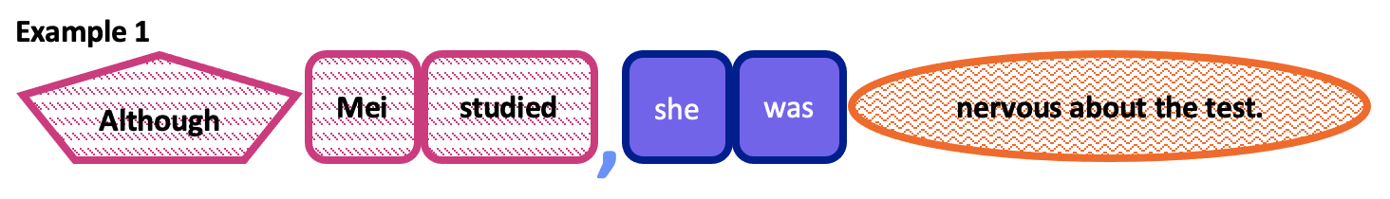

The order of the clauses can change. If the independent clause is first, the comma is not necessary.

* Although – She does not want to eat pizza tonight although she loves it.
* Even if – The soccer game will happen even if it rains tomorrow.
* Even though – You were able to finish your homework even though you were tired.
* If – I can watch the Zoom recording later if I miss the lecture.
* Though – They did not play well at the concert though they practiced every day.
* Whether – We will have a picnic whether it is sunny tomorrow or not

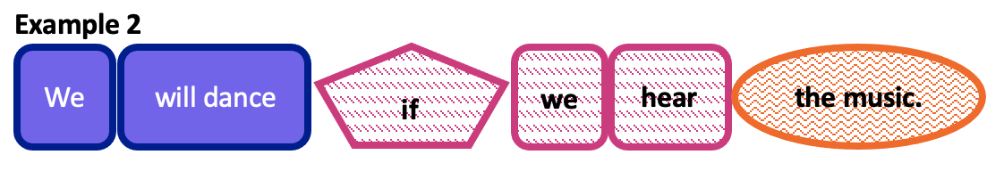

## Relative Clauses

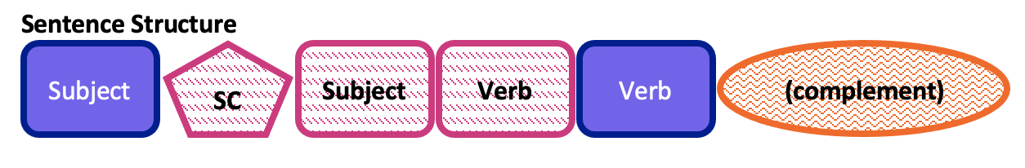

Sometimes a dependent clause is used within a sentence to add more information about a noun or noun phrase. This is called a relative clause. Instead of using a subordinating conjunction, the relative clause uses a relative pronoun to introduce the dependent clause. Relative pronouns include which, that, who, whom, and whose.

* Which – The ELC, which is a language school in Provo, is in the University Parkway Center.
* That – The car that passed me on the freeway was pulled over by a police officer.
* Who – I am going to visit my sister who lives in Las Vegas.
* Whom – The person whom I like is not at the party.
  + This is more commonly reduced because it sounds dumb.
* Whose – Will the person whose car is blocking the driveway please move it?

Sometimes we do not write the relative pronoun, and this is called a reduced clause. A relative clause can only be reduced if the information is not required.

* Which – The soup which she cooked yesterday is delicious.
  + The soup she cooked yesterday is delicious.
* That – The hat that I’m wearing looks exactly like yours.
  + The hat I’m wearing looks exactly like yours.
* Who – The doctor who she goes to doesn’t have any availability today.
  + The doctor she goes to doesn’t have any availability today.
* Whom – The person whom I like is not at the party.
  + The person I like is not at the party.
* Whose – not possible

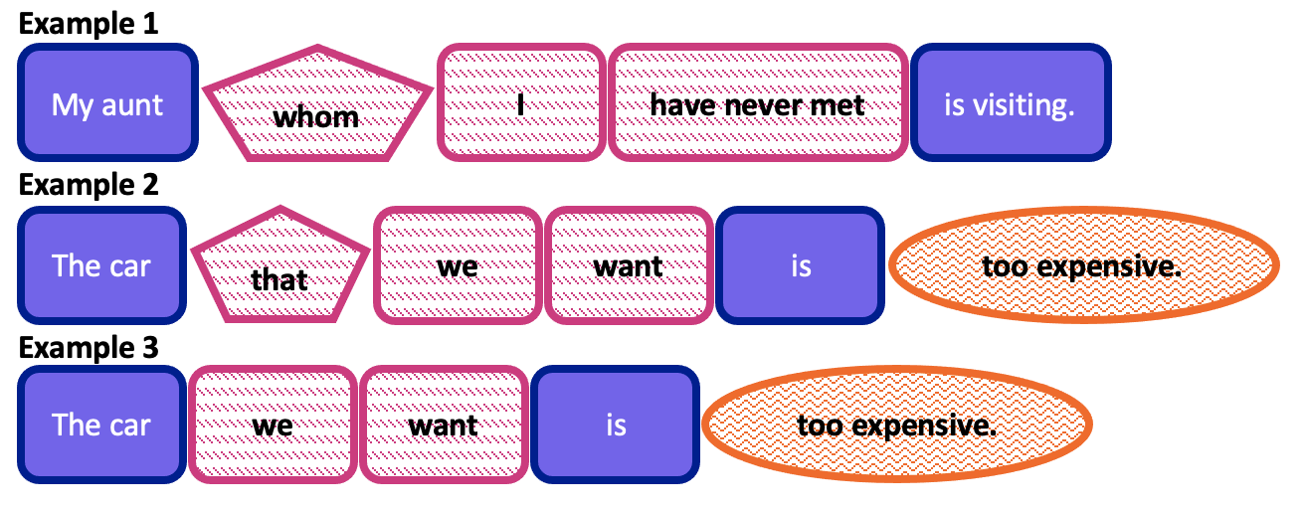

Read this online at <https://edtechbooks.org/up_writing_winter/complex_sentences_pa>