# Holistic Student Assessment (HSA)





This assessment was developed at The PEAR Institute: Partnerships in Education and Resilience at McLean Hospital and Harvard Medical School. Based on The PEAR Institute’s Clover Model, a developmental process theory by PEAR Director Gil Noam, this assessment focuses on the balance between active engagement, assertiveness, belonging, and reflection. Consistent with these categories, the HSA is a youth self-report survey that assesses students’ social emotional strengths and challenges across three domains: resiliencies (action orientation, emotional control, assertiveness, trust, empathy, reflection, and optimism); relationships (relationships with peers, relationships with adults); and learning and school engagement (learning interest, critical thinking, perseverance, academic motivation, and school bonding). With this coverage the HSA provides an extensive overview of the student’s social and emotional development.

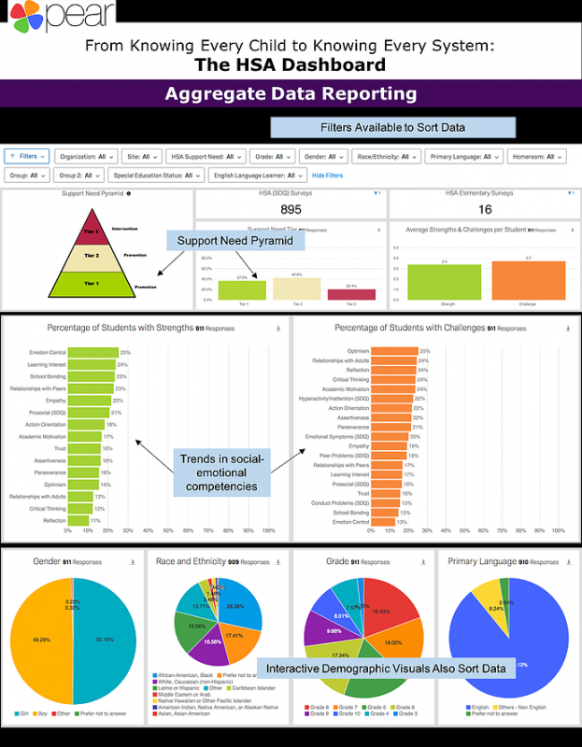

The HSA has both a long and a short version. The long version, consisting of 61 items (measuring scales from all three domains (resiliencies, relationships, and learning and school engagement) requires 20 minutes administration time. The short version, HSA Core, consists of 30 items (measuring only the resiliency domain) and can be administered in 10 minutes. Both versions are reliable and valid. For more specific information on its reliability and validity, RAND lists several studies which detail their specific findings. The HSA is appropriate for Grades 3-12 and is available in 14 different languages. A per-student survey fee is required for use, and “cost of survey implementation depends on number of participants and wraparound training services requested by the school or program” (Access Assessment Guide). Scores are analyzed by The PEAR Institute and are returned within one week as online access to a secure, dynamic data dashboard containing individual student portraits and an aggregate dashboard for school, program, or school district. “Scores are compared to national norms by age and gender for youth ages 9 to 18” (Access Assessment Guide). The images to the right are a sample portrait and dashboard.

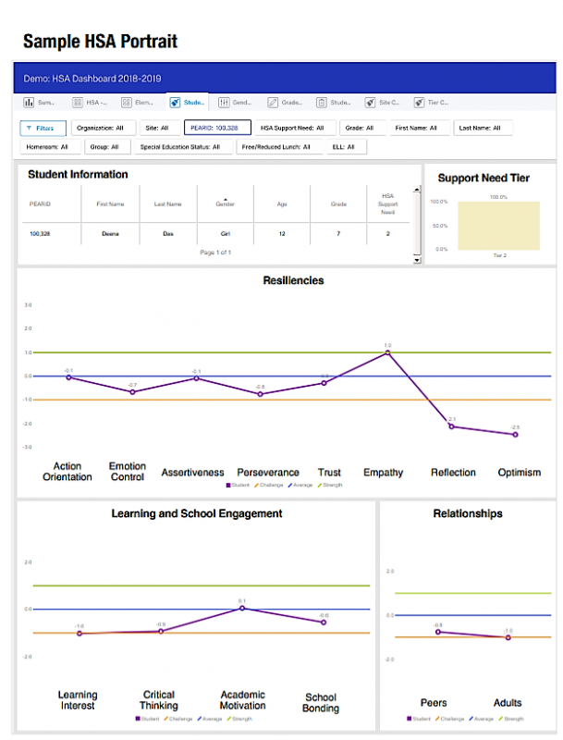

|  |  |
| --- | --- |
| **Pros for Schools** | **Cons for Schools** |
| Has a long and a short version Reliable and valid Includes Grades 3-12 Available in 14 different languages (more upon request) Scores compared to national norms Scores returned within one week of administration | Long version requires 20 minutes to complete (61 items) Requires purchase |

Images in this sections are used with permission by [The PEAR Institute](https://www.thepearinstitute.org/holistic-student-assessment)

### Suggestions for Further Research

Allen, P. J., Thomas, K., Triggs, B., & Noam, G. (2017). The Holistic Student Assessment (HSA) technical report. The PEAR Institute: Partnerships in Education and Resilience.

The PEAR Institute (n.d.). Holistic student Assessment. [https://edtechbooks.org/-ERr](https://www.thepearinstitute.org/holistic-student-assessment).

Malti, T., Zuffianò, A., & Noam, G. (2017). Knowing every child: Validation of the Holistic Student Assessment (HSA) as a measure of social-emotional development. Prevention Science. [https://edtechbooks.org/-PGj](https://edtechbooks.org/wellbeing/about:blank)

Measuring SEL. (n.d.). Access assessment guide: Holistic Student Assessment (HSA). [https://edtechbooks.org/-qfRa](https://measuringsel.casel.org/assessment-guide/measure/holistic-student-assessment-hsa/)

Noam, G., Malti, T., & Guhn, M.  (2012). From clinical-developmental theory to assessment: The Holistic Student Assessment tool. International Journal of Conflict and Violence, 6(2), 201–213.

Noam, G.G., & Triggs, B. (2018) The clover model: A developmental process theory of social-emotional development. [https://edtechbooks.org/-QcQC](https://www.thepearinstitute.org/clover-model-overview)

RAND. (n.d.). Holistic Student Assessment (HSA). [https://edtechbooks.org/-KbN](https://www.rand.org/education-and-labor/projects/assessments/tool/2007/holistic-student-assessment-hsa.html)

Read this online at <https://edtechbooks.org/wellbeing/HSA>