Types of Planning
Lickteig, A.
Planning is one of the most important time investments for a teacher and although many pre-service and novice teachers have some anxiety about getting in front of a class full of students, effective teachers recognize that thoughtful planning can make the difference between a successful or unsuccessful lesson (Savage, Savage, & Armstrong, 2012). Although the necessity of conscientious planning is frequently overlooked because the general public does not observe the amount of time and careful decisions an educator invests in lessons prior to starting class, a well-planned lesson can reduce classroom management issues by keeping students on task, progress in a logical flow where concepts build upon one another, prepares teachers to respond to unexpected situations, and provides educators with an increased sense of confidence. To the untrained eye, an outstanding lesson looks effortless because everything goes as expected, but seasoned educators know that a great lesson is accomplished—in part—through deliberate planning.
Instructional planning can be subdivided into three different types: long-term planning, intermediate planning, and short-term planning (see Figure 1). Each planning type has unique considerations and demands. While the core components of each type of planning remain consistent, minutiae can vary based on the requirements of a teacher’s school, district, or discipline.
Figure 1
Types of Planning

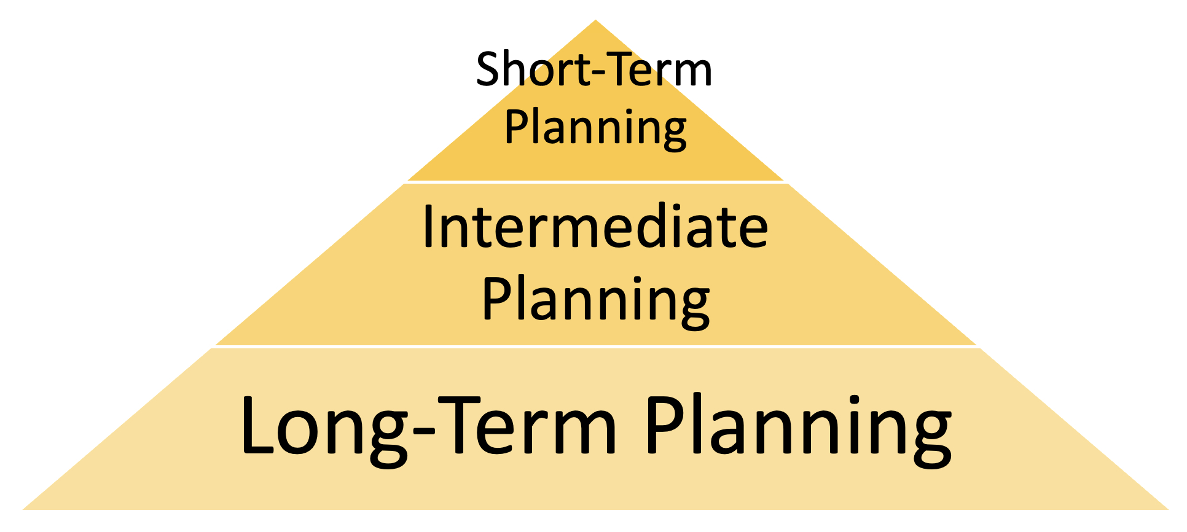

Long Term Planning
When an educator is initially hired by a school or district, they are typically given a specific teaching assignment—something like, “freshman English,” or “eighth grade social studies.” While, in cases like these, there is some direction (in the form of a singular grade level), it can be overwhelming for new teachers to know where to begin due to the sheer range of content that can be covered in those classes. This is where long-term planning can be useful.
Long-term planning, also called long range planning, is an overview of an entire academic year (or term, for those teaching one-semester courses). Remaining largely unchanged for decades, a typical school year includes 180 instructional days, not including holidays, which breaks down to about 35-36 weeks over a nine-month academic year (U.S. Department of Education, 2020). Engaging in long-term planning requires educators to consider their scope (the range of content to be taught—which brings up related deliberation about breadth vs. depth) and sequence (the progressive order in which that content is presented) and therefore helps educators review not only what content they will focus on and in what order, but also considerations such as budgeting for an upcoming order of supplies and ensuring the proper working order of equipment, to name a few. If possible, teachers should start the long-term planning process as soon as they know their teaching assignment (many veteran teachers even spend time over the summer months planning for the upcoming year). So, how do you begin?

District Calendar
One of the first resources you should draw from when beginning long-term planning is the district’s academic calendar. Academic calendars, which are voted on each year by the local school board, contain essential information about holidays and breaks, grading periods, student conferences, and perhaps even the schedule of required testing—which can vary based on subject and grade level (Kansas State Department of Education, 2023a). By starting your planning with this calendar in mind, you can immediately cross-off non-instructional days, block off days dedicated to high-stakes assessments, and note unique situations that may impact the length of class or the school’s schedule (such regular assemblies, home sporting events, etc.).

Standards
Another great resource for starting long-term planning are national and state standards, which were briefly addressed previously in this book. Standards serve as guideposts for planning and educators can use them to know what the outcomes of a course of study should be; standards should inform instruction According to the U.S. Department of Education (2019),
Raising academic standards for all students and measuring student achievement to hold schools accountable for educational progress are central strategies for promoting educational excellence and equity in our Nation's schools. The Elementary and Secondary Education Act (ESEA) supports State efforts to establish challenging standards, develop aligned assessments, and build accountability systems for districts and schools that are based on educational results. In particular, ESEA includes explicit requirements to ensure that students served by Title I are given the same opportunity to achieve to high standards and are held to the same high expectations as all other students in each State. (para. 1)
While voluntary national standards exist in many of the disciplines, the U.S. Department of Education does not determine state education standards; rather, that responsibility is handled by the various states and districts as well as public and private organizations. This link can be used to quickly access each state’s individual standards. In Kansas, the Kansas State Department of Education (KSDE) separates standards by academic (assessed) and model (non-assessed).

Reflections from Interns
Q: What role do standards play in your classroom?
A: The standards that the state of Kansas provides for social studies education are
fantastic in my opinion because they allow the teacher to have a lot of freedom in how they teach. Kansas provides social studies with four standards that we can fit our lessons into. These standards are important in order to ensure that all students across the state are receiving a similar education while also giving teachers the freedom to adapt the material to their students and their unique needs.
-Ms. Rebecca Hertog, pre-service social studies teacher

Curriculum Materials
In some areas, districts may have pre-established curriculum guides, which are often the result of teachers and curriculum experts collaborating grade- and/or subject-based outlines to provide educators with vetted resources or detailed scope-and-sequence outlines. While the content and specificity of the information within may vary from district-to-district, some districts (such as a Topeka Public Schools, USD 501) publish their curriculum guides online—which can be useful for novice teachers looking for ideas on where to start because “they provide a framework that can be followed and often offer good suggestions for teaching” (Savage, Savage, & Armstrong, 2012, p. 150).
Additionally, outside resources can also be a great way for new teachers to get a sense of the subject. By skimming a textbook, those new to the classroom—or even those moving to teach a new grade level—can quickly see an overview of commonly addressed subject matter and ideas for suggested unit breakdowns. By diving deeper into the pages, teachers can typically find suggested teaching procedures and student activities, organized units with connections to standards and essential questions, and connections to external content such as related videos, simulations, articles, and more. However, textbooks are not without their weaknesses. Because textbooks can be so costly to adopt, districts often wait a decade or more to update them—and then the information shared with students is outdated or irrelevant. Additionally, textbooks cannot take into account individual students’ backgrounds year-to-year and therefore are not tailored to unique interests or activities of the individuals in the class. Textbooks are also notorious for having a reading level that is too high for the audience and for filling the pages with collections of facts and figures—which often fail to encourage higher-level thinking or problem-solving approaches. This causes frustration and boredom among the students. So, while textbooks can be a valuable aide for novice educators, you should avoid using them as the sole source of information in a class. They are just one tool in a teacher’s vast repertoire of resources.
Another valuable resource is your network of fellow educators. Content-area colleagues, department chairs, librarians, and instructional coaches are all individuals who you can call upon (really at any point in your teaching journey) to gain insight into what to teach and when. We recommended earlier in this chapter to start as soon as possible in the planning process—and you can’t get any earlier than your teacher preparation program. During your field experiences and practicums, request copies of assignments, plans, and activities from your mentor teacher and save those to begin to develop your own personal library of instructional resources.

Implementation
Completed long-term plans take the form of documents that are prepared before the beginning of the year or term. While not synonymous with curriculum mapping (which tends to have more detail takes into consideration vertical and horizonal alignment), long-term plans to have the sense of a “map” because of the direction they provide teachers once completed.
As we’ve previously addressed, finished products vary in form and format depending on the district, but one easy way to begin is simply to print blank calendar pages and use a pencil to broadly note basic unit topics. That’s it—really. While the vaguest, this method allows teachers to quickly sketch out an idea of what units they will cover and when. Because there is not a lot of detail provided within, it is quick to erase and rearrange topics as needed.
For individuals wanting a little more detail, developing a graphic organizer with dedicated spaces for standards, essential questions, key assessments, unit titles, and interdisciplinary connections can be an effective strategy. Whether crafted in GoogleDocs or Microsoft Word, these can be edited, saved, shared, and distributed easily. In fact, in larger schools or districts where multiple teachers are assigned the same classes, it can be extremely beneficial to collaborate in planning.
There are also a plethora of technology-based options for teachers to utilize in long-term planning. Slides Mania is a site with hundreds of templates that teachers can customize through Microsoft PowerPoint or Google Slides (or save them as a PDF and use them with tools like GoodNotes or Notability). This undated digital planner (see Figure 2) can be reused year after year and can be a helpful way to digitally organize and save long-term plans—as well as share them with colleagues, administrators, and even parents.
Figure 2
Undated Digital Planner from SlidesMania

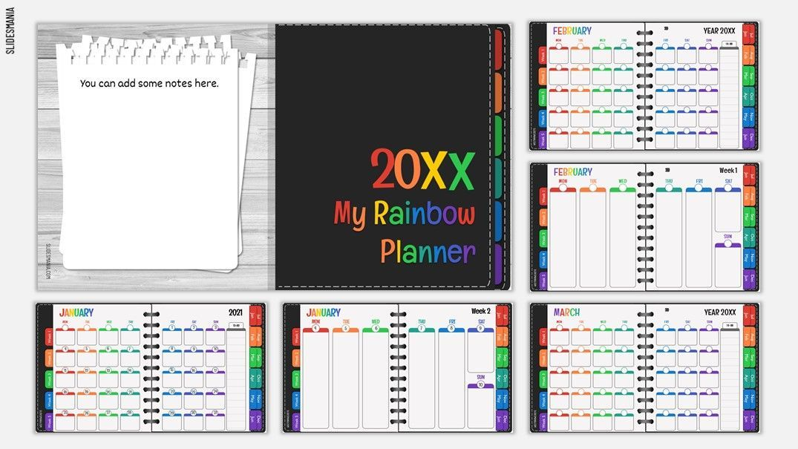

Intermediate Planning
Planning that focuses in depth on the major academic divisions (instructional segments called units) is termed intermediate planning. While academic units are typically organized into logical, systematic sequences—and there are even free, online resources available for digital planning—some disciplines are likely more linear than others. For example, it is often necessary for students in mathematics classes to master prerequisite skills before moving on, and social studies classes tend to follow a more chronological timeline of events. However, other disciplines, such as a language arts classroom, often have a little more flexibility in how they structure the organization of their units. Additionally, planning may be influenced by available resources in your school. One example could be if a school only had one set of heart rate monitors to use between three physical education classes or if there were only a class set of microscopes to use among all science courses. In these cases, teachers will need to coordinate with their colleagues, which is sometimes easier at the middle grades due to their organization of a “teams” approach versus the content-area silos that can often occur in high schools.

Backward Design
Utilizing the backward planning process—also called backward design—is an important part in intermediate planning. This process helps ensure that teachers “keep the end in mind” when planning the instructional design for their units. In their 2005 book, Understanding by Design, authors Wiggins and McTighe assert that the starting point for planning instruction is to identify the “big ideas” or “enduring understandings” that students should know as a result of studying a specific topic, rather than simply a collection of facts. By doing so, the content and tasks are focused more on what will be transferable knowledge.
Therefore, the first step in Backward Planning is for teachers to identify the desired outcomes or results. After reviewing your disciplinary standards, identify these “big ideas” that students should know, and then put them into the logical, systematic sequence described above. These become the unit’s goals. Goals are broad statements identifying what students should learn as a consequence of their exposure to the content. These statements provide a general sense of direction and focus regarding the students’ learning, but they aren’t explicit about day-to-day outcomes. Goals should be focused on students understanding and applying key concepts and generalizations or principles. While goals are not the same as standards, content standards can inform our goals. Another such method of identifying these “enduring understandings” is to craft essential questions. McTighe and Wiggins explain that, in a practical sense, we can think of enduring understandings and essential questions as flip sides of the same coin. They write, “our essential questions point toward important transferable ideas that are worth understanding, even as they provide a means for exploring those ideas” (2013). We’ll talk more about overarching and topical essential questions soon, but it’s important to note that size and scope matter and some questions are more appropriate for units (overarching) while others fit best within specific lessons (topical).
The second step in Backward Design is to identify your acceptable evidence—so, how do you know students “got it"? You should match your assessment tools to your various learning objectives. Teachers should consider a range of assessment approaches and delivery types, including basic assessments like quizzes and tests, but also open-ended prompts that require critical thinking as well as performance tasks and projects. Again, this step should occur before designing the specific lessons and instruction.
The final step (but often the step teachers frequently put first) is to select the teaching approaches and various learning activities. This third and final step begins to segue into Short-Term Planning, which we’ll discuss in a moment, because it involves providing a progression of experiences in a daily lesson; so, beginning with capturing students’ attention, then providing information, moving to a culminating state, and then evaluating students’ understanding of material. This progression aligns with the Literacy First format (see next section).
Jay McTighe, one of the original authors, has written a brief synopsis of the three steps more recently in a 2019 post titled, “The Fundamentals of Backward Planning” for ASCD. He writes that there are a multitude of daily challenges, and it can be easy for newer teachers to fall into poor unit and lesson planning habits, but an effective method for helping novice educators avoid these “traps” is this concept of Backward Design. He summarizes the method as “essentially curriculum planning that begins with establishing clear learning goals (with a focus on in-depth understanding) and then works backward to determine how to get students there” (McTighe, 2019, para. 1). His graphic for filtering what is classified as an “enduring understanding” is found below.
Figure 3
Enduring Understanding Filters

Overarching Essential Questions.
What we call overarching essential questions are those general questions that can apply to a larger unit of study, although they often make no mention of the specific unit’s content. Rather, they transcend subject matter and point the students toward more transferable understandings that cut across course topics. These questions meet seven defining characteristics:
- Is open-ended; that is, it typically will not have a single, final, and correct answer.
- Isthought-provoking and intellectually engaging, often sparking discussion and debate.
- Calls for higher-order thinking, such as analysis, inference, evaluation, prediction. It cannot be effectively answered by recall alone.
- Points toward important, transferable ideas within (and sometimes across) disciplines.
- Raises additional questions and sparks further inquiry.
- Requires support and justification, not just an answer.
- Recurs over time; that is, the question can and should be revisited again and again.
In their chapter, “What Makes a Question Essential?,” provide numerous examples of essential questions broken down by discipline. For example, in a social studies course, essential questions could include “Whose ‘story’ is this?” or “Why do people move?” or “What is worth fighting for?”. Essential questions in a mathematics classroom might include “How does what we measure influence how we measure?” or “When and why should we estimate?”. A question in an English/language arts class could be “How do effective writers hook and hold their readers?” while essential questions in the sciences could ask “What makes objects move the way they do?” or “How are structure and function related in living things?”. Each of these questions are broad, sweeping inquiries that could cover a whole unit of study with multiple individual lessons feeding into it.

Topical Essential Questions.
The specific questions that fit under the unit’s broader (overarching) essential question and are usually applicable to a 1-2 day lesson are called topical essential questions. It is easy to think of these as “exit slip” questions. For instance, what single question could you pose to students at the end of class where their response would reveal if they understood the main idea behind your lesson? Therefore, in a two-week instructional unit, you would likely have a single overarching essential question, but 8-10 topical essential questions. The table below by Wiggins and McTighe demonstrates how topical essential questions (appropriate for a specific day’s lesson) could be nestled within a unit’s overarching essential question.
Overarching Essential Questions | Topical Essential Questions
Whose “story” (perspective) is this? | How did Native Alaskans view the “settlement” of their land?
How are structure and function related? | How does the structure of various insects help them to survive?
In what ways does art reflect, as well as shape, culture? | What do ceremonial masks reveal about the Inca culture?
How do authors use story elements to establish mood? | How does John Updike use setting to establish mood?
What makes a system? | How do our various body systems interact?
What are common factors in the rise and fall of powerful nations? | Why did the Soviet Union collapse?

As you can see, the essential questions on the left (overarching) are broader in nature while those on the right (topical) focus on particular topics that fall within their overarching counterpart.

Short Term Planning
The most in-depth type of planning is called short term planning, and it often takes the form of lesson plans that cover 1-2 days of content.

Lesson Planning
While a lesson plan can have a variety of different formats, it is essentially a guide for the teacher to know what to teach, how it will be taught, and how learning will be assessed. In short, it is a roadmap of what a teacher needs to cover and how it will be done effectively so students learn what they need to within the scope of a class period. While teachers’ lesson plans often become less formal after years of experience, these documents can be a helpful tool in facilitating a smooth delivery and synthesizing curricular. So how thorough should new teachers be in their plans? Authors Savage, Savage, and Armstrong (2012) offer key advice for the novice educator: “As a general rule of thumb, we recommend that beginning teachers should have enough detail in a lesson plan so that it could be picked up and taught by a substitute teacher” (p. 158). By thinking through, What would someone else need to know in order to teach this successfully in my absence?, new teachers can identify gaps in their original plan. Simply considering the prompt, “How?”, can enable new teachers to elaborate on their sequence of tasks and include details that will add clarity and direction. For example, if a teacher listed “Discussion” in their lesson plan, preemptively adding how the discussion will occur can help the teacher consider pacing, engagement, classroom management, and transitions to next tasks. Therefore, “Discussion” could become “For 30 seconds, students think about the prompt and jot down 1-2 sentences on their notes page. Students then share their ideas with a shoulder partner. After about 1 minute, three pairs of volunteers will share their response with the whole class.”
Additionally, a well-detailed lesson plan can become a self-contained document that holds all resources and materials within that are necessary for delivery. For example, by linking any instructional slides, handouts, video clips, etc. directly into the document, the teacher simply needs to pull up the one digital file in future semesters and they would have access to all the pre-developed materials for delivering the lesson. This level of detail has other practical benefits, as well. If a student is planning a prolonged absence (such as medical leave or vacation) and materials aren’t yet uploaded to a learning management system, the teacher can quickly locate and send everything to the student in advance. Or if you have a new content colleague and you want to share materials to help them get started, you just need to send a single document and they can view everything.
What are the parts of lesson plan, then? Well, there are numerous different types of lesson plans, and each varies a little on the format (i.e., the 5E Instructional Model, the Direct Instruction Model, the Literacy First Instructional Model, etc.). However, most lesson plans have the same basic elements—they’re just found in different places of the document. The list below is not exhaustive, but does outline some typical components located in lesson plans.
- State or National Standards: Descriptions of specific knowledge and skills that every student should know, broken down by discipline, grade levels, and topic.
- Lesson Objectives: Student-centered statements that focus on the daily instructional outcomes.
- Topical Essential Question: Questions that focus on the specific content or topic of that day’s lesson.
- Materials: Physical resources, handouts, digital tools, etc. necessary for teachers and students during the lesson.
- Vocabulary:Tier 2 and Tier 3 words that are prominent in the day’s lesson (can be new or review)
- Lesson Sequence and Pacing: The order in which the lesson occurs (beginning, middle, and end) as well as the length of each lesson part.
  - Including: Entry point, activities, and wrap-up
- Assessment: Can be formative or summative ways of evaluating if the students understood the concept during the lesson.
- Concepts/Practices: These vary by school, but could include skills outside your discipline that are being emphasized in a lesson, such as WICOR approaches, team-building exercises, digital citizenship competencies, etc.
- Extensions and Support + Accommodations and Modifications: Considerations for how teachers will differentiate a lesson (not only keeping in mind students on IEPs for exceptionalities, 504 plans, second language learners, etc., but also ways to scaffold the lesson if students seem to be struggling in the moment or ways to extend their learning if they “get it” quickly).
While many items in this list are covered in other sections of the text, we’ll go into more detail regarding lesson objectives here.

Objectives
Each lesson will have one or two objectives, and these objectives should align with the unit’s goals. Lesson objectives are specific statements that focus on the daily outcomes of the instruction and they address the question, “What should students be able to do as a result of this lesson?”. Objectives identify specific and observable student behavior that serve as an indicator of what the student has learned. Like unit goals, lesson objectives are student-centered and don’t refer what to the teacher is doing. Therefore, these narrow purpose statements should focus on what students will learn as a result of a given lesson and therefore frequently begin with the stem, “Students will be able to (SWBAT)…” followed by a specific and measurable verb. While appropriate for writing goals, which are broad and overarching, using verbs such as understand, learn, or comprehend are generally not acceptable for objective writing because they are difficult to measure. However, teachers can glean a host of specific verbs from existing Bloom’s Taxonomy verb charts, such as those found here, or here, or here. Additionally, lesson objectives should be skill-based, rather than activity-based—meaning, “what students will be able to do” should be represent a content-area transferrable skill rather than completion of that lesson’s activity.
Unit Goals  Applies to an entire unit. | Lesson Objectives  Applies to a lesson falling within that unit.
Students will understand how plant cells reproduce. | SWBAT [explain] why plants with flowers need outside help (animals/insects) to reproduce.
Students will understand the relationship between multiplication and addition when solving equations. | SWBAT [solve] equations using both addition and multiplication processes.
Students will learn the differences between connotative and figurative meanings of specific word choices. | SWBAT [locate] connotative and figurative meanings of specific word choices in Whitman’s I Hear America Singing.
Students will learn about habits that promote healthy lifestyles. | SWBAT [create] a weekly exercise and nutrition plan.
Students will comprehend causes of the civil war. | SWBAT [list] 2 economic and social differences between the Civil War era north and south.
Students will recognize elements of American Realism art pieces. | SWBAT [identify] examples of American Realism artwork.
Students will distinguish values of musical notes. | SWBAT [translate] a paragraph of El Alquimista by Paulo Coelho.

Domains of Instructional Objectives.
Developed in 1956 by educational psychologist Dr. Benjamin Bloom, Bloom’s Taxonomy, which we just utilized to identify active, observable verbs for lesson objectives, is a system to classify learning objectives by domains, or categories. These three learning domains include the cognitive domain, the affective domain, and the psychomotor domain.
The cognitive domain is perhaps the most well-known and includes six hierarchical levels of cognitive or intellectual skills that progress from foundational skills to more complex behaviors. Bloom’s original taxonomy (with the levels represented as knowledge, comprehension, application, analysis, synthesis, and evaluation) was revised in 2001 by a group of researchers led by Bloom’s colleague David Krathwohl and one of Bloom’s students Lorin Anderson; while the taxonomy remained with the lower-order skills (LOTS) as the foundation and the higher-order skills (HOTS) at the top, the levels were renamed from nouns to verbs, as you can see below. The diagram below further explains each of the skills, as well as provides verbs that could be used to write objectives for that specific level of cognitive skill.
Figure 4
Bloom’s Taxonomy Pyramid
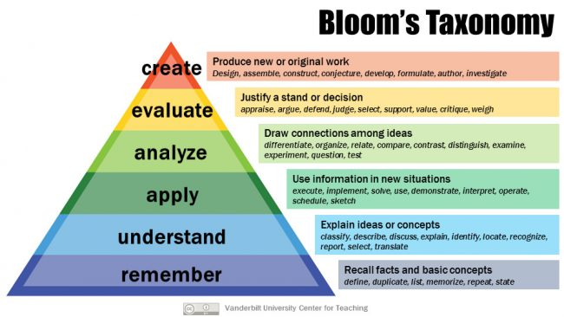

The affective domain includes learner behaviors relating to attitudes, values, feelings, and emotions. Similar to the cognitive domain, the five areas of the affective taxonomy are listed from lowest-level to highest level.

Figure 5
Affective Taxonomy Links
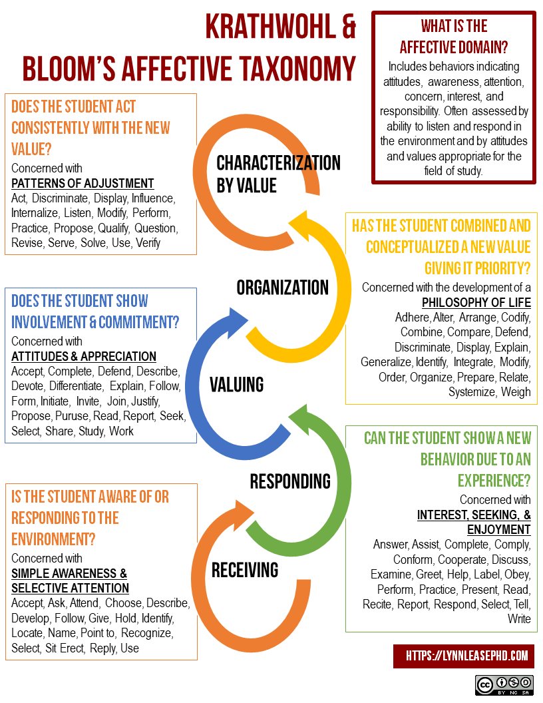

The psychomotor domain refers to coordination of the body’s muscular system and the learner’s ability to use physical skills and movement. While this domain was identified by Dr. Bloom, it was expanded on in the 1970s by educators such as Dr. Elizabeth Simpson, who organized the skills in a simple-to-complex arrangement.

Figure 6
Psychomotor Domain Steps

The University of Waterloo’s Centre for Teaching Excellence provides an excellent synthesis of Bloom’s Taxonomy learning activities and assessments, which can be found here.

ABCD Objectives.
The ABCD Method is a way of structuring instructional objective writing. In this method, there are four distinct components: audience, behavior, condition, and degree. Keep in mind, however, that ABCD objectives are not always written in order. Below, you will see several examples that demonstrate how objectives following the ABCD (audience, behavior, condition, degree) method can be worded.
· Students (A)will be able to describe foreign policy differences of the Republican and Democratic presidential candidates (B) on a multiple-choice exam (C) with 85% accuracy (D).
· 6th graders in Mr. Math’s class (A) will be able to correctly solve (B) 8 of 10 problems (D)on a weekly quiz featuring questions about right triangles (C).
· During a dissection with their lab partner (C), students in Ms. Frizzle’s life science course (A) will be able to identify (B) 4 out of 5 parts of the animal’s internal anatomy (D).

Not every school will require teachers to use this structure for objective writing, but they can be helpful for novice teachers to clarify their intended outcomes in a lesson.

Reflections from Interns
Q: Describe the "worst" lesson you have taught. What did you learn from it?
A1: The worst lesson I ever taught was when I was instructing students in an after-school program. It was one of my first days and I was not prepared at all. It was with a younger age group that I had never worked with before and I had the opportunity to research before my lesson time and didn’t because I underestimated the work that would need to go into a lesson for first graders. I gave them supplies and it got messy very quickly because I did not give proper instructions before giving students materials.
I learned that in every grade level it is important to be specific with lesson planning. I have learned so much more through my schooling that has allowed me to understand more about the background work that goes into preparing instruction/class work every day.
-Ms. Tabitha Cowley, pre-service English/language arts teacher

A2: The worst lesson I have taught happened not too long ago. I was at an event where I was supposed to be leading a lesson about snow and water. I knew going into it that I was supposed to do some sort of activity where I would show the students the same amount of snow and water in ml. Then, I would melt the snow and they would see that it is not the same amount.
When I got to the event, there was about five minutes when I was figuring out what to do. And this was not enough time, I soon found out. When I started teaching, I felt as though I was stumbling through it and that the students had no idea what I was talking about.
From this, I learned that I personally need more preparation as a teacher. I need to plan out my lessons and to practice the parts where I am not comfortable before I teach it in front of students. I need to do this so that I can give my students the best education that I can. And, I have been doing this.
-Miss Alex Gentry, pre-service dual biology and earth & space science teacher

Conclusion
So, while long-term planning is often required by school or district administrators, the process of long-term planning can be extremely helpful for teachers because the finish product provides direction for the entire academic year. Intermediate planning—or planning that encapsulates a single unit of study—begins to get more detailed and allows teachers to utilize backward design to plan “with the end in mind.” Short term plans, then, are the most detailed type of planning and come in the form of 1-2 day lessons. Careful attention to planning can help teachers be successful by being prepared and proactive rather than reactive.

References
Council of Chief State School Officers. (n.d.). Common Core State Standards. Retrieved February 9, 2023, from https://learning.ccsso.org/common-core-state-standards-initiative
Gerges, E. (2022, March 4). How to use the 5E model in Your science classroom. Edutopia. https://www.edutopia.org/article/how-use-5e-model-your-science-classroom/
Kansas State Department of Education. (2023a). Assessments Overview. KIDS. Retrieved February 8, 2023, from https://kidsweb.ksde.org/Assessments
Kansas State Department of Education. (2023b). Teaching & Learning. Retrieved February 9, 2023, from https://www.ksde.org/Teaching-Learning
Kenna, J. L., & Russell, W. B. (2018). The culture and history of standards-based educational reform and Social Studies in America. Journal of Culture and Values in Education, 1(1), 26–49. https://doi.org/10.46303/jcve.01.01.3
Klein, A. (2015, April 10). No Child Left Behind: An Overview. Retrieved February 9, 2023, from https://www.edweek.org/policy-politics/no-child-left-behind-an-overview/2015/04
Klein, A. (2020, December 9). The Every Student Succeeds Act: An ESSA Overview. Retrieved February 9, 2023, from https://www.edweek.org/policy-politics/the-every-student-succeeds-act-an-essa-overview/2016/03
Lombardi, P. (n.d.-b). Direct instruction teaching method. The Roles and Responsibilities of the Special Educator. https://granite.pressbooks.pub/edu606-701/chapter/direct-instruction-teaching-method/
McTighe, J., & Wiggins, G. P. (2013). Essential questions: Opening doors to student understanding. ASCD.
McTighe, J. (2019, September 1). The Fundamentals of Backward Planning. ASCD. https://www.ascd.org/el/articles/the-fundamentals-of-backward-planning
Rainbow, Undated Digital Planner. SlidesMania. (2021, June 18). Retrieved February 10, 2023, from https://slidesmania.com/rainbow-undated-digital-planner/
Savage, T. V., Savage, M. K., & Armstrong, D. G. (2012). Teaching in the Secondary School (7th ed.). Pearson.
Shabatura, J. (2014, September 18). Bloom’s taxonomy verb chart. Teaching Innovation and Pedagogical Support. https://tips.uark.edu/blooms-taxonomy-verb-chart/
State Standards Table of Contents. Education World. (n.d.). Retrieved February 9, 2023, from https://www.educationworld.com/standards/state/toc/
U.S. Department of Education. (2019, October 29). Standards, Assessment, and Accountability. Retrieved February 9, 2023, from https://www2.ed.gov/admins/lead/account/saa.html
U.S. Department of Education. (2020). State Education Practices: Table 1.1. National Center for Education Statistics (NCES). Retrieved February 8, 2023, from https://nces.ed.gov/programs/statereform/tab1_1-2020.asp
USD 501. (n.d.). TPS Curriculum Guide. Topeka Public Schools Staff Site. Retrieved February 9, 2023, from https://staffsite.topekapublicschools.net/curriculum_guide
Vogels, J. (2023, January 13). Breadth vs. Depth: What's the Best Way to Learn? Colorado Academy News. Retrieved February 9, 2023, from https://news.coloradoacademy.org/breadth-vs-depth-whats-the-best-way-to-learn/
Read this online at https://edtechbooks.org/effective_teaching_in_the_secondary_classroom/types_of_planning

