# Professional Involvement

## Professional Development

**Professional development** is an essential part of a teacher's career that helps them improve their knowledge, skills, and effectiveness in the classroom. It provides opportunities for new teachers to learn and grow and stay current with the latest teaching strategies and best practices.

Professional development is critical not just for new teachers, but for all teachers throughout their careers. Teaching is a constantly evolving profession, and new teaching strategies, instructional technology, and research are continually emerging. As such, it is essential for teachers to continue learning and growing throughout their careers. Being a life-long learner is a key component of being an effective teacher, and professional development opportunities can help teachers stay up to date with the latest teaching practices and trends.

Professional development opportunities can help teachers build their skills in specific areas, such as classroom management, instructional technology, and subject matter expertise. Professional development can also provide opportunities for teachers to collaborate with other educators, learn about the latest research and best practices in education, and pursue advanced degrees or certifications (University of San Diego, n.d.).

### Types of Professional Development

The following are some common types of professional development that new teachers may encounter:

Figure 1

Types of Professional Development

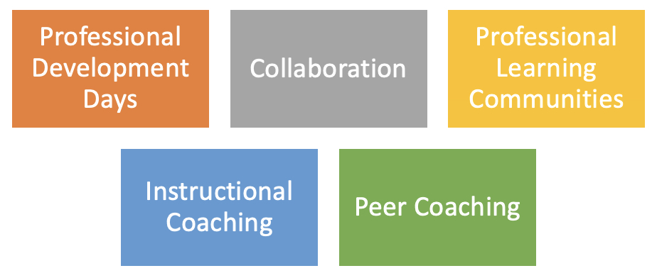

* Professional Development Days
  + **Professional development days** are days set aside by schools or districts for teachers to engage in professional learning activities, such as workshops, training sessions, and seminars. These days are designed to help teachers learn new skills and strategies, and to stay up to date on the latest trends and research in education (Darling-Hammond, Hyler, & Gardner, 2017).
* Collaboration
  + **Collaboration** is an effective way for teachers to learn from one another and improve their practice. Teachers can collaborate with their colleagues within their own school or district, or they can collaborate with teachers from other schools and districts. Collaboration can take many forms, including lesson study, peer observation, and co-teaching (Vescio, Ross, & Adams, 2008).
* Professional Learning Communities (PLCs)
  + A **PLC** is a group of teachers who come together regularly to share knowledge and resources, reflect on their practice, and work together to improve student learning. PLCs provide a supportive environment where teachers can collaborate and learn from each other (DuFour, DuFour, Eaker, & Many, 2010).
* Instructional Coaching
  + I**nstructional coaching** is a one-on-one professional development approach where an experienced teacher provides guidance and support to a new teacher. The coach observes the new teacher's classroom practice and provides feedback and suggestions for improvement. Instructional coaching can be a powerful way for new teachers to learn and grow (Knight, 2007).
* Peer Coaching
  + **Peer coaching** is similar to instructional coaching, but it involves two teachers who provide feedback and support to each other. Peer coaching can be a valuable form of professional development because it allows teachers to learn from their colleagues and build a supportive professional network (Joyce & Showers, 2002).

## Professional Associations

Joining a professional association can be a valuable resource for new teachers. Professional associations provide a community of support, access to resources and information, and opportunities for networking and professional development. Professional development is essential for new teachers to build their skills, stay up-to-date with the latest teaching strategies, and improve their effectiveness in the classroom.

Professional associations offer a variety of resources for new teachers. Many associations provide access to online libraries of resources, research studies, and best practices. These resources can help new teachers develop their teaching strategies and classroom management skills. Professional associations also offer opportunities for networking with other teachers in the same subject area or grade level. This can be particularly valuable for new teachers, as they can learn from the experiences of other educators and get advice on how to navigate the challenges of the profession.

In addition, some professional associations offer liability insurance to their members. Liability insurance can protect teachers from legal liability in the event of a lawsuit. For example, if a student is injured in a teacher's classroom or on a school-sponsored trip, liability insurance can help cover the costs of any legal claims or damages. While liability insurance is not required for teachers, it can provide an extra layer of protection and peace of mind.

### List of Professional Associations

The following is a list of professional associations including content specific professional associations:

* American Alliance for Theatre and Education (AATE): <https://www.aate.com/>
* American Association of Middle-Level Education (AMLE): <https://www.amle.org/>
* American Association of Physics Teachers (AAPT): <https://www.aapt.org/>
* American Council on the Teaching of Foreign Languages (ACTFL): <https://www.actfl.org/about-actfl>
* Association for Career and Technical Education (ACTE): <https://www.acteonline.org/>
* Music Teachers National Association (MTNA): <https://www.mtna.org/>
* National Art Education Association (NAEA): <https://www.arteducators.org/>
* National Association of Biology Teachers (NABT): <https://nabt.org/>
* National Association of Geoscience Teachers (NAGT): <https://nagt.org/index.html>
* National Association of Teachers of Singing (NATS): <https://www.nats.org/>
* National Council for the Social Studies (NCSS): <https://www.socialstudies.org/>
* National Council of Teachers of English (NCTE): <https://ncte.org/>
* National Council of Teachers of Mathematics (NCTM): <https://www.nctm.org/>
* National Educators Association (NEA): <https://www.nea.org/>
* National Science Teachers Association (NSTA): <https://www.nsta.org/>
* National Speech and Debate Association: <https://www.speechanddebate.org/>
* Society of Health and Physical Educators (SHAPE): <https://www.shapeamerica.org/>

*\*Many of the national organizations will also have state affiliates.*

## References

Darling-Hammond, L., Hyler, M. E., & Gardner, M. (2017). Effective teacher professional development. Learning Policy Institute. <https://learningpolicyinstitute.org/product/effective-teacher-professional-development-report>

DuFour, R., DuFour, R., Eaker, R., & Many, T. (2010). Learning by doing: A handbook for professional learning communities at work (2nd ed.). Solution Tree Press.

Joyce, B., & Showers, B. (2002). Student achievement through staff development (3rd ed.). Association for Supervision and Curriculum Development.

Knight, J. (2007). Instructional coaching: A partnership approach to improving instruction. Corwin Press.

University of San Diego. (n.d.). 8 Reasons Why Professional Development is Critical for Teachers. <https://pce.sandiego.edu/8-reasons-why-professional-development-is-critical-for-teachers/>

Vescio, V., Ross, D., & Adams, A. (2008). A review of research on the impact of professional learning communities on teaching practice and student learning. Teaching and Teacher Education, 24(1), 80-91. <https://doi.org/10.1016/j.tate.2006.11.007>

Read this online at <https://edtechbooks.org/effective_teaching_in_the_secondary_classroom/professional_involvement>