# More about Reference Pages

You will need to include a reference page at the end of your essay. The **reference page** is a page at the end of your paper where you list information about any of the sources you cited in your paper. Sources that you quoted, summarized, and/or paraphrased need to be listed on your reference page.

Only sources cited in your paper can be put on a reference page. If you didn't cite the source with an in-text citation somewhere in your paper, then you can't put it on your reference page. If you used a souce and want to put it on your reference page, but didn't cite it somewhere in your essay with an in-text citation that is a problem that needs to be fixed. If you used even just ideas from a source, it should be cited. Find the place you used the source in your essay, cite it with an in-text citation, and then you can add the source properly to your reference page.

The reference page serves several purposes. If a reader is interested in your paper and wants to read the sources that you read, they can look in your references and find them. The reference list can also add to your credibility as an academic writer. It can show that you have done enough research that your reader can believe what you wrote.

When you build a reference page, you need to know what type of sources you used. Books have a different format than journal articles; newspaper articles have a different format than websites. The following pages include a series of sources you may use in your researched essays. Each source will include the type of source (e.g., newspaper article) and a general citation format. In addition to the general information, an example will be provided of the source and how that source should be cited.

The format of your reference page (as well as your in-text citations) depends on which style guide you are using. Style guides are a list of rules about how to format your writing. Common style guides include APA, MLA, Chicago, and Turabian. Your college professors will tell you which style guide to use. You will learn what a reference page for APA looks like in this section of the book, but there are other style guides to be aware of. You do not need to memorize the rules for any particular style guide, but you **do** need to know where to find them and how to use them. As with the in-text citations, there are many rules about how to format your reference page, and this section of the book is not comprehensive. If you have a source that is not explained in this section of the book, you can look up the APA Publication Manual (7th edition) or the [Purdue OWL.](https://owl.purdue.edu/owl/research_and_citation/apa_style/apa_formatting_and_style_guide/index.html)

To cite your source you will need to do the following:

1. You need to know the style required by your teacher: APA, MLA, Chicago, etc.
2. You need to know what type of source you are citing: website, journal, book, etc. The type of source determines the exact information you will need and the order of that information in its own special format.
3. Use a citation website or style guide to help you format the information about your source into the correct order.

### How to Make a Reference Page

1. Start with the word "References" centered on the first line.
2. Organize your references in alphabetical order.
3. Use a "hanging indent". This means that the first line of the entry will start at the left margin, but the subsequent lines will be indented in .5" from the margin.
4. Double-space between each entry on the entire reference page.
5. The reference page should be included on a separate page after the body of the essay.

The information you include in each individual reference will vary by style and by source type. There are entire books and websites dedicated to each style that include pages upon pages of specific instruction for each source type and possible variation. So, for specific guidlines, you will need to look up how to cite your specific type of source in one of those style guides. However, there are a few citation formatting tips you can use for how to cite sources in general.

1. Last Name and 1st initial of the author(s)/Organization
2. Year of publication
3. Title of the article, chapter, or website
4. Title of the journal or book
5. Edition, volume, and/or page number
6. Publication location (city, state, etc) or website information

### Example

Culhane, E. C. (2019). Hearing Absence: Shusaku Endo's Silence and the Dark Night of the Soul. Religion & Literature, 51(2), 23-45. Retrieved from https://doi-org.byu.idm.oclc.org/10.1353/rel.2019.0030

### Example Breakdown

Culhane, E. C. (2019). Hearing Absence: Shusaku Endo's Silence and the Dark Night of the Soul.Religion & Literature,51(2), 23-45. Retrieved from https://doi-org.byu.idm.oclc.org/10.1353/rel.2019.0030

|  |  |
| --- | --- |
| Culhane, E. C. | Author's Name(s) |
| (2019). | Publication Year |
| Hearing Absence: Shusaku Endo's Silence and the Dark Night of the Soul. | Title |
| Religion & Literature, | Journal Name |
| 51(2), 23-45. | Volume number, Issue number, and page numbers |
| Retrieved from  https://doi-org.byu.idm.oclc.org/10.1353/rel.2019.0030 | website infromation |

### Example: References

Culhane, E. C. (2019). Hearing Absence: Shusaku Endo's Silence and the Dark Night of the Soul. Religion & Literature, 51(2), 23-45. Retrieved from https://doi-org.byu.idm.oclc.org/10.1353/rel.2019.0030

Guerber, H. A. (1895). Stories of the Wagner Operas. New York: Dod, Mead and Company.

Arponen, V. et al. (2019). Between natural and human sciences: On the role and character of theory in socie-environmental archeology. The Holocene, 29(10), 1671–1676. https://doi.org/10.1177/0959683619857226

NOAA, (n.d.). What is the difference between a hurricane and a typhoon?. Para 2. Retrieved from https://oceanservice.noaa.gov/facts/cyclone.html

Lieth, P. (n.d.). Pru Lieth's Raspberry Blancmange. The Great British Bake Off. Retrieved from https://thegreatbritishbakeoff.co.uk/recipes/all/prue-leith-raspberry-blancmange/

## Journal Article with DOI

A doi is a digital object identifier. This number acts as a permanent link to be able to find a copy of a specific article on the internet. Journal articles sometimes have a doi assigned to them. If the journal article you use has a doi, you should include it in the citation.

### General format:

Surname, Initial. (Year). Title of article. Title of Journal, volume(issue), pages. doi: ############

Kaye, D. & Gray, J. E. (2021). Copyright Gossip: Exploring copyright opinions, Theorires, and Strategies on YouTube. Social Media + Society, 7(3). doi: 10.1177/20563051211036940

## Journal Article without DOI

As mentioned in the previous example, a doi acts as a permanent link to be help people find a copy of a specific article on the internet. If the journal article you use does not have a doi, you should include the URL you got the article from.

### General format:

Surname, Initial. (Year). Title of article. Title of Journal, volume(issue), pages. Retrieved from <http://site>

Bailey, C. et al. (2023). Retire the Conventional Laryngoscope?. American Association of Nurse Anesthesiology, 91(1), 39-45. Retrieved from https://www.aana.com/publications/aana-journal

## Book

There are slight variations in requirements for citing chapters of books, books with editors, and books that have several editions. The following is a general format.

### General format:

Surname, Initial. (Year). Title of book. Location: Publisher.

Guerber, H. A. (1895). Stories of the Wagner Operas. New York: Dod, Mead and Company.

## **Newspaper Articles**

Journal articles take time to develop, review, and publish. If you are looking for information about an event of current interest (especially in quickly changing fields like technology and politics) a reputable newspaper can be a good source.

### General format:

Surname, Initial. (Year, Month Date). Title of article. Title of Newspaper. Retrieved from <http://site>

If you use a paper copy of a newspaper article, replace the website with the page numbers of the article.

Heyward, G. (2023, February 16). Larry the Cat celebrates 12 yeaers of dutiful service at No. 10 Downing St. National Public Radio. Retrieved from https://www.npr.org/2023/02/16/1157507569/larry-cat-no-10-downing-street-british

## **Entry in an Online Reference**

Online references include dictionaries and encyclopedias. These words frequently do not list an author or a date of publication. If they do list the author, then you should list the author's name like you usually would.

### General format:

Search term (n.d.). In Title of reference. Retrieved from <http://site>

Antidisestablishmentarianism, (n.d.) Cambridge University Press & Assessment. Retrieved from https://dictionary.cambridge.org/us/dictionary/english/antidisestablishmentarianism

If you cite a website with an organization listed (e.g., NASA, EPA, etc.) instead of an author, the or- ganization should be listed as the author. If there is not an organization, write the title of the article in the author’s position. (If there is no article title, write the name of the website). The article or website title does not need to be italicized. If the date, month, and year are included on the website, list all of them. If not, just use the year.

## **General Websites**

If you cite a website with an organization listed (e.g., NASA, EPA, etc.) instead of an author, the organization should be listed as the author. If there is not an organization, write the title of the article in the author's position. (If there is no article title, write the name of the website). The article or website title does not need to be italicized. If the date, month, and year are included on the website, list all of them. If not, just use the year.

### General format:

Surname, Initial. (Year). Title of article. Retrieved from <http://site>

National Council of Teachers of English (2001, Novermber 30). Resolution on Teaching in a Time of Crisis. Retrieved from https://ncte.org/statement/teachingtimeofcrisis/

### Exercise 1: Find Citable Information

Look at the screenshots of possible sources below and answer the following questions.

* What information could you use to add to a citation for each source?
* What information is missing for a citation about each source?

1.



2.

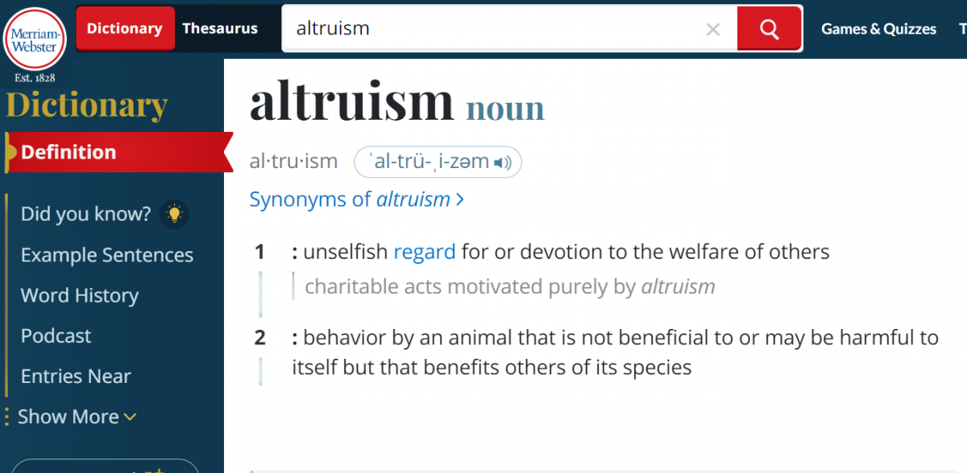

3.

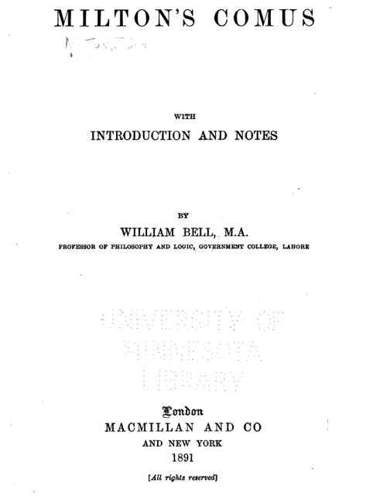

4.

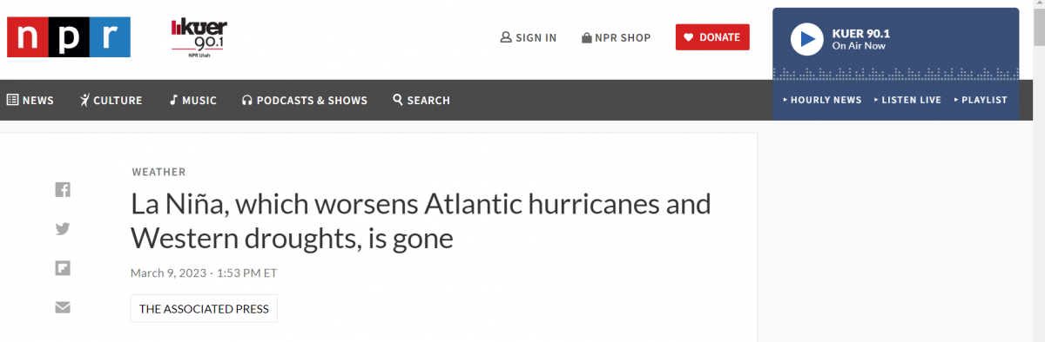

### Exercise 2: Make Reference Page Entries

Write a reference page entry on the lines for the following quotes, summaries, and paraphrases used in an essay about the life of Dieter F. Uchtdorf. You can do this by hand or use the Citation Machine website to make your entries.

1. Quote: “To avoid suspicion, the rest of the family would not be able to travel together. They would have to make the attempt separately” (Nelson, July 2008, para. 1).

Source: [https://edtechbooks.org/-KQGU](https://www.churchofjesuschrist.org/study/ensign/2008/07/president-dieter-f-uchtdorf-a-family-man-a-man-of-faith-a-man-foreordained?lang=eng)

2. Summary: The faith in the family started with the faith of President Uchtdorf’s grandmother. She was in a standing line for food following the end of the War, when an elderly sister with no family invited her to the church (Holland, 2005).

Source: [https://edtechbooks.org/-ZSCX](https://www.churchofjesuschrist.org/study/ensign/2005/03/elder-dieter-f-uchtdorf-on-to-new-horizons?lang=eng)

3. Paraphrase: Harriet was still single when Uchtdorf returned from serving in the military, and he managed to capture her heart (Hill, 2004).

Source: [https://edtechbooks.org/-JLvx](https://www.thechurchnews.com/2004/10/16/23237568/elder-dieter-f-uchtdorf-apostle-2004)

Read this online at <https://edtechbooks.org/up_writing_fall/reference_page2>