# Cognitive Load Theory

Clark, C., Kimmons, R.

Cognitive Load Theory (CLT), formulated by John Sweller, describes how working memory processes information and includes three types: intrinsic, extraneous, and germane. Each type of cognitive load plays a crucial role in educational technology and instructional design, and by minimizing extraneous cognitive load and promoting germane cognitive load, educators can enhance learning effectiveness. CLT has become widely recognized as an influential framework in educational research, guiding instructional practices and fostering continuous improvement in designing effective and engaging learning experiences for students.

The concept of cognitive load was first presented by Sweller (1988) in relation to the effectiveness of conventional problem-solving methods for acquiring domain-specific knowledge and skills. Sweller (1988) indicated that working memory has a limited capacity and stressed the importance of minimizing extraneous cognitive load to maximize learning. Specifically, Sweller (1988) noted “human short-term memory is severely limited and any problem that requires a large number of items to be stored in short-term memory may contribute to an excessive cognitive load” (p. 265). In the ensuing years, CLT has become a foundation for the design and application of many instructional design principles (Paas, Renkl, & Sweller, 2003) and has also undergirded elaboration of multimedia learning principles (Mayer & Moreno, 2003). Many educational researchers and theorists make the connection between CLT and instructional design (Van Merriënboer, Kirschner, & Kester, 2003) and contextualize CLT within instructional design principles (Chandler & Sweller, 1991).

## Three Discrete Types of Cognitive Load

Sweller and others have articulated three types of cognitive load: intrinsic, extraneous, and germane (see Figure 1).

Figure 1

Visualization of the Three Types of Cognitive Load

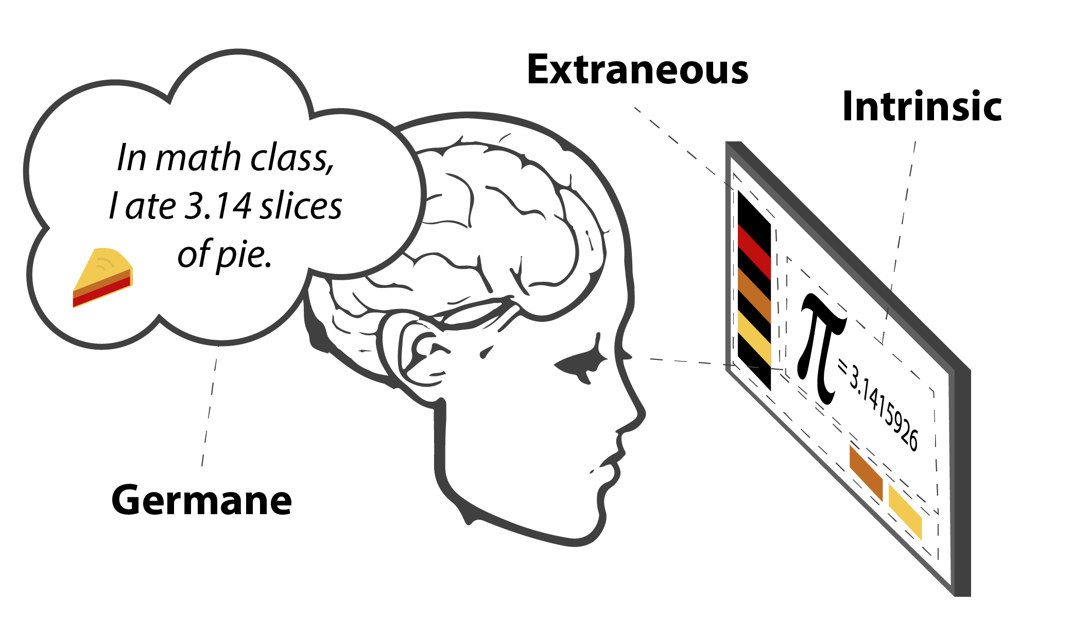

### Intrinsic Cognitive Load

Intrinsic cognitive load refers to the degree of difficulty inherent in a learning event. All concepts are not equal and the tasks that are higher up the visual pyramid of Bloom’s Taxonomy of Learning will require more intrinsic cognitive load allocation (e.g., the learning tasks of application and creation tax the intrinsic load levels of the learner more than remembering or understanding do). Likewise, some concepts themselves are much more intrinsically complex and reciprocally require more cognitive load to reach understanding. Sweller (2010) described this as the allocation of working memory necessary for dealing with the “intrinsic complexity of information” (p. 123).

### Extraneous Cognitive Load

As originally articulated, the word “extraneous” is never explicitly stated in conjunction with cognitive load but is indirectly referenced as “measures” that are “presumably irrelevant to schema acquisition” because they are not critical to new schema induction (Sweller, 1988, p. 282). Put another way, these are aspects of gaining understanding and ultimately of knowledge construction that are superfluous to such ends. This is especially important with more complex learning tasks as strategies that rely upon “a heavy cognitive load” (p. 277) leave less cognitive capacity free for dealing with intrinsic load.

Elements of the educational experience that do not support the learning task, such as instruction that is poorly organized or includes irrelevant information,constitute extraneous cognitive load. Stated alternatively, extraneous cognitive load distracts from accomplishing the learning objective and is therefore “concerned with the manner in which instruction is designed” (Sweller, 2010, p. 123), including such factors as language difficulty, media use, examples, images, sounds, distractors, etc.

### Germane Cognitive Load

Germane cognitive load refers to the effort needed to transfer short-term information to long-term knowledge and understanding via schemas. Sweller (2010) characterizes germane cognitive load in the context of the other types of cognitive load as follows:

Unlike intrinsic and extraneous cognitive load, germane cognitive load does not constitute an independent source of cognitive load. It merely refers to the working memory resources available to deal with the element interactivity associated with intrinsic cognitive load. (p. 126)

As such, germane cognitive load would involve the learning activities and mental processes that attempt to connect information to long-term knowledge schemas in a constructivist manner, such as using mnemonic devices, activating prior knowledge, etc.

## Reconciling the Elements

Pass (1992) summarized CLT as “a multidimensional concept in which two components—mental load and mental effort—can be distinguished. Mental load is imposed by instructional parameters . . . and mental effort refers to the amount of capacity that is allocated to the instructional demands” (p. 429). Therefore, when teaching students, Sweller, van Merriënboer, and Pass (1998) indicated that instructional strategies should be followed to reduce extraneous cognitive load while increasing germane cognitive load. Five years later, van Merriënboer et al. (2003) concluded that CLT continues to offer “useful guidelines for decreasing intrinsic and extraneous cognitive load, so that sufficient processing capacity is left for genuine learning” (p. 5). Succinctly stated, when designing and delivering instruction, to reduce extraneous cognitive load, educators can simplify the presentation of information, engage in instructional practices that promote germane cognitive load, and adapt instruction to fit learners’ zone of proximal development or level of expertise.

## Conclusion

Cognitive Load Theory is a widely recognized and influential model in the fields of educational research and instructional design and permeates a great many aspects of educational practice and research. CLT has been described as an “internationally well known [sic] and widespread theory, which has been empirically confirmed in numerous studies” (Bannert, 2002, p. 139). Initially credited as originating from John Sweller in the 1980s, CLT has since been examined, expanded upon, and applied in practice by a great many educators to optimize learning outcomes. CLT can provide valuable insights for minimizing extraneous cognitive load while promoting germane cognitive load, and can therefore help educators create more effective and engaging instruction that maximizes learners’ potential for genuine understanding and knowledge construction. As CLT continues to inform educational practices, it holds the promise of contributing to the ongoing improvement of instructional design and educational effectiveness for years to come.

## References

Bannert, M. (2002). Managing cognitive load—recent trends in cognitive load theory. Learning and Instruction, 12(1), 139–146. [https://doi.org/10.1016/S0959-4752(01)00021-4](https://psycnet.apa.org/doi/10.1016/S0959-4752(01)00021-4)

Chandler, P., & Sweller, J. (1991). Cognitive Load Theory and the Format of Instruction. Cognition and Instruction, 8(4), 293-332. [https://doi:10.1207/s1532690xci0804_2](https://doi.org/10.1207/s1532690xci0804_2)

Mayer, R. E., & Moreno, R. (2003). Nine ways to reduce cognitive load in multimedia learning.Educational Psychologist, 38(1), 43–52.[https://doi:10.1207/S15326985EP3801_6](https://doi.org/10.1207/S15326985EP3801_6)

Paas, F. G. W. C. (1992). Training strategies for attaining transfer of problem-solving skill in statistics: A cognitive-load approach. Journal of Educational Psychology, 84(4), 429–434. [https://doi.org/10.1037/0022-0663.84.4.429](https://psycnet.apa.org/doi/10.1037/0022-0663.84.4.429)

Paas, F., Renkl, A., & Sweller, J. (2003). Cognitive Load Theory and Instructional Design: Recent Developments. Educational Psychologist, 38(1), 1–4. [https://doi:10.1207/S15326985EP3801_1](https://doi.org/10.1207/S15326985EP3801_1)

Sweller, J. (1988). Cognitive load during problem solving: Effects on learning. Cognitive Science, 12(2), 257–285. <https://doi.org/10.1207/s15516709cog1202_4>

Sweller, J. (2010). Element interactivity and intrinsic, extraneous, and germane cognitive load. Educational psychology review, 22, 123–138.<https://doi.org/10.1007/s10648-010-9128-5>

Sweller, J., Van Merrienboer, J. J., & Paas, F. G. (1998). Cognitive architecture and instructional design. Educational Psychology Review, 10, 251–296. <https://doi.org/10.1023/A:1022193728205>

Van Merriënboer, J. J., Kirschner, P. A., & Kester, L. (2003). Taking the load off a learner’s mind: Instructional design for complex learning. Educational Psychologist, 38(1), 5–13. [https://doi.10.1207/S15326985EP3801_2](https://doi.org/10.1207/S15326985EP3801_2)

Read this online at <https://edtechbooks.org/encyclopedia/cognitive_load_theory>