# Creating Stronger Design Systems for Collaboration: Skills, Resources, and Practices Needed to Support an Effective Co-Design Experience

McNeil, S., Gronseth, S.L., Woodard, L., Rollins, A., Obanua, F., Carpousis-Bowers, A.

This paper describes a design case that addressed a healthcare training need for clinicians and administrators about Value-Based Care (VBC) through the design, development, implementation, and evaluation of seven massive open online courses (MOOCs). The context was an industry-academic partnership that linked subject matter experts in VBC with university faculty and designers. Courses were developed using a co-design approach to provide multiple perspectives on the issues involved, ensure the accuracy of the content, and enhance the alignment between the design and stakeholders’ needs. The team worked collaboratively to define the opportunity, brainstorm ideas, prototype solutions, evaluate prototypes based on identified needs, and ultimately design online educational experiences for a wide variety of learners in different healthcare contexts. This paper shares lessons learned about creating stronger design systems for collaboration in the areas of selecting and supporting co-design teams, fostering collaborative learning environments, and modeling collaboration in the instructional design process. Reflections about this design case underscored the importance of forming relationships among team members, which was a key outcome of the co-design structure and, facilitated the communication and psychological safety needed to support the iterative cycles of feedback during course development.

## Introduction

This paper describes a design case (Howard, 2011) that addressed a critical healthcare training need through the design, development, implementation, and evaluation of seven massive open online courses (MOOCs). The context was an industry-academic partnership that linked subject matter experts (SMEs) with university faculty and designers. The courses were developed using a co-design approach that sought to integrate multiple perspectives, ensure content accuracy, and align stakeholders’ needs to the instructional strategy (Sanders & Stappers, 2008, 2012). Studies have shown that co-design is effective in developing professional development curricula in MOOCs (Kolling et al., 2022; McGregor et al, 2018; Perestelo-Perez, 2020) and that the meaningful involvement of stakeholders is critical to improving learning and practice as well as producing effective outcomes (Iniesto et al., 2022; O’Brien et al., 2021; Redman et al., 2021).

There has been an increase in the use of co-design methods to create healthcare educational programs (Slattery et al., 2020) that recognize, value, and integrate the different types of knowledge and experiences of all stakeholders. In this "highly facilitated, team-based process" (Penuel et al., 2007, p. 53), the team in the present design case worked collaboratively to define the education opportunity, brainstorm ideas, prototype solutions, evaluate the prototypes based on identified needs, and ultimately produce on-demand courses for learners in targeted healthcare contexts.

## Background

### Co-Design

Co-design can facilitate collaborations among educators, health professionals, and industry leaders in developing innovative and effective educational programs that consider the needs and perspectives of all stakeholders. It is being used increasingly in health and social care contexts (Masterson et al., 2022), providing notable impacts in facilitating change and improvement in policies and practices (Harrison et al., 2022; Robert et al., 2015). Roschelle & Penuel (2006) define co-design as “a highly-facilitated, team-based process in which teachers, researchers, and developers work together in defined roles to design an educational innovation, realize the design in one or more prototypes, and evaluate each prototype’s significance for addressing a concrete educational need” (p. 606). Ideally, co-designed curricula emerge through an integration of the knowledge, resources, and contributions of all team members (Ward et al., 2018). In coordinating the involvement of different contributors, prototypes can provide tangible means to incorporate user characteristics, community values and perspectives, and relevant initiatives of a particular context in an iterative project development progression (Australian Healthcare and Hospitals Association, 2017; Iniesto et al., 2022).

One of the key benefits of co-design is that it is situated in authentic contexts, that is, “… the reality of people’s everyday work environment rather than designing from theory something that ‘should’ work for them” (Ward et al., 2018, p. 10). Because stakeholders are involved throughout design and development (Bird et al., 2021; Bolster et al., 2021; Iniesto et al., 2022; Palomo-Carrión et al., 2022), the resulting designs tend to be user-centered, considering the needs and perspectives of all end-users (Kolling et al., 2019; McGregor et al., 2018) and leading to higher user satisfaction (Steen et al., 2011). In addition, stakeholder involvement fosters “‘considerable depth and richness’ that emerges through the co-design process” (Blackwell et al., 2017) and ensures that the product is effective (Maciver et al., 2021). In sum, this collaborative process supports trust and engagement among the co-design team members through synergy and interaction (Ohag et al., 2023; Torrents et al., 2021).

### Massive Open Online Courses for Health Professionals

The seven courses that were developed in this project were Massive Open Online Courses (MOOCs). MOOCs are courses available to theoretically unlimited numbers of participants, without formal admission, accessible via the Internet, and formatted as organized programs of study (Kennedy & Laurillard, 2019; Nieder et al., 2022). MOOCs have become a “global phenomenon” over the past decade (Shah, 2020, para. 3), growing from 300,000 learners in 2011 to 220 million learners in over 3,100 courses in 2021 (Shah, 2021). The MOOC platform used in the present project is Coursera, which currently boasts 118 million learners (Shah, 2023) and over 700 health- and medicine-related courses (Coursera, 2023b).

MOOCs have become an attractive, no- or low-cost option for continuing education for health professionals who have varied hours and schedules that make in-person professional development sessions more difficult (Eglseer, 2023; El Ali et al., 2023; Gleason et al., 2021; Gómez Gómez & Munuera Gómez, 2021; Nieder et al., 2022). For example, Coursera courses such as Health Informatics and Healthcare Delivery Providers enable healthcare professionals to stay current with the latest research and best practices in their field. In a scoping review of 39 studies that focused on healthcare MOOCs in low- and middle-income countries, Nieder et al. (2022) found that MOOCs can support healthcare providers' enhancement in their knowledge and understanding. MOOCs have also been found to contribute to significant improvements in healthcare professionals’ skills in areas of malnutrition (Eglseer, 2023), dementia (Eccleston et al., 2019), nutrition (Adamski et al., 2022), and patient safety (Gleason et al., 2021).

MOOCs can also expand learners’ professional learning networks, connecting them to exchange ideas and share reflections on best practices (Anderson et al., 2020; Kennedy et al., 2019). This feature can be especially helpful for those in rural or remote areas who may not have as many opportunities for networking and collaboration (Kolling et al., 2019; Nieder et al., 2022). MOOCs are also used by healthcare professionals for purposes of assessments and certifications that aid in meeting licensing requirements and demonstrate their commitment to continuing education (Maxwell et al., 2018).

### Co-Design of MOOCs

Using a co-design approach to the development of a MOOC involves collaboration among multiple stakeholders, including instructors, instructional designers, SMEs, technology specialists, and learners. Co-design has been used successfully in the development of many healthcare-related MOOCs. For example, the IC-Health project co-designed thirty-five MOOCs in eight different languages to improve the digital health literacy skills of European citizens (Perestelo-Perez et al., 2020). From a research perspective, the co-design approach generates design principles that can be useful for informing future designs in this innovative healthcare context (Jackson-Barrett et al., 2019).

This collaborative approach presents some challenges, though, to design teams. With so many stakeholders involved in the design, diverse perspectives on how a MOOC should be designed and delivered (Álvarez-Pérez et al., 2022; Cinquin et al., 2021) can add complexity to reaching consensus on important decisions. More time may be needed for this process (Iniesto et al., 2022) amidst competing demands of deadlines and course launch schedules.

## The Co-Design Process in the Development of the Value-Based Care MOOCs

### Defining the Content

The scope of content for the courses focused on value-based care (VBC), an alternative payment model that structures payments for healthcare providers, including hospitals and physicians, around improving and maintaining patient health while simultaneously reducing cost (NEJM, 2017; Rutherford et al., 2022; Teisberg et al., 2020). VBC addresses concerns about the current unsustainable trajectory of healthcare spending in the U.S. under a traditional fee-for-service model in which health insurance companies have paid healthcare providers for services on a volume basis. The COVID-19 pandemic has further exacerbated the need for changes to health systems’ funding, affordability, and equity and “forced healthcare players to make radical shifts to how care is delivered and used” (Noël, 2022, p. 26). Studies have also demonstrated a significant association between a VBC program and positive outcomes for patients, such as medication adherence (Agarwal et al., 2018) and increased valued healthcare services while controlling costs (Zhang & Cowling, 2023). VBC information, processes, and best practices are not typically taught in medical schools (Freer, 2023), leading to a gap in knowledge for many healthcare providers. According to the 2020 Deloitte Survey (Abrams et al., 2020), most U.S. physicians believe that the next generation of physicians should focus on understanding the business of medicine (65%) and how to deliver care that fosters prevention and well-being (59%). Since the Centers for Medicare & Medicaid Services plans to transition all Medicare patients to VBC arrangements by 2030 (CMS, 2023), there is an urgent need for professional development that provides information and training in this area.

### Defining the Learners

Anderson and Meiselbach (2023) suggest that clinicians need to be engaged in the design of successful VBC programs. A survey by the New England Journal of Medicine Catalyst Insights Council found that many clinicians and administrators are positive about the potential benefits of VBC models with more than two-thirds indicating that their organization’s value-based payments would likely increase “somewhat” or “greatly” in the next two to three years (Shrank & Powers, 2022). The need for understanding VBC has thus emerged for a range of healthcare professionals, including clinicians, administrators, and support staff, to be able to implement and manage their practice using VBC, as well as carry out their roles within larger care teams (Teisberg et al., 2020; Walsh, 2020). Therefore, the target learners for the VBC MOOCs in this design case included all healthcare professionals who work with patients, have a clinical background, and possess basic healthcare and Medicare knowledge.

### Defining the Design Context

The University of Houston (UH) and Humana Inc., a national health plan and healthcare services company, formed a strategic partnership in 2020 to provide innovative educational programs for current and future healthcare professionals and create programs for community transformation. The University also had an established partnership with Coursera to support the design and development of MOOCs in different disciplinary areas. Coursera’s features offer asynchronous, on-demand learning capabilities aligned with project aims (Coursera, 2023a). For example, Coursera’s progress-tracking feature visualizes learners’ real-time progress and suggests the next steps toward target goals. Project-based learning features were also utilized in the development of a capstone that learners would complete to obtain the Value-Based Care specialization, a micro-credential that signifies their competency in this area. The data analytics features of the platform enabled the design team to continually improve the content and delivery of the courses after they were launched.

### Defining Teams, Roles, and Responsibilities

A core team was initially formed of two UH faculty from the Learning, Design, and Technology program area and two Humana professionals who drafted the agreement for the partnership. Jointly embracing the assumption that "anybody is an expert regarding their own experience and mobilizes their practical and experiential knowledge as well as their conceptual knowledge" (Cavignaux-Bros & Cristol, 2020, para. 5), the co-design group was expanded to involve multiple teams that included the project manager; learning and graphic designers; medical, nursing, and social work faculty; physicians with VBC experience; other SMEs; and potential learners (see Table 1). Intentionally including potential learners in strategic points of the design fostered understanding and appreciation of stakeholder perspectives in the co-design process (Farmer, 2021). During the yearlong design and development of the courses, the core team met online once a week to discuss the progress of tasks on the project plan. The six extended multidisciplinary teams also met weekly to discuss and develop the course content. Core and support teams worked together in the development of the videos and other course resources, and stakeholders were engaged throughout every step to provide input and feedback.

Table 1

Teams, Roles, and Responsibilities

|  |  |
| --- | --- |
| Role | Responsibilities |
| Executive Steering Committee |
| Senior executives from both organizations (e.g., Senior VPs at Humana and UH) | * Sets the overall strategic direction for the project. * Ensures that the project aligns with the organization's goals and objectives. * Guides priorities and focus areas. * Allocates resources to the project, including funding, staff, and other necessary resources. * Monitors the progress of the project and ensures that it is on track to meet its objectives. |
| Program Sponsors |
| Sponsors from Humana and UH(Highest level change leader) | * Ensures alignment with each organization’s goals; connects the project to the larger organization; ensures look and feel (branding) is consistent with look and feel of the organization’s requirements. * Determines structure and components. * Identifies existing documentation and reference materials. * Brings in talent. * Selects project manager. |
| Core Team |
| Project Leaders | * Facilitates communication between different stakeholders (organizing meetings, leading discussions, and ensuring that everyone has an opportunity to share their ideas and feedback). * Determines project goals and objectives based on the needs and requirements of the project in collaboration with the stakeholders involved. * Identifies key project milestones and establishes timelines for achieving them (with the project manager). * Manages the resources required for the project (personnel, equipment, and materials) to meet quality standards and objectives. * Leads the project evaluation, uses feedback and data to make improvements, and ensures that it meets the needs of stakeholders. |
| Project Manager | * Defines project scope (goals, objectives, and deliverables) in collaboration with project leaders and ensures the project stays within boundaries. * Creates project plan in collaboration with project leaders (outlines the tasks to be completed, the timeline for completion, and the resources required). * Tracks project tasks to ensure deadlines are met. * Facilitates communication within the co-design team (schedules regular meetings, creates communication channels, and makes sure that all team members are up-to-date with project progress and changes). * Conducts a reflective “lessons learned” activity with co-design group to inform iterations of the project and future collaborative work. |
| Extended Multidisciplinary Team |
| Learning Designer | * Collaborates in the development of the “Process Thinking Documents” and guided questions for each course. * Interviews subject matter experts to develop content for courses by using the “Process Thinking Documents.” * Works with subject matter experts to ensure content accuracy. * Creates the final design document for each course and revises it after stakeholder feedback. |
| Subject Matter Experts for all courses from Humana and UH | * Contributes to content development for all courses. * Helps identify and prioritize design opportunities. * Evaluates design ideas against project requirements. * Provides feedback on the feasibility and practicality of proposed solutions. * Provides feedback for the final design document for all courses. |
| Specialized Services Team |
| Subject Matter Experts in specific content areas | * Contributes to content development for specific topics in their specialty areas. * Provides feedback on the final design documents in their specialty areas. |
| Compliance Specialists | * Ensures that the final design documents comply with Humana guidelines and align with organizational goals. |
| Communication Specialists | * Supports copyediting of final design documents. |
| Branding Team | * Ensures look and feel (branding) is consistent with the look and feel of each organization. |
| Development Team |
| Graphic Designer | * Creates designs that effectively communicate the project goals (sketches, mockups, and prototypes). Solicits feedback from other teams and revises designs to meet program needs. * Prepares the final graphic files for implementation. |
| Videographers | * Films subject matter expert speakers. * Creates videos from presentation and audio files. * Edits video content through the selection of footage and the addition of sound and visual effects. |
| Multimedia Specialists | * Works closely with other teams to conceptualize multimedia elements that support the design vision of the project. * Creates multimedia elements for the courses (animations, infographics, diagrams). |
| Pilot Testing Team |
| Pilot Testing Lead and Learners who are representative of the different populations who would take the courses (social work, insurance specialists, clinicians, social workers, nurses) | Pilot Testing Lead:   * Works with the project manager to develop a plan for pilot testing (defines the testing environment and parameters, test user groups with roles and objectives, and testing timelines) * Selects pilot testers. * Monitors pilot testers during the review. * Collects and analyzes feedback from pilot testers.   Manages course update process based on feedback.  Pilot Testing Learners:   * Enrolls in the pilot courses. * Provides feedback about the course structure, usability, and content accuracy. |

### Collaborative Team Processes

#### Approach and Communication Document

To frame the project, the executive steering committee and program sponsors created an Approach and Communication Document, an important resource that would serve as the roadmap for the development activities to follow. The document articulated the communications strategy, project management processes and tools, and team organizational structure.

#### Project Plan

The project manager then created the project plan spreadsheet with input from the core team. This living document became a crucial tool in the co-design process as it helped ensure that all stakeholders had a clear understanding of the implementation of the project scope, goals, and timeline. It also facilitated communications regarding key deliverables, deadlines, and responsibilities.

The spreadsheet listed tasks across four project phases: (a) gather current and updated materials, (b) design course structure, (c) develop media materials, and (d) deliver the courses. Key collaborative team processes were initiated and employed in each phase. In particular, psychological safety techniques were chosen to promote openness, respect, and empowerment for all members of the project. For example, inquiry language was used to ensure that all members had opportunities to provide feedback, share ideas, and ask questions (Harrison et al., 2022). Also specified in the project plan were names of SMEs who would provide the content and resources for specific course materials, as well as start and finish dates, status, and notes about approvals. Figure 1 shows a screenshot of a sample page of the project plan.

Figure 1

VBC MOOCs Project Plan Excerpt

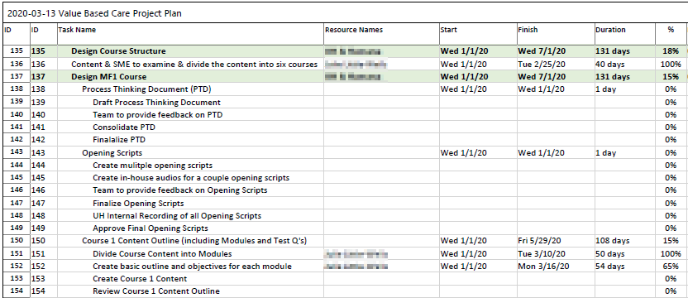

**Phase 1: Gather Current and Updated Materials.**The project lead from Humana identified, contacted, set up, and conducted meetings with the SMEs at the company and the university who were specialists on various topics in the curriculum. For example, in the Population Health course, one of the experts led the population health vision and strategy for Humana and another from UH was a board-certified internist, clinician educator, and health services researcher. The SMEs offered insights about the scope of the proposed content and aided the team by providing relevant materials that could be used to inform the program, such as reports, presentations, videos, and articles. These materials were cataloged in a resource spreadsheet, approved by the compliance and communication specialists where applicable, and shared with the core team. Figure 2 shows a screenshot of an excerpt from the resource spreadsheet.

Figure 2

Resource Spreadsheet Excerpt

**Phase 2: Design Course Structure**. The core and support teams brainstormed and discussed the content for each course in a “Process Thinking Document” (PTD). The PTDs were constructed to outline the anticipated steps, decisions, and considerations for each course. They identified the various activities that would be involved in completing each task or achieving each goal and became useful communication tools for this project, as they were used to track content provided by SMEs and to identify areas for further development and improvement. The PTDs were instrumental in curating content that would be accurate, relevant, and up-to-date. As part of the co-design approach, they facilitated team collaboration, ensured that goals were aligned among team members, and fostered continuous improvement during the project.

Each PTD was structured as a living design document that provided an overall course goal; specific objectives for each associated topic; a detailed outline of the content and how it related to varied learner contexts; questions for the SMEs about baseline knowledge, knowledge building, and problems/issues in context; ideas for learner deliverables and assessments; and a section for noting requests for internal and external content/resources and story creation ideas. PTDs were sent as Microsoft Word documents to SMEs with requests to return the documents with their responses and comments or to alternatively discuss their answers with the learning designer. Figure 3 illustrates how the PTD organized input from six SMEs (shown in blue).

Figure 3

SME Input Excerpt from Course 1 Process Thinking Document

Once constructed, each course PTD served as a reference point for the team throughout the project. The documents were also later reviewed by the associated topic SMEs, the compliance office, and communications specialists to ensure consensus and clarity before course media components were created. Figure 4 provides an excerpt from the first course PTD in which SME input was utilized for the instructional plan.

Figure 4

Excerpt of Course 1 Instructional Plan in Process Thinking Document

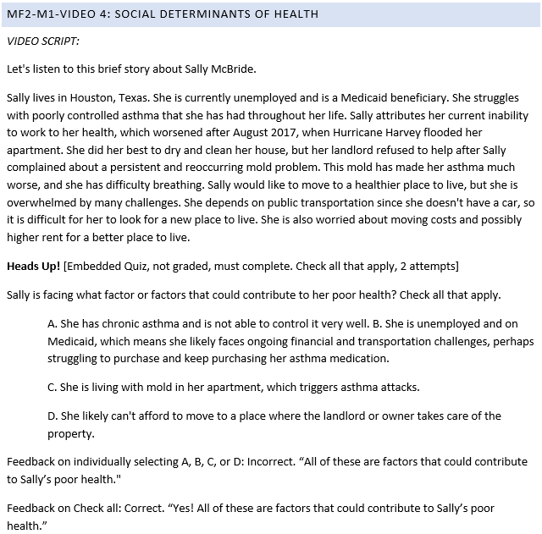

**Phase 3: Develop Media Materials.** Most of the content in each course was delivered through short videos of five to eight minutes each. The graphic designer and core team collaborated to create presentations in Microsoft PowerPoint that were based on the instructional plans in the PTDs. Shared cloud-based storage in Dropbox was utilized to manage the multiple media elements, materials drafts, and core team feedback. The voice-over narration was recorded by multiple diverse voices within and outside the design group, and the graphic designer paired the audio files with the presentation slides to produce the videos. Figure 5 shows a sample of a presentation slide accompanied by the voice-over script.

Figure 5

Sample Presentation Slide with Voice-Over Script in the Notes Section

**Phase 4: Deliver the Courses**. The course materials were uploaded onto the Coursera platform, and pilot testing was conducted to determine the effectiveness of each course and identify needed revisions before the full program launch. Approximately 20 learners who were similar to the target audience for the courses were asked to participate, including health professionals and students at UH, clinicians, nurses, and Humana employees. The learners worked through course content and provided feedback about accuracy and delivery. The core team reviewed the feedback and collaboratively revised the courses. The complete VBC specialization was then released to the broader Coursera learner base in December 2020. Figure 6 illustrates the collaborative design and development process from the inception of the project to the delivery of the courses.

Figure 6

Collaborative Design and Development Process of the VBC Project

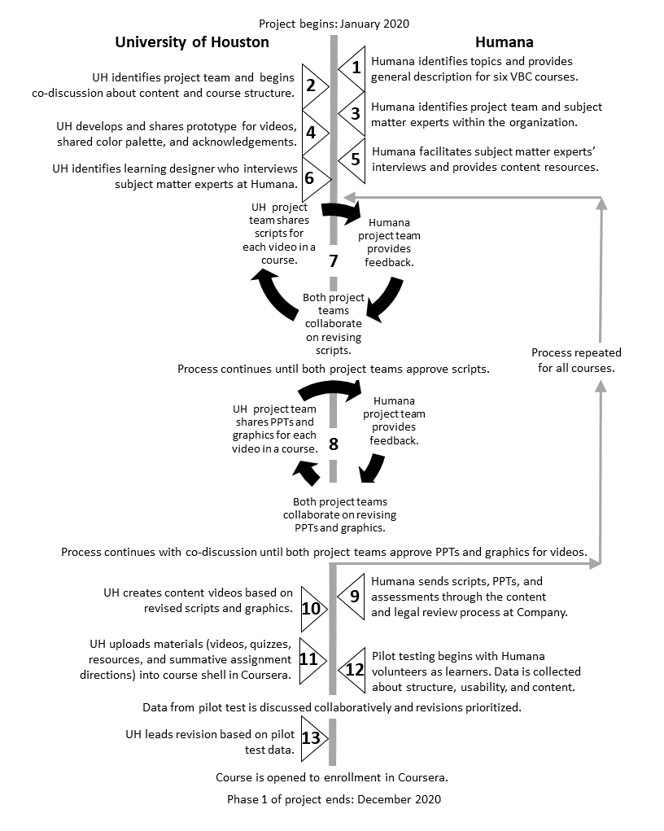

## Discussion of Lessons Learned

In reflecting on this project, there are key lessons learned that offer insights into the building and sustaining of strong, resilient, collaborative teams. As depicted in Figure 7, the lessons address three co-design aspects of creating stronger design systems for collaboration–team, environment, and process. The lessons within each aspect are described in the sections that follow.

Figure 7

Co-Design Aspects Insights from the VBC Co-Design Project

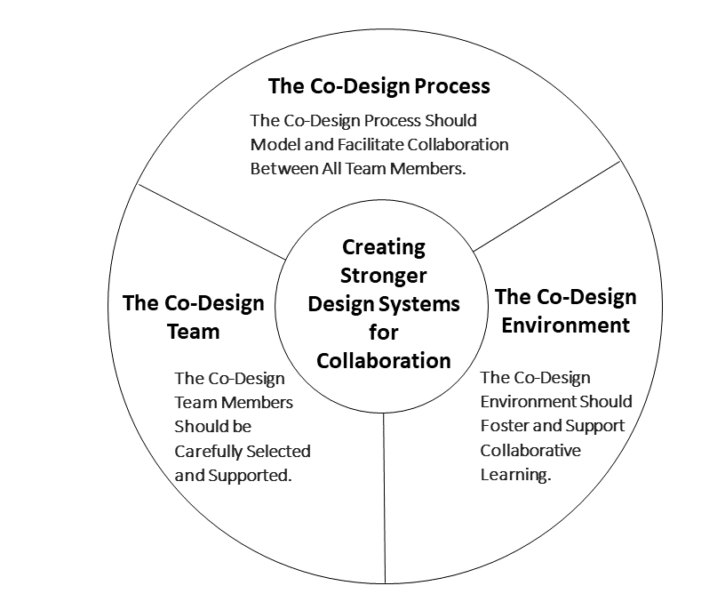

## Team: The Co-Design Team Members Should be Carefully Selected and Supported

For co-design teams to operate efficiently, effectively, and with a high degree of cohesion, team members should be selected purposefully. Successful co-design teams develop shared understandings of goals, roles, and contributions. They also utilize project management effectively while supporting team members' personal growth and learning. For the VBC project, some particular lessons emerged regarding how to identify and support team members.

### The Co-Design Team Members Should Contribute Diverse Experiences, Excellent Communication Skills, and a Positive Working Relationship

Since co-design projects can be challenging and time-consuming (Pallesen, 2020; Roschelle & Penuel, 2006), it is essential to have team members who are willing to put in the effort to ensure success. In the VBC project, one team member noted,

You need to have the right people around the table to do the project. You need people who are collaborative, who have an open mind, who are willing to think out-of-the-box, and who have a team mentality. To be successful, I think it's critical to have the right people on the team, so you can move the project forward.

Team members should demonstrate commitment to the project and be able to dedicate the necessary time to make it succeed.

When selecting team members for a co-design project, several factors must be considered. Selecting team members with diverse experiences can provide differing perspectives, skills, and levels of expertise (Penuel et al., 2011) that can deepen the collaboration (Muller-Schoof et al., 2023). Minichiello and Caldwell (2021) noted that the development of an interdisciplinary team is critical to a project’s success, “While interdisciplinary team members possess specific expertise and defined project roles, they also willingly contribute across shared technical objectives that span the boundaries of their area of expertise” (p. 48). Team members should demonstrate good communication skills, a positive attitude, and a willingness to contribute to the team's success. Facilitating and supporting collaborative communication about design ideas is essential to the success of a co-design project (Kolling et al., 2019, 2022; Nakanjako et al., 2021).

### The Co-Design Team Members Should Have a Shared Understanding of Goals, Roles, and Responsibilities

Having a shared understanding of project goals, roles, and responsibilities is crucial for the success of a co-design team. A shared understanding ensures that all team members work towards the same objectives to minimize confusion or miscommunication about the project's direction. It promotes a sense of trust and cooperation that can lead to increased productivity, creativity, and innovation as team members build on each other's ideas and expertise more cohesively.

When team members know what is expected of them and how they contribute to the broader project goals, many conflicts and confusion about who is responsible for what tasks can be avoided. Because individual commitment to projects can wane over time as competing priorities arise, it can be helpful to establish team members’ connections to the project at the beginning and then intentionally reestablishing connections periodically as the team navigates the design and development phases (Minichiello & Caldwell, 2021).

### The Co-Design Team Members Should Reflect on Their Personal Growth and Learning

Co-design can lead to an increase in team members’ growth in skills and knowledge as they engage in self-reflection and shared perspectives on teaching and learning (Kolling et al., 2022; Roschelle & Penuel, 2006). Hoadley and Campos (2022) noted, “More importantly, we see that on top of designs and findings as outcomes, there is the possibility of transforming systems, organizations, and, notably, transforming researchers and participants” (p. 215). Calvo and Sclater (2021), drawing on Freire’s (1970) social theories of learning, noted that co-design facilitates informal-mutual learning that “occurs in community engagement settings with non-hierarchical relationships…which nurture a collective power capable of actually solving the actual issues of communities…” (p. 235). As team members contribute their knowledge and skills to a co-design project, they can learn from one another. One team member reflected,

The most rewarding parts of this project were collaborating with passionate professionals and multiple specialists to leverage one another’s strengths to build a program that could help so many. As I think about my most memorable activities, it's learning from one another that I liked so much.

To support personal growth and learning, team members can be encouraged to take time to reflect on their experiences and provide feedback to one another. By fostering an environment of open communication, team members can learn to listen to and recognize varied perspectives that may lead to the identification of areas for their improvement. Ward et al. (2018) noted, “Co-design is a labour intensive process and involves real listening to the ‘different’ perspectives in the room and attempting to understand each person’s reality as different but complementary to others” (p. 10).

## Environment: The Co-Design Environment Should Foster and Support Collaborative Learning

Navigating through this instructional design project illuminated three environmental aspects that grounded the collaborative design process–support for consensus building, provision of psychological safety, and use of technology for collaboration. These elements contribute to an environment that fosters collaboration in a diverse group of participants with different backgrounds, experiences, and perspectives (Pallesen et al., 2020). Lessons learned relating to each of these aspects are described next.

### The Co-Design Environment Should Intentionally Support Consensus Building

Consensus building is an important part of the co-design process as it grounds shared understandings and agreements on project goals, objectives, and outcomes. In co-design, stakeholders are often from different backgrounds, perspectives, and areas of expertise, leading to divergent opinions and conflicting ideas. By engaging in consensus building, stakeholders can work together to identify areas of agreement and disagreement, and negotiate trade-offs. This process helps to encourage active participation, build trust, and promote buy-in from all parties involved, not just the most vocal or powerful ones. Ultimately, consensus building is crucial for the success of co-design projects because it helps to create a shared vision and commitment among stakeholders, which is essential for implementing and sustaining the project over time.

Strategies used in this project to encourage consensus building include practicing active listening, identifying common ground, being open to compromise, sharing thoughts and feelings openly and honestly, and being mindful of the need to maintain constructive dialogue (McLeskey et al., 2017; Vostal et al., 2021). Similarly, Muller-Schoof et al. (2023) observed in their design case, “A positive atmosphere, as well as personal qualities such as listening and paying attention to others, enabled collaboration and cohesion of the teams” (p. 15). These techniques can be further promoted through modeling by project leads during meetings and through team member recognition efforts.

### The Co-Design Environment Should Provide Psychological Safety

The co-design environment should provide techniques that value collaboration, openness, respect, and empowerment to promote psychological safety. Psychological safety is “the shared belief that it is safe to engage in interpersonal risk-taking in the workplace” (Hunt et al., 2021, para. 1). Psychological safety is vital to team learning and performance, as it facilitates willingness for team members to contribute towards shared goals. Psychological safety is crucial in co-design because it creates an inclusive environment where all participants feel comfortable sharing their thoughts, ideas, and perspectives without fear of judgment. One team member said,

I think you have to build trust and learn to lean on one another. Take time to get to know one another. We’re in this together. I think that's huge–just the relationship-building aspect. We got to laugh, and we cared about the work and about one another and making sure that this was a quality product that could really help a lot of people. So, that's what I enjoyed.

When participants feel safe to express themselves, more diverse and inclusive ideas and perspectives are welcomed, which can lead to more effective and innovative products. Team members must be encouraged to express their thoughts and ideas openly in a safe and supportive environment (Hunt et al., 2021; Jackson-Barrett et al., 2019). Project leads can create opportunities for feedback from the team and encourage communication skills (Harrison et al., 2022).

### The Co-Design Environment Should Leverage Technology to Facilitate Collaboration

Technology played a significant role in the VBC project co-design environment, as varied tools and platforms were leveraged to facilitate collaboration, communication, and information exchange among team members. With the rise of remote work and distributed teams, technology can be leveraged to overcome geographical barriers. In 2010, Sanders et al. suggested that the ability to use online tools and techniques for the entire co-design process was “a distant possibility” (p. 197). Such a possibility became reality in this project with online technologies supporting all stages of the co-design process, from ideating to prototyping to testing. Digital tools such as screen sharing, collaboration platforms, and design software enabled team members to work together in real-time, exchange feedback and ideas, and build prototypes (Mallakin et al., 2023). Moreover, technology supported the sharing, documentation, and archival of design artifacts, making it easier for team members to access and share information.

## Process: The Co-Design Process Should Model and Support Collaboration Among All Members

The co-design process can involve collaborative decision-making and content design. It is also supported through the use of strong facilitators who can guide teams through the process while modeling collective leadership. By demonstrating the value of collaboration, co-design team members can inspire others to collaborate more effectively.

### The Co-Design Process Should Support Collaborative Decision-Making

The co-design team navigated design decisions collectively during course development. For example, the team discussed how the content would be communicated to learners throughout the courses. Since the intended audience for the MOOCs was very broad, it was prioritized in this project that specialized terminology and jargon should be avoided as much as possible. One core team member shared,

We kept expanding the learners because just about anybody who's a consumer of healthcare could benefit from understanding the history of healthcare and why there are different systems. So, I think that that was significant to think about how broad our audience was.

Thus, course content needed to be written such that prior knowledge of VBC would not be required. Often the co-design team had to simplify technical information from SMEs and explain complex topics for learners who would likely have minimal prior VBC familiarity. The team created resources that defined terms to ensure that all learners would have access to the foundational vocabulary for each course. Additionally, a historical timeline of insurance was created to show the major events that have influenced current practices. Annotated lists of additional web links where learners could explore deeper on various topics were also developed.

### The Co-Design Process Should Support Collaborative Content Design

Team member levels of prior VBC knowledge varied greatly, with some having no prior knowledge and others with extensive experience managing VBC processes and payment models. The core team found that they needed to intentionally structure meetings and discussions for all stakeholders to be able to take part in the design process and provide feedback. The core team and learning designer also worked extensively with SMEs to collaboratively construct the content for the courses, utilizing the PTDs to support input from multiple people that would be used to inform content development.

### The Co-Design Process Should Be Guided by Leaders Who Can Provide Clear Direction and Establish Goals

In co-design, the leaders and project managers structure, organize, and guide the project, ensuring that it progresses smoothly and achieves its goals. In addition to overseeing and facilitating the design process, project managers can help to set and manage expectations for all stakeholders so that everyone understands what is expected of them and what they can expect from the project (Kolling et al., 2022; Mallakin et al., 2023). They ensure that all team members are on the same page, information is shared effectively, and the project stays on track and within budget. Project leaders can offer a broader vision, detect challenges, and find solutions when challenges arise. Ward et al. (2018) noted, “It takes a lot of time to prepare and facilitate sessions and requires facilitators to always have the bigger picture in mind” (p. 10). Project leaders should also model a collective leadership approach, enabling team members to fully contribute to the design as co-creators (Pallesen et al., 2020). In designing the VBC courses, this was accomplished by the continuous use of feedback throughout the process that allowed all team members to participate in content design and development.

## Reflections on the Co-Design Process and Partnership

In this design case, the co-design process was supported through intentional steps taken by team members from both organizations to establish a shared vision, work constructively to collaboratively navigate the design process, and engage stakeholders in all stages of the project from concept to creation. The industry-academic partnership leveraged the strengths of both organizations to support the creation of instructional content that was novel, authentic, robust, and applicable to a wide range of target learners in healthcare settings. Humana provided domain knowledge, resources, and varied examples in practice, and the UH team applied pedagogical strategies and instructional planning insights to cultivate the content into clear, modular, and engaging online, on-demand courses. Working together, the team was able to provide learners with knowledge about Value-Based Care as well as its implementation in healthcare workplaces, thus increasing its relevance and likelihood of adoption (Morris et al., 2022; Theobald et al., 2021). In reflecting upon the experience of this partnership, team members identified the relationships built during the co-design project to be integral to its success, as they not only made the project more enjoyable for those involved but also facilitated the communication and psychological safety needed to support the iterative cycles of feedback during course development. The forming of relationships is essential to establishing trust in the team, as Zelenko et al. (2021) explain:

… university–industry partnerships would benefit from framing as relationships, in which the development of trust might form the basis for achieving successful outcomes and impact. A relationship implies something deeper than merely collaboration; it suggests a meaningful connection between parties that might not be created immediately but rather fostered over a length of time. (p. 3)

The relationships are nurtured by three significant factors. First, a supportive co-design process facilitates and sustains equitable sharing of knowledge and other contributions from stakeholders through the project timeframe (Theobald et al., 2021). In our case, the project seemed to be much smaller when it was initially proposed, but it grew in scope as the team was fully formed and the project plan drafted. The co-design approach necessitated that representatives from both organizations be involved in the project conceptualization. Contrasted with a client-ID consultant-type relationship, the co-design partnership involves the integration of expertise from both sides of the partnership. By having the industry and academic team members at the table from the beginning, aspects such as clinical content, context, and teaching approaches could be discussed and negotiated, which Henderson and Creedy (2008, as cited in Theobald et al., 2021) contend contribute to high-quality learning experiences for students.

In the first two phases of development, the collaborative team processes, including the project plan spreadsheet, resource spreadsheet, and process thinking documents, enabled the growing team to onboard new members, stay up to date on project progress, and understand their individual roles and tasks. Conducting this project during the time of a pandemic and with a geographically distributed team presented some challenges; however, team members from both organizations had previous extensive experiences collaborating virtually, a factor that Sjöö and Hellström (2019) noted positively influences subsequent collaborations.

In reflecting on the co-design approach of this project, lessons for creating stronger design systems for collaboration centered on aspects of the team, the environment, and the process. First, team members’ selection and support are essential to project success. Second, it is important to recognize elements in the co-design environment, such as psychological safety and communication technologies, that help to sustain the collaborations among team members with such diverse backgrounds, experiences, and perspectives. Finally, the co-design process models and maintains collaboration among team members through shared decision-making, content design, and project management leadership. These lessons serve as starting points for organizations and practitioners interested in engaging in co-design.

Approaching an instructional design project with a co-design framework introduces inherent complexities associated with convening a diverse team to engage in shared decision-making and productive content development. However, the lessons from this design case about team, environment, and process offer insights into the skills, resources, and practices that are needed to support effective co-design experiences. Relationship-building within the team serves as the foundation upon which the collaborative processes can function. For the VBC project, these relationships were a key outcome of the co-design structure, providing continued engagement between the organizations for potential future industry-academic initiatives.

## References

Abrams, K., Korba, C., Shah, U., & Elsner, N. (2020, July 9). How the virtual health landscape is shifting in a rapidly changing world: Findings from the Deloitte 2020 Survey of US Physicians. Deloitte Insights. https://www2.deloitte.com/us/en/insights/industry/health-care/physician-survey.html

Adamski, M., Truby, H., Bennett, C., & Gibson, S. (2022). Exploring impacts of a nutrition-focused massive open online course. Nutrients, 14(18), Article 3680. <https://doi.org/10.3390/nu14183680>

Álvarez-Pérez, Y., Perestelo-Pérez, L., Rivero-Santanta, A.; Torres-Castaño, A., Toledo-Chávarri, A., Duarte-Díaz, A., Mahtani-Chugani, V., Marrero-Díaz, M.D., Montanari, A., Tangerini, S., et al. (2022). Co-creation of massive open online courses to improve digital health literacy in pregnant and lactating women. International Journal of Environmental Research and Public Health, 19, Article 913. <https://doi.org/10.3390/ijerph19020913>

Anderson, G., & Meiselbach, M. (2023). Why are some value-based programs successful? JAMA Network Open, 6(3), Article e234412. <https://doi.org/10.1001/jamanetworkopen.2023.4412>

Anderson, V., Gifford, J., & Wildman, J. (2020) An evaluation of social learning and learner outcomes in a massive open online course (MOOC): A healthcare sector case study. Human Resource Development International, 23(3), 208-237. <https://doi.org/10.1080/13678868.2020.1721982>

Agrawal, R., Gupta, A., & Fendrick, A. (2018). Value-based insurance design improves medication adherence without an increase in total health care spending. Health Affairs, 37(7), 1057-1064. <https://doi.org/10.1377/hlthaff.2017.1633>

Australian Healthcare and Hospitals Association. (2017). Experience-based co-design toolkit. Available at: <https://ahha.asn.au/experience-based-co-design-toolkit>.

Bird, M., McGillion, M., Chambers, E.M. et al. (2021). A generative co-design framework for healthcare innovation: Development and application of an end-user engagement framework. Research Involvement and Engagement, 7(12), 1-12. <https://doi.org/10.1186/s40900-021-00252-7>

Blackwell, W., Lowton, K., Robert, G., Grudzen, C., & Grocott, P. (2017). Using experience-based co-design with older patients, their families and staff to improve palliative care experiences in the emergency department: A reflective critique on the process and outcomes. International Journal of Nursing Studies, 68, 83–94. https://doi.org/10.1016/j.ijnurstu.2017.01.002

Bolster, E. A. M., van Gessel, C., Welten, M., Hermsen, S., van der Lugt, R., Kotte, E., van Essen, A., & Bloemen, M. A. T. (2021). Using a co-design approach to create tools to facilitate physical activity in children with physical disabilities. Frontiers in Rehabilitation Sciences, 2, Article 707612. <https://doi.org/10.3389/fresc.2021.707612>

Calvo, M., & Sclater, M. (2021). Creating spaces for collaboration in community co-design. International Journal of Art & Design Education (iJADE), 40(1), 232-250. <https://doi.org/10.1111/jade.12349>

Cavignaux-Bros, D. & Cristol, D. (2020). Participatory design and co-design—The case of a MOOC on public innovation. In M. Schmidt, A. A. Tawfik, I. Jahnke, & Y. Earnshaw (Eds.), Learner and user experience research: An introduction for the field of learning design & technology. EdTech Books. <https://edtechbooks.org/ux/participatory_and_co_design>

Centers for Medicare & Medicaid Services. (2023). Strategic direction. https://innovation.cms.gov/strategic-direction

Cinquin, P., Guitton, P., & Sauzéon, H. (2021). Designing accessible MOOCs to expand educational opportunities for persons with cognitive impairments. Behaviour & Information Technology, 40(11), 1101-1119. <https://doi.org/10.1080/0144929X.2020.1742381>

Coursera. (2023a). Coursera for campus. Retrieved from <https://www.coursera.org/campus>

Coursera. (2023b). Healthcare courses. Retrieved from <https://www.coursera.org/search?query=healthcare>

Eccleston, C., Doherty, K., Bindoff, A., Robinson, A., Vickers, J., McInerney, F., 2019. Building dementia knowledge globally through the understanding dementia massive open online course (MOOC). npj Science of Learning, 4, Article 3. <https://doi.org/10.1038/s41539-019-0042-4>

Eglseer, D. (2023). Development and evaluation of a Massive Open Online Course (MOOC) for healthcare professionals on malnutrition in older adults. Nurse Education Today, 123, Article 105741. <https://doi.org/10.1016/j.nedt.2023.105741>

El Ali, M., Leathwick, S., Jacob, A., & Jacob, E. (2023). In partnership: A just-in-time MOOC to support continuing professional development during a pandemic. Science Talks, 6, Article 100198. <https://doi.org/10.1016/j.sctalk.2023.100198>

Farmer, T. (2021). Using co-design to create K-12 online and hybrid learning resources. [Doctoral Dissertation, Purdue University]. <https://hammer.purdue.edu/articles/thesis/Utilizing_Codesign_to_Create_K-12_Online_and_Hybrid_Learning_Resources/17348540>

Freer, E. (2023, May). Learning through a value lens: Texas medical students learn Value-Based Care tenets. Texas Medicine. Texas Medical Association. https://www.texmed.org/Template.aspx?id=61907

Freire, P. (1970). Pedagogy of the oppressed. Continuum.

Gleason, K., Commodore-Mensah, Y., Wu, A., Kearns, R., Pronovost, P., Aboumatar, H., & Dennison Himmelfarb, C. (2021). Massive open online course (MOOC) learning builds capacity and improves competence for patient safety among global learners: A prospective cohort study. Nurse Education Today, 104, Article 104984.  <https://doi.org/10.1016/j.nedt.2021.104984>

Gómez Gómez, F., & Munuera Gómez, P. (2021). Use of MOOCs in health care training: A dDescriptive-exploratory case study in the setting of the COVID-19 pandemic. Sustainability, 13(19), Article 10657. <https://doi.org/10.3390/su131910657>

Harrison, R., Chin, M., & Ni She, E. (2022) What does co-design mean for Australia’s diverse clinical workforce? Australian Health Review, 46(1), 60-61. <https://doi.org/10.1071/AH21116>

Henderson, A., & Creedy, D. (2008). Leading engagement of academic and clinical communities for learning. Australian Learning and Teaching Council.

Hoadley, C., & Campos, F. (2022) Design-based research: What it is and why it matters to studying online learning. Educational Psychologist, 57(3), 207-220. <https://doi.org/10.1080/00461520.2022.2079128>

Howard, C. (2011). Writing and rewriting the instructional design case: A view from two sides. International Journal of Designs for Learning, 2(1), 40-55.

Hunt, D.F., Bailey, J., Lennox, B.R., Crofts, M., & Vincent, C. (2021). Enhancing psychological safety in mental health services. International Journal of Mental Health Systems, 15, Article 33. <https://doi.org/10.1186/s13033-021-00439-1>

Iniesto, F., Charitonos, K. & Littlejohn, A. (2022). A review of research with co-design methods in health education. Open Education Studies, 4(1), 273-295. <https://doi.org/10.1515/edu-2022-0017>

Jackson-Barrett, E. M., Gower, G., Price, A. E., & Herrington, J. (2019). Skilling up: Providing educational opportunities for Aboriginal education workers through technology-based pedagogy. Australian Journal of Teacher Education, 44(1), Article 4. Retrieved from <https://ro.ecu.edu.au/ajte/vol44/iss1/4>

Kennedy, E., & Laurillard, D. (2019). The potential of MOOCs for large-scale teacher professional development in contexts of mass displacement. London Review of Education, 17(2), 141–158.  <https://doi.org/10.18546/LRE.17.2.04>

Kennedy, E., Moghli, M. A., Chase, E., Pherali, T., & Laurillard, D. (2019). A co-design methodology for blended teacher professional development in contexts of mass displacement. NORRAG SPECIAL ISSUE 02: Data collection and evidence building to support education in emergencies, 2019. Retrieved from <https://discovery.ucl.ac.uk/id/eprint/10074742>

Kolling, A., Weinberger, A., Batangan, D., Saad, A., & Wan, TC. (2019). Using co-design to create MOOCs for Southeast Asian audiences. [paper presentation]. ASEM Education in a Digital World: Bridging the Continents - Connecting the People Conference, Cologne, Germany. <https://doi.org/10.22028/D291-37033>

Kolling, A., Weinberger, A., & Niegemann, H. (2022). Co-designing MOOCs with CoDe-Graph. Journal of Formative Design in Learning, 6, 25-39. https://doi.org/10.1007/s41686-022-00064-2

Maciver, D., Hunter, C., Johnston, L., Forsyth, K. (2021). Using stakeholder involvement, expert knowledge and naturalistic implementation to co-design a complex intervention to support children’s inclusion and participation in schools: The CIRCLE framework. Children, 8(3), Article 217. <https://doi.org/10.3390/children8030217>

Mallakin, M., Dery, C., Vaillancourt, S., Gupta, S., & Sellen, K. (2023). Web-Based co-design in health care: Considerations for renewed participation. Interactive Journal of Medical Research, 12, Article e36765. <https://doi.org/10.2196/36765>

Masterson, D., Areskoug Josefsson, K., Robert, G., Nylander, E., & Kjellström, S. (2022). Mapping definitions of co-production and co-design in health and social care: A systematic scoping review providing lessons for the future. Health Expectations: An International Journal of Public Participation in Health Care and Health Policy, 25(3), 902–913. <https://doi.org/10.1111/hex.13470>

Maxwell, W., Fabel, P., Diaz, V., Walkow, J., Kwiek, N., Kanchanaraksa, S., Wamsley, M., Chen, A., & Bookstaver, P. (2018). Massive open online courses in U.S. healthcare education: Practical considerations and lessons learned from implementation. Currents in Pharmacy Teaching and Learning, 10(6), 736-743. <https://doi.org/10.1016/j.cptl.2018.03.013>

McGregor, D., Rohne, I., Solman, A., Shaw, T., Yeung,W., Jones, A., Herring,A., Sukovic, S., Culver,A., Shrapnel, J., &Linehan, T. (2018). Curriculum resource co-design and development for a digital health workforce and digital health ready graduates. Health Education in Practice: Journal of Research for Professional Learning, 1(2), 7-14. https://openjournals.library.sydney.edu.au/index.php/HEP/article/view/13054

McLeskey, J., Barringer, M.-D., Billingsley, B., Brownell, M., Jackson, D., Kennedy, M., et al. (2017). High-leverage practices in special education. Council for Exceptional Children & CEEDAR. Retrieved from <https://ceedar.education.ufl.edu/hlps/>

Minichiello, A., & Caldwell, L. (2021). A narrative review of design-based research in engineering education: Opportunities and challenges. Studies in Engineering Education, 1(2), 31–54. https://doi.org/10.21061/see.15

Morris, I., O’Sullivan, K., Fitzgerald, N.P., Walsh, J., Boyle, F., O’Connell, E., & Corkery, G. (2022).  Co-design and co-development of an overarching work placement framework with industry. INTED 2022 Proceedings, 1046-1053. <https://doi.gov/10.21125/inted.2022.0326>

Muller-Schoof, I. J. M., Verbiest, M. E. A., Snoeren, M., & Luijkx, K. G. (2023). Lessons learned from co-designing educational programs for student and practicing healthcare professionals in nursing homes: A participatory qualitative study. Journal of Participatory Research Methods, 4(1), 1-24. <https://doi.org/10.35844/001c.57529>

Nakanjako, D., Kendall, D., Sewankambo, N. K., Razak, M. H., Oduor, B., Odero, T., Garcia, P., & Farquhar, C. (2021). Building and sustaining effective partnerships for training the next generation of global health leaders. Annals of Global Health, 87(1), Article 66. <https://doi.org/10.5334/aogh.3214>

New England Journal of Medicine (NEJM). (2017). What is Value-Based Care? NEJM Catalyst. <https://catalyst.nejm.org/doi/full/10.1056/CAT.17.0558>

Nieder, J., Schwerdtle, P., Sauerborn, R., & Barteit, S. (2022). Massive Open Online Courses for health worker education in low- and middle-income countries: A scoping review. Frontiers in Public Health, 10, Article 891987. <https://doi.org/10.3389/fpubh.2022.891987>

Noël, F. (2022). Accelerating the pace of value-based transformation for more resilient and sustainable healthcare. Future Healthcare Journal, 9(3), 226-229. <https://doi.org/10.7861/fhj.2022-0118>

O’Brien, J., Fossey, E., & Palmer, V. J. (2021). A scoping review of the use of co‐design methods with culturally and linguistically diverse communities to improve or adapt mental health services. Health & Social Care in the Community, 29(1), 1-17. https://doi.org/10.1111/hsc.13105

Ohag, M., Nawawi, A. H., Muhammad, F., & Hashim, N. (2023). Critical coordination factors affecting design and build projects: A comprehensive review of the literature. International Journal of Environment, Architecture, and Societies, 3(1), 59-71. <https://doi.org/10.26418/ijeas.2023.3.01.59-71>

Pallesen, K., Rogers, L., Anjara, S., De Brún, A., & McAuliffe, E. (2020). A qualitative evaluation of participants' experiences of using co-design to develop a collective leadership educational intervention for health-care teams. Health Expectations, 23(2), 358-367. <https://doi.org/10.1111/hex.13002>

Palomo-Carrión, R., De Araújo Ferreira Jesus, C. C., Santana, C. A. S., Lindquist, R., Alencar, R., Romay-Barrero, H., Contell-Gonzalo, E., Monteiro, K. S., Pinero-Pinto, E., & Longo, E. (2022). Co-design of an intervention to increase the participation in leisure activities including adolescents with cerebral palsy with GMFCS Levels IV and V: A study protocol. Journal of Clinical Medicine, 12(1), Article 182. <https://doi.org/10.3390/jcm12010182>

Penuel, W. R., Roschelle, J., & Shechtman, N. (2007). Designing formative assessment software with teachers: An analysis of the co-design process. Technology Enhanced Learning, 2(1), 51–74. <https://doi.org/10.1142/S1793206807000300>

Penuel, W., Fishman, B., Haugan Cheng, B., & Sabelli, N. (2011) Organizing research and development at the intersection of learning, implementation, and design. Educational Researcher, 40(7), 331–337. <https://doi.org/10.3102/0013189X11421826>

Perestelo-Perez, L., Torres-Castaño, A., González-González, C., Alvarez-Perez, Y., Toledo-Chavarri, A., Wagner, A., Perello, M., Van Der Broucke, S., Díaz-Meneses, G., Piccini, B., Rivero-Santana, A., Serrano-Aguilar, P., & on behalf of the IC Project Consortium. IC-Health Project: Development of MOOCs to promote digital health literacy: First results and future challenges. Sustainability, 12(16), Article 6642. <https://doi.org/10.3390/su12166642>

Redman, S., Greenhalgh, T., Adedokun, L., Staniszewska, S., & Denegri, S. (2021). Co-production of knowledge: The future. BMJ,372(434), 1-2. <https://doi.org/10.1136/bmj.n434>

Robert, G., Cornwell, J., Locock, L., Purushotham, A., Sturmey, G., & Gager, M. (2015). Patients and staff as codesigners of healthcare services. BMJ, 350, Article 7714. <https://doi.org/10.1136/bmj.g7714>

Roschelle, J., & Penuel, W. R., (2006). Co-design of innovations with teachers: Definition and dynamics. Proceedings of the 7th International Conference on Learning Sciences, 606–612.

Rutherford, B., Brockman, M., Hunt, S., Helton, J., & Schmidt, R. N. (2022). Transitions from a fee-for-service (FFS) payment model: Evolutionary triple to quadruple aim transformation, value-based care and decreased provider burnout. Journal of Business and Educational Leadership, 12(1), 97-109.

Sanders, E., & Stappers, P. J. (2008). Co-creation and the new landscapes of design. Codesign, 4(1), 5–18. <https://doi.org/10.1080/15710880701875068>

Sanders, E., & Stappers, P. J. (2012). Convivial toolbox: Generative research for the front end of design. Bis Publishers.

Sanders, E., Brandt, E., & Binder, T. (2010). A framework for organizing the tools and techniques of participatory design. In Proceedings of the 11th Biennial Participatory Design Conference. Presented at PDC '10: The 11th Biennial Participatory Design Conference; Nov 29 - Dec 3, 2010; Sydney, Australia. <https://doi.org/10.1145/1900441.1900476>

Shah, D. (2020). Capturing the hype: Year of the MOOC timeline explained. Class Central. <https://www.classcentral.com/report/mooc-hype-year-1/>

Shah, D. (2021). A decade of MOOCs: A review of MOOC stats and trends in 2021. Class Central. <https://www.classcentral.com/report/moocs-stats-and-trends-2021/>

Shah, D. (2023). 2022 Year in Review: The “New Normal” that Wasn’t. Class Central. <https://www.classcentral.com/report/2022-year-in-review/>

Shrank, W., & Powers, B. (2022). Payers and providers seek value-based care, but progress is slow. NEJM Catalyst Innovations in Care Delivery, 3(5). <https://doi.org/10.1056/CAT.22.0122>

Sjöö, K., Hellström, T. (2019). University-industry collaboration: A literature review and synthesis. Industry & Higher Education, 33(4), 275-285. <http://dx.doi.org/10.1177/0950422219829697>

Slattery, P., Saeri, A. K., & Bragge, P. (2020). Research co-design in health: A rapid overview of reviews. Health Research Policy and Systems, 18(1), 1-13. https://doi.org/10.1186/s12961-020-0528-9

Steen, M., Manschot. M., & De Koning, N. (2011). Benefits of co-design in service design projects. International Journal of Design, 5(2), 53-60. https://www.ijdesign.org/index.php/IJDesign/article/view/890

Teisberg, E., Wallace, S., & O'Hara, S. (2020). Defining and implementing value-based health care: A strategic framework. Academic Medicine: Journal of the Association of American Medical Colleges, 95(5), 682–685. <https://doi.org/10.1097/ACM.0000000000003122>

Torrents, C., Balagué, N., Hristovski, R., Almarcha, M., & Kelso, J. (2021). Metastable coordination dynamics of collaborative creativity in educational settings. Sustainability, 13(5), Article 2696. <https://doi.org/10.3390/su13052696>

Vostal, B., Mrachko, A., Vostal. M., & McCoy, A. (2021). Effects of group behavioral skills training on teacher candidates’ acquisition and maintenance of active listening. Journal of Behavioral Education, 31, 679-698. <https://doi.org/10.1007/s10864-021-09431-8>

Walsh, A., Harrington, D., & Hines, P. (2020). Are hospital managers ready for value-based healthcare? A review of the management competence literature. International Journal of Organizational Analysis, 28(1), 49-65. <https://doi.org/10.1108/IJOA-01-2019-1639>

Ward, M. E., De Brún, A., Beirne, D., Conway, C., Cunningham, U., English, A., Fitzsimons, J., Furlong, E., Kane, Y., Kelly, A., McDonnell, S., McGinley, S., Monaghan, B., Myler, A., Nolan, E., O'Donovan, R., O'Shea, M., Shuhaiber, A., & McAuliffe, E. (2018). Using co-design to develop a collective leadership intervention for healthcare teams to improve safety culture. International Journal of Environmental Research and Public Health, 15(6), Article 1182. <https://doi.org/10.3390/ijerph15061182>

Zelenko, O., Gomez, R., & Kelly, N. (2021). Research co-design: Meaningful collaboration in research. In A. Blackler & E. Miller (Eds.), How to be a design academic: From learning to leading (pp. 227-243). CRC Press.

Zhang, H., & Cowling, D. (2023). Association of participation in a value-based insurance design program with health care spending and utilization. JAMA Network Open, 6(3), Article e232666. <https://doi.org/10.1001/jamanetworkopen.2023.2666>

Read this online at <https://edtechbooks.org/jaid_13_1/creating_stronger_design_systems_for_collaboration_skills_resources_and_practices_needed_to_support_an_effective_codesign_experience>