# Studio Structures and Habits of Mind

The article explores how studio structures and cognitive habits impact student learning in the arts, highlighting the importance of cultivating specific mindsets within studio settings to enhance educational outcomes.

## Lessons From an Art Studio

A research team in Boston, led by Lois Hetland, conducted research in successful visual arts classrooms to study the habits of mind that students develop in these classrooms and the structures of the studio setting that nurture a student's ability to think like an artist. They reported their findings in the book .

From their data, researchers identified eight habits of mind that students develop in a studio art setting and four strategies that art educators used to foster these habits of mind.

## Four Studio Structures for Learning

The four structures are different elements of the studio learning experience that support student learning in distinct ways. They are demonstration/lecture, students-at-work, critique, and exhibition. We have adapted critique to include reflection and have added performance to the culminating structure of the exhibition to apply the structures across multiple curricular areas.

The first three structures are used interchangeably. They can occur in a sequence, or in any order. The majority of time should be spent with students at work creating art. Needed background knowledge and skills are taught directly through short sessions of lecture/demonstration. Ongoing interspersed reflection and critique, while developing at work, bring relevant conversation to improve judgment and increase skills. The fourth structure is a culminating event used as a summative assessment for the work done in class.

You can find detailed descriptions and examples of these four structures in the following chapters.

* Lecture/Demonstration
* Students-at-Work
* Critique & Reflection
* Performance & Exhibition

While Lois Hetland and her colleagues' formulation of the four studio structures grew from their experience and observational research in visual arts classrooms, we believe that the four structures provide a holistic and powerful model of the way arts education could function across all art forms: dance, drama, media arts, and music, as well as visual arts. Using the language of the sciences, Hetland's conceptions reveal the potential of an emergent paradigm for arts education in both arts-based curricula and cross-disciplinary integrative curricula. Hetland's structures and habits of mind advance a simple but elegant explanation for the how and why of arts in education while providing a template for artful teaching in non-arts classrooms as well.

## Studio Habits of Mind

Over the last thirty years, research efforts around habits of mind have reached a global scale. Australian researchers Art Costa and Bena Kallick have created a Habits of Mind infographic that synthesizes sixteen behaviors. When applied, these behaviors "can increase an individual's ability to achieve successful outcomes in any number of situations" (Whatboots.com.au/are-habits-of-mind.html.)

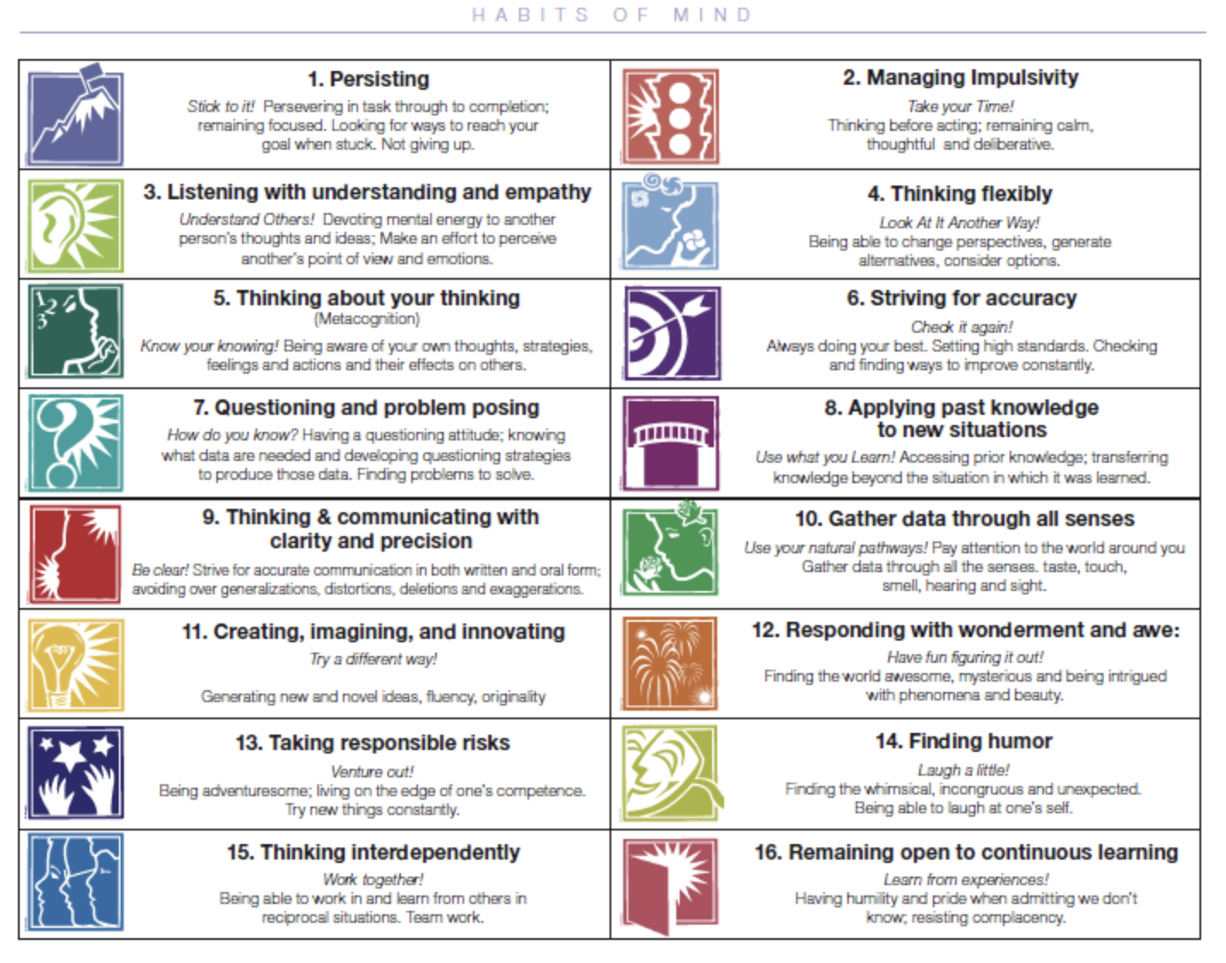

In like manner,  include: Develop Craft, Engage & Persist, Envision, Express, Observe, Reflect, Stretch & Explore, Understand Art Worlds. This list describes “the thinking that teachers intend for their students to learn during the process of creating” in their studio art class (Harvard Graduate School of Education).

“The Habits of Mind … are non-hierarchical, so none logically comes ﬁrst or last. The habits do not operate and should not be taught in a set sequence that privileges one or another over the others. Instead, one can begin with any habit and follow its generative energy through dynamic, interacting habit clusters that animate studio experiences as they unfold” (Hetland et al., 2013).

The following are definitions and descriptions of the Studio Habits of Mind from :

### Envision

Learning to picture mentally what cannot be directly observed and imagine possible next steps in making a piece

### Engage and Persist

Learning to embrace problems of relevance within the art world and/or of personal importance, to develop focus and other mental states conducive to working and persevering at art tasks

### Express

Learning to create works that convey an idea, a feeling, or a personal meaning

### Observe

Learning to attend to visual contexts more closely than ordinary “looking” requires, and thereby to see things that otherwise might not be seen

### Reflect

Question and Explain: Learning to think and talk with others about an aspect of one’s work or working process

Evaluate: Learning to judge one’s own work and working process, and the work of others in relation to standards of the ﬁeld

### Stretch and Explore

Learning to reach beyond one’s capacities, to explore playfully without a preconceived plan, and to embrace the opportunity to learn from mistakes and accidents

### Understand Art Worlds

Domain: Learning about art history and current practice

Communities: Learning to interact as an artist with other artists (i.e., in classrooms, in local arts organizations, and across the art ﬁeld) and within the broader society

### Develop Craft

Technique: Learning to use tools (e.g., viewﬁnders, brushes), materials (e.g., charcoal, paint), learning artistic conventions (e.g., perspective, color mixing)

Studio Practice: Learning to care for tools, materials, and space

### 

Listen to students describe what artists do by explaining the 8 Studio Habits of Mind.

## Read More About Studio Learning and the Benefits of Arts Education

You can read more about studio habits of mind and studio structures in the 3rd edition of the book Studio Thinking 3: The Real Benefits of Visual Arts Education by , , , and (June 3, 2022).

A version of the book was adapted for elementary and middle school educators titled Studio Thinking from the Start: The K-8 Art Educator's Handbook (2018).

Downloadable resources can be found at .

**References**

Harvard Graduate School of Education. Eight Habits of Mind. Project Zero. https://pz.harvard.edu/resources/eight-habits-of-mind

Hetland, L., Winner, E., Veenema, S., & Sheridan, K. (2013). Studio thinking 2: The real benefits of visual arts education (2nd Edition). Teachers College Press.

Read this online at <https://edtechbooks.org/advancingartsleadership/studio_structures_and_habits_of_mind>