Leveraging AI to Support Access, Equality and Inclusion
,

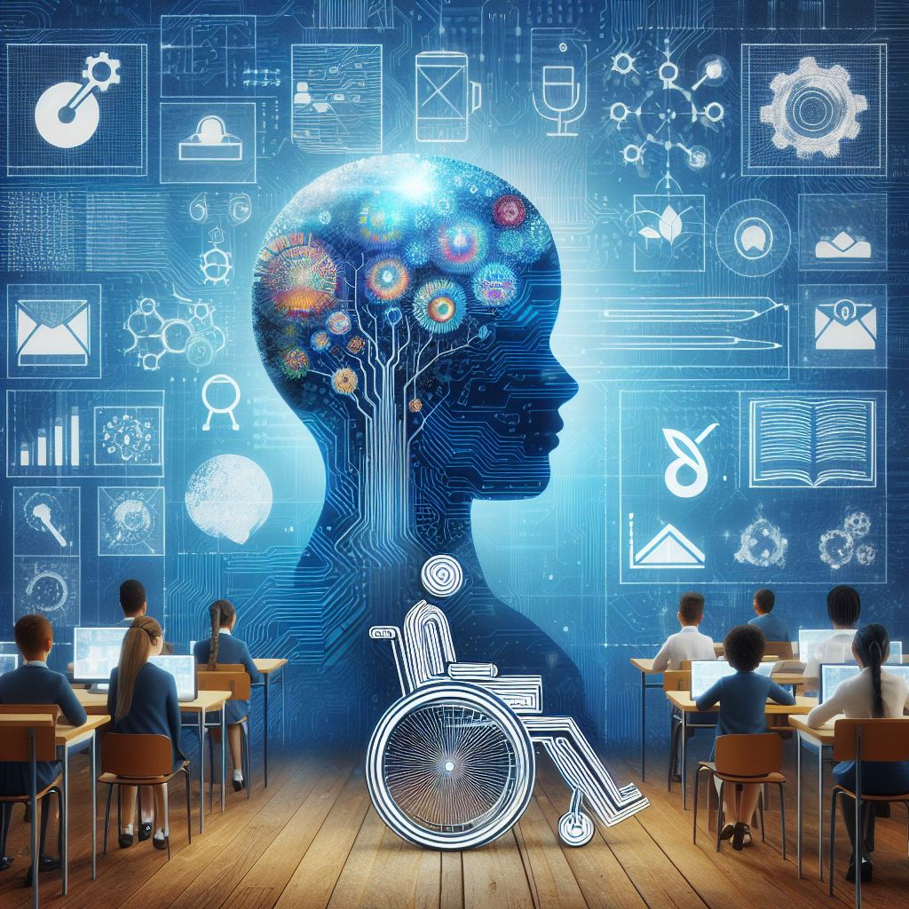

Learning Objectives
I. Leveraging AI for Inclusive Education in Economically Disadvantaged Regions
- Understand how AI can break barriers to education in economically disadvantaged regions.
- Evaluate the role of AI in improving access to quality education in developing countries.
II. Advancing Gender Equality through AI in Education
- Identify existing gender disparities in educational opportunities.
- Explore how AI tools can promote personalized learning, mitigate gender biases, and foster gender equality in education.
III. Enhancing Inclusion for Learners with Disabilities through AI
- Recognize the challenges faced by individuals with physical, sensory, and cognitive disabilities in education.
- Evaluate the impact of AI in addressing disability-related challenges and promoting inclusive learning environments.
- Explore ethical considerations in the deployment of AI for educational purposes.
The chapter explores the transformative impact of artificial intelligence (AI) on education, specifically focusing on three critical dimensions: advancing education in economically disadvantaged regions, promoting gender equality, and fostering inclusion for learners with disabilities. By leveraging AI technologies, this exploration delves into innovative approaches that have the potential to reshape educational landscapes, dismantle barriers, and enhance learning opportunities for all.
Introduction
In our journey over the past year, both as authors and advocates of inclusive education, we have actively embraced Artificial Intelligence (AI) as a transformative force. Hailing from Afghanistan, our collective experiences have fueled a commitment to dismantling barriers in education, beginning with economic inclusivity. Recognizing the profound impact of socio-economic backgrounds on educational opportunities, particularly for those with limited resources, we embarked on an exploration of how AI can surmount these barriers. This initial lens in our chapter explores the ways in which AI tools can bridge gaps in access to quality education, addressing challenges ranging from poverty-related constraints to the scarcity of affordable learning materials.
Moving forward, our narrative unfolds to shed light on the pivotal role AI plays in advancing women's education. Drawing inspiration from the challenges faced by women in Afghanistan, we share our journey of using AI as a catalyst for change. Through initiatives aimed at providing education for women in our homeland, we have not only taught and mentored but also employed AI on online educational platforms. This section of our chapter delves into the intersection of technology and gender equality, showcasing how AI can empower women by tailoring educational support to their unique needs and preferences.
Transitioning seamlessly, our intellectual journey guides us into the critical realm of inclusive education for individuals with disabilities. Recognizing that the topic of inclusive education remains incomplete without addressing the provision of educational services for students with special needs, our exploration takes on added significance. Aligned with the Sustainable Development Goals (SDG), countries are progressively leaning towards developing policies aimed at advancing education for individuals with disabilities. In the course of our MA in education program, we seized the opportunity to meticulously analyze some of these policies, focusing on the intricacies of inclusive education for students with special needs.
Despite substantial investments in both monetary and human capital, the desired impact on inclusive education for students with disabilities has proven elusive for many countries. This reality accentuates the critical need for the adoption of alternative strategies and innovative solutions that can significantly enhance the chances of success in this challenging endeavor.
Our quest for solutions extends beyond traditional approaches as we explore the transformative potential of AI in elevating education for students with diverse needs and backgrounds. This pursuit is rooted in our experiences within the course named “Strong School” in which we learned the integration of AI-powered technologies into education. Motivated by the potential of AI tools, we have embarked on an exploration into their viability as a means of providing essential support for inclusive education, particularly catering to the unique requirements of those with special needs.
Originating from the heart of Afghanistan, our experiences have been a guiding light, propelling us to address barriers, whether rooted in economic disparities, gender inequalities, or the complexities of inclusive education for individuals with disabilities. We recognize that the intersection of technology and education is a powerful catalyst for change, and our exploration into the potential of AI tools is an ongoing endeavor. This chapter, a testament to our year-long odyssey, serves as a call to action—a call to embrace innovation, challenge conventions, and usher in a future where education knows no bounds, offering equitable opportunities for every learner, regardless of their background or unique needs.
The chapter unfolds in three main parts, each addressing a crucial dimension of leveraging AI in education. The initial segment explores the application of AI in economically disadvantaged regions, emphasizing how technology can overcome barriers to access and elevate the quality of education. The second part scrutinizes gender disparities in education, unveiling how AI can contribute to gender-inclusive strategies, personalized learning, and unbiased educational content and assessments. The third part focuses on learners with disabilities, detailing the challenges they face and showcasing how AI-driven solutions can revolutionize their educational experiences.
What is inclusive Education?
Educational inclusivity ensures equal access to opportunities for all students, regardless of socio-economic background, gender, or disability. It aims to create an environment where every learner feels valued and supported. This includes promoting equity, eliminating biases, and providing tailored support services to address the unique needs of students from diverse backgrounds, fostering an inclusive educational system.

Breaking Barriers in Economically Disadvantaged Regions
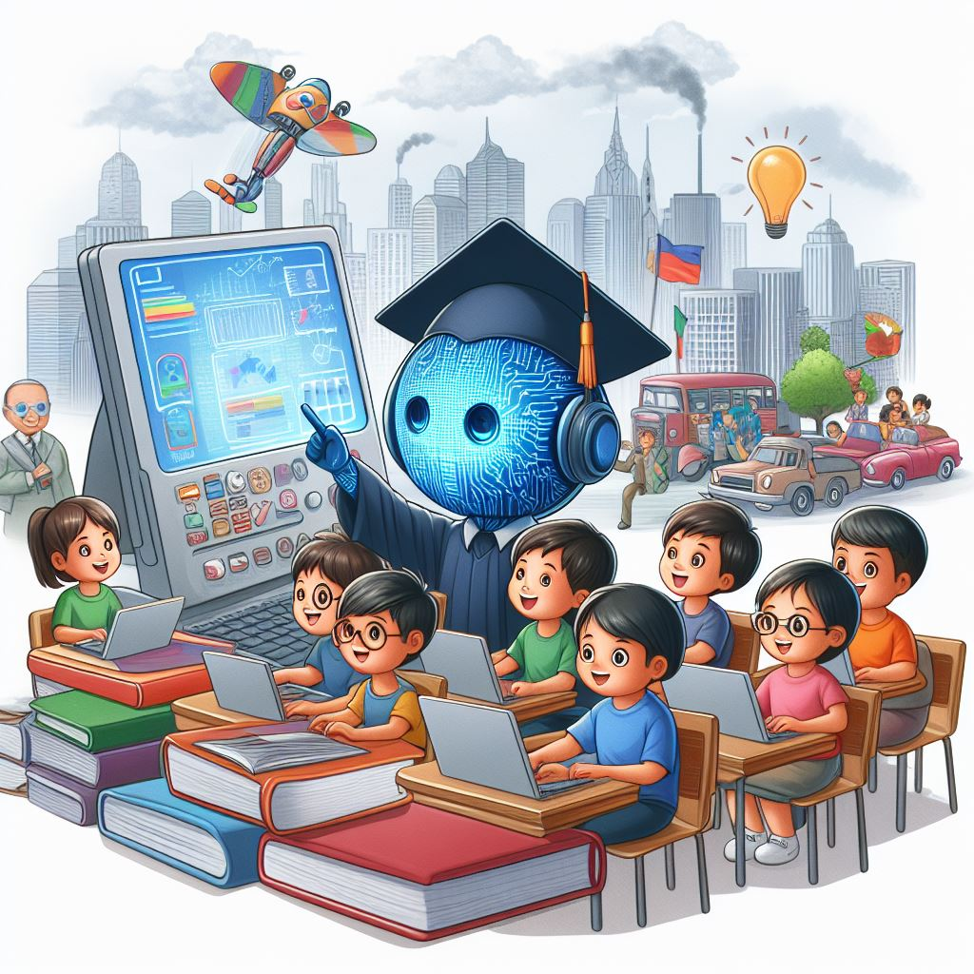

Despite notable advancements in the realm of education, the persistent challenge of achieving inclusive education for students from economically disadvantaged communities remains a matter of grave concern both at the national and international levels. The latest statistical data underscores a sobering reality: a significant majority of these economically disadvantaged students are situated in developing countries (World Bank, 2022), where they confront a myriad of obstacles. These challenges encompass not only limited access to education but also issues such as substandard educational quality and unavailability of essential learning materials (World Bank, 2022).
In the first section of this chapter, we will thoroughly explore the most significant of these hurdles, scrutinizing the most promising strategies through which AI can actively contribute to mitigating these issues. The overarching goal is to augment the accessibility, quality, and affordability of education for students in economically disadvantaged communities.

What does the term “Economically Disadvantaged” mean?

The terms “Economically disadvantaged” or "developing countries" are used to define countries that are characterized by lower-income levels, less industrialization, lower Human Development Index (HDI) scores, and lower standards of living compared to more economically advanced nations (World Bank, 2022). These countries often face challenges in areas such as health care services, inclusive and quality education, environmental disaster, and limited infrastructure (World Bank, 2022).
While there is not a universally agreed upon definition, these terms are often used interchangeably to describe countries with economies that are in the process of industrialization and have lower GDP per capita. The United Nations, World Bank, and International Monetary Fund are among the organizations that provide technical, research, and financial support for these countries (Steinbach, 2019). Also, these organizations are responsible for providing classification and criteria for identifying economically developing countries. For instance, the World Bank categorizes based on into income groups based on Gross National Income (GNI) per capita. The "low-income" and "lower-middle-income" groups often encompass nations considered economically disadvantaged or developing (Steinbach, 2019).
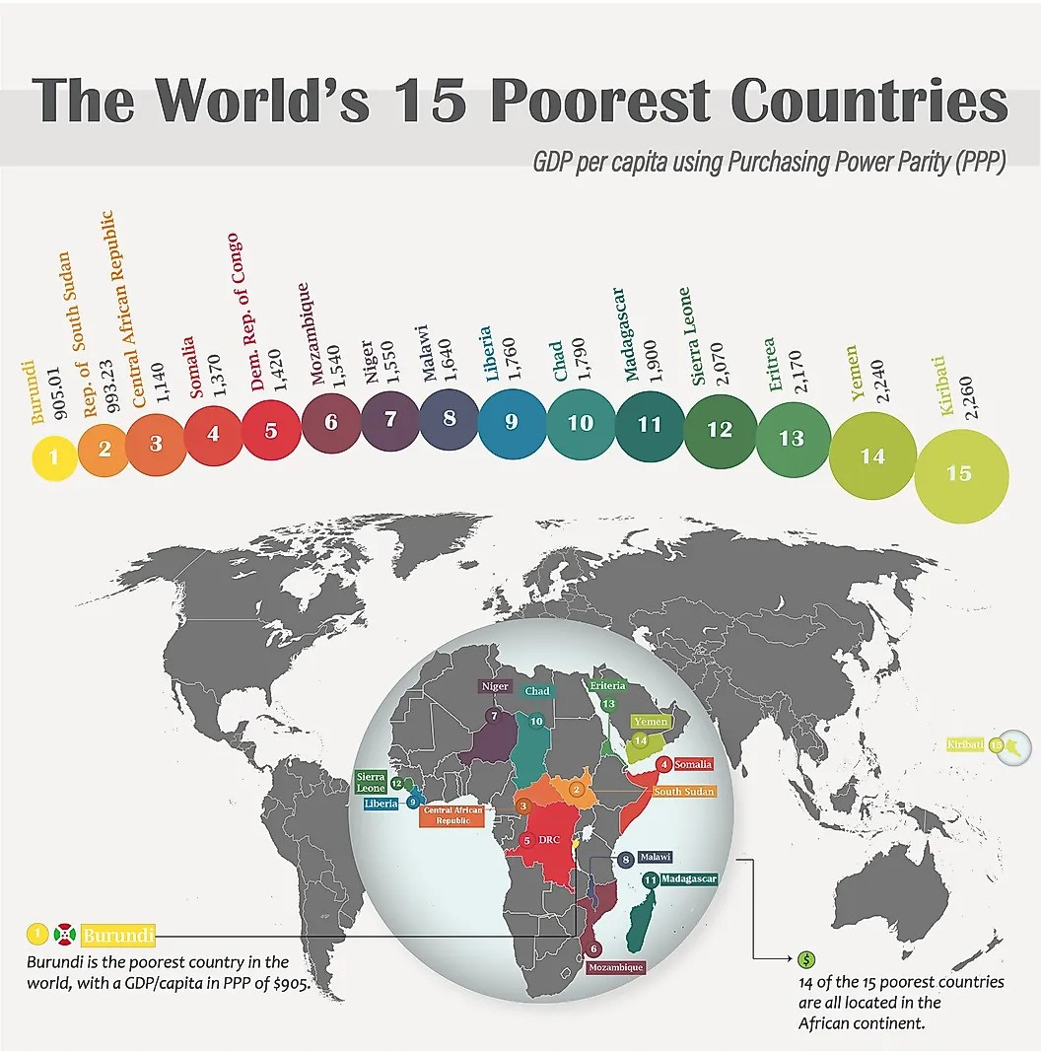
Nevertheless, 13% of kids in developing nations do not complete their elementary education, and more than 33% do not enroll in secondary education. The overwhelming body of research demonstrating that pupils in underdeveloped nations learn significantly less than those in wealthy nations is even more concerning (Damon et al., 2016). 58.1% of fifteen-year-old students in the United States received a literacy score of Level 3 or higher in a 2009 worldwide comparison; Level 3 is equivalent to "capable of reading tasks of moderate complexity” (Damon et al., 2016). In contrast, the percentages of fifteen-year-old students demonstrating proficiency in mathematics Level 3, which involves the ability to "execute clearly described procedures, including those that require sequential decisions," varied significantly between developed and developing countries (Damon et al., 2016). For the United States, the proficiency rate was 52.2%. However, in many developing countries, the corresponding figures were considerably lower: 23.3% for Brazil, 12.2% for Indonesia, 20.1% for Jordan, and 13.1% for Peru. This highlights a substantial gap in mathematical proficiency levels between developed and developing nations (Damon et al., 2016). Given that these problem exists despite millions of dollars’ investment, makes the international community think about other non-monetary solutions in solving some of the significant challenges in education that will be discussed below.

Access to Education
Access to education in developing countries is a persistent challenge. According to UNESCO data from 2019, 8% of the world's 787 million children of primary school age, equivalent to 58.4 million children, were not attending school (Roser, 2021). Despite the hope for a return to pre-pandemic levels, the temporary increase in this number during the pandemic underscored an already alarming situation (Roser, 2021). Even before the pandemic, the 58 million children deprived of primary education represented a significant challenge, as they were denied the fundamental opportunity to learn essential skills such as reading and writing (Roser, 2021).
One significant factor contributing to the high number of out-of-school children, totaling 58.4 million, is the prevalence of violence in ongoing conflict areas worldwide, including regions such as Syria, Yemen, Sudan, and Nigeria (Roser, 2021). Notably, half of all children deprived of education reside in these conflict-affected countries. Another major obstacle, often interconnected with conflict, is poverty (Roser, 2021). In low-income countries, public finances allocated for education are disproportionately low, exemplified by the stark contrast between annual spending in a high-income country like Austria and that in a low-income country like the Democratic Republic of Congo. Poverty, in its most extreme forms, compels children to engage in labor, frequently on smallholder farms, leading to early withdrawal from or non-entry into school (Roser, 2021).

How War Impacts Access to Education
The YouTube video "The children getting an education in a war zone - learning world" sheds light on the profound challenges faced by schools and students in conflict-affected regions, specifically northern Iraq's Kurdish province and Lviv, Ukraine. Despite the pressing need for education, schools in these areas are not only targeted but are also repurposed as shelters, depriving countless children of their right to education. The video features interviews with local authorities, families, students, and teachers, revealing the resilience of communities in the face of adversity. It underscores the critical role of education in providing children with a foundation for future success. In the conflict-ridden Crimea, the annexation and subsequent threats to children's safety have led to innovative educational approaches, such as peace rooms and specialized tutors, to help them integrate into new schools. The video advocates for increased support from organizations and initiatives to address the multifaceted challenges these children encounter, from the loss of schools and teachers to limited resources and displacement. Despite the hardships, the narrative concludes on a hopeful note, urging viewers to join the collective effort to make education accessible to all children, irrespective of their circumstances.
Although limited access to education can have other reasons too. According to a research conducted by Phuyal et al. (2005) in Nepal limited access to education among underserved communities in Nepal are due to reasons like the mishandling of scholarships is one major problem that mostly affects Dalit kids in Grang village. The disparity in educational chances has been made worse by the exclusion of Dalits from scholarship programs due to inadequate identification. Furthermore, only a small percentage of eligible girls are obtaining the intended benefits, which raises serious concerns about the incomplete distribution of girls' scholarships. Lack of knowledge regarding deposited scholarship amounts among schools is another factor contributing to the unequal distribution of these vital resources.
Another challenge in Nepal’s education is the distribution of textbooks, as problems and delays continue at Rasuwa's Grang School. When parents buy textbooks on their own, they frequently run into problems getting their money back (Phuyal et al, 2005). All of the sampled districts' book corner grants are being implemented inefficiently, which is indicative of stakeholders' unclear and incomplete grasp of this educational idea (Phuyal et al, 2005). Looking into the types of challenges different communities face in terms of access to education one understands that the reasons behind limited access to education can be common or very different among various disadvantaged communities.

Quality of Education
Large investment in providing education services (with a focus on primary education) for by local governments and international organization has brought impressive progress in the number of children enrolled in schools throughout developing countries (Verspoor, 1989). Many developing countries offer free primary education to children from all economic and social backgrounds in their country (Verspoor, 1989). However, the ever increasing demand for formal education services has stretched the managerial, financial, and professional resources beyond the limit of minimal effectiveness. Many schools across developing countries now suffer from a shortage of instructional material and decaying administrative infrastructure (Verspoor, 1989). Strong body of research confirms that the quality of learning and teaching continues to be very low especially in rural areas (Verspoor, 1989).
Even though the majority of children can go to school these days in most nations, very few actually learn as much as their governments want them to. Many school systems in underdeveloped countries are, by their own admission, unable to provide their children with even the most basic skills in reading, writing, and math. The majority of primary school students in many education systems do not even reach the basic competencies in reading and arithmetic needed to continue their education, and approximately 125 million children worldwide do not acquire functional literacy or numeracy even after four years of school (World Bank 2017 as cited in Hossain & Hickey, 2019).
The substandard quality of education received by the majority in developing nations is a significant concern due to its potential to either ameliorate or exacerbate economic and associated inequalities. Good quality education is now recognized as a more potent catalyst for economic growth than the mere size of an education system, with higher-quality basic education linked to more inclusive and equitable forms of development (Hanushek, 2009; Hanushek & Woessmann, 2007 as cited in Hossain & Hickey, 2019). However, the ongoing learning crisis both exacerbates and is exacerbated by various social and economic inequalities. Notably, there are substantial differences in learning achievements between lower- and higher-income regions and countries, as evidenced by a comparison of PISA (Program for International Student Assessment) test scores: an average student in a low-income country performs worse than 95 percent of students in OECD countries, indicating a need for remedial lessons in any developed country's school system (Hossain & Hickey, 2019). Nevertheless, some nations perform better than others in terms of learning measures. Vietnam, for example, outperforms expectations based on per capita income, and pupils in Latvia and Albania perform better than expected based on other social and economic variables (World Bank 2017).
It is known that raising the number of students enrolled would not necessarily result in higher quality, and there is a perceived trade-off between maximizing learning attainment and minimizing unit costs (Nicolai et al. 2014, 2 as cited in Hossain & Hickey, 2019). Because of institutional or individual biases against children from underprivileged or marginalized groups, enabling high-quality learning is especially difficult for low-income communities (UNESCO 2010); Obstacles within the home environment pose significant challenges (Smith and Barrett, 2011), along with the detrimental cognitive impacts of early and persistent malnourishment (Crookston et al., 2010, 2013; World Bank, 2017 as cited in Hossain and Hickey, 2019). Factors such as dropout rates, poor attendance, child labor, and other distinctive aspects of childhood in extreme poverty further contribute to the complexities (Rose and Dyer, 2008 as cited in Hossain & Hickey, 2019). While initiatives like school meals can enhance participation and attendance rates, the evidence supporting their efficacy in improving learning outcomes is less consistent (Adelman, Gilligan, and Lehrer, 2008; Snilstveit et al., 2015 as cited in Hossain & Hickey, 2019). Poverty and inequality are identified as substantial barriers to education quality (Tikly and Barrett, 2013 as cited in Hossain & Hickey, 2019). Although high-quality education is acknowledged as a key pathway out of poverty towards more equitable societies, finding effective solutions to elevate education standards in such contexts is far from straightforward. Notably, there is limited consensus on strategies for improving learning outcomes, as highlighted in a recent 'review of reviews' (Evans and Popova, 2016 as cited in Hossain & Hickey, 2019).
However, the influence of resources on education quality is widely recognized to be variable, contingent on how they are governed and managed across different levels of education systems (Kumaravelu & Suresh, 2017). Often, the resources allocated to schools suffer from inadequate deployment, frequently due to excessive centralized control. Consequently, meager resources are inefficiently and ineffectively utilized. The impact of increased resources on enhancing learning outcomes through mechanisms such as lower pupil–teacher ratios and the presence of more qualified teachers is inconclusive and context-specific (Glewwe et al., 2011 as cited in Hossain & Hickey, 2019). Based on their examination of seventy-nine studies in developing countries, Glewwe et al. 2011, 41) determined that a functional physical classroom was important, as were teachers with greater subject knowledge, longer school days, and the provision of tuition. Conversely, teacher absenteeism had a clear negative effect. Many teachers engage in freelance work as private tutors or explore alternative means to supplement their income (Bray, 2006 as cited in Hossain & Hickey, 2019). Leakage of resources is a common issue, particularly through the loss of public sector employee time (Chaudhury et al., 2004 as cited in Hossain & Hickey, 2019).
In settings where teachers are present, their own educational qualifications are often insufficient to facilitate high-quality learning. A significant proportion of new teachers in countries such as The Gambia, Botswana, Lesotho, Chad, Togo, Guinea-Bissau, and Cameroon did not meet the minimum secondary school qualifications for teachers in the 1990s (UNESCO, 2004). Despite substantial investments in teacher training during the 2000s, in many countries, less than 75 percent of teachers received training up to the national standards, which are often relatively low (UNESCO, 2014). Tikly and Barrett (2013, 4) observed that while low reading and mathematics achievements were closely associated with poverty and inequality, schools could still make a difference, particularly in lower-income countries. Effective school leadership and teacher management played crucial roles, as highlighted by the World Bank (2017), which identified four determinants of the learning crisis: (i) children often lack readiness to learn; (ii) teachers frequently lack necessary skills and motivation; (iii) school management skills are generally low; and (iv) school resources have not kept pace with the expansion of education (Kumaravelu & Suresh, 2017).

AI-Driven Solutions for Expanding Educational Access
Education is a human right that should be accessible to every individual. However, there are many people in the world who do not have access to education and basic literacy (Jordan, 2020). Of this population which is estimated to be over 750 million people most of them are residing in developing countries (Jordan, 2020). Lack of access to education is due to several causes such as poverty, gender inequality, geographical location, disability, and more. In recent years the progress in artificial intelligence has provided a potential solution to overcome these barriers and provide accessible education for everyone (AI for Social Good, 2023). Artificial intelligence can assist developing countries in enhancing the quality of education as well as providing affordable education. Below are some of the benefits that AI can bring to underserved societies.

Grading Software
Grading is a tedious and time-consuming administrative task that takes up approximately 20 hours of teacher’s time per week. Machine learning software can reduce this time by question-independent model to grade open-ended and short-answer questions which was done manually by teachers in traditional grading process. Instructors build on their earlier work by exposing the machine to a greater variety of features in order to teach it question-specific models (Sharma, 2022). The model then suggests a way to use the data to convert those characteristics into a collection of features that preserve their structural relationship with the labels across questions. With the use of these attributes, the model trains a single supervised model that can be used to generate ungraded answer to an unobserved query for a given language across questions (Sharma, 2022). This work offers a fresh version on the supervised learning approach, and the lessons learned can be applied to other grading jobs like grading arithmetic questions (Sharma, 2022). Through automated grading machines as such teachers are able to spend more time in developing students analytical and critical thinking skills.

Personalized and Versatile Learning Material
One of significant challenges faced to education in developing countries is unviability of high quality education materials (Sharma et al., 2022). The school education in developing countries is dominantly thought by public high school curriculum which has very low quality compared to international standards. Due to a lack of expertise in the curriculum development ear, very high financial cost, tedious legal procedures, and political considerations reproducing or reforming the national curriculum is not possible (Sharma et al., 2022). So the same curriculum last in the education systems of the countries for long period of time; even for decades. This problem is intensified by the fact that due to financial constrains the governments in developing countries are not able to provide assistive materials that help the student to understand the text books (Sharma et al., 2022).
In the realm of education, it is increasingly recognized that a uniform approach to learning may not be effective for every student. Acknowledging the diverse learning and communication styles of students, machine learning algorithms are proving to be instrumental in tailoring educational content to each learner's unique experience and goals. This transformative capability of Machine Learning (ML) models is reshaping the landscape of education and offering numerous benefits to students worldwide.
1. Individualized Influence and Dynamic Learning Routes:
Traditional, pre-determined frameworks often limit a student's influence over their learning journey. With AI-driven machine learning algorithms, learners gain more control (AI for Social Good, 2023). These algorithms predict outcomes and, based on collected data, establish continually evolving learning routes that adapt to a student's changing needs and abilities. This dynamic approach ensures that education becomes a personalized and fluid experience for each student (AI for Social Good, 2023).
2. Responsive Learning Platforms:
The infusion of AI in education extends to learning platforms, making them more responsive and adaptable to students' needs. By intelligently analyzing data on individual learning preferences, strengths, and weaknesses, AI enhances these platforms, making them more open and accommodating. This responsiveness ensures that learning materials align with the cultural and social contexts of diverse student demographics (Sharma et al., 2022).
3. Content Creating:
AI provides a variety of interesting and easy tools for creating high quality content that could be very expensive and time consuming otherwise. Nowadays, there are many AI tools that help teachers diversify their learning material. The Night Café Creator, Bing Image Creator, Fotor and Picsart are some of thos AI Image Creators that generates images based on the prompts it receives from the user. Using this AI tool educator can create images for their lectures of lessons. I believe this tool is particularly interesting as it increases inclusivity by providing the possibility for every individual to create images that resonates with their own reality, beliefs and culture. Another useful tool “Is Pictor.AI” which helps learners or educators to convert text into videos.

Example Prompt for Image Creation with "Bing Image Creator"
Prompt: Create an image to show How AI can advance education in economically disadvantaged regions, gender equality, and inclusion for learners with disabilities.
Response: With each prompt, the Bing Image Creator creates four images.
We can see the creation process as bellow: 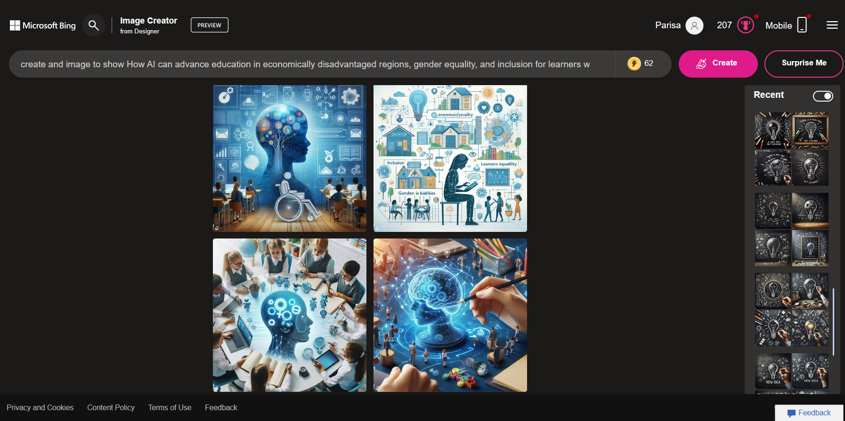

Screenshot from Bing Image Creator.
Daptio: A Case Study in Adaptive Learning:
Daptio, an adaptive learning platform in Africa, exemplifies the transformative power of AI in education. Utilizing content-agnostic AI, Daptio personalizes learning for children by assessing their educational levels and knowledge. The software gathers content from various creators, ensuring cultural and social relevance. Moreover, it dynamically adjusts its curriculum based on real-time data, considering factors such as strengths, weaknesses, and even variations in data connectivity, making education accessible to all (Sharma, 2022).
Overcoming the One-Size-Fits-All Barrier:
A common obstacle in education is the one-size-fits-all approach, which may not cater to the unique needs and learning styles of individual students. AI addresses this challenge by offering personalized learning experiences (AI for Social Good, 2023). Through data analysis and machine learning algorithms, AI identifies individual strengths, weaknesses, and learning patterns. Educators can then tailor content and teaching methods accordingly, significantly enhancing engagement, comprehension, and overall learning outcomes (AI for Social Good, 2023).
In summary, the integration of AI in education marks a paradigm shift towards personalized learning experiences and diverse educational resources. By leveraging the capabilities of machine learning algorithms, education becomes more adaptable, responsive, and culturally relevant. The case of Daptio in Africa serves as a testament to how AI can revolutionize education, ensuring that students of varying backgrounds and preferences receive the best possible learning experience.
Language and Accessibility
In developing countries, language and translation barriers pose significant challenges for students, particularly those with disabilities or diverse linguistic backgrounds (Schmidt & Strasser, 2022). Fortunately, AI technologies play a crucial role in addressing these issues. Real-time translation facilitated by AI-powered tools, such as Google Translate and the increasingly popular ChatGPT, has become instrumental in breaking down language barriers. These tools empower students to access instructional materials in their local languages, enabling a more inclusive learning environment (Schmidt & Strasser, 2022).
Moreover, AI algorithms contribute to the creation of accessible digital resources, including screen readers, closed captioning, and text-to-speech technologies. These advancements ensure that educational content is not only translated but also presented in a format that caters to various learning needs, promoting inclusivity and accessibility for all students (AI for Social Good, 2023). Through real-time translation and the development of supportive technologies, AI emerges as a transformative force, allowing students to fully comprehend and engage with educational content, thus overcoming language barriers in the realm of education.
In Africa, two prominent learning platforms, Daptio and Eneza Education, harness the power of artificial intelligence to enhance educational accessibility. Daptio facilitates remote learning by collecting student data, including strengths and weaknesses, and dynamically adjusting its curriculum to meet individual needs. On the other hand, Eneza Education, with over 860,000 subscribers, delivers lessons and assessments through web communication or SMS messages, offering quizzes, offline access to Wikipedia, and a unique "Ask-A-Teacher" feature for live inquiries.

Example Prompt: Translate the text to different languages
Prompt: Translate the below text to "Name of Language"
Language and Accessibility
In developing countries, language and translation barriers pose significant challenges for students, particularly those with disabilities or diverse linguistic backgrounds (Schmidt & Strasser, 2022). Fortunately, AI technologies play a crucial role in addressing these issues. Real-time translation facilitated by AI-powered tools, such as Google Translate and the increasingly popular ChatGPT, has become instrumental in breaking down language barriers. These tools empower students to access instructional materials in their local languages, enabling a more inclusive learning environment (Schmidt & Strasser, 2022).

Persian
ChatGPT:
زبان و دسترسی
در کشورهای در حال توسعه، موانع زبانی و ترجمه چالش‌های قابل توجهی برای دانش‌آموزان ایجاد می‌کنند، به خصوص کسانی که دارای معلولیت یا زمینه‌های زبانی متنوع هستند (Schmidt & Strasser، 2022). خوشبختانه، فناوری‌های هوش مصنوعی نقش حیاتی در پرداختن به این مسائل ایفا می‌کنند. ترجمه زمان واقعی که توسط ابزارهای مبتنی بر هوش مصنوعی، مانند Google Translate و ChatGPT که روز به روز محبوب‌تر می‌شوند، فراهم شده است، نقش مهمی در از بین بردن موانع زبانی ایفا می‌کند. این ابزارها به دانش‌آموزان امکان می‌دهند تا به مواد آموزشی به زبان محلی خود دسترسی داشته باشند، که یک محیط یادگیری بیشتر دربرگیرنده را فراهم می‌کند (Schmidt & Strasser، 2022).
French
ChatGPT:
Langue et Accessibilité
Dans les pays en développement, les barrières linguistiques et de traduction posent d'importants défis pour les étudiants, en particulier ceux en situation de handicap ou issus de milieux linguistiques diversifiés (Schmidt & Strasser, 2022). Heureusement, les technologies de l'IA jouent un rôle crucial dans la résolution de ces problèmes. La traduction en temps réel facilitée par des outils alimentés par l'IA, tels que Google Translate et le ChatGPT de plus en plus populaire, est devenue essentielle pour surmonter les barrières linguistiques. Ces outils permettent aux étudiants d'accéder aux supports pédagogiques dans leurs langues locales, favorisant ainsi un environnement d'apprentissage plus inclusif (Schmidt & Strasser, 2022).
Bangla
ChatGPT:
ভাষা এবং অবসরপ্রাপ্ততা
উন্নতমুক্ত দেশগুলিতে, ভাষা এবং অনুবাদের বাধা শিক্ষার্থীদের জন্য গুরুত্বপূর্ণ চ্যালেঞ্জ সৃষ্টি করে, বিশেষভাবে যাদের দৃষ্টি বা বিভিন্ন ভাষার পশ্চাত্তাপ রয়েছে (Schmidt & Strasser, 2022)। ধন্যবাদকরণীয়ভাবে, এই সমস্যা সমাধানে AI প্রযুক্তিগুলি গুরুত্বপূর্ণ ভূমিকা পালন করে। AI-প্রযুক্তির সহায়ে সক্রিয় অনুবাদ সুবিধা, উদাহরণস্বরূপ Google অনুবাদ এবং ক্রমশঃ জনপ্রিয় ChatGPT, ভাষা বাধা উপেক্ষা করার জন্য অত্যন্ত গুরুত্বপূর্ণ হয়ে উঠেছে। এই সরঞ্জামগুলি শিক্ষার্থীদেরকে তাদের স্থানীয় ভাষায় শিক্ষামূলক উপাদানে অ্যাক্সেস প্রদান করে, একটি আরও সমবেত শেখার পরিবেশ সৃষ্টি করে (Schmidt & Strasser, 2022)।
AI for Tutoring
The emergence of Intelligent Tutoring Systems (ITS) represents a groundbreaking trend in mathematics education, as demonstrated by studies over the past two decades. Contrary to replacing teachers, educational systems incorporating artificial intelligence serve as valuable supportive and revision tools, effectively emulating human math tutors (Pappas & Drigas, 2016). ITS typically assess students' mathematical skills prior to practice, enabling the creation of personalized intervention programs tailored to each student's unique learning profile. This personalized approach aims to optimize the learning outcome for individuals (Pappas & Drigas, 2016).
Intelligent tutors possess the capability to present educational material flexibly, utilizing hypertext, audio, video, and graphics. This versatility proves instrumental in fostering engagement with mathematics, encouraging children to view it as more than a mundane obligation. A critical aspect of Intelligent Tutoring System design revolves around the user's problem-solving process in mathematics. Detailed answers facilitate the intelligent tutor's provision of step-by-step feedback and hints throughout the entire problem-solving journey. Unlike computer-aided tools, ITS stands out by guiding the resolution of intricate math problems, further enhancing the learning experience for students. The integration of such systems into education holds the promise of transforming the landscape of mathematics learning, making it more interactive and tailored to individual needs.
In Africa, two prominent learning platforms, Daptio and Eneza Education, harness the power of artificial intelligence to enhance educational accessibility. Daptio facilitates remote learning by collecting student data, including strengths and weaknesses, and dynamically adjusting its curriculum to meet individual needs (Jordan, 2020). On the other hand, Eneza Education, with over 860,000 subscribers, delivers lessons and assessments through web communication or SMS messages, offering quizzes, offline access to Wikipedia, and a unique "Ask-A-Teacher" feature for live inquiries (Jordan, 2020).
AI plays a crucial role in serving as intelligent tutoring systems, offering personalized guidance and support to students. Virtual assistants, driven by AI, analyze student performance, pinpoint areas for improvement, and deliver tailored feedback and resources (Jordan, 2020). This approach aids students in overcoming learning challenges, reinforcing concepts, and ensuring continuous progress (Jordan, 2020). Regardless of geographical location or time constraints, AI provides students with individualized tutoring and support, making education more accessible and inclusive. In essence, AI's impact on breaking down barriers in education is both significant and promising, transforming the learning landscape and fostering inclusivity for individuals worldwide (Jordan, 2020).
Global Connectivity and Open Educational Resources (OER):
AI facilitates global connectivity by leveraging the internet to provide access to a wealth of Open Educational Resources (OER) (UNESCO, 2019). Initiatives like Khan Academy and Coursera offer free, quality courses, leveling the playing field for students in underserved regions (Hew & Cheung, 2014). AI-driven translation tools also break language barriers, making content accessible to diverse linguistic communities.
Hybrid education incorporates OER seamlessly, allowing educators to curate online resources that align with the curriculum. This integration enhances the richness of educational materials available to students.
Digital Divide in Developing Countries
The digital divide, as coined by Larry Irving, Jr. in the mid-1990s, signifies the gap in access to information services based on socio-economic disparities, highlighting the inequality in opportunities to utilize Information and Communication Technologies (ICTs) and engage with the Internet (Acilar, 2011). This division has global implications, reflecting disparities between countries concerning ICT access. The primary digital divide encompasses inequalities in ICT access, while the secondary divide pertains to differences in ICT use. Larry Irving, Jr. introduced the term to draw attention to the existing disparity in access to information services, emphasizing the divide between those who can afford the necessary computer hardware and software for global information network participation and those who cannot, particularly low-income families and communities (Acilar, 2011).
Wilson defines the digital divide as an imbalance in the access, distribution, and utilization of information and communication technologies among different populations, identifying eight aspects: physical access, financial access, cognitive access, design access, content access, production access, institutional access, and political access (Acilar, 2011). The digital divide is multifaceted, involving geographic, demographic, socio-economic, philosophical, and sociological dimensions. It represents a missed opportunity for millions to access desirable jobs and enhance their lives through computer and internet use, reflecting both practical and societal implications (Acilar, 2011).
Digital Divide in Education for Developing Countries
Digital divide in developing countries is a multidimensional problem that encompasses disparities in both access to and utilization of digital tools within educational contexts. This divide reflects substantial inequalities in both the physical infrastructure necessary for digital learning and the digital literacy skills required to navigate and leverage online educational resources effectively (Tarman, 2003).
According to the IEEE Future Network Program (2023), the disparity in digital access creates educational inequalities, placing students at a disadvantage compared to those with greater technological resources. For instance, students without a home computer faced challenges during the COVID-19 pandemic when many schools transitioned to virtual learning. These disadvantages escalate, impeding proper education and hindering the acquisition of skills necessary for job opportunities with growth potential. To address these disparities, policymakers must address questions related to ensuring equitable global access to technologies like 5G
Causes of Digital Divide
- Insufficient internet accessibility, including limited bandwidth for activities such as video and audio conferencing
- Lack of education and training in digital literacy, hindering effective technology use
- Inadequate infrastructure, marked by unreliable electricity
- Lack of access to essential technological devices, such as computers
- Absence of secure storage locations for devices, adding complexity to fostering digital inclusion
Obstacles for Developing Countries to Overcoming the Global Digital Divide
The path toward bridging the Global Digital Divide for developing countries is riddled with formidable obstacles. In this section, we will delve into the key challenges that impede progress, encompassing social and legal constraints, technological and infrastructural hurdles, financial costs, and the impact of war and instability. Each of these barriers plays a distinct role in hindering access to digital resources, amplifying the complexity of achieving digital inclusion on a global scale. Through a detailed exploration of these obstacles, we aim to shed light on the intricacies and interconnections that demand careful consideration and strategic interventions for sustainable progress.
1. Social and legal constraints
Social and legal constraints, encompassing censorship and access denial, are prevalent in various countries seeking strict control over internet access and resources. The mechanisms employed to enforce such constraints, particularly proxy servers, inevitably impact data performance and currency (Saheb, 2022). This inevitably restricts the breadth of available information, the scope of accessed resources, and limits the number of individuals with access to even non-proscribed data (Saheb, 2022).
Authoritarian regimes, drawing from a history of control over information technologies, extend their influence to internet development within their borders. Potential challenges to the state emanate from various sectors such as the mass public, civil society, the economy, and the international community. Authoritarian states respond to these challenges with reactive measures like restricting internet access, content filtering, online behavior monitoring, and, in extreme cases, prohibiting internet use entirely. Examples include restrictions on internet use in countries like China, Cuba, Burma, the United Arab Emirates, Vietnam, and Iran (Saheb, 2022).
2. Technological and infrastructural Obstacles
Physical access to technology, particularly in rural areas of developing countries, poses a significant barrier due to the high cost of devices, limited existing infrastructure, and other obstacles. This challenge is compounded by insufficient or low-quality data, a crucial factor for AI systems (Goel, 2023). The bias problem arises when AI algorithms are not adequately trained on representative and high-quality data, leading to potentially discriminatory results. Outdated infrastructure further hinders AI implementation, as these systems require modern equipment with the processing capabilities to handle vast amounts of information in real-time. Integration into existing systems is another hurdle, extending beyond simple plugin installations (Goel, 2023). Organizations must invest in advanced infrastructure, tools, and applications, while also ensuring that employees are trained to use these new tools and troubleshoot issues. Overcoming these challenges requires strategic planning, significant investments, and collaboration with experienced AI providers to ensure a smooth transition to machine learning in education (Goel, 2023).
3. Financial Cost
Financial cost associated with implanting artificial intelligence tools and systems is underscored by many researchers. Sharma et al. (2022), adoption of Artificial intelligence in educational institution of emerging economies involves considerable financial costs. The initial investment encompasses acquiring the necessary hardware, software, and infrastructure to support AI applications.
Additionally, the costs associated with training educators and administrators on AI tools contribute to the financial burden (Sharma et al., 2022). The maintenance and regular updates of AI systems further compound the overall expenses. This financial strain is particularly pronounced in developing countries with limited budgets and competing socioeconomic priorities. The study emphasizes that while the long-term benefits of AI in education are promising, overcoming the initial financial barrier requires strategic planning and collaborative efforts (Sharma et al., 2022).
4. War and instability
Wars have a profound negative impact on the tech industry, manifesting in a decline in investment and subsequent innovation reduction. This uncertainty about the future during conflicts makes businesses less likely to invest in new technologies, leading to a substantial setback in technological progress. Additionally, wars result in the destruction of physical and digital infrastructure, hindering the development and rollout of new technologies. This includes vital components such as power grids and communications networks, crucial for economic stability and societal well-being (Pure Tech Innovations, 2023).
In a broader context, wars not only impede technological advancement but also contribute to the lasting and impactful destruction of vital infrastructure. Historical evidence reveals that wars often involve the deliberate targeting and destruction of infrastructure, aiming to cripple the enemy's capabilities (Pure Tech Innovations, 2023). However, the unintended consequence is the considerable time and resources needed for post-war reconstruction, imposing significant economic burdens and negatively affecting overall well-being. The intertwined relationship between warfare, infrastructure destruction, and technological setbacks underscores the complex challenges societies face during and after conflicts (Pure Tech Innovations, 2023).
According to Hoeffler (1998), who extensively examined the challenges of infrastructure rehabilitation and reconstruction in twelve war-affected economies in Africa, the standard of infrastructure provision is remarkably low across these countries, encompassing water, transport, energy, and telecommunication sectors. The telecommunications sector emerges as a potential beneficiary of private investment due to relatively high expenditures per line and shorter payback periods, despite the low number of telephone main lines per 100 inhabitants. However, widespread individual ownership of telephones remains financially infeasible in these low-income economies.
Hoeffler (1998), suggests that shared access and the availability of public telephones are key to achieving universal access. Given the financial constraints of war-affected countries, the rehabilitation and reconstruction of infrastructure surpass the governments' financial capacity. The paper explores private investment as an alternative to public investment, recognizing that such investment is deterred by high perceived risks in Sub-Saharan African countries, particularly those affected by war. Even though attracting private investors in the presence of ongoing conflict is unlikely, certain war-affected economies have managed to secure private investment for cellular telephone networks (Hoeffler, 1998).

Bridging the Gender Gap with AI in Education
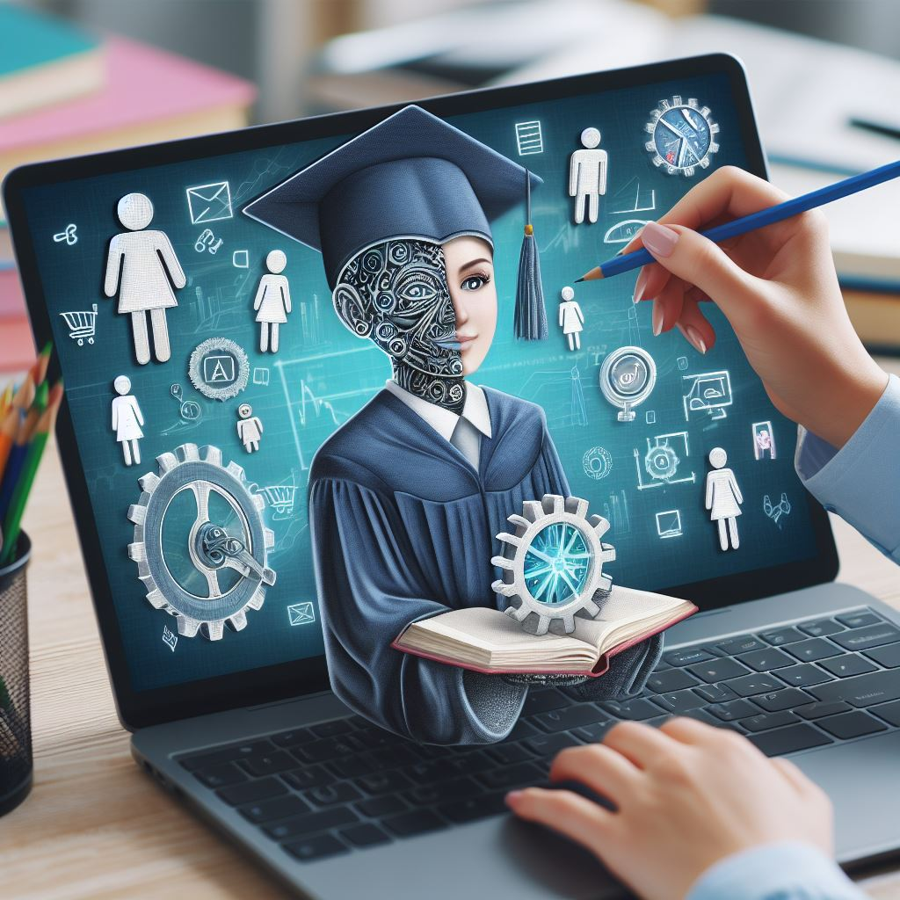

Gender inequality in education has long been a pervasive challenge, reflecting disparities in access, opportunities, and outcomes between genders. It encompasses the systematic discrimination and biases that hinder individuals based on their gender identity, limiting educational access and impeding the realization of one's full academic potential. As we embark on an exploration of this critical issue, it becomes evident that artificial intelligence (AI) stands as a powerful ally in dismantling barriers and fostering gender equality in education.
This section unravels the complexities of gender inequality in educational settings and delves into the transformative role that AI can play in reshaping educational landscapes, ensuring equal opportunities and outcomes for all learners. By leveraging AI, educators and policymakers can pave the way for a more inclusive, equitable, and empowering educational journey, transcending gender-based obstacles and nurturing an environment where every learner can flourish academically.

What is Gender Inequality in Education?
Educational gender disparity is marked by variations in access, achievements, and experiences between males and females, encompassing differences in enrollment, dropout rates, literacy, academic performance, and tertiary education accessibility (Nowak, 2021). The inequality in educational opportunities obstructs both girls and boys, women and men, from realizing their fundamental right to education (Nowak, 2021).
In 2010, 53 percent of the 61 million out-of-school children in primary school were girls, a figure that decreased to 49 percent out of 57 million in 2013. Surveys across 30 countries, each with over 100,000 out-of-school children, revealed that, on average, 28 percent of girls were not attending school compared to 25 percent of boys (Karam, n.d.). The completion of primary school poses a specific challenge for girls in sub-Saharan Africa and Western Asia. Additionally, surveys in 55 developing countries indicate that, irrespective of household wealth or location, girls at lower secondary age are more likely to be out of school than boys (Karam, n.d.).
Globally, almost two-thirds of the 775 million illiterate adults are women. In tertiary education, developing regions exhibit a ratio of 98 women per 100 men, reflecting significant disparities. Notably, these inequalities extend beyond overall enrollment, with women being overrepresented in humanities and social sciences but significantly underrepresented in engineering, science, and technology disciplines (Karam, n.d.).
Why Gender Equality in Education matters?
Today more than every girl receive education all around the world. However, that does not mean we do not face any challenges in the field of women education as still more than one hundred million girls do not have access to education (Kapur, 2019). The importance of equal rights to education encourages national and international organizations to support and invest in women education. It is proven by consistent researches that education protects women from the danger of early marriage. In developing countries girls sometimes marry as early as the age of 6. Based on some data 1 in every 3 girls is married before reaching adulthood; this in turn opens up the door to domestic violence, poor healthcare, and inability to nurture a healthy family (Salisu Mammam, n.d.).
Uneducated women encounter an increased risk of acquiring sexually transmitted diseases, including HIV. Studies suggest that women who successfully complete their education are three times less likely to contract such diseases, including AIDS (Salisu Mammam, n.d.). In the event of a woman contracting these diseases and subsequently becoming pregnant, there is a heightened chance of transmitting the infections to her infants, thereby contributing to elevated infant mortality rates. Education equips women with knowledge on disease prevention, reducing their susceptibility to such infections, as they learn essential measures to safeguard their health (Salisu Mammam, n.d.).
The study conducted by Getinet Gezahegn Gebre (2020) exploring the role of female education in the economic development of Gimbo woreda concludes that women's access to education is likely to contribute to improvements in both individual and community socioeconomic status. Educating and empowering women demonstrate a positive impact on economic development. Furthermore, female education, especially up to the completion of primary school, is closely associated with lower fertility rates and improved infant and child health. Additionally, educated mothers are more inclined to provide education to their children, leading to reduced costs associated with environmental degradation (Gebre 2022). This research is among many other research papers that support the importance of equal education for women.
Challenges of Women Education
According to a report by World Bank group (2016), despite the improvements in women education still large number of women have problem with access to education. Based on this report The location and accessibility of schools play a vital role in determining children's ability to attend educational institutions. The distance between residences and schools poses a more substantial obstacle for girls, particularly in rural areas where secondary schools are commonly located at a considerable distance from small villages. Safety concerns add to the reluctance of parents to permit girls to undertake lengthy journeys on foot to reach their schools (World Bank Group, 2016).
During periods of conflict and crisis, girls are frequently the initial ones withdrawn from schools and the ones who take the longest to resume their education. As per the Global Partnership for Education, girls experiencing conflict have a 2.5 times higher likelihood of being excluded from school compared to boys, and their return to education is less probable after a ceasefire (Egbetayo & Nyambura, 2019). Many times political and regime changes in a country can eliminate women education like the Case of Women in Afghanistan who have been banned from attending school since the Taliban took control of Afghanistan in August 2021. In this situation that even not international organization can physically go and provide education for women, there are online learning platforms that use current technology including Artificial intelligence tool for teaching Afghan girls online. Below we look at two of these platforms.
How AI Can Promote Gender Equality in Education
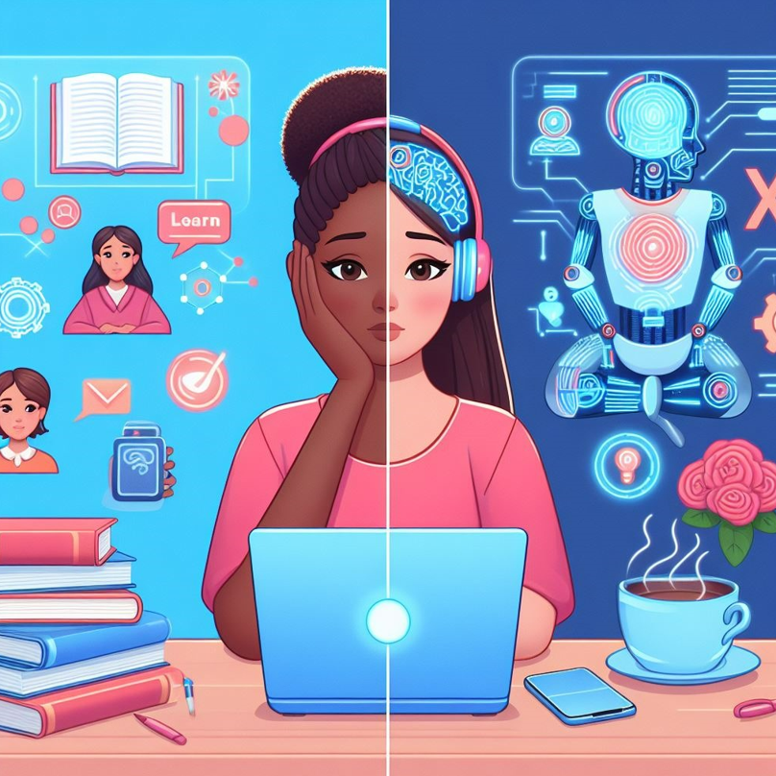
In the quest for gender equality in education, Artificial Intelligence (AI) emerges as a transformative force, offering innovative solutions to address challenges faced by women in economically disadvantaged regions. This section delves into the ways AI can promote gender equality in education, exploring initiatives that provide remote learning support, offer free learning resources, and leverage AI for language learning.
Remote Learning Support:
Remote Learning Support encompasses a comprehensive array of strategies, tools, and technologies meticulously crafted to facilitate and enhance educational experiences within virtual or remote environments. This approach becomes particularly indispensable in circumstances where physical attendance at traditional educational institutions is fraught with challenges or deemed impractical, as witnessed during crises, geographical limitations, or global events such as the COVID-19 pandemic. In this dynamic arena of Remote Learning Support, Artificial Intelligence (AI) emerges as a transformative force, elevating the educational journey by addressing the distinct challenges inherent in remote environments. The capabilities of AI span various dimensions, offering a multifaceted contribution to cultivate a remote learning experience that is more personalized, efficient, and engaging.
In the realm of online education, the significance of Remote Learning Support powered by Artificial Intelligence takes center stage, presenting itself as a potent tool for empowering women in their educational journeys. AI-driven platforms exhibit the capacity to provide tailored assistance, seamlessly adapting to the specific learning needs of women within virtual classrooms. From crafting personalized lesson plans to delivering real-time feedback, the integration of AI in remote learning not only opens up new avenues for inclusive education but also serves as a catalyst for reshaping the entire educational landscape. This section ventures into the practical applications and manifold benefits of Remote Learning Support, providing a nuanced exploration of how AI technologies are dynamically transforming the contours of education and championing gender equality within online learning environments.

Case Study 1: Roshni-E-Omid Online Learning Platform
The initiative known as Roshini e Omid has been undertaken by AUW’s MA in Education program with the aim of providing an educational opportunity for Afghan girls who have experienced an interruption in their schooling. This initiative seeks to revive hope and aspirations among Afghan girls, inspiring them to pursue their academic goals despite the challenges presented by the current political situation.
Due to the cessation of education beyond grade 7 for Afghan girls, Roshini e Omid has become a significant initiative, albeit serving a limited number of students. Commencing in 2023, the program initially focused on the Kandahar region, selecting 60 girls primarily in grades 11 and 12. Some of these girls, despite a lack of formal education in the past two years, were automatically advanced to these grades. The girls were categorized, with MA in Education students assuming instructional roles for various subjects (Asian University for Women, 2023).
The program, spanning a duration of three months, adheres to Afghanistan’s national curriculum, covering subjects such as English, Mathematics, History, Geography, Biology, and Islamic studies. Essential skills are imparted through classes in ICT and English writing. To facilitate the successful completion of their classes, AUW has provided the girls in Afghanistan with a range of technological equipment and additional support. Subjects are taught by MA in Education students based on their interests and expertise.
With the exception of English, all subjects are instructed in Dari/Persian, aiming to support the girls in making significant academic progress. Certificates are awarded upon successful completion of mid-term and final exams. The commitment and enthusiasm demonstrated by Roshni- e- Omid students and MA in Education students are a source of immense pride (Asian University for Women, 2023).
MA students have adeptly guided the learning process, drawing upon strategies and expertise gained through their educational experiences at AUW. Before program enrollment, students participated in comprehensive orientation sessions to ensure their proficiency with various online learning tools. Since 2023, the program has received approximately 1,000 applications from Afghan girls within a year (Asian University for Women, 2023).
·

Case Study 2: The Future Learn
As per FutureLearn, a prominent digital platform, a declaration regarding higher education in Afghanistan states that female students, prevented from attending universities, now have complimentary access to FutureLearn courses. During the period of the Taliban's prohibition on their involvement in higher education, Afghan women residing in the country will enjoy free access to FutureLearn's premium digital learning platform. Girls and women with internet connectivity will be able to engage in expert tracks and short courses from top British higher education institutions without incurring any charges.
This announcement was made by FutureLearn on Thursday, December 22, 2022, in London. By enrolling in FutureLearn's digital courses, students can explore a diverse range of over 1,200 courses available on the platform through a complimentary subscription (The American University of Afghanistan, 2022).
·
2. Providing Free Learning resources
Besides the formal education and its costs and challenges, women in disadvantaged societies had a huge problem when it came to finding educational materials that were available or affordable for them. As someone growing up in a developing country (Afghanistan), I remember that me and my classmates at school and university had a hard time finding articles or websites that provided free information for us. Thus, we had to either by the available hard copy book or lower the quality of our assignments. In addition to being costly, many women cannot access to learning materials just for the barrier of not having a bank account or any other means of payment. this problem is solved to a very high degree with the advent of Open Educational Resources (OER).
Open Educational Resources (OER) encompass educational, teaching, and research materials available in various formats and mediums, either in the public domain or subject to copyright but released under an open license. These licenses allow for free access, reuse, repurposing, adaptation, and redistribution by individuals and entities. The term "open license" denotes a licensing framework that upholds the intellectual property rights of the copyright owner while granting the public specific permissions to utilize, reuse, repurpose, adapt, and redistribute educational content. It has been year that majority of Afghan girls in Afghanistan are reliant on this material for their education both in school and university level.
3. AI for Language Learning
Artificial Intelligence (AI) holds great potential in facilitating English language learning for women in impoverished communities, especially through online platforms. AI-powered language learning applications can personalize the learning experience, catering to individual needs and progress. For instance, Duolingo, a language learning app, employs AI algorithms to adapt lessons based on user performance, providing tailored exercises to enhance specific skills.AI chatbots, such as those integrated into platforms like Babbel or Rosetta Stone, offer interactive conversations, allowing learners to practice English in real-life scenarios. These chatbots use natural language processing (NLP) to understand and respond to user inputs, providing valuable feedback for improvement.
Moreover, AI-driven platforms like Busuu leverage machine learning to identify areas where learners struggle, offering targeted exercises to address weaknesses. These platforms often incorporate speech recognition technology, enabling users to practice pronunciation and oral communication. In underserved regions, initiatives like the Mobile Learning for English Language Learning (MELL) project in Bangladesh utilize AI to deliver English language lessons via mobile phones. These projects aim to increase accessibility, allowing women in remote areas to access quality language education (Sultana & Hasan, 2019).
The Digital Gender Divide
The digital revolution presents vast opportunities for both economies and societies. However, the advantages of this transformation are currently unevenly distributed among different societal groups and genders, with disparities in access, usage, and ownership of digital tools (Mahraj, 2023). The term "digital gender divide" is commonly employed to describe these gender-related variations in resources and capabilities for accessing and effectively utilizing information and communication technologies (ICTs) across countries, regions, sectors, and socio-economic groups, as highlighted by UN Women in 2005 (Mahraj, 2023).
In the context of AI, bias emerges when machine learning algorithms reflect the biases inherent in the training data. This phenomenon can lead to discriminatory outcomes, disproportionately affecting specific groups, with women being one such group (Mahraj, 2023).
Instances of AI bias against women encompass prejudiced hiring algorithms that exhibit a preference for male candidates, facial recognition software demonstrating lower accuracy rates for women and individuals of diverse ethnicities, and voice assistants that, by default, use female voices and respond in subservient tones, thereby reinforcing gender stereotypes (Mahraj, 2023). Additionally, AI-driven credit scoring models have been identified as having discriminatory effects on women, potentially penalizing them for taking breaks from work for caregiving or other familial responsibilities (Mahraj, 2023).
The term "gender gap in AI" denotes the inadequate representation of women in AI-related fields and the absence of gender diversity within AI development teams (Mahraj, 2023). This imbalance holds substantial consequences for the development of equitable and inclusive AI systems. For instance, a dearth of diversity within AI development teams may lead to the creation of products and services that either neglect the needs of women or perpetuate damaging gender stereotypes (Mahraj, 2023).
Causes of Digital Gender Divide
Several underlying factors contribute to the digital gender gap, encompassing barriers related to access, affordability, education disparities, technological illiteracy, and embedded biases within socio-cultural norms (OECD, 2018d; OECD, 2015a; Hilbert, 2011; Cooper, 2006; Korupp and Szydlik, 20050F1, OECD, 2018). Women, often burdened with 2.6 times more unpaid care and domestic work than men, face constraints in dedicating time to advancing their careers (UN Women, 2018, OECD, 2018).
Recognizing the imperative for action, diverse measures are proposed to enable full participation of all women and girls in the digital realm. Recent recommendations from the Broadband Commission Working Group on Digital Gender Divide emphasize key areas, including digital literacy, confidence-building, and ensuring the availability of relevant content, applications, and services (Broadband Commission, 2017a, as cited in OECD, 2018). The role of skills, their distribution, and demand are integral in shaping and constraining the digital gender divide.
Affordability poses a significant hurdle for both genders, yet its impact is disproportionately felt by women and girls, constituting a key challenge in ICT access. As technological sophistication and functionality increase, along with ownership costs, the digital gender divide expands (BMZ, 2017, as cited in OECD, 2018). According to a study by Intel and Dalberg (2012) as cited in OECD (2018) ,affordability not only deters non-Internet users but also hinders existing users from fully utilizing the World Wide Web, particularly if data allowances are tied to the quantity of megabits in the contract. Variations in the cost of Internet access exist globally, contingent on the level of a country's development.
Moreover, the digital gender gap widens due to limited awareness of the potential benefits of the Internet, with women more likely than men to abstain from internet usage citing reasons such as not perceiving a need or desire for it (OECD, 2018). The Intel and Dalberg (2012) as cited in OECD (2018) survey indicates that a quarter of non-engaging women express disinterest in internet use, believing it brings no benefits. Trust issues with digital devices or the internet also play a role, with women often citing a lack of interest or low expectations regarding usefulness and relevance in their local context, including the absence of content in local languages.
Digital illiteracy, stemming from factors like education, employment status, and income levels, contributes to discomfort in technology use and internet access, a phenomenon termed "technophobia" (Intel and Dalberg, 2012). This discomfort is more prevalent among women with no formal education, as highlighted by the survey. The gender gap in confidence extends to girls in formal education who exhibit lower confidence in ICTs, mathematics, or science, often influenced by societal biases and parental expectations.
Socio-cultural factors also play a significant role in the digital gender divide. Cultural perceptions in countries like India and Egypt contribute to women viewing the internet as inappropriate for them (OECD, 2018). Family support emerges as a critical enabler, with active female internet users having more supportive families, while female non-users face family opposition. Safety concerns, particularly related to cyber violence, are a key reason for family opposition to internet use, with women and girls facing risks like cyberstalking, online harassment, and sexual trafficking (OECD, 2018).
In developed economies, women encounter socio-cultural biases limiting their access to senior roles in digital companies. Market-related factors, such as investment dynamics and regulations, also affect women's ability to access and use digital technologies, particularly in rural areas where infrastructure installation is less economically viable (OECD, 2018). Women and girls in rural areas face additional challenges, including higher probabilities of being out of school, precarious employment, and limited resources for using digital technologies (OECD, 2018).

Advancing Education for Learners with Disabilities through AI in Education
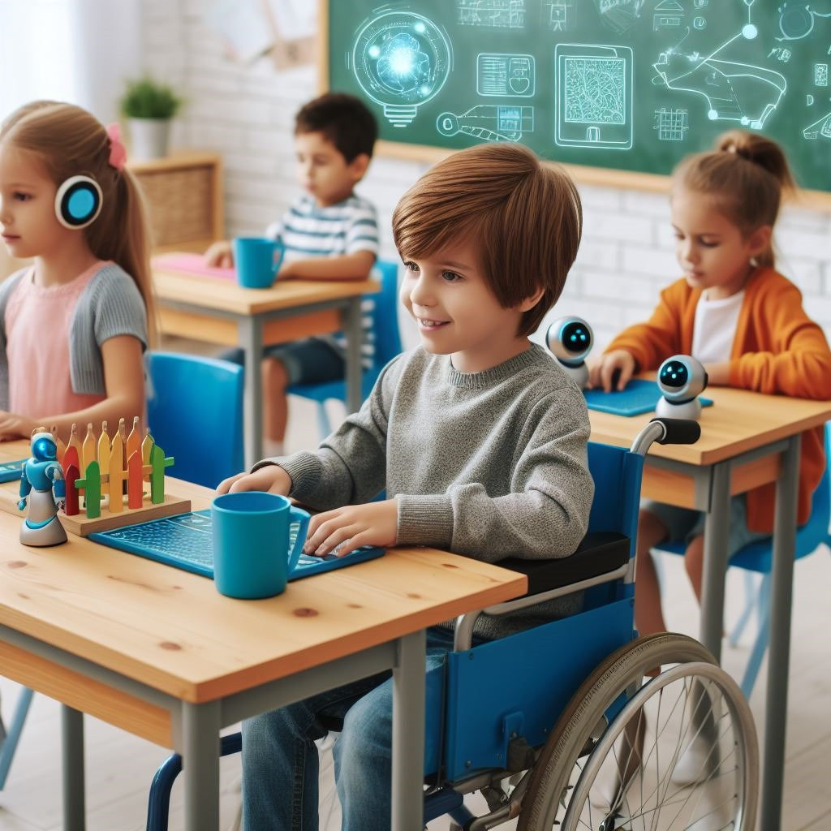
Learners with disabilities, encompassing physical, sensory, and cognitive challenges, often encounter substantial barriers in traditional educational settings (Hays, 2009). These obstacles hinder their access to quality education, leading to a significant gap in learning outcomes (Ziadat, 2021). In recent years, the integration of artificial intelligence (AI) in education has opened new avenues for fostering inclusivity in many ways, for example for learners with disabilities. As we delve into the realm of inclusion, it becomes evident that AI has the potential to revolutionize educational practices, providing tailored solutions to address the diverse needs of learners (Zaman, 2023). This section explores the multifaceted issues surrounding disability in education and delves into the transformative potential of artificial intelligence (AI) in addressing the unique needs of learners with physical, sensory, and cognitive disabilities. leveraging AI, educators, and policymakers can forge a more inclusive and supportive educational environment, ensuring that every learner can participate fully and thrive academically.

Understanding Disability in Education:
Disability, as defined by the World Health Organization (WHO), is a complex phenomenon encompassing a range of conditions that result from the interaction between individuals with impairments and attitudinal and environmental barriers (WHO, 2011) that almost everyone suffers from whether temporarily or permanently (Garg and Sharma, 2020). The WHO's International Classification of Functioning, Disability, and Health (ICF) provides a comprehensive framework, acknowledging that disability is not solely a health issue but a broader concept that involves social and environmental factors (WHO, 2011).

Expert Corner: Interview with Dr. Kathlyn Elliott of Boston Children's Hospital Trauma and Community Resilience Center and current Faculty at MA in Education Program at Asian University for Women

In this interview, Professor Kathlyn Elliott underscores the significance of inclusive education, emphasizing the integration of students with disabilities into mainstream classrooms with additional support. The challenges faced by students with disabilities vary widely, necessitating individualized tailoring by educators. The impact of technology and AI, particularly in simplifying individualization and facilitating access to curriculum, is highlighted. However, there is a diverse awareness among educators regarding the potential benefits of AI in education. Professor Elliott stresses the importance of addressing basic issues like internet access and infrastructure to ensure equitable AI use. Additionally, concerns are raised about the sustainability of free AI tools and their potential evolution into paid services, posing potential challenges to accessibility. Overall, the interview sheds light on the multifaceted landscape of inclusive education, acknowledging both the promise and concerns associated with the integration of AI in the educational realm.
Inscription of the video

Parisa Fadayee: Hello and welcome to this insightful interview. Professor Kathlyn Elliott, an esteemed expert in the field of education from Boston Children's Hospital, is with us. She is also currently a faculty member in the Masters in Education program at Asian University for Women. We will be delving into the multifaceted realm of inclusive education, with a particular focus on students with disabilities and the integration of AI into education. The discussion aims to shed light on critical aspects of inclusive education, exploring the challenges, advancements, and the future landscape of AI and education.
Good morning, Professor Elliott. Thank you for joining us today. Could you please start by briefly introducing yourself and telling us about your background in education?

Professor Elliott: Yes, my name is Kathlyn Elliott. I hold a PhD in education leadership and am currently working at Boston Children's Hospital in their Trauma and Community Resilience Center, examining the role that schools and education can play in preventing violence. Before obtaining my PhD, I was a secondary history teacher for about 10 years in the US, in both California and Texas, and also in Shanghai.

Parisa Fadayee: Thank you so much, Professor Elliott. Let's begin by discussing how you define inclusive education and why you believe it's crucial to advocate for the implementation of inclusive education, specifically in the context of students with special needs.

Professor Elliott: I think my definition of inclusive education is not necessarily a formal one, but it is the understanding that we want all students to participate in the least restrictive environment as part of their education. This means integrating students into mainstream classrooms with additional support, informed by best practices in the school or country based on research. It is essential because historically, disabled students, especially those with additional vulnerabilities, have been excluded from education. You know, there's a history of wealthy families continuing to ensure that their disabled children still have access to education by hiring private tutors or other types of situations, but for students who are from middle class or poor families. There's not always the money for that, so it then becomes the role of the state to ensure that all students with disabilities have access to high quality education and that ensures right that they are productive and cared for members of society. But it also means that their classmates, the other citizens of the country, learn how to interact with people who have disabilities and who learned differently.

Parisa Fadayee: Professor, from your experience, what challenges do students typically face in traditional educational settings with disabilities?

Professor Elliott: Yeah, I think, you know, one of the things that's so interesting with disabilities is there's such a wide range. So. In my. In my experience, students can experience almost no struggles with their disability in the academic setting, but they may have struggles with their disability that impact them socially, or it could impact them physically in terms of accessing the classroom, engaging in certain classes. And then there are other disabilities that do impact. Them academically, so there could be learning disabilities that we see. There also may be social-emotional disabilities that impact their academic success indirectly. So I'm thinking I've had students who might have had physical disabilities all the way, so in a wheelchair. I've had students who have had severe allergies, so they had to sit at separate lunch tables because they couldn't eat the same food as other people. I have had students with learning disabilities with dyslexia with processing disorders. And then I've had students with. Emotional disturbances who either caused by trauma or by caused by brain chemistry. Who had panic attacks in the classroom. Or who were violent. So all of this means that we as teachers and we as educators in school systems. Are really looking at a very individualized tailoring for what that student needs and then thinking about, OK, how does that fit into the regular workings of our school? And So what generally I have found is if you are saying asking what does this one particular student who has all these restrictions need, that's going to be good for all the other students as well. So whether it's physical accessibility, ensuring that you know there are ramps, so students who are. In wheelchairs are able to get into the building that helps all students. They can all use the ramps, whether it's mindfulness practices or having breaks available for students who have anxiety or who have difficulty testing. That helps other students as well. So, but it's a lot of work to do that level of individualization.
Parisa Fadayee: Professor, while we know that how much it's important to consider inclusivity of these students into education settings, how have you seen technology, including AI, impact education for those students?
Professor Elliott: So some of this is hypothetical because I was no longer teaching in the K-12 space when AI became readily available. But I can speak a little bit to my experience teaching in higher education since AI has become readily available, and then also based on conversations with my sisters who are teachers, friends and the schools that I'm currently working with. So I'd say one of the. Biggest things that AI allows is for that individualization to happen at a much easier. In a much easier way, with less burden on the teacher, which is amazing, especially when it comes to intellectual disabilities. Or disabilities that impact students' academic success.
In terms of access to curriculum, not necessarily physical access to buildings. But one of the best things is that teachers are able to take a text that's available and then say this text is at this reading level. Can you rephrase the text? Rewrite the text at a different reading level? And so my sisters have both talked about using that that it provides like such an easy way.To make really minor changes. And I know when I was teaching. I did a lot of differentiation at one of the schools I worked at and so I was often trying to find 3 levels of text on the same topic and it was very hard. So I would use like a a textbook. Often for the mid level topic and then I would find the original primary source for. The more rigorous topic and then for the lowest level. Often I would rewrite things myself, and so if you're doing that every single day for every single lesson, it becomes very time consuming. So to have a tool that can do that or can pull it from different things that already exist. And then you as a teacher are fact-checking it to make sure it's correct. That is a huge, huge help.
Parisa Fadayee: Professor, with this huge help that AI can provide, what do you think? What is the level of awareness among educators and school administrators regarding the potentials of AI and other technological tools in education?
Professor Elliott: I think it's really a wide range, you know, I think some people are really excited about it. And feel like, oh gosh, we can do so much with this. And then I think there are many teachers who are interested but don't have the time or the bandwidth to explore this. And so may need. Support or help?In finding the time in learning how to use the tools. I also think there are probably some teachers and educators who are very worried about this being dangerous. About. It leading to. Negative impacts on the education system, so I think there's a wide range. As with all technologies, you know, it's, you know, it's not just this that there's a wide range on.
Parisa Fadayee: I think I got a part of answer for the other question I had that what is your vision about the future of inclusive education with AI. And I got the answer that some educators are excited about it while some other things that they're worried about usage of it and it's dangerous in the future. So Professor what steps do you believe that the educators and like what the steps needs to be taken? For ensuring equitable access to AI and beneficial use of it for the students and educators both.
Professor Elliott: That is such a good question and such an important question because I do think you know and I some of my research is on education in emergencies and I think. I think back to when COVID started, how we were like, oh, we'll just go online, Everyone can go online. And the fact was that everyone can't go online. So one of the things we see often with access to the Internet, access to devices, is that that's not always equal in countries. In terms of infrastructure? And also around gender. So we see that young men have. More access to the Internet and technology than young women often do. We also see that rural communities often have less access to Internet and technology. And so I think for me, at the same time as there's this really exciting conversation about what does using AI in the classroom look like, we also need to ensure we have the maybe more basic conversation about. What does access look like? And for me, that's maybe the more interesting conversation, but I think for some people it's the less interesting conversation because it's not a new conversation, right? We've been talking about access and infrastructure building in rural communities, access to marginalized groups. Since at least the 1950s, if not centuries. So I think it looks like. How do we get? How do we increase Internet access in rural communities? Often that's roads, often that's stable infrastructure. How do we change? How do we get access to more young women? Often that's dealing with gender norms, with family norms, with household norms, and these are not easy things to engage with. They take a long time. So that I worry more about the access being inequitable. I imagine that wealthy students in urban centers. Will have a lot of access to really great things that AI can do. And I think my biggest concern is that the gap between. The people who have access and those who don't continues to grow.
Parisa Fadayee: Thank you so much Professor Elliott, for sharing your valuable insights before concluding. Is there anything else you want you would like to add or you would like to emphasize more on them?
Professor Elliott: No, although I would love to hear if you have any thoughts about some of the access or concerns around AI because you are a student? Are there things that you see that AI would may help and support with disabled students and students with learning disabilities.
Parisa Fadayee: Professor, something very interesting that was in your very last answer that I heared was the problem with the access to Internet itself. The chapter we are writing is about how AI can provide more accessible education, more inclusive education to the people of underprivileged regions, to the woman who doesn't have access to education and to people with disabilities. So we have found that there are many AI tools that are free, but just what is not free is the Internet, the connections. So what is interesting in that answer is that while AI is providing many facilities for more accessible educational tools, the problem that still exists is access to the network itself, because AI does not work without networks. But still we have found that there are many AI tools that sometimes they work offline and they are free also. The worry that we had and the challenges that we included in our chapter is what AI and other artificial intelligence tools remain free because the ones who developed it are sitting behind it to find the benefits, the financial benefits, so would they allow while the AI has this much accessibility and providing facilities, would they let it to remain free or will it be like all paid ones? So now we have the paid ones with more advanced options and we have the free ones. But with would it remain free? Would it be like this in the future or even some? There are claims that it will be even more accessible for these students, so no one knows what happens in the future, but it's still. Worry is access to the network itself, as you mentioned.
So thank you once again, Professor, for your time and for your contribution to our book chapter. We truly appreciate your insights, thank you so much.

Professor Elliott: Thank you
Categorization of Disabilities

Diverse disabilities can impact individuals across physical, sensory, and cognitive domains. The categorization includes:
· Physical Disabilities: Affecting mobility, dexterity, or physical functioning.
· Sensory Disabilities: Involving impairments in vision or hearing.
· Cognitive Disabilities: Impacting cognitive functions like memory, attention, or learning.
Understanding the nuances within each category of disability is vital for tailoring educational approaches and interventions to meet the specific needs of learners.

Physical Disability
A physical impairment is described as a restriction in an individual's physical functioning, mobility, manual skills, or endurance, which significantly and persistently hinders their capacity to engage in regular daily tasks, as per the Equality Act of 2010.

Sensory Disability/Impairment
A sensory disability is a condition in which one or more of our body’s sensory functions, such as vision, hearing, touch, taste, or smell, are impaired or do not function as expected (MAPLE Community Services, 2023). In the existing literature, sensory disability and sensory impairment are used differently. While in some literature, they are used interchangeably, in others, they are distinguished to varying degrees.
In articles where sensory disability and sensory impairment are considered to have some differences, the distinctions are often subtle but significant. Researchers may emphasize that sensory impairment refers specifically to the loss or limitation of sensory functions, such as visual or auditory impairments (MAPLE Community Services, 2023). On the other hand, sensory disability may encompass a broader concept that extends beyond the impairment itself to include the societal and environmental factors influencing an individual's ability to navigate and participate fully in various aspects of life (MAPLE Community Services, 2023). However, in this chapter, both are used interchangeable.
In the realm of education, addressing the needs of individuals with sensory disabilities is paramount for fostering an inclusive learning environment. The challenges associated with different types of sensory impairments require tailored approaches to ensure equitable access to educational opportunities.

1. Visual Impairment
Visual impairment encompasses conditions ranging from partial vision loss (low vision) to complete blindness (MAPLE Community Services, 2023). It can result from congenital factors, injuries, or degenerative eye diseases (Raising Children Network, 2021). Individuals with visual impairments may face difficulties in accessing written information, navigating their surroundings, and recognizing facial expressions or non-verbal cues (World Health Organization, 2023).

2. Hearing Impairment
Hearing impairment involves partial or complete loss of hearing and can be present from birth or acquired later in life due to factors such as exposure to loud noises, infections, or aging (World Health Organization, 2023). Communication barriers may arise for individuals with hearing impairments, impacting their ability to understand spoken language and participate in verbal interactions (World Health Organization, 2023).

Cognitive Disability
According to the Centers for Disease Control and Prevention (2011), cognitive impairment refers to difficulties in remembering, learning new information, concentrating, and making decisions that impact one's daily life. This spectrum of impairment spans from mild, where individuals may observe changes in cognitive functions but can still manage routine activities, to severe, where there is a loss of understanding the significance of things and the capacity to communicate through speech or writing, ultimately hindering independent living (Centers for Disease Control and Prevention, 2011)

Impacts of Disability on Learning
Disabilities exert profound effects on the learning process, influencing not only academic achievements but also social integration and emotional well-being (Babik and Gardner, 2021). Different types of disabilities affect students' learning experiences in distinct ways. For instance, individuals with dyslexia confront hurdles in reading and spelling, directly impeding the development of crucial literacy skills (Reis et al., 2020). Attention-Deficit/Hyperactivity Disorder (ADHD) manifests as challenges in maintaining focus, organizing tasks, and efficiently managing time, compromising the overall effectiveness of the learning experience (Johnston, 2013).
,traditional learning activities, impacting both engagement and inclusivity within educational settings (Akude et. al, 2018). Visual impairments pose unique challenges, creating obstacles in accessing printed materials and visual content and, consequently, hindering the overall acquisition of knowledge (Agesa, 2014).
Hearing impairments further contribute to the complexity of learning by impeding the understanding of spoken language and limiting access to auditory information (Mpofu & Chimhenga, 2013). The communication and comprehension difficulties associated with hearing impairments underscore the need for specialized support and accommodations within the learning environment (Mpofu & Chimhenga, 2013).
In essence, the multifaceted impacts of disabilities on learning underscore the importance of adopting inclusive educational practices, accommodating diverse learning needs, and providing tailored support to ensure equitable opportunities for all learners.

Challenges Faced by Individuals with Disabilities in Educational Settings:
Individuals with disabilities face various challenges according to the type of their disability and they level of its severity. Below we explore some of the challenges that affect the learning process of students with special needs.
1. Physical Disability:

· Mobility Challenges: Students with physical disabilities may face difficulties in navigating school environments, accessing classrooms, and using facilities such as restrooms and libraries. This can affect their overall participation in academic and extracurricular activities. Classrooms and lecture halls may not be designed to accommodate diverse mobility needs, limiting the participation of students with physical disabilities.

· Resource Accessibility: Learning materials, such as textbooks, may not always be available in accessible formats for students with physical disabilities. This can create barriers to obtaining and processing information effectively.

· Specialized Equipment and Assistive Technology: Some students with physical disabilities may require specialized equipment or assistive technology to participate fully in the learning process. Schools need to invest in and provide these resources to ensure an inclusive educational environment.

· Social Interaction: Physical disabilities can impact a student's ability to engage in social interactions and form connections with peers. This may lead to feelings of isolation, affecting their overall school experience and emotional well-being.

· Educational Support: Students with physical disabilities may require additional educational support, such as personal aides or specialized instruction, to address their unique learning needs. Ensuring that these resources are available is crucial for their academic success.

· Adaptations in Assessment: Traditional assessment methods may not be suitable for students with physical disabilities. Educators need to consider alternative assessment approaches, such as modified assignments or assessments that take into account the student's abilities and challenges.

2. Sensory Disability:

· Lack of Accessible Learning Materials: Traditional learning materials may not be accessible for students with visual impairments. Printed texts without alternative formats and lack of braille resources pose significant barriers.

· Communication Challenges: Students with hearing impairments may face difficulties in fully engaging with lectures, discussions, and other interactive activities that heavily rely on verbal communication.

3. Cognitive Disability:

· Limited Learning Support: Educational settings may lack adequate support systems for students with cognitive disabilities, such as personalized learning plans, extra time for exams, and accessible instructional materials.

· Social Stigma and Misunderstanding: Students with cognitive disabilities may experience social stigma and misunderstanding from peers and educators, impacting their self-esteem and overall learning experience.

AI and Special Education
Education for the learners with special needs presents unique challenges and they require innovative solutions. To address these unique needs with innovative solutions, AI plays an important role and it enhances and transforms eduction for the students with special needs by making it more personalized, effective and accessible and promotes inclusion in education.

The need to Integrate AI in providing education to learners with special needs.
Education for the students with special needs/disabilities contains unique challenges due to the unique barriers that the students face because of their disabilities. They require more personalized and individualized educational methods to meet their learning needs that traditional classrooms fail to provide since they are not always able to address these diverse needs.
Thus, the integration of AI-powered tools into the classrooms can provide support to both the students and the educators by providing personalized learning experiences, supports in skill developments, improving accessibility and many other supports that AI assistive tools can provide. AI for example can help with designing Intelligent Tutoring Systems that can be adapted to the learning preferences of each student. It also helps educators in collecting data and its analysis to understand the performance of their students and develop effective teaching methods and strategies.

AI’s potential to support students with special needs
The potential of AI in special education is vast, offering personalized learning experiences tailored to individual student needs and abilities, optimizing learning outcomes, and fostering skill development. AI extends its impact to assistive technology, aiding communication for students with speech impairments and supporting those with dyslexia in writing. It enhances accessibility by converting text to speech for visually impaired students and vice versa for the hearing impaired.
Additionally, AI's analytical capabilities enable effective data analysis, identifying learning patterns and suggesting personalized learning paths. Ongoing advancements in AI technology promise further innovative solutions to address the challenges in special education, making it more inclusive, efficient, and personalized. The integration of AI has the potential to revolutionize the delivery of special education, ensuring that every student, regardless of their learning needs, has the opportunity to thrive.

How can AI Support Special Education?
Educators and researchers globally are acknowledging the significance of AI in special education. This technology holds the promise of bringing about substantial transformations in the delivery of special education, rendering it more personalized, efficient, and accessible. Here are some ways in which AI can provide support to the students with special needs:

1. Personalized Learning:
AI-powered educational platforms offer the ability to create personalized learning paths for students with disabilities. Machine learning algorithms can analyze individual learning styles, preferences, and challenges, enabling educators to tailor curriculum materials and teaching methods to suit the unique needs of each learner (Owan et al., 2023).
For instance, AI can understand the type of learning disability that students with special needs have and according to that recommend personalized learning strategies and materials (Sharif & Elmedany, 2022). This approach enhances engagement and ensures that educational content is accessible and comprehensible for all students, regardless of their abilities.

2. Adaptive learning:
Inclusion is not just about modifying content; it also involves adapting the learning environment. AI-driven adaptive technologies, such as speech-to-text and text-to-speech tools, can significantly benefit learners with disabilities. For students with visual impairments, AI can convert text into speech or provide audio descriptions of visual content. Similarly, for those with hearing impairments, speech can be transcribed into text in real time, fostering a more inclusive and interactive learning experience.
3. Universal Learning Design:
Universal design for Learning is a framework where all students regardless their background and ability can access the quality education (Mayasari and Wan, 2023). Universal Design for Learning (UDL) aims to provide inclusive educational experiences for all students, including those with disabilities, by offering multiple means of representation, engagement, and expression. Artificial Intelligence (AI) complements UDL by facilitating flexibility in content delivery through features like text-to-speech and adaptive learning platforms. AI enables personalized and differentiated learning experiences, accommodating individual preferences and learning styles. Additionally, AI contributes to accessibility by incorporating features such as closed captions and alternative navigation methods. Continuous monitoring and support provided by AI systems further assist students with disabilities, ensuring a more inclusive and supportive educational environment. Integrating UDL principles with AI technologies enhances educational accessibility and addresses the diverse needs of learners.
Read more about UDL in Chapter 1.4 Leveraging AI for Universal Design for Learning by Mayasari and Nila Wan in the book AI for Education (2023) Access the book chapter with the link below:
https://edtechbooks.org/ai_in_education/leveraging_ai_for_universal_design_for_learning
4. Virtual Assistants:
AI-powered virtual assistants play a crucial role in supporting students with disabilities by addressing various challenges they may encounter (Owan et al., 2023). For students with cognitive disabilities, these assistants streamline task management, providing features such as “scheduling”, “reminders”, and “organization tools” to alleviate the burden of administrative tasks (Owan et al., 2023). Additionally, virtual assistants equipped with accessibility features, such as text-to-speech and speech-to-text, enhance accessibility for students with visual or auditory impairments (Shah et al., 2020; Ozarkar et al., 2020).
The immediate academic support offered by platforms like Brainly, utilizing machine learning for personalized assistance, ensures that students with learning disabilities receive prompt answers and relevant resources. Moreover, the adaptability of virtual assistants enables personalized learning experiences, catering to the diverse needs and preferences of students, ultimately contributing to a more inclusive educational environment.

Assistive AI Tools to Support Learners with Disabilities/ Special Needs
Various AI assistive tools provide support for students with disabilities/ special needs in educational contexts. Below we introduce some of those AI-Assistive tools that help students overcome some of the limitations they face due to their disabilities.

1. For students with physical disability:
Students with physical disabilities may face challenges related to mobility, dexterity, or other physical limitations. Assistive technology can play a crucial role in overcoming these challenges and promoting inclusivity in educational settings. Here are some examples of assistive tools for students with physical disabilities:
- Voice Recognition Software like Dragon NaturallySpeaking and Google's Speech-to-Text converts spoken words into written text, allowing students with physical disabilities to control computers or devices without using a keyboard or mouse.
- Head-Tracking Systems like Tobii Dynavox and Camera Mouse allows users to control the cursor on a computer screen using head movements, providing access to digital content without requiring manual input.
- Switch Access and Adaptive Keyboards like AbleNet Switches, BigKeys Keyboard customizable switches or keyboards designed for individuals with limited motor skills, making it easier for them to input commands or type.
- Eye-Tracking Technology like Tobii Eye Tracker, Eyegaze Edge enables users to control a computer or communication device by tracking eye movements, offering a hands-free interaction method.
- Alternative Pointing Devices like Joysticks, trackballs, mouth-operated devices provides alternative ways to control the cursor on a computer, catering to individuals who may have difficulty using a standard mouse.
- Assistive Apps for Touchscreens like TouchChat, Proloquo2Go supports communication through touchscreens, allowing students with physical disabilities to express themselves using symbols, pictures, or text.
- Electronic Page Turners like PageFlip Cicada, AirTurn assists students in turning pages of physical books or digital content without the need for manual page-turning.
- Customizable Environmental Control Systems like Smart home devices (e.g., smart lights, thermostats) allows students to control their environment using adaptive switches or voice commands, promoting independence in daily activities.
- Sip-and-Puff Systems like Jouse3 and QuadStick enables control of a computer or device by sipping or puffing air through a straw or tube, suitable for individuals with limited motor function.
- Wearable Devices for Gesture Control like Myo Armband, GestureTek Cube allows users to control devices through gestures or movements, providing an alternative input method for those with physical disabilities.
- Accessible Learning Management Systems (LMS) like LMS with keyboard shortcuts, accessible interfaces ensures that digital learning platforms are designed with accessibility in mind, accommodating students with physical disabilities.

For the students with Sensory Disabilities:
Assistive tools for students with sensory disabilities aim to enhance accessibility and learning experiences for those with visual or hearing impairments. Here are some specific tools tailored to address the needs of students with sensory disabilities.

2. For Visual Impairments:
Students with visual impairments face difficulties in accessing written or visual learning materials and producing written contents. Here are some examples of assistive tools for students with physical disabilities to receive and deliver informations:
- Screen Readers like JAWS (Job Access With Speech), NVDA (NonVisual Desktop Access) which converts on-screen text into synthesized speech or Braille output, facilitating navigation and content comprehension for visually impaired students.
- Braille Displays like Focus Braille Display, Orbit Readers converts digital text into Braille, allowing students with visual impairments to read content on electronic devices.
- Text-to-Speech (TTS) Software like Kurzweil 3000 and NaturalReader reads aloud digital text, providing auditory access to written content for students with visual impairments or reading difficulties.
- OCR (Optical Character Recognition) Technology like KNFB Reader, Seeing AI converts printed or handwritten text into digital text, enabling students with visual impairments to access printed materials.
- Audio Descriptions for Videos like YouDescribe, Actiview provides additional audio narration describing visual content in videos, making them more accessible to students with visual impairments.

For Hearing Impairments:
Individuals with hearing impairment encounter unique challenges in educational settings that can hinder their learning experiences. The incorporation of assistive technology becomes instrumental in addressing these challenges and fostering inclusivity. Below are examples of assistive tools tailored to enhance the educational journey for students with hearing impairment:
- Closed Captioning and Subtitling Tools like YouTube's automatic captions and CaptionSync adds text captions to videos, enhancing accessibility for students with hearing impairments or those who prefer visual reinforcement.
- Speech-to-Text (STT) Software like Dragon NaturallySpeaking, Google's Speech-to-Text converts spoken language into written text, aiding students with hearing impairments in capturing spoken information.
- Visual Alert Systems like Vibrating alarms, flashing lights provides visual or tactile alerts for events like doorbells, alarms, or notifications, benefiting students with hearing impairments.t
- Transcription Services for example Otter.ai and Rev transcribes spoken words into written text in real time, aiding students with hearing impairments during live events or lectures.
- Sign Language Learning Apps for example SignSchool and Signily supports students in learning sign language, promoting communication and inclusion for those with hearing impairments.
- Hearing Aid Compatible (HAC) Technology like HAC-compatible phones, audio devices ensures compatibility with hearing aids, reducing interference and ensuring clear audio for students with hearing impairments.

For students with Cognitive Disability:
Assistive tools for students with cognitive disabilities are crafted to boost accessibility and enrich learning experiences. These tools cater to specific needs related to cognitive challenges, providing personalized support for comprehension and organization. Designed to suit unique learning styles, they include graphic organizers, text-to-speech software, and adaptive learning platforms. By offering specialized assistance, these tools empower students to overcome cognitive barriers, promoting inclusivity in education.
- Graphic Organizer Software for example MindMeister and Inspiration supports students in organizing thoughts and ideas visually, aiding in understanding and recall of information.
- Text-to-Speech (TTS) and Speech-to-Text (STT) Tools for examples Kurzweil 3000 and NaturalReader (TTS); TTS reads aloud digital text, aiding in content comprehension. STT converts spoken language into written text, supporting those who may have difficulty in writing.
- Word Prediction Software as Co-Writer and WordQ assists students with writing challenges by predicting and suggesting words as they type, promoting smoother composition.
- Mindfulness and Relaxation Apps like Headspace and Calm offers guided mindfulness and relaxation exercises to help students manage stress and improve focus.
- Interactive Learning Apps like Educational games and interactive simulations engages students through gamified learning experiences, making education more interactive and enjoyable.
- Speech Recognition Tools like Dragon NaturallySpeaking, Google's Speech-to-Text converts spoken language into written text, assisting students who may have difficulty with traditional writing methods.
- Predictive Text and Auto-Correct Software like Grammarly, Predictable predicts and corrects words and phrases as student’s type, supporting accurate and efficient communication.
- Visual Schedules and Timers like Choiceworks and Time Timer help students understand and manage their daily routines through visual schedules and timers, promoting organization and time management.
- Digital Note-Taking Apps such as Microsoft OneNote and Evernote facilitates note-taking and organization of information in a digital format, providing flexibility and searchability.
- Adaptive Learning Platforms like DreamBox and Knewton utilizes AI algorithms to personalize learning experiences, adapting to the individual needs and pace of students with cognitive disabilities.
- Virtual Assistants with Task Management like Siri and Google Assistant provides virtual assistance for task management, reminders, and organization, supporting students with cognitive challenges.
In the dynamic landscape of education, Artificial Intelligence (AI) emerges as a transformative force, heralding a new era of possibilities and redefining conventional paradigms. Recent research documents underscore AI's pivotal role in shaping the future of education, offering promising prospects along with a set of challenges(Göksel & Bozkurt, 2019). The influence of AI on the learning experience is revolutionary, introducing unprecedented changes to both formal and informal education processes. While AI cannot replace the irreplaceable role of teachers, it provides a myriad of tools and strategies that elevate the quality, accessibility, and dependability of education systems(Göksel & Bozkurt, 2019). However, the impact of AI is not uniform across the globe, as its progress is intricately linked to the prevailing political and economic patterns(Kengam, 2020). In developed countries, millions benefit from advanced technology, while in developing nations, individuals grapple with the challenge of securing basic digital devices and internet access(Kengam, 2020). The geopolitical landscape, marked by factors such as war and instability, exacerbates these discrepancies, as illuminated in the discussed in this chapter.
Opportunities
- Adaptive Learning and Personalization:
  - Tailored Educational Experiences: AI-driven adaptive learning systems leverage data analytics to understand individual learning styles and paces. This customization ensures that educational content is delivered in a manner that resonates with each student, optimizing comprehension and retention(Kengam, 2020).
  - Personalized Learning Plans: Adaptive learning goes beyond a one-size-fits-all approach, offering personalized learning plans that address specific strengths and weaknesses. This approach enhances the effectiveness of education by catering to the unique needs of each learner(Kengam, 2020).
- Efficiency Enhancement:
  - Automation of Administrative Tasks: AI's capability to automate administrative tasks such as grading, attendance tracking, and scheduling liberates educators from routine responsibilities. This allows teachers to redirect their time and energy towards refining teaching methodologies and fostering a more interactive learning environment (Göksel & Bozkurt, 2019).
- Global Accessibility:
  - Overcoming Geographical Barriers: AI-powered remote learning platforms transcend geographical constraints, providing students with access to quality education irrespective of their location. This global accessibility promotes inclusivity and equal opportunities for learners worldwide (Göksel & Bozkurt, 2019).
- Continuous Learning and Skill Development:
  - Identification of Skill Gaps: AI algorithms analyze student performance data to identify skill gaps. This data-driven approach enables the creation of personalized learning paths, fostering a culture of continuous learning and skill development that aligns with the evolving demands of the workforce (Göksel & Bozkurt, 2019).
- Enhanced Student Engagement:
  - Interactive Learning Tools: Virtual tutors, educational games, and other interactive AI tools have the potential to make the learning process more engaging and enjoyable. By incorporating elements of gamification and interactivity, AI enhances student motivation and participation in educational activities.
Challenges:
- Ethical Considerations:
  - Balancing Data Use and Privacy: Utilizing student data for educational purposes while respecting privacy raises ethical concerns. Striking a balance between leveraging data for personalized learning and safeguarding individual privacy requires careful consideration and robust ethical frameworks.
- Teacher Training and Adaptation:
  - Continuous Professional Development: The rapid evolution of AI necessitates ongoing teacher training to ensure educators are well-equipped to integrate and effectively use new tools. Professional development programs should focus on enhancing digital literacy and adapting teaching methods to align with AI-driven educational approaches (International Forum on AI and the Futures of Education, 2020)
- Equity and Access Concerns:
  - Digital Divide: While AI enhances accessibility, ensuring equitable access to technology and resources remains a challenge. Bridging the digital divide requires concerted efforts to provide all students, regardless of socio-economic background, with the necessary tools and connectivity for effective AI-based learning (Mahraj, 2023).
- Algorithmic Bias and Fairness:
  - Addressing Bias in Algorithms: The risk of perpetuating biases in AI algorithms poses a challenge. Efforts must be directed towards identifying and rectifying biases to ensure fairness and impartiality in educational applications, preventing discriminatory outcomes (Mahraj, 2023).
- Loss of Human Touch:
  - Maintaining Human Interaction: Striking a harmonious balance between AI-driven learning and human interaction is crucial. While AI enhances efficiency, the role of human educators in providing mentorship, emotional support, and a personalized touch to education should not be overshadowed. Efforts must be made to prevent the potential loss of the essential human element in the learning process.

Expert Corner: Challenges of AI for Women Inclusive Education- Interview with Sima Ahmadi Asian Univeristy for Women's Alumni and PH.d Student of Kent State Univeristy in Educational Technology

In this interview Sima Ahmadi, Asian University for Women Alumni and current PH.d student at Kent State University in Education Technology, delves into the challenges and opportunities for gender inclusivity in artificial intelligence (AI), specifically within the educational realm. Sima, discusses her research aimed at fostering female students' interest in computer science through AI and robotics. The conversation highlights the critical importance of prioritizing gender inclusivity in AI development to mitigate biases, emphasizing the direct correlation between gender representation and AI predictions. Sima underscores the need to rectify biases in AI tools, citing examples such as Google Translate, and advocates for unbiased data to improve AI applications. The interview concludes with a focus on the digital divide and practical solutions for enhancing inclusivity in AI education, including projects, STEM activities, and mentorship programs. Overall, the interview provides valuable insights into addressing challenges and promoting inclusivity for women in AI within educational settings.
Inscription of the Video
Zainab Rezaiee: I'm so happy to have dear Sima Ahmadi former AUW student, in this interview, which is about the challenges and future outlook of making AI more inclusive for women. Dear Sima, welcome to this interview and I would like to have a short introduction from you. Tell me about yourself and your background.
Sima Ahmadi: OK, thank you so much for having me for this interview and I hope that it will be productive. So my name is Sima Ahmadi and I'm currently my PhD at Kent State University in Educational Technology. And the research area that I'm concentrating, it is about the education, robotics and AI and how we can promote students, I mean female students', interest toward the computer science in the STEM fields. And I graduated from AUW in 2023 from the Master of Education. And I'm happy to be here with you today. Thank you.
Zainab Rezaiee: Thank you so much. So let me ask you my first question. This will be acknowledged that millions of women currently face challenges in the education sector, whether related to the access to education quality or the availability of learning materials. I would like to enquire about the extent to which AI innovations can assist women in overcoming these challenges.
Sima Ahmadi: Thank you so much for the good question. So at first I'd like to tell you that the responses that I would provide is based on my little knowledge. So I think there are a lot to talk about but I'll try to make the comprehensive responses that I can. So in order to response your first question I think. In order, we are trying to promote gender inclusivity in all other areas, like education. Medical fields, computer science and everything. I think it is crucial to prioritize the inclusion of gender, not only women, in AI fields, because I believe that there is a direct relationship between these two phenomena. You know that AI tools predicts.
Based on the existed historical data and trained data in the community and through the machine learning algorithm. So then the gender inclusion is not a lot in other areas. So the AI will automatically have a bias in their prediction tools. That is why I think it is critical to prioritize Gender inclusivity in AI area. And the other thing is that there is a problem that there are only 12% of women participated in machine learning researches that it can lead to a low quality of products in AI when there is a lot of like mail in machine learning or AI fields but there are very. Low rate of females so it can produce a bias and there is a report by UNICEC that the result is interesting that unfortunately, On the rate of students or females, there are 20 percent, 25% or five times lower less likely than men to know how to use technologies or for basic things like how to do programs. And there are 13 times less likely of women participations in technological patents that it shows that you know gender. Participation in AI and in state in general is slow when there is low gender participation. So the bias will be increased I think. And there is a popular another publication of Unis school that is titled about. I would play, I would blush if I could. Yeah. In this publication that the aim is to like promote the gender inclusivity in technological things it mentions that there are stereotypes because of the lack of gender inclusivity in other areas, and these stereotypes can cause bias in AI. So due to these things, I think it is a mast or it is essential to prioritize the AI gender inclusivity, especially in education.
Zainab Rezaiee: Thank you dear Simo, just to elaborate a little bit more on it, I want to ask that why it is essential to prioritize the development of gender Inclusive AI? I mean the inclusivity within AI tools and developments.
Sima Ahmadi: I think the response that I provided you know that there is. In other field like. If we think about the other areas like in biology in recent years there are increasement of females, but in its team, I mean in computer science, in engineering and other fields that it is related to AI, you know there are lack of presentation of women. So if you would like to have equality Society. Then because our life is related directly related to AI these days especially like the academic life. So in order to remove or mitigate the gender biases in AI, it is important to Prioritize the gender inclusivity in AII hope that I can respond to you correctly.
Zainab Rezaiee: The next question is. Could you provide insight into the issues of AI bias? I mean, what issues currently exist inside AI innovations like the new tools that we are using nowadays under the name of AI? And also whether there is a serious AI bias towards women or not.
Sima Ahmadi: I think it is clear and obvious that AI is biased. In different educational tools that be concerned it will lead to discriminatory outcome in educational. Opportunities for no matter for women or men. And I'm sure that there is AI bias in currently in the tools that we are currently using. For example, as a very basic example, if we look at the Google Translate that I did it like yesterday. So if you write in English that she's a doctor and he is a nurse and translated to your native language, so it will translate into your native language. And then if you translate is again in from your native language into English, it will translate that he is a doctor and she is a mess you know The translation. And it's a very basic example. We can understand that yeah, there is bias hidden into the AI tools like Google Translate that every. Students, kids, even they use it when they use it. So their attitude will be changed that OK, maybe n can nurse be a female and doctor can be a good fit for a male and then, you know, I was reading. Research. A few days ago that is mentioned that in educational tools they are there are bias based on the existing historical data and the stereotypes that existed and the outcome of these fires Like this educational tool can provide different feedbacks for different genders. For example, it can offer like different supports and challenges for female and various supports and challenges for male. According to the existed data that is common in our community. And due to these things, I think it is important to have more inclusivity in gender, especially for females in this area, in order to address these biases, as I mentioned before that if you wanted to have a free bias data that is produced by the AI tools. So we have to Increase or concentrate in promoting of female, not only female, female from different backgrounds. A female from different contexts into technological. Board.

Zainab Rezaiee: Yes, thank you. And the next question is? Writing this chapter, I came to face a repeated term that was Digital bias. I want to ask a question related to this term and what exactly is the digital divide and what factors contribute to its existence?
Sima Ahmadi: Thank you. It's a good question. In a simple language, I think education divide, we can say that this term refers to the gap. Between those who access the technology and those who do not access. And the factors that contribute to these like phenomena or this term I mean. You said educationally back Digital divide. Yeah, digital. The factors that contribute in the existence of this phenomena it's about. Socioeconomic status it's about. Geographical locations, infrastructure limitations and other factors. For example, if we consider like underdeveloped countries or developing countries and compare these countries with the developed countries, we can see that in developed countries like in here in United States. So the concentration of school principals is to provide. Computers, at least computers and other technological tools for the students and there are working to promote. And to include computers and scary column even for the elementary schools while in in underdeveloped countries or developing countries like Afghanistan. If you consider you know that there is not even a basic computer lab for the students and they don't know how to use computer. Even when I remember myself when I passed the national examination and got entered to the computer science faculty. I know that it is a shame for an undergraduate students who don't know how to use a computer, how to turn it on, how to use the different. Programs, basic programs and computers but due to lack of like accessibility, lack of electricity
in our countries, lack of knowledge and affordability. So these devices this gap existed and these factors are different in different contexts. But in the context is like Afghanistan and other like developing countries. The factor that contribute to contribute to this lack it's mostly about the four categories. Maybe five that it's accessibility, affordability, electricity. Activity and lack of knowledge in this area.
Zainab Rezaiee: Thank you for your insightful responses and as the last question in this interview I would like to ask. What educational solutions can be implemented to enhance inclusivity in AI?
Sima Ahmadi: In education, I mean with inclusivity. I emphasize on making AI education more intuitive for women. This can be a solution, any social solution, educational technical solutions that are relevant based on your own experience. I mean, I think that if we think about inclusivity I get that. You mean how to increase? Gender. Participation or engagement in AI, you know, you're right. Right. OK, so. There are lots of researchers that indicate. A problem? That is existed no matter in developed or underdeveloped country. It is about the stereotypes and devices that exist among the communities that they divided. Like the what field is related to what? Genders for example, arts for example, nursing or Veterinary may be in some communities they think that it is good fit for female and engineering computer science. Maybe sometimes doctors, based on the different contexts it is good fit for the for the male and the important things. It's about the lack of interest and the lack of role models. If communities, if school principals or educational can. Promote the students or increase students, female students interest toward the computer science, toward the technological area. I think it can be a solution and how to promote it. You know how to change their attitudes toward these fields. We cannot change the student’s attitude in like in one day, but there are solutions. For example, implementing activities. Projects, educational or STEM projects and trainings in schools can help to mitigate these gaps. For example, in a project that I'm currently working, it's about the aim of this project is to how we can build a self-esteem and promote student’s attitudes toward computer science and robotics. You know and how. They know that there is a role model for me, for example. Graduate computer science students in AI and robotics and we train them to be a mentor for high school students. And we developed a curriculum of science that is concentrating in energy and computer science is concentrating on robotics and the robotic like. There are basic hand metropolitans. When they train the high school students. So not only their knowledge will increase, I mean the students’ knowledge. Interest to our computer science will increase and they see literally that these females graduated from computer science and this is my achievement in real world. Like in the previous project they built a. Trash bin robotics that these robots can see around and figure and identify the trashes and then collected the trashes. When they see these things like in a physical world that they in a real world that they solve a challenge so their interest is self-confidence and attitude will be changed. And then these high school students mentored the middle school and the middle school students mentored the primary schools. So their confidence, their self-esteem, attitudes and interests like gradually will be increased And also the relationship that how to make communication in a real world and the ethics of like computer science will be increased I think with the implementing these kind of projects. Can be a solution for like gender inclusivity, especially for increasing women participation in computer science and AI field.
Zainab Rezaiee: Thank you so much. It was a really useful interview. Thank you for your insight and for your generosity to share it with me and with the viewers.
Sima Ahmadi: Thank you so much. Thank you so much for inviting me and I hope I could provide comprehensive responses for you. Thank you. It was awesome. Thank you so much. Thank you. Have a good day. proof read this caption text

Conclusion
In conclusion, the exploration of leveraging Artificial Intelligence (AI) to support access, equality, and inclusion in education reveals a transformative landscape poised for positive change. Across economically disadvantaged regions, AI stands as a potent tool, tearing down barriers to access and ushering in a new era of personalized learning. Initiatives like FutureLearn's free online courses for female Afghan students exemplify how AI can break gender constraints, promoting inclusivity and empowering women in education.
Crucially, for learners with disabilities, AI emerges as a powerful ally. From assistive technologies addressing physical, sensory, and cognitive challenges to virtual assistants providing tailored support, AI ensures a more inclusive educational experience. As we celebrate these strides, it is essential to confront challenges such as data privacy, algorithmic biases, and the digital divide. Addressing these issues collectively is paramount to ensuring universal access to the benefits of AI in education.
Looking ahead, the trajectory of AI in education holds immense promise. By breaking socio-economic barriers, fostering inclusivity, and tailoring educational experiences, AI has the potential to revolutionize global learning ecosystems. However, the responsibility lies with educators, policymakers, and technologists to navigate the evolving landscape collaboratively. The goal is to ensure that AI remains a force for positive transformation, leaving no learner marginalized or excluded.
In essence, the integration of AI in education signifies more than a technological evolution—it is a commitment to building a world where education becomes a universal right. Regardless of economic status, gender, or ability, AI offers the potential to make education truly inclusive, realizing the transformative power of knowledge for all.

Glossary:
1. Artificial Intelligence (AI): A branch of computer science that involves creating intelligent machines capable of performing tasks that typically require human intelligence, such as speech recognition, problem-solving, and learning.
2. Assistive Technology: Tools and devices, including software, designed to assist individuals with disabilities in performing tasks that might be challenging due to their impairment. In the context of education, assistive technology helps create an inclusive learning environment.
3. Cognitive Disabilities: Challenges related to cognitive functions, such as memory, attention, and problem-solving. AI tools for cognitive disabilities aim to provide personalized support for comprehension and organization.
4. Digital Divide: The gap between those who have or do not have access to modern information and communication technology, particularly the internet. Addressing the digital divide is crucial for ensuring equitable access to AI-powered educational resources.
5. Gender Equality: The concept of providing equal opportunities, rights, and treatment to individuals regardless of their gender. AI initiatives that promote gender equality aim to remove barriers and biases in education, fostering equal participation.
6. Inclusivity: The practice of ensuring that all individuals, regardless of background, characteristics, or abilities, have equal access and opportunities. AI's role in education is pivotal for creating inclusive learning environments.
7. Machine Learning: A subset of AI that enables systems to automatically learn and improve from experience without being explicitly programmed. Machine learning algorithms in education can provide personalized learning experiences.
8. Personalized Learning: An educational approach that tailors instruction, pace, and content to meet the individual needs and preferences of each learner. AI platforms often utilize personalized learning to enhance the educational experience.
9. Sensory Disabilities: Impairments related to sensory functions, such as vision or hearing. AI tools for sensory disabilities aim to enhance accessibility and learning experiences for individuals with visual or hearing impairments.
10. Virtual Assistants: AI-driven applications that provide support and assistance to users. In education, virtual assistants can offer personalized help, cater to diverse needs, and contribute to a more inclusive educational environment.
11. Accessible Learning Management Systems (LMS): Learning Management Systems designed with features such as keyboard shortcuts and accessible interfaces, ensuring digital learning platforms are accessible to students with physical disabilities.
12. Closed Captioning: The display of text on a video screen to provide a transcript of the audio content, benefiting individuals with hearing impairments. Closed captioning tools are essential for enhancing accessibility in educational videos.
13. Gesture Control: The use of body movements or gestures to interact with devices or control actions. Wearable devices for gesture control, such as the Myo Armband, offer alternative input methods for individuals with physical disabilities.
14. OCR (Optical Character Recognition) Technology: Technology that converts printed or handwritten text into digital text. OCR tools like KNFB Reader benefit students with visual impairments by enabling access to printed materials.
15. Speech-to-Text (STT) Software: Software that converts spoken language into written text. STT tools like Dragon NaturallySpeaking support students with hearing impairments in capturing spoken information.
16. Switch Access: Input method using switches for individuals with limited motor skills. Adaptive keyboards and switches, such as AbleNet Switches, assist students with physical disabilities in inputting commands or typing.
17. Transcription Services: Services like Otter.ai and Rev that transcribe spoken words into written text in real time, aiding students with hearing impairments during live events or lectures.
18. Visual Schedules and Timers: Tools like Choiceworks and Time Timer that help students with cognitive disabilities understand and manage their daily routines through visual schedules and timers.
19. Voice Recognition Software: Software like Dragon NaturallySpeaking and Google's Speech-to-Text that converts spoken words into written text, enabling students with physical disabilities to control computers without a keyboard or mouse.
20. Wearable Devices: Devices like Myo Armband and GestureTek Cube that allow users to control devices through gestures or movements, providing alternative input methods for those with physical disabilities.
21. AI Adoption in Education: The integration and utilization of Artificial Intelligence technologies in educational institutions, facilitating personalized learning experiences, and addressing various challenges in the education sector.
22. Assistive Apps for Touchscreens: Applications like TouchChat and Proloquo2Go designed to support communication through touchscreens, enabling students with physical disabilities to express themselves using symbols, pictures, or text.
23. Predictive Text and Auto-Correct Software: Software like Grammarly and Predictable that predicts and corrects words and phrases as students type, supporting accurate and efficient communication, particularly for those with cognitive challenges.
24. Sensory Disabilities: Conditions affecting the senses, including visual or hearing impairments. Various assistive tools and technologies aim to enhance accessibility and learning experiences for students with sensory disabilities.
25. Virtual Assistants with Task Management: Virtual assistants like Siri and Google Assistant that provide support for task management, reminders, and organization, assisting students with cognitive challenges.
26. AI for Social Good: The application of Artificial Intelligence to address societal challenges and promote positive impacts, such as enhancing access to education and supporting learners with disabilities.

Practive the Glossary with Below Link - H5P
Here you can review and practice the chapter glossary. Read the word guess and then press "Turn" button to check for the defination.

Chapter Quiz:
Click on the Media below to access the Google-Quiz for passing the chapter quiz or directly take the quiz down here. To earn a badge, you need at least to score 10 out of 15 and email the result to "Parisa.fadayee@auw.edu.bd".

References:
Agesa, L. (2014). Challenges faced by learners with visual impairments in inclusive settings in Trans-Nzoia County. Journal of Education and Practice, 5(29), 185. Retrieved from https://core.ac.uk/reader/234636400
AI for Social Good. (2023, December 10). AI Can Remove Barriers to Accessing Education Around the World. AI for Social Good. https://aiforsocialgood.ca/blog/ai-can-remove-barriers-to-accessing-education-around-the-world
Akude, S. K., Huagie, S. D., & Sorkpor, R. S. (2018). Barriers physically challenged students faced during practical physical education inclusive lessons and how assistive approach helps to eliminate these barriers. International Journal of Scientific and Research Publications, 8(12), 205. http://dx.doi.org/10.29322/IJSRP.8.12.2018.p8429
Author(s). (2002, December 6). Developing Countries: Definitions, Concepts, and Comparisons (Order Code RL31662). Retrieved from https://www.everycrsreport.com/files/20021206_RL31662_e027b76c031d8532c67726eaf62662c27fb8d24b.pdf
Babik, I., & Gardner, E. S. (2021). Factors Affecting the Perception of Disability: A Developmental Perspective. Frontiers in Psychology, 12, 702166. https://doi.org/10.3389/fpsyg.2021.702166
Concept Note. (2020, December 7-8). AI and the Futures of Education: Developing Competencies for the AI Era. International Forum on AI and the Futures of Education.
Damon, A., Glewwe, P., Wisniewski, S., & Sun, B. (2016). Education in developing countries – what policies and programmes affect learning and time in school? Retrieved from https://www.oecd.org/derec/sweden/Rapport-Education-developing-countries.pdf
Egbetayo, V., & Nyambura, C. (2019, March 28). Forced displacement in Africa has a female face: Africa’s bold steps to address the gender dimension of forced displacement and its impact on the education of girls. Global Partnership for Education. https://www.globalpartnership.org/blog/forced-displacement-africa-has-female-face
Gebre, G. G. (2020). The Role of Female Education on Economic Development: Cross Sectional Data. Developing Country Studies, 10(4), 1. ISSN 2224-607X (Paper), ISSN 2225-0565 (Online). https://core.ac.uk/download/pdf/327152125.pdf
Glewwe, P. (2013). Education Policy in Developing Countries. University of Chicago Press.https://www.academia.edu/31354304/Overview_of_Education_Issues_in_Developing_Countries
Goel, V. (2023, June 25). 6 AI Implementation Challenges And How To Overcome Them. eLearning Industry.
Göksel, N., & Bozkurt, A. (2019). Artificial Intelligence in Education: Current Insights and Future Perspectives. Retrieved from
H, Salisu Mammam J. (n.d.). Importance of Women Education. Retrieved from https://www.academia.edu/38171217/IMPORTANCE_OF_WOMEN_Education_pdf
Hew, K. F., & Cheung, W. S. (2014). Students’ and instructors’ use of massive open online courses (MOOCs): Motivations and challenges. Educational Research Review, 12, 45-58.
Hoeffler, A. (1998). Challenges of Infrastructure Rehabilitation and Reconstruction in War-affected Economies. Oxford University. https://www.afdb.org/fileadmin/uploads/afdb/Documents/Publications/00157630-EN-ERP-48.PDF
Hossain, N., & Hickey, S. (2019). The Problem of Education Quality in Developing Countries. In The Politics of Education in Developing Countries (pp. 1–21). Oxford University Press. https://doi.org/10.1093/oso/9780198835684.003.0001
Hossain, Naomi, and Sam Hickey, 'The Problem of Education Quality in Developing Countries', in Sam Hickey, and Naomi Hossain (eds), The Politics of Education in Developing Countries: From Schooling to Learning (Oxford, 2019; online edn, Oxford Academic, 23 May 2019), https://doi.org/10.1093/oso/9780198835684.003.0001, accessed 17 Dec. 2023.
Johnston, V. (2013). University students diagnosed with attention deficit hyperactivity disorder: A hermeneutical phenomenological study of challenges and successes (Doctoral dissertation). Liberty University. Retrieved from https://core.ac.uk/download/pdf/58825326.pdf
Jordan, N. (2020, March 1). Artificial Intelligence Is Helping Developing Countries. The Borgen Project. https://borgenproject.org/artificial-intelligence-is-helping-developing-countries/
Kapur, R. (2019). Gender Inequality in Education. Retrieved from https://www.researchgate.net/publication/334162862_Gender_Inequality_in_Education/citation/download
Karam, A. (n.d.). Education as the Pathway towards Gender Equality. UN Chronicle. Retrieved from
Kengam, J. (2020). Artificial Intelligence in Education. Bournemouth University. DOI: 10.13140/RG.2.2.16375.65445.
Kumaravelu, Arul & Suresh, E. (2017). The Quality of Education and its Challenges in Developing Countries. https://www.researchgate.net/publication/335972264_The_Quality_of_Education_and_its_Challenges_in_Developing_Countries
MAPLE Community Services. (2023). Types of Sensory Disabilities and Impairment 2023. Retrieved from https://mapleservices.com.au/types-of-sensory-disabilities-and-impairment/
Max Roser (2021) - “Access to basic education: Almost 60 million children of primary school age are not in school” Published online at OurWorldInData.org. Retrieved from: 'https://ourworldindata.org/children-not-in-school'. https://ourworldindata.org/children-not-in-school
Mpofu, J., & Chimhenga, S. (2013). Challenges faced by hearing-impaired pupils in learning: A case study of King George VI Memorial School. IOSR Journal of Research & Method in Education, 2(1), 69-74. Retrieved from https://www.iosrjournals.org/
Nowak, J. K. (2021). Gender Inequality in Education. Human, Technologies and Quality of Education. Doctoral School of Social Sciences, University of Białystok, Poland. https://doi.org/10.22364/htqe.2021.31
OECD. (2018). Bridging the Digital Gender Divide: Include, Upskill, Innovate. Retrieved from https://www.oecd.org/digital/bridging-the-digital-gender-divide.pdf
Owan, V. J., Abang, K. B., Idika, D. O., Etta, E. O., & Bassey, B. A. (2023). Exploring the potential of artificial intelligence tools in educational measurement and assessment. European Journal of Mathematics Science and Technology Education, 19(8), em2940. https://doi.org/10.29333/ejmste/13428
Ozarkar, S., Chetwani, R., Devare, S., Haryani, S., & Giri, N. (2020). AI for Accessibility: Virtual Assistant for Hearing Impaired. In Proceedings of the 11th International Conference on Computing, Communication and Networking Technologies (ICCCNT) (pp. 1-7). Kharagpur, India: IEEE. doi: 10.1109/ICCCNT49239.2020.9225392.
Reis, A. I. D., Araújo, S., Morais, I. S., & Faísca, L. (2020). Reading and reading-related skills in adults with dyslexia from different orthographic systems: a review and meta-analysis. Annals of Dyslexia, 70(5). https://doi.org/10.1007/s11881-020-00205-x
Sharif, M. S., & Elmedany, W. (2022). A proposed machine learning based approach to support students with learning difficulties in the post-pandemic norm. 2022 IEEE Global Engineering Education Conference (EDUCON), 1988–1993.
Sharma, H., Soetan, T., Farinloye, T., Mogaji, E., & De Freitas Noite, M. (2022). AI Adoption in Universities in Emerging Economies: Prospects, Challenges and Recommendations. In E. Mogaji et al. (Eds.), Re-imagining Educational Futures in Developing Countries. Springer Nature Switzerland. https://doi.org/10.1007/978-3-030-88234-1_9
Steinbach, R. (2019, July). Growth in Low-Income Countries: Evolution, Prospects, and Policies (Policy Research Working Paper No. 8949). Equitable Growth, Finance and Institutions Global Practice. World Bank. https://openknowledge.worldbank.org/server/api/core/bitstreams/a97a268a-4d41-51f6-8733-ba0b416e39c3/content
Sultana, N., & Hasan, M. (2019). Using mobile-assisted language learning (MALL) to enhance communication in English of engineering students in Bangladesh. Journal Title, 7, 1-16.
The American University of Afghanistan. (2022, December 22). FutureLearn Free Online Courses for Female Afghan Students. Retrieved from
The Library of Congress. (2002). Developing Countries: Definitions, Concepts, and Comparisons (Order Code RL31662). Retrieved from
UNESCO. (2019). IITE Policy Brief: Artificial Intelligence in Education. United Nations Educational, Scientific and Cultural Organization.
Verspoor, A. (1989). Pathway to Change: Improving the Quality of Education in Developing Countries. The World Bank, Washington DC. https://files.eric.ed.gov/fulltext/ED311002.pdf
WHO. (2011). World Report on Disability. Retrieved from: https://www.who.int/teams/noncommunicable-diseases/sensory-functions-disability-and-rehabilitation/world-report-on-disability
World Bank Group. (2016). Reaching Girls, Transforming Lives. World Bank Group Education Global Practice Smarter Education Systems for Brighter Futures. Retrieved from https://documents1.worldbank.org/curated/en/212341467999691082/pdf/98450-REVISED-PUBLIC-WB-EGP-Reaching-Girls-040816-final6-web.pdf
World Bank. (2022). "World Bank Country and Lending Groups." https://datahelpdesk.worldbank.org/knowledgebase/articles/906519-world-bank-country-and-lending-groups
World Health Organization. (2023, August). Blindness and vision impairment. WHO. https://www.who.int/blindness/en/
World Health Organization. (2023, February). Deafness and hearing loss. WHO. https://www.who.int/news-room/fact-sheets/detail/deafness-and-hearing-loss
Zaki Ewiss, Mohamed. (2020). Issues in Education Development in Developing Countries. IOSR Journal of Humanities and Social Science. 25. 64-75. 10.9790/0837-2511056475.https://www.researchgate.net/publication/346234233_Issues_in_Education_Development_in_Developing_Countries
Zaman, B. U. (2023). Transforming Education Through AI: Benefits, Risks, and Ethical Considerations. Retrieved from https://www.researchgate.net/publication/374373743_Transforming_Education_Through_AI_Benefits_Risks_and_Ethical_Considerations#fullTextFileContent
Ziadat, A. H. (2021). Online learning effects on students with learning disabilities: Parents’ perspectives. Cypriot Journal of Educational Science. 16(2), 759-776. https://doi.org/10.18844/cjes.v16i2.5656
Read this online at https://edtechbooks.org/ai_in_education/leveraging_ai_to_support_learners_in_underserved_regions_and_economically_developing_countries

