# Icons

Books can tap into the site's icon library by including icon URLs as images. For a full list of site icons, see the [Site Resources](https://edtechbooks.org/site?tab=resources) page.

Figure 1

Example Site Icons

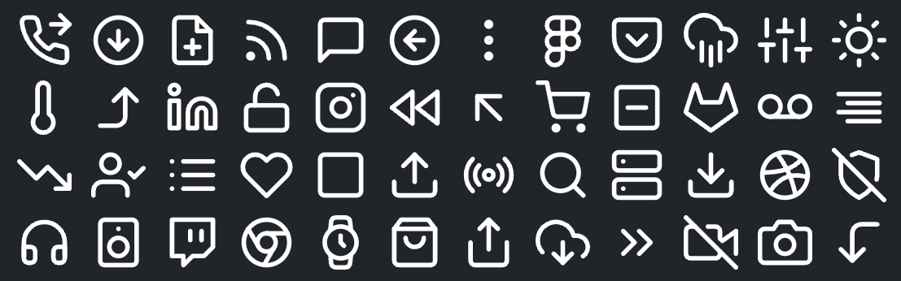

## Example Usage

The site uses SVGs for icons, so you will likely need to include a style attribute in your image tag where you define the width to ensure that it looks the way you like. The nice thing about this is that it means you can scale icons as large as you would like without losing any quality.

Read this online at <https://edtechbooks.org/userguide/icons>