# 3. Assessment and Grading

## Advantages of SpeedGrader

·      Access speed grader from each assignment

·      You can browse through all student submissions online, enter points, and provide feedback – all in one place. No need to download anything.

·      You can save comments that you make repeatedly in a library. [Instructions](https://community.canvaslms.com/t5/Instructor-Guide/How-do-I-use-the-Comment-Library-in-SpeedGrader/ta-p/469482)

·      You can give feedback in a video (click the video button instead of entering text and record your feedback).

·      You can grade anonymously. [Instructions](https://community.canvaslms.com/t5/Instructor-Guide/How-do-I-hide-student-names-in-SpeedGrader/ta-p/768)

## Assignment & Gradebook Settings

### General

* All graded assignments create a gradebook column (published or unpublished)
* All assignment groups create a gradebook columns
* You can have rules for each assignment group to, for example, drop the lowest 3 grades. [Instructions](https://community.canvaslms.com/t5/Instructor-Guide/How-do-I-create-rules-for-an-assignment-group/ta-p/848)
* Each student has a row in the gradebook
* You can choose to override final grades. For this you have to activate the setting ‘[allow final grade override’](https://community.canvaslms.com/t5/Instructor-Guide/How-do-I-override-a-student-s-final-grade-in-the-Gradebook/ta-p/946).

### Student Access to Grade Distribution

Per default, students can view scoring details for each graded assignment that include grade distribution as well as the mean, highest and lowest score.

If you do not want students to see this information, you can turn it off under course settings. In Course Navigation, click the Settings link. Click the Course Details tab. Click the more options link. Check the Hide grade distribution graphs from students checkbox. Click the Update Course Details button.

When the grade distribution graph is hidden, students can view their score, but cannot view any other aspect of the graph, including the high, low, and mean scores.

### Availability of Grades

Per default, all grades are accessible once you enter them. To hide grades by default and manually choose when to post grades and make them visible to students, select the Manually Post Grades option in Gradebook Settings. Students will not be notified of grades and comments automatically until you post them in the gradebook. [Instructions](https://community.canvaslms.com/t5/Instructor-Guide/How-do-I-post-grades-for-an-assignment-in-the-Gradebook/ta-p/576)

## Rubrics

You can add a rubric to an assignment to help students understand expectations for the assignment and how you intend to score their submissions. See [Instructions](https://community.canvaslms.com/t5/Instructor-Guide/How-do-I-add-a-rubric-to-an-assignment/ta-p/1058) for setup. Your rubric will automatically pull up as you use SpeedGrader. See [Instructions](https://community.canvaslms.com/t5/Instructor-Guide/How-do-I-use-a-rubric-to-grade-submissions-in-SpeedGrader/ta-p/1015) for scoring.

## Submission Comments: Download and Edit Options

The Link ‘Download Submission Comments’ creates a downloadable PDF with time stamps and content of all comments for the respective student and submission.

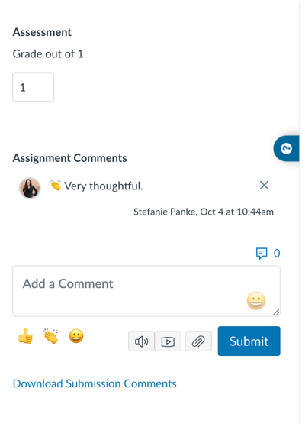

 To edit and see an overview of your comments, access the grade book.

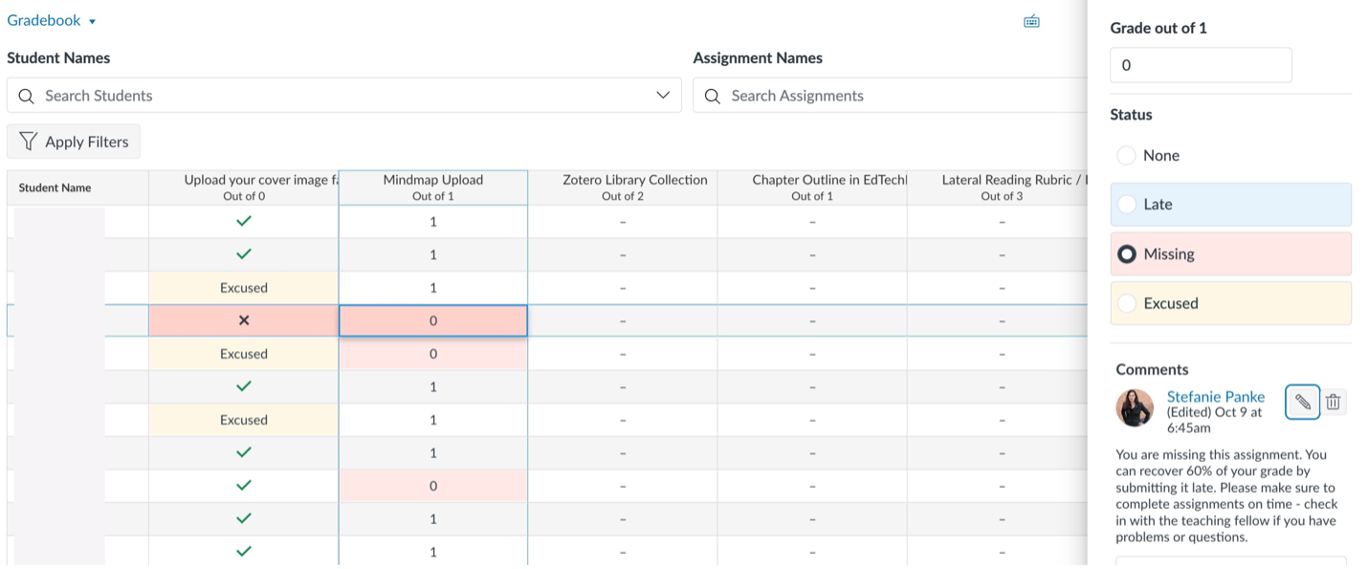

## Effective Feedback

Giving effective feedback is an important skill in teaching. It requires effective guidance through praise and criticism in a balanced way that blends care and challenge ([Yoshida, 2018](https://coachtakeshi.medium.com/radical-candor-61c98768d1d1)).

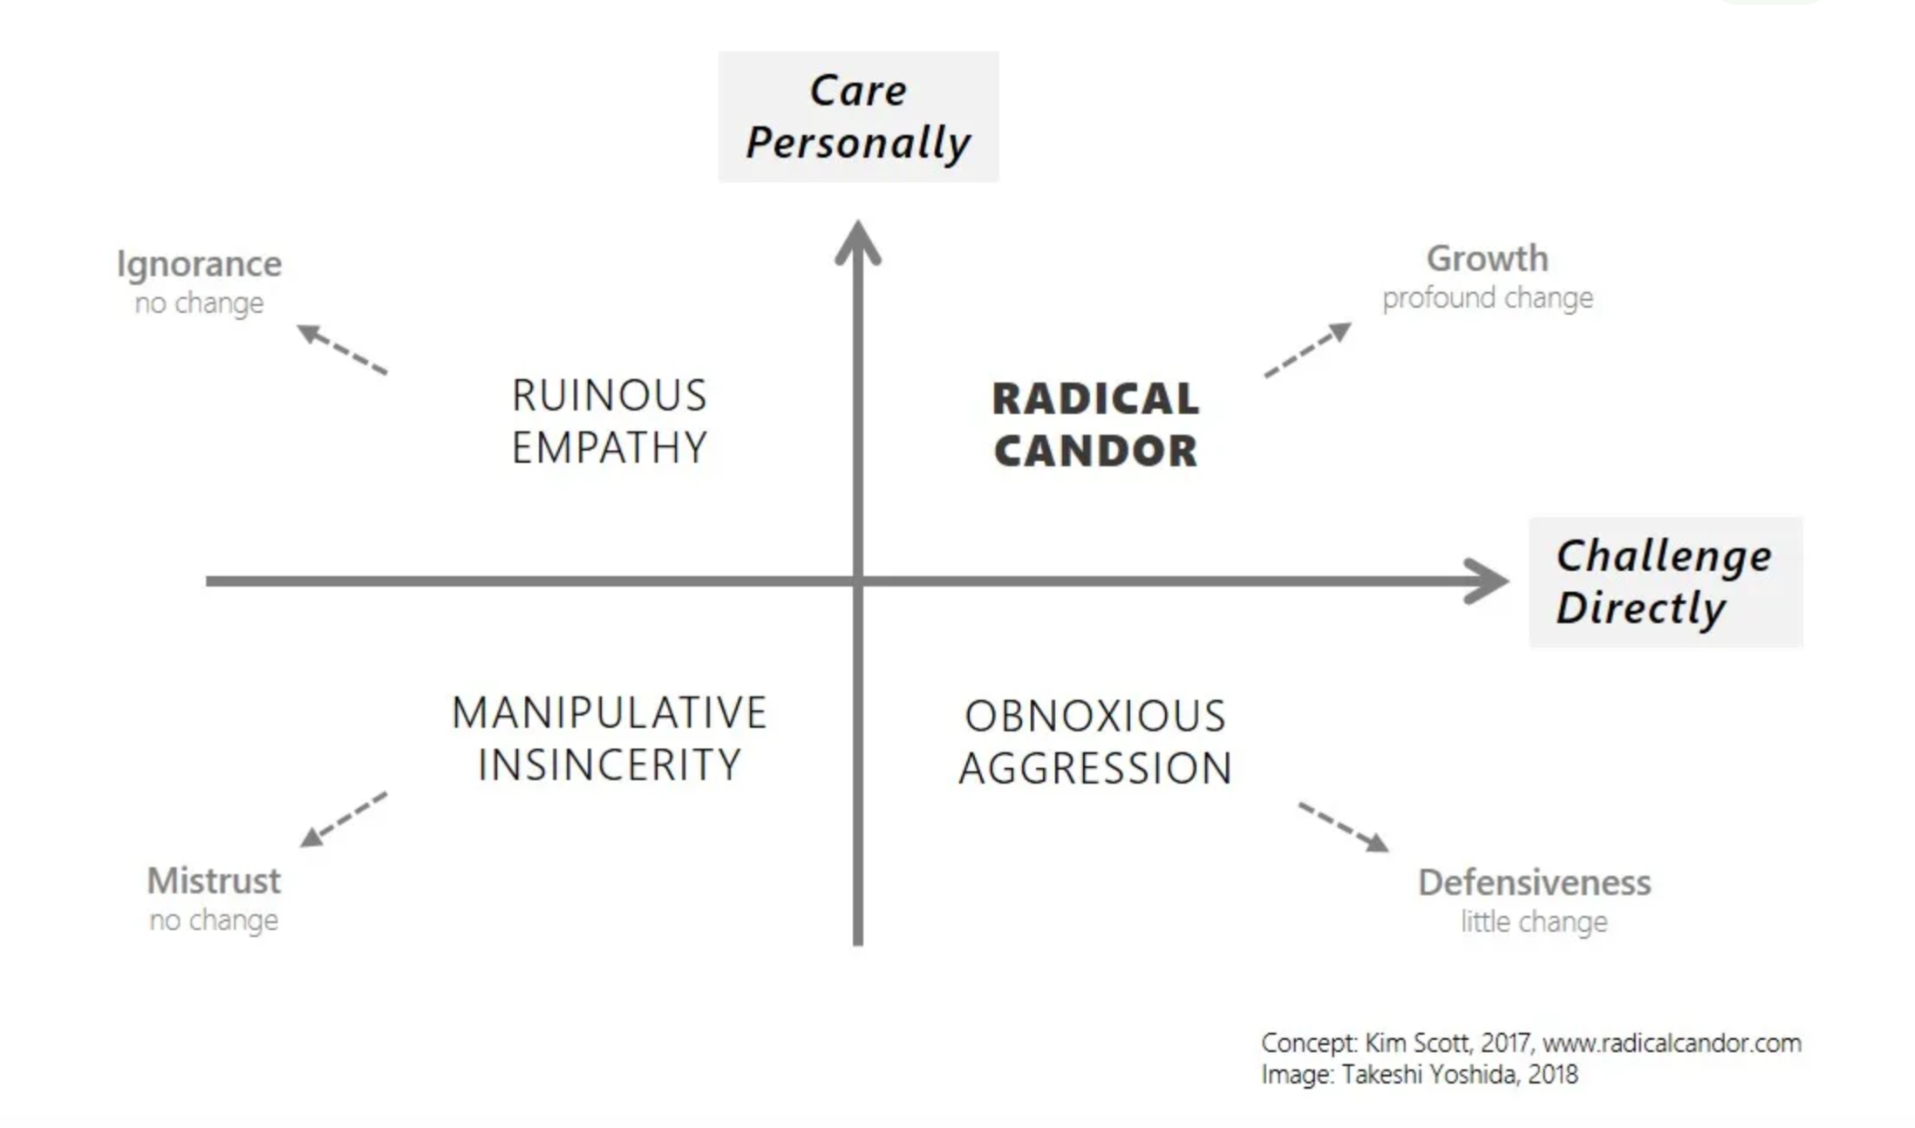

Sometimes, students do not hear feedback in the way the instructor intended. In these cases, it helps to take a step back and reflect.

The [Four Sides Model](https://medium.com/seek-blog/the-art-of-misunderstanding-and-the-4-sides-model-of-communication-7188408457ba) is a communication framework to understand the multifaceted nature of communication, emphasizing both the transmission and reception of messages. This model suggests that every communication act involves four distinct dimensions, each with its own "voice" for sending and "ear" for receiving.

1. Content Dimension: The "Content Voice" communicates factual information, focusing on the literal meaning that is conveyed. The speaker transmits facts and data. Correspondingly, the "Content Ear" of the listener is attuned to deciphering the factual content of the message, focusing on the information being shared.
2. Self-Revelation Dimension: Through the "Self-Revelation Voice," the speaker shares aspects of themselves, intentionally or unintentionally revealing their feelings, thoughts, or attitudes. This voice can express the speaker's inner state or personal insights. The listener's "Self-Revelation Ear" picks up on these cues, forming assumptions on the speaker's personal world beyond the factual content of the message.
3. Relationship Dimension: The "Relationship Voice" conveys the speaker's perception of their relationship with the listener through tone, choice of words, and non-verbal signals. This voice can indicate respect, affection, distance, or disdain, reflecting the speaker's stance towards the listener. The listener's "relationship ear" interprets these signals to understand the speaker's relational stance.
4. Appeal Dimension: Finally, the "Appeal Voice" embodies the speaker's desires or intentions, directing the listener towards a specific reaction or action. This can range from explicit requests to more subtle suggestions or influences. The "Appeal Ear" is sensitive to these directives, discerning what the speaker hopes to achieve or elicit from the listener, deciphering what the speaker is seeking, whether it's to perform an action, change a viewpoint, or offer support.

Integrating both the "voices" and "ears" aspects, the Four Sides Model illuminates the complexity of human communication and the multiple ways a messages can be framed. It highlights how every message is layered with multiple meanings and purposes, and how understanding and navigating these dimensions can enhance our interpersonal skills, reduce misunderstandings, and foster deeper connections with others.

Read this online at <https://edtechbooks.org/faculty_handbook/3_assessment_and_grading>