# Virtual Office Hours

You are expected to offer regular, weekly office hours.

You have two options for organizing your virtual office hours: Canvas Scheduler or Microsoft Bookings. It is recommended to choose one of these two. If your (work) life already runs on Outlook calendar, the Bookings link has the tremendous advantage that it automatically integrates with your calendar.

If you don't use Outlook, then using Canvas might be easier for you. SOWO instructional support can help you with the setup.

## Microsoft Bookings

Bookings (part of Office 365) is a web-based booking calendar that integrates with your Outlook calendar and email.

To use it, visit this link <https://outlook.office.com/bookwithme/me>, and log in to your account to start.

Important: Use the format ONYEN@ad.unc.edu to sign in.

The next screen should prompt you for your ONYEN password.

Next, you will need to enter a verification code.

Afterwards, you will see your bookings page. You may have existing meetings, or you can set up your first one.

The booking app can also be found in your outlook online email account.

### Create a new meeting option

Click  at the top right corner of the Publicor Privatesection

### Set up your meeting details

Detailed instructions in this [Link](https://uncschoolofsocialwork.h5p.com/content/1292117651904461478)

You can offer a link that allows students to set up a meeting any time you are available within your work hours to you can use the advanced options to specify dates and times when you hold regular office hours.

### Share the link

In your booking home page, click the Share button and there will be three ways to share your booking link: Copy link, Share via email, or Email signature settings. We suggest sharing the link regularly in your email announcements, and also ask SOWO instructional support to add it to your course overview.

## Canvas Scheduler

The Scheduler is a Calendar tool that creates appointment groups within a course allowing students to sign-up for a time slot within the appointment group.

Typically, instructors use the Canvas Scheduler to create office hours, schedule TA sessions or assign class presentation times.

### Go to your Canvas Calendar tool

The best way to ensure you are selecting the right calendar is to use 'Settings' and select 'Course Calendar'.

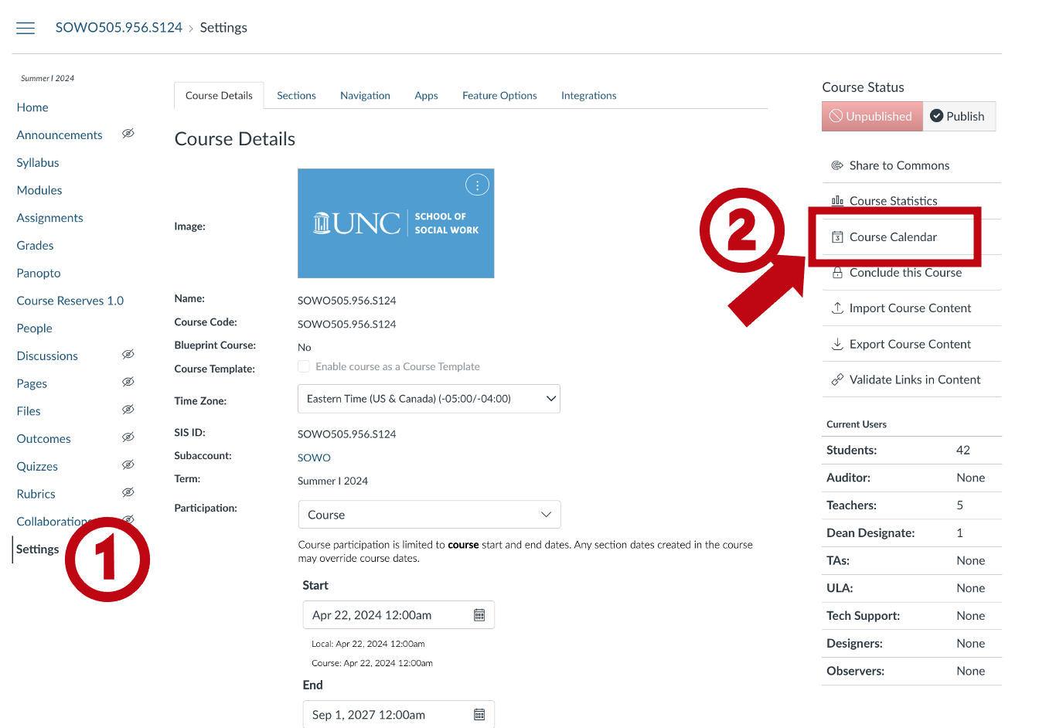

Click "+"

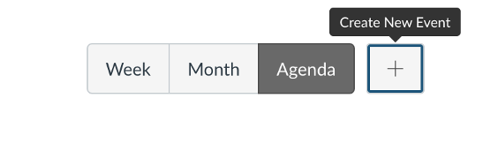

This displays the Edit Event dialogue box.

Select the Appointment Group tab to access the Edit Appointment Group form.

### Edit your Appointment Group

Start by entering a Name for the Appointment group and a Location. You can also provide details.

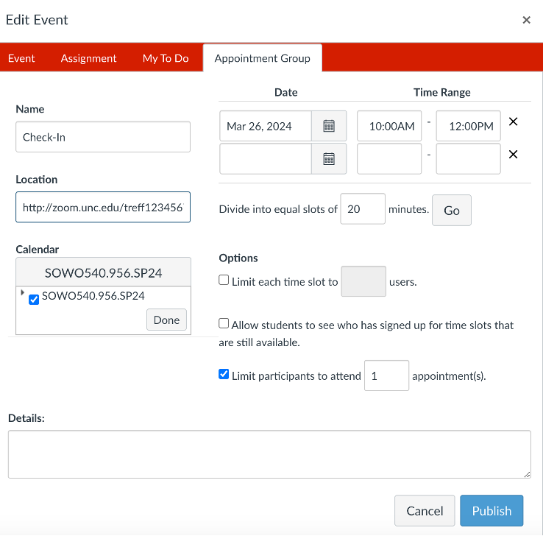

Use the Select Calendar dropdown box to select your course for this appointment group, then click Done.

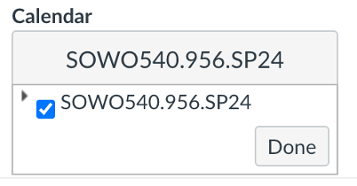

Select a date and time range for the Appointment group.

**Note:** You can add as many days and time ranges as you want to the appointment group.

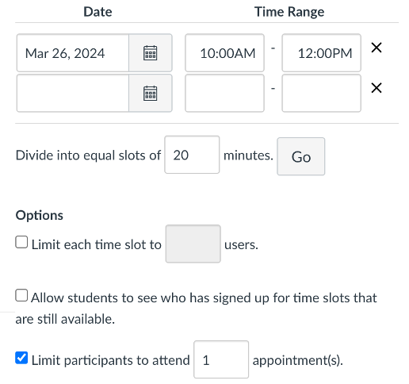

Enter a slot dividing time and Click Go. This will divide each time range into equal time slots of the specified dividing time.

**Note:** You must set a time slot interval AND click "Go" to divide EACH Time Period into EQUAL time slots. If the "Go" button is not pressed, the sign-up slots will be the same as the time periods.

Add Options (if desired), then click Publish. This creates the Assignment group.

### Accessing Appointments

To see how students sign-up for an appointment see: <https://community.canvaslms.com/t5/Student-Guide/How-do-I-sign-up-for-a-Scheduler-appointment-in-the-Calendar-as/ta-p/536>

As an instructor, you can view your calendar via Agenda View and all appointments and registrants will be listed – for more information see: <https://community.canvaslms.com/t5/Instructor-Guide/How-do-I-view-or-edit-a-Scheduler-appointment-group-in-a-course/ta-p/1244>

If a student has signed up for an appointment you will receive an email notification.

Read this online at <https://edtechbooks.org/faculty_handbook/virtual_office_hours>