# Design-Based Research

Allman, B., Leary, H.

Design-based research (DBR) is an educational research approach that addresses real-world educational problems and seeks to improve practice. DBR is part of the educational design research (EDR) research approaches. In educational psychology, the terms educational design research (EDR) and design-based research (DBR) are often used interchangeably when referring to the overall approach. DBR combines theories and practices from education, psychology, and human-computer interaction. It is use-inspired and practitioner-led. Its dual aim is to promote context-specific practical outcomes and to advance theoretical knowledge. DBR methodology employs iterative analysis, design, and evaluation cycles to refine educational interventions and to plan for their implementation and spread. Various research methods, including quantitative, qualitative, and mixed-method, are utilized depending on the research questions and the investigation stage. As a situated yet systemic approach with practical impact and theoretical contributions, DBR has the potential to transform people, practices, and systems and to bring value to educational research.

Educational design research (EDR) as a genre, rather than a discrete methodology, “encompasses the systematic study of designing, developing and evaluating educational interventions—such as programs, learning processes, learning environments, teaching-learning materials, products and systems” (Plomp, 2013, p. 11). Its main goal is to iteratively develop solutions to complex educational problems while enhancing theoretical understanding to inform further practice (Reeves & Lin, 2020). Related research designs within this family of approaches slightly vary in goals and characteristics and include, among others, design experiments (Brown, 1992), design research (Collins et al., 2004), development research (van den Akker, 1999), formative research (Weston et al., 1995), design-based research (Design-Based Research Collective, 2003), and design-based implementation research (Fishman et al., 2013). Although a specific subgroup, the term design-based research (DBR) often refers both to the overall family of approaches and the more specific approach. This article will use design-based research (DBR) to describe the overall research approach. However, EDR may be more accurate (see McKenney & Reeves, 2019, p. 17 for details).

In the 1990s, researchers realized that conducting educational research in controlled, laboratory-like settings does not lead to a complete understanding of the variables, their relationships, and related processes in naturalistic settings (Barab & Squire, 2004; Brown, 1992). Design-based research was introduced as an alternative interventionist approach for solving ill-structured problems in real-world contexts, aiming to design interventions to achieve desired outcomes and build fine-grained theoretical knowledge. DBR is particularly useful for addressing complex educational problems that cannot be solved through simple, one-size-fits-all solutions, such as developing and studying technology-based educational innovations, instructional methods, assessments, and curriculum materials. The results of DBR studies inform and improve educational practices and inform policy decisions (Plomp, 2013).

The DBR family of approaches share several distinct characteristics. We conceptualize these characteristics in terms of orientation, processes, and outcomes. DBR has a use-inspired orientation. It is situated and practitioner-led. DBR projects always strive to identify and solve educational problems through designing interventions. Being situated in real-world contexts allows for a nuanced understanding of specific needs in a particular setting, such as a school or a community (Barab & Squire, 2004). Based on this understanding, effective solutions tailored to those needs can be developed and improved, and reusable design principles related to teaching, learning, and performance can be identified (Reeves & Oh, 2017). Throughout the process, researchers closely collaborate with practitioners, such as teachers and administrators, to identify problems, develop solutions, help evaluate and refine the design, and study its effects (Herrington et al., 2007). The collaborative nature of DBR brings various perspectives to the table, ensuring that the design is relevant, usable, and sustainable in real-world settings and is based on the needs and perspectives of key stakeholders, including the learners (Design-Based Research Collective, 2003). Resulting designs and theoretical understanding more accurately reflect reality (ecological validity) and build knowledge that is both context-specific and potentially applicable to other settings and populations (generalizable; Anderson & Shattuck, 2012; McKenney & Reeves, 2019).

DBR processes are design-oriented, iterative, and flexible. Although DBR processes have been represented through different models (e.g., Anderson & Shattuck, 2012; Bannan-Ritland, 2003; Collins, 1990; McKenney & Reeves, 2019), there is a significant crossover. DBR typically starts with identifying a problem or challenge, followed by a thorough review of relevant literature to understand the issue deeply. Next, the research team engages in the design process, which typically involves generating multiple potential solutions, prototyping and testing them, and refining the design based on feedback from students, teachers, and other stakeholders. The design-test-refine cycle is repeated multiple times until the solution is optimized. The iterative design and evaluation process provides a rich data source for solving practical problems and informing our theoretical understanding. See Figure 1 for an illustration of the cyclical process.

Figure 1

The iterative design-based research process

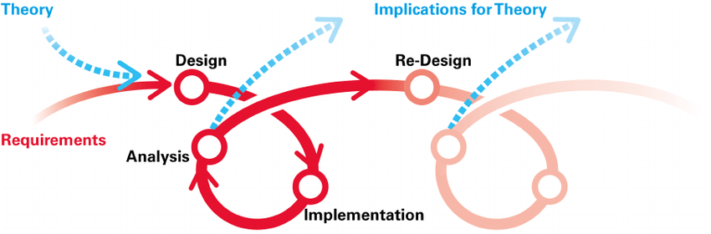

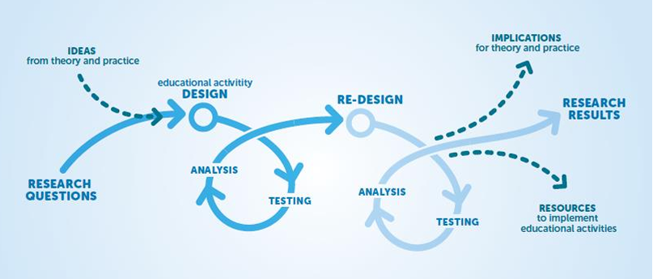

The DBR process reflects iterative cycles on different levels. Each DBR project and its components can be viewed as different combinations of micro-, meso-, and macro-cycles, where the results of each cycle inform the next steps within and across cycles (see Figure 2). For example, during the initial phase, identifying the problem is its own micro-cycle, carried out until a satisfactory result is reached. However, it also informs and is informed by the literature review, forming a meso-cycle. Furthermore, even reporting findings may further refine and bring understanding to the initial problem articulation (macro-cycle).

Figure 2

The iterative nature of BDR projects on micro-, meso-, and macro-level

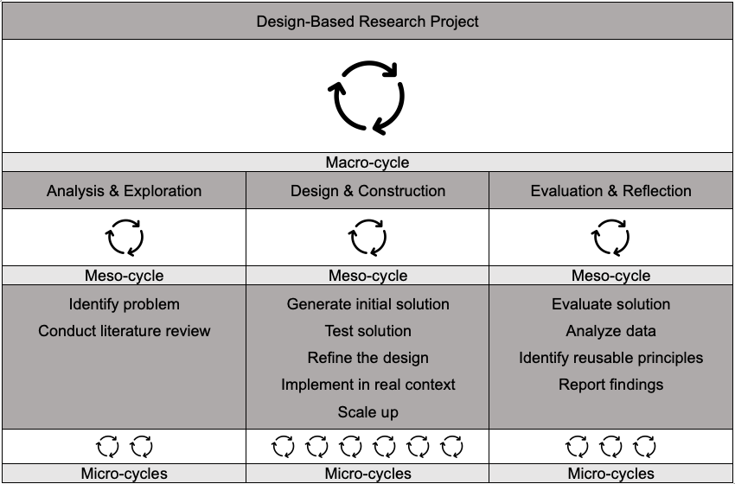

DBR is methodologically framed through questions, challenges, and problems of practice rather than following a prescribed set of procedures (Jacobsen & McKenney, 2023). Various existing quantitative and qualitative research methods and established norms for sampling, data collection, and analysis are used—different phases of DBR and the maturity of the project influence method selection (McKenney & Reeves, 2013). Specific approaches, procedures, and instruments are selected based on the most accurate and productive ways to answer given research questions. Methodological fit for purpose requires careful balancing of accuracy vs. cost, time demands, and invasiveness of selected methods (McKenney & Reeves, 2019).

DBR integrates design and research processes, where the design process informs the research, and the research guides the design. The resulting outcomes reflect this duality, always seeking to directly impact practice while advancing theory that can be useful to others (Barab & Squire, 2004). Practical outputs are typically presented as designed artifacts but could also represent innovative practices related to teaching, design, and research. Theoretical outputs come as reusable design principles and fine-grained theoretical understandings. Although such knowledge is contextually grounded, it is often general enough to be transferred to similar situations. The collaborative nature of DBR brings additional benefits to all involved participants by enhancing their professional development (Herrington et al., 2007).

While DBR can be a powerful tool for improving educational practice, it has challenges. DBR is often imprecisely defined and uses inconsistent terminology (Christensen & West, 2018). Because of its flexibility and complexity, steps and processes are vague and difficult to embrace, especially for novice researchers (Herrington et al., 2007). The design and evaluation processes are time-consuming and resource-intensive. Additionally, researchers must take on many demanding roles to complete DBR projects (Christensen & West, 2018). The iterative nature of DBR also poses issues, making it difficult to determine the overall impact of the intervention and replication with authenticity.

## References

Anderson, T., & Shattuck, J. (2012). Design-based research: A decade of progress in education research? Educational Researcher, 41(1), 16-25. <https://doi.org/10.3102/0013189X11428813>

Barab, S., & Squire, K. (2004). Design-based research: Putting a stake in the ground. Journal of the Learning Sciences, 13(1), 1-14. <https://doi.org/10.1207/s15327809jls1301_1>

Brown, A. L. (1992). Design experiments: Theoretical and methodological challenges in creating complex interventions in classroom settings. Journal of the Learning Sciences, 2(2), 141–178. <https://doi.org/https://doi.org/10.1207/s15327809jls0202_2>

Christensen, K. D. N. & West, R. E. (2018). The development of design-based research. In R. E. West (Ed.), Foundations of learning and instructional design technology. EdTech Books. <https://edtechbooks.org/lidtfoundations/development_of_design-based_research>

Collins, A., Joseph, D., & Bielaczyc, K. (2004). Design research: Theoretical and methodological issues. The Journal of the Learning Sciences, 13(1), 15–42. <https://doi.org/https://doi.org/10.1207/s15327809jls1301_2>

Design-Based Research Collective. (2003). Design-based research: An emerging paradigm for educational inquiry. Educational Researcher, 32(1), 5-8. <https://doi.org/10.3102/0013189X032001005>

Fishman, B. J., Penuel, W. R., Allen, A. -R., Cheng, B. H., & Sabelli, N. (2013). Design-based implementation research: An emerging model for transforming the relationship of research and practice. Teachers College Record, 115(14), 136-156. <https://doi.org/10.1177/016146811311501415>

Herrington, J., McKenney, S., Reeves, T. C., & Oliver, R. (2007). Design-based research and doctoral students: Guidelines for preparing a dissertation proposal. In C. Montgomerie & J. Seale (Eds.), Proceedings of World Conference on Educational Multimedia, Hypermedia and Telecommunications 2007 (pp. 4089–4097). AACE. <https://doi.org/10.1017/CBO9781107415324.004>

Jacobsen, M., & McKenney, S. (2023). Educational design research: Grappling with methodological fit. Educational Technology Research and Development, 71. <https://doi.org/10.1007/s11423-023-10282-5>

McKenney, S., & Reeves, T. C. (2013). Systematic review of design-based research progress: Is a little knowledge a dangerous thing? Educational Researcher, 42(2), 97–100. <https://doi.org/10.3102/0013189X12463781>

McKenney, S., & Reeves, T. (2019). Conducting educational design research (2nd ed.). Routledge. <https://doi.org/10.4324/9781315105642>

Plomp, T. (2013). Educational design research: An introduction. In T. Plomp & N. Nieveen (Eds.), Educational design research - Part A: An introduction (pp. 10-51). SLO Netherlands Institute for Curriculum Development. <https://s2pnd-matematika.fkip.unpatti.ac.id/wp-content/uploads/2022/10/educational-design-research-part-a.pdf>

Reeves, T. C., & Oh, E. G. (2017). The goals and methods of educational technology research over a quarter century (1989–2014). Educational Technology Research and Development, 65(2), 325–339. <https://doi.org/10.1007/s11423-016-9474-1>

Reeves, T. C., & Lin, L. (2020). The research we have is not the research we need. Educational Technology Research and Development, 68(4), 1991–2001. <https://doi.org/10.1007/s11423-020-09811-3>

Van den Akker, J. (1999). Principles and methods of developmental research. In J. van den Akker, R.M. Branch, K. Gustafson, N. Nieveen, & T. Plomp (Eds.), Design approaches and tools in education and training (pp.1-14). Springer. <https://doi.org/10.1007/978-94-011-4255-7_1>

Weston, C., McAlpine, L., & Bordonaro, T. (1995). A model for understanding formative evaluation in instructional design. Educational Technology Research and Development, 43(3), 29-48. <https://doi.org/10.1007/BF02300454>

## Related Resources

<https://edtechbooks.org/lidtfoundations/development_of_design-based_research>

<https://edtechbooks.org/studentguide/design-based_research>

Read this online at <https://edtechbooks.org/encyclopedia/designbased_research>