# Intelligence

Spielman, R. , Dumper, K., Jenkins, W. , Lacombe, A., Lovett, M., Perlmutter, M.

### Editor’s Note

The following is excerpted from an OpenStax book produced by Rice University. Download at [https://edtechbooks.org/-Gz](http://cnx.org/content/col11629/latest/).

Spielman, R. M., Dumper, K., Jenkins, W., Lacombe, A., Lovett, M., & Perlmutter, M. (n.d.). What are intelligence and creativity? In Psychology. Retrieved from [https://edtechbooks.org/-Is](http://cnx.org/contents/Sr8Ev5Og@5.75:llWPi2c1@5/What-Are-Intelligence-and-Crea)

The way that researchers have defined the concept of intelligence has been modified many times since the birth of psychology. British psychologist Charles Spearman believed intelligence consisted of one general factor, called g, which could be measured and compared among individuals. Spearman focused on the commonalities among various intellectual abilities and de-emphasized what made each unique. Long before modern psychology developed, however, ancient philosophers, such as Aristotle, held a similar view (Cianciolo & Sternberg, 2004).

Other psychologists believe that instead of a single factor, intelligence is a collection of distinct abilities. In the 1940s, Raymond Cattell proposed a theory of intelligence that divided general intelligence into two components: crystallized intelligence and fluid intelligence (Cattell, 1963). Crystallized intelligence is characterized as acquired knowledge and the ability to retrieve it. When you learn, remember, and recall information, you are using crystallized intelligence. You use crystallized intelligence all the time in your coursework by demonstrating that you have mastered the information covered in the course. Fluid intelligence encompasses the ability to see complex relationships and solve problems. Navigating your way home after being detoured onto an unfamiliar route because of road construction would draw upon your fluid intelligence. Fluid intelligence helps you tackle complex, abstract challenges in your daily life, whereas crystallized intelligence helps you overcome concrete, straightforward problems (Cattell, 1963).

Other theorists and psychologists believe that intelligence should be defined in more practical terms. For example, what types of behaviors help you get ahead in life? Which skills promote success? Think about this for a moment. Being able to recite all 44 presidents of the United States in order is an excellent party trick, but will knowing this make you a better person?

Robert Sternberg developed another theory of intelligence, which he titled the triarchic theory of intelligence because it sees intelligence as comprised of three parts (Sternberg, 1988): practical, creative, and analytical intelligence (Figure 1).

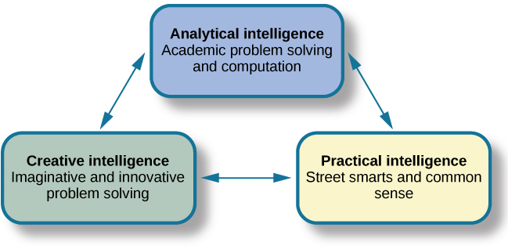

**Figure 1.** Sternberg’s theory identifies three types of intelligence: practical, creative, and analytical. Included in original OpenStax chapter.

Practical intelligence, as proposed by Sternberg, is sometimes compared to “street smarts.” Being practical means you find solutions that work in your everyday life by applying knowledge based on your experiences. This type of intelligence appears to be separate from traditional understanding of IQ; individuals who score high in practical intelligence may or may not have comparable scores in creative and analytical intelligence (Sternberg, 1988).

This story about the 2007 Virginia Tech shootings illustrates both high and low practical intelligences. During the incident, one student left her class to go get a soda in an adjacent building. She planned to return to class, but when she returned to her building after getting her soda, she saw that the door she used to leave was now chained shut from the inside. Instead of thinking about why there was a chain around the door handles, she went to her class’s window and crawled back into the room. She thus potentially exposed herself to the gunman. Thankfully, she was not shot. On the other hand, a pair of students was walking on campus when they heard gunshots nearby. One friend said, “Let’s go check it out and see what is going on.” The other student said, “No way, we need to run away from the gunshots.” They did just that. As a result, both avoided harm. The student who crawled through the window demonstrated some creative intelligence but did not use common sense. She would have low practical intelligence. The student who encouraged his friend to run away from the sound of gunshots would have much higher practical intelligence.

Analytical intelligence is closely aligned with academic problem solving and computations. Sternberg says that analytical intelligence is demonstrated by an ability to analyze, evaluate, judge, compare, and contrast. When reading a classic novel for literature class, for example, it is usually necessary to compare the motives of the main characters of the book or analyze the historical context of the story. In a science course such as anatomy, you must study the processes by which the body uses various minerals in different human systems. In developing an understanding of this topic, you are using analytical intelligence. When solving a challenging math problem, you would apply analytical intelligence to analyze different aspects of the problem and then solve it section by section.

Creative intelligence is marked by inventing or imagining a solution to a problem or situation. Creativity in this realm can include finding a novel solution to an unexpected problem or producing a beautiful work of art or a well-developed short story. Imagine for a moment that you are camping in the woods with some friends and realize that you’ve forgotten your camp coffee pot. The person in your group who figures out a way to successfully brew coffee for everyone would be credited as having higher creative intelligence.

Multiple Intelligences Theory was developed by Howard Gardner, a Harvard psychologist and former student of Erik Erikson. Gardner’s theory, which has been refined for more than 30 years, is a more recent development among theories of intelligence. In Gardner’s theory, each person possesses at least eight intelligences. Among these eight intelligences, a person typically excels in some and falters in others (Gardner, 1983). Figure 2 describes each type of intelligence.

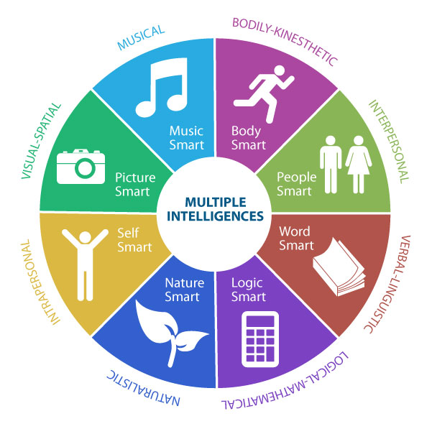

**Figure 2.**

Multiple intelligences theory proposed by Gardner. Image from Sajaganesandip on Wikimedia Commons and licensed CC-By, Share Alike

Gardner’s theory is relatively new and needs additional research to better establish empirical support. At the same time, his ideas challenge the traditional idea of intelligence to include a wider variety of abilities, although it has been suggested that Gardner simply relabeled what other theorists called “cognitive styles” as “intelligences” (Morgan, 1996). Furthermore, developing traditional measures of Gardner’s intelligences is extremely difficult (Furnham, 2009; Gardner & Moran, 2006; Klein, 1997).

Gardner’s inter- and intrapersonal intelligences are often combined into a single type: emotional intelligence. Emotional intelligence encompasses the ability to understand the emotions of yourself and others, show empathy, understand social relationships and cues, and regulate your own emotions and respond in culturally appropriate ways (Parker, Saklofske, & Stough, 2009). People with high emotional intelligence typically have well-developed social skills. Some researchers, including Daniel Goleman, the author of Emotional Intelligence: Why It Can Matter More than IQ, argue that emotional intelligence is a better predictor of success than traditional intelligence (Goleman, 1995). However, emotional intelligence has been widely debated, with researchers pointing out inconsistencies in how it is defined and described, as well as questioning results of studies on a subject that is difficult to measure and study empirically (Locke, 2005; Mayer, Salovey, & Caruso, 2004).

Intelligence can also have different meanings and values in different cultures. If you live on a small island, where most people get their food by fishing from boats, it would be important to know how to fish and how to repair a boat. If you were an exceptional angler, your peers would probably consider you intelligent. If you were also skilled at repairing boats, your intelligence might be known across the whole island. Think about your own family’s culture. What values are important for Latino families? Italian families? In Irish families, hospitality and telling an entertaining story are marks of the culture. If you are a skilled storyteller, other members of Irish culture are likely to consider you intelligent.

Some cultures place a high value on working together as a collective. In these cultures, the importance of the group supersedes the importance of individual achievement. When you visit such a culture, how well you relate to the values of that culture exemplifies your cultural intelligence, sometimes referred to as cultural competence.

### Application Exercises

* Some argue “that emotional intelligence is a better predictor of success than traditional intelligence.” Discuss whether you agree and/or disagree with this statement, and support why you feel this way.
* What intelligence theory did you find most compelling? Why?



Please complete this short survey to provide feedback on this chapter:

<http://bit.ly/IntelligenceTheory>

Read this online at <https://edtechbooks.org/lidtfoundations/intelligence>