# The Necessary and Proper Clause

## **Standard 5.1: The Necessary and Proper Clause**

Explain the necessary and proper clause and why it is often referred to as the “elastic clause.” **(**Massachusetts Curriculum Framework for History and Social Studies) **[8.T5.1]**

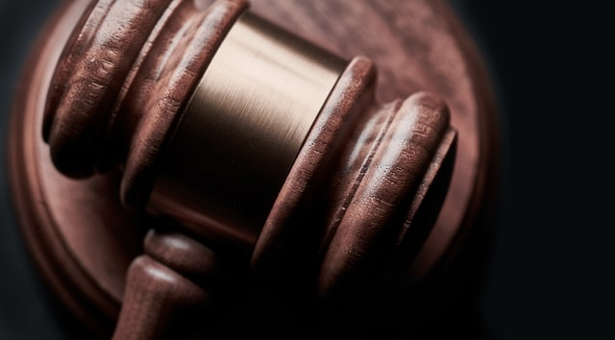

## **FOCUS QUESTION: What is the Role of the Necessary and Proper Clause?**

The [**Necessary and Proper Clause**](https://constitutioncenter.org/interactive-constitution/interpretation/article-i/clauses/754) (also known as the [**Elastic Clause**](https://legaldictionary.net/elastic-clause/)) is one of the most far-reaching aspects of the United States Constitution. Article 1, Section 8, Clause 18 of the Constitution reads:

"The Congress shall have Power ... To make all Laws which shall be necessary and proper for carrying into Execution the foregoing Powers, and all other Powers vested by this Constitution in the Government of the United States, or in any Department or Officer thereof."

Legal scholars have called it the "single most important provision in the Constitution" ([The Necessary and Proper Clause](https://constitutioncenter.org/interactive-constitution/interpretation/article-i/clauses/754)).

There is an **inherent tension** between the necessary and proper clause and the 10th Amendment. While the necessary and proper clause states Congress can make the laws needed to carry out its Constitutional functions, the 10th Amendment states powers not delegated to the federal government are given to the states. As a result, there are ongoing disputes over which part of government (federal or state) has the power to take certain actions.

You can learn more about the [10th Amendment in Topic 6.5](https://edtechbooks.org/democracy/tenthamendment) of this book.

#### **History of the Necessary and Proper Clause**

In writing the Constitution, the framers gave Congress both defined and assumed powers. "**Defined**" means specified and fixed powers. "**Assumed**" means that Congress may enact any law that can be seen as: 1) necessary; 2) proper; and 3) carries out federal power (McDaniel, 2019). You can read text and commentary about the Necessary and Proper Clause from [National Constitution Center's Interactive Constitution website](https://constitutioncenter.org/interactive-constitution/interpretation/article-i/clauses/754).

Reviewing the origins of the necessary and proper clause, [Doug Linder of the University of Missouri-Kansas City School of Law](http://law2.umkc.edu/faculty/projects/ftrials/conlaw/nec&amp;proper.html) explained that **Alexander Hamilton** and **Thomas Jefferson** had sharply opposing views about the clause and its uses.

Hamilton who favored a strong central government saw the elastic clause as a broad license to act whenever needed.

Jefferson who wanted a smaller, more limited federal government, thought this power should be used only when absolutely necessary.

Still, Linder notes, it was Jefferson who authorized the Louisiana Purchase even though he was not sure he had the power to do so.

Uses of the [necessary and proper clause during the 20th Century are listed on its Wikipedia page](https://en.wikipedia.org/wiki/Necessary_and_Proper_Clause), including the Federal Kidnapping Act of 1932 which made transporting a kidnapped person across state lines a federal crime under the Constitution's Commerce Clause.

In Printz v. United States (1997), the Supreme Court ruled that requiring states to follow federal gun registration rules **was not proper** it because it infringed on the powers of states.

In the 2012 case [National Federation of Independent Business v. Sebelius](https://www.oyez.org/cases/2011/11-393), the Supreme Court said Congress could not use the necessary and proper clause to justify the individual mandate feature of the Affordable Care Act (also known as Obamacare).

You can learn more about the enumerated and implied powers of government in [Topic 6.3 of this book](https://edtechbooks.org/democracy/powers#h3_uUjvi).

### Suggested Learning Activities

* **Role-Play a Landmark Case**
  + In small groups,
    - Select a legal case in which the Necessary and Proper Clause was used
    - Create a video in which you role-play the most influential aspects of the case and the use of the clause
* **State Your View**
  + Discuss and debate: How broad should the powers of Congress be under the elastic clause?

## Online Resources for the Necessary and Proper Clause

* [Sharing the Necessary and Proper Clause: The indeterminacy of deference](https://harvardlawreview.org/2014/11/sharing-the-necessary-and-proper-clause/), Harvard Law Review
* [McCulloch v. Maryland](https://billofrightsinstitute.org/educate/educator-resources/lessons-plans/landmark-supreme-court-cases-elessons/mcculloch-v-maryland-1819/) (1819) from the Bill of Rights Institute

Read this online at <https://edtechbooks.org/democracy/properclause>