Pre-Algebra Student Negative Sign Computer-based Learning
Grimm, B., Kolski, T.
Middle school students who struggle with manipulating math expressions involving the negative sign have demonstrated difficulty learning pre-algebra content that prepares them for higher-level math courses. This study involved a multimedia intervention to improve middle school students' negative sign proficiency and math self-efficacy. A mixed-methods action research study was implemented involving 28 middle school students who participated in an intervention three days a week, working on 12 computer-based math learning modules. The module's learning goals focused on students evaluating negative sign expressions supported by Realistic Mathematics Education learning theory, cognitive theory of multimedia learning, and multimedia self-efficacy instructional strategies. The results showed a statistically significant improvement in negative sign math proficiency, a non-significant improvement in math self-efficacy, and that student perceptions of learning through the modules were favorable. This research contributes to understanding technology intervention learning environments that include middle school math self-efficacy instructional strategies.

Introduction
Since the publication of A Nation at Risk: The Imperative for Educational Reform (National Commission on Excellence in Education, 1983), the United States educational school systems have been vigilantly working to improve mathematics achievement for K-12 students. Despite the increased national focus, many students still have difficulty learning algebra concepts because they cannot perform operations with negative numbers (Vlassis, 2004). More recent research on Algebra I students shows that students are making more errors when working with a negative sign, exceeding errors in arithmetic and fraction operations (Young & Booth, 2020). The difficulties are further exacerbated because being able to work with negative numbers and the negative sign is critical to students being able to learn higher-level math concepts.

Negative sign knowledge
In the United States education system, students are typically first taught integer operations in middle school. During their previous years in elementary school, students are taught extensively positive number mathematics, which may provide obstacles when they are exposed to working with negative numbers (Bruno & Martinon, 1999). With a backdrop of the earlier rules learned for positive numbers, negative numbers present counterintuitive concepts, such as -5 being greater than -1 (Whitacre et al., 2017). Developing knowledge of a learner’s conceptual understanding of the negative sign has been accomplished through historical concept development comparisons, dissecting the various applications of the negative sign in mathematics, and research on instructional approaches (Bishop et al., 2014). The cognitive role of learning through contextualization approaches to math learning through a focused instructional model that uses hypothetical learning trajectories has been empirically demonstrated to be an effective strategy for mathematical learning environments (Simon, 2018).

Math self-efficacy
A learner’s mathematical self-efficacy has been shown to have implications for learning but also shows there are opportunities to develop it through instructional strategies (Huang et al., 2020). Bandura (1997) identified four sources of self-efficacy: physiological state, vicarious experience, social persuasion, and mastery experience. Employing a vicarious experience source of self-efficacy, Knapp (2020) used teacher-made screencasts of geometry lessons which led to the students reporting higher self-efficacy after watching them. Improved math proficiency and positive self-efficacy effects may be achieved through strong teacher-student and peer relationships that impact student social persuasion while providing multiple opportunities to observe the modeling of peers provide positive vicarious and social persuasion experiences (Townsend, 2016). Math instruction should maximize mastery experience opportunities for a student as it is the most potent source of math self-efficacy (Usher & Pajares, 2009).

Multimedia learning
The cognitive theory of multimedia learning and its associated principles provide a framework for developing educational multimedia presentations. To promote cognitive information processes for knowledge construction, an instructional design incorporating computer technology should consider research-based principles that provide insight into the influences of learner cognitive load on information gathering and integration (Mayer, 2019). Supporting the development of instructional products, cognitive load theory provides a foundation for product design that enhances learning through the way information is exhibited and interacted with (Mayer, 2019). Information a learner is given to process should be minimized if it has no value to the learning objective, and depending on the complexity of the material, the information should be appropriately scaffolded based on the ability of the learner to optimize the demand to their working memory (Clark & Mayer, 2016). Consistent with the constructivist view of learning, Mayer (2019) encompasses multimedia platforms used for knowledge construction supported by twelve multimedia learning principles. Six multimedia learning principles were incorporated into the intervention instructional design for this research project: Coherence, Spatial Contiguity, Segmenting, Personalization, Voice, and Image principles. This approach provided opportunities for the computer modules to optimize student negative sign knowledge construction while working within the computer-based learning environment.

Purpose
When students struggle with math expressions involving negatives, their proficiency and self-efficacy are negatively impacted. An intervention that provides a directed approach was needed to improve students’ math proficiency and self-efficacy. The following research questions were explored:
- How and to what extent did the computer-based intervention influence students’ negative sign math proficiency?
- How and to what extent did the computer-based intervention influence students’ math self-efficacy?
- What were students’ perceptions about the computer-based intervention on their learning experience?

Intervention components
The computer-based mathematics learning modules (CMLM) were developed using the topics of negative sign math expressions, Realistic Mathematics Education learning theory, hypothetical learning trajectories, self-efficacy instructional strategies, and the cognitive theory of multimedia learning. The participants in this study included 28 middle school students enrolled in a pre-algebra course. Written, parental consent was obtained for each participant. The students engaged in the intervention three days a week for four weeks completing 12 CMLM which included computer-assisted instruction features for math proficiency strategies focused on student conceptual understanding and procedural fluency. The CMLM included interactive digital slideshows created using PowerPoint that the student could complete without teacher assistance. Use of the PowerPoint presentations allowed for self-efficacy instructional strategies to be incorporated through physiological state growth mindset videos, teacher-created lecture screencasts for vicarious experiences, mastery experience practice problems, and social persuasion feedback that included middle school student images and caption bubbles (see Figure 1).
Figure 1
Example of feedback following a correct response. Picture from Pexels.com, (Taylor, 2020). All rights reserved. Used with permission.
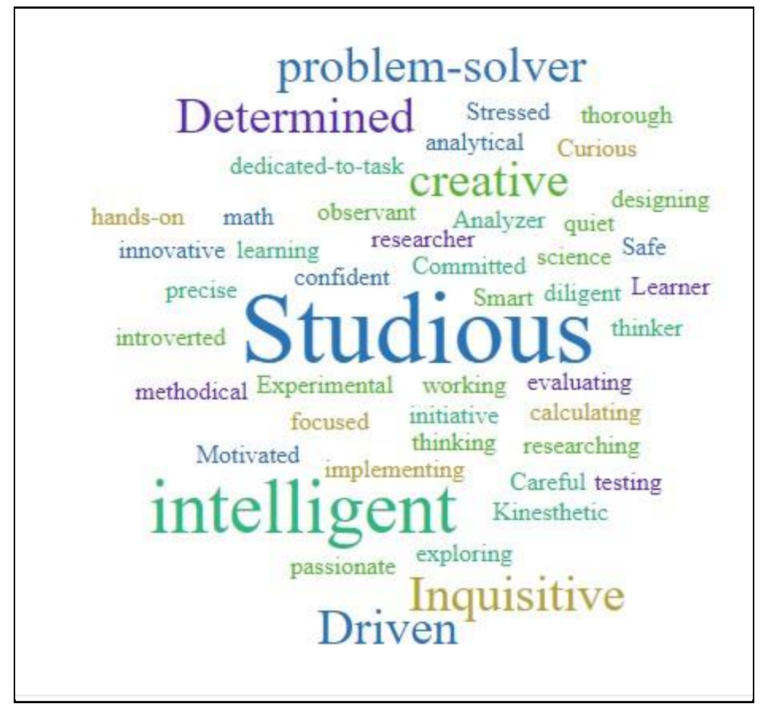

Method and Results
This was a mixed-methods action research study. Quantitative data was collected using four instruments: Pre/Post Mathematics Proficiency Assessment, Pre/Post Sources of Middle School Mathematics Self-Efficacy Scale (Usher & Pajares, 2009), Post Student Perception Survey (Bryant et al., 2020), and Lesson Exit Tickets. Qualitative data were collected from participant think-aloud activities and individual student interviews. The Mathematics Proficiency Assessment consisted of sixteen questions that had three multiple-choice answers. These results support that students scored statistically significantly higher on the post-assessment, t(27) = -4.50, p < .001. The Sources of Middle School Mathematics Self-Efficacy Scale consisted of four subscales, totaling 24 statements, each with a four-point Likert rating scale. An analysis of the data indicated that students showed a non-significant difference from the
pre-survey (Mdn = 2.50) to the post-survey (Mdn = 2.46; W = 140.50, p = .80). The Student Perceptions Survey consisted of 22 Likert-rating scale statements divided into two subscales: Math Activities (8 statements) and Computer Modules (14 statements). Using descriptive statistics to identify quantitative trends (Creswell & Creswell, 2018), the results support student perspectives about using the CMLM in their learning to have been positive overall. Students were given Likert-rating scale lesson exit tickets covering student math proficiency, student self-efficacy, and student perceptions. The student’s perceptions of the intervention helping them improve their understanding of math expressions involving negative signs were positive (in agreement) to the questions offered regarding their math proficiency (M=3.84, SD=0.73), student self-efficacy (M=3.81, SD=0.74), and student perceptions (M=3.92, SD=0.78).
Three themes emerged from the qualitative data: CMLM’s provided a productive learning environment for reviewing math concepts and skill mastery, feedback supported students' mathematical proficiency and self-efficacy mastery experiences, and conceptualized learning fostered student's persistence in working through their struggles with mathematical language. Theme one was supported by quantitative data through the Student Perception survey. Interview comments included “Computer modules help me understand what I need to work on” and “Computer modules help me to learn from my mistakes. Theme two was supported by the self-efficacy scale outcomes, which indicated positive increases between the pre/post-survey means related to mastery experience, physiological state, and social persuasion. Supporting comments included “it really helps to know how I did in a problem”, “modules made me think”, and “math can be boring, but I need to learn it.” Theme three was supported by quantitative data through the proficiency assessment, showing a statistically significant increase in pre/post-test means. Student comments also reflected this finding, for example, “Some videos were good, like the ones that talked about money” or “Three is bigger than the one, and three is negative, so it should be negative two dollars.”

Discussion
The present research contributes to understanding a technology instruction intervention for negative sign math proficiency and student self-efficacy in a traditional classroom learning environment. The pedagogical implications for teachers include implementing technology interventions for math content review and using think-aloud activities for instructional formative feedback on student understanding. This research replicated aspects of previous work in showing evidence that middle school students see CMLM as beneficial (Aytekin & Isiksal-Bostan, 2019), that contextualizing negative sign applications assists student understanding (Clarke & Roche, 2018), and that self-efficacy instructional strategies can influence math self-efficacy (Huang et al., 2020).

References
Aytekin, E., & Isiksal-Bostan, M. (2019). Middle school students’ attitudes towards the use of technology in mathematics lessons: Does gender make a difference? International Journal of Mathematical Education in Science and Technology, 50(5), 707–727.
Bandura, A. (1997). Self-efficacy: The exercise of control. W.H. Freeman.
Bishop, J. P., Lamb, L. L., Philipp, R. A., Whitacre, I., Schappelle, B. P., & Lewis, M. L. (2014). Obstacles and affordances for integer reasoning: An analysis of children’s thinking and the history of mathematics. Journal for Research in Mathematics Education, 45(1), 19–61.
Bruno, A., & Martinon, A. (1999). The teaching of numerical extensions: The case of negative numbers.International Journal of Mathematical Education in Science and Technology, 30(6), 789–809.
Bryant, D. P., Bryant, B. R., Dougherty, B., Roberts, G., Pfannenstiel, K. H., & Lee, J. (2020). Mathematics performance on integers of students with mathematics difficulties. Journal of Mathematical Behavior, 58, 1-13.
Clark, R. C., & Mayer, R. E. (2016). E-learning and the science of instruction: Proven guidelines for consumers and designers of multimedia learning (4th ed.). Wiley.
Clarke, D., & Roche, A. (2018). Using contextualized tasks to engage students in meaningful and worthwhile mathematics learning. The Journal of Mathematical Behavior, 51, 95–108.
Creswell, J. W., & Creswell, J. D. (2018). Research design: Qualitative, quantitative, and mixed method approaches (5th ed.). SAGE.
Huang, X., Mayer, R. E., & Usher, E. L. (2020). Better together: Effects of four self-efficacy-building strategies on online statistical learning. Contemporary Educational Psychology, 63, 1-14.
Knapp, A. (2020). Making eLearning engaging: The effect of technology strategies on student engagement and content knowledge development in a secondary mathematics digital classroom (Order No. 27999894) [Doctoral dissertation, University of South Carolina]. ProQuest Dissertations & Theses Global.
Mayer, R. E. (2019). Thirty years of research on online learning.Applied Cognitive Psychology, 33(2), 152–159. National Commission on Excellence in Education. (1983). A nation at risk: The imperative for educational reform.
http://www.channelingreality.com/UN/Education/NationAtRisk/NATION_AT_RISK_Background.pdf Simon, M. A. (2018). An emerging methodology for studying mathematics concept learning and instructional design. The Journal of Mathematical Behavior, 52, 113–121. https://doi.org/10.1016/j.jmathb.2018.03.005 Taylor, M. (2020). Student outside with laptop. https://Pexels.com
Townsend, C. A. (2016). Culturally relevant mathematics for high poverty 8th graders: Influences on mathematics self-efficacy (Order No. 10240287) [Doctoral dissertation, Washington State University]. ProQuest Dissertations & Theses Global.
Usher, E. L., & Pajares, F. (2009). Sources of self-efficacy in mathematics: A validation study. Contemporary Educational Psychology, 34(1), 89–101.
Vlassis, J. (2004). Making sense of the minus sign or becoming flexible in `negativity.' Learning and Instruction, 14(5), 469-484.
Whitacre, I., Azuz, B., Lamb, L. L. C., Bishop, J. P., Schappelle, B. P., & Philipp, R. A. (2017). Integer comparisons across the grades: Students’ justifications and ways of reasoning. The Journal of Mathematical Behavior, 45, 47–62.
Young, L. K., & Booth, J. L. (2020). Don’t eliminate the negative: Influences of negative number magnitude knowledge on algebra performance and learning. Journal of Educational Psychology, 112(2), 384–396.
Read this online at https://edtechbooks.org/jaid_13_2/prealgebra_student_negative_sign_computerbased_learning

