# Background Knowledge

A listening strategy is a conscious action a listener does to better understand what he or she is listening to. In other words, it is a choice the listener makes to improve comprehension. One of the fundamental strategies for listening is connecting the content to your own background knowledge.

### Objectives

1. Explain the listening strategy of connecting content to background knowledge
2. Connect background knowledge to topic to predict content
3. Use background knowledge and content to understand more fully

## Introduction to Background Knowledge

What is a **background**? Let's start with an example. Think of a movie or tv show that you enjoy watching. The actors exist in a specific environment and time. This is the background or **context** of the story. All of those details surrounding the actor add to your understanding. There are certain things you would expect to see in a story about kings and queens that would be different from a story about astronauts exploring space. When we see the actors telling their story with that background, our brains are actively making sense of what happens and predicting what will happen next.

All listening happens in the same way. Regardless of whether you are listening to a friend talk about a bad date or a professor explaining neuroscience, your brain will be creating a background using the information you already have and the information you are receiving. The idea behind this listening strategy is to activate the background knowledge as quickly as possible so the information you begin receiving has a logical place to exist in your mind. That will make it easier to comprehend what you hear.

Why would this be so important in your second language? Activating background knowledge does a few useful things for you in your second language:

1. The knowledge you already have about the topic in your first language is active, which means you are more ready to create those ideas in English.
2. Your brain searches for and recalls important vocabulary for the topic.
3. You think about possible organization (ex. Will the person be presenting an opinion? Or will it be a comparison?)

### Practice 1: Use Background Knowledge

Watch these videos and practice activating your background knowledge on these different topics.

Science: Volcanoes

* Look at the title of this video. On a piece of paper, make a list of what you know about volcanoes. If you don't know the word in English, you can still write it in your native language.
* Before you watch the video, predict how the speaker will organize the ideas.
* Circle words in your list that you think the speaker will use.
* Watch the video. You may use subtitles if that is helpful for you.
* After you watch the video, write down any new words you learned.
* How did activating your background knowledge prepare you to listen to this topic?

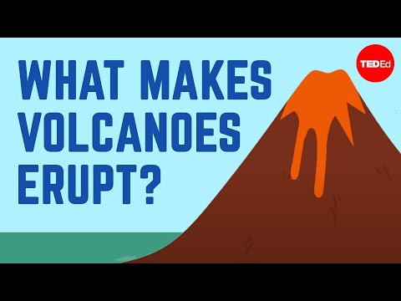

Health: Vaccines

* Look at the title of this video. On a piece of paper, make a list of what you know about vaccines. If you don't know the word in English, you can still write it in your native language.
* Before you watch the video, predict how the speaker will organize the ideas.
* Circle words in your list that you think the speaker will use.
* Watch the video. You may use subtitles if that is helpful for you.
* After you watch the video, write down any new words you learned.
* How did activating your background knowledge prepare you to listen to this topic?



History: English

* Look at the title of this video. On a piece of paper, make a list of what you know about the history of English. If you don't know the word in English, you can still write it in your native language.
* Before you watch the video, predict how the speaker will organize the ideas.
* Circle words in your list that you think the speaker will use.
* Watch the video. You may use subtitles if that is helpful for you.
* After you watch the video, write down any new words you learned.
* How did activating your background knowledge prepare you to listen to this topic?

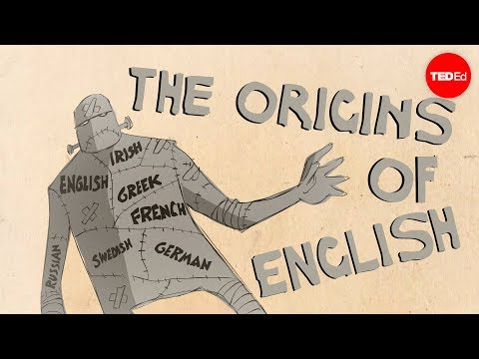

Conversation: Climate Change

* Look at the title of this video. On a piece of paper, make a list of what you know about climate change, the environment, and Greta Thunberg. If you don't know the word in English, you can still write it in your native language. The first part of this video is a conversation, but it is still more structured than a typical conversation.
* Before you watch the video, predict how the speaker will organize the ideas.
* Circle words in your list that you think the speaker will use.
* Watch the video. You may use subtitles if that is helpful for you.
* After you watch the video, write down any new words you learned.
* How did activating your background knowledge prepare you to listen to this topic?



### Practice 2: Did you hear?

1. You will first make a list of 5 random topics. They can be anything you are familiar with.
2. You and your partner will go into a breakout room to have a conversation.
3. One partner will start the conversation with the first topic on the list by saying "Did you hear..."  
   to introduce information about that topic.
   * Example: Did you hear that NASA is investigating life on Venus?
4. The two partners will talk about that topic for 1 minute. Partners are not allowed to use the internet or a dictionary to help them talk about the topic. They are allowed to ask the other partner for help with vocabulary or ideas.
   * Example:
   * A: What is the word for the machine that NASA puts in space to do research?
   * B: A space shuttle? A rover?
   * A: No, it's a machine that takes pictures.
   * B: Oh! You mean like the Hubble Telescope!
5. The second partner will choose one of their topics and will change the direction of the conversation to talk about something new by saying "Did you hear..." to introduce a new idea.
6. After one minute, the first partner will introduce a new topic from the list. Repeat until your teacher stops you.

### Practice 3: Ready, set, go!

1. Have a piece of paper or word document open and ready.
2. Your teacher will give you a topic.
3. You will have 30 seconds to make a list of words that you think of when you hear that topic.
4. After the 30 seconds, you will have time to think about how to use these words to explain the topic.
5. Be prepared to share with the class.
6. The teacher will call on you to share your background knowledge about the topic with the class.

### Practice 4: Activation questions

1. Think about a topic you think is interesting.
2. Find a short video about that topic (less than 5 minutes).
3. Watch the video and make a list of 3 questions.
   * The questions should focus on helping your partner activate their background knowledge so they are prepared to listen to the video.
   * For example, if you choose a video about Steve Jobs, you could ask the following questions:
     + What do you know about Apple technology products?
     + What do you think makes someone a successful businessperson?
     + Do you think computers and smartphones are important? Why or why not?
4. After you have prepared your questions for the video, share them with your partner.
5. Once your partner has thought about these questions and the topic, share the video.
6. When both partners finish the activity, talk about how the questions helped to prepare you to listen. Give an idea of ONE more question that could be used to help activate background knowledge for the listening practice.

Read this online at <https://edtechbooks.org/advanced_low_listening__speaking/background_knowledge>