Universal Design for Learning
McMurry, A., Vandagriff, J., Auman, E.
Universal Design for Learning (UDL) is an educational framework that promotes accessibility and flexibility. It focuses on three key principles: Engagement, Representation, and Expression. By accommodating diverse learning needs, UDL ensures inclusive instructional materials and assessments. Educators can proactively design curricula that support all students, fostering a culture of inclusivity and success in education.
Universal Design for Learning (UDL) is is a strength-based approach to education. It focuses on a person's abilities rather than disabilities, their knowledge rather than their ignorance, and their potential rather than their shortcomings. This perspective can help all students build self-confidence, motivation, and skills in challenging areas.
UDL asks educators and instructional designers to create for the diverse needs of all learners. It emphasizes proactive design, rather than retroactive accommodations, of an inclusive educational environment where every learner can thrive. This promotes equitable educational opportunities for all students because it provides multiple means of engagement, representation, action, and expression.

Explanation
These three key principles of UDL, engagement, representation, and expression, are shown across the top row in Figure 1 (below). Three areas of their application are the ways students access information, build knowledge, and internalize learning. In Figure 1, these are down the left-side column.
Engagement involves the "WHY" of learning and an instructional designer needs to consider how to engage student interest in the learning activities, building their affective support networks, and self-regulated learning.
Representation involves the "WHAT" of learning and an instructional designer needs to consider options for ways students access, understand, and internalize the learning materials.
Expression involves the "HOW" of learning and an instructional designer needs to include various physical activities for accessing information, expressing and communicating knowledge, and facilitating executive function.
Figure 1
The Universal Design for Learning Guidelines

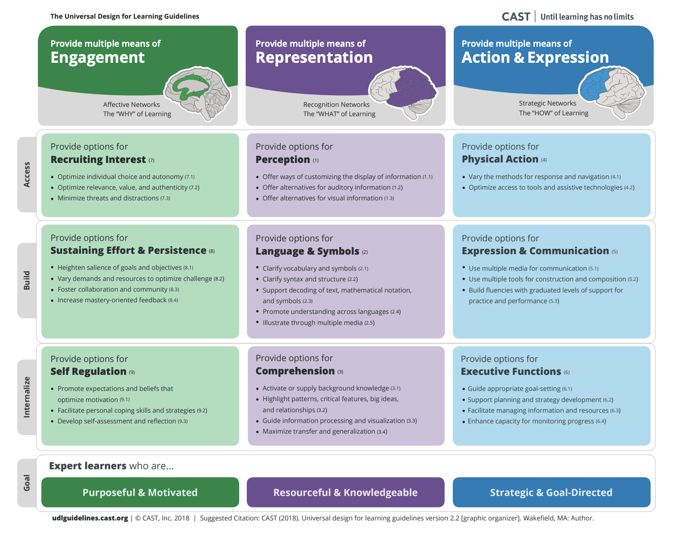

Engagement: Fostering motivation and sustaining interest
Engagement involves the "WHY" of learning. It looks at what motivates students, the value they place on learning, the way they manage their time and resources. Therefore, educators and instructional designers need to provide multiple means of engagement to cater to diverse learners and allow students a level of autonomy. Because each student has unique background experiences, interests, and emotional triggers that affect their learning, each one needs to be uniquely engaged in the learning. Engagement strategies in UDL include (a) offering choices in how content is learned and expressed, (b) creating real-world connections to the material, and (c) creating a supportive classroom atmosphere that promotes taking risks and appreciates individual differences. Personalized engagement not only increases motivation but also enhances persistence and effort, leading to more effective learning outcomes.

Representation: Fostering student comprehension and resourcefulness
Representation involves the "WHAT" of learning. It looks at the importance of offering information in multiple formats to cater to diverse learner needs. Therefore, educators and instructional designers need to acknowledge that individuals process information differently, influenced by factors like cultural background, sensory preferences, and cognitive abilities. By providing various ways of presenting content to students—such as text, audio, visuals, and interactive media—UDL aims to ensure all learners can access and comprehend the material. This approach supports the recognition network of the brain, facilitating understanding through tailored, flexible methods. It challenges educators to think creatively about how to convey the same information in different ways, thus removing barriers to learning and making education more inclusive. Designing educational content with multiple representations not only accommodates learners with diagnosed neural differences but also enriches the learning experience for all students. Representation under UDL is not just about accessibility but about engaging learners in meaningful ways that resonate with their individual learning needs and preferences.

Expression: Promoting diverse demonstration of understanding
Expression involves the "HOW" of learning. It looks at the importance of offering multiple formats for students to demonstrate their understanding. Therefore, educators and instructional designers accommodate learners' strengths by offering multiple modalities of expression such as speaking, writing, drawing, or using assistive technologies. This allows learners to choose the most suitable method for conveying their knowledge, ensuring that they can demonstrate their understanding regardless of individual differences. It encourages creativity, critical thinking, and self-expression while minimizing barriers to learning. Ultimately, expression in UDL fosters a supportive and inclusive learning environment where every learner can thrive and succeed.

Conclusion
Universal Design for Learning (UDL) is a strength-based approach to education. It focuses on a person's abilities, knowledge, and potential, and allows greater autonomy in the learning process. The student chooses how to access, process, and demonstrate information. The learning experiences are inclusive and accessible, promoting equity in education by addressing the wide range of learners' needs, preferences, and challenges.

Related Terms
Accessibility, Education, Design, Learning

References

General Resources
CAST. (2018). Universal Design for Learning Guidelines version 2.2. https://udlguidelines.cast.org
Griful-Freixenet, J., Struyven, K., Vantieghem, W., & Gheyssens, E. (2020). Exploring the interrelationship between Universal Design for Learning (UDL) and Differentiated Instruction (DI): A systematic review. Educational Research Review, 29, 100306.
Scott, L. A., Thoma, C. A., Puglia, L., Temple, P., & D'Aguilar, A. (2017). Implementing a UDL framework: A study of current personnel preparation practices. Intellectual and developmental disabilities, 55(1), 25-36.
Shultz, S. (2023). Universal Design for Learning: An Introduction. National Educational Association. https://www.nea.org/professional-excellence/student-engagement/tools-tips/universal-design-learning-introduction

UDL in K-12 Education
Crevecoeur, Y. C., Sorenson, S. E., Mayorga, V., & Gonzalez, A. P. (2014). Universal Design for Learning in K-12 Educational Settings: A Review of Group Comparison and Single-Subject Intervention Studies. Journal of Special Education Apprenticeship, 3(2), n2.
Lowrey, K. A., & Smith, S. J. (2018). Including individuals with disabilities in UDL framework implementation: Insights from administrators. Inclusion, 6(2), 127-142.
Rao, K. (2021). Inclusive instructional design: Applying UDL to online learning. The Journal of Applied Instructional Design, 10(1), 83-97.
Smith, S. J., Rao, K., Lowrey, K. A., Gardner, J. E., Moore, E., Coy, K., ... & Wojcik, B. (2019). Recommendations for a national research agenda in UDL: Outcomes from the UDL-IRN preconference on research. Journal of Disability Policy Studies, 30(3), 174-185.

UDL in Higher Education
Black, R. D., Weinberg, L. A., & Brodwin, M. G. (2015). Universal design for learning and instruction: Perspectives of students with disabilities in higher education. Exceptionality Education International, 25(2).
Fornauf, B. S., & Erickson, J. D. (2020). Toward an inclusive pedagogy through universal design for learning in higher education: A review of the literature. Journal of Postsecondary Education and Disability, 33(2), 183-199.
Fovet, F. (2021). Developing an ecological approach to the strategic implementation of UDL in higher education. Journal of Education and Learning, 10(4), 27-39.
Kennette, L. N., & Wilson, N. A. (2019). Universal design for learning (UDL): Student and faculty perceptions. Journal of Effective Teaching in Higher Education, 2(1), 1-26.

Read this online at https://edtechbooks.org/encyclopedia/universal_design_for_learning

