# Native American Influences on U.S. Government

Researchers believe governmental practices of native/First American peoples influenced the writers of the U.S. Constitution, and in so doing, shaped the governmental institutions of the new republic. Activities explore a broader historical background of native/settler relations and conflicts, including the Peskeompskut-Wissatinnewag Massacre in western Massachusetts and the case of Jeffrey Amherst and the smallpox blankets along with modern-day issues of how to decide to restore Native American names to geographic places and how indigenous peoples are represented in films, local history publications, and school mascots.

## **Standard 1.5:  Native American Influences on U.S. Government**

Analyze the evidence for arguments that the principles of the system of government of the United States were influenced by the governments of Native Peoples. (Massachusetts Curriculum Framework for History and Social Studies) **[8.T1.5]**

As native populations migrated and settled across the vast expanse of North America over time, they developed distinct and increasingly complex societies by adapting to and transforming their diverse environments.**[AP U.S. History Key Concept 1.1]**

The American Revolution’s democratic and republican ideals inspired new experiments with different forms of government. **[AP U.S. History Key Concept 3.2]**

## **FOCUS QUESTION**: (TeachingHistory.org., 2018)

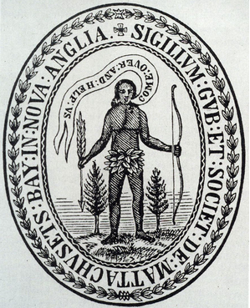

First American peoples and their histories remain largely invisible in school curriculums. The National Congress of American Indians has reported that 87% of state history standards do not mention Native American history after 1900 while 27 states have no reference to a single Native American in their K-12 curriculum ([Becoming Visible:  A Landscape Analysis of State Efforts to Provide Native American Education for All](http://www.ncai.org/policy-research-center/research-data/prc-publications/NCAI-Becoming_Visible_Report-Digital_FINAL_10_2019.pdf), September 2019).

[First Americans](https://www.history.com/topics/native-american-history/the-first-americans-video) lived in North America for 50,000 years before initial encounters with European explorers and colonists. These indigenous peoples adapted cultures and lifestyles to the geographic and environmental conditions where they lived. You can read a brief [Overview of the First Americans](https://www.digitalhistory.uh.edu/era.cfm) from Digital History.

The achievements of First American peoples are impressive, but not well-known. Just east of present-day St. Louis, Missouri, the pre-contact First American city of [**Cahokia**](https://cahokiamounds.org/) had a population of more than 10,000, with at least 20,000 to 30,000 more in outlying towns and farming settlements that spread for fifty miles in every direction. Its Grand Plaza was the size of 35 football fields, the largest public space ever created north of Mexico. At its center was a packed clay pyramid that reached 100 feet high. Cahokia is now the largest archaeological site in the United States. [Back to the City of the Sun: An Augmented Reality Project](https://cahokiamounds.org/augmented-reality-project/) offers more ways to learn about the Cahokia Mounds.

**Etzanoa** was located in modern-day Kansas, south of Wichita, near the Oklahoma border (learn more: [Archaeologists](https://www.latimes.com/nation/la-na-kansas-lost-city-20180819-htmlstory.html)). There is more information on these native settlements on the resourcesforhistoryteachers wiki page [Cahokia and](http://resourcesforhistoryteachers.pbworks.com/w/page/123879546/Cahokia%20and%20Etzanoa%2C%20Pre-Contact%20Native%20American%20Cities) .

Population figures for how many First Americans lived in North America in 1492 vary widely. [Teaching Tolerance](https://www.tolerance.org/classroom-resources/tolerance-lessons/native-american-influences-in-us-history-and-culture) puts the figure at 500 tribes totaling about 22 million people. Shortly after the arrival of Europeans, disease and violence took the lives of an enormous number of indigenous people. Twenty million, 95% of the indigenous population, died - many from the smallpox infection to which natives had no immunity. Today, Native Americans number just over 2 million or 1% of the U. S. population. Nearly 4 out of 5 (78%) live off-reservations and 72% live in cities or suburbs ([The Guardian](https://www.theguardian.com/us-news/2017/sep/04/native-americans-stories-california), September 4, 2017).

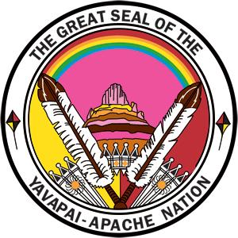

The relationship between Native peoples and European settlers was complex, contentious, and sometimes collaborative (Calloway, 2018). Tribes and settlers fought over access to land and resources, but also created military alliances and conducted trade. The website [Raid on Deerfield: The Many Stories of 1704](http://1704.deerfield.history.museum) shows the multiple dimensions of native/settler contacts.

Today, Native Americans still live with a legacy of inadequate resources and services and continuing social and economic discrimination. In its ["Broken Promises" report](https://aihc-wa.com/broken-promises-continuing-federal-funding-shortfall-for-native-americans/), the U.S.Commission of Civil Rights (2018) recounted the history as follows:

"In exchange for the surrender and reduction of tribal lands and removal and resettlement of approximately one-fifth of Native American tribes from their original lands, the United States signed 375 treaties, passed laws, and instituted policies that shape and define the special government-to-government relationship between federal and tribal governments. Yet the U.S. government forced many Native Americans to give up their culture and, throughout the history of this relationship, has not provided adequate assistance to support Native American interconnected infrastructure, self-governance, housing, education, health, and economic development needs" (para. 1).

For more background:

* [How Native American Women Inspired the Women's Rights Movement](https://www.nps.gov/articles/000/how-native-american-women-inspired-the-women-s-rights-movement.htm) from the National Park Service. The Six Nation Haudenosaunee Confederacy had, and still have today, a family/governmental structure based on female authority.
* [Native American Governments in Today's Curriculum](http://www.socialstudies.org/sites/default/files/publications/se/6106/610601.html), an older article that offers an overview of governmental structures of the League of the Iroquois, the Muscogee Nation, the Lakota Nation, and the Pueblo peoples.

### Modules for this Standard Include:

1. [INVESTIGATE: The Iroquois Confederacy and the Great Law of Peace](https://edtechbooks.org/democracy/nativeinfluence#h2_rqqyV)
   * MEDIA LITERACY CONNECTIONS: Representations of Native Americans in Film, Local History Publications, and School Mascots
   * SPECIAL TOPIC BOX: The Case of Jeffrey Amherst and the Smallpox Blankets
   * TEACHER-DESIGNED LEARNING PLAN: [First American Dwellings: A Makerspace Activity](http://resourcesforhistoryteachers.pbworks.com/w/page/138280065/First%20American%20Homes%20and%20a%20Makerspace%20Learning%20Activity)
2. [UNCOVER: The Peskeompskut-Wissatinnewag Massacre or the Battle of Great Falls](https://edtechbooks.org/democracy/nativeinfluence#h2_YIFVZ)
3. [ENGAGE: Who Should Decide to Restore Native American Names for Geographic Places?](https://edtechbooks.org/democracy/nativeinfluence#h2_jaTwo)

## **1.INVESTIGATE: The Iroquois Confederacy and the Great Law of Peace**

**The Iroquois Confederacy** refers to a group of indigenous tribes living in northeastern North America that had a participatory democracy government with executive, legislative, and judicial branches. **The Great Law of Peace** was the constitution of the Iroquois Confederacy. Here is the text of [The Constitution of the Iroquois Confederacy](https://sourcebooks.fordham.edu/MOD/iroquois.asp) and its 117 articles.

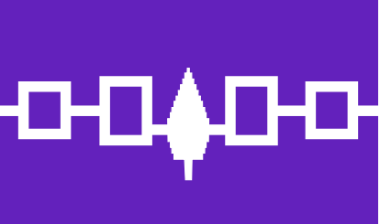

The framework of government in the Iroquois Confederacy is said to have inspired Thomas Jefferson, George Washington, Benjamin Franklin and other founders as they wrote the Constitution. The founders adopted the Iroquois nation's symbol, the bald eagle, as the new nation's national symbol.

Some historians credit the Iroquois chief **Canasatego** with influencing Benjamin Franklin’s thinking about government (Franklin included references to the Iroquois Confederacy in his writing). Canasatego shared how the Great Law of Peace, the Iroquois Confederacy’s unwritten constitution, included rules of democratic self-government including the rights and responsibilities of each member tribe, and in so doing, stressed the importance of a unified, representative government. Other historians are unsure of these connections, citing the lack of definitive historical evidence. [Iroquois and the Founding Fathers](https://teachinghistory.org/history-content/ask-a-historian/24099) from TeachingHistory.org presents both sides of this historical debate.

You can learn more at [Iroquois Democracy & the U.S. Constitution](https://www.pdx.edu/iroquois-democracy/), a website with learning plans from Portland State University.

In 1988, the United States Senate passed a resolution acknowledging the contributions of the Iroquois Confederacy ([Text of Senate Resolution on the Contributions of the Iroquois Confederacy](https://www.senate.gov/reference/resources/pdf/hconres331.pdf)). However, none of the constitutions of the 13 colonies included First Americans’ rights and Native Americans did not gain citizenship until 1924.

In addition to influencing the founders, feminist scholar Sally Roesch Wagner (2001) contended that the social and political organization of indigenous societies impacted the thinking of early women suffragists including Lucy Stone, Lucretia Mott, Susan B. Anthony, and Elizabeth Cady Stanton. In Haudenosaunee (Iroquois) society, women were included in tribal leadership, could hold political office, controlled property, had spiritual authority within the community, and children belonged to the mother's clan. The women's rights advocates who wrote the Declaration of Sentiments were inspired by native women to argue for a more co-equal status for women in American society. You can access an overview of this idea from [The Impact of Haudenosaunee Culture on the Early Suffragettes](https://edtechbooks.org/democracy/In%20addition%20to%20influencing%20the%20founding%20generation,%20feminist%20scholar%20Sally%20Roesch%20Wagner%20(2001)%20contended%20that%20the%20social%20and%20political%20organization%20of%20native%20societies%20impacted%20the%20thinking%20of%20early%20women%20suffragists%20including%20Lucy%20Stone,%20Lucretia%20Mott,%20Susan%20B.%20Anthony,%20and%20Elizabeth%20Cady%20Stanton.%20In%20Haudenosaunee%20(Iroquois)%20society,%20women%20were%20included%20in%20tribal%20leadership,%20could%20hold%20political%20office,%20controlled%20property,%20had%20spirtual%20authority%20within%20the%20community,%20and%20children%20belonged%20to%20the%20mother's%20clan.%20The%20women's%20rights%20advocates%20who%20wrote%20the%20Declaration%20of%20Sentiments%20were%20inspired%20by%20native%20women%20to%20argue%20for%20a%20more%20co-equal%20status%20for%20women%20in%20American%20society.).

#### **Native American Civil Rights**

Importantly, many history and civics classes in K-12 schools fail to mention the efforts of indigenous Americans to achieve equal rights under the Constitution. They were the last racial group to gain the right to vote. [Native American Activism: 1960s to Present](https://www.zinnedproject.org/materials/native-american-activism-1960s-to-present/) from the Zinn Education Project focuses on events including the 1969 Alcatraz Island occupation, the 1970 occupation of Mount Rushmore, and the [1973 occupation of Wounded Knee](https://www.theatlantic.com/national/archive/2012/10/occupy-wounded-knee-a-71-day-siege-and-a-forgotten-civil-rights-movement/263998/). These are just a few of many events that happened in the 20th century to show their impact on civil rights legislation as well as the impact protest has on governmental change. There is more historical information at our wiki page for the [Native American Civil Rights Movement](http://resourcesforhistoryteachers.pbworks.com/w/page/128203098/Native%20American%20Civil%20Rights%20Movement).

### Suggested Learning Activities

* **Design a Video**
  + Explore the [Native American Influences in U.S. History and Culture Quiz](https://www.tolerance.org/classroom-resources/tolerance-lessons/native-american-influences-in-us-history-and-culture), from Teaching Tolerance
  + Then, create a social media video that highlights the 3-5 most surprising things you learned.
* **State Your View:** How did Native American Government Shape the U.S. Constitution?
  + [How the Iroquois Great Law of Peace Shaped U.S. Democracy](https://www.pbs.org/native-america/blogs/native-voices/how-the-iroquois-great-law-of-peace-shaped-us-democracy/), Native Voices, PBS.
  + [Iroquois Constitution:  A Forerunner to Colonists' Democratic Principles](https://www.nytimes.com/1987/06/28/us/iroquois-constitution-a-forerunner-to-colonists-democratic-principles.html)
* **Analyze a Primary Source**
  + [1994 Constitution of the Wampanoag tribe of Gay Head](http://thorpe.ou.edu/constitution/wampanoag/index.html) (Martha's Vineyard, Massachusetts)
    - What parallels to the United States Constitution do you notice in this document?
* **Create a Sketchnote:** In what ways have Native Americans influenced life in the United States?   
  + [Native American Contributions](https://www.nrcs.usda.gov/Internet/FSE_DOCUMENTS/nrcs141p2_024206.pdf) from United States Department of Agriculture
  + [Native American Contributions](https://www.scholastic.com/teachers/articles/teaching-content/native-american-contributions/) from Scholastic
  + [Iroquois and the Founding Fathers](https://teachinghistory.org/history-content/ask-a-historian/24099) from TeachingHistory.org.
  + [Native American Rights Movement](http://resourcesforhistoryteachers.pbworks.com/w/page/128203098/Native%20American%20Rights%20Movement), resourcesforhistoryteachers wiki page
* **Compare and contrast the 1973 occupation of Wounded Knee and the 1961 Freedom Riders Protest**.
  + Create a list of similarities and differences between these protests.
  + What were they trying to achieve, how did they go about protesting?
  + Then, create your own modern protest poster. What will your protest be for? What historical techniques will you use to make your protest successful? (This activity suggeted by University of Massachusetts Amherst history major Katelyn Maskell)

### Media Literacy Connections: Representations of Native Americans in Film, Local History Publications, and School Mascots

Although November is [National Native American Heritage Month](https://www.whitehouse.gov/briefing-room/presidential-actions/2021/10/29/a-proclamation-on-national-native-american-heritage-month-2021/#:~:text=NOW%2C%20THEREFORE%2C%20I%2C%20JOSEPH,National%20Native%20American%20Heritage%20Month.), most students learn little about Native peoples or First American cultures in schools.

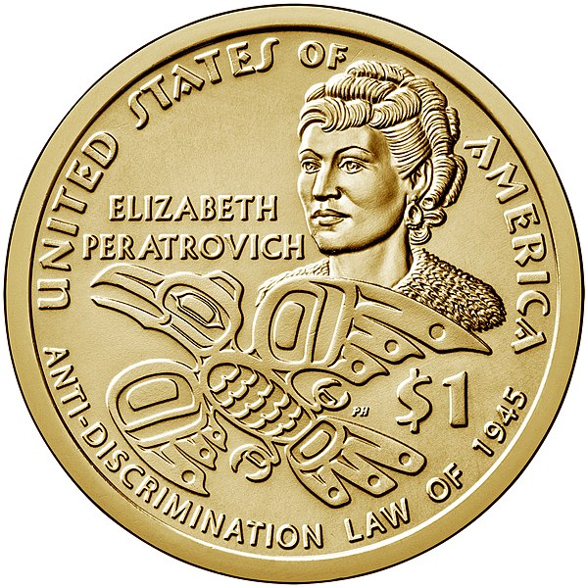

The indigenous education organization [IllumiNative](https://illuminatives.org/nativenow/) reports that most (87%) state level history standards do not address Native history past 1900. Much of what students do learn about Native history comes from the media. These activities ask you to critically consider how Native peoples have been represented in films and in local history publications and how those representations have shaped people's attitudes:

* [**Activity 1:**](https://edtechbooks.org/mediaandciviclearning/representation_of_NativeAmericans#p_SwYo)
* [**Activity 2: Design a Film or TV show About Native Americans' Influence on the U.S. Government**](https://edtechbooks.org/mediaandciviclearning/representation_of_NativeAmericans#p_fwAg)
* [**Activity 3: Research & Redesign the First American History of the Place Where You Live Today**](https://edtechbooks.org/mediaandciviclearning/representation_of_NativeAmericans#p_dhVm)

### Special Topic Box: The Case of Jeffrey Amherst and the Smallpox Blankets

The complexities of place names and indigenous history is illustrated by the case of Jeffrey Amherst and the smallpox blankets. **Jeffrey Amherst** was a British army general during the French and Indian War and then royal governor of Virginia (although he refused to live there) in the decades before the American Revolution. The Town of Amherst, Massachusetts, founded in 1759, is named after him. Amherst College, founded in 1821, is named after the town. There are also towns named Amherst in Wisconsin, Virginia, Texas, Tennessee, South Dakota, Ohio, North Carolina, New York, New Hampshire, Nebraska, Montana, Minnesota, Maine, and Colorado.

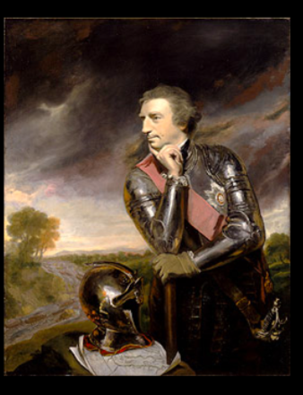

Jeffrey Amherst is a very controversial historical figure. Throughout his life, he displayed overt hatred and racism toward native people. Historians have charged him with suggesting—or actually providing—smallpox-infected blankets to American Indians in the Ohio Valley of North America. In a 1763 letter he wrote, “You will do well to try to inoculate the Indians by means of blankets, as well as to try every other method that can serve to extirpate this execrable race” (quoted in Berg, 2019).

In 2016, Amherst College dropped “Lord Jeff” as its athletic team and school mascot. More recently, there have been calls from citizens to rename the town of Amherst itself. The case of Jeffrey Amherst raises questions about how to evaluate the reputations of famous people in history, especially those who engaged in undemocratic and discriminatory actions toward other people, by including them in the name of a town.

**How should Jeffrey Amherst be evaluated historically?** Is there sufficient evidence to condemn him as an advocate for biological warfare? In what ways does the case of Jeffrey Amherst relate to current debates over Native American mascots and Confederate monuments from the Civil War?

Based on those answers to those questions, should towns named Amherst - including Amherst, Massachusetts - change their names based on historical evidence of his actions? Some groups in the local area have proposed renaming the town "Norwottuck" to acknowledge the indigenous peoples who lived there; others have suggested renaming the town for "Tubman" for Harriet Tubman or "Dickinson" for Emily Dickinson.

## **2.UNCOVER:The Peskeompskut-Wissatinnewag Massacre or Battle of Great Falls**

**Peskeompskut** is the name for the waterfalls on the Connecticut River between the communities of Turners Falls and Gill, Massachusetts. The Peskeompskut Massacre or the Great Falls Fight was a pivotal event in King Philip's War that unfolded when a colonial militia led a pre-dawn surprise attack of an Indian fishing village on the shores of the river on May 16, 1676. An interactive photograph and summary of the scene entitled [**Assault on Peskeompskut**](http://1704.deerfield.history.museum/scenes/scene.do?title=Peskeompskut) is available from the Memorial Hall Museum, Deerfield, Massachusetts.

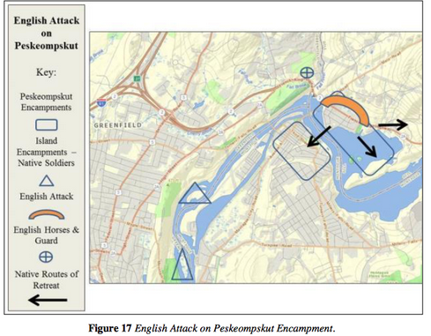

Different writers have described the event differently, as a massacre or a battle. Regardless of how it is described, it is clear that hundreds of English soldiers and native people were involved and that many women and children were killed in the raid on the village. In 2018, the town of Montague, Massachusetts received a grant from the National Park Service to survey the battlefield and apply for recognition in the National Register of Historic Places. But what really happened on that day?

### Suggested Learning Activities

* **Analyze Two Competing Histories and Then Write Your Own History**
  + [Technical Report: Battle of Great Falls/](https://www.montague-ma.gov/files/Battle_of_Great_Falls_Phase_I_Final_Technical_Report.pdf), American Battlefield Protection Program, National Park Service (February 2016)
  + [Remembering & Reconnecting: Nipmucs and the Massacre at Great Falls](https://www.montague-ma.gov/files/Nipmuc_Tribal_Statement.pdf), Chaubunagungamuug Nipmuck Historic Preservation Office (October 2015)
* **Design a First American People's History Poster**
  + Present the history of one of the following events from an indigenous First Americans' perspective:
    - [King Philip's War](http://resourcesforhistoryteachers.pbworks.com/w/page/138868686/King%20Philip's%20War)
    - [The Louisiana Purchase](http://resourcesforhistoryteachers.pbworks.com/w/page/125270561/The%20Louisiana%20Purchase)
    - [The Trail of Tears and the Indian Removal Policy](http://resourcesforhistoryteachers.pbworks.com/w/page/123902535/The%20Trail%20of%20Tears)
    - [The California and Alaska Gold Rush](http://resourcesforhistoryteachers.pbworks.com/w/page/125274467/The%20California%20and%20Alaska%20Gold%20Rush#view=edit)
    - [The Transcontinental Railroad](http://resourcesforhistoryteachers.pbworks.com/w/page/125185328/The%20Transcontinental%20Railroad)
    - [DAPL Standing Rock Sioux Uprising](http://resourcesforhistoryteachers.pbworks.com/w/page/125439650/DAPL%20Standing%20Rock%20Sioux%20Uprising)

**TEACHER-WRITTEN LEARNING PLAN: First American Homes and Makerspace Activity**

### **Online Resources for the Peskeompskut-Wissatinnewag Massacre**

* [Our Beloved Kin: Remapping a New History of King Philip’s War](https://ourbelovedkin.com/awikhigan/about?path=index) website by Lisa Brooks
* Explore resourcesforhistoryteachers wiki page for [English Settlers and Native Peoples](http://resourcesforhistoryteachers.pbworks.com/w/page/124016760/English%20Settlers%20and%20Native%20Peoples)
* [Native Land Map](https://native-land.ca), an interactive exploration of native peoples in the Americas

## **3.ENGAGE: Who Should Decide to Restore Native American Names for Geographic Places?**

Native American names for geographic places are everywhere in this country. 27 states have Native American origins for their names: Alaska from the Aleut word "Alyeska;" Massachusetts from the Algonquian language meaning "at or about the great hill;" Wisconsin is derived from Menominee word meaning "a good place;" and North and South Dakota come from a Sioux word for "friend" ([The United States of Indigenous Names](https://indiancountrytoday.com/archive/names-have-power-the-united-states-of-indigenous-names), Indian Country Today, September 2018, para. 9).

The names of towns, streets, rivers, mountains, lakes, and natural landmarks in every state have indigenous origins. Wikipedia maintains an ongoing listing of [Place Names of Native American Origin in the U.S](https://en.wikipedia.org/wiki/List_of_place_names_of_Native_American_origin_in_the_United_States).

Whose Land Do You Live On? Use this [N](https://native-land.ca) to find out the ancestral land that your school stands on.

For Massachusetts, you can access [Native American Names in the Greater Boston Area](https://litdigitaldiversity.northeastern.edu/native-american-names-in-the-greater-boston-area/) by members of a class at Northeastern University; this resource includes a Google Map of Native American place name locations in and around the city. Names of places also can change. In 1997, the residents of "Gay Head" on Martha Vineyard Island voted to change the name of the town to "Aquinnah" (meaning "under the hill" to the Wampanoag people).

Not all names convey positive images and meanings. The U.S. Interior Department reported in 2022 that there are 660 place names that use "squaw," a racist slur term directed at Native American women. Other place names have wording that Native people find offensive or degrading, similar to the use of offensive terms of imagery by [school mascots or professional sports teams](https://edtechbooks.org/mediaandciviclearning/native_mascots). You can learn more at [Indigenous Erasure in Plain Sight: Place Names in New England](https://intercontinentalcry.org/indigenous-erasure-plain-sight-place-names-new-england/) (2017).

Facing the long history of exploitation and oppression of indigenous peoples, multiple local, state, and national efforts seek to restore Native American names to places as a way to present truthful history and show respect for all peoples and cultures.

Bilingual road signs featuring native translations of English place names are being installed by multiple states including New York, Maine, Wisconsin, MInnesota and Iowa as well as communities with states. One community in Alaska has signs and street signs in both English and the native Tlingit language ([APNews](https://apnews.com/article/native-american-language-translation-highway-signs-93ea9edb4da876da61fa5635c0139388), December 19, 2023)

In August 2023, President Joe Biden designated nearly one million acres of federal lands the [Baaj Kwaaujo I'Tah Kukveni-Ancestral Footprints of the Grand Canyon National Monument.](http://npshistory.com/publications/usfs/baaj-nwaavjo-itah-kukveni/index.htm) Baaj nwaavjo (BAAHJ – NUH-WAAHV-JOH) means “where Indigenous peoples roam” in the Havasupai language, and i’tah kukveni (EE-TAH – KOOK-VENNY) means “our ancestral footprints” in the Hopi language ().

In 2015, President Barack Obama issued an executive order to change the name of Alaska's Mount McKinley (named for the nation's 25th President William McKinley) to Denali -- the mountain's name in the indigenous Athabasian language. Native tribes and political leaders in the state supported the change while officials in Ohio (President McKinley's home state) and then presidential candidate Donald Trump opposed it.

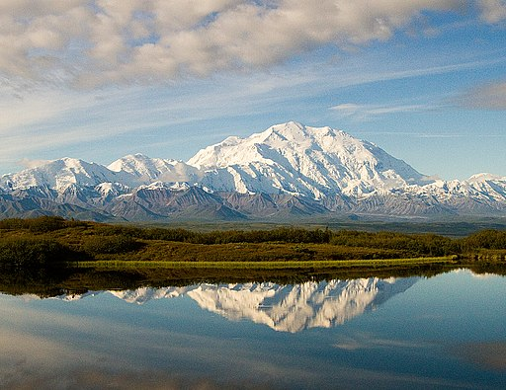

The controversy over the Mount McKinley/Denali name change demonstrates the complex political, historical, and social dynamics surrounding the naming and potential renaming of places.

**Who decides what geographic place names should stay as they are and what names need to be changed and why: Local people? Elected politicians? Governmental agencies? Native tribal groups? Others?**

### Suggested Learning Activities

* **Design a Place Names Interactive Map:** ResearchNative Americanplace names in your community or state. You can include streets, towns, and natural landmarks. You can also identify place names that have negative or racist meanings and suggest (in the text box) alternative Native American names.
  + Display your findings on an [interactive Google map](https://www.google.com/maps/about/mymaps/) or a [Padlet map](https://www.youtube.com/watch?v=zuQEkTR28Is).
* **State Your View**: How should your community decide whether to restore Native American names to places in the town or region?
  + Would you recommend a vote by community members, a policy from the state or federal government, appointing an independent commission, supporting the decision of local tribes, or some other approach?
  + Present your ideas as video or written policy proposal to share with local and school officials
* **Propose a Names and Mascot Policy for Your School**: How can Native American peoples and cultures be fairly represented in school mascots or names?
  + [National School Mascots Tracking Database](https://www.ncai.org/NCAI_School_Mascot_Tracking_Database_-_Overview_and_Numbers.pdf), National Congress of American Indians (2021)
  + [2,128 Native American Mascots People Aren't Talking About](http://fivethirtyeight.com/features/the-2128-native-american-mascots-people-arent-talking-about/) from FiveThirtyEight, September 2014.
  + [Timeline - A Century of Racist Sports Team Names](http://www.motherjones.com/politics/2013/11/timeline-history-offensive-sports-mascots-redskins-snyder/), Mother Jones
  + [UnLearning Sports Mascots](https://www.fivecolleges.edu/system/files/attachments/Unlearning-Lesson%20Plan.pdf) from FiveColleges in Massachusetts.
  + [Native Americans Blast Redskins Gambit to Defuse Name Controversy with Financial Contributions](https://thinkprogress.org/native-americans-blast-redskins-gambit-to-defuse-name-controversy-with-financial-contributions-27b4c9a756b1/), March 24, 2014.

### **Online Resources for Teaching First American/Native American History**

* [Indigenous People in Massachusetts: A Library Guide](https://robbinslibrary.wordpress.com/2021/11/05/indigenous-people-in-massachusetts-a-library-guide/), Robbins Library, Arlington, Massachusetts
* [Lord Jeffrey Amherst and the Smallpox Blankets](http://resourcesforhistoryteachers.pbworks.com/w/page/124640007/Lord%20Jeffrey%20Amherst%20and%20the%20Smallpox%20Blankets), resourcesforhistoryteachers wiki
* [Svalbard Seed Bank and Global Food Histories](http://resourcesforhistoryteachers.pbworks.com/w/page/123874938/Svalbard%20Seed%20Bank%20and%20Global%20Food%20Histories), resourcesforhistoryteachers wiki
* [Montana State Constitution Article X and Indian Education For All,](https://opi.mt.gov/Portals/182/Page%20Files/Indian%20Education/Social%20Studies/9-12/HS%20Montana%20Constitution%20Article%20X%20and%20IEFA.pdf) Montana Office of Public Instruction
  + Montana's 1972 constitutional amendment requires teachers to integrate information about Native American cultures and history in all subjects and grades.
* [Many Maine Schools 'Do Little' to follow a 20-Year-old Law Requiring Wabanaki Studies](https://nenc.news/report-many-maine-schools-do-little-to-follow-20-year-old-law-requiring-wabanaki-studies/). New England News Collaborative (October 10, 2022).
* [American Indian Perspectives on Thanksgiving](https://americanindian.si.edu/sites/1/files/pdf/education/thanksgiving_poster.pdf), National Museum of the American Indian
* [The Other Side of Plymouth Rock](https://valleyadvocate.com/2020/01/29/the-other-side-of-plymouth-rock-river-stories-series-highlighting-the-valleys-native-population-is-a-counterpoint-to-plymouth-400/?utm_source=eHistory+News+Feb+5&amp;utm_campaign=Emerging+E+news+Feb+5&amp;utm_medium=email): River Stories 2020, Nolumbeka Project
* [American Indians in Children's Literature](http://r20.rs6.net/tn.jsp?f=0017RwBG9QVTHDPjAfhm44MFnNQ7OcoM34Ngs91HdrL57LdCrxLxOP9kOfQSkau4b8JglQq9VMt9Rb-R3IW1mCU7vtoe5kiXDcQHWcNz3RSa4iH7oDLKvGLWcluthp962tO_UH0V_cHtl77bkaK3yGNNWKfy2IhymeUtY688yDzhm0R0kooKwyiHqEhO_yxqHwBBtQS4qzce0-uDAiM5FuxiNhYGmjyQ9jagXSrSWyQ3W0ca05sFGPELfk-lqb8PaEjn9Xep5zsCPzw9uQDS4UrdRj1jO7uR_GVy0TCwmGHq0AAy0zMr3SLbbBrMRfXHNIcpe_E0h1lX8RjLUjsBPKJ2QbIyb2XaJUTKTcBGVmQXjw=&amp;c=CoHrAF0Yf6Xtu31gZ-AaylQaYV3DHamRrpYQ18tVS3fotWTpEHxWOg==&amp;ch=Gu_V26rRREKrpOQ2ekiEXolpuL9-zHoT41Z085Jo84U7l-bdOzmrjQ==), Blog by Debbie Reese of Nambé Pueblo
* GOOGLE EARTH: [Explore Canada's Original Place Names](https://earth.google.com/web/data=MkEKPwo9CiExTlQxOUdfN0tSRFYzWHdMb1BzR1RYVjYwUFJQUnA3ZFQSFgoUMDgyRTU5QUZBMzJCODgwMEY5QjYgAQ)
* Maps:  
  + [Tribal Nations Map](https://www.npr.org/assets/news/2014/06/Tribal_Nations_Map_NA.pdf) - Pre-contact homelands of hundreds of tribal nations in Canada and the lower 48 states of the United States
  + [Native Reservations Today Map](https://www.bia.gov/sites/bia.gov/files/assets/bia/ots/webteam/pdf/idc1-028635.pdf)

## **Conclusion for Standard 5**

Standard 5’s **INVESTIGATE** examined how the governmental practices of Native Americans (in particular, The Iroquois Confederacy) may have influenced the thinking of the founders of the United States system of government. **UNCOVER** presented the different historical accounts of what is known as the Peskeompskut-Wissatinnewag Massacre or the Battle of Great Falls. **ENGAGE** used the case of Jeffrey Amherst and the Smallpox Blankets to ask how people today might assess the naming of places.

Read this online at <https://edtechbooks.org/democracy/nativeinfluence>