# Assessment

### Introduction

Assessment is an important part of instruction regardless of how it is delivered. Adult educators use assessment for several reasons: to determine an appropriate placement for a student before instruction begins, to inform instructional approaches and content, to gauge learner progress in the course of an instructional sequence, and to measure how well a program of instruction is working. Determining placement and measures of program effectiveness are often accomplished using standardized tests (e.g., TABE, CASAS, BEST Plus) or assessments developed by a program. Gauging learner progress can be accomplished by using a combination of formative and summative assessment strategies.

## Why Assess?

When assessment is done well, it provides valuable information about a learner and the instruction provided (Edutopia, 2008).

**Provides diagnostic feedback**

* What is the student’s knowledge base?
* What is the student’s performance base?
* What are the student’s needs?
* What has to be taught?

**Helps educators set standards**

* What performance demonstrates understanding?
* What performance demonstrates knowledge?
* What performance demonstrates mastery?

**Evaluates progress**

* What teaching methods or approaches are most effective?
* What changes or modifications to a lesson are needed to help the student?

**Relates to a student’s progress**

* Can the student talk about the new knowledge?
* Can the student demonstrate and use the new skills in other projects?

**Supports student self-evaluation**

* How am I doing?
* Now that I know how I am doing, how can I do better?
* What else would I like to learn?

Supports teacher self-evaluation

* What can I do to help the students more?
* In what direction should we go next?

## Formative Assessment to Gauge Student Progress and Guide Instruction

Assessing student work on a regular basis provides both the teacher and the student with a sense of the student’s progress, indicates strengths and areas for improvement, and helps the teacher plan appropriately to meet the student’s needs. This formative assessment is part of the process of a learning sequence (Bakerson et al., 2015; Popham, 2011). Formative assessment can be structured using rubrics, quizzes, or observation protocols. It might also be less formal, quick comprehension check questions asked throughout an instructional period or exit tickets turned in at the end of class (Sparks, 2015). Assessments are valuable for students because they provide a way for them to gauge their progress toward meeting goals.

### Tips for Doing Formative Assessment in Distance and Digital Education

Collect data over time. Formative assessment is a process, so you should collect evidence of learning throughout the semester.

#### **Require students to submit evidence of learning.**

For example, you might have students submit reflection videos using [Flip](https://info.flip.com/), formerly called FlipGrid, or send photos or screenshots of their progress. Learners can use [Padlet](https://padlet.com) or [Google Sites](https://sites.google.com) to develop a portfolio of their learning progress. Ask students to complete regular self-assessments by having them indicate progress by completing a weekly survey that lists expected progress markers; give them opportunities for reflection on that progress (Miller, 2020a).

#### **Provide feedback.**

Provide written feedback on shared documents or discussion boards. If you have some face-to-face time, provide oral feedback during that time. You might use breakout rooms for students to give feedback to each other. In a distance format, you can use a discussion post or collaborative work in a Google Doc for students to provide feedback during established time frames (Miller, 2020a).

#### **Include comprehension checks in remote live class meetings.**

Embed quick comprehension checks in your instruction (Miller, 2020a). Use Yes/No buttons in your webinar tool, short question response prompts in chat, or “handswers” (an engagement strategy where students are prompted to hold up a number of fingers to select a response). Get creative and embed questions directly in your presentation slides. For example, using a slide like this, you can have students add responses to quick feedback questions.

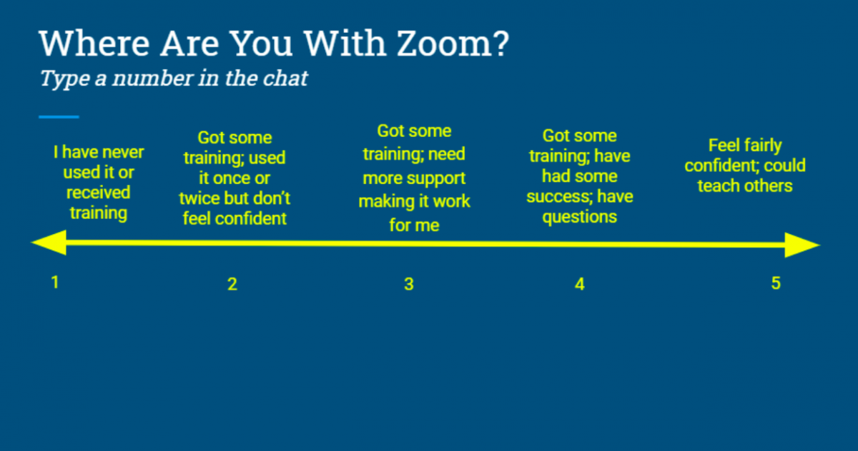

You can also create class slides using [Pear Deck](https://www.peardeck.com/googleslides/) integration in Google Slides. This extension for Google Slides makes it possible to embed questions for your students to answer as you give a lesson.

#### Connect personally.

When teaching and learning happens largely at a distance, both teachers and students can feel isolated. A recent study of adult education instructors showed that most instructors relied on reaching out to learners personally between video classes—often via a phone call (Belzer et al., 2020). You can make the most of these conversations by following these tips:

1. Prepare for the call; know what you want to ask about. Plan questions that will inform you about where students are in their assigned work and what problems they might be having. Decide ahead of time how formal you want the call to feel. If you have particular learning objectives that you need to assess, plan out the questions ahead of time.
2. Keep track of what you learn in these calls. [Use a tracking sheet such as this example](http://www.andrewkmiller.com/wp-content/uploads/2018/09/DailyCheck-In-LearningGoalScaleTypeable.pdf) that helps you maintain records of learner progress around their goals.
3. Include questions about how students are experiencing the distance education format and activities. Ask about what’s working or what activities are particularly challenging. Ask for suggestions on what changes the student sees as useful.

#### Use what you learn.

Adjust your instruction based on what you are hearing from your students. Gathering data, organizing it, and reviewing it will show patterns about where your technology and activity choices are not working or where you might need to add supplemental resources for more content.

Interim and summative assessments both measure learning over time. Interim assessments show individual student progress toward a set of standards. These might be considered summative tests of a chunk of content. They happen periodically, like in the middle of a curriculum unit. They are also somewhat formative because teachers can adjust instruction for the rest of the unit or block of time (Sparks, 2015).

Summative assessments compare a student or group of students against a set of standards. Though they do show individual student progress, they also measure the efficacy of instruction. This assessment occurs at the end of a unit or course or program year. Summative assessments are standardized in order to support comparisons among students or groups of students (Sparks, 2015).

### Tips for Doing Summative Assessment in Distance and Digital Education

Do not assess everything. Your list of standards is likely longer than what is possible for you to assess in the time you have with students. Follow this [R.E.A.L. guide](https://cloudfront-s3.solutiontree.com/pdfs/Reproducibles_EYT/prioritizingthestandardsusingrealcriteria.pdf) to determine what to prioritize (Many & Horrell, 2014):

* **Readiness**: Teachers can design assessments to determine if learners have the skills needed for the next class, level, or step after completing the adult education program.
* **Endurance**: Teachers can design assessments to determine if learners can demonstrate the skill in other contexts such as how they might use the skill in real-life situations like the workplace, daily life interactions, or postsecondary education.
* **Assessed**: Teachers can design assessments to determine if learners have the skills they need to pass formal assessments like high school equivalency tests or entrance exams.
* **Leverage**: Teachers can design assessments to determine if learners can demonstrate the skills taught in different subject areas (e.g., analyzing graphs in math as well as social studies).

#### Make use of performance assessment.

Performance assessments require application of knowledge and skills, rather than just rote recall or demonstration of them. They often result in an end-product like a presentation that is informed by more than one subject and crafted by drawing on a range of technology skills. There is generally no single correct answer, but evaluation is done by using a rubric (Miller, 2020b).

#### Take into account differing access to technology.

Don’t assume that students will have the same access to technology. Because access might be limited to specific times, have students take the assessments during a remote synchronous class session. You can also provide oral assessments by phone, and you can have students complete handwritten activities that they photograph and text to you (Miller, 2020b).

## Examples of Assessments Possible in Distance Education

Classroom teachers have a variety of formative and summative methods they can use to assess students’ performance: homework and class assignments, student feedback and what they say about what and how they are learning, the questions students raise in class, students’ body language, and unit quizzes and tests. Teachers working with learners primarily at a distance can also assess students’ progress, but they may need to use different tools and technology than a classroom teacher. Thus, one of the key tasks for distance teachers is to develop ways of obtaining the information they need to conduct assessment of student progress on a regular basis. Collecting this information is part of the learning sequence; it involves determining when, what, and how to test and making instructional choices based on results (Popham, 2011). Teachers in a blended learning class will want to include formative and summative assessments in both the in-person and online portions of the class. The following section includes examples of assessment methods and how they can be used in a distance education and/or blended learning environment.

### Reviewing Student Online Work

One way for teachers to assess student progress is to regularly review the student’s work and provide feedback. Another option would be using tests and quizzes to assess distance students; this may make distance assessment more parallel to classroom-based assessment. These quizzes could be completed using online websites, posted in a learning management system, or emailed to the student. When providing synchronous remote instruction, teachers can assess students’ work similar to in-person methods, such as asking questions, using real-time formative assessment tools and games, or having students submit writing samples through chat. Since the primary focus of these formative assessments is to gain information to help the teacher in instructional planning, issues about secure testing sites, which are a concern for accountability purposes, are less relevant.

Most comprehensive online curricula offer some form of tailored assessment (e.g., diagnostic instruments, unit quizzes, tests) designed to help teachers and students gauge student progress. Teachers can use these tools to gauge overall understanding of a specific topic as well as to identify specific skills where students may need additional instruction. While these product-tailored assessment measures are not accepted for accountability purposes, they can be valuable tools in monitoring student progress and determining readiness.

Some examples of how teachers review student online work include:

* Comparing the pre- and post-test scores generated by the curriculum products
* Requiring students to visit the program in person either to have work reviewed or to take a quiz
* Having students use their phone’s camera to take a picture of completed work and send it to the teacher via text, email, or some other method
* Assigning online tests (either those associated with the curriculum or those created by the teacher using something like Google Forms or a learning management system, or by a third-party site)
* Using real-time online assessment tools and games (e.g., [Kahoot](https://kahoot.com/), [Quizizz](https://quizizz.com/), [Baamboozle](https://www.baamboozle.com/)) in blended learning or remote synchronous classes
* Asking students to demonstrate skills by writing on the whiteboard, chatting answers, or responding to questions either within the webinar software or through add-ins such as [Poll Everywhere](https://www.polleverywhere.com/) or [Mentimeter](https://www.mentimeter.com/)
* Creating exit tickets where students answer a few questions to demonstrate mastery of the skill and share what questions they still have about a topic using online tools such as [Google Forms](https://www.google.com/forms/about/), [Socrative](https://www.socrative.com/), or texting their response to the teacher.

Note, if you are creating your own assessments, do follow some key principles of Universal Design for Learning (UDL), a framework for developing flexible learning environments or activities that can meet the needs of a wide range of learners. The UDL framework provides principles, guidelines, and considerations to ensure educators offer multiple means of representation, representation, and action and expression. UDL should be considered and implemented into instruction as well as assessment development and implementation. The [Center for Applied Special Technology (CAST)](http://www.cast.org/our-work/about-udl.html#.X06hIWdKiuV) provides extensive guidance and resources around Universal Design for Learning, including the [National Center on Accessible Educational Materials website](http://aem.cast.org/).

#### Be sure items are clear and concise.

Keep things simple so you won’t distract sudents from the key skills you are trying to assess. Avoid idiomatic language, like “brainstorm ideas” or “think outside the box.” Avoid false cognates—words that sound or look the same but have different meanings in two languages (Dame & Lea, 2020). For example, the English verb, “to record,” looks like the Spanish verb “recordar” but “recordar” means "to remember". 

#### Pay attention to content and language.

Take into account student differences in your class; consider cultural, linguistic, geographical, gender, disability, or socioeconomic demographic information. Create items based on topics familiar to all students, making sure they are not likely to be viewed as insensitive, biased, or relying unnecessarily on culturally bounded background information (Dame & Lea, 2020).

Avoid sensitive topics.

Do not include content involving sensitive or controversial topics that might distract students, like natural disasters, death, crime, or violence. You never know what trauma someone has experienced. If it is essential to include a sensitive topic as the context for an assessment item, let students know ahead of time and give an option to opt out of the item (Dame & Lea, 2020).

### Culminating Activity

Teachers may also have students work on a culminating activity to show mastery of skill. Some examples of culminating activities include:

* Participating in an online discussion; longer writing assignments; or projects submitted via email, a learning management system, [Google Docs](https://docs.google.com/document), or a class website.
* Presenting on a topic using presentation software such as [Google Slides](https://www.google.com/slides/about/) along with online collaboration tools such as webinars or videoconferencing.
* Creating a product such as a blog, picture dictionary, newsletter, or website.

In a blended learning scenario, a cohort of students can use online collaboration tools, which will allow you to assess their interactional skills and participation (Herr et al., 2015).

### Portfolios

Students and teachers can maintain a portfolio of student work to track and demonstrate progress. Although portfolios do not meet National Reporting System requirements, they can provide additional evaluation information to guide instruction. In a blended learning scenario, integration of portfolios can provide the means to extend classroom-based learning to out-of-class or online work.

### Using a Portfolio in Blended Learning

"I teach in a blended Vocational ESL writing class and use Weebly as a digital portfolio for learners. Not only can I easily monitor progress by looking at the weekly posts, but my learners can look back, see their improvement, and use old work to help them with new activities."

– An adult ESL teacher in California

These portfolios could include:

* Samples of student work, completed culminating activities and projects, and self-reflection tools, such as inventories, checklists, or logs
* Performance-based products, such as a resume or performance in a mock interview (particularly for students studying work-based curricula)

### Using Rubrics for Alternative Assessments

Teachers who use performance-based assessments, like culminating activities or portfolios, provide both clear expectations from the start and incremental feedback along the way. The use of rubrics or assessment tools for sharing assignment expectations, along with offering timely feedback and grading of student work, is central to the effectiveness of student learning.

#### Analytic Rubric

This common rubric (for a student writing assignment) lists criteria for completion in the left column and evaluation levels across the top. The cells of the grid explain in detail what the teacher will be looking for when they evaluate the work (Roell, 2019).

For example:

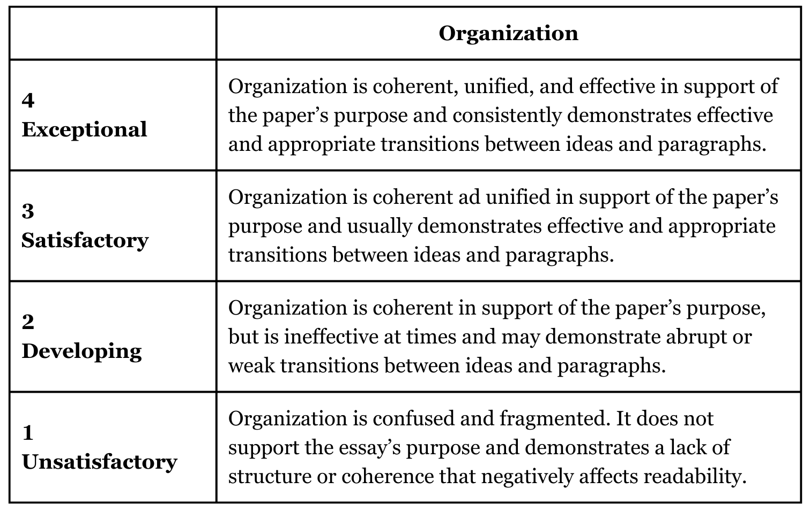

#### Holistic Rubric

This simple rubric is less structured (Gunner, 2022). A teacher provides a series of letter grades or a range of numbers (1–4 or 1–6, for example) and then assigns expectations for each of those scores. Teachers grade and rate the students according to the rubric. This is a faster way to evaluate work but leaves no room for comments or detailed feedback (Roell, 2019).

For example:

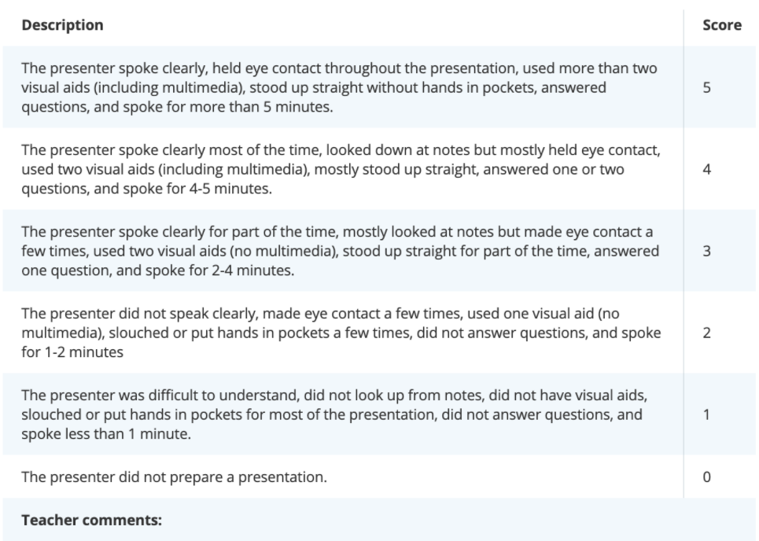

You could [use this template to create either an analytic or holistic rubric](https://edtechbooks.org/ideal9thedition/klpoomzxbv#).

### Interaction with Students

Using the telephone or an online tool (such as Zoom or Google Meet), teachers working with learners at a distance can meet with their students to review their work and ask them questions to assess their understanding of concepts. These meetings may also be held in person for students in blended or hybrid offerings. The following video shows how a K-12 teacher makes the most of a short conversation by turning it into an interview assessment:

[Watch on YouTube](https://www.youtube.com/embed/CQw9wENGygc?autoplay=1&amp;rel=0&amp;showinfo=0&amp;modestbranding=1)

### Progress Checklists

Skills checklists can show a student’s progress while in the program. Skills checklists may be part of a goal plan or a stand-alone tool used by teachers and students to document skills attainment.

Documenting students’ progress can support persistence by changing students’ beliefs about their capabilities and achievements (New England Literacy Resource Center, 2013). A visual representation of learned skills can build students’ self-confidence and self-efficacy in terms of their ability to learn and be successful in education. This change in how students view their abilities can have a profound effect on their persistence in the program and achievement. Digital badges, referenced in the previous section, provide a great visual presentation of learner milestones and accomplishments.

Here are some tips for making your own checklist:

* List standards or other learning outcomes for the unit in language a student can understand.
* Enlist students to write indicators of progress (i.e., how they’ll know when they achieve the desired outcome).Ensure that checklists are dated so you can chart progress.
* Leave room for comments to help fully illustrate learner progress.
* Always use the same template so that students can fluently use it.
* Make space for students to add their own criteria to a checklist or even their own checklists—to support learner-directed learning (Lauzon, 2014).

### Additional Assessment Measures

In addition to the ideas presented above, IDEAL Consortium states have suggested several possibilities for ongoing or interim assessment of distance student progress, including:

* High school equivalency practice tests (e.g., HiSET™, GED®, TASC™)
* Passing individual sections of high school equivalency tests
* Certifications related to digital literacy and workplace skills (e.g., Northstar, WorkKeys®)
* National Reporting System (NRS) tests (e.g., TABE, CASAS, BEST Plus 2.0)

## Assessment to Meet the NRS Guidelines

The U.S. Department of Education’s Office of Career, Technical, and Adult Education (OCTAE) National Reporting System (NRS) Technical Assistance Guide (2024) states that distance learners can be included in NRS reporting as a subset of the learners the state reports, as long as states have an approved distance learning policy in their state’s adult education plan. OCTAE first announced this option in 2007. In order to be included in the NRS, distance learners must be assessed according to the same policy that is in place for all adult learners in the state. Your state will provide guidance on how to report distance learners. The following discussion of NRS requirements is intended only to provide some general background information; refer to the appropriate NRS, OCTAE, and state policy documents for specific details. Note that Distance and Digital Education Definitions and Reporting Practices: What We Have and What We Need (Cherewka et al., 2024) reports on a survey of state directors and summarizes how different states report on the different modalities of distance and digital education.

The NRS Technical Assistance Guide (2024) states that distance learners may be assessed in person, at a secured proctored program site that meets the state’s assessment policy or via virtual proctoring (i.e., remote test administration) when the NRS-approved test publisher allows it. The NRS Technical Assistance Guide states that distance learners “should be post tested after the same amount of instructional time as other students, according to the state’s approved NRS assessment policy” (p. 19). Assessment must be done using a standardized test identified in the state’s assessment policy. This does not mean, however, that the assessment must occur at the adult education center. Some adult education organizations have made arrangements with local public schools or libraries and trained staff there to administer and proctor testing for distance learning students living in those communities. A few teachers travel to remote locations to administer the assessments.

Remote test administration that began during the COVID-19 period allows more opportunities for distance learners to be tested. Organizations remotely testing students when in-person contact was not allowed have found innovative solutions to this new testing method. Remote test administration continues to be a valuable option for assessing learners who may face barriers, such as transportation and childcare, that make in-person assessment difficult. See the table below for examples of challenges that some programs have found with remote test administration and the solutions they used to address them.

|  |  |
| --- | --- |
| **Remote test administration challenge** | **Possible solutions** |
| Students do not have a device that can be used to take the test. | Partner with K-12 school districts to secure permission for adult learners to use their child’s school-issued device for adult education activities, such as assessment and online assignments. |
| Students do not have access to Wi-Fi. | Create a map of local Wi-Fi spots available from places such as libraries and school districts. Provide learners with hotspots. . |
| More than one student at a time needs to be tested. | Some test publishers allow multiple students to be tested simultaneously. To make the process more efficient, have a staff member meet with students to test their technology and set everything up before the student is scheduled for a remote test. |

## Measuring Instructional Time for Distance Learners

### Contact Hours

How do you measure instructional time for distance learners? In a classroom, the most commonly used approach is to record “contact hours,” the amount of time a student is physically present in orientation, the classroom, the lab, and so on. This figure determines when a learner becomes an enrolled student (at 12 hours) and when assessment of educational functioning level should be administered (frequently after 40 or 50 hours, but it can be longer). Contact hours can also be counted for distance learners, but these hours extend beyond times when a student is physically present.

The NRS Technical Assistance Guide (2024) states “contact hours for distance learners can be a combination of actual in person contact and contact through telephone, video, teleconference, or online communication, where the participant and program staff can interact and through which participant identity is verifiable” (p. 46). This allows distance education programs to count contact hours for times when a distance teacher provides instruction using the telephone, webinars, video chat technologies, or interaction in the assigned distance learning curriculum.

### Proxy Contact Hours

States have the option to report proxy contact hours for the time learners engaged in specific distance learning activities. From an assessment perspective, proxy contact hours serve the same functions as contact hours: they allow adult education providers to determine when to post-test students. They also provide instructors with another way of monitoring their students’ engagement with the curriculum and help instructors determine where additional support or intervention might be warranted.

Proxy contact hours are assigned using a systematic process. Your state will provide guidance on what proxy contact hour model (if any) you will use for your distance learners; this is not typically a decision that individual teachers or adult education centers make. For NRS purposes, the following three models of determining proxy contact hours are acceptable:

* **Clock Time Model**: This model can be used with online or stand-alone software programs that track the time that a student is engaged with the curriculum and that log out students after a predetermined period of inactivity. Typically, one hour of time in the program is accepted as one proxy contact hour.
* **Teacher Verification Model:** This model is well suited to multimedia curricula, where students receive instruction from a variety of sources, or with distance activities developed by the instructor. In this model, a fixed number of proxy contact hours are given for completion of each instructional activity in the curriculum. The assignment of hours is based on a teacher verifying that the assignment was completed.
* **Learner Mastery Model**: In this model, the degree to which learners have mastered instructional content determines the number of proxy contact hours. The Learner Mastery Model assigns a fixed number of proxy contact hours based on the learner passing a test on the content of each lesson. Students must score at a predetermined level (typically 70-80%) to earn the credit hours attached to the material.

States are not required to report proxy contact hours to the NRS. However, if proxy contact hours are reported, they must be used to determine when it is appropriate to post-test students. States that do not use proxy contact hours must provide information in their distance learning policy that explains how they will make decisions about appropriate post-testing intervals.

### Post-testing Students

Getting students to come back to the adult education center for post-testing is one of the major challenges facing distance teachers. While remote test administration may resolve transportation issues, other barriers may still exist. Students might not have time to come in or adequate transportation. They might feel unwilling to meet face-to-face due to health issues. Even students who are post-testing remotely might feel reluctant. They may not see the importance of testing, or they may not have a device or adequate space in their home that allows remote testing. Yet post-testing is important both for monitoring student progress to guide instruction and for accountability purposes.

### Post-testing Students

Our state requires students to return to an adult education class and take a post-test in at least one subject every three months. First, we remind students to go in and take a post-test. We point out how valuable this is to us and them. Then if they do not respond or go in and take a post-test,  access to their online lessons is temporarily blocked. If they have a good reason for not post-testing right away, I will give them some extra time.

– A Teacher in Missouri

Teachers in IDEAL Consortium states report that they have used the following approaches to encourage post-testing:

* **Use incentives**: To bring students back for testing, teachers have used incentives ranging from gas cards to pizza parties to raffles. Others find that certificates or other tangible forms of recognition may motivate students to post-test.
* **Set expectations for post-testing at orientation and reminding students of this as they study**: Thus, students perceive post-testing as an integral part of their distance education program, and teachers build in a reminder to themselves to prepare students for the post-test.
* **Explain the point of post-testing (for both the student and the program)**: Tell students that post-testing will benefit them because it will allow them to quantifiably see progress and identify areas for improvement. Furthermore, post-testing will benefit the program because the program is required to report scores to the state in order to continue qualifying for funding. Their participation in post-testing will help keep the program going.
* **Put students at-ease**: Teachers can let learners know that post-testing is in most cases low stakes, which may address some learners’ reluctance to test.
* **Offer post-testing in locations that are convenient for the students**: Some organizations have made arrangements with local libraries or schools located in the students’ communities to conduct post-testing. A few teachers have reported that they will drive to the students’ communities to administer post-tests.
* **Use remote assessments to post-test**: Programs administering remote assessments often work with digital navigators or teachers to ensure that learners have a device and internet that will allow remote assessment.
* **As a last resort, block students from the distance program until they post-test.**

## Considering Your Assessment Strategies

### Activity 6.1 Assessment to Gauge Learner Progress and Guide Instruction

**Plan how you will use the different assessment strategies described in this chapter.**

Of the strategies listed in this chapter, which will you use and how will you implement them? If you are a practitioner new to distance or blended instruction but working where there is an established program, be sure to first consider what is currently in place.

### Activity 6.2 Assessment for NRS Reporting

**Articulate how you will fulfill NRS testing and reporting requirements for your distance and digital education program.**

You will first need to review your state’s distance education policy and assessment policy. Then, describe how you will handle assessment for NRS reporting of your distance learners and your plan for post-testing distance students. If you are a practitioner new to distance or digital education but working within an established program, be sure to first consider what is currently happening in your distance education program.

Note that in the course, IDEAL 101: Foundations of Distance and Digital Education, these prompts are expanded into fully developed collaborative activities for your team to complete together.

### Suggested Resources for Further Exploration

Please see [Appendix A](https://edtechbooks.org/ideal_dl_handbook/appendix_a) for a list of useful resources related to this topic that you may want to explore more.

## References

Bakerson, M. A., Trottier, T., & Mansfield, M. (2015). The value of embedded formative assessment: An integral process in online courses implemented through advances in technology. In S. Koç, X. Liu, & P. Wachira (Eds.), Assessment in Online and Blended Learning Environments (pp. 3–20). Information Age Publishing.

Belzer, A., Leon, T., Patterson, M., Rhodes, C., Salas-Isnardi, F., Vanek, J., Webb, C., & Wilson-Toso, B. (2020). COVID-19 rapid response report from the field. ProLiteracy. <https://www.literacynewyork.org/documents/Covid-19/COVID-19-Report.pdf>

Cherewka, A., Hart, S., Vanek, J., & Yamashita, J. (2024). Distance and digital education definitions and reporting practices: What we have and what we need. World Education. <https://edtech.worlded.org/resource/distance-and-digital-education-definitions-and-reporting-practices-what-we-have-and-what-we-need/>

Dame, B., & Lea, K. (2020, May 29). Using universal design to create better assessments. Edutopia. <https://www.edutopia.org/article/using-universal-design-create-better-assessments>

Edutopia. (2008, July 15). Why is assessment important? George Lucas Educational Foundation. <https://www.edutopia.org/assessment-guide-importance>

Gunner, J. (2022, December 13). Simple rubric examples for teachers. YourDictionary; LoveToKnow Media. <https://examples.yourdictionary.com/simple-rubric-examples-for-teachers.html>

Herr, N., Rivas, M., Chang, T., Reveles, J. M., Tippens, M., Vandergon, V., d’Alessio, M. A., & Nguyen-Graff, D. (2015). Continuous formative assessment during blended and online instruction using cloud-based collaborative documents. In S. Koç, X. Liu, & P. Wachira (Eds.), Assessment in Online and Blended Learning Environments (pp. 187–214). Information Age Publishing.

Lauzon, N. (2014, September 10). Checklists and achievement charts for students with learning disabilities. LD@School; Learning Disabilities Association of Ontario. <https://www.ldatschool.ca/checklists-achievement-charts>

Many, T., & Horrell, T. (2014). Serving Texas PreK-8 school leaders. TEPSA News, 71(1), 1–2. <https://absenterprisedotcom.files.wordpress.com/2016/06/real-standards.pdf>

Miller, A. (2020a, April 7). Formative assessment in distance learning. Edutopia. <https://www.edutopia.org/article/formative-assessment-distance-learning>

Miller, A. (2020b, April 7). Summative assessment in distance learning. Edutopia. <https://www.edutopia.org/article/summative-assessment-distance-learning>

New England Literacy Resource Center. (2013, December 13). Drivers of persistence: Competence. Adult Learner Persistence; World Education. <http://www.nelrc.org/persist/drivers_competence.html>

Popham, W. J. (2011). Transformative assessment in action. ASCD.

Roell, K. (2019, July 3). How to create a rubric in 6 steps. ThoughtCo. <https://www.thoughtco.com/how-to-create-a-rubric-4061367>

Sparks, S. D. (2015, November 9). Types of assessments: A head-to-head comparison. Education Week. <https://www.edweek.org/teaching-learning/types-of-assessments-a-head-to-head-comparison/2015/11>

## Heading

Read this online at <https://edtechbooks.org/ideal_dl_handbook/ch6__assessment>