# All About the LMS

Griffiths, C.

With the advent of the Learning Management System (LMS) came the need to standardize the requirements for online learning content. Two standards were developed: SCORM and xAPI. As the first standard created, SCORM turned the LMS into a repository for online content, where learners could retrieve specific content such as online courses or curricula. SCORM is a content-centered standard, and tracks data about online content such as test scores and course completion status. For nearly two decades, SCORM was the cornerstone of the LMS. However, as the Internet adopted Web 2.0 technologies, SCORM became insufficient to meet the needs of a new generation of online learners. The xAPI standard was developed to address SCORM’s shortcomings, specifically on the relationship between learners and the learning experience. xAPI is able to track both formal and informal learning experiences, such as test scores, simulations, and group work. For the first time, xAPI provided instructional designers with robust data about what learners were doing with content. As the second iteration of the LMS, xAPI-integrated systems are able to track learning that occurs outside of the LMS. However, neither SCORM nor xAPI provide a full picture of the learning experience. The LMS is at the start of its third evolution, into an open, adaptive system that supports learning across a variety of frameworks and services.

## Background of LMS Standards

### A brief history of the development of LMS standards

The rise of computer-based and online learning in the 1990s resulted in the availability of a large number of Learning Management Systems (LMS) and online course authoring software. However, each system and software had its own technical specifications, which meant that the software used to create online courses was often incompatible with the LMS systems meant to host the course. These differing technical requirements made developing and delivering online content time-consuming, cumbersome, and costly (Advanced Distributed Learning, “SCORM Overview”, n.d.)

In 1999, the Advanced Distributed Learning (ADL) initiative was created by the United States’ Department of Defense (DoD) to develop common standards and specifications for online learning (Lundy, 2003). One of the goals of the ADL initiative was to create an interoperable learning specification that would let eLearning software and LMS systems “talk” to each other. The Shareable Content Object Reference Model, or SCORM, was the result (Advanced Distributed Learning, “SCORM Overview”, n.d.).

Released in 2000, SCORM was the first set of standards and specifications for online learning. It defined how online content should be published, launched, and tracked (U.S. Department of Defense, “SCORM Users Guide for Instructional Designers”, 2011). For the first time, any online content developed with SCORM-compliant software could be hosted on any LMS, as long as the LMS was also compliant with the new standards. This greatly reduced the time, effort, and cost to develop and publish online content. Additionally, SCORM gave greater insight into user interactions with online content. SCORM’s ability to track online content allowed instructional designers to see what content users were accessing, what their quiz scores were, as well as how many users were completing a course.

However, emerging technologies of mobile learning and cloud computing exposed limitations in the SCORM standard. SCORM was developed for self-paced, asynchronous online learning content that was accessible through an LMS. Such content did not work well on mobile devices, and the demand for learning content that was easily accessible from anywhere and on any device led to the need for a new set of online standards and specifications (Miller, Soh, Riley, & Samal, n.d).

The Experience API, or xAPI, was the result of this second initiative. Created by Project TinCan, the xAPI was designed to meet current and future requirements for online learning (“Project Tin Can Requirements”, 2018). Released in 2013, the xAPI allows learning content to be launched from any application, on any device. Additionally, the xAPI tracks any learning-related activity done by a user. These learning experiences can include traditional eLearning courses, as well as informal learning activities, games, simulations, and group-based or social learning.

The xAPI went beyond reporting on test scores and course completions, and gave instructional designers specific, detailed information about what users were doing with learning content. For example, with the xAPI, instructional designers were able to see where in an online course users clicked, what content they are accessing or ignoring, and whether or not users went to a website to get more information after they completed the course.

Unlike SCORM, with xAPI all learning experience data is stored in a Learning Record Store (LRS) instead of an LMS. A growing number of instructional designers used xAPI in developing their courses, and the DoD added the xAPI as an online learning standard in 2017.

Currently, SCORM and xAPI are the two online learning standards recognized by the DoD (U.S. Department of Defense, 2017). As such, SCORM and xAPI have been adopted by the learning industry as the standards and specifications to use when developing and deploying any online learning content.

### What is SCORM?

SCORM stands for Shareable Content Object Reference Model. SCORM is a standard specification for publishing, launching, and tracking eLearning content such as course completions, quiz and test scores, and the number of pages or slides viewed. SCORM was the first specification developed for eLearning content. It is used to track self-paced, asynchronous eLearning content (Ostyn, 2003).

### What is xAPI?

Experience API, or xAPI, is a technical specification for tracking and sending learning statements to an LRS (Learning Record Store). The xAPI specification is the second-generation specification for eLearning content. It focuses on the relationship between the learner and the learning experience, and tracks all components that make up a learning activity. Examples of learning activities that xAPI can track include: games, simulations, real world performance, group work, and traditional eLearning content such as online courses, quizzes, and materials (Torrance, 2016).

## LMS Standards and Specifications

Two standards used by Learning Management Systems today are SCORM and xAPI.

### SCORM

#### SCORM Standards

These explain what SCORM enabled content should do:

1. **Be accessible.** All SCORM content can be uploaded to and accessed from any SCORM-compliant LMS that uses the same version of SCORM.
2. **Operate in multiple LMS systems.** All SCORM content delivered in one LMS can also be delivered in another LMS, either at the same or different times.
3. **Function independently of system or software changes.** Content can be launched despite upgrades to the LMS or content-authoring software.
4. **Be re-used or repurposed depending on learning needs.** SCORM content can be used by or altered to fit the needs of different learning audiences.

Source: U.S. Department of Defense, “SCORM Users Guide for Instructional Designers”, 2011.

#### SCORM Specifications

These are the technical requirements that make SCORM content work with an LMS:

1. **Interoperability:** defines how web-based content and LMS systems communicate with each other. SCORM uses a combination of a common data model and application program interface (API) that standardizes communications between learning content and the LMS.
2. **Portability:** defines how to package online content for publishing to an LMS. All SCORM content is saved and uploaded to an LMS as a ZIP file.
3. **Reusability:** defines how to build lessons, modules, courses, and curricula; and how to attach metadata tags to content. All SCORM content is organized from the smallest learning object (lesson) to the largest (curricula). Metadata tags are added to each piece of content so that the content is easily located and accessed from an LMS.
4. **Sequencing:** defines how content is delivered to learners through navigation, and how to set the order in which learners receive content. Content can be set so that it is required, optional, or taken in a prescribed order.

Source: Advanced Distributed Learning, “SCORM Overview”, n.d.

### xAPI

#### xAPI Standards

These explain what xAPI enabled content should do:

1. **Access eLearning content using modern technology devices.** This includes desktop computers and mobile devices such as tablets and phones.
2. **Track and report any learning experience.** Learning experiences range from test scores, to downloading documents, or even visiting a museum exhibit.
3. **Launch content, and send and retrieve eLearning data without an LMS.** xAPI uses JavaScript Object Notation (JSON), a common computer programming language, to execute commands and track data. All data is stored in an LRS.
4. **Adaptable for current and future learning performance needs.** With a common programming language that can be enabled to track nearly every learning experience taken both online and offline by learners, xAPI-enabled content can be adjusted to meet changing learning needs.

Source: Rustici Software, “Project Tin Can Requirements”, 2018.

#### xAPI Specifications

These are the technical requirements that make xAPI content work:

1. An LRS must meet three levels of compliance to work with xAPI:

* **MUST** requirements are absolute; if a service or system does not meet this requirement they will not work with xAPI.
* **SHOULD** are recommended requirements for systems to work with xAPI; an LRS does not have to include these requirements to work with xAPI.
* **MAY** are optional requirements; an LRS does not have to include these requirements to work with xAPI (Bradner, 1997).

Example:

* The LRS MUST reject requests to store Statements that contain malformed signatures, with 400 Bad Request (Creighton et al., 2017).
* An LRS SHOULD include a message in the response of a rejected statement. (Creighton et al., 2017)
* An LRS MAY reject (batches of) Statements that are larger than the LRS is configured to allow (Downes, Johnson, Yang, & Richard, 2017).

1. **JSON:** xAPI uses the JSON programming language to write the statements that are used to gather data about the learner’s experience (Downes, Johnson, Haag, Yang, Castro, & O’Connell, 2017). JSON is a common language that works with the majority of computer programs.

**Figure 1**

JSON Example

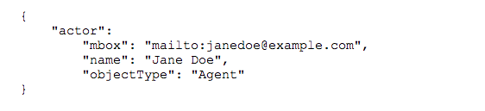

1. **xAPI statements:** Statements are used to gather data about a user’s learning experience. Statements must follow a basic format of actor-verb-object, such as “Learner did activity” (“Parts of an xAPI Statement”, 2018). For example, a xAPI statement may look like, “Mary experienced Skydiving 101 Intro Course”.

* **Actor:** describes who is doing the activity. This field contains the learner’s name and an email address. An email address helps to tell learners with the same or similar names apart, so instructional designers can track the right data for the right learner (“Parts of an xAPI Statement”, 2018).
* **Verb:** describes the action of the learning experience. Some verbs used in xAPI statements include: experienced, completed, and answered. A registry of all verbs used in xAPI statements is available online at the Experience API Registry (“The Experience API Registry”, 2018).
* **Object:** describes the learning activity that is taking place. Activities can be anything from an online course to skydiving. The type of activity is described in the Object Type sub-field. Each activity has a unique identifier, so that the right activity is tracked and not confused with a similar activity (“Parts of an xAPI Statement”, 2018).

xAPI statements can include additional fields, such as Results or Attachments, to gather more information about the learning experience. However, all statements must include an actor, a verb, and an object to work.

**Figure 2**

Example of Actor-Verb-Object xAPI statement

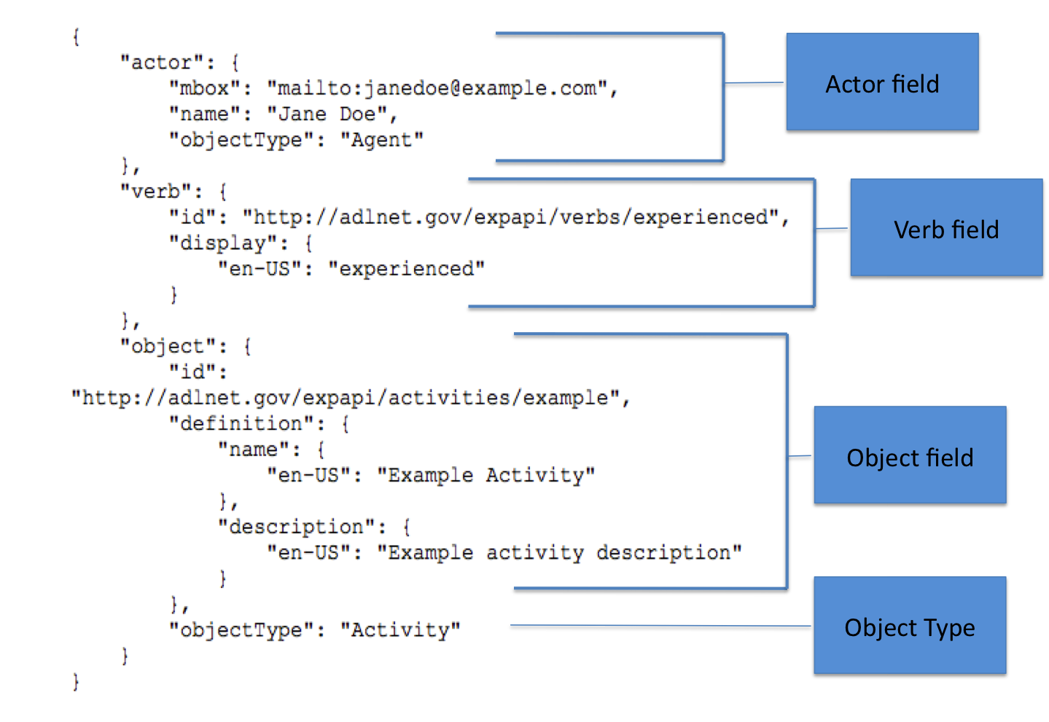

### Similarities and Differences Between SCORM and xAPI

At first glance, SCORM and xAPI appear to be the same: instructional designers use both standards to develop their online learning content, and both standards achieve the same goal of making content available to learners. However, the method of content delivery, and what they can track about content is what sets SCORM and xAPI apart from each other.

#### Similarities

Content development: Both SCORM and xAPI drastically reduce the time needed to develop learning content. The specifications for both standards clarified how learning content should be built and packaged (Advanced Distributed Learning, “SCORM Overview”, n.d.; Rustici Software, “Project Tin Can Requirements”, 2018). Additionally, most content authoring software, such as Articulate Storyline and Captivate, are compatible with both SCORM and xAPI. This means that instructional designers don’t have to worry about the technical requirements of SCORM and xAPI, and can instead focus on developing the actual learning content.

Accessible and reusable: Both standards allow learners to easily access compatible learning content. This means that learners can locate, launch, and revisit content made with SCORM and xAPI. Both standards also ensure that content is reusable. SCORM or xAPI-compatible learning content can be uploaded to multiple LMS’s or systems. Additionally, content is not affected by software and system updates (Advanced Distributed Learning, “SCORM Overview”, n.d.; Rustici Software, “Project Tin Can Requirements”, 2018).

#### Differences

System requirements: SCORM and xAPI have very different technical requirements to deliver learning content. SCORM-packaged content must be uploaded to an LMS in order to work; otherwise learners cannot access the content. Additionally, all SCORM content needs to be sent to and retrieved from an LMS, using an Internet connection; SCORM does not work offline (Nguyen, 2017). xAPI-enabled content does not need an LMS, or even an Internet connection, to be delivered to learners. Although it can work with an LMS, xAPI only requires an LRS to store activity statements (Anderson, 2017).

Mobile compatibility: SCORM content does not work well on mobile devices, although improvements with mobile compatibility are being made. Unlike SCORM, xAPI-enabled content does work on mobile devices (Nguyen, 2017).

Content format: Because of its specifications, SCORM content must be defined as a lesson, course, or curricula (Advanced Distributed Learning, “SCORM Overview”, n.d.). Learning content that falls outside of these parameters either does not work with SCORM, or must be re-purposed to fit one of SCORM’s content formats. xAPI does not define content, but rather the learner experiences or activities that occur (Torrance, 2016). Any type of content can be enabled with xAPI, including eLearning courses, group activities, or simulations.

Tracking and reporting: SCORM is able to track different information, depending on what version is used. There were earlier versions of SCORM, but only SCORM 1.2 and SCORM 2004 are in use today. SCORM 1.2 tracks quiz and test scores, as well as the number of slides viewed. This version reports whether or not a learner completed the content. SCORM 2004 dives deeper, and tracks the response on individual quiz and test questions (Rustici, “SCORM Versions – an eLearning Standards Roadmap”, 2009). Detailed score reports let instructional designers know exactly what questions are being missed. This can provide insight into improving the assessment, or whether additional training on a particular topic is needed.

xAPI can track almost anything: quiz and test scores, completion status, what buttons or links learners clicked on, what materials or websites they viewed, and more. The drawback with xAPI is that since learning is often unpredictable, learning experiences can be missed, giving the instructional designer an incomplete picture of the learning event.

Refer to Table 1 for more information about the requirements and capabilities of the current versions of SCORM and xAPI.

**Table 1**

What SCORM and xAPI Can Do

|  |  |  |  |  |  |  |  |
| --- | --- | --- | --- | --- | --- | --- | --- |
| **Version** | **Release Date** | **Web Browser Needed?** | **LMS needed?** | **Cross-Domain Functional?** | **Tracking & Reporting** | **Works on Mobile Device** | **In Use?** |
| SCORM 1.2 | 2001 | Yes | Yes | No | * Course completions * Slides viewed * Quiz and test scores | No | Yes |
| SCORM 2004 | 2004 | Yes | Yes | No | * Course completions * Slides viewed * Quiz and test scores * Correct/incorrect question choices | No | Yes |
| xAPI | 2013 | No | No | Yes | * Course completions, quiz and test scores * Correct/incorrect question choices * Buttons clicked on * Materials accessed * Sites visited * Offline activities | Yes | Yes |

Source: Rustici, “SCORM Versions – an eLearning Standards Roadmap”, 2009.

## Application of Current Standards with LMS

### How it Works: SCORM and the LMS

Online courseware authoring tools, such as Articulate Storyline and Captivate, simplify publishing and uploading learning content to an LMS. When the content is ready to be published to an LMS, the authoring tool will package the content in a SCORM wrapper. A SCORM wrapper is a set of files that make it possible for a SCORM-compliant LMS and any digital content to communicate back and forth (Johnson, 2011).

**Figure 3**

SCORM 1.2 Package

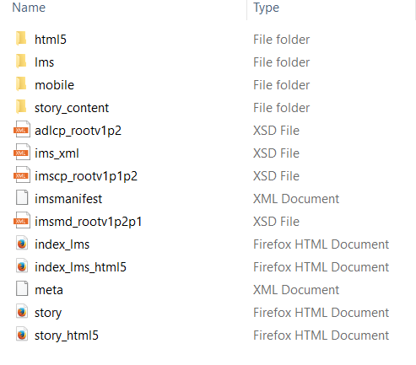

Next, the content is uploaded to an LMS. The LMS will host the content and make it available for learners to download. When a learner launches the content, the LMS uses the SCORM wrapper files to track the learner’s progress. Data from the learning content is reported back to the LMS, where it is logged and stored. When a learner finishes the learning content, a completion status and any quiz scores are reported back to the LMS.

SCORM is able to track and report on the following:

* Number of slides viewed
* Completion status
* Quiz scores
* Quiz questions answered (SCORM 2004 only)

The below graphic visualizes how SCORM-enabled content works with an LMS.

**Figure 4**

SCORM and the LMS

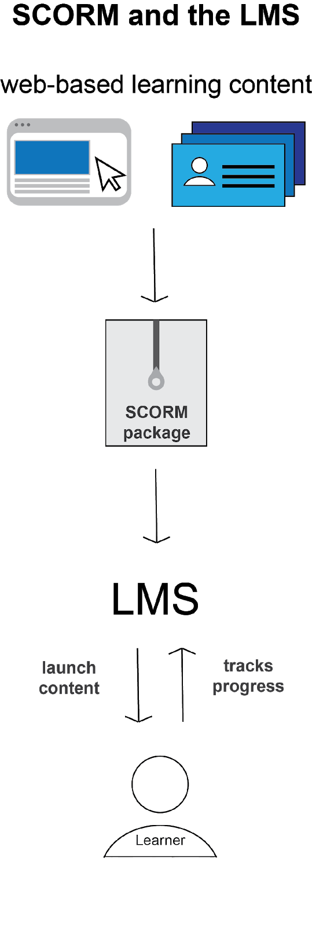

## SCORM: Advantages and Disadvantages

### Advantages

* Easy to migrate courses between different LMS systems.
* Easily reuse course content in any LMS.
* Manage, track and report content from a single host.

### Disadvantages

* Static content, such as documents, videos or website links, do not work well in LMS systems.
* SCORM is limited in what type of user activities in can track and report on.
* Does not work well on mobile devices.

## How it Works: xAPI

xAPI tracks formal and informal learning as it happens. This can be done online or offline, and so an LMS is not always needed for xAPI content to work; only xAPI statements and an LRS are required.

First, xAPI statements are attached to learning content. The xAPI statements track specific actions or activities that a learner may experience. The learning content is then hosted online, in the Cloud or in an LMS that has an LRS. Each time a learner accesses content or does an activity that has a xAPI statement attached to it, the statement is triggered and is sent to the LRS for storage. The LRS then aggregates all of the learner’s activity statement data into a format that is easy to understand.

xAPI tracks and reports on the following:

* Quiz scores
* Quiz questions answered
* Completion status
* Online learning activities (elearning courses, simulations, websites visited)
* Offline learning activities (learning content accessed on mobile devices)
* Social learning activities (games, online forums, group discussions)
* Videos watched
* Documents downloaded or read

**Figure 5**

xAPI and the LMS

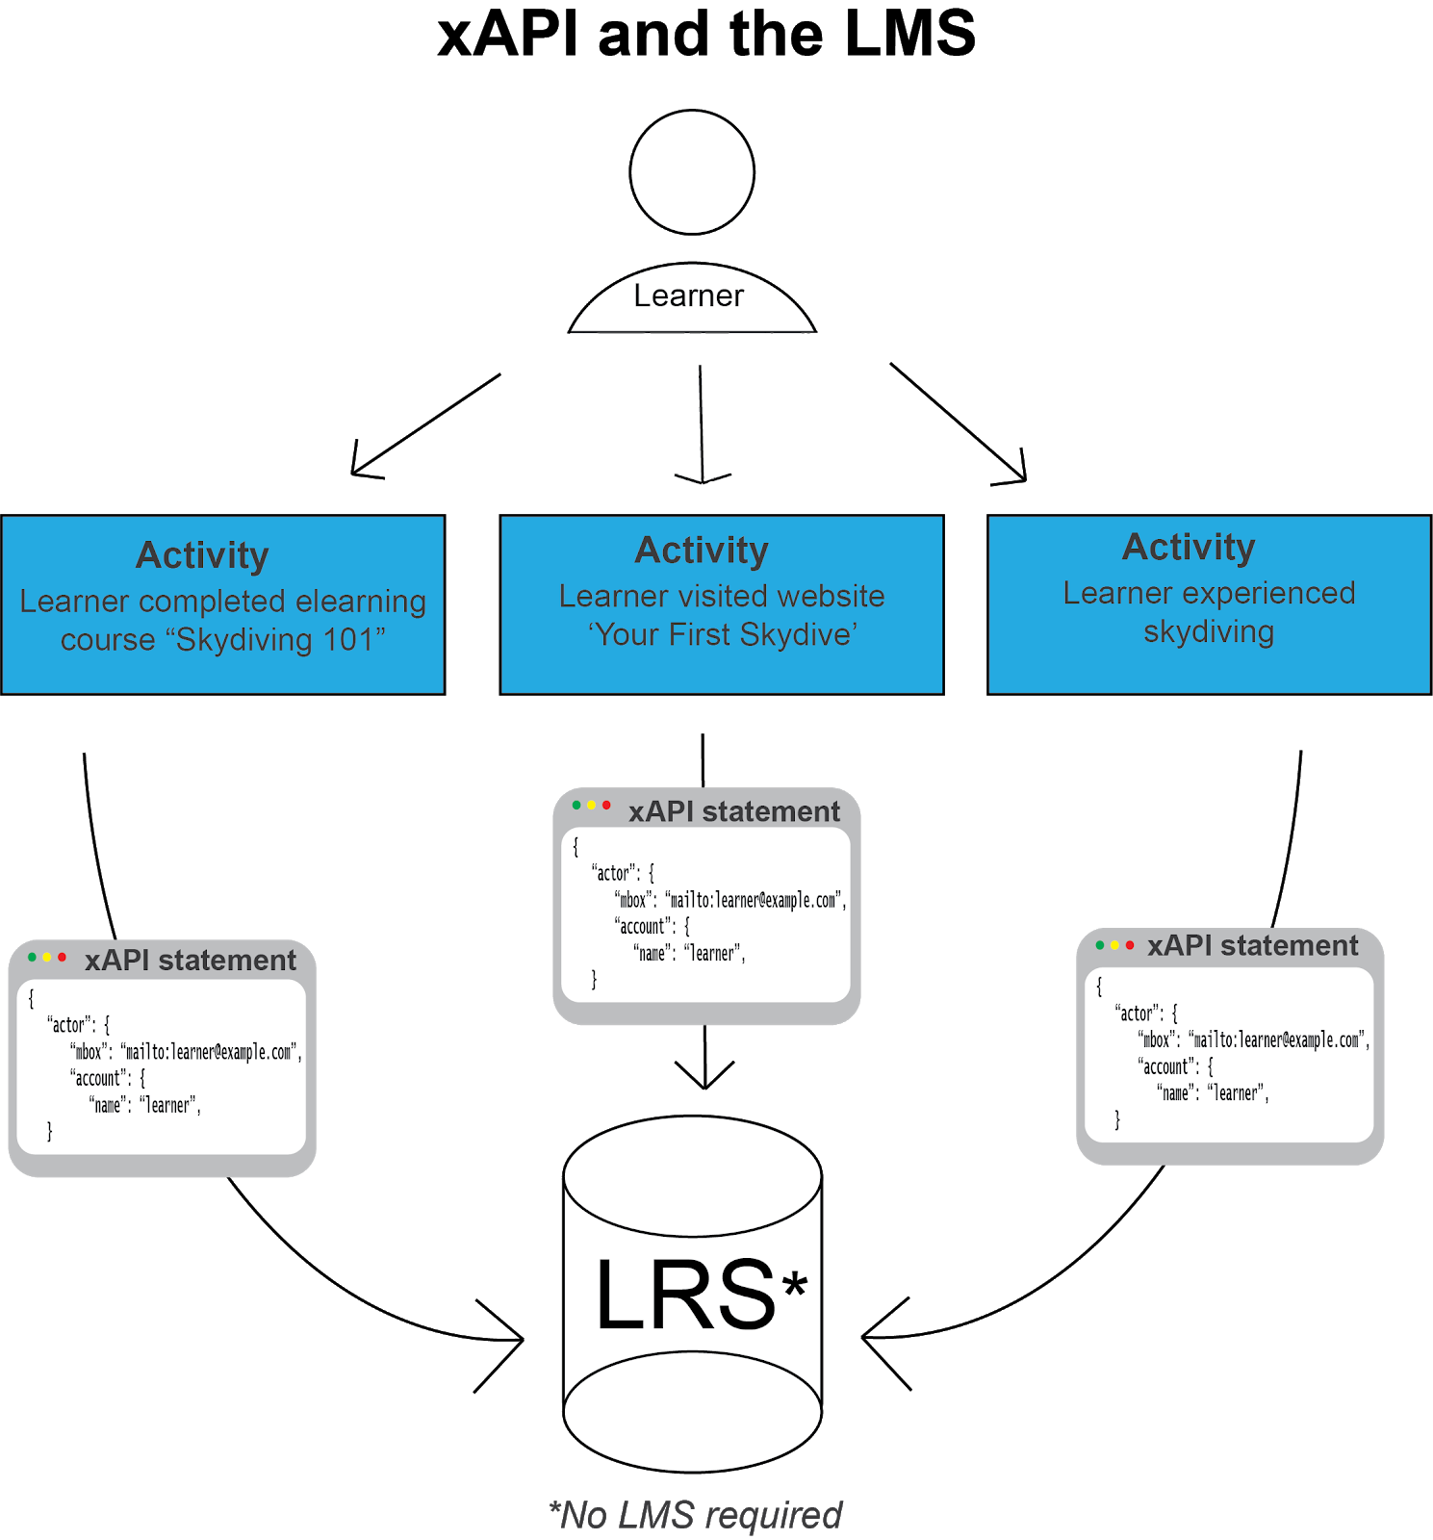

## xAPI: Advantages and Disadvantages

### Advantages

* An LMS is not needed to launch or store content.
* Gather detailed data about learning experiences.
* Works with social and mobile technologies.

### Disadvantages

* Need basic knowledge of JavaScript to implement.
* Need an LRS to store xAPI statement data.
* Few defined best practices on how to use xAPI.

## Which should you use: SCORM or xAPI?

There are three things instructional designers should consider when deciding between SCORM and xAPI to create learning content: Will the content work without an LMS? What information needs to be tracked? and How will the content be used?

Will the content work without an LMS?

If an LMS is needed to launch and store learning content, use SCORM to create the content. Although xAPI-created content can also be stored on an LMS, it can be hosted elsewhere. However, SCORM-created content will not work without an LMS.

What information needs to be tracked?

Deciding which standard to use depends largely on what data should be tracked. SCORM will only track data related to the learning content, such as course completions, the number of slides viewed, and quiz or test scores. xAPI tracks data about learning activities, such as what the learner is doing with the content, where they accessed it, and what the learner did both online and offline.

When it comes to deciding what data to track, instructional designers should approach this in two ways: first, decide what information is essential to collect. Then, determine what information is not essential, but would be nice to have. Instructional designers should use the answers to these two questions as guides in selecting SCORM or xAPI to create their content.

How will the content be used?

Will the learners be taking an online course or an instructor-led training? Will they need to access the content on a computer or a mobile device? Knowing how the intended audience will use the content is important when deciding which standard to use. SCORM works best with online, asynchronous content that is accessed through a desktop computer. xAPI works best when learners need to connect online and offline learning activities, or when they need to use multiple systems that support xAPI, such as social media sites and other learning platforms (Martin, 2018).

It is important to note that each project or set of learning content has different needs. What worked for one project or set of content may not work for another. Before content is created, instructional designers must carefully consider how their content will function with an LMS, what the data needs are, and how learners will interact with the content in order to determine whether SCORM or xAPI is the best standard to use. Thinking ahead clarifies content needs, saves development time, and minimizes the potential for content redesign.

## Impact of Current Standards on the LMS

### The Traditional LMS

SCORM has been the cornerstone of the traditional LMS for nearly 20 years. Developed at a time when learning content was beginning to move online, SCORM bridged the gap between content development and its online administration. SCORM’s standards of content interoperability, packaging, organization, and delivery, are reflected in the traditional LMS’s focus on content management.

Traditional LMS systems view learning management as a means of keeping track of data about the learning content. This is not surprising, since these systems are fully compliant with the deeply content-centered SCORM standard. In traditional LMS systems, learning is not distinguished from information or data (Alavi & Leidner, 1999). Instead, traditional LMS systems serve specific requirements for managing online courseware assets, tracking results of student tests and content completion, and making sure that the content used to represent the course itself is accurate and available on demand (Davis, Carmean, & Wagner, 2009).

Each of these primary functions of the traditional LMS is reflected in the SCORM standard: SCORM defines how to publish, organize, and deliver online learning content; it specifies what components are tracked and reported; and it sets guidelines for content accessibility and reusability across multiple systems and software. Many of the traditional LMS’s functions and features are driven by the SCORM standards.

Traditional LMS systems give instructional designers insight into content-related data. With SCORM, an LMS is able to track and report on what content is being accessed by learners; how many slides they are viewing, or what their test scores were; and what progress learners have made in a course or curriculum. This data helps instructional designers make decisions about how to structure online learning content in the LMS. For example, should the content be in one course, or multiple courses? Should these courses be part of a curriculum? Should the courses standalone?

SCORM data also helps instructional designers decide how the LMS should track content. For example, should there be a graded assessment? Or can the learner get what they need from the content by going through a required number of slides?

Nearly every LMS in use today follows the SCORM standard (The eLearning Industry, “SCORM 1.2 Compliant Learning Management Systems”, 2018). Instructional designers are familiar with SCORM, and it is well implemented across LMS systems and supported software. However, SCORM presents only a partial picture of the entire learning experience. Content and its related data are no longer sufficient to meet the needs of emerging technologies and those of learners who are used to a more robust and responsive online experience. In turn, the LMS is slowly adapting to the demands of Web 2.0 technologies and audiences.

### The New LMS (LMS 2.0)

Learning is not a one-time event. Today, when learners have a question or want to learn something, they use a variety of tools to find an answer: they search online, watch instructional videos, read forums and wikis, post to social media, or ask their friends and colleagues. The xAPI standard was developed in recognition that learning is ongoing, and occurs through a variety of interactions and resources (Rustici, 2013). Reflecting a shift from managing content to managing learning, LMS systems are increasingly adopting xAPI to provide a more complete picture of the learning experience.

The Internet is not the same today as it was 20 years ago, when LMS systems first began to adopt standards for its online content. Learners are increasingly comfortable switching between a wide range of tools and sites, making simultaneous use of locally installed applications, books, and the Internet, and participating in a variety of online and face-to-face communities of practice (Sclater, 2008). Standards that worked 20 years ago no longer meet the needs and expectations of today’s online learners. Traditional LMS systems appear dull and non-responsive to today’s learners, who want to be able to move uninterrupted between systems and activities (García-Peñalvo & Forment, 2014; Sclater, 2008).

Administrators and instructional designers who recognize these needs have started integrating xAPI with existing LMS systems. xAPI enables learners to move fluidly from one activity to another, while simultaneously tracking each learning experience that occurs both online and offline. In turn, xAPI is transforming the LMS. Now LMS systems have the potential to track learning beyond the content it hosts on site. This includes traditional online learning, such as online assessments and course completions, but also learning that occurs outside of the LMS. With xAPI, LMS systems can track both formal and informal learning activities such as visiting websites, viewing or downloading documents or images, reading a blog post, real world performance, group work, and more (Torrance, 2016).

xAPI focuses on the relationship between the learner and the learning experience. The data it gathers provides instructional designers and LMS administrators with a deeper understanding of what learners are doing and how they learn. Additionally, instructional designers can use the data from xAPI to identify learning gaps, and ways to improve the learning experience. With the help of xAPI, the LMS has started to shift from managing content, to managing learning.

However, xAPI is altering the LMS in another way: by removing the LMS altogether. Although xAPI can work with an LMS, it can track, report, and store data without one. Many instructional designers are using xAPI, without an LMS. Instead, they use an LRS to store activity statements. Additionally, since xAPI statements can be adjusted to meet changing learning needs, xAPI offers a level of flexibility that is currently unavailable in most LMS systems. In this way, instructional designers and their content are freed from the constraints of an LMS. Learning content does not have to conform to the strict parameters of a traditional LMS. xAPI provides unprecedented possibilities for customization that are currently impossible in traditional LMS systems (Sclater, 2008).

## Future of the LMS

The LMS is changing. As eLearning standards continue to evolve with emerging technology and learner needs, so will the LMS. SCORM turned the LMS into a powerhouse for storing online learning content, and for the first time gave instructional designers insight into how learners were interacting with online content. xAPI broadened the LMS’s definition of online content, and provided a deeper understanding of the learning experience. Combined, these data on learning content and the learning experience are creating a new understanding of what learning is, which in turn informs new standards for online learning.

The LMS is at the precipice of its next iteration. The standards of SCORM and xAPI are changing the LMS into a more learner-centered, adaptive environment with content that is easily accessible to learners through multiple devices, systems, and services. What the third evolution of the LMS will look like is yet to be determined, however it is evident that the integration of Web 2.0 tools, social networks, and cloud computing will be a key part in the LMS’s next phase.

The application of Web 2.o tools to educational concepts will continue to open new ways to carry out learning activities and learning services (Conde et al., 2014). These tools will open up the LMS, so that it becomes an adaptable and flexible framework for supporting the learning process (García-Peñalvo & Forment, 2014). Finally, it is even possible that LMS’s will become service-oriented systems that can be integrated into a variety of different learning scenarios (Ros et al., 2015).

While the LMS of the future is yet to be realized, what is certain is that the LMS and the standards that drive it will continue to seek methods that will support learners, instructional designers, and LMS administrators throughout the entirety of the learning experience.

## References

Introducing JSON. Retrieved from [https://edtechbooks.org/-zmL](https://www.google.com/url?q=https://www.json.org&amp;sa=D&amp;ust=1585947361016000).

Advanced Distributed Learning. (n.d.). SCORM Overview. Retrieved from [https://edtechbooks.org/-kkX](https://www.google.com/url?q=http://adlnet.gov/scorm&amp;sa=D&amp;ust=1585947361016000).

Alvari, M., Leidner, D. (1999). Knowledge Management Systems: Issues, Challenges, and Benefits. Communications of the Association for Information Systems, 1(7), 1-37. Retrieved from [https://edtechbooks.org/-WInE](https://www.google.com/url?q=http://aisel.aisnet.org/cgi/viewcontent.cgi?article%3D2486%26context%3Dcais&amp;sa=D&amp;ust=1585947361017000).

Anderson, K. (3 March 2017). “xAPI Enabled LMS: Tracking Learning Experiences”. Retrieved from [https://edtechbooks.org/-tGqT](https://www.google.com/url?q=https://elearningindustry.com/xapi-enabled-lms-tracking-elearning-experiences&amp;sa=D&amp;ust=1585947361017000).

Bradner, S. (1997, March). Key words for use in RFCs to Indicate Requirement Levels [Memo]. Retrieved from [https://edtechbooks.org/-LrR](https://www.google.com/url?q=https://www.ietf.org/rfc/rfc2119.txt&amp;sa=D&amp;ust=1585947361018000).

Conde, A., García-Peñalvo, F.J., Rodríguez-Conde, M.J., Alier, M., Casany, M.J. & Piguillem, J. (2014). An evolving Learning Management System for new educational environments using 2.0 tools. Interactive Learning Environments, 22(2), 188-204. Retrieved from [https://edtechbooks.org/-mBz](https://www.google.com/url?q=https://www.tandfonline.com/doi/abs/10.1080/10494820.2012.745433&amp;sa=D&amp;ust=1585947361019000).

Creighton, T., Johnson, A., Downes, A., O’Connell, T., Yang, A., Castro, S., … Bowen, A. (2017). LRS Requirements. Experience xAPI. Retrieved from [https://edtechbooks.org/-Uac](https://www.google.com/url?q=https://github.com/adlnet/xAPI-Spec/blob/master/xAPI-Data.md&amp;sa=D&amp;ust=1585947361020000)

Davis, B., Carmean, C., & Wagner, E.D. (2009). The Evolution of the LMS: From Management to Learning. The eLearning Guild Research. Retrieved from [https://edtechbooks.org/-Wvb](https://www.google.com/url?q=https://www.blackboard.com/resources/proed/guild-lmsreport.pdf&amp;sa=D&amp;ust=1585947361020000).

Downes, A., Johnson, A., Haag, A., Yang, A., Castro, S., & O’Connell, T. (2017). Part One: About the Experience API. Experience API. Retrieved from [https://edtechbooks.org/-AuSx](https://www.google.com/url?q=https://github.com/adlnet/xAPI-Spec/blob/master/xAPI-About.md%23partone&amp;sa=D&amp;ust=1585947361021000).

Downes, A., Johnson, A., Yang, A., & Richard, J. (2017). LRS Requirements. Experience xAPI. Retrieved from [https://edtechbooks.org/-JSZE](https://www.google.com/url?q=https://github.com/adlnet/xAPI-Spec/blob/master/xAPI-Communication.md&amp;sa=D&amp;ust=1585947361022000).

García-Peñalvo, F.J., & Forment, M.A. (2014). Learning management system: evolving from silos to structures. Interactive Learning Environments, 22(2), 143-145. Retrieved from [https://edtechbooks.org/-jVGW](https://www.google.com/url?q=https://www.tandfonline.com/doi/abs/10.1080/10494820.2014.884790?journalCode%3Dnile20&amp;sa=D&amp;ust=1585947361022000).

Johnson, S. (2011, April 27). SCORM Wrapper [Blog post]. Retrieved from [https://edtechbooks.org/-bmn](https://www.google.com/url?q=https://elearning.net/scorm-wrapper-2&amp;sa=D&amp;ust=1585947361023000).

Lundy, J. (2003). SCORM Standard Unites E-Learning Software and Content. Gartner Research, April. Retrieved from [https://edtechbooks.org/-HQx](https://www.google.com/url?q=http://www.bus.umich.edu/KresgePublic/Journals/Gartner/research/114200/114233/114233.html&amp;sa=D&amp;ust=1585947361024000).

Martin, T. (2018, April 13). Tips for Deciding Whether to Implement an xAPI Solution. Learning Solutions Magazine. Retrieved from [https://edtechbooks.org/-XWXL](https://www.google.com/url?q=https://www.learningsolutionsmag.com/articles/tips-for-deciding-whether-to-implement-an-xapi-solution&amp;sa=D&amp;ust=1585947361025000).

Miller, L.D., Soh, L., Riley, S., & Samal, A. (n.d.). Motivation for a Direct Access Tunnel between Content Developers and Learning Objects. Retrieved from [https://edtechbooks.org/-GSB](https://www.google.com/url?q=https://scorm.com/wp-content/assets/LETSI-white-papers/LETSI%2520White%2520Papers%2520-%2520Miller%2520-%2520Motivation%2520for%2520Direct%2520Access.pdf&amp;sa=D&amp;ust=1585947361026000).

Nguyen, V.A. (22 September 2017). The Differences Between SCORM and Tin Can API (xAPI). Retrieved from [https://edtechbooks.org/-ADYh](https://www.google.com/url?q=https://atomisystems.com/elearning/differences-between-scorm-tin-can-api-xapi/&amp;sa=D&amp;ust=1585947361026000).

Ostyn, C. (2003). A brief introduction to SCORM. Retrieved from [https://edtechbooks.org/-oYhk](https://www.google.com/url?q=https://scorm.com/wp-content/assets/cookbook/SCORM%25201_2%2520Overview.htm&amp;sa=D&amp;ust=1585947361027000).

Ros, S., [Hernández](https://www.google.com/url?q=https://onlinelibrary.wiley.com/action/doSearch?ContribAuthorStored%3DHern%25C3%25A1ndez%252C%2BRoberto&amp;sa=D&amp;ust=1585947361027000), R., [Caminero](https://www.google.com/url?q=https://onlinelibrary.wiley.com/action/doSearch?ContribAuthorStored%3DCaminero%252C%2BAgust%25C3%25ADn&amp;sa=D&amp;ust=1585947361028000), A., [Robles](https://www.google.com/url?q=https://onlinelibrary.wiley.com/action/doSearch?ContribAuthorStored%3DRobles%252C%2BAntonio&amp;sa=D&amp;ust=1585947361028000), A., [Barbero](https://www.google.com/url?q=https://onlinelibrary.wiley.com/action/doSearch?ContribAuthorStored%3DBarbero%252C%2BIsabel&amp;sa=D&amp;ust=1585947361028000), I., [Maciá](https://www.google.com/url?q=https://onlinelibrary.wiley.com/action/doSearch?ContribAuthorStored%3DMaci%25C3%25A1%252C%2BAraceli&amp;sa=D&amp;ust=1585947361029000), A., & [Holgado](https://www.google.com/url?q=https://onlinelibrary.wiley.com/action/doSearch?ContribAuthorStored%3DHolgado%252C%2BFrancisco%2BPablo&amp;sa=D&amp;ust=1585947361029000), F. (2015). On the use of extended TAM to assess students’ acceptance and intent to use third-generation learning management systems. British Journal of Educational Technology, 46(6), 1250-1271. Retrieved from [https://edtechbooks.org/-DVh](https://www.google.com/url?q=https://onlinelibrary.wiley.com/doi/abs/10.1111/bjet.12199&amp;sa=D&amp;ust=1585947361029000).

Rustici, M. (6 January 2009). SCORM Versions – An eLearning Standards Roadmap. Retrieved from [https://edtechbooks.org/-Tza](https://www.google.com/url?q=https://scorm.com/scorm-explained/business-of-scorm/scorm-versions/&amp;sa=D&amp;ust=1585947361030000).

Rustici, M. (26 April 2013). The World Just Changed [Blog post]. Retrieved from [https://edtechbooks.org/-GsWH](https://www.google.com/url?q=https://scorm.com/blog/the-world-just-changed/&amp;sa=D&amp;ust=1585947361030000),

Rustici Software. (2018). Parts of an xAPI Statement. Retrieved from [https://edtechbooks.org/-adD](https://www.google.com/url?q=https://xapi.com/statements-101/&amp;sa=D&amp;ust=1585947361031000).

Rustici Software. (2018). Project Tin Can Requirements. Retrieved from [https://edtechbooks.org/-LUoE](https://www.google.com/url?q=https://xapi.com/project-tin-can-requirements/&amp;sa=D&amp;ust=1585947361031000).

Rustici Software. (2018). SCORM vs The Experience API. Retrieved from [https://edtechbooks.org/-ITRa](https://www.google.com/url?q=https://xapi.com/scorm-vs-the-experience-api-xapi/&amp;sa=D&amp;ust=1585947361032000).

Rustici Software. (2018). The Experience API Registry. Retrieved from [https://edtechbooks.org/-Sgr](https://www.google.com/url?q=https://registry.tincanapi.com&amp;sa=D&amp;ust=1585947361033000).

Sclater, N. (24 June, 2008). Web 2.0, Personal Learning Environments, and the Future of Learning Management Systems. Educause Center for Applied Research, 2008 (3), 1-13.

The eLearning Industry. (22 February 2018). SCORM 1.2 Compliant Learning Management Systems. Retrieved from [https://edtechbooks.org/-AIE](https://www.google.com/url?q=https://elearningindustry.com/directory/software-categories/learning-management-systems/compliance/scorm-12&amp;sa=D&amp;ust=1585947361034000).

Torrance, M. (2016). What is xAPI? Association for Talent Development, February. Retrieved from [https://edtechbooks.org/-TVL](https://www.google.com/url?q=https://www.td.org/magazines/what-is-xapi&amp;sa=D&amp;ust=1585947361034000).

United States Department of Defense. (2017). Implementing DL Technology, Standards, and Specifications. In DoD Instruction 1322.26 Distributed Learning (DL) (section 4). Retrieved from [https://edtechbooks.org/-ZaZ](https://www.google.com/url?q=http://www.esd.whs.mil/Portals/54/Documents/DD/issuances/dodi/132226_dodi_2017.pdf?ver%3D2017-10-05-073235-400&amp;sa=D&amp;ust=1585947361035000).

United States Department of Defense. (15 September, 2011). SCORM Users Guide for Instructional Designers. Retrieved from [https://edtechbooks.org/-qdY](https://www.google.com/url?q=https://www.adlnet.gov/public/uploads/SCORM_Users_Guide_for_ISDs.pdf&amp;sa=D&amp;ust=1585947361036000).

Read this online at <https://edtechbooks.org/learning_management_systems/all_about_lms>