# Frequently Asked Questions (FAQs)

## Images

### Why do I get an "API error" while trying to upload an image?

This might mean many things, but here are the usual culprits.

* **The image is too large.** Large images are slow to load and are inaccessible for users with poor bandwidth. Reduce your image size to be less than 1MB using an image editing tool, like Adobe Photoshop. On the web, any image size larger than 1200px wide is overkill, so the simplest thing to do is to scale the image to 1200px wide or less.
* **The image is in an unsupported format.** Only common web formats are allowed for images, such as **.png** and **.jpg**. Images in other formats should be converted to a more common format using an image editing tool, like Adobe Photoshop.
* **The image file name has unsupported characters.** Sometimes file names have weird characters that are not website friendly. To be safe, you should only include standard letters and numbers in a filename (no punctuation or other characters). To be extra safe, you should replace spaces with underscores or dashes (e.g., "my_great_image.png" is a good filename, while "my great image:)!.png" would be a poor one).
* **The image file name does not have an extension.** Sometimes image file names are missing an extension at the end that designates the file type (such as ".png" in "my_great_image.png"). Please make sure that the filename has a proper extension and try again.

If those suggestions don't work, please send your image to admin@edtechbooks.org for further troubleshooting.

## Authors

### Can I create additional authors to list on my publication?

**Typically, no. An author needs to login to the site first, be approved, and then you can add them as a co-author, just like someone needs an email address first before you can share a Google Doc with them.**

Author accounts are used to manage many things on ETB, including permission to edit content, visible author profiles, logins, citations, connections to Google Scholar, etc. This is why when you create an account your citations will automatically be built for you, you get an author page that lists all of your publications, and so forth. All of this is done to maintain simplicity and to give authors full control over their own digital footprints. Imagine if every Google Doc you worked on over the years was associated with a different account with your name on it or if you didn't have the ability to update your Google Scholar profile. It would be madness!

Because author accounts are so powerful and have direct impacts on peoples' professional lives, we do not allow users to create accounts for other people. Rather, if you would like a co-author to be listed with you, simply ask them to login to the site, and then you can add them. It's easy; all they need to do is login. :) This helps to ensure that they have joint control over anything that has their name on it and removes the onus on you to be the maintainer of their personal information. If they want to update their last name, remove their middle initial, update their pic, or add their promotion to their bio, they can do so without contacting you ten years from now.

In some rare cases, it might be appropriate for accounts to be created on behalf of another person. In these cases, author information will need to be sent to an administrator via email with an explanation for the request.

### Why can't I add another author to my content?

Authors must first login to the site and have their account approved.

To expedite approval, you may email an admin after the user logs in. This precaution exists to eliminate spam and to prevent a security vulnerability where a malicious actor could create an account and give it a recognizable name, which you might then give full access to your content.

### Why is an author's name not visible on my content?

You just need to update your account settings by going to My Account > Settings ("Sortable Name" is the usual culprit).

Names are complicated things. If your name is Jane Anne Watkins-Doe, how should this show up in an APA citation? Should it be listed as Doe, J.? Watkins, J. A.? Watkins-Doe, J. A.? Watkins-Doe, J.? Because we each have preferences on how we want our names to be represented, a computer cannot automatically figure out what our preference might be across contexts. For this reason, you will find multiple fields in your account settings that deal with your name, and if you have not completed some of these fields, the system will have difficulty knowing what you want to show.

Here are a few of the fields to be aware of:

|  |  |  |
| --- | --- | --- |
| Field Name | Example | Uses |
| Name | Jane Doe | Titles, profile pages |
| Sortable Name | Doe, J. | Citations, bylines, and author lists |
| First Name | Jane | DOI Registration |
| Last Name | Doe | DOI Registration |

If a co-author's name is not showing up properly on your content, you can contact them and ask them to update their account settings or notify an administrator for assistance.

## PDFs

### Why am I getting an error when I try to download a PDF?

**The PDF probably just needs to be rebuilt by going to Settings > Rebuild PDF on the publication cover or by rebuilding any content item in the publication.**

The PDFs for these publications can be huge (sometimes 1,000+ pages or more with images and all kinds of stuff), so they can't be generated on the fly. Instead, the server needs to build the PDF in the background and save it as a file for folks to download when they click the button. This error normally occurs because the PDF has not been generated to begin with. So, you just need to initiate a rebuild, and it should be available after a brief delay.

### How long do PDF rebuilds take?

**It depends on the size of your publication and the number of other PDFs in the queue, but normally between 10 minutes and an hour.**

Rebuilding any content item in the publication initiates a rebuild for the entire publication, because the PDFs include page numbers, and if you change anything in Chapter 1, it may change page numbers for any subsequent chapter. For this reason, any PDF rebuild takes time, and rebuilding just one content item takes as long as rebuilding the entire publication. It also means that you don't need to initiate a rebuild on each content item; just one will do.

## Google Docs

### Why won't my Google Doc import?

**Make sure that it is shared with anyone with the link and that it is a true Google Doc.**

There are two main reasons that a Google Doc will not import: (1) it is not shared or (2) it is not a true Google Doc.

1. **Share the Google Doc.** Click on the Share button on your Google Doc and change the General Access option to "Anyone with the link."

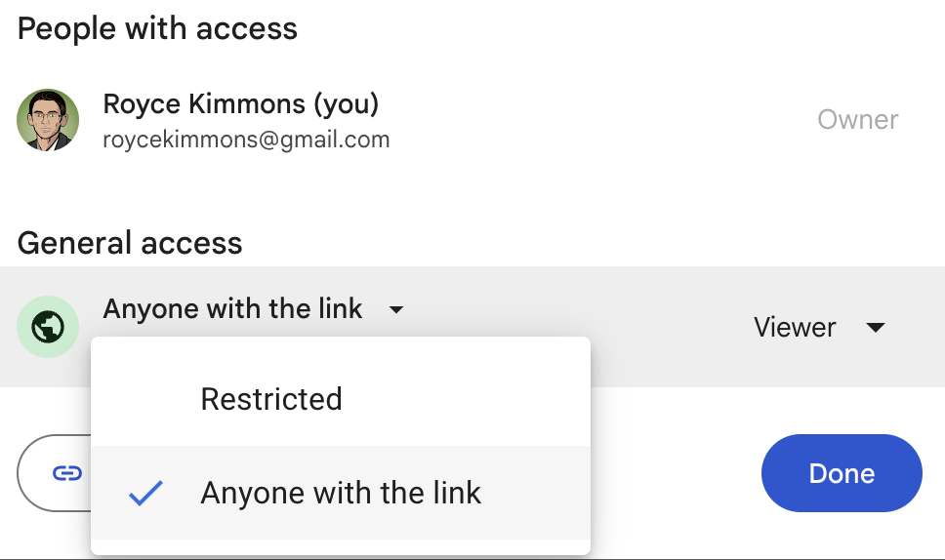

2. **Resave the document as a true Google Doc.** Sometimes a document will look like a Google Doc, but it is actually a different kind of file. You can check this by looking at the title field of the document. If there is an extension to the right (like .docx), then it is not a true Google Doc.

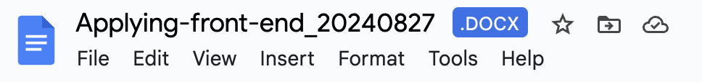

To fix this, click File > Save as Google Docs. Then, be sure that you share the new document and use it instead.

Read this online at <https://edtechbooks.org/userguide/faqs>