# Branches of the Government and the Separation of Powers

Separation of powers between the executive, legislative, and judicial branches is a foundation of the U.S. government system. Activities explore the three branches of the government, highlight the career of the pioneering African American politician Shirley Chisholm, and outline the debate about whether Puerto Rico or Washington, D.C. should become the nation's 51st state. A Media Literacy Connection looks at Hollywood movies about the branches of the government.

## **Standard 3.1: Branches of the Government and the Separation of Powers**

Distinguish the Three Branches of the Government (Separation of Powers). (Massachusetts Curriculum Framework for History and Social Studies) **[8.T3.1]**

## **FOCUS QUESTION: How does the Separation of Powers Function Within the United States Government?**

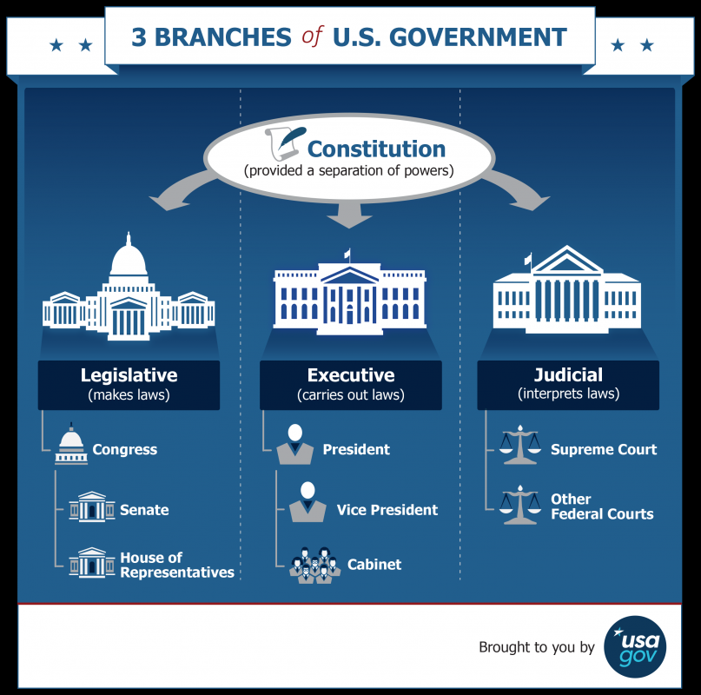

The federal government of the United States is a vast organization. Its **executive, legislative, and judicial branches** arecomprised of hundreds of agencies, commissions, and departments. It has been estimated that there are as many as 2,000 different agencies in the federal bureaucracy, employing some 2.1 million workers in 2020.

But people's knowledge of the branches of the government and their functions is surprisingly limited. The 2022 Annenberg Public Policy Center's [Constitution Day Civics Survey](https://thehill.com/changing-america/enrichment/education/3640520-less-than-half-of-americans-can-name-all-three-branches-of-government-survey-finds/) found that fewer than half of all Americans can even name the three branches of the government; one in four cannot name a single branch.

Learn about the relationships of the three branches of U.S. government by exploring Standard 2: [Checks and Balances Between the Branches](https://edtechbooks.org/democracy/relationship) and Standard 3: [Roles of Congress, the President, and the Courts](https://edtechbooks.org/democracy/roles).

[History teacher Adam Moler](https://twitter.com/moler3031/status/1470479674828546048?s=11) shared on Twitter a learning activity where students turned the branches of the government into superheroes and highlighted their special powers. A **power** is what a branch of the government can legally do to enact policies and impact people.

### Modules for this Standard Include:

1. [INVESTIGATE: Federalism and the Three Branches of the Government](https://edtechbooks.org/democracy/branchesofgov#h2_UMSxW)
   * MEDIA LITERACY CONNECTIONS: [Hollywood Movies About the Branches of Government](../mediaandciviclearning/political_films)
2. [UNCOVER: Shirley Chisholm, African American Politician and Presidential Candidate](https://edtechbooks.org/democracy/branchesofgov#h2_ZKNBz)
3. [ENGAGE: Should Puerto Rico or the District of Columbia become the 51st State?](https://edtechbooks.org/democracy/branchesofgov#h2_HyKHX)

## **1.INVESTIGATE: Federalism and the Branches of the Government**

The United States government has three branches - the legislative, executive, and judicial - that have different powers and perform different functions:

* The **legislature makes** the laws
* The **executive administers** the laws
* The **judiciary interprets** the laws

Learn more about [**The Three Branches of the Government**](https://trumanlibrary.org/whistlestop/teacher_lessons/3branches/1.htm) from the Harry S. Truman Presidential Library and Museum's webpage.

Here are the powers of the branches as stated in the first three articles of the Constitution:

**Article I, Section 1**: All legislative Powers herein granted shall be vested in a Congress of the United States, which shall consist of a Senate and House of Representatives.

**Article II, Section 1**: The executive Power shall be vested in a President of the United States of America. He shall hold his Office during the Term of four Years, and, together with the Vice President, chosen for the same Term, be elected, as follows: Each State shall appoint, in such Manner as the Legislature thereof may direct, a Number of Electors, equal to the whole Number of Senators and Representatives to which the State may be entitled in the Congress: but no Senator or Representative, or Person holding an Office of Trust or Profit under the United States, shall be appointed an Elector.

**Article III, Section 1**: The judicial Power of the United States shall be vested in one supreme Court, and in such inferior Courts as the Congress may from time to time ordain and establish. The Judges, both of the supreme and inferior Courts, shall hold their Offices during good Behaviour, and shall, at stated Times, receive for their Services a Compensation, which shall not be diminished during their Continuance in Office.

The above Articles of the Constitution are intended to establish three co-equal branches of government with shared powers. This system is called **federalism,** meaning a system of government that divides power between the national (or federal) government and the various state governments. Each level of government has the responsibility and the authority to take specific actions since each level of government has its own powers and duties.

### Media Literacy Connections: Hollywood Movies About the Branches of Government

Films about U.S. political history tell viewers as much about the times in which the films were made as the historical stories shown on the screen. Dr. Strangelove (1964) expresses people's fears of nuclear war during the Cold War. All the President's Men (1976) shows courageous reporters uncovering government scandals and secrets. Rambo (1982) extolls the power of American heroes in the post-Vietnam War era. Malcolm X (1992) reflected a growing awareness of the need for racial and social justice in society.

In these activities, you will critically evaluate how political films portray the roles of each branch of the government and then design a movie trailer for your own political film.

* [**Activity 1: Analyze Political Films About the Branches of the Government**](https://edtechbooks.org/mediaandciviclearning/political_films)
* [**Activity 2: Design a Movie Trailer for Your own Political Film**](https://edtechbooks.org/mediaandciviclearning/political_films)

### Suggested Learning Activities

* **Play an Online Game**
  + [Separation of Powers: What’s for Lunch](https://www.icivics.org/teachers/lesson-plans/separation-powers-whats-lunch), iCivics
  + [Branches of Power](https://www.icivics.org/node/74/resource), iCivics
* **QR Code Activity\***
  + Create a series of [QR codes](https://www.qr-code-generator.com/) that present images, videos, or websites dealing with different aspects of Article 1 of the Constitution and the Powers of Congress. Have students visit each QR code, explore the content, and record details.
  + Based on their QR code research, students answer questions about each section of Article 1:
    - What are the requirements to become a Representative? (3 big ones)
    - How long does someone serve as a Representative?
    - What powers are granted to the members of the House of Representatives?
    - What are the requirements to become a Senator? (3 big ones)
    - Who is the President of the Senate? What purpose does this individual serve?
    - What powers are granted to members of the Senate?
  + As a concluding activity, students could create an infographic comparing and contrasting the powers set forth in Articles 1, 2, and 3 of the Constitution.

*This activity was developed by teacher Francesca Panarelli and can be repeated for Article 2 on the Powers of the President and Article 3 on the Powers of the Judiciary.

### **Online Resources for Separation of Powers in American Government**

* Learn more at these resourcesforhistoryteachers wiki pages:
  + [Supreme Court Decisions on Separation of Powers](http://resourcesforhistoryteachers.pbworks.com/w/page/125622359/Supreme%20Court%20Decisions%20on%20Separation%20of%20Powers)
  + [Branches of American Government and Separation of Powers](http://resourcesforhistoryteachers.pbworks.com/w/page/125619248/Branches%20of%20American%20Government%20and%20the%20Separation%20of%20Powers)
  + [Separation of Powers in American Government](http://resourcesforhistoryteachers.pbworks.com/w/page/125621699/Separation%20of%20Powers%20in%20American%20Government)
* [Separation of Powers,](https://www.acslaw.org/wp-content/uploads/2018/08/Elementary-School-Lesson-on-the-Separation-of-Powers.pdf) a learning activity from the American Constitution Society asking how separation of powers in a school might function.
* [How the U.S. Government is Organized](https://www.usa.gov/branches-of-government), from USA Gov
* [What are the Branches of the Government](https://bensguide.gpo.gov/a-what-are-branches), from Ben's Guide
* [Branches of the Government](https://www.pbs.org/tpt/constitution-usa-peter-sagal/constitution-games/branches-power/), from Constitution USA with Peter Sagal
* [U.S. Foreign Policy Powers: Congress and the President](https://www.cfr.org/backgrounder/us-foreign-policy-powers-congress-and-president), Council on Foreign Relations, 2017

## **2.UNCOVER: Shirley Chisholm, African American Politician and Presidential Candidate**

[**Shirley Chisholm**](https://www.womenshistory.org/education-resources/biographies/shirley-chisholm) was an African American educator, politician, and author who in 1968 at age 44 was the first Black woman elected to Congress. In 1972, she became the first Black person to run as a major party candidate for President of the United States.

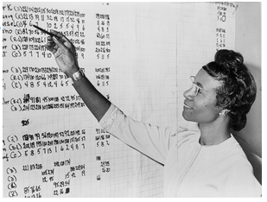

Shirley Chisholm began her career as a teacher and daycare center director before winning a seat in the New York State Assembly—the second African American woman elected to that position. When she ran for Congress, her campaign slogan was “unbought and unbossed.” Announcing her run for the Presidency, Shirley Chisholm declared:

"I am not the candidate of black America, although I am black and proud. I am not the candidate of the women's movement of this country, although I am a woman and I am equally proud of that. . . I am the candidate of the people of America, and my presence before you now symbolizes a new era in American political history" (quoted in Synder, 2019).

Learn more about Shirley Chisholm from the resourcesforhistoryteachers wiki page: [**Shirley Chisholm, African American Politician and Presidential Candidate**](http://resourcesforhistoryteachers.pbworks.com/w/page/125464181/Shirley%20Chisholm%2C%20African%20American%20Politican%20and%20Presidential%20Candidate).

Learn more at [History of Women of Color in U.S. Politics](https://cawp.rutgers.edu/history-women-color-us-politics).

### Suggested Learning Activities

* **Video Analysis**
  + In this 2010 [interview](https://www.youtube.com/watch?v=qB_krfRLSVM), Shirley Chisholm reflects on her bid for the Presidency.
  + What do her remarks tell you about her beliefs about democracy and social justice for African Americans?
* **Design Your Presidential Slogan**
  + Shirley Chisholm’s campaign slogan was “**unbought and unbossed**." What do you think it means to be an unbought and unbossed politician?
  + What would your presidential slogan be? Design a graphic to showcase your slogan.

## **3. ENGAGE: Should Puerto Rico or the District of Columbia become the 51st State?**

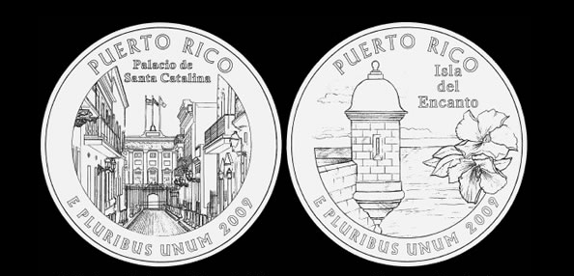

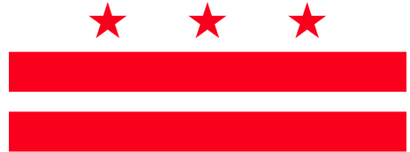

In 1959, Alaska and Hawaii were admitted as the nation's 49th and 50th states. Now there are calls for adding a **51st state**— either **Puerto Rico**, a territory of 3.4 million people, or **Washington D.C.**, a federal district with a population of over 700,000 residents. More people live in Washington, D.C. than in the states of Vermont or Wyoming.

Puerto Rico elects a non-voting representative in Congress; the District of Columbia has 3 electoral votes in Presidential elections.

Adding a new state would have huge implications for American politics. Constitutionally, such a state would automatically have two senators and one or more representatives in the House of Representatives (depending on the size of its population). Politically, it is likely one of the major political parties would gain votes in Congress (most experts agree that voters in both Puerto Rico and Washington, D.C. lean strongly toward the Democratic Party).

Also part of the political equation are the wishes of the people who live in those places. People in Washington, D.C. broadly favor becoming a state, but Puerto Ricans are divided between maintaining their current status as a commonwealth, gaining full independence as a separate nation, or becoming a state within the United States.

The history of new statehood is fascinating and complex. Between 1889 and 1890, North Dakota, South Dakota, Montana, Washington, Idaho, and Wyoming were admitted as new states - adding greatly to the power and influence of the Republican Party ([When Adding New States Helped the Republicans](https://www.theatlantic.com/ideas/archive/2019/09/when-adding-new-states-helped-republicans/598243/)). Then there was the 1905 case of **Sequoyah**, a proposed Native-American governed state in eastern Oklahoma that failed when Congress refused to consider statehood bills; instead Oklahoma as a combination of Indian territories and White settler land was admitted in 1907. You can learn more about the effort to create [Sequoyah in Topic 6.1](https://edtechbooks.org/democracy/functionsofstate#h2_bDhmx) of this book.

On April 21, 2021, the U.S. House of Representatives voted along party lines (Democrats in favor; Republicans opposed) to establish Washington, D.C. as the 51st state to be called **Washington, Douglass Commonwealth** to honor the Black abolitionist Frederick Douglass.

### Suggested Learning Activities

* **Write a Public Policy Recommendation**
  + State the case for Puerto Rico to: a) remain a **commonwealth**, b) become a **state**, or c) gain **independence** as a nation.
* **Inform Others About Past Connections to Present-Day Issues**
  + Design a video, [podcast](https://docs.google.com/document/d/1YMVhXBhqUU4qDBLO1jYNpMG0IzAl_YLSJ3OndOm6C6k/edit?usp=sharing), or website to educate others about the challenges faced when **Alaska and Hawaii** became states and how that connects to the issue of Washington, D.C. and Puerto Rico statehood today?
    - Historical background: [American Annexation of Hawaii](https://edtechbooks.org/democracy/conflict#h2_bIbPr)
    - Historical background: [Two Versions of the Story of how the U.S. Purchased Alaska from Russia](https://www.smithsonianmag.com/history/why-russia-gave-alaska-americas-gateway-arctic-180962714/)
* **Take a Position**
  + [Should the District of Columbia Become the 51st State?](https://constitutioncenter.org/blog/should-the-district-of-columbia-become-the-51st-state) National Constitution Center
* **Read and React to a Story**
  + In this episode of [The America Project](https://www.tolerance.org/magazine/spring-2020/the-america-project?utm_source=Teaching+Tolerance&amp;utm_campaign=acdfa11c2e-Newsletter+5-26-2020&amp;utm_medium=email&amp;utm_term=0_a8cea027c3-acdfa11c2e-83542603), a young girl named Carmen learns that Puerto Rico is a territory, not a state, but she is both a Puerto Rican and an American.
  + What does the story tell you about how your place of birth impacts your identity?

### **Online Resources for Puerto Rican Statehood or Independence**

* WIKI page: [Puerto Rico: History and Government](http://resourcesforhistoryteachers.pbworks.com/w/page/131918259/Puerto%20Rico%3A%20%20History%20and%20Government)
* [How A Change of Color for the Puerto Rican Flag Became a Symbol of Resistance](https://www.motherjones.com/media/2019/07/puerto-rico-resistance-flag-black-and-white-flag-san-juan-la-puerta-colonial/), Mother Jones, July 4, 2019
* [The Lost History of Puerto Rico’s Independence Movement](https://www.motherjones.com/media/2015/04/puerto-rico-independence-albizu-campos/), Mother Jones, April 21, 2015

## **Standard 3.1 Conclusion**

In the United States, power is divided between three branches of the government. **INVESTIGATE** identified the powers of the legislative, executive, and judicial branches, as set forth in the first three articles of the Constitution. **UNCOVER** told the story of Shirley Chisholm, an African American politician who became the first Black woman to run for President. **ENGAGE** asked whether Puerto Rico or Washington, D.C. should become the nation's 51st state?

Read this online at <https://edtechbooks.org/democracy/branchesofgov>