# Learning Theories

Oyarzun, B. , Conklin, S.

Learning theories are the foundation for designing instructional solutions to achieve desired learning outcomes. Analogies can assist in understanding new concepts, so imagine that you have purchased a new home and are considering the best options for furniture placement in the living room. Your desired outcome is a furniture arrangement that is aesthetically pleasing yet also functional. Many factors can play into the decision depending on how you view the problem, and there can also be more than one solution that meets the desired outcomes.

Similarly, theories and models provide a foundation and framework for any instructional design project. Theories serve as lenses to view the problem from different perspectives, much like interior design styles and preferences may affect decisions about which furniture to purchase for your new home based on your overall aesthetic. Models then provide guidance about how to build the solution or where to place the furniture in the home. Depending on the theory and model used, the solution might look different, much like a living room would look very different using modern vs. western-style decor with various arrangements. However, the desired outcomes can still be achieved. It is essential to conduct a thorough analysis to ensure the theory and/or selected strategy will support the desired outcomes and the targeted learners.

Learning theories help instructional designers understand how people retain and recall information and stay motivated and engaged in learning. There are three main families of learning theories and an emerging fourth: behaviorism, cognitivism, constructivism, and connectivism. Referring back to the house analogy, these could be different decorative styles (lenses) used to view a room in the house or to view an instructional problem and how to address it. Much like decorative styles have evolved and changed over time, so have learning theories. This chapter will define the four main families of learning and then explore some additional social and motivational learning theories that have derived from some of the families of learning.

## Behaviorism

Behaviorism grew from the work of many psychologists in the early 20th Century, such as Watson (1913), Thorndike (1898), and Skinner (1953), who hypothesized that learning occurs through interaction with the environment. Hence, observable behaviors resulting from a response to a stimulus followed by a reward or punishment based on the behavior is how a behaviorist would condition learners to elicit the desired outcome. Conversely, if the stimulus is removed, then the behavior will stop over time. This phenomenon is called extinction.

This type of behavior modification can be considered conditioning. Two types of conditioning were defined by Pavlov (1960) and Skinner (1953): classical and operant respectively. An example of classical conditioning is Pavlov’s dog in which he trained the dog to salivate with a bell ringing by providing food every time a bell rang. Extinction occurred when the food was not delivered when the bell rang over time. Operant conditioning relies on positive and negative consequences occurring to shape behavior. This method is focused on changing the learner's external behavior using stimuli (an event that evokes a specific functional reaction) with positive and negative reinforcement. Reinforcements (positive or negative) are environmental responses that increase the probability of a behavior being repeated. Punishment, on the other hand, decreases the likelihood of a behavior being repeated, yet weakens the behavior. As an illustration, a simple way to shape student behavior is to provide feedback on learner performance. Through positive feedback (e.g., praise, compliments, encouragement), students are reinforced on learning a new behavior. Over time, as the performance improves, the feedback occurs less frequently until only exceptional outcomes are reinforced. Over time the behavior changes given the response to or removal of the stimulus. In the elementary school environment, operant conditioning methods are often used for behavior modification. Behavior charts in which learners earn stickers for displaying good behavior and have stickers removed for displaying bad behavior during the week is an example. A reward or punishment is delivered at the end of the week based upon the number of stars accumulated or removed. The rewards for learners might be a class party, or the punishment might be taking away privileges.

Behaviorist theory informs key aspects of the instructional design process such as the task analysis. The task analysis involves identifying observable behaviors or steps learners need to take to achieve the desired learning outcome. A designer often observes learners from various expertise levels completing the task to create a thorough task analysis to inform the design of instruction. Behaviorism has been criticized due to the emphasis on external behaviors only, which led to the development of a new learning theory in the mid-1900s.

## Cognitivism

A contrast to the external nature of behaviorism is the internal natured cognitivism learning theory. Cognitivism focuses on how the brain internally processes, retains, and recalls information based upon how the learner organizes information into existing knowledge schemas. Schemas are structures of existing information in the learner's mind. To ensure new information is retained for recall, instruction can be designed to enhance the probability that the new information will be added to the learner's existing schema. For instance, if the desired learning outcome is to explain the water cycle, then the instructor may use questions to have learners recall information in their existing schemas about water and weather by having them tell stories about storms, clouds, lakes, and oceans. Once they have activated those schemas, the instructor could then relate the new information about the water cycle to the stories they told, in order to help learners integrate this new information into their existing knowledge about water.

A common tool used by cognitivist learning theorists are taxonomies of learning outcomes that specify what mental processes are relied upon for various types of learning. Perhaps one of the more well-known and used taxonomies is Bloom's taxonomy (1956), which was later revised (Anderson & Krathwohl, 2001). The revised taxonomy has six levels: remember, understand, apply, analyze, evaluate, and create (see Figure 1). Using this taxonomy to identify the level of desired learning can assist in writing learning objectives, selecting appropriate instructional methods, and designing assessments to increase the probability that the desired learning outcome is achieved. The taxonomy relies on the use of action verbs to ensure learning outcomes are measurable. Many resources such as [this one from the University of Nebraska-Lincoln](https://executivevc.unl.edu/documents/4-Revised-Blooms-Taxonomy.pdf) provide a variety of verbs to use for each level of the taxonomy (Anderson & Krathwohl, 2001, available at <https://executivevc.unl.edu/documents/4-Revised-Blooms-Taxonomy.pdf> ).

**Figure 1**

Bloom's Revised Taxonomy

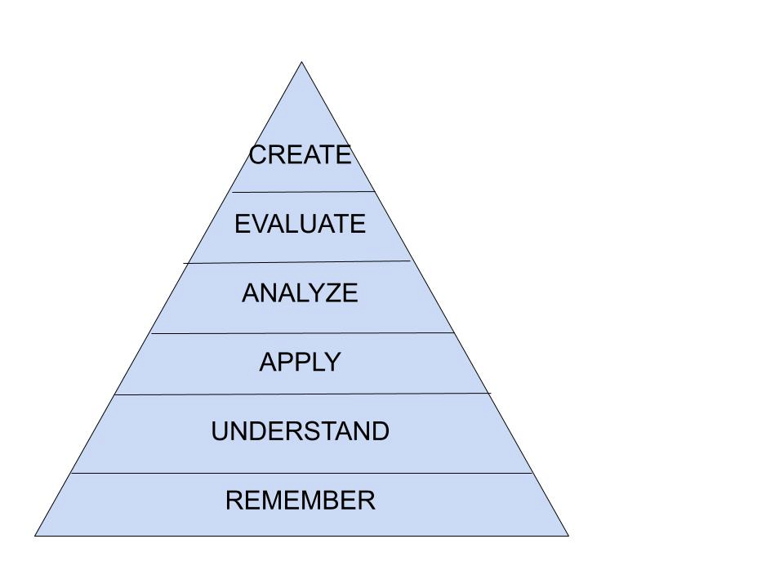

For example, if the desired learning outcome were for a student to solve a simple algebraic equation, that would fall under the application level of Bloom’s revised taxonomy because the learners will apply previously learned concepts to solve the problem. The instructor may use the [suggested verbs](https://community.articulate.com/articles/blooms-taxonomy-interactive-examples) (eLearning Heroes, 2020, available at <https://community.articulate.com/articles/blooms-taxonomy-interactive-examples>) to write a clear instructional objective such as “given an algebraic equation, the learner will solve the equation by selecting the appropriate method, showing work, and checking the solution.” Next, the instructor would design assessment items that measure the attainment of that objective. In this case several equations would serve as assessment items (i.e. x + 5 = 7, x - 8 = 12, 7 + x = 9). Lastly, the instructional methods would be designed to align with the objective and assessment. Here, presenting examples with and without manipulatives, and practice problems with and without manipulatives, would be appropriate.

Cognitivism also brought about the shift from learning theory to instructional theory, which focused on the design of instruction instead of how learners process information or learners' behavior. This is an important shift that provided the foundation for the instructional design field. In 1971, a revolutionary project entitled TICCIT, an acronym for Time-shared, Interactive, Computer-Controlled Information/Instructional Television, was funded by the National Science Foundation and MIT research corporation to test computer-assisted delivery of instruction using a cognitive approach. This project produced learner-controlled instruction that was adaptive to learner choices (Gibbons & O’Neil, 2014). Other projects followed that similarly sought to apply new cognitive theories to emerging educational technologies, leading to the explosion of computer-assisted instruction applications.

## Constructivism

Cognitivism added a new perspective based upon research of brain functionality during the learning process. However, another learning theory gained attention in the mid-1990s, which combined learner’s interactions with the external environment and their internal learning process: constructivism. Constructivism is divided into two major schools of thought: cognitive constructivism and social constructivism.

Cognitive constructivism is based upon the work of Dewey (1938), Bruner (1966), and Piaget (1972). This theory revolves around the concept that learners construct their knowledge through individual personal experiences. For example, when learners are exploring complex concepts through project-based learning, some learners may grasp the concepts quickly while others may struggle. Facilitating knowledge development through probing questions to help learners identify where they are having difficulty is part of an inquiry method to alleviate misinterpretation. It can also help learners reflect on their knowledge, misconceptions, and progress. Anchored instruction is an example of a cognitive constructivist theory that incorporates instructional technology such as video (Bradsford et al., 1990). Anchored instruction suggests that learning is anchored in a realistic, evolving context with guiding resources available to help the learners solve the instructional problem presented. [The Adventures of Jasper Woodbury](http://jasper.vueinnovations.com/overview/adventures-jasper-woodbury%E2%84%A2-overview) is a mathematics video series that was designed using the anchored instruction theory (Cognition and Technology Group at Vanderbuilt, 1992, available at <http://jasper.vueinnovations.com/>).

Social exchange and collaboration are foci of the social constructivist theory grounded in the work of Vygotsky (1978). A major theme of social constructivist theory is that social interaction plays a fundamental role in the development of cognition. Vygotsky postulated that cultural development happens twice, first on the social level (between people), then later on the individual level (inside the mind). One example of social constructivist theory is the development of language. If you are building a house, you may have basic language skills but may be unaware of terms associated with construction. As you continue to work with your peers, you begin to learn various tools and terms associated with construction through your interactions with them. Think about learning another language. Language mobile applications now offer the ability to have conversations with a native speaker electronically. This social interaction allows learners to first hear and engage with correct grammar and pronunciation. Over time, the learner can begin to process and think in another language, using proper grammar and pronunciation.

This perspective deepens our experiences in the world and aids our construction of new knowledge through the exchange of ideas with others. Often group activities such as projects, experimentation, and discussions are utilized. Learners engage with the content and then decompress with one another to develop or construct meaning from various activities. The teacher acts as a guide or translator by setting up the instruction to allow the learners to explore concepts. As the learners explore the concepts, the teacher then assists the learners in translating what they have found into the learner’s current state of understanding.

Quest Atlantis is an example of an instructional design and technology product based on social constructivist theory (Barab et al., 2005). The goal of Quest Atlantis was to provide an immersive learning environment that combined academics and play with interdisciplinary cultural quests that supports learning, development, and social transformation. Players created a persona and by completing quests they engaged in educational activities while interacting with other users and mentors. The authors described the design as socially responsive because the quests adapted to the decisions of the players.

## Connectivism

Early in the 21st Century, a new learning theory emerged from the digital age: connectivism. Connectivism is based on the work of Siemens (2004) and is the first theory that defines learning as more than an internal and individual process (see <https://edtechbooks.org/lidtfoundations/connectivism> for a republishing of this article). The connectivist theory posits that learning takes place when learners make connections between ideas located throughout personal learning networks (e.g., other individuals, databases, social media, Internet, learning management systems). The connection of the right individuals to the right resources can enhance the learning for all within the network.

Technology increases learners’ access to information and their ability to be a part of a greater learning community (Siemens, 2004). There are premises around connectivism. One premise is that learners need to distinguish between important and unimportant information, as well as valid information, since there is a continuous flow of new information. If we go back to the house example, you are working on building your house, and you want to install a fireplace. You can go to the Internet and join a builder’s community on YouTube or a Do-It-Yourself (DIY) forum. You may also be able to access reviews for various types of fireplaces and what has worked and what has not. Once you have built the fireplace, you can share your experience with these communities to enhance the experiences of others.

To summarize the four families of thought on learning theories, Figure 2 identifies some possible instructional methods for each learning theory presented so far.

**Figure 2**

Methods Used for Learning Theories Adapted from Morrison (2013)

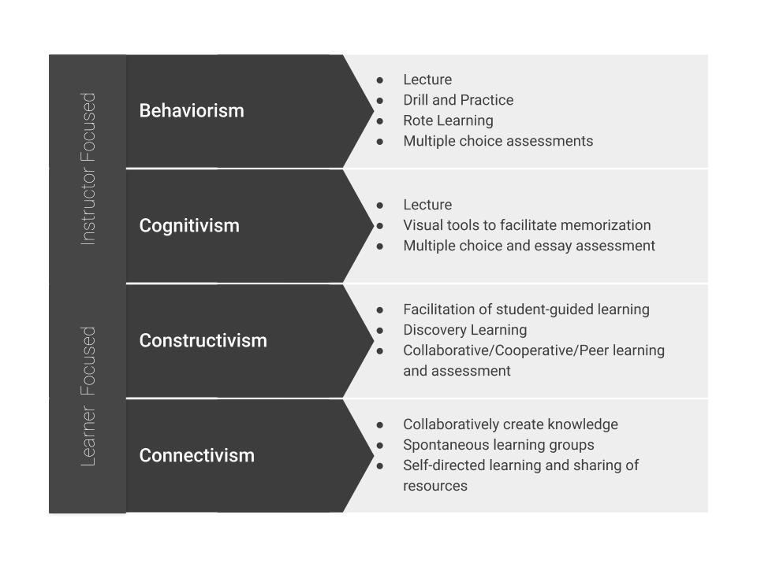

### Additional Readings and Resources

1. [Foundations of Learning and Instructional Design Technology Book](https://edtechbooks.org/lidtfoundations) - Chapters 9, 10, 11 and 19. (West, 2018)
2. [Learning Theory and Instructional Design](https://pdfs.semanticscholar.org/0f20/69063f35553917aca882cddfb6cd6e361c3f.pdf) (Mcleod, 2003)
3. [Understanding the practices of Instructional Designers through the lens of different Learning Theories](https://pdfs.semanticscholar.org/930b/e61d199cd6df9dd3f4d0bb0f5ad8dfa7a3a8.pdf) (Yeo, 2013)
4. [How People Learn I](https://www.nap.edu/read/9853/chapter/1) (National Research Council, 2000)

## Social Learning Theories

As noted above, interaction with both individuals and the environment is embedded in learning theories. From these types of interactions, multiple social learning theories emerged during the late 1990s that enhanced or deepened some of the ideas from the major families of thought around learning at that time. We will discuss the following social learning theories: social cognitive theory, social development theory, collaborative learning, and cooperative learning.

### Social Cognitive Theory

Social cognitive theory teaches that people learn by observing others and is based upon the work of Bandura (1986). He believed that people construct knowledge from learning from others' experiences. By observing others' behavior, learners derive conceptions regarding the behavior being modeled. This observation can happen directly or through the media. Reflection is a crucial component of this theory as once the learner observes the action, they reflect and determine whether this is something they want to incorporate or use. Four processes coincide with observational learning techniques: attention, retention, reproduction, and motivation. Within the social cognitive theory, motivation is seen as depending upon one's self-efficacy and agency. In order to proceed through all four processes, the learner must have the confidence to exhibit control over a desired behavior or self-efficacy. Social cognitive theory is rooted in the view of human agency in which individuals are agents proactively engaged in their development and can make things happen through individual actions. For example, if a learner struggles with learning a particular behavior or task, allowing the learner to work with another person that has mastered the behavior or task will allow the learner to view how the ideal behavior or task is performed successfully.

### Collaborative Learning

Instructors and designers sometimes want learners to work together to construct new knowledge deliberately. Collaborative learning is a social learning theory that involves learners grouping themselves together to explore a concept or to work on a project collectively. Collaborative learning is a loosely structured, discovery learning approach in which learners have much control. It is an “umbrella” term that encompasses a variety of educational approaches involving joint efforts by learners working together. Group members capitalize on the skills of one another through the sharing of information and ideas that build towards a common group goal.

### Cooperative Learning

Cooperative learning is a carefully structured type of collaborative learning. In both of these social learning theories, the instructor's role is that of facilitator, and the tasks for the groups should be open-ended and complex. Cooperative learning is rooted in social interdependence theories (Deutsch, 1949; Lewin, 1935). Johnson and Johnson (1989) conducted extensive research on defining the parameters of cooperative learning, which requires these five components: interaction, positive interdependence, group processing, individual accountability, and social skills. In other words, groups need to interact, depend on one another, monitor their progress, be responsible for their work, and be able to work together. For example, a team research project could require each team member to find several resources, and an annotated bibliography of those resources could be submitted individually (individual accountability). The team could then co-write and edit the research paper with all of the resources (interaction, social skills, and positive interdependence). The group could use a cloud-based text editor to ensure all team members are contributing in a timely fashion (group processing). Cooperative learning requires intentional planning by the instructor or the designer to ensure all five components are present.

### Additional Readings and Resources

1. [Collaborative vs. cooperative learning video](https://www.youtube.com/watch?v=uwvtfYa169k) (wufei87, 2018)
2. [Social Cognitive Theory](https://youtu.be/S4N5J9jFW5U) video (Bandura, 2010)

## Motivational Theories

Keeping learners motivated and engaged is just as important as understanding how they learn best. Therefore, motivation and engagement theories are essential to include when discussing learning theory. We will discuss three motivation theories (self-determination, hierarchy of needs, ARCS), and one engagement theory (flow).

### Self-Determination Theory

Self-determination theory is a motivational theory that suggests learners can become self-determined when their needs for competence, connection, and autonomy are satisfied (Deci & Ryan, 1985). Self-determination theory views internalization as a process for transforming external regulations into internal regulations and thereby integrating them into one’s self (Deci, Eghrari, Patrick, & Leone, 1994). Social support, along with intrinsic and extrinsic motivators are important factors for developing self-determination. Extrinsic motivators can hinder self-determination, whereas intrinsic motivators can enhance self-determination. Intrinsic motivators such as joy and self-fulfillment allow learners to be autonomous and engage with learning. When learners complete their work or a challenge, they feel competent. Both competence and autonomy are components necessary to maintain intrinsic motivation. Extrinsic motivators can hinder self-determination, whereas intrinsic motivators can enhance self-determination. External motivators, such as being rewarded for making an A on a test, can hinder learning. Social support should be considered over extrinsic rewards to foster self-determination. For example, ensuring every member of a team can play a role and understand their contributions are valuable. Methods to complete that could be establishing roles based on team member talents and providing positive feedback. Allowing individual learners and teams to set their own learning goals can also be beneficial. Another example of utilizing intrinsic motivators is giving learners an assignment where learners teach the concepts to other learners (internal) rather than teaching the learners to take a test on the concepts (external). This type of motivation is fostered and encouraged by fostering autonomous support for the learners rather than controlling.

### Maslow’s Hierarchy of Needs

Creating an autonomous environment may not always motivate learners as there are basic needs that need to be in place before learners can begin to move in the direction of self-fulfillment. Maslow’s hierarchy of needs (Maslow, 1943) is a second motivational theory. Maslow stated that some needs take precedence over others, such as basic needs for survival. Maslow developed a hierarchy stating the needs at the bottom should be met first and then move their way up (see Figure 3).

**Figure 3**

Maslow’s Hierarchy of Needs

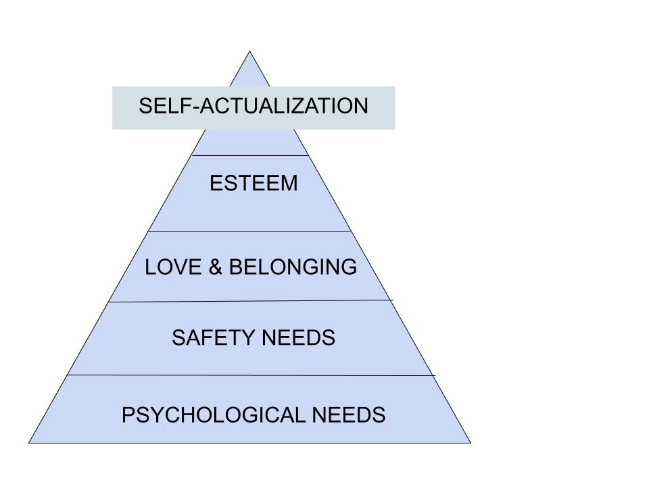

At the bottom of the pyramid are the physiological needs such as air, food, shelter. Next is safety needs, such as protection from the elements, order, and freedom from fear, followed by love and belongingness. Next, are esteem needs, which are achievement, mastery, and the desire for reputation or respect from others. Finally, the self-actualization needs are realizing personal potential or the ability or desire to become capable. Although the order of the needs seems rigid, they are flexible, depending on the external circumstances or individual differences. For example, if a learner is concerned about where they are going to sleep or eat that night, they will not be as inclined to learn new concepts as their basic needs are not met. However, if a learner who is well-fed and is loved and has a sense of belonging, whether it is part of a social group or family, they are more inclined to strive to learn new concepts.

### Keller’s ARCS Model

Within the motivational theories, there are models that provide guidance to assist designers in planning to ensure learners’ motivation. For example, Keller’s Attention, Relevance, Confidence, and Satisfaction (ARCS) is a motivational model that can be used to guide instructional planning to be intentionally motivational for learners (Keller, 1987). This model focuses on promoting and sustaining motivation throughout the learning process. First, gain the attention of the learner by piquing their curiosity. Games, roleplay, humor, or the use of inquiry are all techniques to gain learner attention, particularly when introducing a new concept. Next, to increase the learner’s motivation, relevance needs to be established. To establish relevance, you need to present the worth of knowledge gained, what does it mean to the learner? How will this knowledge directly affect the learner? Next, provide confidence and give the learners control over their learning while providing feedback. The instructor can achieve this by providing the learner’s opportunities for short term wins and small steps of growth during the learning process. Finally, the learning needs to be rewarding or satisfying in some way, either from a sense of achievement or external means; however, without patronizing the learner through over-rewarding easy tasks.

### Flow

Once a learner’s attention is gained, the instructor or designer’s focus should turn to keep the learner engaged. Flow is an engagement theory that is sometimes described as “being in the zone.” Flow was defined by Csíkszentmihályi (1990), who was inspired by watching artists, athletes, chess players, and others who become immersed in completing tasks. Flow tends to happen when someone is engaged in an activity they enjoy, either due to their skill level or other intrinsic stimuli. Csíkszentmihályi defined 10 components of flow, but not all 10 have to happen for flow to occur. These 10 components are: (1) clear and challenging goals, (2) strong concentration, (3) intrinsic motivation, (4) serenity feeling, (5) timelessness, (6) immediate feedback, (7) a balance between challenge and skill level, (8) feeling of control, (9) loss of awareness of other needs, and (10) complete focus. To create flow for learners, designers should allow some choice of activity to build on the learner’s strengths and interests and strive to match and personalize the challenge level of the learning to the learner’s abilities. “Genius Hour” (West & Roberts, 2016) is an example of applying Flow theory to education. In this approach, learners are given an hour each day, or every other day, to be “geniuses" in whatever topic they are excited about. They work for an extended period of time to complete a major project in their area before sharing their ideas with the class or families. These types of projects often produce substantial learning benefits by encouraging conditions where learners are more likely to be in flow.

## Conclusion

Learning theories and models are tools that help to shape and guide learning. Like decorating a living room in a new house, various tools can be employed to move an empty room to one with a functional design and a pleasing look and feel to the designer and client. Instructional designers can rely on learning theories and models to design learning solutions that meet the needs of their clients. The theories and models also give designers language and structure to communicate their designs and research to give evidence that their designs will be effective. Consider if you were the client that bought the house and received several proposals from interior designers for the living room decorations. Proposal 1 was a diagram and a budget. Proposal 2 had a narrative description that justified the attached diagram and budget. The justification was based on their interior design philosophy and detailed how the diagram would prove to be functional for the client. Provided the design philosophies match, you would probably select proposal 2. Using instructional design theories and models helps guide your design or learning solution and helps justify your design solution as an effective one for potential clients.

### Additional Readings and Resources

1. [Foundations of Learning and Instructional Design Technology Book](https://edtechbooks.org/lidtfoundations) - Chapters 12, 13, 14 and 16. (West, 2018)
2. [Development and use of the ARCS model in instructional design article](https://link.springer.com/article/10.1007/BF02905780) (Keller, 1987)
3. [Flow TED talk](https://www.ted.com/talks/mihaly_csikszentmihalyi_flow_the_secret_to_happiness?language=en) (Csikszentmihalyi, n.d.)
4. [Edward Deci—Self-determination theory](https://youtu.be/m6fm1gt5YAM) (Deci, 2017)

### Application Exercises

1. Create a reference guide or chart of theories, characteristics, methodologies, and how you may best apply them to your own design context and situation.
2. Create a timeline of the evolution of learning theories.

## References

Anderson, L.W. & Krathwohl, D.R. (2001). A taxonomy for teaching, learning, and assessing: A revision of Bloom’s taxonomy of educational objectives. New York, NY: Longman

Bandura, A. (1986). Social foundations of thought and action: A social cognitive theory. Englewood Cliffs, NJ: Prentice-Hall.

Bandura, A. (2010, June 22). Bandura’s Social Cognitive Theory: An Introduction (Davidson Films, Inc.) [Video file] Retrieved from <https://youtu.be/S4N5J9jFW5U>

Barab, S., Thomas, M., Dodge, T., Carteaux, R., & Tuzun, H. (2005). Making learning fun: Quest Atlantis, a game without guns. Educational Technology Research and Development, 53(1), 86-107. <https://doi.org/10.1007/BF02504859>

Benware, C.A., and Deci, E.L. (1984). Quality of learning with an active versus passive motivational set. American Educational Research Journal, 21, 755–65. <https://doi.org/10.3102/00028312021004755>

Bloom, B.S. (1956). Taxonomy of educational objectives: The classification of educational goals. New York, NY: Longmans, Green.

Bruner, J. S. (1966). Toward a theory of instruction, Cambridge, Massachusetts: Belkapp Press.

Cognition and Technology Group at Vanderbilt. (1992). The Jasper experiment: An exploration of issues in learning and instructional design. Educational Technology Research and Development, 40, 65-80. <https://doi.org/10.1007/BF02296707>

Csikszentmihalyi, M. (1990). Flow: The Psychology of Optimal Experience. Journal of Leisure Research, 24(1), 93–94. <https://doi.org/10.1080/00222216.1992.11969876>

Csikszentmihalyi, M. (n.d.). Flow, the secret to happiness. Retrieved from <https://www.ted.com/talks/mihaly_csikszentmihalyi_flow_the_secret_to_happiness?lang%5C>

Deci, E. L., & Ryan, R. M. (1985). Intrinsic motivation and self-determination in human behavior. New York, NY: Plenum.

Deci, E. L., Eghrari, H., Patrick, B. C., & Leone, D. R. (1994). Facilitating internalization: The self-determination theory perspective. Journal of Personality, 62(1), 119-142. <https://doi.org/10.1111/j.1467-6494.1994.tb00797.x>

Deci, E. L., (2017, October 17). Edward Deci—Self-Determination Theory [Video file] Retrieved from <https://youtu.be/m6fm1gt5YAM>

Dewey, J. (1938). Experience and education. New York, NY: Collier.

E-Learning Heroes. (2020). Learn About Bloom's Taxonomy with These Interactive Examples #141. [online] Available at: https://community.articulate.com/articles/blooms-taxonomy-interactive-examples [Accessed 14 Feb. 2020].

Gibbons, A., & O'Neal, A. (2014). TICCIT: Building theory for practical purposes. International Journal of Designs for Learning, 5(2). <https://doi.org/10.14434/ijdl.v5i2.12894>

Keller, J. (1987). Development and use of the ARCS model of motivational design. Journal of Instructional Development, 10(3), 2-10.<https://doi.org/10.1007/BF02905780>

Johnson, D. W., & Johnson, R. T. (1989). Cooperation and competition: Theory and research. Interaction Book Company.

Lewin, K. (1935). A Dynamic Theory of Personality. New York: McGraw Hill.

Maslow, A. H. (1943). A theory of human motivation. Psychological Review, 50(4), 370-96. <https://doi.org/10.1037/h0054346>

McLeod, G. (2003). Learning theory and instructional design. Learning Matters, 2(1), 35-43.

Morrison, D. (2013). How course design puts the focus on learning not teaching. Retrieved from <https://onlinelearninginsights.wordpress.com/2013/05/15/how-couse-design-puts-the-focus-on-learning-not-teaching/>

National Research Council. (2000). How people learn: Brain, mind, experience, and school: Expanded edition. National Academies Press.

Pavlov, I. (1960). Conditioned reflexes; an investigation of the physiological activity of the cerebral cortex. New York: Dover Publications.

Piaget, J. (1972). The psychology of the child. New York, NY: Basic Books.

Siemens, G. (2004). “Connectivism: a learning theory for the digital age”, Retrieved from [www.elearnspace.org/Articles/connectivism.htm](http://www.elearnspace.org/Articles/connectivism.htm).

Skinner, B. F. (1953). Science and Human Behavior. New York, NY: Macmillan.

Thorndike, E. L. (1898). Animal intelligence: an experimental study of the associative processes in animals. The Psychological Review: Monograph Supplements, 2(4), <https://doi.org/10.1037/h0092987>

Vygotsky, L. S. (1978). Mind in society: The development of higher psychological processes. Cambridge, MA: Harvard University Press.

Watson, J. B. (1913). Psychology as the behaviorist views it. Psychological Review, 20(2), 158. <https://doi.org/10.1037/h0074428>

West, R. E. (2018). Foundations of Learning and Instructional Design Technology: The Past, Present, and Future of Learning and Instructional Design Technology (1st ed.). EdTech Books. Retrieved from https://edtechbooks.org/lidtfoundations

West, J. M., & Roberts, K. L. (2016). Caught up in curiosity: Genius hour in the kindergarten classroom. The Reading Teacher, 70(2), 227-232. <https://doi.org/10.1002/trtr.1497>

wufei87. (2018). Retrieved 25 February 2020, from https://www.youtube.com/watch?v=uwvtfYa169k

Yeo, S.S. (2013). Understanding the practices of instructional designers through the lenses of different learning theories (unpublished master's thesis). Bowling Green State University, Career and Technology Education/Technology, Bowling Green, OH. retrieved from <http://rave.ohiolink.edu/etdc/view?acc_num=bgsu1367862206>

Read this online at <https://edtechbooks.org/id/learning_theories>