# Robert Gagné and the Systematic Design of Instruction

Curry, J. H., Johnson, S., Peacock, R.

To begin any study of instructional design, it is beneficial to examine the roots of the field. Where did the field originate? How did we develop into a field of study and practice? As your study continues, you can better see how the knowledge base of the field began, how it progressed, and how it was researched and when, which will help you gain a better understanding of the process and practice of instructional design as well as the field as a whole. Specifically, understanding the origins of the systematic design of instruction will give the learner a greater appreciation for today’s more robust design theories and models.

As the United States entered World War II, they faced an enormous problem: How were they going to train so many troops? The numbers are staggering. The military trained over 16 million troops. In addition, the technology of the war had changed drastically from World War I, and the troops needed to be trained on all the skills necessary to complete their tasks at hand, and FAST. They did not have the luxury of time—the training needed to be done quickly, effectively, and efficiently.

After the war ended, cognitive psychologists, many of whom had served in World War II themselves, began studying how to apply the training lessons from the war to other instructional settings to help people learn better. Combining the work of those researchers, the systematic instructional design process was born.

## Gagné’s Conditions of Learning

### Conditions of Learning

Robert Gagné was working on his Ph.D. in Psychology when World War II began. While assigned to Psychological Research Unit No. 1, he administered scoring and aptitude tests to select aviation cadets. After the War, Gagné joined the Air Force Personnel and Training Research Center where he directed the Perceptual and Motor Skills Laboratory. He held multiple academic positions throughout his career, ranging from the Connecticut College for Women to Princeton to Florida State University. His experiences in the military and training there guided much of his research. In 1959, he participated in the prestigious Woods Hole Conference, a gathering of outstanding educators, psychologists, mathematicians and other scientists from the United States in response to the Soviet Union launching the Sputnik satellite. The results of the conference were published in Bruner’s The Process of Education (1961). Four years later, Gagné published The Conditions of Learning (1965).

### Taxonomy of Learning Outcomes

Gagné posited that not all learning is equal and each distinct learning domain should be presented and assessed differently. Therefore, as an instructional designer one of the first tasks is to determine which learning domain applies to the content. The theoretical basis behind the [Conditions of Learning](https://youtu.be/FgDcUnObLqI) is that learning outcomes can be broken down into five different domains: verbal information, cognitive strategies, motor skills, attitudes, and intellectual skills (see Figure 1).

**Figure 1**

Gagné’s Domains of Learning

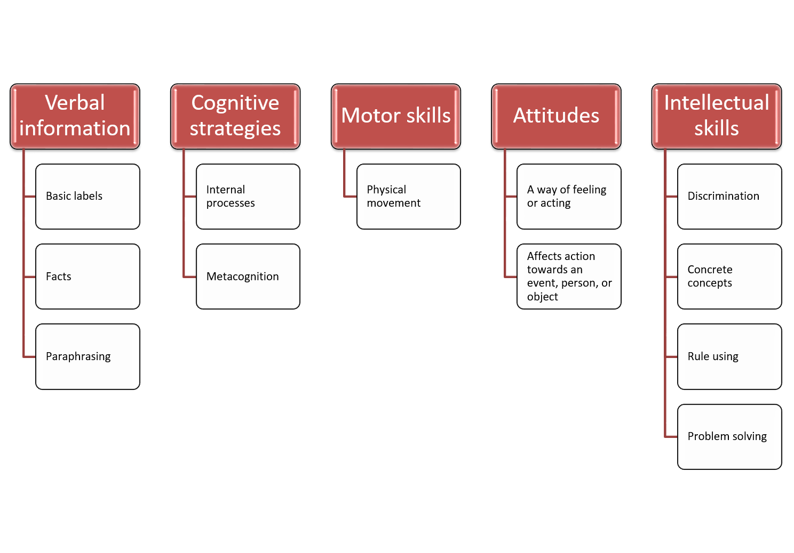

Verbal information includes basic labels and facts (e.g. names of people, places, objects, or events) as well as bodies of knowledge (e.g. paraphrasing of ideas or rules and regulations). Cognitive strategies are internal processes where the learner can control his/her own way of thinking such as creating mental models or self-evaluating study skills. Motor skills require bodily movement such as throwing a ball, tying a shoelace, or using a saw. Attitude is a state that affects a learner’s action towards an event, person, or object. For example, appreciating a selection of music or writing a letter to the editor. Intellectual skills have their own hierarchical structure within the Gagné taxonomy and are broken down into discrimination, concrete concepts, rule using, and problem solving. Discrimination is when the learner can identify differences between inputs or members of a particular class and respond appropriately to each. For example, distinguishing when to use a Phillips-head or a flat-head screwdriver. Concrete concepts are the opposite of discrimination because they entail responding the same way to all members of a class or events. An example would be classifying music as pop, country, or classical. Rule using is applying a rule to a given situation or condition. A learner will need to relate two or more simpler concepts, as a rule states the relationship among concepts. In many cases, it is helpful to think of these as “if-then” statements. For example, “if the tire is flat, then I either need to put air in the tire or change the flat tire.” Finally, problem solving is combining lower-level rules and applying them to previously unencountered situations. This could include generating new rules through trial and error until a problem is solved.

### Nine Events of Instruction

Beyond his assertion that not all learning is equal, Gagné also theorized an effective learning process consisting of nine separate and distinct steps or events (see Figure 2). These events build naturally upon each other and improve the communication supporting the learning process. The events facilitate learner engagement as well as retention of the content being presented. For an instructional designer, they provide a framework or outline to structure the delivery of instructional content.

**Figure 2**

Gagné’s Nine Events of Instruction

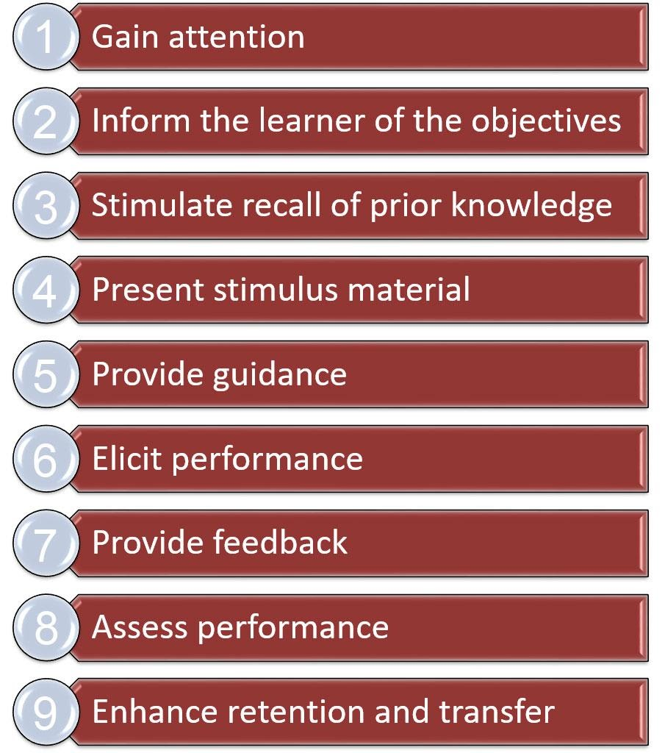  
**Event one: Gain attention**. Before learning can happen, the learners must be engaged. To gain the learners’ attention, any number of strategies can be employed. It could be as simple as turning the lights on and off, the teacher counting down, or the teacher clapping three times. Other options could include a discussion prompt, showing a video, or discussing current events.

**Event two: Inform learners of objective**. Once learners are engaged, they are informed of the objective of the instruction, which gives learners a road map to the instruction. It allows them to actively navigate the instruction and know where they are supposed to end up. This could be written on a whiteboard in front of the class, highlighted on materials, spoken verbally, or posted clearly in an online context.

**Event three: Stimulate recall of prior learning**. Stimulating recall of prior learning allows learners to build upon previous content covered or skills acquired. This can be done by referring to previous instruction, using polls to determine previous content understanding (and then discussing the results), or by using a discussion on previous topics as a segue between previous content and new content.

**Event four: Present the stimulus material**. Presenting the stimulus material is simply where the instructor presents new content. According to Gagné, this presentation should vary depending on the domain of learning corresponding to the new content.

**Event five: Provide learner guidance**. Providing learner guidance entails giving learners the scaffolding and tools needed to be successful in the learning context. Instructors can provide detailed rubrics or give clear instruction on expectations for the learning context and the timeline for completion.

**Event six: Elicit performance**. Eliciting performance allows learners to apply the knowledge or skills learned before being formally assessed. It allows learners to practice without penalty and receive further instruction, remediation, or clarification needed to be successful.

**Event seven: Provide feedback**. Hand in hand with eliciting performance in a practice setting, the instructor provides feedback to further assist learners’ content or skill mastery.

**Event eight: Assess performance**. Following the opportunity to practice the new knowledge or skill (events five, six, and seven), learner performance is assessed. It is imperative that the performance be assessed in a manner consistent with its domain of learning. For example, verbal knowledge can be assessed using traditional fact tests or with rote memorization, but motor skills must be assessed by having the learner demonstrate the skill.

**Event nine: Enhance retention and transfer**. Enhancing retention and transfer gives the learner the opportunity to apply the skill or knowledge to a previously unencountered situation or to personal contexts. For example, using class discussion, designing projects, or by writing essays.

### The Nine Events: Explained by Training Cats

### Gagné’s Impact on Instructional Design

The impact Robert Gagné had on the field of instructional design cannot be understated. For example, from his initial work we can trace the evolution of the domains of learning from the Conditions of Learning through other theories such as [Merrill’s Component Display Theory](https://mdavidmerrill.wordpress.com/publications/Component%20Display%20Theory/) (1994), to [Smith and Ragan’s Instructional Design Theory](https://www.calvin.edu/~dsc8/documents/ID-Process.pdf) (1992), to van Merrienboer’s complex cognitive skills in the [4C/ID model of instructional design](https://www.4cid.org/about-4cid) (1997). Beyond that, Gagné’s Nine Events of Instruction also paved the way for a systematic process for designing instruction. For the first time, those designing instruction had a process to follow, a blueprint. And almost 60 years later, Gagné’s work still serves as the basic framework all instructional designers who use systematic processes follow.

## ADDIE

In 1965, the United States Air Force created their first major instructional system. By 1970, the system had grown into a full Five-Step Approach to designing instruction (US Air Force). The five steps for designing instruction were: Analyze system requirements; Define education training requirements; Develop objectives and tests; Plan, develop, and validate instruction; and Conduct and evaluate instruction. Reflexive within this circular model was feedback and intervention. This model gave way to the conceptual framework known as ADDIE, upon which the majority of subsequent systematic instructional design (ID) models are inherently based. It consists of five phases: Analysis, Design, Development, Implementation, and Evaluation (see Figure 3). Each of these phases builds on the previous phase to systematically identify and clarify an instructional problem, develop and implement a solution, and evaluate the effectiveness and efficiency of the solution. Additionally, evaluation occurs throughout the other phases to inform the design of the instruction.

**Figure 3**

The ADDIE model

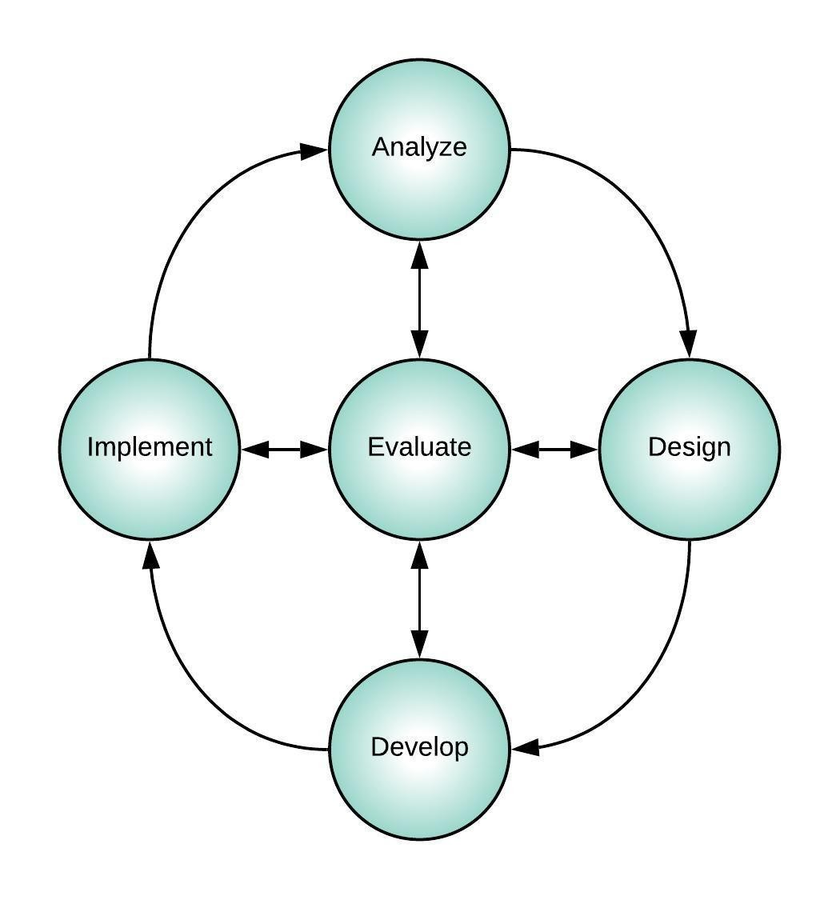  
The systematic process of designing instruction begins with the analysis of a problem to determine whether instruction is a possible solution. The analysis phase includes analyzing the needs, tasks, and learners in order to clarify the problem, goals and objectives of the instruction, the learning environment, and learner characteristics. Based on the results of the analyses, the instructional designer clarifies the instructional problem and identifies the instructional goals and objectives. During the design phase, the instructional designer writes the learning objectives and chooses an ID model. The development phase consists of creating all instructional materials. Implementation is when the instruction is delivered to learners either in a formative or summative setting. The evaluation phase is reflexive with formative evaluation, which consists of ongoing feedback as the instruction is designed and developed, and summative evaluation consisting of the final evaluation after full implementation. These phases are discussed more in-depth in their respective chapters.

## Dick and Carey Model

Working from the conceptual framework of the ADDIE model and building upon a systematic approach to instruction like Gagné’s Conditions of Learning, the Dick and Carey Model is one of many systematic instructional design processes. While each model may have its own individual process, they also have many characteristics in common such as attention to detail and precision. The Dick and Carey model is comprised of nine stages incorporating elements from previous design models as well as elements from behaviorism, cognitivism, and constructivism (see Figure 4). This model provides the designer with a process that incorporates flexibility and allows the designer to make appropriate adaptations for their particular situation.

**Figure 4**

The Dick and Carey model

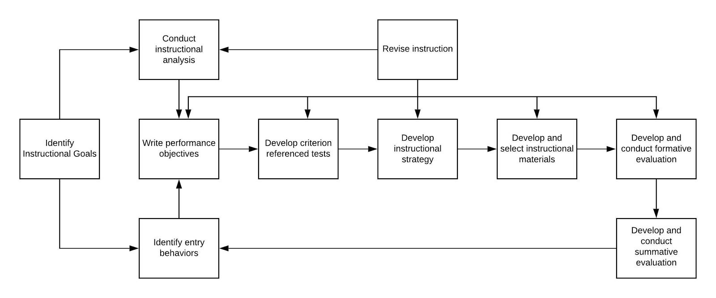

### Instructional Goals

Instructional goals can be set using a variety of methods; however, the key is to determine whether instruction truly is the solution or if there are other factors that may be contributing to a performance issue. The designer’s job is to sift through many points of data to get to the root of the problem. For example, employees in auto manufacturing may not be meeting company-defined benchmarks due to poor training, but it could also be due to poorly defined processes that take too much time to complete. In education, students may fall behind on benchmarks due to poor teaching, but it could be that teachers are required to cover too many topics and the students are not able to retain all of this information. To help gather this information, instructional designers perform a performance analysis and needs assessment.

**Performance analysis.** In a performance analysis, the designer will compare a desired performance outcome to the current performance level and identify a performance gap. This process involves reviewing data to identify the gap. Some designers will use a [SWOT (strengths, weaknesses, opportunities, threats) analysis](https://ctb.ku.edu/en/table-of-contents/assessment/assessing-community-needs-and-resources/swot-analysis/main) framework to help define this gap.

**Needs assessment.** In a needs assessment, the designer works to identify what the learners will need in order to bridge the identified performance gap. Some methods to help identify this gap can be performance data, including tests, observations, interviews, surveys, and even doing the work of the learner to help identify challenges or opportunities.

### Instructional Analysis

Once goals have been established, it is important to map out the step-by-step process students will need in order to achieve these goals. In an instructional analysis it often helps to use a [flow-chart](https://youtu.be/iJmcgQRk048) to map out each skill into its smallest step but also to identify any additional steps or skills, often called subordinate skills, that must be mastered before mastering the main skill.

### Entry Behaviors and Characteristics

It is also essential to identify the behaviors and characteristics of the learner in order to provide the optimum learning experience. This involves determining what the learner already knows or can do—these are called entry skills. However, it is also important to gather information on their attitudes toward learning, their motivation for learning, education backgrounds, ability levels, and personal characteristics such as age or experience with technology.

### Performance Objectives

Performance objectives are what the learner will be able to do following instruction. While there are variations on how to write performance objectives, a general rule is to include a condition, a behavior, and a criterion. Many designers use [Bloom’s Taxonomy](https://cft.vanderbilt.edu/guides-sub-pages/blooms-taxonomy/) or [Mager’s ABCD model](https://youtu.be/6b9ahqnC8Xc) to help define measurable behaviors in their objectives. Ultimately, objectives should be specific and measurable.

### Criterion-Referenced Test Items

Criterion-referenced test items are used to measure the performance objectives. These items can be used on assessments such as pre- and post-tests as well as performance-based measures such as performance observations using rubrics or attitude changes.

### Instructional Strategy

When the assessment has been defined, the designer can work on mapping out an instructional strategy. The designer will need to review and sequence the content into a meaningful lesson. They will also need to decide on the types of learning experiences and activities they want the learner to engage in. As described earlier in this chapter, Gagné’s Nine Events of Instruction is one method for structuring a learning experience.

### Instructional Materials

Once the instructional framework is developed, appropriate materials are created. This can include using existing print or media materials or creating new materials. This should be an iterative process, gathering feedback and making improvements. Some designers will provide rough draft outlines to graphic or multimedia designers for development.

### Formative Evaluation

As mentioned previously, formative evaluation is used to help a designer measure the effectiveness of their instructional strategy and materials. The designer will work with individuals and groups to review the instruction and identify weaknesses and/or gaps. The materials are revised based on this input to make sure the instruction is appropriate and clear for the learners.

### Summative Evaluation

Finally, the instruction is reviewed by experts and field-tested. The objective is to ensure that the instruction targets the necessary skills defined in the instructional analysis and produces the desired results in the field.

## Conclusion

The study of instructional design is eclectic and full of history. From its roots in cognitive psychology and the training of troops in World War II to the rise of the systematic instructional design models, researchers have worked to provide those designing instruction a process by which not only could they create meaningful instruction more quickly, but also to consider the diversity of learners and learning contexts as well as the difference in the types of content to be learned.

If a student of instructional design looks critically at the models and theories in the field, it is not very hard to trace the continuing influence of these early researchers into today’s current practices. For example, Gagné’s domains of learning influenced [Merrill’s Component Display Theory](https://mdavidmerrill.wordpress.com/publications/Component%20Display%20Theory/) (Merrill, 1983), as Merrill had similar categories of learning, but gave them different names. However, the idea that all content falls into one distinct domain of learning shifted with the research of [van Merrienboer](https://www.4cid.org/about-4cid) (1997) who wrote about complex cognitive skills that have aspects of multiple domains. The same can be said of the systematic instructional design models. The Conditions of Learning led to the Air Force model (Department of the Air Force, 1993) and the ADDIE framework. The ADDIE framework gave way to other instructional design models like the Smith and Ragan (1992); [ASSURE](https://educationaltechnology.net/assure-instructional-design-model/) (Heinich, Molenda, Russell, and Smaldino, and 2001); and the [Morrison, Ross, and Kemp](https://educationaltechnology.net/kemp-design-model/) (2012). Most recently, David Merrill (2002) distilled the similarities in each model down to what he termed the “[First Principles of Instruction](https://www.youtube.com/watch?v=OReU2n1RyqY),” a model that encompasses all the others and provides a new framework for designing problem-based instruction.

The influence of Robert Gagné and the systematic instructional design models on the field of instructional design is clear. What was new in the 1950s and 1960s is now accepted unilaterally and generally implemented: not all instruction is equal; there are different domains of learning and each should be presented and assessed appropriately; and an intentional design process should lead to more effective and efficient instruction.

### Application Exercises

1. Consider the different ID models in this chapter. What are the benefits of using these processes? What are the challenges with using these processes?
2. Compare and contrast the ID models in this chapter. How might the differences in each model impact the overall design process?
3. Consider instruction you have participated in at school, work, or in the community. Describe how you would apply Gagne's Nine Events of Instruction to improve that instruction.
4. You have been asked to design instruction for a large company on their new telephone system. Use either ADDIE or the Dick and Carey Model to describe the steps you would take to provide this instruction. Be specific and use the language of the model to frame your discussion.

## References

Bloom, B.S. (Ed.) (1956). Taxonomy of Educational Objectives. New York: Longmans, Green.

Bruner, J. (1961). The process of education. Cambridge: Harvard University Press.

Dick, W., & Carey, L. (1996). The systematic design of instruction, 4th edition. New York: Harper Collins College Publishers.

Gagné, R.M. (1965). The conditions of learning. New York: Holt, Reinhart & Winston.

Glaser, R. (1962). Psychology and Instructional Technology. Training Research and Education. Glaser, R. (ed). Pittsburgh: University of Pittsburgh Press.

Heinich, R., Molenda, M., Russell, J. D., & Smaldino, S. E. (2001). Instructional media and technologies for learning (7th ed.), Englewood Cliffs, NJ: Prentice Hall.

Mager, R.F. (1962). Preparing objectives for programmed instruction. Pitman Learning.

Merrill, M. D. (1983). Component display theory. In C. M. Reigeluth (Eds), Instructional-design theories and models: An overview of their current status (pp. 282-333). New Jersey: Lawrence Earlbaum Associates, Inc.

Merrill, M.D. (1994). The descriptive component display theory. In M.D. Merrill, Instructional design theory (pp. 111-157). Educational Technology Publications.

Merrill, M. D. (2002). First Principles of Instruction. Educational Technology Research and Development. 50(3), 43-59.

Skinner, B F. (1959). Teaching Machines. In A. A. Lumsdine & R. Glaser (Ed.) Teaching Machines and Programmed Learning. Washington, D.C.: National Education Association. Pp. 137-158.

Smith, P.L. & Ragan, T.R. (1992). Instructional Design. New York: Wiley.

U.S. Air Force. (1970). Instructional System Development. AFM 50-2. Washington DC: U.S. Government Printing Office.

Department of the Air Force. (1993). Manual 36-2234 Instructional System Development.

Van Merrienboer, J.G. (1997). Training complex cognitive skills: A four-component instructional design model for technical training. Educational Technology Publications.

Read this online at <https://edtechbooks.org/id/robert_gagn_and_systematic_design>