# Cooperation Between Individuals and Elected Leaders

Activities explore whether elected leaders listen to and respond to the everyday people who contact them or do individuals and groups need other ways to make their voices heard by elected leaders. The historical experiences of youth activists for change are explored along with the effectiveness of consumer boycotts and buycotts as tools for influencing policies. A Media Literacy Connection examines how political activism happens on social media platforms.

## **Standard 4.8: Cooperation Between Individuals and Elected Leaders**

Explain the importance of individuals working cooperatively with their elected leaders. (Massachusetts Curriculum Framework for History and Social Studies) **[8.T4.8]**

## **FOCUS QUESTION: How can Everyday People Communicate Effectively With Their Political Leaders?**

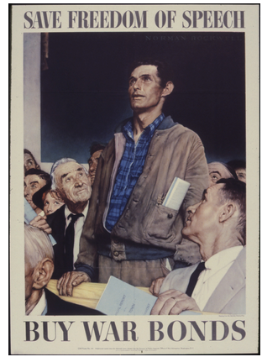

The idea that a single individual can contact their elected senator or representative to influence and change public policy is part of how many people think American government should work. **The Constitution’s First Amendment includes the right “to petition the government for a redress of grievances.”** The image of a highly motivated, civic-minded person making a difference (like the speaker in [Norman Rockwell’s famous Freedom of Speech painting](https://www.nrm.org/2012/01/norman-rockwells-four-freedoms/)) is deeply ingrained in popular culture.

The reality of an individual citizen being able to contact elected leaders is quite different. Members of Congress receive enormous amounts of correspondence every day, particularly about hot-button political issues. In **2016, the Senate received more than 6.4 million letters**. In 2017, New York Senator Chuck Schumer’s office reported receiving as many as 1.5 million phone calls a day. Much of this correspondence comes from advocacy groups engaging in mass communications.

Given the complexities of directly communicating with elected representatives, how else can citizens, young and old, engage in movements for political change?

### Modules for this Standard Include:

1. [INVESTIGATE: Contacting Congress](https://edtechbooks.org/democracy/cooperation#h2_LdPLh)
2. [UNCOVER: Youth Activists and Change Makers](https://edtechbooks.org/democracy/cooperation#h2_rJdRV)
   * MEDIA LITERACY CONNECTIONS: Political Activism Through Social Media
3. [ENGAGE: Would You Join a Consumer Boycott or Buycott to Promote Change?](https://edtechbooks.org/democracy/cooperation#h2_CMuMa)

## **1. INVESTIGATE: Contacting Congress**

Once Congress installed its first telephone switchboard in 1898, people started calling their elected representatives and they have not stopped since, observed [Kathryn Schulz (2017) in](https://www.newyorker.com/magazine/2017/03/06/what-calling-congress-achieves) . In today’s world of social media and mass communication, people not only call, they write, email, tweet, fax, post on representative's social media pages, send videos, and otherwise try to influence their elected representatives. One group estimates that members of the Congress post more than 1300 times a day on Twitter, Facebook, and Instagram ([How to Engage Members of Congress on Social Media](https://www.quorum.us/blog/how-to-engage-members-of-congress-on-social-media/), Quorum).

Schulz distinguishes between how members of Congress think about **constituent services** and **constituent demands**. Elected representatives, she notes, are more likely to help solve a particular problem (a constituent service) than change their vote on a politically contentious issue (a constituent demand).

Most educators agree that learning how to contact one’s elected leaders is a core skill for citizens interested in expressing ideas and promoting change in our democratic society. There are many ways to do so, from writing letters to sending emails to meeting face-to-face. The Union of Concerned Scientists believes that phone communications are an effective way to contact and influence elected officials ([How to Have a Productive Phone Call with Your Legislator's Office](https://www.ucsusa.org/action/phone-calls.html)).

What is it like to be a Congresswoman or Congressman? Here is one view of [A Day in the Life of a Member of Congress](https://junior.scholastic.com/issues/2019-20/090219/a-day-in-the-life-of-a-member-of-congress.html) (Junior Scholastic, September 2, 2019). Watch as well [A Day in the Life of John Lewis: The Congressman Shares His Personal Journey](https://www.youtube.com/watch?v=t2sxftaIldQ).

#### **Letter Writing Campaigns and Online Petitions**

Letter writing campaigns and online petitions have become an important means of contacting people, especially political leaders, to generate action for change in the 21st century.

A **letter writing campaign** is a "method of making your group's voice heard on issues that are important . . . a way of informing elected officials and decision-makers of the implications of their actions and encouraging them to act in accordance with the wishes of their constituencies" ([Interstate Commission on the Potomac River Basin](https://www.potomacriver.org/resources/get-involved/water/letter-writing-campaign/), April 14, 2022, para. 1).

Individuals and groups engage in impactful letter writing campaigns. **Write for Rights** began in 2002 and has grown into a worldwide effort -- leading to freedom and justice for individuals wrongly imprisoned by dictatorial governments ([15 Big Wins for Write for Rights](https://www.amnesty.org/en/latest/campaigns/2017/11/15-big-wins-for-write-for-rights/), November 17, 2017). The 2020 Election saw the emergence of **The Big Send**, an effort to increase voter turnout in swing states and districts. Millions of letters, many generated by writing parties on Zoom, were sent by postal mail -- an old school alternative to digital ads and telephone cold calls to voters.

[**Online digital petitions**](https://billmoyers.com/story/sign-save-world-online-petitions-explained/) are ways for large numbers of people to express their demands for change to political leaders and public policy decision-makers.

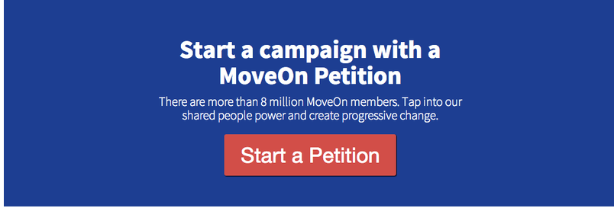

As David Harpf documented in his book The MoveOn Effect (2012), online petitions are a form of 'netroots' political action, replacing face-to-face grassroots organizing with ways to engage people politically through the Internet. Users of the advocacy organization [Change.org](https://www.prnewswire.com/news-releases/changeorg-releases-top-ten-petitions-that-changed-2021-301448464.html) started some 791,896 petitions and generated more than 463,883,172 signatures in 2021 alone.

### Suggested Learning Activities

* **Describe, Analyze, and Create**
  + What are the meanings and messages in [Norman Rockwell’s 1943 Freedom of Speech painting in the](https://picturingamerica.neh.gov/downloads/pdfs/Resource_Guide_Chapters/PictAmer_Resource_Book_Chapter_19A.pdf) ?
  + Create a painting or a collage showing how you would make your voice heard in your community.
* **Civic Action Project**
  + Select an issue you care about and write an email or letter to a local, state, or national elected official.
    - [Writing Congress FAQs](https://www.aps.org/policy/tools/writingfaq.cfm), American Physical Society
    - [How to Write a Letter or Email to Congress](https://www.apa.org/advocacy/guide/letter-email), American Psychological Association
    - [Tips for Writing Effective Letters to Congress](https://www.thoughtco.com/write-effective-letters-to-congress-3322301), ThoughtCo. (February 13, 2018)

### **Online Resources for Contacting Congress**

* [The Psychologist's Guide to Advocacy](https://www.apa.org/advocacy/guide)
* [How to Effectively Engage Your Elected Officials](https://rethinkmedia.org/blog/how-effectively-engage-your-elected-officials), ReThink (February 15, 2017)
* [How To Be a Political Influence—As An Average Citizen](https://smea.uw.edu/about/student-blog/blog/how-to-be-a-political-influence-as-an-average-citizen/), College of the Environment, University of Washington

## **2. UNCOVER: Youth Activists and Change Makers**

On August 28, 2019, 16-year-old **Greta Thunberg**, a Swedish activist, arrived in New York City to attend a United Nations summit on the climate crisis. She had sailed to the United States on a zero-carbon, solar-powered yacht, refusing to fly because airplanes use so much fossil fuel. She had risen to international prominence by starting a series of school strikes called **Fridays for Future** to raise awareness for the need for urgent action to save the planet. More than 100,000 schoolchildren have joined those strikes ([Climate Change Activist Greta Thunberg, 16, Arrives in New York After Sailing Across the Atlantic)](https://time.com/5663534/greta-thunberg-arrives-sail-atlantic/).

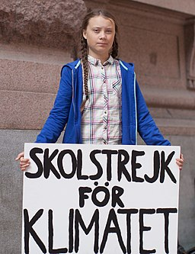

Decades earlier, in 1960, six-year-old **Ruby Bridges** of New Orleans, Louisiana became the first African American student to integrate into a formerly all-white elementary school in the American South. Four federal marshals escorted her to class every day past crowds of White protesters.

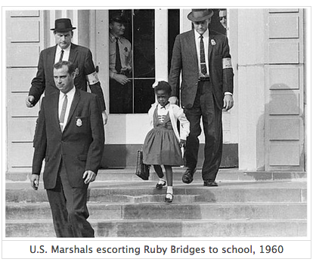

She was the only student in her class - white families had withdrawn their children from the school. She ate lunch alone. Her teacher, Barbara Henry, originally from Boston, Massachusetts, sometimes played with her at recess. She never missed a day of school all year long. Her courageous actions were celebrated in Norman Rockwell’s famous 1963 painting “[The Problem We All Live With](https://www.nrm.org/2011/05/norman-rockwells-the-problem-we-all-live-with-to-be-exhibited-at-the-white-house/).” Watch [Freedom's Legacy](https://www.youtube.com/watch?v=BvnxYDZ4ymY), a video where Ruby Bridges reflects on her life and activism in 2019.

Greta Thunberg and Ruby Bridges are just two recent and prominent examples of young people taking bold and impactful steps to promote political change and social justice by seeking to influence elected officials. As Dawson Barrett, author of Teenage Rebels (2015) noted, activism by young people in this country has been going on for a long long time ([The History of Student Activism in the United States](https://www.teenvogue.com/story/the-history-of-student-activism-in-the-united-states)). Here are just a few of many important, but less-well known examples:

* Four years of efforts by students in an AP Government class at Hightstown New Jersey High School led to the passage of the **Civil Rights Cold Case Collection Act**. It was the first time high schoolers wrote a law that was passed by Congress ([High School Students Lobby Congress - And Win](https://www.historians.org/publications-and-directories/perspectives-on-history/october-2019/high-school-students-lobby-congress%E2%80%94and-win-an-ap-government-class-helps-families-of-civil-rights-murder-victims)).
* Beginning during their freshman year, students from the Oakland Technical High School - known as the "Apollos" - spent four years **lobbying elected representatives to make Dr. Martin Luther King's birthday a California state holiday**. Their efforts helped lead to the first MLK Day in California in 1982, four years before it became a national holiday. In 2019-2020, current students at the school wrote and performed a stage play honoring the Apollos and their public policy achievement ([California High School Students Who Lobbied for State MLK Holiday Honored in Oakland Tech Play](https://edsource.org/2020/california-high-school-students-who-lobbied-for-state-mlk-holiday-honored-in-oakland-tech-play/622643)).
* In Massachusetts, **students have joined community members to lobby state legislators to create a new state flag and seal honoring Native Americans** to replace the current one with its image of a sword over the head of an American Indian figure. Student activism to honor Native Americans is not new in the state. In 1989, a letter writing campaign by second graders from the Fort River Elementary School in Amherst helped influence the Massachusetts Turnpike Authority to redesign its highway signs that showed a Pilgrim hat with an Indian arrow shot through it.

There are many more occasions of youth activism and civic action throughout United States history, though most remain hidden histories and untold stories: the [Lowell Mill Girls](https://www.nps.gov/lowe/learn/historyculture/the-mill-girls-of-lowell.htm), [the March of the Mill Children](https://www.zinnedproject.org/news/tdih/mother-jones-march-mill-children/), [the Newsboys Strike](https://www.zinnedproject.org/news/tdih/newsboys-strike/), [the Little Rock Nine](https://nmaahc.si.edu/blog-post/little-rock-nine), [the Birmingham Children’s Crusade](https://nmaahc.si.edu/blog/childrens-crusade), and more. All these occasions of youth activism demonstrate how young people (elementary, middle, high school, and college-age) can exercise power and agency in community and political life. Youth have the power to create change, sometimes individually or locally, and sometimes on national and international scales.

### Media Literacy Connections: Political Activism Through Social Media

What is **activism**? The climate justice activist Anjali Appadurai said it is "the practice of addressing an issue, any issue, by challenging those in power" ([Activist Handbook](https://www.activisthandbook.org/en/getting-started), 2021, para. 5). According to [Newsela](https://newsela.com/read/elem-what-is-activism/id/37699/), activism happens "when people fight for social change" (para. 1). Faculty in the [Department of Anthropology](https://www.maxwell.syr.edu/anthro/Social_Activism___Social_Movements/) at Syracuse University frame activism as "organizing, strategizing, mobilizing, and educating" (para. 1). All of these definitions connect activism and change.

Social media is an important tool for activism, advocacy, and change.

In this activity, you will explore how to use social media to advocate for an issue of personal interest while also considering the following questions: What might be the upsides and downsides of online activism? How do individuals evaluate the impact of their activism through social media?

* [**Activity: Advocate for an Issue You Care About on Social Media**](https://edtechbooks.org/mediaandciviclearning/social_media_activism)

### Suggested Learning Activities

* **Make a Video about an Issue That Matters to You**  
  + Record a video to influence an elected official's opinion about a local, national, or global issue.
* **Write & Present a Speech**
  + Write a two-minute speech about the changes you want to see happen in society and how might you go about making them happen.
    - Examples of student presentations can be found at [Project Soapbox](https://mikvachallenge.org/our-work/programs/project-soapbox/) and on its Vimeo channel.
  + Present your speech in-person or record it on video and send it to an elected official.
* **Create a Youth Activism in History Digital Poster**
  + Choose one of the following events or individual change-makers for your poster; information is available at [Youth Activists and Change Makers in History](http://resourcesforhistoryteachers.pbworks.com/w/page/124220319/Youth%20Activists%20and%20Change%20Makers)
    - The Lowell Mill Girls
    - Teenage Soldiers in the Civil War
    - The March of the Mill Children
    - Newsboys Strike of 1899
    - Shirtwaist Makers Strike of 1909
    - The American Youth Congress
    - Port Chicago Mutiny and the Port Chicago 50
    - Mendez v. Westminster
    - The Green Feather Movement
    - Barbara Rose Johns and the Morton School Strike
    - The Little Rock Nine
    - The Greensboro Four
    - Student Non-Violent Coordinating Committee
    - Birmingham Children's Crusade
    - Tinker v. Des Moines
    - Students for a Democratic Society
    - Berkeley Free Speech Movement
    - East LA Walkouts/Chicano Blowouts

### [**Youth Activists Choice Board**](https://docs.google.com/document/d/153qvZXs6ja81DeUVieKSrY6uEF3dn9Y4oLwdvbJIQxY/edit?ts=5f71e934)

**(click here to make your own copy of the choice board)**

### **Online Resources for Youth Activism**

* [100 Years of Youth-Led Social Activism](https://communitychange.org/100-years-youth-led-social-activism/) from the Center for Community Change
* [Global Nonviolent Action Database](http://nvdatabase.swarthmore.edu/content/issue-clusters)
* [We Had Sneakers, They Had Guns: The Kids Who Fought for Civil Liberties](https://www.loc.gov/today/cyberlc/feature_wdesc.php?rec=4571)Library of Congress, 2009
* [Meet the Young Pioneers Using Tech to Make the World a Better Place](https://www.forbes.com/sites/nicholasfearn/2019/06/17/meet-the-young-pioneers-using-tech-to-make-the-world-a-better-place/#7f27ad07bdc7), Forbes (June 17, 2019)

## **3. ENGAGE: Would You Join a Consumer Boycott or Buycott to Promote Change?**

Many people consider consumer boycotts and buycotts to be a more effective way of promoting change than contacting elected representatives.

A **boycott** is an ongoing decision **NOT** to purchase goods or services from a specific individual or company. A **buycott** works in the opposite way. It is an ongoing action **TO** purchase goods and services from a specific individual or company.

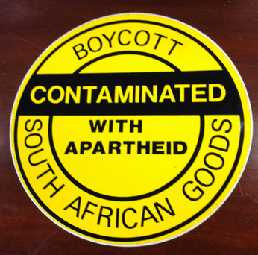

For example, a coffee drinker might decide to stop purchasing coffee from one store in protest over that store’s actions or policies (boycott) while also deciding to get coffee from only a fair trade store (buycott), even if it meant spending more time and/or money to do so.

**Boycotts** have a long and compelling history. **Rosa Parks**’ brave actions launched the Montgomery Bus Boycott in 1955; **Cesar Chavez** and the National Farm Workers organized a national grape boycott in the 1960s. In the 1980s, the United States and other nations in the world boycotted South Africa for its apartheid system of racial segregation. Boycotts by professional and collegiate sports teams helped in the 2017 repeal of a North Carolina law dictating that transgender people must use a particular bathroom.

In Brewing a Boycott, historian Allyson P. Brantley (2021) records the history of the Coors Beer Boycott of the 1970s and 1980s by a coalition of the Chicano union organizers, gay men and women, student activists, and environmentalists. This longstanding effort (also called a "Beercott") became the foundation for wider consumer campaigns and political protests. For those involved, notes Brantley, "the rejection of the beer (or other offending products) communicated broader political demands . . . against wealthy business owners and corporations engaged -- and invested in -- conservative causes."

In 2020, in the aftermath of the killing of George Floyd in 2020 and ongoing racist postings on social media by white supremacist groups, Civil rights organizations including the NAACP, Color of Change, and the Anti-Defamation League urged advertisers to boycott Facebook till the company adopts more stringent measures to block hate speech on the site ([Civil Rights Organizations Want Advertisers to Dump Facebook](https://www.vox.com/recode/2020/6/17/21294451/facebook-ads-misinformation-racism-naacp-civil-rights)). Beginning in late June, hundreds of major companies including Verizon, Ben & Jerry's, Patagonia, Starbucks and Coca-Cola announced they were pausing advertising on Facebook to protest hate speech and misinformation on the site.

To further extend the approach, commentator Eric Alterman (2020,p. 8) writing in The Nation, has suggested users boycott the ads on Facebook by refusing to click on them. Facebook's business model is based on getting users to visit advertisers' websites; the data generated by those visits enable companies to more precisely target potential customers, or in the case of politically-minded groups, potential followers.

Another boycott campaign is the [#](https://www.grabyourwallet.org/our-work) Alliance that focuses on getting people to stop doing business with companies associated with Donald Trump, his family or the Trump Organization. Companies including Papa John’s, Uber, United Airlines, Target, Starbucks, New Balance and Chick-fil-A have faced recent consumer boycotts. In 2019, conservative groups called for a boycott of Dick’s Sporting Goods after the retailer decided to stop selling guns in many stores nationwide. GrabYourWallet added a listing of companies engaging in questionable business practices during the COVID-19 pandemic.

Meanwhile, buycotts may be emerging as an even more widely favored change strategy for citizen activists ([Battle of the Wallets: The Changing Landscape of Consumer Activism](https://www.webershandwick.com/wp-content/uploads/2018/05/Battle_of_the_Wallets.pdf)). There is research that shows consumers are willing to pay the extra costs associated with not buying a product from one company if they perceive that company was engaged in misdeeds and exploitative behaviors ([Hahn, 2018](https://www.forbes.com/sites/esade/2018/10/16/why-consumers-boycott-even-if-prospects-look-bleak/#7fd3a8b84910%20)). Rewarding another company by only buying their products because that company is “doing the right thing” is an extension of this type of thinking.

### Suggested Learning Activities

* **State Your View**
  + Would you join a consumer boycott or buycott?
  + If so, what would you boycott or buycott and why?
* **Compare and Contrast Boycotts and Buycotts**
  + Are boycotts or buycotts more effective in achieving goals and promoting change?
  + The [Ethical Consumer](https://www.ethicalconsumer.org/ethicalcampaigns/boycotts) website based in the United Kingdom lists current boycotts along with ethical ratings for more than 10,000 companies.
* **Start an Online Petition**
  + Go to petition-generating section of [Moveon.org](https://sign.moveon.org/petition/new?source=petition_email_footer)
  + Define an Issue that matters and what you want people to do to create change
  + Explain why this change is important
    - * Sample Petition: [Do Not Destroy the 10,000 Year Old Ancient Village in Northampton, MA](https://sign.moveon.org/petitions/preserve-the-10-000-year-old-undisturbed-ancient-village-in-northampton-ma)

### **Online Resources for Boycotts and Buycotts**

* [The American Tradition of Consumer Politics](https://www.oah.org/tah/issues/2017/may/the-american-tradition-of-consumer-politics/), The American Historian
* [Q & A: Here's When Boycotts Have Worked - And When They Haven't](https://www.latimes.com/nation/la-na-boycotts-history-20180228-htmlstory.html), Los Angeles Times (March 1, 2018)
* The Delano Grape Strike and Boycott, 1965 - 1970 at the [Latino Civil Rights Movement](http://resourcesforhistoryteachers.pbworks.com/w/page/125464322/The%20Latino%20Civil%20Rights%20Movement) wiki page
* [Democratic Decision-Making in Cooperative Organizations and Worker-Owned Companies](https://edtechbooks.org/democracy/components#h2_WzXKx) (Chapter 6.10)
* [An Open Letter to the Companies That Advertise on Facebook](https://www.adl.org/news/letters/an-open-letter-to-the-companies-that-advertise-on-facebook), Anti-Defamation League (June 25, 2020)

## **Standard 4.8 Conclusion**

The United States has a representative form of democracy. Citizens vote to decide who will represent them at every level of government. Once an election is over, however, voters typically find themselves far removed and unable to contact the individuals they elected to represent them. **INVESTIGATE** looked at strategies citizens can use to go about contacting Congress. **UNCOVER** explored modern day and historical examples of youth activism for change. **ENGAGE** asked whether consumer boycotts and buycotts are an effective way for people to express their preferences for goods, services, and social and economic change.

Read this online at <https://edtechbooks.org/democracy/cooperation>