# Educating Faculty and Senior Administrators: How Online Education Really Works

Piña, A.A., Martindale, T.

This paper explores online education’s broad and systemic nature within higher education, involving multiple units, departments and functions across the institution. Educating faculty and senior administrators on the complexities and realities of online learning is critical. Effective online education consists of four primary areas: program and course development, online teaching, student services, and administration. We examined each area to reveal the integrated approach necessary for institutional success. Challenges faced by both faculty and leaders include the lack of knowledge about online learning, and limited implementation resources. We discuss these challenges to illustrate the critical need for comprehensive institutional support for the online learning ecosystem.

## Introduction

Online education is not an isolated activity but is a systemic process which requires the involvement of an entire institution (Piña, 2017). In this paper we discuss the essential elements which contribute to effective online education in higher education, particularly targeting faculty and senior administrators who may lack a background in online learning, instructional design, or educational technology. With the increasing demand for online learning, institutions must adopt a cohesive strategy involving program development, teaching methodologies, student services, and administrative support to foster a supportive and effective online learning environment.

The COVID-19 pandemic brought an immediate demand for online education at colleges and universities, many of which did not previously include distance education within their missions and emphases (Roache et al., 2020). Most of these institutions were ill-prepared for the switch to emergency remote teaching and online instruction (Garrett, et al., 2020; Hodges, et al., 2020). The pandemic experience, coupled with the changes in demographics and growing criticism over the cost and value of higher education, has led to enrollment declines (Blankenberger & Williams, 2020).

As the threat of the pandemic has abated, calls for "going back to normal" have not resulted in the abandonment of online education (Lockee, 2021). In 2023, after most on-campus courses were reinstated, 53% of students still chose to enroll in online courses (National Center for Education Statistics, 2024). More institutions than ever are implementing new online initiatives, hiring chief online learning officers and instructional designers, establishing online education units and departments, and increasing their offerings of online degrees, certificates, and micro-credentials.

### Challenges for faculty and leaders in online education

One of the significant challenges many faculty and leaders face is their limited background in online education, instructional design, and educational technology. Most faculty members and administrators have trained and worked in traditional educational settings, meaning on-campus and in-person. They may not be familiar with the unique needs and structure of online learning. Furthermore, media, legislators, and regulators often send mixed signals about the value and legitimacy of online education, confounding a campus leader’s ability to make informed decisions about online initiatives. Faculty and administrators often face resource constraints which limit the support available for online program development and management, further complicating decision-making processes and program effectiveness.

## What do faculty and leaders need to know?

While resources abound for those who create and teach online courses, relatively little exists for those who lead online at the institutional level (and even less for leadership at the executive level). Therefore, one should not be surprised when both senior leaders and faculty mistakenly think that growing online enrollment at a college or university is merely a function of developing more online courses and programs, providing training to faculty, and rolling out marketing campaigns. The distributed nature of many institutions can be a barrier to successful online implementation due to a lack of coordination, cooperation and sharing of information and resources. In light of these challenges, it is imperative for those who oversee online learning at their institutions to focus their efforts on educating faculty, academic leadership, and senior administrators about how online learning really works in higher education.

### Online education is institutional and systemic

Leaders need to understand that online learning is institutional (Watson, et al., 2024), involving every department, service, and individual that interacts with online students, as illustrated in Figure 1 below. From enrollment and course registration to student support services and administrative oversight, successful online education cannot operate in silos. Just as with in-person instructional efforts, online learning connects with and relies upon a broad spectrum of stakeholders across the institution.

Figure 1

Institutional Units Interacting with Online Education

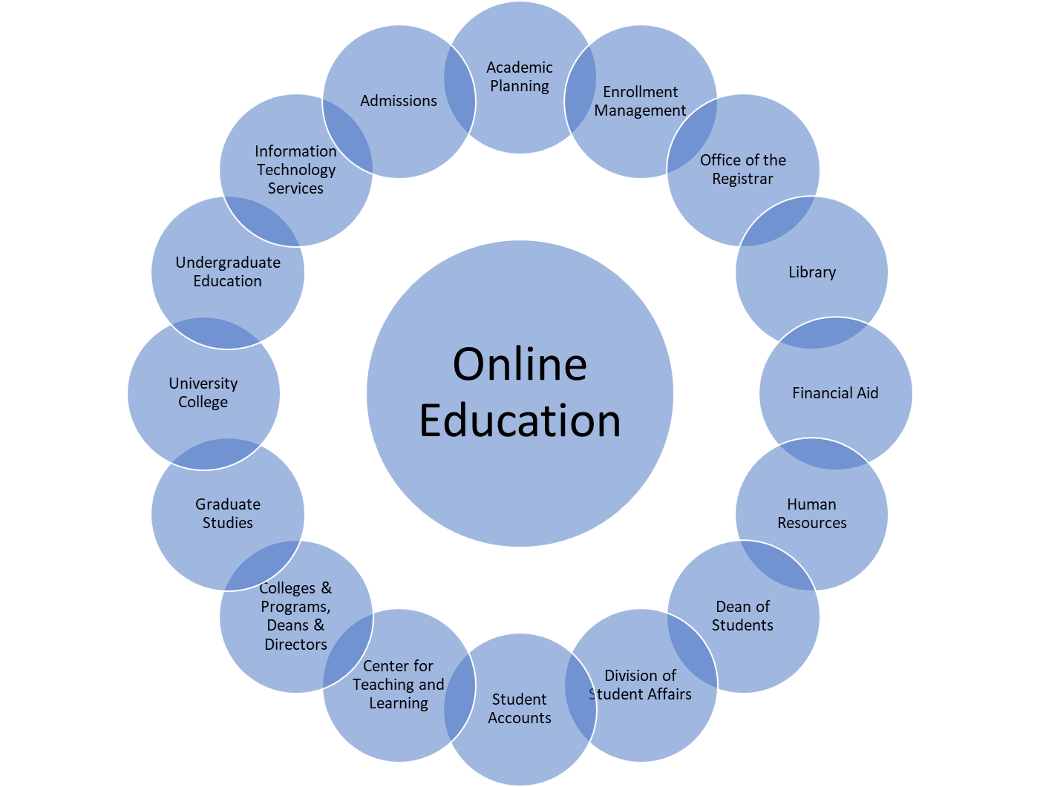

Institutions must take a systemic approach to ensure online learning is a cohesive and well-supported experience for all involved. To provide online leaders with a framework for educating faculty and administrators about online learning at their institutions, we recommend four broad components: 1) Program and Course Development, 2) Online Student Services, 3) Online Teaching, and 4) Online Administration and Operations, as illustrated in Figure 2 below. Neglecting any of these components risks failure of the online learning endeavor.

**Figure 2**

Framework for Online Education

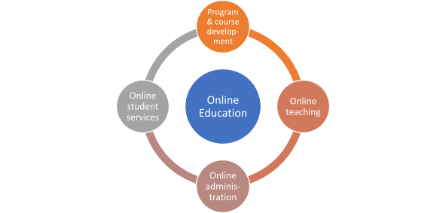

### Program and course development

Faculty and leaders must understand teaching in person, teaching online, and developing online courses are significantly different tasks, each requiring different skills (Magruder & Kumar, 2018). It is neither accurate nor fair to assume all faculty have: 1) knowledge of the differing rules and guidelines for online courses by state and federal regulatory bodies and accreditation agencies; 2) knowledge of how to format and chunk content for maximum effectiveness for online learners; 3) expertise in making digital content accessible according to the latest Title II/ADA/WCAG requirements (Moorefield-Lang, 2019); 4) knowledge of all the relevant instructional options within the institutional learning management system (Walker, et al., 2016); and 5) knowledge of which tools, strategies and activities are most effective for online learners. Online learning leaders can help faculty and administrators understand how instructional designers play a critical role in online course development. This role includes using course templates to facilitate development and provide students with consistent learning experiences. Each institution needs a detailed and systematic plan for how faculty, instructional designers, and multimedia developers will work together to produce online courses which are efficient, effective, and appealing.

Developing a fully online degree program should also be a collaborative effort with faculty and instructional designers. This collaboration may be a novel experience for faculty. A key is thinking systematically and mapping each desired learning outcome of a degree program to a specific course. Developing, following, and maintaining this curriculum map of learning outcomes can position students for success in acquiring the relevant knowledge and skills.

### Online teaching

Teaching in an online environment requires an understanding of pedagogy, student engagement, and technology integration. Faculty need training in instructional strategies, particularly for implementing required regular and substantive interaction between instructors and students (Piña & Martindale, 2023). An online course must be fully planned and developed before the course begins. This is particularly true as more institutions consider courses in which students work at their own pace or may have multiple starting and ending dates.

Online instructors must make effective use of the institution’s learning management system (LMS) for both developing and teaching online courses. Learning the LMS and what it can do takes time, effort, and support from others with expertise. Each LMS has pedagogical affordances and constraints which affect what happens in an online course. Institutional leaders must allow time and provide support for instructors as they use the LMS and other technological tools to shape the student experience. These leaders must prioritize continuous professional development for faculty to ensure they are equipped with the skills and knowledge needed for effective online teaching.

### Online student services

Comprehensive student services are crucial to the online learning experience. Technical support is key because everything the online student experiences is mediated by the internet and software such as the LMS. The institution must provide reliable access to these tools and assistance when the tools don’t work as expected. Many online students complete coursework late at night and on weekends, and the institution must consider how to staff the technology “help desk” so that a student gets help within a reasonable time period.

The library should be a key partner in supporting online students. The institution should consider dedicated librarians who work with faculty to create web-based portals to information for specific online programs and courses. Online tutoring should be available to online students. This could be in the form of live tutoring from the institution or contracted tutoring services that may be available at all times during the academic term.

Many institutions have expanded their offerings of mental health services for in-person and online students. These services could be offered “in-house” or be outsourced to vendor services available at hours beyond the typical working day. In summary, an institution which provides robust support services helps create a learning environment where online students feel connected and supported despite the physical distance from campus (Travers, 2016).

### Administration and operations

Online learning administration involves policies, technology infrastructure, resource allocation, and support systems which facilitate the smooth operation of online programs. Institutional leaders must understand the unique challenges and requirements of online learning, including accreditation requirements, state reciprocity agreements, and state and federal regulations for distance education. Effective online learning administration requires an integrated approach where administrators, faculty, and staff work collaboratively to create a sustainable online learning model which serves both students and faculty.

## Conclusion

The move towards online education is more than a shift in the mode of delivery; it represents a fundamental transformation in how institutions serve and educate their students. Faculty and administrators need to understand online learning encompasses multiple components, each requiring dedicated resources, training, and strategic planning. Higher education institutions can create a supportive and effective online learning environment by addressing the unique challenges of online program development, teaching, student services, and administration.

## References

Blankenberger, B., & Williams, A. M. (2020). COVID and the impact on higher education: The essential role of integrity and accountability. Administrative Theory & Praxis, 42(3), 404–423. <https://doi.org/10.1080/10841806.2020.1771907>

Garrett, R., Legon, R., Fredericksen, E. E., & Simunich, B. (2020). CHLOE 5: The pivot to remote teaching in spring 2020 and its impact, the changing landscape of online education, 2020. Retrieved from https://qualitymatters.org/qa-resources/resource-center/ articles-resources/CHLOE-project

Hodges, C. Moore, S., Lockee, B. Trust, T., & Bond, A. (2020). The difference between emergency remote teaching and online learning. EDUCAUSE Review.https://er.educause.edu/articles/2020/3/the-difference-between-emergency-remote-teaching-and-online-learning

Lockee, B. (2021). Online education in the post-COVID era. Nature Electronics, 4, 5-6. https://doi.org/10.1038/s41928-020-00534-0

Magruder, O., & Kumar, S. (2018). E-learning instruction: Identifying and developing the competencies of online instructors. In A. A. Piña, V. L. Lowell & B. R. Harris (Eds.) Leading and managing e-learning: What the e-learning leader needs to know (pp. 221-234). Springer.

Moorefield-Lang, H. (2019). Accessibility in online course design. Library Technology Reports 55(4), 14-16.

National Center for Education Statistics (2024). Trend generator. Retrieved from https://nces.ed.gov/ipeds/TrendGenerator/ app/build-table/2/42?rid=6&cid=85

Piña, A. A. (2017). An organizational development framework for assessing readiness and capacity for expanding online education. Online Journal of Distance Learning Administration, 20(3), 1-13.

Piña, A. A., & Martindale, T. (2023). Regular and substantive interaction in online courses: Why it matters for administrators. Online Journal of Distance Learning Administration 25(2).

Roache, D., Rowe-Holder, D., & Muschette, R. (2020). Transitioning to online distance Learning in the COVID-19 era: A call for skilled leadership in higher education institutions (HEIs). International Studies in Educational Administration, 48(1), 103-110.

Travers, S. T. (2016). Supporting online student retention in community colleges: What data is most relevant? Quarterly Review of Distance Education,17(4), 49-61.

Walker, D. S., Lindner, J. R., Murphrey, T. P., & Dooley, K. (2016). Learning management system usage: Perspectives from university instructors. Quarterly Review of Distance Education, 17(2), 41-50.

Watson, F. F., Piña, A. A. & Small, J. (2024). A strategic framework for developing a master plan for online learning at your institution. Online Journal of Distance Learning Administration, 27(2).

Read this online at <https://edtechbooks.org/jaid_14_2/ofvrlmvvbn>