Innovative Solutions: Designing Accessible Alternatives for Complex, Field-Specific Course Content
Malone, C., Hansel, C. A., Richwine, B., Stores, M., Goodbeer, C., Popek, R., Stevens-Goddard, A., Winningham, S.
This chapter suggests a practical roadmap for making complex STEM learning accessible without sacrificing academic integrity. Grounded in U.S. legal and technical requirements—WCAG 2.1 AA, Section 504/508, and ADA Title II—it reframes compliance as “effective communication” and equitable participation rather than one-off accommodations. The authors outline a collaborative workflow among instructional designers, accessibility specialists, and subject-matter experts that begins with identifying access gaps and aligning changes to learning objectives. They propose three evaluative questions (perception, interaction, and supports) to guide redesign, then translate them into discipline-specific strategies: accessible math via LaTeX/MathML/AsciiMath and equation editors; principled image description using DIAGRAM and NWEA guidelines; and when needed, tactile graphics, 3D models, and tactile tours. Case studies demonstrate application across mathematics (equation remediation, long descriptions for graphs, ruler measurement supports), geology (visual-property identification reworked through standardized terminology, decision trees, and accessible alternatives), and computer science (ERDs with Crow’s foot notation described for instruction vs. assessment and supported with tactiles). The chapter also addresses faculty concerns—rigor, workload, and scale—highlighting proactive design, shared templates, and communities of practice. It concludes with key takeaways and resources to help teams iterate toward sustainable, standards-aligned accessibility in online STEM courses.
All students, regardless of ability, must be provided access to interact with the content on a similar level (Guzman-Ortho et al., 2021). For students with disabilities to have sufficient access to science, technology, engineering and mathematics (STEM) education, instructional designers (IDs) must engage with subject matter experts (SMEs) and accessibility experts to ensure proper provision of accessibility and accommodations. Lack of accessibility can result in students experiencing lower self-esteem, poorer performance, and a reduced interest in STEM, even though they may have the curiosity, ambition, and intelligence to succeed (Todorov et al., 2024).
This chapter outlines the process of making complex STEM materials accessible, beginning with a discussion of key regulations that apply to Indiana University (IU) as a United States public institution of higher education. For broader application, the chapter describes foundational concepts behind these regulations and how their incorporation into STEM content improves access for students with disabilities beyond simply providing one-time accommodations. It then discusses the process of determining appropriate accessibility improvements through research, collaboration with accessibility experts, and dialogue with SMEs. This process is illustrated in three example courses in mathematics, geology, and computer science.
Creating discipline-specific best practices in an ongoing process which involves sharing workflows and expertise along with specific solutions. By contributing to the wider collection of best practices for online STEM courses, we hope that readers working in similar fields can build upon our knowledge and strategies in their own work.

Guiding Questions
Identify a discipline-specific assessment that should be redesigned to be accessible.
- What are the learning objectives?
- Which aspects of the assessment are of special concern?
- What resources or potential solutions have been shared by practitioners in the field?

Key Terms and Concepts

Academic Integrity/Rigor
Ensuring assessments measure all students’ performance equally.

AsciiMath, LaTeX, MathML
Methods for formatting math accessibly in webpages.

Blind/low vision (B/LV)
People who cannot see or have limited sight.

Crow’s Foot Notation
Notation for indicating relationships between entities in entity-relationship diagrams (see below).

Entity-Relationship Diagram (ERD)
A modeling technique used to show relationships between entities (e.g. objects, individuals) in a computer system.

Section 504 of the Rehabilitation Act of 1973
U.S. federal law that prohibits discrimination against people with disabilities. Relevant sections include Section 504 (programs or activities receiving federal funding) and Section 508 (2024, information technology standards).

Subject Matter Expert (SME)
An individual with discipline-specific knowledge; often a course instructor, faculty member, or training facilitator.

Tactile graphic
A two-dimensional (2D) object used as an alternative to images such as diagrams.

Tactile tour
A guided tour giving additional context to a tactile object provided through braille or a support person.

Three-dimensional (3D) model (tactile)
A physical object used as an alternative for images that cannot be interpreted via a tactile graphic.

Title II of the Americans with Disabilities Act (ADA, U.S. Department of Justice, 2024)
U.S. federal law describing accessibility requirements specific to public institutions.

Visual bias
Content or assessments that can only be perceived through sight with no equivalent alternative.

Web Accessibility Content Guidelines (WCAG) 2.1 levels A and AA (W3C, 2025)
Technical standards for accessible web content used in regulatory requirements such as the ADA (1990) and Section 504 (1973).

Content Discussion
This chapter highlights cross-disciplinary collaborations between IU accessibility experts from the Assistive Technology and Accessibility Centers (ATAC), IDs from Teaching and Learning Design (TLD), and SMEs to build or update course content in IU’s online learning management system (LMS). Potential accessibility issues were identified during initial project discussions. ATAC experts provided guidance on best practices which were implemented by IDs during the course build process. Changes were made as a collaboration between IDs and SMEs, ensuring that new designs met the learning objectives (LOs) for all students while maintaining academic rigor.
Collaboration is required when supporting complex course topics. IDs with general accessibility knowledge can implement basic accessibility changes, such as text formatting, simple image alternative (alt) text, or fixing accessibility errors in PDF or Microsoft Word files (document remediation). However, complex content may require topic expertise to reproduce correctly and accessibly, such as detailed diagrams, math or chemistry equations, or visual content that requires specialized description to maintain clarity and academic integrity. In-depth knowledge of how students with disabilities access and perceive content, as well as of the course topic, should be provided by accessibility experts and SMEs, respectively.

Legal Requirements for Making Courses Accessible
When creating accessible content, begin with relevant standards and legal requirements for your institution and country. For IU, this includes the Web Content Accessibility Guidelines (WCAG) 2.1 criteria levels A and AA (W3C, 2025); the Americans with Disabilities Act (ADA, 1990), including a recent ruling on Title II deadlines (U.S. Justice Department, 2024); and sections 504 (1973) and 508 of the Rehabilitation Act of 1973 (2024).

Technical Accessibility
The WCAG (W3C, 2025) accessibility principles: Perceivable, Operable, Understandable, and Robust (POUR) and associated Guidelines and Success Criteria are foundational for evaluating the technical accessibility of electronic resources or software that students are required to access or use as part of their educational experience. The following summarizes the Success Criteria for each principle.
- Perceivable: “Information and user interface components must be presentable to users in ways they can perceive” (W3C, 2025, Perceivable section), such as: text alternatives for visuals; captions and transcripts for video and audio; document structure that can be communicated to assistive technologies; alternatives for colors that convey meaning; and sufficient contrast between text and background colors.
- Operable: “User interface components and navigation must be operable” (W3C, 2025, Operable section), such as: operating elements with the keyboard only; providing adequate time to complete activities including options for requesting extensions or pauses; avoiding flashing or animated content that could trigger seizures or vestibular disorders; and consistent navigation, layouts, and descriptive page titles.
- Understandable: “Information and the operation of the user interface must be understandable” (W3C, 2025, Understandable section), such as: text written at an appropriate reading level for the audience; terms and jargon explained in context; consistent interfaces and navigation; and clear instructions for online forms and assessments with feedback when students make mistakes.
- Robust: “Content must be robust enough that it can be interpreted by a wide variety of user agents, including assistive technologies” (W3C, 2025, Robust section) such as screen readers, voice recognition software, and alternative input devices.

Beyond Technical Accessibility
While the WCAG (W3C, 2025) POUR principles are vital when ensuring base-level accessibility of content, additional regulations – including disability rights legal requirements – apply to materials used in instructional contexts.
Under Section 504 (1973) and Title II of the ADA (U.S. Justice Department, 2024), public institutions must ensure that students with disabilities have equal access to the benefits of the academic program and are entitled to reasonable modifications unless doing so would fundamentally alter the nature of the course. The U.S. Department of Education’s Office for Civil Rights (OCR) emphasizes that accessible materials must provide equal opportunity to “acquire the same information, engage in the same interactions, and enjoy the same services” as others, in an equally effective and integrated manner, with comparable timeliness and ease of use (Office of Civil Rights, 2011, p. 2). Accessibility features must preserve the intellectual rigor, disciplinary integrity, and professional relevance of the course content; unnecessary content changes, even when providing an advantage for students with disabilities, will not fulfill these requirements. Changes should not dilute academic expectations or bypass essential cognitive processes, even if the representation mode or engagement changes. Factors that must be considered when determining equal access include content format, effective communication, and potential barriers in required activities.

Content Format and Effective Communication
For example, Section 504 (1973) requires “effective communication” (Rights of Students, 2025), not merely the provision of some communication. Math expressions presented as images with alt text of math speech grammar (e.g., “x equals; fraction, negative b plus or minus; square root, b squared minus 4 a c; over 2 a”) may satisfy the basic WCAG requirement for an accurate text alternative (W3C, 2025, Guideline 1.1). However, this may not meet Section 504’s (1973) standard of effective communication if a student is trained in a different math speech grammar, prefers braille, or must navigate the expression structurally for comprehension. Structuring math content using web technologies (discussed later) and accessible equation editors should meet Section 504’s (1973) requirements, as the result both displays visually and can be rendered by assistive technologies into speech, braille, or navigable formats based on the user’s preferences and access needs.

Accessibility of Required Activities
Evaluate course activities for unnecessary barriers that could limit equal access. For example, requiring a specific brand and model of graphing calculator with a visual LCD display and small physical buttons may be a barrier to students who are blind/low vision (B/LV) or have physical disabilities impacting fine motor control. If the course’s LOs focus on mathematical reasoning or problem-solving rather than proficiency with a particular device, then requiring use of inaccessible tools may constitute a barrier that is not educationally essential. Revising the assignment to allow for an accessible alternative – such as graphing software compatible with a student’s assistive technology – supports compliance with civil rights laws and advances inclusive pedagogy by aligning the method of assessment with the actual learning outcomes.

Evaluating Courses
Based on these regulations, our course evaluations can be categorized into the following three questions. Note that applying these questions does not imply compliance with any regulatory framework but rather acts as a starting point for potential course redesigns.
- Can all course information be accessed without reliance on one mode of perception?
- Can all course activities be interacted with regardless of input method?
- Are there sufficient supports for content that relies on specific knowledge, experiences, or abilities that people with disabilities may not have?
After defining potential accessibility gaps, analyze the LOs to determine whether the current design is fundamental or if supports can be provided while maintaining academic rigor. Select assessments with the accessibility gap and identify the LOs with your SMEs. Consult with accessibility experts to determine whether a type of perception or operation is essential, or if an underlying skill is the true goal. For example, if students are assessed on specific steps in a process diagram, the visual aspect is not essential; rather, the focus is on recalling the steps and their sequence in the overall process, and alternatives can be provided in text and audio to create an equivalent experience for B/LV students while still meeting the original LOs.
SMEs may hesitate to make changes to assessment or content types that are traditional to their fields due to concerns regarding academic rigor. However, an evaluation may determine that the activities are not as unmodifiable as they first appear. For example, in environmental science, evaluation of charts and data maps is an LO, and SMEs may be concerned that image descriptions would provide B/LV students with the answers. Discussions would consider the level of detail being assessed. If the LO is to evaluate large collections of data points or complex graphs, then B/LV students could interpret the data using alternatives such as spreadsheets or tactile maps in the same manner as their classmates. However, general data trends may be adequately presented with extended image descriptions or a short summary which students are required to interpret.

Research and Collaboration with Accessibility Experts

Research Accessibility Best Practices
Begin your research with local accessibility organizations, as your country or field may have specific best practices or regulatory requirements. This involves exploring common issues, required supports, how people with specific disabilities interact with content, and potential solutions you can implement in your materials.

Research Field Best Practices
Next, collect resources and discipline-specific best practices for inspiration and note common activity types that may have accessibility gaps. Instructors may share accessible activities they’ve created on teaching websites, published articles on the results in journals, or solicited guidance via discussion boards in communities of practice. Students with disabilities may also share their perspectives on blogs or social media. Collect this information to share with collaborators in future discussions.

Identify Specific Issues
Based on your research, examine the course materials and identify accessibility gaps. This can often involve complex images and third-party tools.
Any essential images require descriptions. To determine whether an image requires additional supports, ask the following:
- Does it require more than a short summary to be adequately described? Although screen readers may be able to handle long alt text, the result is not navigable like page text.
- Will students need to examine specific parts, such as data points or identifying details?
- If you close your eyes and describe the image verbally, will essential information be lost without certain visuals?

Consult Accessibility Experts
Seek advice on complex issues from accessibility experts. To prepare for a consultation:
- Choose one or two examples of each issue.
- Identify relevant LOs and assessment questions with your SME. How much detail will students need to know? What will they be expected to do? For example, could they answer questions based on a summary of a diagram, or do they need to know details of every step? Will they have to identify visuals such as shapes, color, or symbols?
- Collect your notes, questions, and materials in a central place that can be easily shared. Providing materials before meetings can facilitate research and make discussions more productive.
Schedule a consultation to introduce all SME(s) and accessibility expert(s). Emphasize the shared goal of adding accessibility while maintaining academic integrity. Identify high-priority items so work can start immediately. Establish methods for ongoing communication and iteration to collaboratively develop solutions.

Image Descriptions for Complex Topics
Alternatives for complex visual content are often needed when designing STEM courses. Two widely cited resources, summarized below, offer guidance for this work.

DIAGRAM Center Image Description Guidelines
DIAGRAM Center Guidelines (Benetech, 2019) include two main sections:
- General Guidance: Foundational guidance on the style, tone, language, formatting, and layout that should be used when describing any type of image.
- Category Specific Guidance: Strategies for different categories of images (e.g. art, chemistry, maps, tables, etc.), recognizing that each presents its own challenges.

Northwest Evaluation Association (NWEA) Image Description Guidelines for Assessments
NWEA (2021) Guidelines go further to focus on:
- Integrity and Fairness: Does the description…
  - Contain information students need to answer related questions?
  - Does not interpret writing or cue answers to related questions?
  - Include the same ambiguities and distractors present in the original image?
- Visual Bias of the image, the context, or in the skill being assessed:
  - Is the necessary image description too complex and present an unfair cognitive burden? Students may be unable to keep track of text information as efficiently as visuals.
  - Does the situation presented require familiarity with a visual concept which B/LV student would not know (e.g., font character shapes, estimating distance)?
Test with native screen reader users to ensure that descriptions are communicated effectively. If an image cannot be described to meet the above requirements, it or the containing item may need to be redesigned or replaced.

Considering Pedagogical Purpose
The pedagogical purpose of the image should guide how it is described. Instructional images should:
- Clarify unfamiliar terminology or visual notations.
- Highlight patterns and relationships.
- Support building mental models.
- Provide context and interpretive cues.
In contrast, assessment images should be described objectively and neutrally and should neither advantage nor disadvantage the student. Assessment descriptions should:
- Use the same terminology from instructional course materials.
- Avoid leading language or interpretations.
- Provide the same distractions and ambiguities from the visuals.
- Substantially match the cognitive challenge of the original.

Subject-Matter Expertise
Creating accurate and pedagogically sound image descriptions requires someone with subject-matter expertise. Insufficient understanding of the discipline or LOs can lead to:
- Mislabeling or omitting critical visual elements.
- Failing to convey essential relationships or hierarchies.
- Using inconsistent or incorrect terminology.
- Changing the complexity of the content or altering assessment rigor.
SMEs can ensure accuracy by:
- Describing complex visuals (e.g., maps, diagrams, graphs, technical illustrations).
- Creating accessible specialized content (e.g., math expressions, chemical formulas).
- Ensuring consistent terminology across materials.
- Supporting high-stakes assessments where accuracy and fairness are critical.
- Differentiating essential information from what may be safely omitted.
- Determining when alt-formats beyond image description are necessary.

Tactile Diagrams and 3D Models
Tactile graphics or three-dimensional (3D) models should be considered when image information cannot be adequately conveyed through text without becoming overly complex or cognitively burdensome. These supplemental materials can work together with descriptive text to assist in understanding the selected images.
People who are B/LV since birth may know of visual concepts like symbols or diagrams but may have never heard them explained or had the opportunity to engage with a tactile equivalent. For example, they might know what a tissue box feels like but may not receive exposure to a two-dimensional (2D) tactile diagram of the box. Supplemental information is often required to help BL/V students understand a particular drawing or symbol. However, interpreting tactiles is an acquired skill that someone who becomes B/LV later in life may not have, and some B/LV people may not be able to perceive tactiles due to neuropathy or other conditions. A text equivalent should always be provided.

Tactile Diagrams
The Braille Authority of North America (BANA, 2022) defines tactile graphics, or tactiles, as “The raised version of a print graphic that is adapted for the sense of touch” (Braille Authority of North America, 2022, p. A-46). Tactiles convey 2D visual information such as maps, graphs, diagrams, or representations of 3D objects. Lines, shapes, textures, and symbols in tactiles, representing 2D spatial relationships and structures, can be felt with the fingertips and interpreted by B/LV individuals familiar with the medium.
Tactiles are made of any materials that can be combined to create feelable representations of visual information, including:
- Simple materials (e.g. string, beads, puff paint) glued to paper
- Construction blocks (e.g. LEGO®)
- 3D-printed objects
- Embossed braille designs
- Plastic thermoformed raised-line drawings
- Swell touch paper (special paper printed with black carbon ink that swells when heat is applied using a Swell Form Machine)
Other creative solutions may be used according to content requirements, especially if budgets or resources are limited. Tactiles may be designed with physical materials or with programs such as Adobe Illustrator.
Line width can communicate hierarchy within a tactile diagram: the thicker the line, the stronger the emphasis. Lines can be broken into dashes, dots, or patterned combinations to represent different information, such as color or purpose (e.g. grid, label lines). Textures used as a filler for shapes or color differentiation should be easily distinguishable from adjacent textures (e.g. dots next to lines, polka dots next to a tight grid pattern).
Although much of the supporting text (captions, alt text, etc.) can be provided in accompanying formats (electronic text, embossed braille), some text needs to be on the tactile. This includes identifying text such as source and image titles, print and braille page numbers, symbol keys, labels for parts of the image, etc., so that the reader can quickly determine what they are reading. Text is transcribed in standard Unified English Braille (UEB) code, a braille code requested by the reader, and/or codes for other languages or subjects like math, music, computer science, etc.
BANA published a set of Guidelines and Standards for Tactile Graphics in 2022 which provides detailed instructions for producing tactile graphics that meet field-tested quality standards, informed by experts in tactile graphics production. These standards reduce variability and allow students to transfer their tactile literacy skills between courses.
Before designing a tactile, consider if a tactile is useful for the situation. Examine the image, captions, adjacent text, and consult with SMEs to determine what should be communicated to students.
Questions to consider include:
- Will tactiles provide information more speedily, thoroughly, and/or efficiently than text and/or images alone?
- Is the information simple enough to be read tactilely? Dense information can be overwhelming in tactile form (e.g. human anatomy charts).
- Can the information be understood without a visual reference? E.g., conventional methods for conveying 3D diagrams, such as dashed lines symbolizing hidden areas of shapes.
- Can the scope of an image be interpreted with only the fingertip “view” of tactile reading? Sometimes it is necessary to scan the whole image to understand the relationship of the parts. Can access to this type of gathered visual information be simulated given the limited viewpoint?
Second, what workable solutions are available?
- If the image is overwhelming, can unnecessary information be omitted?
- Can alterations be made to communicate the information more efficiently?

3D Models
A 3D model is a tangible representation of a complex shape or structure used to convey information that is difficult to interpret in two dimensions. In education, this may include molecular structures, geometric solids, 3D surfaces, anatomical features, or others. 3D models support tactile and kinesthetic learning and are especially helpful for B/LV students when spatial relationships are essential to understanding. 3D models should be considered for any topic where students struggle to visualize surfaces from 2D diagrams alone.

Tactile Tours
A tactile tour is a guided, structured walkthrough of a tactile graphic or 3D object, provided in text or led by an instructor or support specialist. It introduces the layout, symbols, textures, and organizational structure of the material, helping the learner to build a mental model and understand how to explore it independently. Tactile tours are especially important when introducing new formats or unfamiliar concepts.
If tactile diagrams and 3D models are only introduced during assessment, they can become barriers rather than supports. To be effective, students need prior scaffolded experiences through guided tactile tours and hands-on activities, and assessment accommodations should use the same tactile formats and design conventions established during instruction.

Discussing Accessibility with Instructors
Instructors may express hesitance to add accessibility to their courses. While regulations certainly matter, leading with a discussion of the benefit to students and instructors generally has a more positive reception.

Academic Integrity
When responding to concerns about maintaining academic integrity, cite the best practices of foundational accessibility principles, such as the DIAGRAM Center or NWEA guidelines on integrity and fairness.

Percentage of Students
Instructors may be unaware of accessibility’s potential impact if they have not knowingly encountered students with disabilities before. In the United States, up to 20% of undergraduate students identify as having a disability (National Center for Education Statistics, 2023), but only one-third of these students will request supports from their institution (National Center for Education Statistics, 2022). If instructors have taught for any length of time, it is likely they have already had students with disabilities in their courses.

Instructor Workloads
When accommodation requests are applicable and legally appropriate, they usually occur at short notice at the start of busy semesters. Proactive accessibility measures can reduce heavy workloads for instructors under tight deadlines.

Scalability and Sustainability
While SME guidance is essential, general best practices (e.g. equation formatting) can be shared with other disciplines and institutions. Internal and external communities of practice can help share ideas, document solutions, and crowdsource research. Training instructors and IDs to produce accessible content can raise awareness and reduce future remediation requirements.

Practice-Based Learning Activities

Case Study: Mathematics
The Math OnRamp course is a self-paced algebra and geometry review for incoming freshmen. Students read lessons and complete practice problems, then demonstrate their topic proficiency in module post-tests.
Our evaluation identified the following accessibility gaps in the course:
- Access: Improper formatting of math content used shortcuts that were superficially visually correct but would not be read correctly by screen readers, e.g. using the letter ‘o’ for degrees. Geometry modules included complex images of lines and shapes, including some with multiple shapes drawn inside one another or sharing sides. Many practice problems included variables in images for which students were expected to solve.
- Interaction: Most modules included practice worksheets provided as inaccessible PDFs^{[1]}. All worksheets were remade as Microsoft Word documents with accessible equations using the built-in Equation Editor.
- Supports: For the geometry module, protractors and rulers were identified as highly visual tools that B/LV students may have never used or heard described. This affected images of lines and angles with the tools overlaid, as well as word problems that used common measurements (e.g. one and a half inches, three-quarters of an inch).

Math Equation Remediation
Math content must be formatted so its underlying structure can be understood. Plain text used for math can be misinterpreted by assistive technologies. For example:
- Screen reader verbosity settings may skip certain symbols (e.g., dashes indicating negative numbers, parentheses for order of operations or ordered pairs).
- Functions (fractions, logarithms, etc.) may be read as non-math.
- Notes and general text may not be associated with math content.
Proper mathematical notation can be accomplished on the web with a combination of LaTeX, MathML, and AsciiMath – languages that communicate meaning using specialized notation – which can be interpreted by different technologies independently of how they are visually displayed. For example, MathJax, a JavaScript display engine (MathJax, n.d., para. 1), can visually render content for sighted users, while assistive technologies such as screen readers can also interpret the math unambiguously.
Consider the scenario of the following sine ratio formula. Copying this formula from a document into the LMS resulted in the removal of essential notation, causing it to appear as:
\sin A = BCAB = ac
This may be read by JAWS^{[2]} as: “Sin [as in morality] a equals b c a b equals a c”. The formula would be more accurately formatted in LaTeX as follows:
\sin \sin \angle A = \frac{BC}{AB} = ac
This would be read as: “Sine angle cap A equals fraction cap B cap C over cap A cap B end fraction equals a c”. This provides all the notation needed to properly understand the formula.
Manually converting or retyping math content can be an onerous process. Optical character recognition (OCR), an artificial intelligence-based process of converting content into digital formats, can aid in accurately extracting text and equations from scanned PDFs^{[3]} and handwritten documents, and can then be converted to Microsoft Word documents or web content.
Not all LaTeX functions are supported by every platform. For example, Canvas LMS does not support LaTeX packages besides amsmath, which prevents the use of arc notation for angles in geometry. Workarounds may look visually similar, but do not communicate the same meaning. In these cases, MathML notation may provide an alternative.

Math Images and Figures
Alt text only accepts plain text, so LaTeX functions in alt text will not be interpreted properly by a screen reader. Additionally, short alt text written by non-SMEs may lack important information or contain incorrect terminology (e.g., wrongly labeling intersecting lines as perpendicular).
Math Onramp images containing equations were rewritten as LaTeX or accompanied by on-page descriptions. For longer descriptions, HTML detail widgets (“accordions”) that can be collapsed were used to present the content while reducing page length. Formatting the descriptions into sections and lists allowed for easier navigation for assistive technology users.
Figure 1
Original Graph Before Accessible Features Were Added
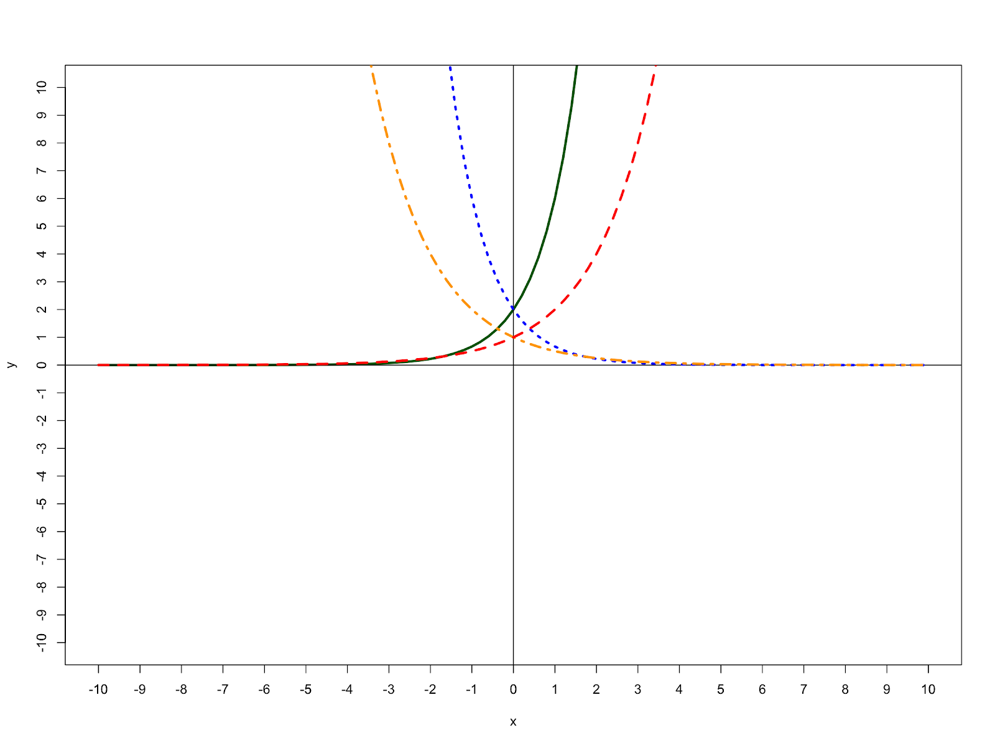
For example, the image above originally had the alt text: “Graph with axes extending from -10 to 10 in increments of 1. Two exponential growth curves, and two exponential decay curves are plotted on the graph. The curves with their equations are listed after the graph”. This is insufficient to describe the functions depicted, as it does not describe their shape at key points on the graph. A better description would include axes, intersections, and directions:
Graph with axes extending from -10 to 10 in increments of 1.
There are 4 exponential curves graphed, labeled by color and line style:
- Yellow (dot and dash): exponential decay graph. Begins at (-3.3, 10) and decreases steeply to intersect the y-axis at (0, 1) and eventually reach the x-axis at (10, 0).
- Blue (small dots): exponential decay graph. Begins at (-1.5, 10) and decreases steeply to intersect the y-axis at (0, 2) and eventually reach the x-axis at (10, 0).
- Green (solid): exponential growth graph. Begins at (-10, 0) on the x-axis and increases steeply to intersect the y-axis at (0, 2) and eventually reach (1.5, 10).
- Red (dash): exponential growth graph. Begins at (-10, 0) on the x-axis and increases steeply to intersect the y-axis at (0, 1) and eventually reach (3.3, 10).
Figure 2
Final Figure with Desmos Link and Long Description
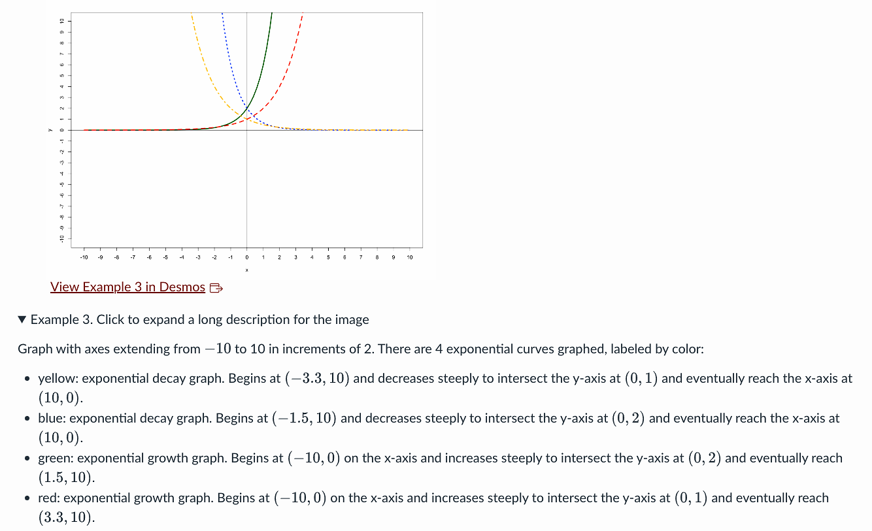

Physical Tools with Visual Components
In the precision measurement lesson, students originally had to physically measure lines that would change scale depending on screen size. In the final version, each line was paired with an image of a ruler to make measurements consistent along with alt text. B/LV students may not have a mental model for physical rulers and their measuring units, so a demo ruler and image descriptions explaining the English and metric sides were created. For example, inches would be described as divided into 16 units, with major and minor tick marks representing fractions of an inch. A list of common measurements such as one-quarter inch, or four-sixteenths, was included.
We used this description as a basis for shorter, clearer worksheet descriptions that would not tax working memory. For example, a line measuring 4 and seven-sixteenth inches was originally described as: “Line segment begins at the 0-mark on the ruler. The end of the segment extends past the 4-mark. Out of the 16 tick marks between inches 4 and 5, the segment ends at the 6th tick mark”. The final description is: “A line segment in English units. It ends 7 minor tick marks past the 4 inches mark”.
Figure 3
Line with Ruler from Final Worksheet Iteration
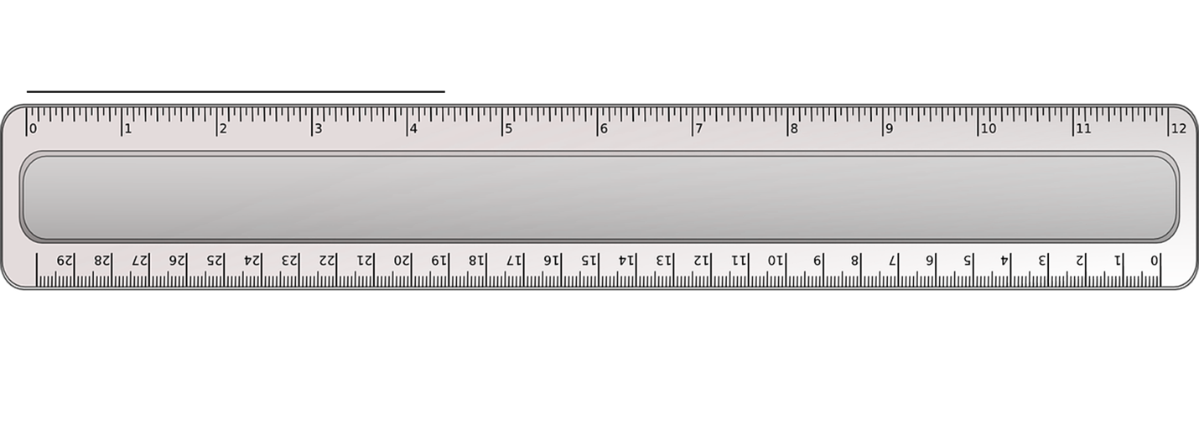

Professional Practice: Geology
The Earth Science: Materials and Processes course introduces topics in Earth and Atmospheric Sciences and is taken for general education and major requirements. Andrea Stevens-Goddard, instructor and SME, required an interactive digital experience that replicated in-person lab courses while minimizing extra costs to students. Our challenge was to provide accessible alternatives to activities and visual data without the aid of physical lab sets.
Course development in 2019 was constrained by time, available tools, and limited access to accessibility experts. The course was only run once in 2020. For future semesters, significant updates would be made to align with accessibility standards. The following examples reflect our current understanding of the topics involved, rather than the original course design.
This example will focus on a major course activity: rock and mineral identification, which appeared in four labs and two exams.

Rock and Mineral Identification
Traditional geology courses task students with identifying rock and mineral samples via physical properties. Of these, four are visually based: color, luster, streak, and potentially hardness (involving surface scratches that may be primarily visual). Cleavage and fracture (the shape of broken samples) were represented by images online, and special properties (e.g., taste, smell, or chemical reactions) were given to students in text. Initial prototypes included images and virtual 3D models that could be manipulated with the mouse only.
Our evaluation identified the following accessibility gaps:
- Access: B/LV students may be unable to perceive essential visual information from the images or 3D models.
- Interaction: 3D models were not operable via keyboard.
- Supports: Students who are B/LV from birth may not have mental models for concepts such as color or luster.
In advanced courses and professional field work, viewing a sample and determining characteristics might be an essential task or LO. However, this course’s primary goal was to communicate the importance of earth sciences to modern life. The core LO was defined as demonstrating the identification of samples using given properties and decision trees. With this in mind, we prioritized the lab identification process (using decision trees to identify samples) over interpreting visual information (e.g., determining a sample’s color).
Special considerations were required to maintain assessment integrity. For example, overly direct alt text could give away answers (e.g. “grey and metallic”), while ambiguous terminology (e.g. “light-colored rock”) might create visual bias. Does “light-colored” mean white, grey, yellow, pink, or tan? No conclusions can be drawn from the term, even if students have prior experience with color.
We identified a multi-step action plan of potential supports, described in the following sections.

Learning Objectives and Assessment Design
When possible, separate the tasks of visually interpreting samples from using diagrams for identification to remove visual bias. For example, one question could require interpreting the visual properties from an image. In another, students could identify a sample based on properties provided in text. Students should be allowed to use course reference charts to answer questions unless memorization of the charts is an essential LO.
Plain text problems can be made accessible using the methods described previously. For visual problems, provide a text equivalent written by the SME to all students alongside any images and 3D models. A consultation with the SME and accessibility experts can determine if the question type contains fundamental visual bias and cannot be described in text.

Consistent Terminology
Other terms in the course need to be standardized to communicate key information, including:
- Luster is a visual concept that may not be understood by someone who is B/LV from birth. While there are two standard options [matte (non-metallic) or shiny (metallic)], some non-metallic samples are smooth enough to reflect light and may be colloquially described as “shiny”. Consistent terms must be used in descriptions so students can interpret luster without being told the answer directly.
- Hardness uses the Mohs scale to compare scratch resistance of minerals to common objects of known hardness. Test results may be given directly or by comparison (e.g., “the mineral was scratched with a nail but not a knife”). Students would interpret charts or accessible tables.

Tools and Technology
An alternative to the virtual 3D modeling tool that aligns with WCAG 2.1 Level AA (W3C, 2025) requirements should be acquired. If one cannot be found, the SME could provide multiple images of each sample from different angles. Essential information should be conveyed outside of 3D models (e.g. in text equivalents and/or static images) in case students cannot access it.

Decision Trees
Decision trees consisted of a single starting point branching into a series of choices that led to a specific rock or mineral. Descriptions were structured as ordered (hierarchical) lists on a separate page. This served several purposes:
- The descriptions provided equivalent, navigable steps communicating relationships.
- Images and descriptions could be opened in a new window for reference during labs.
- The plain text version could be magnified to be viewed easily regardless of screen size.

Professional Practice: Computer Science
Materials in this section are adapted from a computer science course for business majors. The course focused on structures of computer systems, modeled using Entity-Relationship Diagrams (ERDs) with Crow’s foot notation, which is commonly used in the field. ERDs visually represent connections between entities (people or organizations) connected by relationships (often actions or states, such as a customer placing an order). Crow’s foot notation (“cardinalities”) indicates requirements for relationships to be functional and accurate.
Students were required to evaluate ERDs, recognize symbols based on visual appearance, and answer questions about the computer system being modeled. Our evaluation uncovered unique requirements:
- Access: Perception was required to interpret details of the symbols used.
- Interaction: While images can be accessed via both mouse and keyboard, complex image descriptions needed to be navigable so students could review specific parts.
- Supports: B/LV students may not have encountered Crow’s foot notation or have a concrete understanding of its symbology.

Solutions
Expert consultations determined the following:
- Consistent terminology must be defined at the beginning of the course and used in all learning materials and assessments. For example, if describing a crow’s foot, the SME should use one way to describe it (e.g., “a triangle intersected by a line”).
- Image descriptions should come in two forms: instructional versions that provide context and highlight connections between concepts, and assessment versions providing no symbol key and only essential descriptions, requiring students to demonstrate their recall and interpretation. Examples of both types can be found in the next section.
- Concepts requiring support must be introduced as early as possible, providing in-depth explanations alongside images and their descriptions.
- A tactile equivalent and tactile tour should be designed for an equivalent experience, combining the use of braille labels and representations of Crow’s foot notation with a narrative description of the overall diagram, allowing B/LV students to connect terms and concepts with their physical designs.

ERD: Extended Description for Educational Material
Figure 4
ERD with Extended Description for Educational Material
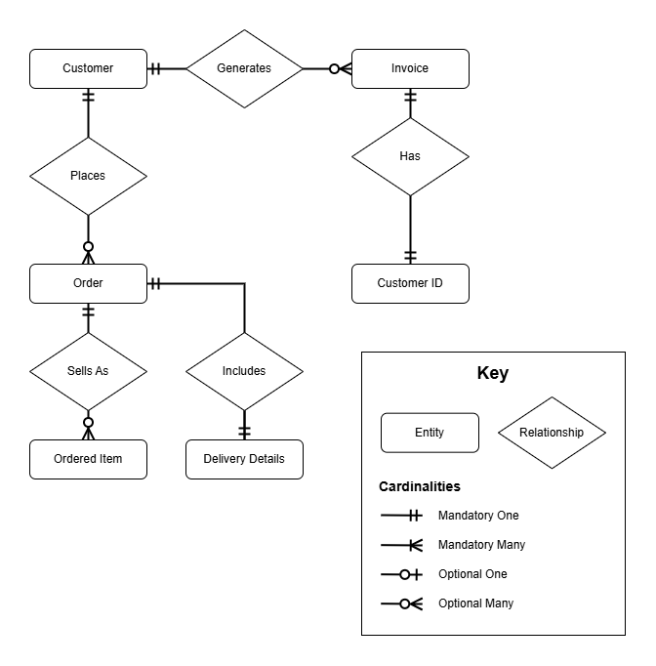
[Begin image description]
This is an Entity Relationship Diagram (ERD) that represents a business process. Customers place orders containing delivery details and ordered items, and these same customers generate invoices that are associated with customer IDs. The diagram uses standard ERD notation with lines and symbols at the relationship endpoints to indicate cardinality (one-to-one, one-to-many, etc.).
Entities (shown as rectangles):
- Customer (top left)
- Invoice (top right)
- Order (middle left)
- Ordered Item (bottom left, below Order)
- Delivery Details (bottom center)
- Customer ID (middle right)
Cardinality Symbols:
Cardinality symbols intersect the connection lines between entities and relationships. The options are:
- Mandatory One: Two lines.
- Mandatory Many: One line and a triangle.
- Optional One: Circle and one line.
- Optional Many: Circle and a triangle.
Relationships (shown as diamond shapes) and their connections:
- "Generates": connects a mandatory one Customer entity to an optional many Invoice entity
- "Places": connects a mandatory one Customer entity to and optional many Order entity
- "Has": connects a mandatory one Invoice entity to a mandatory one Customer ID entity
- "Sells As": connects a mandatory one Order entity to an optional many Ordered Item entity
- "Includes": connects a mandatory one Order entity to a mandatory one Delivery Details entity
Relationship Structure and Flow:
Starting from the top left, a Customer entity connects to an Invoice entity through a "Generates" relationship, indicating that customers generate invoices. The Invoice entity then connects downward to a Customer ID entity through a "Has" relationship.
On the left side, the same Customer entity connects downward to an Order entity through a "Places" relationship, showing that customers place orders. The Order entity then branches into two additional relationships: it connects downward to an Ordered Item entity through a "Sells As" relationship, indicating that orders sell as ordered items, and it connects to the right to a Delivery Details entity through an "Includes" relationship, showing that orders include delivery details.
This creates a complete business process flow where a single customer can generate multiple invoices and place multiple orders, with each order potentially containing multiple ordered items and having associated delivery details, while each invoice is linked to a specific customer ID.
[End image description]

ERD: Limited Version for Assessments
Figure 5
ERD with Limited Version for Assessments
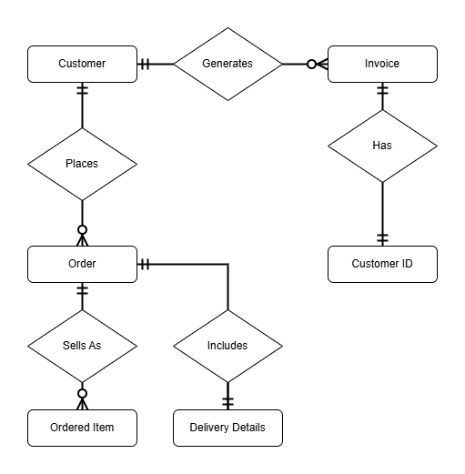
[Begin image description]
A diagram containing rectangles and diamond shapes connected by lines. The lines have various symbols located at the endpoints next to the rectangles.
There are six rectangle shapes. They are listed here by the text they contain:
- Customer
- Invoice
- Order
- Ordered Item
- Delivery Details
- Customer ID
There are five diamond shapes. They are listed here by the text they contain, and the lines and symbols connecting them to the rectangle shapes:
- Generates diamond connects by lines to the Customer and Invoice rectangles
  - Two lines at Customer
  - A circle and triangle at Invoice
- Places diamond connects to Customer and Order rectangles
  - Two lines at Customer
  - A circle and triangle at Order
- Has diamond connects to Invoice and Customer ID rectangles
  - Two lines at Invoice
  - Two lines at Customer ID
- Sells As diamond connects to Order and Ordered Item rectangles
  - Two lines at Order
  - A circle and triangle at Ordered Item
- Includes diamond connects to Order and Delivery Details rectangles
  - Two lines at Order
  - Two lines at Delivery Details
[End image description]

Conclusion
Accessible solutions for complex, topic-specific content can be accomplished through collaboration, research, iteration, and compliance with applicable regulations. By sharing solutions, individuals can contribute to the collective knowledge of IDs and accessibility experts and cultivate a more accessible STEM experience for all students.

Key Takeaways
- Determine accessibility gaps through expert consultation and review of relevant standards and regulations. Research best practices in accessibility and the subject field to identify possibilities for innovation.
- Support complex visuals with additional lecture content, image descriptions, tactile diagrams and/or 3D models, and tactile tours. Adapt supports to the learning objectives and assessments.

Further Exploration
- NWEA. (2021). NWEA Image description guidelines for assessments: Making assessment accessible for all students. NWEA.org. https://www.nwea.org/uploads/2022/11/Image-Description-Guidelines-for-Assessments_NWEA_2021.pdf
- Tobin, T.J. & Behling, K.T. (2018). Reach Everyone, Teach Everyone: Universal Design for Learning in Higher Education. West Virginia University Press. https://www.amazon.com/Reach-Everyone-Teach-Universal-Education/dp/1946684600
- Benetech (2019). Image Description Guidelines. Diagram Center. Retrieved July 14, 2025, from https://diagramcenter.org/table-of-contents-2.html
- National Federation for the Blind (2025). Welcome to the movement. https://nfb.org

Author Note
Carrie Hansel https://orcid.org/0000-0002-5727-8180
Caitlin Malone https://orcid.org/0009-0002-0154-9540
Rebeka Popek https://orcid.org/0009-0004-7447-8215
We have no known conflict of interest to disclose.
Correspondence concerning this article should be addressed to Caitlin Malone, Indiana University, 2709 E 10th Street, Bloomington, IN 47408, United States.
Email: caimalon@iu.edu

References
Abou-Zahra, S. (2024, July 15). Accessibility Principles. Web Accessibility Initiative. https://www.w3.org/WAI/fundamentals/accessibility-principles/
Al-Busaidi, S., & Tuzlukova, V. (2017). Challenges with creating accessible and usable learning environments for visually impaired students’ language education. 2017 6th International Conference on Information and Communication Technology and Accessibility (ICTA), Information and Communication Technology and Accessibility (ICTA), 2017 6th International Conference On, 1–2. https://doi-org.proxyiub.uits.iu.edu/10.1109/ICTA.2017.8336010
Americans with Disabilities Act of 1990, 42 U.S.C § 121010 et seq. (1990). https://www.ada.gov/law-and-regs/ada/
Benetech (2019). Image Description Guidelines. Diagram Center. Retrieved July 14, 2025, from https://diagramcenter.org/table-of-contents-2.html
Braille Authority of North America. (2022). Guidelines and standards for tactile graphics. Retrieved July 14, 2025, from https://www.brailleauthority.org/guidelines-and-standards-tactile-graphics
Brauner, Diane. (n.d.). Accessibility of common math worksheet formats. Perkins School for the Blind. Retrieved September 16, 2025, from https://www.perkins.org/resource/accessibility-of-common-math-worksheet-formats/
Guzman-Orth, D., Supalo, C.A., Smith, D.W., Lee, O. and King, T. (2021), Equitable STEM Instruction and Assessment: Accessibility and Fairness Considerations for Special Populations. ETS Research Report Series, 2021: 1-16. https://doi-org.proxyiub.uits.iu.edu/10.1002/ets2.12324
National Center for Education Statistics. (2022, April 26). A Majority of College Students with Disabilities Do Not Inform School, New NCES Data Show [Press release]. https://nces.ed.gov/whatsnew/press_releases/4_26_2022.asp
National Center for Education Statistics. (2023). Table 311.10. Number and percentage distribution of students enrolled in postsecondary institutions, by level, disability status, and selected student characteristics: Academic year 2019–20 [Data table]. In Digest of education statistics. U.S. Department of Education, Institute of Education Sciences. Retrieved July 16, 2025, from https://nces.ed.gov/programs/digest/d22/tables/dt22_311.10.asp.
NWEA. (2021). NWEA Image description guidelines for assessments: Making assessment accessible for all students. NWEA.org. https://www.nwea.org/uploads/2022/11/Image-Description-Guidelines-for-Assessments_NWEA_2021.pdf
MathJax. (n.d.). What is MathJax? https://docs.mathjax.org/en/latest/basic/mathjax.html
Office for Civil Rights. (2011, May 26). Frequently Asked Questions About the June 19, 2010, Dear Colleague Letter. U.S. Department of Education. https://www.ed.gov/sites/ed/files/about/offices/list/ocr/docs/dcl-ebook-faq-201105.pdf
The Rights of Students with Disabilities Under the IDEA, Section 504, and the ADA. (2025, July 18). https://www.congress.gov/crs-product/R48068
Santos, R. C. dos, Vianna, C. C. de S., & Santos, A. C. F. dos. (2023). Representations of a sector graph for teaching statistics to blind students. Educação Matemática Pesquisa Revista Do Programa De Estudos Pós-Graduados Em Educação Matemática, 25(4), 92–110. https://doi.org/10.23925/1983-3156.2023v25i4p092-110
Section 504 of the Rehabilitation Act of 1973. 29 U.S.C. §794. (1973). https://www.govinfo.gov/app/details/CFR-2002-title28-vol1/CFR-2002-title28-vol1-sec35-104-
Section 508 of the Rehabilitation Act, as amended 2024. 29 U.S.C. §794 (2024). https://www.section508.gov/manage/laws-and-policies/section-508-law/
Todorov, T., Bogdanova, G., Dochkova-Todorova, J., & Sabev, N. (2024). Accessibility of E-Learning and STEM Education. TEM Journal, 13(4), 3505–3513. https://doi-org.proxyeast.uits.iu.edu/10.18421/TEM134-83
United States Department of Justice (2024, April 24). Nondiscrimination on the basis of disability: Accessibility of web information and services of state and local government entities. Federal Register, 89(77), 31320-31379. https://www.federalregister.gov/documents/2024/04/24/2024-07758/nondiscrimination-on-the-basis-of-disability-accessibility-of-web-information-and-services-of-state
W3C World Wide Web Consortium (2025, May 6). Web content accessibility guidelines (WCAG) 2.1. https://www.w3.org/TR/WCAG21/

Footnotes
- As of writing, PDFs containing math content cannot be made accessible (Brauner, n.d.).
- Output is approximate and was generated by a non-native screen reader user with JAWS 2025.2506.170.
- Scanned PDFs are images of documents which cannot be accessed by screen readers.
Read this online at https://edtechbooks.org/accessibility/InnovativeSolutionsSTEM

