# Shape

Before anyone reads your essay, they can see your skill by the shape of the essay. You should divide your essay into paragraphs. Remember that a paragraph is a group of sentences with the same topic, meaning they are closely connected. The paragraph should be indented. Your sentences for one paragraph should not be separated with spaces. It should look like a rectangle of text.

This image shows what an essay shape should look like. The paragraphs are indented. They are about the same length, but the middle paragraph is a little bigger.

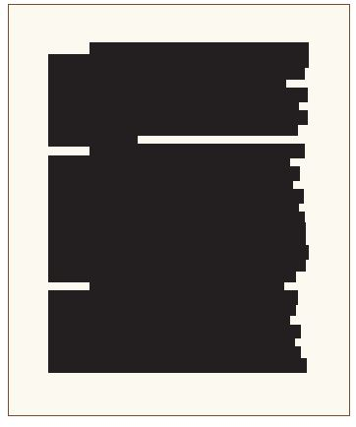

The introduction and conclusion can be a little shorter than the body paragraphs if they need to be, but they should all be pretty equal to each other.

Short essays typically have four, five, or six paragraphs: one introduction paragraph; two, three, or four body paragraphs; and one conclusion paragraph. The number of body paragraphs you need can change depending on the essay's topic, style, or time requirement.

When your essay will be printed (especially for your teacher to give you feedback), you should be careful to format the essay according to the directions your teacher gives you.

### Here are some common formatting directions you may need to know about:

* Write your name at the top of the paper (at left or right).
* Use 12 point font.
* Use 1 inch margins (2.54 cm).
* Double-spaced (2.0 spacing).
* Make each paragraph left-aligned.
* Indent the first line of each paragraph.

## Exercises

### Exercise 1

**Look at the essay below and answer questions :**

Reading books is a valuable activity, especially in the fast-paced world where people are distracted by smartphones, and other smart devices. The habit of reading books not only expands our knowledge but also develops our creativity, and imagination.

One of the main benefits of reading books is the knowledge they offer. Books offer a wide range of knowledge, such as history, science, and technology. They provide detailed explanations and real-life examples that help readers understand complex topics more easily. Hence, readers can learn different things about cultures, ideas, and viewpoints, which can broaden their understanding. This expanded understanding not only makes people more informed but also helps them become more open-minded and respectful of different perspectives.

In addition to knowledge, reading books also improves mental health and emotional intelligence. It encourages critical thinking and concentration, both of which are essential skills in everyday life and problem-solving. By focusing deeply on the content of a book, readers train their minds to stay attentive and process information more effectively. Moreover, reading fictional books can help people become more sympathetic and more imaginative. When readers connect with characters and experience their emotions, they develop a better sense of empathy and creativity. This can lead to a deeper understanding of human behavior and stronger personal relationships.

In conclusion, reading books is an essential habit that brings many benefits. From gaining knowledge to improving focus and empathy, the rewards of reading go far beyond entertainment. Encouraging this habit can lead to personal growth and a more thoughtful, informed society.

Question 1 : How many paragraphs are there?

___________________________________________________________________________

In a well-structured essay, there are usually four main parts: the introduction, the body paragraphs, and the conclusion. Each part serves a specific purpose in developing the main idea of the essay.

Question 2 : Write down the name of each paragraph

Paragraph 1 : _______________________________

Paragraph 2 : ________________________________

Paragraph 3 : _________________________________

Paragraph 4 : _________________________________

Read this online at <https://edtechbooks.org/foundations_c_writing/shape_essay>