Revising

Review: Thesis - Controlling Ideas
The thesis states the main idea, or focus, of the essay. The rest of the essay should give evidence and explanations that show why or how your thesis is true.
In order to focus your main idea, a thesis may also include controlling ideas. Controlling ideas control, or limit, the amount of information that you will write about the topic in your essay. A body paragraph will then be written about each listed controlling idea.
However, listing the controlling ideas in your thesis is optional. You may choose to state or imply them:
- may state controlling ideas (e.g., "The three most popular sports in the United States are baseball, American football, and basketball.").
- may imply controlling ideas (e.g., "There are three popular sports in the United States.").
- REVIEW: Body Paragraphs - SS and CS
The body paragraphs for your classification essay each need to contain descriptions of the topic's categories. Remember, the topic should be divided into three or more categories. Also, make sure each body paragraph is complete with a topic sentence, supporting sentences, and a concluding sentence.
Don't forget to develop your body paragraphs well, so the reader can understand the ideas being discussed. Here is a suggestion for developing your body paragraph. However, each step for writing supporting sentences may not always apply to all essay types:
- State the topic and controlling idea being presented (topic sentence).
- Write your supporting
  - Define the controlling
  - Describe the idea in more
  - Explain how it works,
  - Apply the idea to a context by giving
- Restate the controlling idea of the paragraph (concluding sentence).

Supporting Sentences
Your body paragraph needs to describe the controlling idea presented in your topic sentence. The sentences that explain your topic sentence are called supporting sentences. You can have many types of supporting sentences. Supporting sentences can give examples, explanations, details, descriptions, facts, reasons, etc.
Consider the following topic sentence: Another reason to travel is for business.
These are some examples of supporting sentences that could be used to develop a body paragraph about traveling for business:
- Explain:Nowadays, many businesses are international and require employees to collaborate. (Explains why someone may travel for business reasons.)
- Describe: Once the employee arrives, they are able to assess the situation of the target business and adapt accordingly. (Describes the actions of a person traveling for business.)
- Give reasons:Although technology provides some means of communication, face-to-face encounters allows for more freedom of expression and understanding of the business setting. (Gives a reason for why someone would travel instead of using technology to communicate.)
- Give facts: In order to stay afloat in the business world, businesses must expand their influence and become worldwide. (Gives a fact about businesses related to travelling for business reasons.)
- Give examples: For instance, McDonald's managers and CEOs are sent to new areas where the restaurants are being developed to help the area capture the concept of McDonald's and to succeed. (Gives an example of a business sending workers on a business trip.)Concluding Sentence
The last sentence in a body paragraph is your concluding sentence. Your concluding sentence should end your paragraph logically. Concluding sentences can restate the main idea of your paragraph, state an opinion, make a prediction, give advice, etc. New ideas should not be presented in your concluding sentence.
Again, consider the example topic sentence from before: Another reason to travel is for business.
Concluding sentences . . .
- Restate the Main Idea: Business is also a popular purpose for travelling.
- State an Opinion: Many people feel like travelling for business is the least enjoyable reason to travel.
- Make a Prediction:If you travel for business reasons, you will have a hard time seeing the place you are visiting.
- Give advice: When choosing a career, you should consider whether or not you are willing to travel for business.

Review: Conclusion
Don't forget that your conclusion paragraph should logically conclude your essay, just like your concluding sentences logically conclude your body paragraphs. The conclusion paragraph should begin by restating your thesis, and then you should broaden back out to a general topic. End with a closing statement.
This paragraph looks like the reverse of your introduction paragraph, going from specific to general.
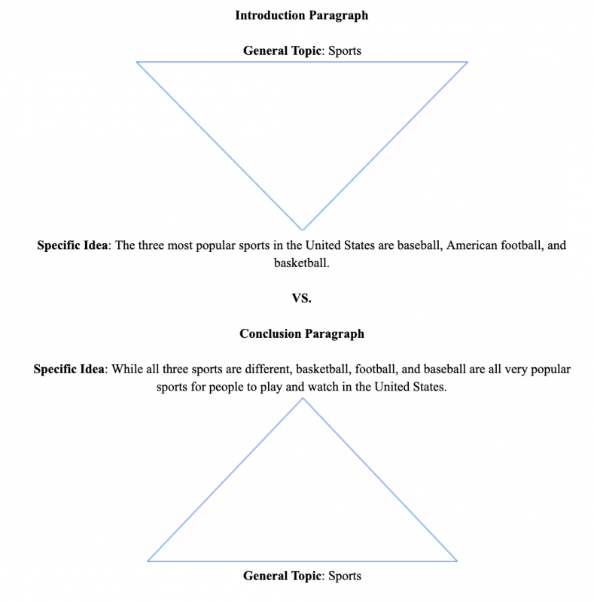

Restate your thesis. The first sentence of your concluding paragraph should restate your thesis.
Remember, in order to restate your thesis, the meaning of your thesis should not change, but the words need to. One way you can do this is by reversing the order of the clauses in your thesis. The clauses are also rephrased, rather than simply copying them and moving them. You can change some vocabulary words for synonyms or change the part of speech. Compare the thesis with the restatement below.
- Thesis: There are many reasons to travel; however, the three main reasons are for sightseeing, visiting, and business.
- Restated Thesis: Travelling to see famous sites, visit family or friends, and for business are all popular purposes for travelling the world.
- Apply your thesis to general contexts. Connect your thesis back to the general topics you mentioned in your introduction. You may invite the reader to make some change based on your essay or discuss possible actions that others should take.
- Give a closing statement. Your concluding statement is very similar to the concluding sentence of a body paragraph except that you will not restate your main idea at the very end of your paper. Your closing statement can be a prediction, suggestion, or opinion.

Example: Conclusion Paragraph
In conclusion, travelling to see famous sites, visit family or friends, and for business are all popular purposes for travelling the world. No matter what ages, backgrounds, experiences we have, traveling has become an essential and inseparable part of our lives. It helps us experience different people’s lives and to know more about the world. Whether you are travelling to Europe, Africa, Asia or South America, every continent and country has a unique culture, people, and food. No matter your reason for travelling, you will have a lot of fun. So start planning a trip today!

Exercises

Exercise 1: Identifying the parts of a thesis statement
Read each thesis statement. Circle the topic and underline the controlling ideas.
- There are many types of video games including adventure, strategy, and sport.
- The most popular brands of cell phones are iPhone, LG, and Samsung.
- There are two great instruments that people enjoy learning.
- Bachata, country, and electronic are some of the many genres of dancing music.
- The major types of watches are casual, smart, sport, and luxurious.
- Fast food restaurants have a wide variety of types.
- Books come in a plethora of genres such as fiction, non-fiction, and fantasy.
- There are many reasons to travel; however, the three main reasons are for sightseeing, visiting, and business.

Exercise 2: Evaluate thesis statements
With a partner share and discuss your thesis statements for your classification essays.
Are they effective thesis statements? Why or why not?

Exercise 3: Write supporting sentences
Read each topic sentence. Write 3-5 supporting sentences that support the topic sentence.
- Topic Sentence: IPhones are one of the most popular brands of cell phones.
- Topic Sentence: Another type of restaurant is fast food.
- Topic Sentence: People may travel to go sightseeing.

Exercise 4: Identify concluding sentences
Choose the best concluding sentence to complete the paragraph.

Rap is a present-day style of music that has gained great popularity among young people. This type of music is characterized by its rhythm with fast speech and no commitment to melody. The voice of the singer also does not matter. The singer, who performs this type of lyric, usually wears loose clothes inspired by basketball players’ or prisoners' clothing. The main purpose of this type of music is to critique social or political conditions or to convey a public message to all people. It is the voice of people. It is the voice of the oppressed. It’s also our voice because it tells the reality of each one of us and expresses our feelings and senses. Some of the most famous rappers include Akon, Eminem, Lil wayne and Jay Z. People love their songs because of the messages that they give and the way that they inspire.___________________________________________.
- As a result, the listeners are more motivated to take action and to take a stand.
- For example, the rap group “Black Eyed Peas” sang a song entitled “Where is the love?” to emphasize the need for more tolerance and understanding.
- Therefore, Rap is a very important type of music because of its influence and ability to change things for better or for worse.

The last film genre is documentaries. Documentary movies are nonfictional motion pictures that have the purpose of showing reality, giving instruction, educating, or informing. It is definitely a good way to show biographies of animals and people in order to share unknown information about them. A documentary can also be an excellent source of acquiring information for research about a specific subject. However, this kind of motion picture may not be as entertaining as others since it has a lot of information and details similar to a journal or sometimes a news report. Example topics and titles of documentaries include “42 ways to kill Hitler”, “The life and times of John F. Kennedy”, and “Supersize Me”. __________________________________________.
- Many different subjects are focused on in documentaries.
- Overall, the documentary genre of movies is a great way to learn and enjoy a film at the same time.
- I especially like documentaries on other countries because I learn more about their food and culture.

One kind of shoe is sneakers. It is the most common style of shoe. The main use of sneakers is for exercising and running since they provide the needed support for your feet and the rest of your body. As a result, the most common people to wear sneakers are athletes because they are usually exercising every day. Thus, they are usually wearing sneakers. In contrast, normal people wear sneakers less often. Since sneakers are more casual, they are seldom worn to work or school. They are a less professional shoe, so they are looked down on as a part of a uniform in most of the world. Therefore, sneakers may not be the best choice of shoe for every occasion. _____________________________________________________.
- However, sneakers are still a very comfortable and durable style of shoe.
- Nowadays, however, they are being worn for more and more special occasions.
- For example, you wouldn’t want to wear sneakers to a fancy party.

Exercise 5: Write concluding sentences
Find the supporting sentences you wrote earlier for these topic sentences;
- Topic Sentence: iPhones are one of the most popular brands of cell phones.
- Topic Sentence: Another type of restaurant is fast food.
- Topic Sentence: People may travel to go sightseeing.
Read each of the paragraphs you wrote to complete the topic sentences.
Now, write a concluding sentence for each paragraph.

Exercise 6: Evaluate concluding sentences
Now check the body paragraphs in your classification essay
Make sure you included all three types of sentences:
- Topic Sentence
- Supporting Sentences
- Concluding Sentence

Exercise 7: Write body paragraphs
As a review of writing body paragraphs, write a complete body paragraph for each/one of the following theses. Don’t forget to focus on only one controlling idea.
- Three popular types of music today are rap, pop, and country.
- There are many reasons to travel; however, the three main reasons are for sightseeing, visiting, and business.
- The most popular genres of entertainment are fiction, romance, and suspense.
- The three most popular sports in the United States are baseball, American football, and basketball.

Exercise 8: Restate thesis statements
Rewrite each thesis statement as you would at the beginning of a conclusion paragraph.
- Three popular types of music today are rap, pop, and country.
- The most popular genres of entertainment are fiction, romance, and suspense.
- The three most popular sports in the United States are baseball, American football, and basketball.

Exercise 9: Give feedback
Read the student essay to complete this exercise.
Does the essay have all of the necessary parts? Discuss any revisions you would make to the essay with a partner.
- Label the introduction paragraph, the body paragraphs, and the conclusion paragraph.
- Circle the hook.
- What is the general topic of the essay?
- Underline the thesis.
- Underline each of the topic sentences.
- Do each of the topic sentences support the thesis?
- Does the conclusion paragraph begin with a restatement of the thesis? Does it end with a closing statement?
Example Essay for Revisions: Types of sports
The United States is a world power when it comes to sports. It has many sports which are practiced and followed by thousands of fans throughout the country. The economic power generated by the most popular sports is enormous. The most popular sports generate a huge interest and entertainment is unique with all the star athletes of sports.
Football, basketball, baseball, boxing and soccer are the sports that attract the most attention. Their large number of fans support them, and the huge amounts of money these sports generate make them more influential. The level of performance is also very high.
Football in the United States is the most popular; however, in the rest of the world, it is not. Despite this, football is the biggest U.S. sport as well as the most seen and most practiced. Basketball is also a very important sport. It is an attractive and emotional game that generates passion and great emotions for fans. In contrast, baseball is a sport that over the years has positioned itself as the most played over all other sports. It was created in the United States, so the best baseball leagues can be found there.
Boxing is one of the oldest and most exciting sports. It is not a sport that works in a team, rather it is an individual sport. It generates a lot of controversy for its violence and the amount of hits involved. Soccer is the best sport in my opinion. It is also the most followed and practiced sport all over the world. It started in England and was perfected in Brazil. Soccer generates the highest excitement for its competitions and games, and its matches always have full stadiums.
In conclusion, the United States has many sports practiced and followed. The athletes with the highest skill play these sports. With the exception of soccer teams in the U.S., the sport leagues are growing and spreading more throughout Europe. The economy that generates these sports helps each country in many aspects by creating jobs and keeping young people active and exercising. All kinds of people can be entertained with these magnificent sports.

Read this online at https://edtechbooks.org/foundations_c_writing/revisingw

