# Prewriting

## Understand the assignment

### Descriptive Essay Prompt

Describe an influential historical person. Through the supporting ideas you choose, show the reader how the person you selected has had an impact on the world in a significant way.

Additional Instructions:

You may choose to focus your suppporting ideas on attributes, characteristics, actions, contributions, inventions, events, etc.

Remember to include adequate biographical information so that your teacher and classmates that read your essay will understand the context of the individual. This is especially important if the person you choose is from your home country, had a significant impact on a specific community, or if the person is from a long time ago (or is making a difference right now)

## Brainstorm

A Google search for "influential people" might be a good place to start if you aren't sure who you want to write about.

Choose people that you can find research on that is written in English and published in a trustworthy place. Research will be much more plentiful and easy to access if you choose someone who was recognized internationally instead of a local figure.

You may start thinking about types of people that you would be interested in writing about.

For example, you could look for:

* athletes
* artists
* politicians
* scientists
* explorers
* inventors
* musicians
* philanthropists, etc.

As you brainstorm, you may also find it helpful to make an idea map like the one below.

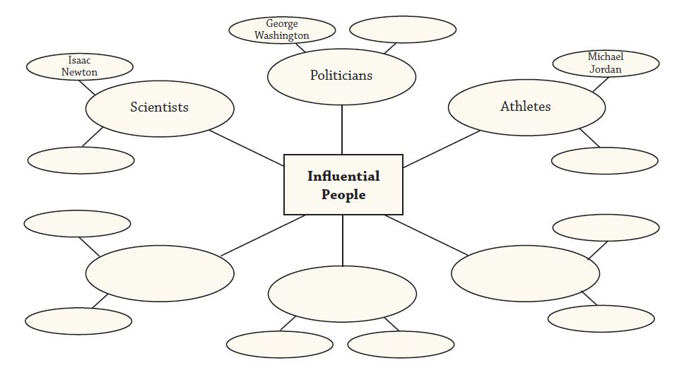

## Choose your focus

Even though it may seem specific enough to have chose a name of a historical figure, you will need to narrow your focus even more. People have complex lives and are often known for many different things. The same historical figure may be viewed as a hero by some and a villain to others. In a 2-3 page essay, you don't have the space to try to give a complete biography for the person.

Focus your essay by deciding what attributes or accomplishments you will talk about. Those will be the focus of your essay even though there may be many other interesting things to say about that person.

## Research

Encyclopedias can be an excellent place to begin looking for information on a specific person. Remember that after you do enough preliminary research to brainstorm and choose your focus, you should do more detailed research about your topic so that you can make your outline.

Finding sources to support your ideas can be a challenge. Here is a list of the type of information you might want to find from a source:

* Basic biographical information (ex. family, work experience, achievements, etc)
* Statistics (ex. sales, amount donated to charity, value of famous artwork, etc)
* Stories (ex. memories shared by people who knew the person, speeches by that person)
* Descriptions (ex. definition of invention, explanation of impact on industry)

## Outline

Start with your topic sentences and thesis. Add questions or quotes to help you develop each of your ideas.

### Example Outline

Thesis: Jimmy Ohnishi is the luckiest and funniest guy in the world because he succeeded as a comedian, painter, and comedian again.

TS1: Jimmy Ohnishi’s life is firstly well-known as a comedian.

* started as a janitor at a comedian hall
* Introduce role of Sanma (boss/supervisor) in becoming successful
* examples of shows

TS2: Surprisingly, when Jimmy was thirty-two years old, he quit his career as a comedian and went to Spain to study painting, even though Jimmy’s fortune as a comedian was still lasting.

* exploring other talents
* Support again from Sanma
* Sales

TS3: In 2015, Jimmy came back to the comedian world again and continued his art.

* debt from bad habits
* continued painting
* success with comedy

Restated Thesis: Jimmy Ohnishi’s life is something mysterious and can’t explain by logic. It is because his life is full of fortune and some destiny that Jimmy has been so successful in both careers.

Sources:

## Introduction

Your introduction should start by describing any background of the person that will be important for the reader to know. For example, in the introduction paragraph for an essay about Martin Luther King Jr, you might explain the context of what was happening in the 1950's in the United States. A brief description of the racial discrimination of the time would help give your reader valuable background knowledge to understand the role of Martin Luther King Jr. in the Civil Rights movement.

At the end of your introduction paragraph, you should give your thesis. The thesis should describe the person in very specific terms.

### Example descriptive thesis statements

1. Martin Luther King Jr. was a courageous, nonviolent social reformer.
2. José Joaquín de Olmedo demonstrated his intelligence in many areas, both political and literary, that he contributed in many ways to the city of Guayaquil.
3. Jorge Luis Borges was one of the most famous writers from Argentina and he was recognized for the passion he had to write, his creativity, and his intelligence.
4. Kurt Cobain was a legendary grunge musician who inspired people because he was reserved, idealistic, and sensitive.
5. Rosa Parks was one of the most influential leaders of the Civil Rights movement because of her dignity and bravery.
6. Ivan the Terrible was considered by some to be a  top-notch leader and conqueror, while others considered him a crazy villain.
7. Homero Gomez, an environmental activist full of love, perseverance and leadership.

Sometimes when you are describing a person from history, you talk about the influence or impact of the person. Because you will write a cause/effect essay during this semester, try to focus this essay away from causes/effects.

Think about your topic in terms of adjectives. How can you describe your person? What qualities are unique to that person?

### Thesis Statements: Parallelism

Parallelism is the grammar principle that words in a list should have the same structure. In other words, if you are making a list of your points in your thesis, you should use only nouns, verbs, or adjectives. You should not be mixing word parts or types of phrases.

Look at the examples below:

* Niina’s success comes from her authenticity as a creative youtuber, talented digital influencer, and sympathetic businesswoman. (adjective + noun list)
* Emma Smith showed us how to be a godly woman by her faithfulness, strength and devotion. (noun list)
* Julio Jaramillo has been the inspiration of many people for creating a new music genre, winning a lot of awards in the world, and having an infamous life. (verb phrase list)

## Body

Your body paragraphs should explain how or why your thesis sentence is true. As you plan each of your body paragraphs, remember that using sources will make your writing more credible and interesting. Use sources properly so that you do not plagiarize. Each of your body paragraphs should have citations.

### Prewriting for Development

At this stage of writing, your "development" of the body paragraphs will be limited. For many students, this might be limited to a list of questions that relate to your topic sentences. It may be a bulleted list of phrases that represent ideas that you think would benefit your description of the impact of the person.

Example

* TH: Jane Goodall was very curious and investigated new ideas to answer questions.
  + How did she show that she was curious?
  + What new ideas did she investigate?
  + How did she answer questions with her research?

Be careful to not include questions that are not connected to your topic sentence. If you ask unconnected questions, your paragraph will lack unity. For example, these questions would not support that same topic sentence about Jane Goodall.

* Where was Jane Goodall born?
* Why did Jane Goodall want to be a researcher?

This does not mean that the information should not be included in your essay. These ideas just do not belong in this paragraph. They would be better at supporting the introduction.

## Conclusion

Your conclusion paragraph should start by restating your thesis. Then, you should speak about the person/event in more general terms and apply their situation to the world more generally. End with a concluding statement.

## Exercises

### Exercise 1: Discussion

Use the questions below to discuss this assignment before you begin.

1. What does it mean to describe a person? What are the typical ways we describe an average person? How is that the same or different to how we describe a famous person?
2. What does it mean to be influential?
3. There are many different ways to have an influence on the world. What issues or topics are you most interested in? Who are some of the famous people connected to those things?
4. Historical in this prompt means that the person is remembered for years after because of specific contributions or characteristics. Do you think people are remembered most for their actions or way of being?
5. Who do you think your audience is for this essay? Why would that person be interested in reading your writing?

### Exercise 2: Brainstorm

Make a brainstorm idea map similar to the one above. Now that you have some options, choose your favorite. If aren't sure which one to talk about, consider the following questions:

1. Which person am I most interested in learning more about and writing about for a few weeks?
2. Who on the list would be the easiest/most challenging for me to write about?
3. Is there a person that would have more sources in English?
4. Is there a person I think the audience should know more about?
5. Are there any options I can eliminate because they are too commonly used as topics?

### Exercise 3: Narrowing the focus

Now that you have selected a person to write about, continue prewriting by deciding what aspects of that person you want to discuss. Create a T chart like the one below to help you organize potential major details:

|  |  |
| --- | --- |
| Personal characteristics, traits, attributes, etc | Contributions, actions, events, discoveries, inventions, etc |
|  |  |

You should choose your major details from only ONE side of the chart. Look at each list and decide which one is strongest or most interesting. Choose three of those points to include as your major details.

### Exercise 4: Looking for Sources

Use the list from Exercise 3: Narrowing the Focus to identify what type of information you need to learn from another source. You can do this by making a list of information you know off the top of your head and a list of things you need to learn (or double-check) to explain the points you chose.

Note: Wikipedia is an ok place to start. However, when you look for sources, try to make sure your source list is:

* from multiple websites/books (not just one perspective)
* in English
* from an author or institution you can trust
* actually related to your ideas

### Exercise 5: Revise thesis statements

Revise these thesis statements to be more effective for a descriptive essay.

1. We understand that Ghandi was a spiritual leader for people around the world and could know the best ways to show people how to live and become more peaceful and caring.
2. First, his concept of leadership, his role in World War II, and at last his legacy.
3. Let me analyze what makes us remember Madame Curie as an important person in history.
4. Khalo changed the way women were depicted and percieved in Mexico through her art.
5. His educational life in Spain at the age of 16 and his married life were two facts in Simon Bolivar's life before he passed away on December 17, 1830, near Santa Marta, Colombia.
6. Vygostky was one of the forerunners of developmental psychology, and one of the most important works in Psychology and Education was the Zone of Proximal Development.

### Exercise 6: Revise developing questions

Cross out the developing questions that do not help develop the topic sentence.

Some of the developing questions below don't support the topic sentence or would be better to provide background information in the introduction.

Peyton Manning was a talented leader.

1. Who was Peyton Manning?
2. What were some of Peyton Manning's talents that helped him lead others?
3. How did Peyton Manning show leadership?
4. What teams did Peyton Manning play on?
5. What successes did Peyton Manning have in his career?
6. What did Peyton Manning help his team achieve through his leadership?

### Exercise 7: Revise the outline

Revise the outline on a piece of paper. Make sure the topic sentences support the thesis.

* TH: Jose de San Martin released three countries from Spanish rule including Argentina, Chile, and Peru.
* TS: San Martin was a good leader because he created a regimen of grenadiers.
* TS: San Martin was a freedom seeker.
* TH: San Martin truly left an important mark on Argentina and the whole world.

### Exercise 8: Make an outline

Make an outline for the example essay in this chapter.

Think about what you have learned about outlines. Remember that the more details you include now, the easier it will be to create your first draft.

Read this online at <https://edtechbooks.org/academic_b_writing/prewritingV>