# Infographic

Infographics are a very popular method for displaying data and important information to target audiences both online and offline. Infographics come in various forms and may range from a very simple, black-and-white graph used in a scientific journal article to a highly-elaborate illustration of people, nations, or products for comparison.

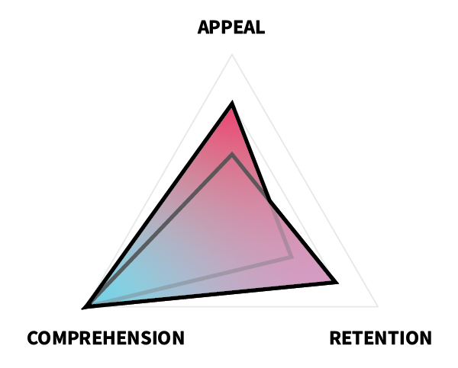

In terms of ARC, the primary goal of an infographic is to help your learner comprehend the information you are providing. Some information can best be conceptualized visually (such as the relative size of the planets to one another), and infographics are uniquely suited for these types of learning scenarios, because visual communication empowers you as the designer to convey important meaning that otherwise might be lost in text.

Because infographics span a gamut of types, whether appeal or retention should be prioritized next depends on your context. Most infographics used on the internet today highly emphasize appeal to ensure that the graphic is re-shared on social media or to encourage reading, but if you have a captive audience (such as in a book or journal), then retention might be more important.

For this project, you will create an infographic to display information or data that you feel is very important and that would be better-presented graphically than as simple text.

### Additional Readings

* ["How to Design Effective Infographics?" by Saadia Minhas](https://uxplanet.org/infographic-design-26dad026bbdd)
* ["12 Infographic Tips That You Wish You Knew Years Ago" by Neil Patel](https://neilpatel.com/blog/12-infographic-tips/)
* ["How designers do it: 15 easy steps to design an infographic from scratch" by Caitlin Jordan](https://www.canva.com/learn/create-infographics/)

## Task

Create your own, original infographic using Adobe Illustrator or another program.

### Requirements

* Create an original infographic.
* Choose some information or data you feel is important (and that would be best communicated visually).
* Cite your source(s).
* Incorporate icons, text, chart/graph elements, and appropriate colors.
* Use only scalable graphics (whenever possible).
* Make the size of your infographic at leat 600x1800px or 1800x600px.

### Guidelines

* **Be creative.**
* **Be simple and focused.** Don't include unnecessary details or graphics.
* **Be narrative-driven.** Don't just throw a bunch of facts on a screen and expect it to have meaning for your audience.
* **Use colors that work well together and that match your tone.**
* **Have fun!**

## Tutorial Videos

### Professional Infographic Illustrator Tutorial

### Illustrator CC Tutorial

## Evaluation Criteria

|  |  |  |  |  |
| --- | --- | --- | --- | --- |
|  | Unsatisfactory | Basic | Competent | Professional |
| Appeal |
| Color | Color is not used or is distracting, disharmonious, or confusing. | Color is used in a non-distracting manner … | … that enhances visibility … | … and enhances meaning and aesthetics. |
| Layout | The layout is either cluttered or sparse. | The layout gives sufficient space to all elements, … | … organizing them in an aesthetic manner … | … that fosters readability and instant recognition. |
| Graphics | Few original graphics are used, or graphics are poorly constructed, not discernible, or distracting. | Many original graphics are used (e.g., illustrations, graphs, icons) … | … that are clearly discernible for what they are … | … and improve aesthetics in a professional-looking manner. |
| Font | Fonts are not used or are inappropriate, inconsistent, or frequently changing. | Appropriate fonts and text sizes are used … | … in a consistent manner … | … that only changes to enhance meaning (e.g. preattentive attributes). |
| Retention |
| Topic | The topic is unimportant, too broad, or otherwise not memorable. | The topic is important, … | … sufficiently focused, … | … and memorable. |
| Visualization | Visuals do not effectively support the memorability of the information/data. | Visuals effectively support memorability of the information/data … | … by effectively illustrating the content … | … in an unforgettable manner. |
| Comprehension |
| Type | The type of infographic does not align well with the information/data presented. | The type of infographic effectively presents the content … | … in a manner that enhances meaning … | … and could not be presented as well via alternate formats. |
| Organization | The organization of content has no discernible flow. | The organization of content has a discernible flow … | … that allows for quick understanding … | … and enhances meaning (e.g. flowing from general concepts to specifics). |
| Citation | Citations for information/data are not provided. | Citations for information/data are provided … | … and are trustworthy … | … and include multiple sources. |

Read this online at <https://edtechbooks.org/design/infographic>