In-text Citations
When you use information you found in your sources, you need to mark that information to show that the ideas are not your ideas. This will help the reader to find the matching entry on the reference page, so they can use that information to go read or listen to the original source if they want to. You need in-text citations in your paragraphs, when you use the ideas or words from another person or organization. In other words, you will need a citation in any of these situations:
- A direct quote
- A summary
- A paraphrase
- Any time you use ideas that aren't general knowledge
Source material is marked in your essay using in-text citations. The exact format of your citation will vary a little depending on the style guide you are using. All of the citations in this book use the APA style guide, but there are other style guides you may need to use in college. Your teacher will usually tell you which style guide they expect you to use.
Three basic types of information are required for an in-text citation:
- The author's last name
- The year that the information was published
- The page number (or for some electronic sources, the paragraph number)

Example: In-Text Citation
(Walker, 2015, p. 10).

The in-text citation is split if you use a phrase to introduce the source material that includes the author's name. The year goes in parentheses directly after the name of the author, and the page number goes in parentheses at the end of the source material. See example below.

Example: In-Text Citation with an Introductory Phrase
According to Walker (2015), "Several districts had sufficient resources to provide some funding for elementary arts but not enough to establish a high-quality, sequential program staffed by fully qualified professionals." (p. 10).
The way you use ideas or words from the source will also determine how much information you need to give the reader for them to find the source. The main difference is that if you use the exact words from the source, you need to give the page or paragraph number for the reader to be able to find those exact words in the source.
 | Author/Organization | Year Published | Page/Paragraph #
Quote | needed | needed | needed
Summary | needed | needed | optional
Paraphrase | needed | needed | optional
Other | needed | needed | optional

Examples
 | Example
Quote | (Walker, 2015, p. 10)
Summary | (Walker, 2015)
Paraphrase | (Walker, 2015)

Variations
You may need to adjust the in-text citation for some of your sources, depending on the information that is available. Some of the more frequent situtations you may encounter are shown below. For more information about these or other situations you encounter while trying to create citations, check out https://owl.purdue.edu/owl/research_and_citation/apa_style/apa_formatting_and_style_guide/in_text_citations_author_authors.html .

No author?
If there is no author listed because something was written by an organization, include the organization's name. If the organization has a widely-recognized acronym, you can use it after the first in-text citation (e.g., NASA).

Example: In-Text Citation with a Group as the Author
The Centers for Disease Control and Prevention (2022) explains that "People infected with RSV usually show symptoms within 4 to 6 days after getting infected." (para. 1). While there are a wide range of symptoms for adults, for "...very young infants with RSV, the only symptoms may be irritability, decreased activity, and breathing difficulties." (CDC, 2022).

If there is no author or organization name, (as is the case with many encyclopedias or dictionaries), you should use the first few important words of the article's title with quotation marks.

Example: In-Text Citation without an Author
"Acid reflux occurs when the sphincter at the base of the esophagus isn’t working well, allowing fluid from the stomach to enter the esophagus. The worst foods for reflux can worsen painful symptoms, while other foods can soothe them, says UH gastrointestinal surgeon Leena Khaitan, MD." ("The Best and Worst Foods for Acid Reflux", 2014, para. 2).

Two authors?
In parentheses, use the ampersand (&) between the names. In an introductory phrase, write the word and.

Example: In-Text Citation with Two Authors
Recent research has concluded that "...progress in fuel efficiency may be perceived as a smokescreen hiding the dramatic increase in absolute fuel burnt and thus aviation’s impact on climate." (Dobruszkes & Ibrahim, 2022, p. 10).

More than two authors?
You only need to list the first author's last name and et. al. for every citation. This is an update for the 7th edition APA style guide.

Example: In-Text Citation with Three Authors
As explained by Shadinger et al., "having students recite aloud a self-affirming statement in unison immediately prior to delivery of a required speech or presentation provides a greater reduction in performance anxiety than not doing so." (Shadinger et al., 2020, p. 1).

No page number?
The paragraph number should be used with the abbreviation para. If there are headings in the text, use the name of the heading before the paragraph number. Put the name of the heading in quotation marks. (Some headings may be very long. In that case, you can use a shortened version.)

Example: In-Text Citation without Page Number
"Color photography started to become popular and accessible with the release of Eastman Kodak’s “Kodachrome” film in the 1930s. Before that, almost all photos were monochromatic – although a handful of photographers, toeing the line between chemists and alchemists, had been using specialized techniques to capture color images for decades before." (Cox, 2022, para. 6).

Example: In-Text Citation without Page Number
"Today, T.E. Lawrence remains one of the most iconic figures of the early 20th century. His life has been the subject of at least three movies—including one considered a masterpiece—over 70 biographies, several plays and innumerable articles, monographs and dissertations. His wartime memoir, Seven Pillars of Wisdom, translated into more than a dozen languages, remains in print nearly a full century after its first publication." (Anderson, 2014, para. 9).

No year?
Use the abbreviation n.d. (no date).

Example: In-Text Citation without Year
William Adams "...was an English navigator who in 1600 was the first of his nation to reach Japan." ("The Life of William Adams," n.d., para. 1).

Other variations?
Check a complete APA citation style guide like the Publication Manual of the American Psychological Association (7th ed.) or the OWL online.

Exercises

Exercise 1: Create Citations
Create citations for the following sources. While this chapter focuses on using APA format, you are welcome to cite your sources in a different way if you prefer. The important skill here is to give credit to the original author for the ideas and to understand how to avoid plagiarism. You will have plenty of time in a university setting to learn how to correctly use the style guide for your area of study.
- Search for these articles on the BYU Library website or Google Scholar to find any other necessary information.
- Write the citation that would be used in an essay paragraph.

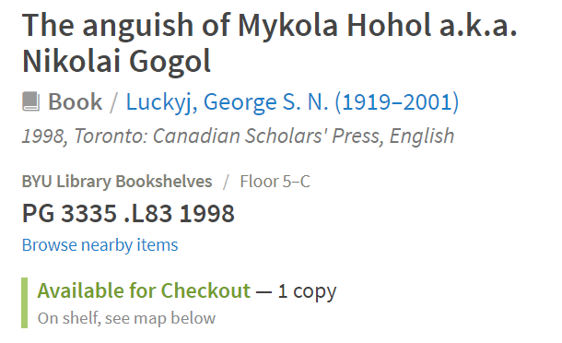



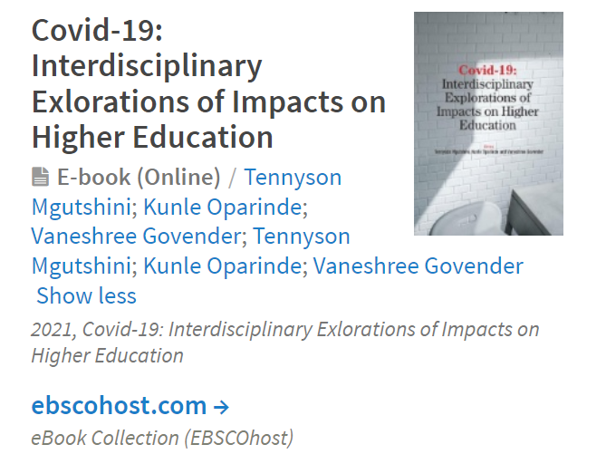

Exercise 2: Create More Citations
Create citations for the following sources. While this chapter focuses on using APA format, you are welcome to cite your sources in a different way if you prefer. The important skill here is to give credit to the original author for the ideas and to understand how to avoid plagiarism. You will have plenty of time in a university setting to learn how to correctly use the style guide for your area of study.
- Open these links to articles to find any other necessary information.
- Write the citation that would be used in an essay paragraph.
- Signs of Arrival
- Culture in the Seminar Room of Poetry: Poetic Insights for Cultural Psychology
- How to learn a heritage language

References
Walker, L. N. (2015). Do You Really Want to Know? Elementary Music Personnel and Potential in Utah. Arts Education Policy Review, 116(4), 201–213. https://doi-org.byu.idm.oclc.org/10.1080/10632913.2014.944968
Centers for Disease Control and Prevention. (2022, October 24). Symptoms and Care of RSV. Retrieved from https://www.cdc.gov/rsv/about/symptoms.html.
The Best and Worst Foods for Acid Reflux. (2014, April 15). The Best and Worst Foods for Acid Reflux. – What to Eat and Avoid | University Hospitals. Retrieved from https://www.uhhospitals.org/blog/articles/2014/04/best-and-worst-foods-for-acid-reflux
Dobruszkes, F., & Ibrahim, C. (2022). “High fuel efficiency is good for the environment”: Balancing gains in fuel efficiency against trends in absolute consumption in the passenger aviation sector. International Journal of Sustainable Transportation, 16(11), 1047–1057. https://doi-org.byu.idm.oclc.org/10.1080/15568318.2022.2106463
Shadinger, D., Katsion, J., Myllykangas, S., & Case, D. (2020). The Impact of a Positive, Self-Talk Statement on Public Speaking Anxiety. College Teaching, 68(1), 5–11. https://doi-org.byu.idm.oclc.org/10.1080/87567555.2019.1680522
Cox, S. (2022, December 19). Introduction to photography: The universal language. Photography Life. Retrieved from https://photographylife.com/what-is-photography
Magazine, Smithsonian. (2014, July 1). The true story of lawrence of arabia. Smithsonian.com. Retrieved from https://www.smithsonianmag.com/history/true-story-lawrence-arabia-180951857/
The life of William Adams. (2023, January 21). Retrieved from https://www.williamadams.fr/the-life-of-william-adams/
Read this online at https://edtechbooks.org/up_writing_winter/citations

