# Technology Integration

Kimmons, R.

### Learning Objectives

* Develop a foundational understanding of learning theories driving current technology development and adoption for K-12;
* Develop a foundational understanding of prominent technology integration models;
* Consider your own values guiding effective technology integration in the classroom.

Technology Integration in education refers to the meaningful use of technology to achieve learning goals. This chapter seeks to answer the question: what is effective technology integration? Though on the surface this may seem like a simple question, it is actually quite difficult to answer, because any answer will be based upon our beliefs and values, how we view learning, and how we view technology's role in the learning process. To approach this question, we will proceed in this chapter by (1) revisiting some common learning theories and how they might influence our perspective of technology's role in learning, (2) exploring the beliefs and values that individuals and institutions might apply when evaluating technology use in the classroom, and (3) providing an overview of some common technology integration models that are used to help teachers better understand the process and goals of technology integration.

### Key Terms

Behaviorism

a learning theory popularized in the mid-20th century, it treats learning as a response to stimulus and it conditions students to properly react to stimuli; the brain's processes are not considered and viewed as a "black box"

Cognitivism

a learning theory that focuses on brain functions and how information is processed, stored, retrieved, and applied

Compliance

legal, ethical, and institutional requirements of technology use (in contrast to their pragmatic use)

Connectivism

a learning theory that believes that learning need not be isolated to the mind, but becoming a learned and capable citizen in a digital society requires learners to become connected with one another in such a way that they can make use of the network as an extension of their own mind and body

Constructionism

a learning theory in which students construct artifacts in the outside world that support and reflect their internal construction of knowledge

Constructivism

a learning theory that considers individual and social factors by holding that learning is constructed by learners on top of previous experience, attitudes, and beliefs

Facility

the ease at which a new technology can be learned, implemented, or managed at the teacher- or student-level

Institutionalization

infrastructural compatibility, cost, lifespan, and management scale of new technologies

Proof

evidence-based efficiency or efficacy of a technology to help improve student learning

RAT

a technology integration model that holds that technology use either Replaces, Amplifies, or Transforms (RAT) pedagogical practices (Hughes, Thomas, & Scharber, 2006)

Technology Integration

the meaningful implementation of technology in educational settings to achieve learning goals

TPACK

a technology integration model that illustrates the complex interplay between Technological Knowledge, Pedagogical Knowledge, and Content Knowledge

## Learning Theories

Ever since there have been educators trying to teach students, there have been theories that guide how those educators view the learning process. These learning theories encompass our beliefs about the nature of knowledge and how a person learns.

Debates surrounding learning theories have existed for millennia, and even in the modern world, there is great diversity in how scientists, psychologists, and educators view learning. Some of the major learning theories that shape modern conversations surrounding technology integration include behaviorism, cognitivism, constructivism, constructionism, and connectivism. Each of these theories has been studied and written about at length, and it is impossible to devote sufficient time and attention to each theory in the limited space provided in this chapter. Rather, all educators should study competing learning theories and develop their own understanding of how people learn. In this chapter, we will merely provide an extremely high level overview of each of these theories, briefly explaining what each entails and what each might mean for teaching and learning with technology.

### Behaviorism

Behaviorism was popularized in the mid-20th century as psychologists studied behavior patterns and response systems in humans and other animals. Behaviorism treats learning as a response to stimulus. That is, humans and other animals are trained to respond in certain ways to certain stimuli, such as salivating when a dinner bell rings or repeating a memorized fact to receive some external reward. Teaching and learning, then, is a process of conditioning students to properly react to stimuli, and technology can help facilitate this training by providing incentives to learning, such as games or other rewards, or by providing systems to efficiently develop stimulus-response conditioning, such as drill-and-kill practices.

### Cognitivism

Cognitivism arose as an alternative to behaviorism in part because behaviorism treated the processes of the brain as an imperceptible black box, wherein understanding how the brain worked was not considered important for helping people learn. Cognitivism, therefore, dealt with brain functions and how information is processed, stored, retrieved, and applied. By treating humans as thinking machines, rather than as animals to be trained, research in cognitivism for teaching and learning focused on helping people develop efficient teaching and studying strategies that would allow their brains to make meaningful use of presented information. Through this lens, technology can help in providing information and study resources that assist the brain in efficiently storing and retrieving information, such as through the use of mnemonic devices or multiple modalities (e.g., video, audio).

### Constructivism

However, both behaviorism and cognitivism tended to treat learning the same for all humans, despite their age, culture, or personal experiences. Recognizing that these factors might influence how learning occurs, constructivism arose as a means for understanding how individual and social factors might influence the process of learning for different groups of people and individuals. Constructivism holds that learning is constructed by learners on top of previous experience, attitudes, and beliefs. This means that for learning to occur, new learning experiences must take into consideration these human factors and assist the individual in assimilating new knowledge to their existing knowledge constructs. Thus, if you are teaching students about fractions, you must teach them using language that they will understand and connect their learning to experiences in their own lives that will have meaning for them. Technology can help the constructivist learning process by making abstract concepts and facts more grounded in personal experiences and the values of learners and also by allowing the learning experience to be differentiated for individual learners (e.g., through personalized developmentally-appropriate software).

### Constructionism

Believing that knowledge is constructed in the mind, some then took constructivism to the stage of a pedagogical process and called it constructionism. From the constructionist viewpoint, the most effective way to teach in a constructivist manner is to have students construct artifacts in the outside world that support and reflect their internal construction of knowledge. For instance, if a student needs to learn about basic engineering concepts, in order to build the internal mind models necessary to understand engineering, students must construct external models, which might take the form of a bridge or catapult. Technology can support constructionist approaches to teaching and learning by empowering students and teachers to create and construct external models reflecting internal mind models with resources and possibilities not available in the real world. By using a simulation, for instance, students can construct any structure or machine without the need of expensive materials, or they might seek to understand economic principles of supply and demand by creating a simulated community that allows them to influence supply chains in ways that would not be possible in the real world.

### Connectivism

Even with these competing theories, some still believed that learning experiences and processes as they actually exist in the real world were not fully represented, and this has become especially obvious now that we live in a society that is heavily networked and connected via electronic and social media. All traditional views about learning had placed knowledge and learning squarely in the mind or body of the student, but modern technologies in particular lead us to consider whether all memory, information processing, and other aspects of learning traditionally ascribed to the mind might not also be distributed with external devices. Connectivism holds that the process and goals of learning in a highly networked and connected world is different than learning in the predigital world, because learners are now persistently connected to information sources and other resources through their electronic devices, such as smartphones or laptops. From the connectivist perspective, learning need not be isolated to the mind, but becoming a learned and capable citizen in a digital society requires learners to become connected with one another in such a way that they can make use of the network as an extension of their own mind and body. Thus from a connectivist perspective, the goal of education is to more fully and efficiently connect learners with one another and with information resources in a manner that is persistent and in which learners can make ongoing use of the network to solve problems. From this perspective, technology can be used to improve learning experiences by more fully connecting students with one another and information resources in a persistent manner.

### Differing Assumptions

Each of these learning theories views the learner, the learner's relationship with society, and the learner's relationship to technology quite differently. For that reason, when we begin to consider what constitutes effective technology integration, we must acknowledge that different people and groups who have differing assumptions about how students learn will view technology integration very differently. A connectivist would believe that guiding students to use modern technologies to develop networked relationships with peers and experts in the field is an essential element of learning. However, this may require very little information processing and recall to be occurring in the mind of the learner, which would seem dubious to a cognitivist. Similarly, a constructionist would look to an architecturally sound structure created in a physics engine as evidence of understanding of mathematical engineering concepts, while a behaviorist might consider such an artifact useless in determining the student's ability to recite foundational mathematical equations that every engineer should know. In short, the effectiveness of technology integration requires evidence that the integration is effective, but what is believed to be effective for learning will depend upon our view of learning.

Thus, the first step toward defining effective technology integration for yourself is to consider how you define learning and what constitutes evidence of learning. Similarly as teachers work within educational institutions, the criteria by which they and their students are evaluated will rely upon one or more of the learning theories mentioned above. If there is misalignment between how the teacher views learning and how the institution views learning, then misunderstandings will arise, because what the teacher views to be effective technology integration may not be recognized or valued by the institution and vice versa.

As such, teachers need to decide for themselves what learning is to them and also understand what learning means in the institutions in which they operate. So, before you can ask yourself what is effective technology integration, you must first ask yourself the following two questions:

* What are my beliefs about learning and how learning occurs?
* What are my institution's beliefs about learning and how learning occurs?

### Learning Check

Which learning theory emphasizes networked thinking?

1. Behaviorism
2. Connectivism
3. Constructivism
4. Cognitivism

Which learning theory emphasizes stimulus and response relationships?

1. Behaviorism
2. Connectivism
3. Constructivism
4. Cognitivism

Which learning theory emphasizes the inner workings of the mind?

1. Behaviorism
2. Connectivism
3. Constructivism
4. Cognitivism

Which learning theory emphasizes prior personal and cultural experiences?

1. Behaviorism
2. Connectivism
3. Constructivism
4. Cognitivism

## Beliefs and Values

Once you understand how both you and your institution view the learning process, then you can move to the next step and consider your beliefs and values with regard to technology. Some people might value the acquisition of technical skills for the sake of technical skills to be a good thing, while others might believe that technology should only be used if it is helping students to learn content better or to learn more. Though all students should learn some level of technical skill competency in order to make them suitable for the modern workplace (e.g., productivity software, keyboarding, basic programming), most technologies in education are not focused on this type of learning.

Rather, when we talk about technology integration, we are generally talking about using technology to improve the learning of content knowledge, such as science, math, history, or language arts. When viewed in this way, teachers and institutions need to consider how well new technologies will help them to teach age-old content in better or more efficient ways and what are the opportunity costs associated with a shift to new technologies.

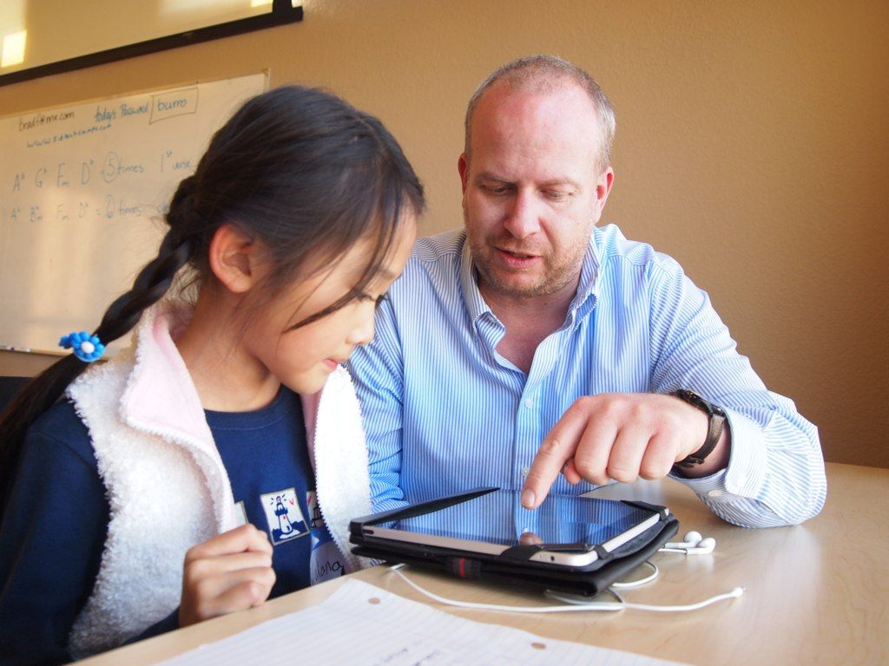

student_ipad_school, Brad Flickinger via Flickr, CC BY 2.0

There is a common myth in education related to technology adoption that older or more experienced teachers are less likely to adopt new technologies and to innovate upon their practice than younger teachers. Though this may sometimes be the case, many people do not stop to consider why this might be happening. Evidence suggests that age ultimately has nothing to do with a person's willingness to innovate, but rather, experience may help people to more quickly identify the transient nature of some changes or that some so-called innovations are actually harmful or ineffective for students.

In the case of technology in education, experienced teachers may have a wealth of understanding of how their students learn and how they can teach in effective ways, whereas new teachers may be eager to try new things and to adopt technologies that they think will help them be effective in the classroom. The problem is that sometimes the most eager teachers are also the least capable of making informed decisions, because they may lack the experiential knowledge necessary to make informed choices about these technologies, how much time to invest in learning them, and what to expect in terms of student outcomes. In every case, a teacher's beliefs and values will drive how they view technology integration, whether old or young, and their willingness to use technologies in their classrooms.

Similarly, schools and districts have their own beliefs and values about technology, how it should be used, and how it will impact students. For this reason it is important for us to understand each of these groups' beliefs and values, how they may be different, and how this influences the process of technology integration. Though personal beliefs and values are complicated and will vary between different people, we will consider four areas of belief and value that guide teachers and institutions in their technology integration practices. These include: Proof, Facility, Compliance, and Institutionalization.

### Proof

First, proof deals with the efficiency or efficacy of a technology to help improve student learning. Proof requires some form of discernible or measurable outcome and will be most important to teachers in the classroom or to principals and other administrators who invest time and money into technology and must prove that it is improving student achievement. From a teacher's or principal's perspective, if a technology does not directly improve students' ability to learn in a discernible or measurable way, then the value of that technology will be dubious. Teachers are stressed for time and they do not want to invest the effort necessary to learn and implement new technologies if they are not going to see actual results in how their students are learning. Likewise, principals face financial and other stressors which require them to provide evidence of student learning and that they are being wise stewards of institutional resources.

Proof might be slightly different for teachers and principals, however, due to their level of vision and operation. A teacher will want evidence that a technology works in her classroom through the creation of student artifacts or saved time, while a principal might want evidence that a technology works in all classes, preferring more generalizable research evidence over anecdotal evidence from one or two teachers. This means that teachers and principals might not always see eye-to-eye when it comes to identifying meaningful evidence for technology integration, because a classroom teacher will not care about what the research says if she is not seeing success in her classroom, and a principal might not care what an individual teacher says as long as the evidence from other teachers is strong.

### Facility

Second, facility (as in facile or easy) deals with the ease at which a new technology can be learned, implemented, or managed at the teacher- or student-level. Teachers want to use tools that are easy to learn, and the greater the learning curve associated with a new technology the less likely a teacher will be willing to invest the time and energy necessary to learn it. Similarly, if the technology requires teachers to invest a large amount of time troubleshooting or providing tutorials to students, then they are much less likely to use it. Teachers value technologies that they can pick up, easily use, and put away. Technology support personnel value these technologies as well, because it means that they can provide less support to teachers in learning and troubleshooting them, but principals and other administrators may not believe that facility is very important in comparison to other values, because in their eyes the value of the technology for learning would outweigh the difficulties in terms of time or effort. Thus, a principal might require all teachers to learn a new technology, because she believes that it will drastically improve student learning, even though that technology is very difficult to use and requires high levels of support.

### Compliance

Third, compliance deals with the legal and ethical requirements of technology use in contrast to their pragmatic use. Those who value compliance will ensure that new technologies meet security requirements or legal requirements regarding student security. Teachers and administrators rarely think about compliance when integrating new technologies, or if they do, they only do so as an afterthought. Rather, strategic technology support personnel deal most heavily with this issue and seek to ensure that technologies that are used in the classroom and across institutions will not pose legal risk to the institution. Thus, the teacher may have students use an online blogging platform without letting school or district personnel know, because those same personnel might tell her to stop, because the platform does not meet mandated security, accessibility, or privacy requirements. Similarly, filtering of web searches is typically managed at the school or district level to ensure compliance with state and federal regulations, while classroom teachers might complain about how strict filtering systems are or may have little say in determining what is allowed and what is banned. In short, compliance is an essential consideration for schools to ensure safe, legal, and ethical technology use, but it is typically only considered by those in specialized positions, such as technology administrators or those in a disabilities office.

### Institutionalization

And fourth, institutionalization deals with infrastructural compatibility, cost, lifespan, and management scale of new technologies. When a teacher purchases a new device or set of devices for her classroom she may not think ahead about the long-term costs associated with those devices (e.g., the price of apps or software updates, breakage, replacement), whether or not the devices are compatible with the school's technology infrastructure (e.g., can they access the network?), or the work involved in keeping those devices up-to-date and working. Rather, technology support personnel often understand these issues very well, and this will guide them to prefer certain technologies over others. For instance, technology personnel might want to provide Chromebooks to students (which are easy to manage at scale) instead of iPads (which are not), even though teachers might want iPads. This can create a tension between technology personnel and teachers, where teachers want to use technologies that may be too difficult to support or technology personnel might want to use technologies that have limited classroom value.

### Differing Beliefs and Values

Based on these four values, it is easy to see why technology integration in school settings can be so complicated. On the one hand, a principal might value proof by wanting to use technologies that are shown through research to improve student learning, while the teacher may want to use a technology that is easy to learn, and a technology support professional might want to use a technology that is compliant and that can easily be implemented at an institutional level. The problem is that a single technology rarely does all things well, and for that reason, certain groups will gravitate toward certain technologies while others will take a very different view.

Thus, though a classroom teacher might want to purchase iPads, a technology administrator might want to purchase Chromebooks, and a principal might want to purchase PC or Mac laptops. Each person in this scenario has certain values driving why they are picking one technology over another, and if the teacher does not understand the reason why a principal or tech support professional might have a differing view about what technologies to adopt, this can cause problems for integrating technology, because the teacher may not be able to get the technologies that she wants, she may not have the support necessary to manage and support them, or she might be required to use a technology that she does not want to use.

In all cases, the best approach to technology integration involves considering the beliefs and values of everyone involved in the institution and making selections and necessary compromises to best meet their needs. As a teacher, you must understand at least at a basic level the beliefs and values that principals and technology support personnel are working under so that you can understand their perspectives and help to inform technology decision-making with your own. So, you must consider the following:

* What are the most important factors that will guide my own technology integration decision-making?
* How do I communicate and collaborate with others who may have different values?

### Learning Check

Which two values would probably be most important to a **classroom teacher**?

1. Proof
2. Facility
3. Compliance
4. Institutionalization

Which two values would probably be most important to a **technology administrator**?

1. Proof
2. Facility
3. Compliance
4. Institutionalization

Which two values would probably be most important to a **principal**?

1. Proof
2. Facility
3. Compliance
4. Institutionalization

## Technology Integration Models

Once you have a basic grasp of your own approach to learning and the beliefs and values that will guide your technology integration, you are ready to begin exploring how to make this happen effectively. Technology integration models are theoretical models that are designed to help teachers, researchers, and others in the education field to think about technology integration in meaningful ways. There are many, many technology integration models that are used by different groups. Some models are very popular while some are only used by very small groups of people, and some are very similar to one another, while others are very unique. Rather than provide an exhausting description of each technology integration model, we will now proceed by providing a brief overview of a few that we believe to be most widely used or valuable to help you begin thinking about technology integration in your classroom. The models we will explore will include the following: TPACK, RAT, SAMR, and PICRAT.

### TPACK

TPACK is the most commonly used technology integration model amongst educational researchers. The goal of TPACK is to provide educators with a framework that is useful for understanding technology's role in the educational process. At its heart, TPACK holds that educators deal with three types of core knowledge on a daily basis: technological knowledge, pedagogical knowledge, and content knowledge. Content knowledge is knowledge of one's content area such as science, math, or social studies. Pedagogical knowledge is knowledge of how to teach. And technological knowledge is knowledge of how to use technology tools.

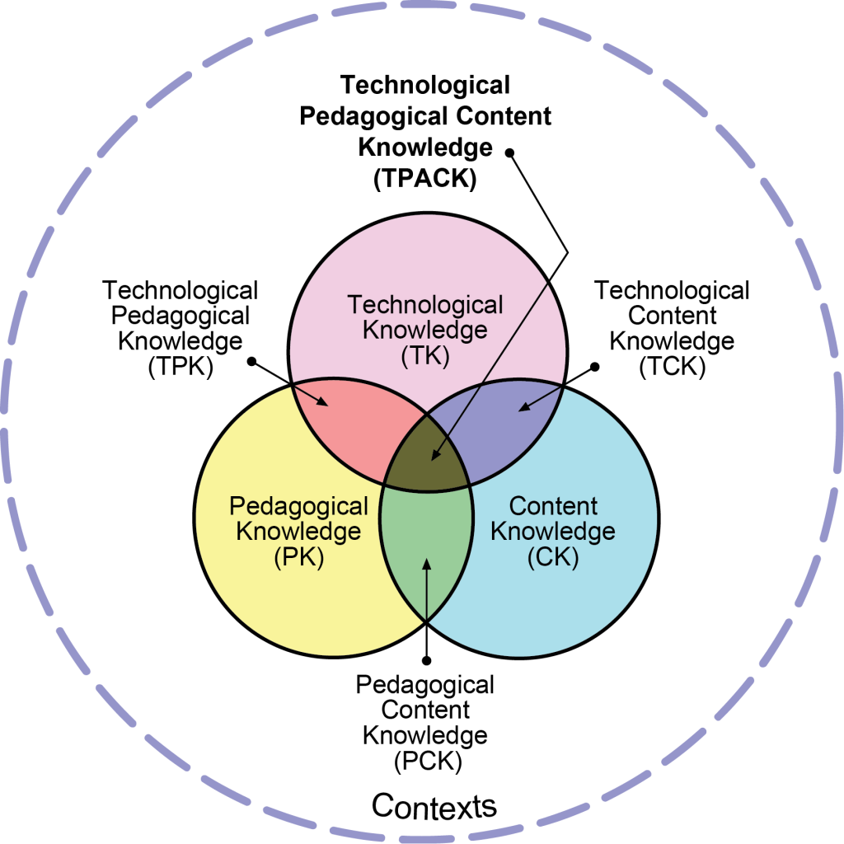

Reproduced by permission of the publisher, © 2012 by tpack.org

These core knowledge domains, however, interact with and build on each other in important and complicated ways. For instance, if you are going to teach kindergarten mathematics, you must both understand mathematics (i.e. content knowledge) and how to teach (i.e. pedagogical knowledge), but you must also understand the relationship between pedagogy and the content area. That is you must understand how to teach mathematics, which is very different from teaching other subject areas, because the pedagogical strategies you use to teach mathematics will be specific to that content domain. When we merge content knowledge and pedagogical knowledge together, a hybrid domain emerges called pedagogical content knowledge. Pedagogical content knowledge includes knowledge about content and pedagogy, but it also includes the specific knowledge necessary to teach the specified content in a meaningful way.

TPACK goes on to explain that when we try to integrate technology into a classroom setting, we are not merely using technological knowledge, but rather, we are merging technological knowledge with pedagogical content knowledge to produce something new. TPACK or technological pedagogical content knowledge is the domain of knowledge wherein technology, pedagogy, and content meet to create a meaningful learning experience. From this, educators need to recognize that merely using technology in a classroom is not sufficient to produce truly meaningful technology integration. Rather, teachers must understand how technology, pedagogy, and content knowledge interact with one another to produce a learning experience that is meaningful for students in specific situations.

### Learning Check

Knowing how to send an email would be an example of what kind of knowledge?

1. PK
2. CK
3. TK
4. TPK

Knowing how to teach biology would be an example of what kind of knowledge?

1. TPK
2. TCK
3. PCK
4. TPACK

Knowing how to use virtual reality headsets to teach about the Renaissance would be an example of what kind of knowledge?

1. TPK
2. TCK
3. PCK
4. TPACK

### RAT and SAMR

RAT and SAMR are very similar technology integration models, though RAT has been used more often by researchers and SAMR has been used more often by teachers. Both of these models assume that the introduction of technology into a learning experience will have some effect on what is happening, and they try to help us understand what this effect is and how we should be using technology in meaningful ways.

RAT is an acronym for replace, amplify, and transform, and the model holds that when technology is used in a teaching setting, technology is either used to replace a traditional approach to teaching (without any discernible difference on student outcomes), to amplify the learning that was occurring, or to transform learning in ways that were not possible without the technology (Hughes, Thomas, & Scharber, 2006). Similarly, SAMR is an acronym for substitution, augmentation, modification, and redefinition (Puentedura, 2003). To compare it to RAT, substitution and replacement both deal with technology use that merely substitutes or replaces previous use with no functional improvement on efficiency. Redefinition and transformation both deal with technology use that empowers teachers and students to learn in new, previously impossible ways.

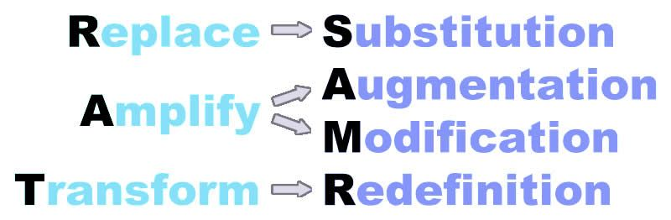

A comparison of the levels of SAMR and RAT

The difference between these two models rests in the center letters, wherein RAT's amplification is separated into two stages as SAMR's augmentation and modification. All of these stages deal with technology use that functionally improves what is happening in the classroom, but in the SAMR model, augmentation represents a small improvement, and modification represents a large improvement.

Both of these models are helpful for leading educators to consider the question: what effect is using the technology having on my practice? If the technology is merely replacing or substituting previous practice, then it is a less meaningful use of technology. Whereas technology use that transforms or redefines classroom practice is considered to be more valuable.

### PICRAT

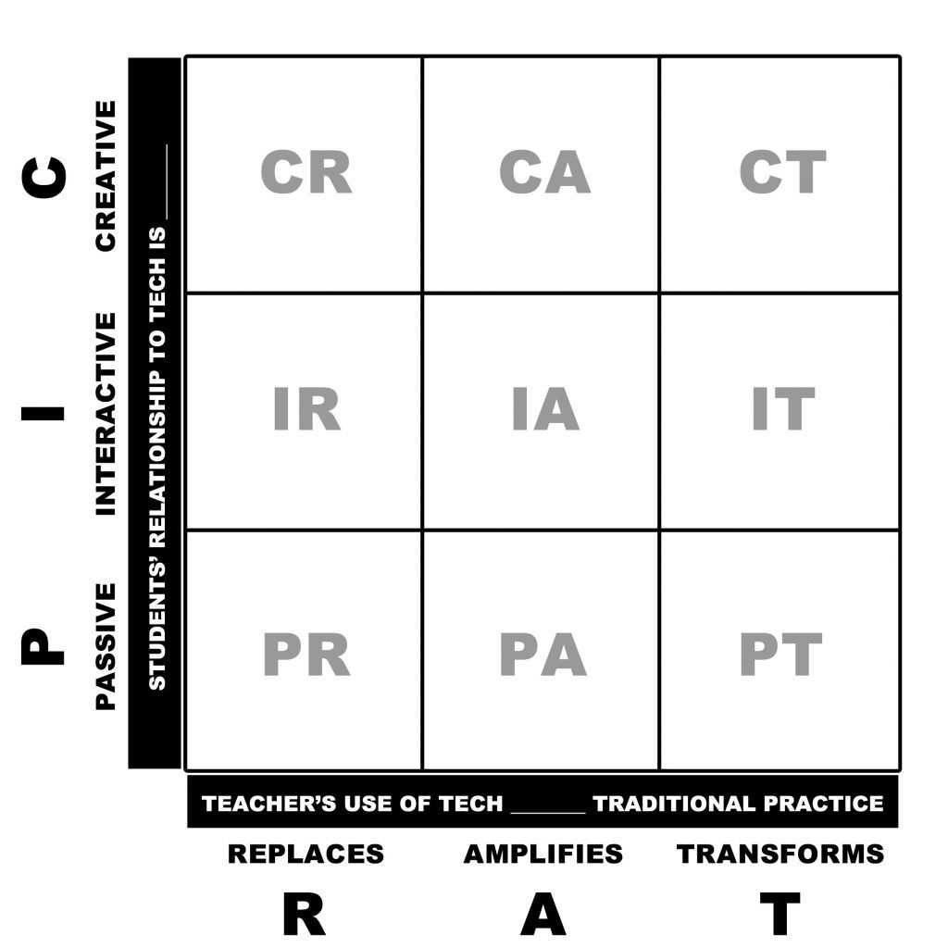

The PICRAT Model

Building off of the ideas presented in the models above, we will now provide one final model that may serve as a helpful starting point for teachers to begin thinking about technology integration. PICRAT assumes that there are two foundational questions that a teacher must ask about any technology use in their classrooms. These include:

1. What is the students' relationship to the technology? (PIC: Passive, Interactive, Creative)
2. How is the teacher's use of technology influencing traditional practice? (RAT: Replace, Amplify, Transform; cf. Hughes, Thomas, & Scharber, 2006)

The provided illustration maps these two questions on a two-dimensional grid, and by answering these two questions, teachers can get a sense for where any particular practice falls.

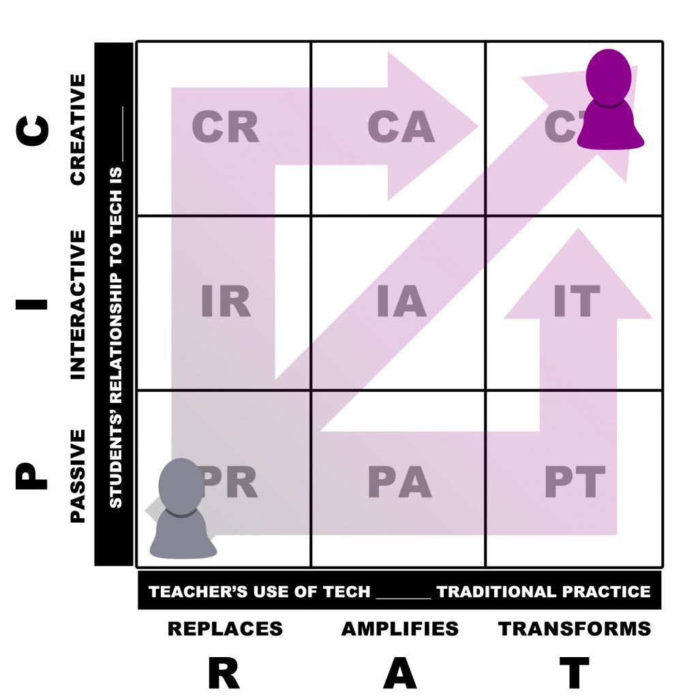

Teachers should seek to move their practice toward the top-right of PICRAT

For instance, if a history teacher shifts from writing class notes on a chalkboard to providing these notes in a PowerPoint presentation, this would likely be categorized in the bottom-left (PR) section of the grid, because the teacher is using the technology to merely replace a traditional practice, and the students are passively taking notes on what they see. In contrast, if an English teacher guides students in developing a creative writing blog, which they use to elicit feedback from peers, parents, and the online community on their short stories, this would likely be categorized in the top-right (CT) section, because the teacher is using the technology to transform her practice to do something that would have been impossible without the technology, and the students are using the technology as a tool for creation.

Experience has shown that as teachers begin using technologies in their classrooms, they will typically begin doing so in a manner that falls closer to the bottom-left of the grid. However, many of the most exciting and valuable uses of technology for teaching rest firmly in the top-most and right-most sections of this grid. For this reason, teachers need to be encouraged to evolve their practice to continually move from the bottom-left (PR) to the top-right (CT) of the grid.

### Application

With these foundational understandings, you are now ready to apply your knowledge to real-life scenarios. Here are a few brief descriptions of how teachers might use technology in a classroom setting. As you read each, consider whether these examples exhibit effective technology integration, what more information you might need to make an informed evaluation, and what factors you believe are most important for making this determination:

1. A teacher uses PowerPoint as part of her lecture.
2. Students are asked to keep an online journal in a blog.
3. Students pass a touch-enabled tablet around the room and write a collaborative poem.
4. Students play an online role-playing game about John Smith and Pocahontas.
5. Students write answers to math problems on an interactive whiteboard.
6. Students organize geometric shapes in patterns on an iPad.
7. A teacher creates a video to introduce herself to her students on the first day.
8. Students make an animated video to tell a story.
9. A teacher designs a WebQuest (inquiry-driven online lesson) for students to complete on their own time.
10. A teacher uses Facebook to remind her students about homework.

### Learning Check

What does PCK stand for?

1. Passive Content Knowledge
2. Pedagogical Content Knowledge
3. Passive Creative Knowledge
4. Pedagogical Creative Knowledge

What does PIC in PICRAT stand for?

1. Pedagogical, Informational, Constructive
2. Primary, Interactional, Concomitant
3. Practical, Intuitive, Collaborative
4. Passive, Interactive, Creative

What does RAT stand for?

1. Replace, Amplify, Transform
2. Redefinition, Augmentation, Transition
3. Remedial, Acceptable, Transitive
4. Represent, Approximate, Triangulate

## Conclusion

This chapter has provided a theoretical foundation for considering how we might determine the effectiveness of technology integration in educational settings. As you can probably tell, there are no easy, universal answers for determining whether a particular use of technology is meaningful or effective. Rather, our determination of effectiveness relies heavily upon our own understanding and acceptance of learning theories, our beliefs and values, and the technology integration models that guide our thinking. Thus, as you approach technology integration in your own teaching, you should use these foundational understandings to articulate the value of your decisions and to guide you in making choices that will be beneficial for your students.

## References

Kimmons, R., Graham, C., & West, R. (2020). The PICRAT model for technology integration in teacher preparation. Contemporary Issues in Technology and Teacher Education, 20(1).

Hughes, J., Thomas, R., & Scharber, C. (2006, March). Assessing technology integration: The RAT–replacement, amplification, and transformation-framework. In Society for Information Technology & Teacher Education International Conference (pp. 1616-1620). Association for the Advancement of Computing in Education (AACE).

Read this online at <https://edtechbooks.org/k12handbook/technology_integration>