# Shape

Before anyone reads your essay, you communicate something about your skill by the shape of your essay. You should divide your essay (more or less evenly) into paragraphs.

Typical formatting guidelines you should be aware of include using 12 pt font, Times New Roman font, double spacing, one inch margins, left-alignment, indented paragraphs, and not leaving a space between paragraphs.

If you are writing a timed essay on the computer, most of these formatting features are not within your control. You should however, still make an effort to divide your essay into paragraphs by either indenting at the beginning of the paragraph or leaving an empty line between paragraphs.

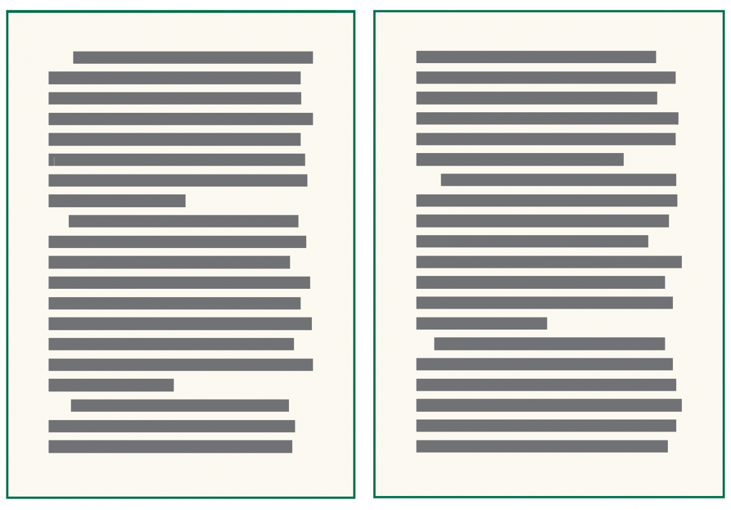

Read this online at <https://edtechbooks.org/academic_a_writing/shape>