# Intentional Learning Design for Educational Games: A Workflow Supporting Novices and Experts

Abbott, D.

This chapter proposes that learning experience design (LXD) and game-based learning (GBL) are mutually beneficial conceptual frameworks for increasing the effectiveness, appropriateness, and user experience of educational games. Drawing on a range of theories, five core LXD principles are defined. LXD is: human-focused, enjoyable and/or playful, goal-oriented, situated and relevant to learner’s desires, and placed in supported environments and/or platforms. These principles are mapped to aspects of GBL, proposing considerable overlap between these disciplines, and supported by a wide range of literature. LXD principles are then suggested as solutions to some current challenges in GBL. A workflow is presented which synthesizes interdisciplinary GBL and LXD design processes and offers guidance suitable for GBL designers at a novice to expert level. The workflow categorizes GBL activities into related disciplines (Instructional Design, Empathy/Emotional Design, Interaction Design, and Game Design) to assist readers in analyzing where their own skills or skill gaps lie. A worked example illustrates every activity within the workflow, including practical methods of mapping learning mechanics to game mechanics and of performing gameplay loop analysis. The workflow aims to increase the rigour of GBL design and ensure it benefits from LXD principles, addressing a prevalent challenge in GBL design by focusing on the importance of both an appropriate pedagogical foundation and the needs and desires of learners.

## 1. Introduction

Learning experience design (LXD) is an approach that foregrounds learners and their desired outcomes in a goal-oriented way, acknowledging individual experience. This chapter proposes that game-based learning (GBL), with its focus on maintaining flow, increasing motivation, and embedding learning, can be a highly effective tool within LXD. Readers can increase their understanding of effective GBL processes using the guided workflow for intentional learning design for educational games, which draws on systematic analysis and matching of learning objectives, learning behaviors, and game mechanics, within an LXD framework. This step-by-step design process will also explicitly identify where GBL benefits from an LXD approach. The workflow is suitable for novices and experts alike; it identifies different disciplinary expertise at each stage and works through a simple example with additional references for GBL designers to follow up. Throughout the workflow, learner experience is at the centre of the process. Reflection on the workflow provides opportunities for readers to identify their own strengths and weaknesses as LX designers using GBL in their own practice.

## 2. Theoretical Context

### 2.1. Mapping LX Principles to GBL

LX research identifies various sets of guiding principles or opportunities for LX designers (Floor, 2018; Jagger, 2016; Raybourn, 2016; Rosencheck, 2015). Whilst there is some variation, core LXD principles are defined across the literature as:

* human-focused (encompassing personalisation, emotion, and experience),
* enjoyable and/or playful,
* goal-oriented,
* situated and relevant to learner’s desires,
* taking place in supported environments and/or platforms.

Previous research on LXD applies these principles to online e-learning systems (Dinimaharawati, 2013; Jagger, 2016; Park & Lim, 2019); however, games are also closed interaction systems within a much wider instructional and human context and it is therefore useful to consider them as case studies alongside the general principles of their design. In mapping the different interdisciplinary elements of LXD, Floor (2018) places game design towards the goal (as opposed to the human) centred end of the spectrum. This chapter argues that existing limitations or weaknesses of GBL can be addressed by taking a more learner-centred approach. Each core LXD principle is analyzed below, showing commonalities with the characteristics of GBL and demonstrating that, as an educational approach, GBL can fit closely with LXD principles.

#### 2.1.1. Human-Focused, Emotional, and Personal

LXD is variously described as “learner-centred” (Rosencheck, 2015), “focuss[ed] on the learner” (Floor, 2018), and “put[ting] the human back at the centre” (Jagger, 2016); within LXD the learner’s needs, experiences, desires, and emotions are crucial. Park and Lim (2019) state that “emotions directly and indirectly affect students’ learning” (p. 53) and note that, despite limited representation in the literature, there is an increasing emphasis on emotional design across many fields, reflected in a range of studies on emotion and empathy in teaching and learning contexts (e.g., Kay & Loverock, 2008; Park & Lim, 2019; Tangney, 2014; Tracey & Hutchinson, 2019). Emotional design is also core to GBL, primarily in consideration of GBL increasing learner motivation and confidence as affective and motivational outcomes are evaluated alongside cognitive outcomes (Clark et al., 2016; Hainey et al., 2016). Both fields acknowledge and foreground affordances (i.e., properties of a system that lead to or trigger human action) as having an emotional as well as a functional role. Notably, standardised ways of evaluating emotion have been developed within GBL and, in wider terms, UX research (e.g., Bernhaupt, 2010, passim; Brockmyer et al., 2009).

LXD principles recommend high levels of personalisation and "humanity" in interactions (Jagger, 2016; Park & Lim, 2019) when creating personal learner journeys through games (driven by players’ goals and enabled by their power over a choice of interactions) and have been a core concern of GBL research for well over a decade (Bellotti et al., 2013; Hauge et al., 2015; Lepe-Salazar, 2015). Player agency and control over game narratives and interactions is woven into both interaction design within GBL and the affordances of the game systems themselves (see Abbott, 2019a; Lim et al., 2013).

#### 2.1.2. Playfulness, Fun, Enjoyment

Playfulness is defined as a core design principle for increasing the emotional affordances of learning situations (Park & Lim, 2019; Weitze, 2016) and overlaps significantly with the "fun" or "enjoyment" outcomes described across the literature for both LXD and GBL. Play has been defined in a number of ways by different theorists; however, the widely accepted characteristics of play are that it constitutes a voluntary activity, lacks (or has negotiable) real-world consequences, and, crucially, must be perceived as such by participants. For some, this perception of playfulness is all that is required for an activity to become play, and play cannot otherwise be defined as any one thing (Glenn & Knapp, 1987, p. 52). In his book Play and the Human Condition, Henricks (2015) defines this playful “disposition” as creating different motivations from those associated with other things we do and having the “distinctive quality of curiosity and enthusiasm” (pp. 28-29), which are both widely accepted as drivers for learning. Games harness the power of playful disposition but add the structure needed to guide players towards particular goals. Juul (2003) defines six features that characterise games:

1. Rule-based;
2. Variable, quantifiable outcome(s);
3. Different potential outcomes are assigned different values;
4. The player invests effort in order to influence the outcome;
5. Players care about the outcome;
6. Negotiable real-life consequences.

GBL uses the rules, outcomes, and values of games to structure learning content in a way that can be experienced by an invested, effortful learner with a playful disposition, in much the same way as learning environments structure their content.

#### 2.1.3. Goal-Oriented, Manageable, and Progressive

The goal-orientation of LXD can be easily mapped to games’ "win conditions" or completion. Typically, a game's completion state is built on interim goals contributing to the overall learning outcome, a common structure directly reflected in multiple game levels, or missions building on previous expertise that progress to a final goal once mastery has been achieved. In the context of e-learning, Jagger (2016) calls this design structure chunking (i.e., learning content being broken into bite-sized pieces). In both LXD and GBL, chunking allows multiple individual interactions, which ideally provide immediate feedback, offers a chance for learner reflection, and builds on their overall understanding. These interactions provide individual pathways towards a coherent and understandable end point, resulting in personalised learning over which the learner has a considerable degree of agency.

The overlap between manageable, progressive goals and learner emotion is clear, and a learner’s perception of success in achieving their goals is confirmed in literature across LXD, GBL, and pedagogy more generally as supporting the process of learning. The LXD principle of Positivity is related to the learner’s confidence in being able to achieve learning completion (i.e., their final goal: Park & Lim, 2019). Again, these principles are reflected in GBL literature with multiple considerations of their relationship to players' experience of flow or intensified concentration (e.g., Hamari et al., 2016). Further examples are available which map this specific learning mechanic to related game mechanics of Behavioural Momentum and Cascading Information (Abbott, 2019a; Arnab et al., 2015). Feedback also contributes to emotional design (Park & Lim, 2019) and is highlighted as a priority in LX-informed GBL as critical for both learning and engagement (Dodero et al., 2015, p. 187).

#### 2.1.4. Situated and Relevant

LXD recommends that learning is well-situated within a relevant context (Jagger, 2016; Rosencheck, 2015) and emphasizes that learner experience is crucial to maintaining relevance (Huang et al., 2019, p. 92). GBL theorists also highlight that learning must be situated in terms of both environment and interactions (Catalano et al., 2014) and propose specific mappings between learning mechanics (such as identify) with game mechanics (such as role-play; Abbott, 2019a; Lim et al., 2013). Learning mechanics (LMs) refers to the pedagogically constructed actions used to achieve the learning outcomes, distilled into specific interactions (Lim et al., 2013). GBL can develop this concept further by providing fictional contexts or simulations that serve as a safe space to practice skills or behaviors without fear of failure.[1] Significant overlap exists between designing for situated learning, reinforcing motivation for learning through human-centred, empathetic design, and creating learning outcomes that match learners’ own goals.

#### 2.1.5. Supported Environments/Platforms

The sections above show that GBL can provide a structure that matches LXD principles by harnessing learners’ motivations to guide them both emotionally and cognitively through a responsive learning environment towards their goals.

Therefore, GBL and LXD are congruently dedicated to foregrounding a human-centered, personal experience, which acknowledges players’ emotional experiences alongside their intellectual goals. A well-designed, educational game can engage learners closely with its content and interactions, often resulting in a highly immersive and emotionally-engaging learning experience as learners pursue their own particular game-enabled learning goals. Furthermore, game interactions (and the user’s control over them) can result in a strong sense of personal identification, agency/responsibility, and ownership over the learning journey.

### 2.2. GBL is Hard to Develop (Well)

However, despite a growing demand for GBL (Westera, 2019, p. 59), the challenges around its development remain (Abbott, 2019b; Lameras et al., 2017; Ney et al., 2012). Systematic research has shown that simply because learning takes place in a game-based medium does not make GBL homogenous across different games (Clark et al., 2016). Further research links different game characteristics (e.g., such as mechanics, visuals, narrative) with different learning behaviors of players (Abbott, 2019a; Grey et al., 2017). The complexities of implementing GBL highlights that, despite games being able to empower learners to create personalised pathways through the material, these interactions are still defined by the affordances of the game system, platform, and overall learning environment. Furthermore, in order to be effective, GBL requires significant interdisciplinary expertise spanning game design, interaction design, and pedagogy (Bellotti et al., 2013), making it a complex and resource-intensive process.

Despite these well-researched linkages between learning behaviors and game mechanics, many GBL interventions fall short of their potential effectiveness and efficiency,[2] partly due to significant barriers in terms of resources and expertise and partly due to the emergent understanding of this interdisciplinary subject. Very little research to date provides a framework which pairs game elements and learning at either a theoretical or empirical level, and this results in educators being “overwhelmed by the plethora of design choices and level of complexity entailed in integrating, combining and balancing learning with game features” (Lameras et al., 2017, p. 990). This overlooked, explicit interdisciplinary link between pedagogy and game design reinforces LXD’s potential role in advancing GBL towards a more human-centred approach by synthesizing player experience with instructional design. Games without a strong pedagogical and learner-focused foundation are likely to fail (Lepe-Salazar, 2015; Westera, 2019) and, without significant interdisciplinary expertise, presenting learning elements as games could create uncertainty and misalignments (Bellotti et al., 2013; Lameras et al., 2017). Furthermore, “The role of the teacher in guiding learning via games seemed to be fuzzy and unclear and may lead to confusion during the design stage, game play and after the end of the game” (Lameras et al., 2017, p. 974). Games and curriculums are experiences designed to engage their respective audience; however, because experiences are unique to each individual, a potential for a disconnect still exists between the designer and the player and/or the educator and the learner (cf. Grey et al., 2017, pp. 64–65). These barriers could be ameliorated if GBL design activities were more explicitly informed by LXD.

### 2.3. GBL Benefits From an LXD Approach

By exploring experience-based pedagogical concepts for GBL, a 2019 article by Westera identifies several improvements that could be applied to GBL, which are of particular relevance within the LX conceptual framework. Games are highly constructivist and rely on an experience-based approach, and Westera (2019) aligns with LXD literature in stating that learning from experience is the dominant pedagogical paradigm (El Mawas et al., 2018; Floor, 2018; Tangney, 2014). He then critically evaluates available evidence to identify common potential weaknesses in GBL design (summarised and analysed in Table 1, which also suggests the most relevant LXD principles to address each). These issues can be tackled if GBL design takes place within the LXD framework, to which it so closely aligns as shown above. However, despite the shared characteristics of LXD and GBL, this approach is not yet widespread or at least not explicitly articulated as such.

|  |  |
| --- | --- |
| Potential GBL weaknesses (Westera, 2019) | LXD-informed improvements (synthesised from previously cited LXD and GBL literature) |
| Emphasis on rote learning over deep understanding | Focus on learner, learner-defined goals, frequent feedback, space for reflection, reward playful exploration and experimentation, situated learning |
| Minimal guidance and scaffolding | Chunked learning, acknowledging surrounding teaching and learning context, interactions outside the game where appropriate, empathetic design, "safe" and relevant learning environments |
| Shallow pedagogical foundations | Explicit use of LXD framework to inform GBL design, embracing emotional design, mapping learning behaviors to game affordances |
| Imbalance between immersion and cognitive load | Situated learning in relevant and familiar contexts, focus on learner-defined goals over system goals, chunked learning content, learner reflection |
| Relationship of reward systems with extrinsic and intrinsic motivation | Empathetic design, emphasis on learner’s intrinsic motivation(s), progressive sub-goals |
| Differences between player performance and learning progress | Close alignment of game mechanics with learner goals, positivity principle, space for reflection, interactions outside game context |

The remainder of this chapter focuses on a guided workflow for developing effective and learner-centred educational games. The aim is not only to increase interdisciplinary expertise in this area but also to mitigate some of the barriers faced by educators choosing to use a GBL approach.

## 3. Design Method: A Workflow for Both GBL Novices and Experts

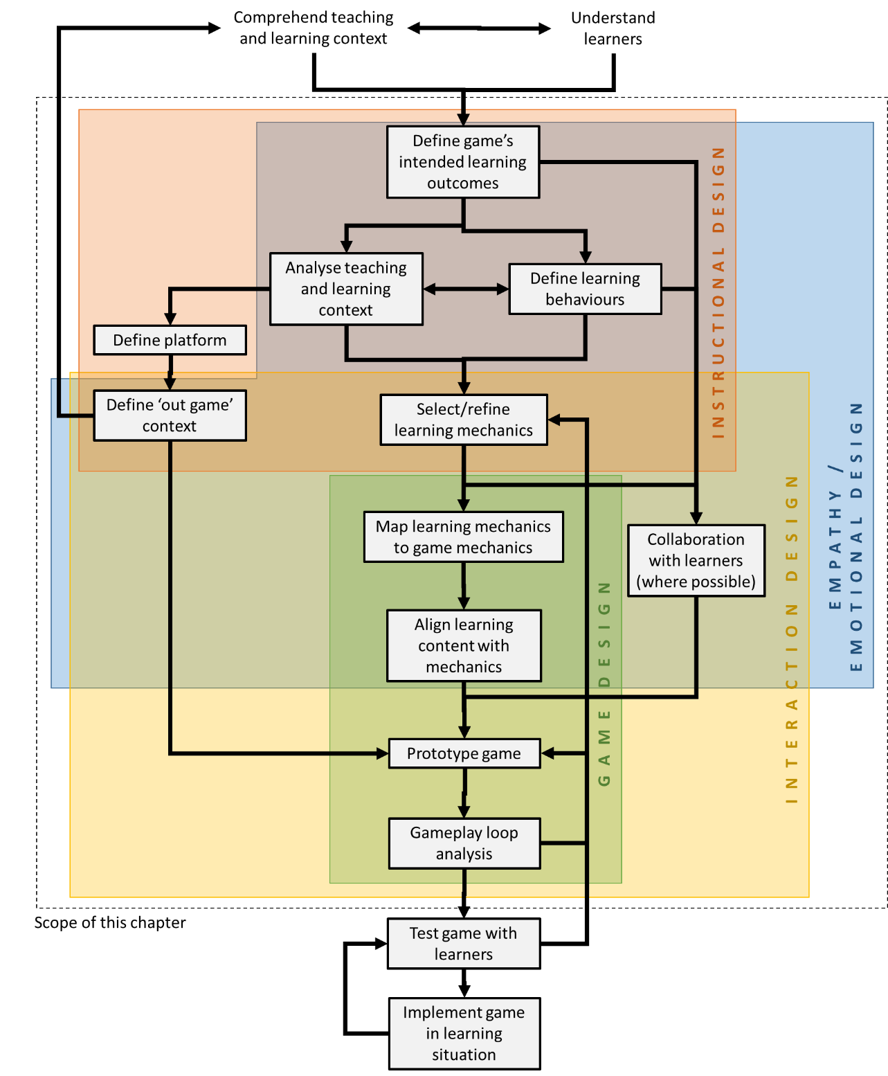

The workflow presented here (Figure 1) synthesizes elements from existing GBL design models (Catalano et al., 2014; Grey et al., 2017; Lui & Au, 2018; Marne et al., 2012; Nicholson, 2011) with a particular emphasis on those aspects most important to LXD by incorporating the design processes proposed by LXD experts (Floor, 2018; Rosencheck, 2015). It should be emphasised that the focus is LXD principles specific to designing one particular intervention – the workflow is situated within Plaut’s Interaction and Sensory planes, namely “What will learners actually be doing, hearing, and seeing during the learning experience?” (Plaut, 2014). Clearly, this question's answer must arise from an overall comprehension of the learning context which can include curriculum requirements, organisational parameters, and, of course, early consultation with learners as advised in LXD; as Plaut (2014) states, “To use these methods effectively, you must have a strong grasp of your learners’ perspectives and experiences as they relate to the content” (Interaction plane section). However, these wider contexts can differ widely and are outside the scope of this chapter. Similarly, game testing, deployment, and evaluation are crucial steps in this process but these deserve a chapter of their own and will not be discussed in detail here. The dashed bounding box in Figure 1 demonstrates this chapter’s focus within the wider LXD context.

The workflow incorporates GBL guidelines specifically aimed at educators (Marklund, 2014; Torrente et al., 2011), recognising that GBL is highly interdisciplinary and requires strong pedagogical as well as game design foundations. Shaded boxes in Figure 1 attempt to show the different specific disciplines within LXD used at each stage and emphasize the need for learner-centred empathy.

The workflow begins by drawing on understandings from the higher planes of LXD: Strategy, Requirements, and Structure (Plaut, 2014). The initial phases of "Comprehend teaching and learning context" and "Understand learners"’ feed into Instructional Design activities such as definition and analysis of learning objectives, teaching and learning context, and appropriate learning behaviours and experiences. These activities overlap with Empathy/Emotional Design, progress into Interaction Design, and culminate in Game Design as learning content and mechanics are systematically matched with game mechanics (Lim et al., 2013). These activities are based on input from learners wherever possible, and linked back into the game’s LXD context by explicit consideration of out-game interactions. Finally the game is iteratively tested.

Each step in the workflow will now be considered in detail and illustrated with a practical, worked example for a non-digital game: a simple intervention in a primary school mathematics context.[3]

### 3.1. Define Intended Learning Outcomes

Defining the intended learning outcomes (ILOs) for the specific GBL intervention is core to the workflow: “you start with formulating the desired learning outcome and every next step in the design process, including the choice of your medium or technology, is geared towards the desired learning outcome” (Floor, 2018). If this seems like an obvious statement, remember that, despite the recognition of ILOs as vital elements across the literature on LXD and GBL, recent reviews still identify significant challenges in linking learning content to game interventions (Lameras et al., 2017). Educators may already know what their learners want the game to achieve and will therefore be able to derive appropriate ILOs for the individual game. However, educators often expect too much from games (for example, a game to assist in teaching the content of an entire course); a position usually doomed to failure. For GBL to be effective, the ILOs must be manageable. ILOs can cover knowledge, understanding, and attitudes; however, it is recommended to keep the ILOs: (a) few in number, (b) specific and focused, (c) well scoped, (d) achievable, and (e) measurable.

#### 3.1.1. Simple Example: Curriculum-Derived ILOs

Maria is a primary school teacher who has noticed that her pupils struggle with comprehending and verbally articulating the concept that the order of terms in a multiplication equation makes no difference to the result. Although her learners are too young to participate directly in game design, Maria has previously had good results and great feedback when delivering unusual and interactive teaching activities. She defines the following ILOs. Pupils should:

1. Understand that, when multiplying numbers, the order of numbers does not change the result;
2. Know the meaning of the term commutative property;
3. Feel more confident about multiplication and this terminology.

These ILOs are achievable and specific—for example, while knowing that 4x5 and 5x4 both = 20 is useful, Maria is less interested in pupils knowing the answer than understanding the core concept. These ILOs will be foregrounded and referenced throughout the entire workflow, maintaining goal-orientation.

#### 3.1.2. Extended Example: ILOs

LXD principles recommend consulting with learners on the specifics of the design and, where possible, directly involving learners in the design process. Whilst for Maria the learner involvement may be limited to testing her prototype and iteratively improving it over time, many other learning contexts support a much higher level of learner involvement and co-design. Refer to the work of Marklund and Alklind Taylor (2016) for more on co-design. Additionally, Floor (2018) provides a useful template for analyzing the overall teaching and learning context in the LX Canvas tool.

### 3.2. Analyze Teaching and Learning Context

The teaching and learning context specific to the intervention covers where and when the game will take place, how long it will take, how often it will be played, how many players it must support simultaneously, what materials or technology it needs, who (if anyone) will be supporting it, and so on. A common pitfall in GBL is for games to be developed in isolation of their context. Typically, the learning context is largely externally defined (e.g., a class has 30 children and lasts 50 minutes), but, even within strict parameters, some flexibility exists. Designers must consider questions such as, "Will the game be played together in class and supported by a teacher?" or "Is the game intended for independent study at home?" Therefore, designers must contemplate how GBL will be effectively integrated into teaching and learning practice in a way that is most effective and responsive to learner needs (Catalano et al., 2014; Marklund, 2014).

### 3.3. Define Platform

Platform refers to what specific delivery mode the game will have (for example, an app, board game, physical game, PC game, virtual reality). The delivery mode is defined largely by what tools are accessible (for example, there is no point trying to design a collaborative app if the school has only one tablet and a patchy wifi connection), but, again, flexibility exists and it is important that GBL design considers learner preferences rather than defaulting to the easy or most obvious platform. Whilst the example here is a physical game, the principles can also be applied to digital GBL.

### 3.4. Define Out-Game Context

Gameplay is affected by more than merely the features of the game itself. An out-game action is defined as an action which does not have an immediate and measurable effect within the game but nevertheless mobilizes perceptive and cognitive capacities and provokes in-game actions (Guardiola, 2016). Out-game actions are particularly important when using GBL within an LXD framework as this is where much of the learner reflection, support/guidance, emotional design, and authentic linking between game and wider context takes place. Some useful examples to consider are:

1. A tutor prompting or reinforcing learning from a game event,
2. A player vicariously learning from something another player does and adapting their own strategy in response,
3. Players collaborating to achieve a goal, or
4. An educator encouraging reflection on learning.

The context in which out-game actions take place could be externally imposed but still need to be considered critically to ensure the learner’s needs and goals remain central to the process. One powerful example is that games provide a space for learners to behave differently, experiment, and fail safely, and evidence shows that being observed by non-players can break the "magic circle" of the game, embarrass players, and inhibit playful and/or learning behaviours (Huizinga, 1955).

#### 3.4.1. Simple Example: Learning Context, Platform, and Out-Game Context

Maria’s learning context is within a primary school class of 30 children, with no teaching assistant, so the game must engage all learners at the same time with only one facilitator (Maria). She will be present at all times, leading and supporting the game and providing explicit assistance to learners who need additional support. The game platform must be immediately familiar to learners to prevent distraction from their learning goals; in addition, Maria has no budget for additional technology or tools. Maths lessons take one hour and (drawing on context external to the intervention) Maria wants the ILOs to be achieved in one lesson, with limited repetitions of the game.

### 3.5. Define Learning Behaviours

An absolutely crucial step in GBL design within an LXD conceptual framework is understanding "how" as well as "what" players are expected to learn. A common mistake is to default to a familiar question and answer model (e.g., Trivial Pursuit) where the learning behavior is in fact simply recalling knowledge the student already knows. This behavior is closer to a test than a game and is poor at enabling learners to embed new knowledge or understanding (Nicholson, 2011). Instead, top-level behaviors that support learning should be defined, such as:

1. Will players collaborate, co-operate, or compete?
2. What existing skills/knowledges are required and how will they be recalled/developed?
3. How might physical movement complement the emotional and cognitive outcomes?
4. Is repetition needed for reinforcement?
5. What are the learning behaviours that suit the learners best and will most effectively help them reach their goals?
6. What is the emotional as well as cognitive impact of particular learning behaviours and their results? and
7. What behaviours are likely to increase enjoyment and motivation?

It is quite clear that learning to play a scale on a piano requires different learning behaviours than learning to analyse a painting. A useful guide can be found in Production of Creative Game-Based Learning Scenarios: A Handbook for Teachers (Torrente et al., 2011).

#### 3.5.1. Simple Example: Learning Behaviours

Based on previous feedback from her learners, Maria identifies suitable learning behaviours compatible with her teaching context:

* The main learning behaviour must emphasise equivalence between sums (i.e., recognition, matching, grouping, or reordering);
* Cognitive processes must take place within interactions the pupils already know how to do;
* Learning must be active and collaborative;
* Repetition is required to reinforce learning and support pupils who are slower to grasp the concept;
* All children must be involved all of the way through (i.e., no-one is "knocked out");
* Learning behaviour should be novel (i.e., disrupting normal classroom behaviour);
* Physical actions must be aligned with cognitive concepts; and
* Pupils’ learning should be self-directed.

Maria is foregrounding empathy in her design. She believes that, if the children have fun, feel ownership over the process, and disrupt usual classroom behavior, they will better learn and remember the ILOs.

Using both context and desired behaviors, Maria defines the platform as a physical game (i.e., the children will move around, matching and forming groups). She decides that the game itself should take no more than 30 minutes with out-game actions including explanations, scaffolding, and reinforcing the principle with applied examples in the lesson time remaining after the game ends.

#### 3.5.2. Extended Example: Learning Behaviors

Learners should ideally be closely involved in co-designing their own learning behaviors to ensure personalised learning pathways, goal-orientation, and appropriately supported environments. Defining learning behaviors with explicit learner input could be achieved by observation, consultation, or co-design. Where possible, GBL interventions should be designed flexibly to allow multiple learning behaviors (as learner groups are rarely homogenous). For example, players could be offered the choice of whether or not to play "against the clock."

### 3.6. Select/Refine Learning Mechanics

Once overall learning behaviors have been defined, more specific actions and interactions for achieving learning outcomes can be identified (learning mechanics). GBL novices could start by putting these mechanics into their own words; however, it would also be useful to use or take inspiration from any pedagogical framework with which the educator is already familiar (e.g., Bloom’s revised taxonomy verbs; Anderson & Krathwohl, 2001). More experienced GBL designers could work from a framework specifically for GBL, such as the LM-GM model (2015) which provides “a non-exhaustive list of learning mechanics that have been extracted from literature and discussions with educational theorists on 21st century pedagogy” (Arnab et al., 2015, p. 396). What is important at this stage is not the exact taxonomy used but clarity of the precise actions that will lead to learner engagement with the ILOs.

#### 3.6.1. Simple Example: Learning Mechanics

Maria has used Bloom’s verbs before and she identifies the following specific LMs which would help learners to acquire the ILOs.

* ILO 1: recognise (identical sums), identify (equivalent sums), compare and contrast (different and equivalent sums), connect/correlate (equivalent sums), transfer knowledge (to other equivalent sums)
* ILO 2: recite (the terminology)
* ILO 3: memorise (the terminology), relate/transfer (the property to other sums), collaborate (across groups with equivalent sums)

#### 3.6.2. Extended Example: Learning Mechanics

Using the LM-GM model, similar LMs can be defined:

* ILO 1: instruction, guidance, participation, action/task, identify, ownership, repetition, generalisation
* ILO 2: imitation, ownership, repetition
* ILO 3: imitation, ownership, responsibility, generalisation, feedback

### 3.7. Map Learning Mechanics to Game Mechanics

Game mechanics (GMs) refers to interactions with the game state, engaging players with the content. In other words, GMs exist to frame the game experience within the defined rules and to guide players in understanding the interactions required to participate (Lim et al., 2013). GMs affect game strategy and flow and require emotional as well as cognitive design. Explicit linking of pedagogically-founded LMs with GMs allows designers to ensure that an educational game focuses on the behaviors they want to encourage and that players can encounter learning content in the way that is most suitable. Arnab et al. (2015) call the resulting match a Serious Game Mechanic (SGM) and state that “SGMs reflect the complex relationships between pedagogy, learning and entertainment/fun, joining educational and gaming agendas. Therefore, SGMs are the game components that translate a pedagogical practice/pattern into concrete game mechanics directly perceivable by a player’s actions” (Arnab et al., 2015, p. 395). By identifying SGMs, their LM-GM model enables further rigor in the analysis and evaluation of games in educational settings. In reality, this stage of the workflow is likely to overlap with the next one, creating a series of swift, intuitive iterations of all steps within the Interaction Design category shown in Figure 1.

### 3.8. Align Learning Content with Designed Mechanics

In this step, actual learning content (in our example, multiplication tables and math terminology) is aligned with each in-game and out-game action. These interactions then enable learners to construct the knowledge needed to achieve their goals. Whilst there may certainly be overlap here with earlier stages of the workflow, ensuring the core game mechanics create the right learning behaviors is crucial. Ensuring learner interactions are appropriate before the game is "skinned" with actual learning content emphasizes the learner-focused approach (i.e., a mode of engagement that is personal, supported, and goes beyond instructional design).

#### 3.8.1. Simple Example: Mapping LMs to GMs and Aligning Learning Content

Using the LM-GM model, Maria maps her LMs as follows: To embrace collaboration, social learning, and enjoyment, the whole game will be based on communal discovery. Pupils will be allowed to discuss and help each other as they play. Game cards (randomly assigned) will contain learning content (some identical, some equivalent sums). Identifying/matching actions function as collecting all identical or equivalent sums together. Grouping will be through physical movement which reinforces the cognitive matching and quick feedback as grouping happens (as the learners realise that all sums in their group are either identical or equivalent) which reinforces the Identify and Connect LMs.

Maria’s class tends to enjoy and learn more if they believe they can achieve the task. She knows their "growth mindset" can be mapped to the urgent optimism GM. Therefore, content cards will start very easy and progress in complexity/difficulty. Recitation/imitation of the terminology must be included in the game. Repetition of the game for memorisation and confidence is mapped to behavioral momentum.

### 3.8. Prototype Game

The mechanics are now ready to be structured into gameplay. Prototyping is again likely to happen as a series of swift iterations, with early ideas being refined mentally before any material prototype is even attempted. It is certainly recommended to consider the next step (gameplay loop analysis) at least once and go through the recursive part of the workflow again before investing time in creating any game materials.

#### 3.8.1. Simple Example: Prototype Game

For learners to achieve the ILOs, the collecting GM must be central to the process and the terminology must be included too. Maria’s initial game idea is as follows:

* Pupils will be randomly assigned cards with multiplication sums written on them. Each pupil will get one card. Cards will be produced such that three equivalent groups can be formed (of 10 pupils each). Within each group, some sums will be identical and some sums will have the same terms but in a different order.
* Pupils will find their matches/equivalents and form physical groups based on their cards.
* Maria decides that shouting out the word "Commutative!" once a group has formed is a fun way to cement the terminology and acts as a "finishing point." This will need an out-game action (the teacher speaking the word and asking pupils to imitate) in the early stages.
* As the pupils learn the concept, the game can be made harder (e.g., with more groups, sums, more than two terms).

#### 3.8.2. Extended Example: Prototype Game

Game prototyping offers fruitful opportunities for learners to become directly involved in the co-design of their own learning activities. Whilst Maria’s options may be limited due to the very young age of her pupils, she directly involves the pupils in creating the game cards by printing out word and sum templates for the children to colour in. This builds ownership over the process and excitement for the first playtest.

GBL designers working with adults or older children can improve their learner-focus by working much more closely with learners at all stages of the workflow. This is likely to be particularly useful in the Define learning behaviors, Align learning content, and Prototype stages. If working directly with learners is not possible, data about their goals, preferences, etc. could be gathered to inform the process.

### 3.9. Gameplay Loop Analysis

Gameplay refers to any interaction with the game and, in the context of LXD-informed GBL, explicitly includes non-tangible emotional and cognitive actions/reactions as well as physical actions influencing the game world. A gameplay loop represents gameplay as linked actions, by breaking down and describing every interaction both inside and outside the game (e.g., teacher scaffolding; Guardiola, 2016). This process allows educators to work with learners during playtesting to confirm that the game reinforces their intended behaviors, appropriately integrates and exposes learners to content, and does not inadvertently create unwanted emergent behaviors (see Grey et al., 2017). Although seemingly daunting, this step can be achieved by creating a simple flowchart during playtesting.

In order to create accurate, learner-focused gameplay loops, actually playing the game is crucial , preferably with a group of people who were not involved in the design process. This development stage is the perfect opportunity to, as suggested by research, explicitly include students as co-designers (Marklund & Alklind Taylor, 2016). This gives much more insight into the social and emotional flow of gameplay that cannot necessarily be discerned simply from reading the rules. Gameplay should be mapped at an overall level, with any sub-loops expanded as far as is useful. The gameplay loop (see Figure 2) is likely to highlight omissions, improvements, or opportunities that can be achieved by refining the game through iterative playtesting with learners and also identify any unforeseen issues that might arise for individual players. Note that, whilst formal testing is crucial, it falls outside the scope of this chapter.

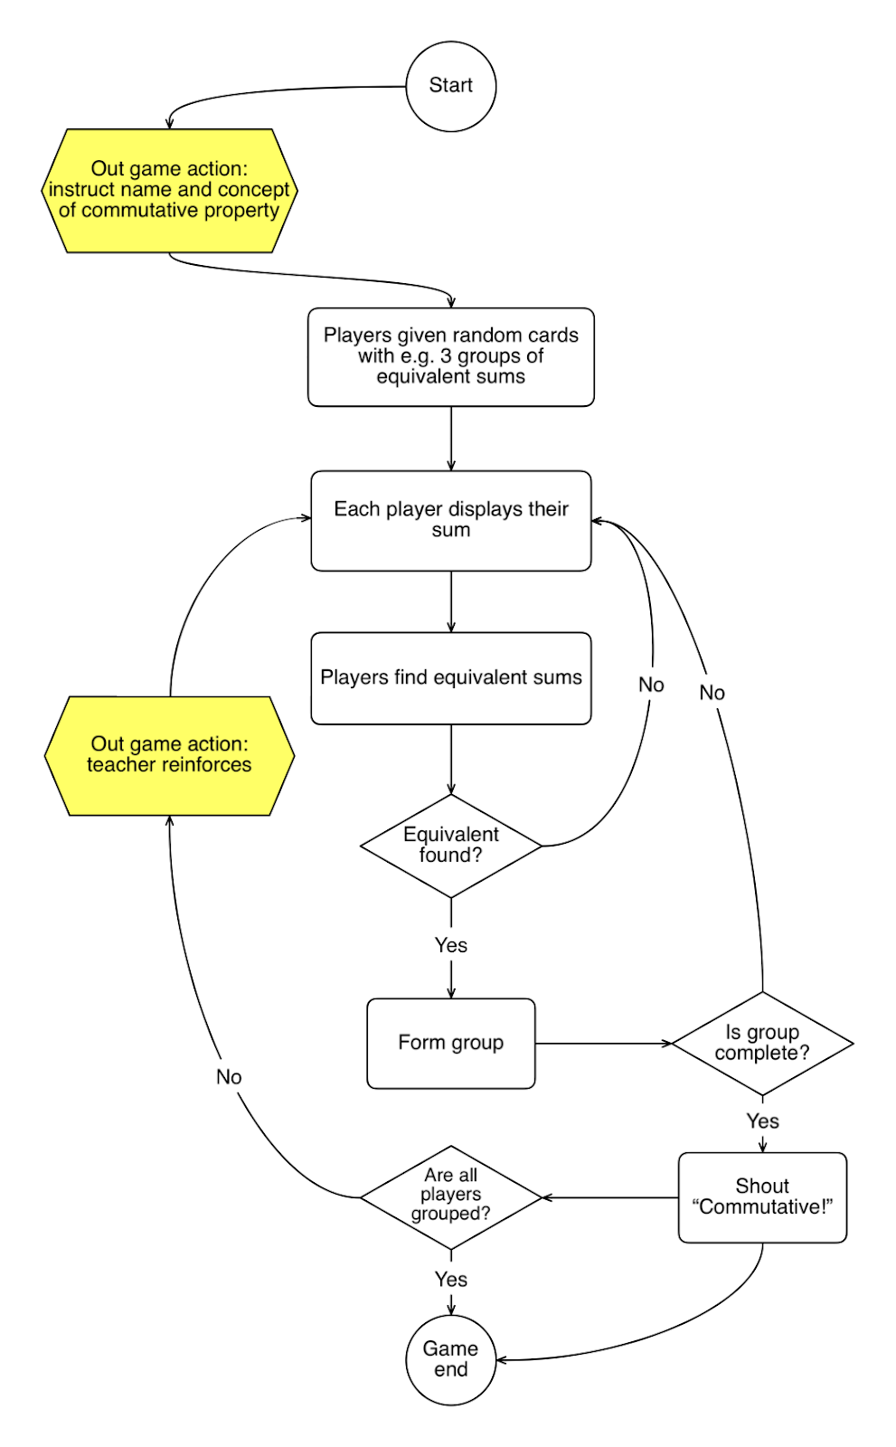

#### 3.9.1. Simple Example: Gameplay Loop Analysis

After a couple of playtests and her gameplay loop analysis (Figure 2), Maria realizes that she will still need to instruct the learners on what the commutative property actually is before they can engage in matching/grouping their sums. She wonders if this concept can be integrated into the game itself. Taking inspiration from another grouping game her class already likes (Animal Sounds), Maria creates a training round at the start of the game. In this game children are randomly assigned one of a few animals and they make the sound of their animal until all animals of the same type are grouped together. Maria realizes that, by combining this grouping behavior with the sum cards, she can encourage her pupils to actively make the connection themselves (e.g., all cats are equivalent to 3x5, all dogs are equivalent to 2x4). Doing so will not only make the learning more constructive but will remove the need for explicit instruction, placing the emphasis back on the learners.

Maria also decides to take the game outside wherever possible and introduces a new element, a chalk circle on the ground for each group containing the correct answer to each groups’ sums. This means that players can find their group in two ways, either by an equivalent sum or by knowing the answer. This gives pupils the flexibility of a different pathway to understanding.

After several iterations checking her LMs, GMs, and gameplay, Maria moves the second ILO to the main game (i.e., it does not happen in the training rounds) and is happy with her final game (see Figure 3).

#### 3.9.2. Extended Example: Gameplay Loop Analysis

Gameplay loops can be made even more rigorous by including the LMs and GMs in the loop for further insight (Abbott, 2019b). This helps to show which behaviors/interactions players are spending most of their time doing (or which are side-lined) and can help GBL designers to centralize those learning behaviors defined as most useful.

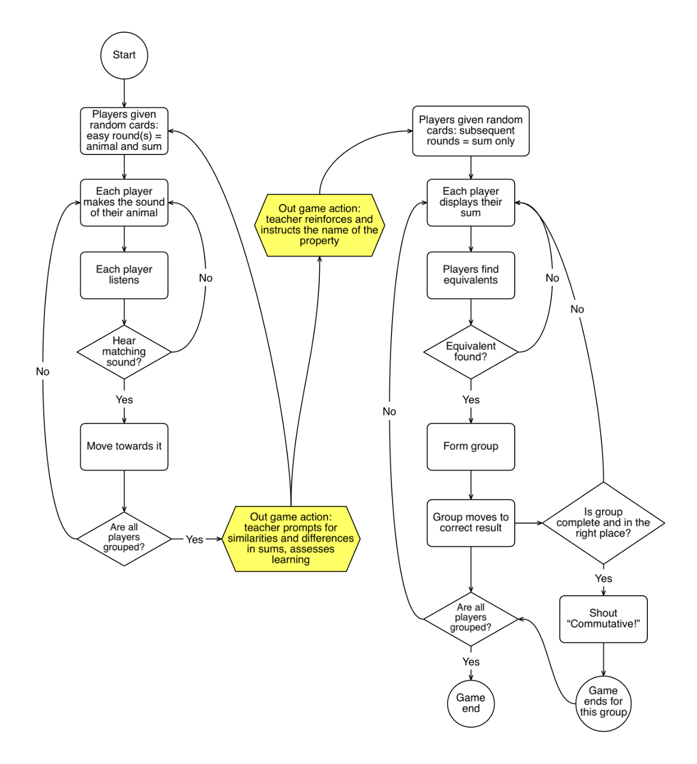

## 4. Conclusion and Reflection on the Workflow

The workflow and simple example presented here aims to guide readers towards increasing the rigour of their GBL interventions and to ensure that they benefit from a more explicit LXD approach. Educational games can be powerful personal learning tools with a focus on emotional flow as well as learner goals. As is clear from the literature, GBL often fails at this core objective due to being too much separated from both an appropriate pedagogical foundation and the needs and desires of the learners. LXD principles ensure this vital connection with learners can be maintained through the game design process.

By examining the interdisciplinary categories at each stage of the workflow, readers can identify where their own particular skills lie, establish any skill gaps that may need to be addressed in order to increase their overall expertise as GBL designers, and, for existing GBL practitioners, increase the focus on emotional design and the wider LXD context in which the workflow takes place. Admittedly, each stage may overlap with others as ideas are considered, and processes may be fuzzy rather than discrete. Whilst some may wish to follow the workflow step by step, others may already have an idea for learner-focussed GBL, in which case the workflow becomes a tool for validation of choices (and improving the rigour of the game design through subsequent iterations).

This chapter focuses on one small part of the overall LXD context (within the Interaction and Sensory planes) and has therefore not been able to discuss strategic, institutional, or practical considerations which impact game design within an LXD framework.

Finally, a widely experienced barrier for those integrating games into learning is resistance from colleagues or managers who may need to be convinced of the value of the GBL approach. In these cases, demonstrating the alignment of this GBL process with learner goals, desires, support-requirements, and enjoyment can help to elucidate the rigour and value of LX-centred GBL interventions.

## References

Abbott, D. (2019a). Game-based learning for postgraduates : An empirical study of an educational game to teach research skills. Higher Education Pedagogies, 4(1), 80–104. [https://edtechbooks.org/-mJVe](https://doi.org/10.1080/23752696.2019.1629825)

Abbott, D. (2019b). Modding tabletop games for education. In M. Allegra, M. Gentile, & H. Söbke (Eds.), Games and learning alliance (pp. 318–329). [https://edtechbooks.org/-pFGA](https://doi.org/10.1007/978-3-030-11548-7_30)

Anderson, L., & Krathwohl, D. (2001). A taxonomy for learning, teaching, and assessing: A revision of Bloom’s taxonomy of educational objectives. Allyn & Bacon.

Arnab, S., Lim, T., Carvalho, M. B., Bellotti, F., Freitas, S. de, Louchart, S., Suttie N., Berta R. De Gloria, A. (2015). Mapping learning and game mechanics for serious games analysis in engineering education. British Journal of Educational Technology, 46(2), 391–411. [https://edtechbooks.org/-ekpR](https://doi.org/10.1111/bjet.12113)

Bellotti, F., Kapralos, B., Lee, K., Moreno-Ger, P., & Berta, R. (2013). Assessment in and of serious games: An overview. Advances in Human-Computer Interaction, 2013, 1–11. [https://edtechbooks.org/-XVeS](https://doi.org/10.1155/2013/136864)

Bernhaupt, R. (Ed.). (2010). Evaluating user experience in games: Concepts and methods. Springer. [https://edtechbooks.org/-Bdx](https://doi.org/10.1007/978-1-84882-963-3)

Brockmyer, J. H., Fox, C. M., Curtiss, K. A., Mcbroom, E., Burkhart, K. M., & Pidruzny, J. N. (2009). The development of the game engagement questionnaire : A measure of engagement in video game-playing. Journal of Experimental Social Psychology, 45(4), 624–634. [https://edtechbooks.org/-wGc](https://doi.org/10.1016/j.jesp.2009.02.016)

Catalano, C. E., Luccini, A. M., & Mortara, M. (2014). Best practices for an effective design and evaluation of serious games. International Journal of Serious Games, 1(1). [https://edtechbooks.org/-iZK](https://doi.org/10.17083/ijsg.v1i1.8)

Clark, D. B., Tanner-Smith, E. E., & Killingsworth, S. S. (2016). Digital games, design, and learning: A systematic review and meta-analysis. Review of Educational Research, 86(1), 79–122. [https://edtechbooks.org/-qezR](https://doi.org/10.3102/0034654315582065)

Dinimaharawati, A. (2013). Designing educational games on E-learning SMANAS based learning experience design. 2018 International Seminar on Research of Information Technology and Intelligent Systems (ISRITI), Yogyakarta, Indonesia, 2018 (pp. 265–270). [https://edtechbooks.org/-rfS](https://doi.org/10.1109/ISRITI.2018.8864470)

Dodero, G., Gennari, R., & Melonio, A. (2015). PALX : Player and learner experience design: Can we design for both? CHItaly 2015 Proceedings of the 11th biannual conference on Italian SIGCHI chapter (pp. 186–187). ACM. [https://edtechbooks.org/-ntev](https://doi.org/10.1145/2808435.2814577)

El Mawas, N., Tal, I., Moldovan, A. N., Bogusevschi, D., Andrews, J., Muntean, G-M., & Muntean, C. H. (2018). Final frontier game : A case study on learner experience. In B. McLaren, R. Reilly, S. Zvacek, & J. Uhomoibhi (Eds.), Proceedings of the 10th international conference on computer supported education (Volume 1, pp. 122–129). SCITEPRESS.

Floor, N. (2018). Learning Experience Design. <https://lxd.org>

Glenn, P. J., & Knapp, M. L. (1987). The interactive framing of play in adult conversations. Communication Quarterly, 35(1), 48–66. [https://edtechbooks.org/-pvGu](https://doi.org/10.1080/01463378709369670)

Grey, S., Grey, D., Gordon, N. & Purdy, J. (2017). Using formal game design methods to embed learning outcomes into game mechanics and avoid emergent behaviour. International Journal of Game-Based Learning, 7(3), 63–73.

Guardiola, E. (2016). The gameplay loop: A player activity model for game design and analysis. ACE '16: Proceedings of the 13th international conference on advances in computer entertainment technology (pp. 1-7). ACM. [https://edtechbooks.org/-fmz](https://doi.org/10.1145/3001773.3001791)

Hainey, T., Connolly, T. M., Boyle, E. A., Wilson, A., & Razak, A. (2016). A systematic literature review of games-based learning empirical evidence in primary education. Computers and Education, 102, 202-223. [https://edtechbooks.org/-nMr](https://doi.org/10.1016/j.compedu.2016.09.001)

Hamari, J., Shernoff, D. J., Rowe, E., Coller, B., Asbell-Clarke, J., & Edwards, T. (2016). Challenging games help students learn: An empirical study on engagement, flow and immersion in game-based learning. Computers in Human Behavior, 54, 170-179. [https://edtechbooks.org/-ndfD](https://doi.org/10.1016/j.chb.2015.07.045)

Hauge, J., Stanescu, I., Arnab, S., Moreno, P., Lim, T., Serrano-Laguna, A., Lameras, P., Hendrix, M., Kiili, K., Ninaus, M., de Freitas, S., Mazzetti, A., Dahlbom, A., & Degano, C. (2015). Learning analytics architecture to scaffold learning experience through technology-based methods. International Journal of Serious Games, 2(1), 2384–8766. [https://edtechbooks.org/-BPpH](https://doi.org/10.17083/ijsg.v2i1.38)

Henricks, T. S. (2015). Play and the human condition. University of Illinois Press.

Huang, R., Spector, J. M., & Yang, J. (2019). Educational technology: A primer for the 21st century. Springer. [https://edtechbooks.org/-kSt](https://doi.org/10.1007/978-981-13-6643-7)

Huizinga, J. (1955). Homo ludens: A study of the play-element in culture. Beacon Press.

Jagger, P. (2016). The dawn of learner experience design. ITNOW, 58(3), 52–53. [https://edtechbooks.org/-MJN](https://doi.org/10.1093/itnow/bww083)

Juul, J. (2003). The game, the player, the world: Looking for a heart of gameness. In M. Copier & J. Raessens (Eds.), Proceedings of the level up: Digital games research conference (pp. 30–45). [https://edtechbooks.org/-xxUA](http://www.jesperjuul.net/text/gameplayerworld/)

Kay, R. H., & Loverock, S. (2008). Assessing emotions related to learning new software: The computer emotion scale. Computers in Human Behavior, 24, 1605–1623. [https://edtechbooks.org/-fDGr](https://doi.org/10.1016/j.chb.2007.06.002)

Lameras, P., Arnab, S., Dunwell, I., Stewart, C., Clarke, S., & Petridis, P. (2017). Essential features of serious games design in higher education: Linking learning attributes to game mechanics. British Journal of Educational Technology, 48(4), 972-974. [https://edtechbooks.org/-Cucw](https://doi.org/10.1111/bjet.12467)

Lepe-Salazar, F. (2015). A model to analyze and design educational games with pedagogical foundations. ACE '15: Proceedings of the 12th international conference on advances in computer entertainment technology (pp. 1-14). ACM. [https://edtechbooks.org/-ttiu](https://doi.org/10.1145/2832932.2832951)

Lim, T., Louchart, S., Suttie, N., Ritchie, J. M., Aylett, R. S., Stanescu, I. A., Roceanu, I., Martinez-Ortiz, I., & Moreno-Ger, P. (2013). Strategies for effective digital games development and implementation. In Y. Baek & N. Whitton (Eds.), Cases on digital game-based learning: Methods, models, and strategies (pp. 168–198). IGI Global. [https://edtechbooks.org/-PhcP](https://doi.org/10.4018/978-1-4666-2848-9.ch010)

Lui, R. W. C., & Au, C. H. (2018). Establishing an educational game development model. International Journal of Game-Based Learning, 8(1), 52–73. [https://edtechbooks.org/-ZFRS](https://doi.org/10.4018/IJGBL.2018010104)

Marklund, B. B. (2014). Working with educational games.[https://edtechbooks.org/-ydIf](http://www.diva-portal.org/smash/get/%20diva2:744438/FULLTEXT02)

Marklund, B. B., & Alklind Taylor, A. S. (2016). Educational games in practice: The challenges involved in conducting a game-based curriculum. Electronic Journal of E-Learning, 14(2), 122-135.

Marne, B., Wisdom, J., Huynh-Kim-Bang, B., & Labat, J.-M. (2012). The six facets of serious game design: A methodology enhanced by our design pattern library. Proceedings of the European conference on technology enhanced learning (pp. 208–221). [https://edtechbooks.org/-zSig](https://doi.org/10.1007/978-3-642-33263-0_17)

Ney, M., Emin, V., & Earp, J. (2012). Paving the way to game based learning: A question matrix for teacher reflection. Procedia Computer Science, 15, 17–24. [https://edtechbooks.org/-Fdq](https://doi.org/10.1016/j.procs.2012.10.053)

Nicholson, S. (2011). Making the gameplay matter: Designing modern educational tabletop games. Knowledge Quest, 40(1), 60–65.

Park, T., & Lim, C. (2019). Design principles for improving emotional affordances in an online learning environment. Asia Pacific Education Review, 20(1), 53–67. [https://edtechbooks.org/-VAdZ](https://doi.org/10.1007/s12564-018-9560-7)

Plaut, A. (2014, January 30). Elements of learning experience design. Boxes and Arrows. [https://edtechbooks.org/-AJSA](https://boxesandarrows.com/elements-of-learning-experience-design/)

Raybourn, E. M. (2016, March 1). A metaphor for immersive environments: Learning experience design challenges and opportunities. OSTI. [https://edtechbooks.org/-ytu](https://www.osti.gov/servlets/purl/1366662)

Rosencheck, M. (2015). Becoming a learning experience designer. DevLearn 2015 Conference. eLearning Guild.

Tangney, S. (2014). Teaching in higher education student-centred learning: Humanist perspective. Teaching in Higher Education, 19(3), 266–275. [https://edtechbooks.org/-pZT](https://doi.org/10.1080/13562517.2013.860099)

Torrente, J., Marchiori, E. J., Blanco, A. Del, Sancho, P., Ortiz, I. M., Moreno-Ger, P., Fernández-Manjón, B., Mellini, B., Talamo, A., Frossard, F, Trifonova, A., Alcaraz, S., Barajas, M., Veneri, A. D., Padmore, M., Owen, M., & Dumitrache, A. (2011). Production of Creative Game-Based Learning Scenarios: A Handbook for Teachers.[https://edtechbooks.org/-cmQp](http://www.ub.edu/euelearning/proactive/documents/handbook_creative_gbl.pdf)

Tracey, M. W., & Hutchinson, A. (2019). Empathic design: Imagining the cognitive and emotional learner experience. Educational Technology Research and Development, 67(5), 1259–1272. [https://edtechbooks.org/-IXfg](https://doi.org/10.1007/s11423-019-09683-2)

Weitze, C. L. (2016). Designing for learning and play: The smiley model as a framework. Interaction Design and Architecture(s), 29(1), 52–75. [https://edtechbooks.org/-tbK](https://backend.orbit.dtu.dk/ws/portalfiles/portal/141009243/CLWeitze_Designing_for_Learning_and_Play_The_Smiley_Model_as_a_Framework.pdf)

Westera, W. (2019). Why and how serious games can become far more effective: Accommodating productive learning experiences, learner motivation and the monitoring of learning gains. Educational Technology & Society, 22(1), 59–69.

Whitton, N. (2011). Encouraging engagement in game-based learning. International Journal of Game-Based Learning, 1(1), 75–84. [https://edtechbooks.org/-tQGF](https://doi.org/10.4018/ijgbl.2011010106)

[1] Much more detail on this can be found in (Abbott, 2019a; Raybourn, 2016; Whitton, 2011) amongst many others.

[2] For more on learning effectiveness, efficiency, and achievement see Huang et al., 2019.

[3] For those readers already familiar and confident with educational game design, an ambitious and complex example involving four high-level, functional outcomes at postgraduate level is presented in the work of Abbott (2019b).

Read this online at <https://edtechbooks.org/ux/11_intentional_learn>