# Leading Project Teams

Smith, A.

My palms were sweaty. The conference room was warm. Seated directly across the table was the Vice President of Asset Protection of Walmart US. The company had flown me from Idaho to Bentonville, Arkansas, for this moment, my first big break, and my chance to make a name for myself. I was leading a team tasked with developing a curriculum that would be implemented everywhere in the United States, and I was ready—ready to spring into action and dazzle the high-level executives with my instructional design prowess.

Finally, the VP turned to me and asked, “When do you think we can roll this out?” I gave an estimate, but that wasn’t what I thought was the most crucial part of my presentation. Then came the follow-up question. “Do you have a breakdown of who will pay for what?” I did not. Reality smacked me square across my overly confident face. I was not there to present a proposal for my innovative, custom-designed, and beautifully-built curriculum. I mean, yes, I was, but that was only a small part of my role. As this development progressed, it became more evident that the senior leadership was more concerned about milestones and deadlines than my knowledge of ADDIE. I was not only an instructional designer; I was the project manager, the bottom line. It was my responsibility to handle timelines, budgets, and all the not-so-fun, not-so-creative details that would enable my team to pull off this massive project and produce an excellent product.

When I left the corporate world behind and started to design curriculum for higher education, my project management skills were invaluable. As you join the world of instructional designers, you will often find yourself in the role of a project manager. Over the years, I have learned, leading project teams is an essential skill for an instructional designer to master. It is something to embrace and not fear.

## Basics of Project Management

From the Project Management Body of Knowledge Guide (PMBOK Guide), a project is “a temporary endeavor undertaken to create a unique product, service, or result” (Project Management Institute, 4). The keyword in the definition of project is temporary. The permanent, everyday production of products and services is called operations. Project management is “the application of knowledge, skills, tools, and techniques to project activities to meet the project requirements” (Project Management Institute, 10).

Now let’s explore several basic concepts of Project Management: Project Phases, Project Constraints, Project Management Triangle, and Ethics of Working with Teams.

### Project Phases

The textbook, Project Management for Instructional Designers, describes four typical lifecycle phases of a project: Initiation, Planning, Execution, and Closeout (or Closing) (see Figure 1).

**Figure 1**

Four Phases of Project Management



The Initiation phase encompasses all the assignments and actions that need to occur before project planning. The Initiation phase starts “with the assignment of the project manager and ends when the project team has sufficient information to begin developing a detailed schedule and budget” (Wiley et al., p. 3.1). The Planning phase centers on developing “an understanding of how the project will be executed and a plan for acquiring the resources needed to execute it” (Wiley et al., p. 3.1). The Execution phase emphasizes “the major activities needed to accomplish the work of the project” (Wiley et al., p. 3.1). The Closeout (or Closing) phase signifies the last stage of a project and where “project staff is transferred off the project, project documents are archived, and the final few items or punch list is completed” (Wiley et al., p. 3.1). I would recommend exploring more about each of these phases in this textbook, [Project Management for Instructional Designers](https://pm4id.org/chapter/3-1-project-phases-and-organization/).

### Additional Videos

* [4 Phases of the Project Life Cycle](https://youtu.be/N3N9-RLSbvo)
* [The Typical Phases in Project Management](https://www.youtube.com/watch?v=sLgdRO5IS9U)

### Project Constraints

#### Scope

With every project, we must consider scope. The definition of project scope is "what tasks the project team is expected to accomplish and, just as importantly, what is not part of the project" ([Wiley et al, p. 7.2](https://pm4id.org/chapter/7-2-project-scope/)).

Every project, being temporary in nature, has a beginning and ending. As the project manager, you need a clear vision of where the project needs to go. To help understand this concept, we will explore the second habit of 7 Habits of Highly Effective People, "Begin with the end in mind." Stephen Covey (2013) states,

“‘Begin with the end in mind’ is based on the principle that all things are created twice. There's a mental or first creation, and a physical or second creation, to all things. Take the construction of a home, for example. You create it in every detail before you ever hammer the first nail into place. You try to get a very clear sense of what kind of house you want…

The carpenter's rule is 'measure twice, cut once.' You have to make sure that the blueprint, the first creation, is really what you want, that you've thought everything through. Then you put it into bricks and mortar. Each day you go to the construction shed and pull out the blueprint to get marching orders for the day. You begin with the end in mind” (p. 95).

Like the construction of a house, you need to plan and create a “blueprint” for your project before work can begin. After you understand the project, you will need to articulate this vision to your team. Your team will never have a better understanding of the project scope than you. As the project manager, if you are unclear about the project’s expectations, your team will also be unclear on them. This path leads to scope creep.

##### Dangers of Scope Creep

Scope creep happens anytime the project’s requirements change after you start the project. This creep is a subtle phenomenon. Threats to time and cost loom as you allow small changes to occur based on last-minute suggestions. These change requests are often coupled with the rationale that, “We are already adjusting the curriculum anyway.” Or “It's only one small change.” One small change can have an enormous impact on the project. In many cases, as the project manager, you will underestimate the full effect of the change. You never want to find yourself in the position where you overpromise and underdeliver. Scope creep will make you unable to fill your commitments and leave your stakeholders disappointed.

#### Cost

As a project manager, you have an essential role to manage budgets and cost. You will need know your budgetary constraints and work to minimize costs. As illustrated in my Walmart example, knowing your budget and costs are of crucial consideration and interest to your stakeholders.

#### Time

Your stakeholders also want to know whether the project is on schedule. Stakeholders’ satisfaction is often tied to project performance expectations. You need to know the timeframe you have to accomplish the project. You will need to estimate how long every stage of the project will take and find the project’s critical path.

Rapid prototyping reduces time and cost in a project. (Rapid prototyping was explored in earlier chapters.) By prototyping, you and your stakeholders can make decisions that will save time and money. This process results in higher overall quality and allows you to influence the decision-making process along the way. Prototyping enables you to make the best use of our next concept, the project management triangle.

### Project Management Triangle

A common adage about project management is, “You can have it good, fast, or cheap. Pick two.” This statement derives from the concept called the “project management triangle,” or sometimes referred to as the “iron triangle.” There are several variations of the triangle. One of the most common variations is the constraints of cost, time, and scope make the sides of the triangle with the center representing quality (see Figure 2).

**Figure 2**

Project Management Triangle

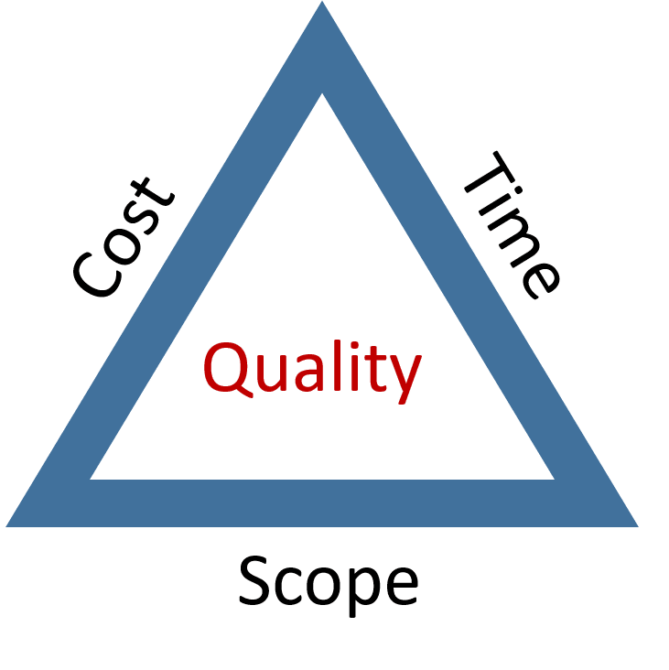

Let’s say you are creating a training course, and you want it to be done quickly (time constraint) and at a low cost (cost constraint.) It becomes evident that the scope needs to be limited (scope constraint). You will not be able to add a lot of extras to the course (e-learning or VR experience). If you try to do all three, the quality of the course will suffer. If the clients want the VR experience, then the costs will rise. There are always tradeoffs for every adjustment made to a project because you cannot improve all three constraints simultaneously. As the project manager, it is critical to understand the consequences of every decision made and how it affects other decisions.

### Application Exercises

* Create a chart that explains what happens at each phase of the project management lifecycle.
* How can effectively managing project constraints (scope, time, and cost) help a project to be successful and prevent scope creep?

## Working With Teams

Besides knowing the constraints, understanding the different teams that you will be working with on a project is imperative. There are several different types of teams that you may work with on any project. In this chapter, we will only highlight a few of those teams.

**Figure 3**

Relationship Between Different Teams on a Project

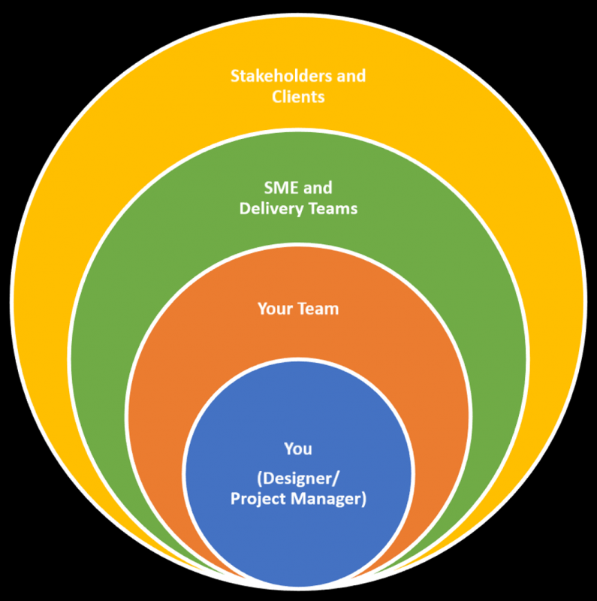

### Working With Your Team

Whether you were given your team or you selected your team, your leadership will determine the team effectiveness and ultimately the success of the project. Your ability to manage and inspire people will be one of the most critical factors to the success of the project. You will need to assess what skills you will need for the project and match them with your team members.

As you identify strengths and skills of your team members, you need to allow people to play off their strengths. In the book, Strengths Finder 2.0, Gallup scientists “discovered that people have several times more potential for growth when they invest energy to developing their strengths instead of correcting their deficiencies” (Rath, 2007, p. i). I have found when people are leveraging their strengths, they are happier and more productive.

### Working With SME

A subject-matter expert (SME) can be a blessing and a curse at the same time. A SME offers much-needed content knowledge; however, the project can quickly become off schedule if the SME is unavailable or unable to meet critical deadlines. Developing a relationship with an SME is explored more in the chapter called, [“Working With Stakeholders and Clients.”](https://edtechbooks.org/id/working_with_stakeholders) Maintaining healthy relationships with key stakeholders, like the SME, will dramatically impact the project.

### Working With the Delivery Team (Instructors, Faculty, Trainers, etc.)

As an instructional designer, rarely are you the one delivering or teaching the curriculum. Because of that, it is critical to keep the instructor/trainer in mind with the design of the materials, and how will it be implemented by the delivery team. With the excellent materials your team created, you will want the instructor training performed at the same high level. It may be necessary for you to work with your organization's delivery arm to ensure that the Train the Trainer (T3) sessions or teacher education programs happen according to plan. With this coordination, a successful implementation will allow the participants to experience the curriculum the way you design it. To explore more about implementation, read the chapter in this textbook titled, [“Implementation and Instructional Design.”](https://edtechbooks.org/id/implementation_and_i)

### Working With the Stakeholders and Clients

Your underlying goal of the project is to deliver what your stakeholders and clients want. To effectively do that, you need to answer these questions: what is the goal and how will success be assessed? You need to know the goal and design in the assessment.

When I created my first workshop for Walmart, I built it solely around the content given to me by the subject matter experts. I created beautiful workbooks and presentations. I even had the chance to attend the workshop as the material was delivered. At the end of the workshop, all the participants were ready to change the world because of my class. I thought to myself, “#LearningWasAchieved.” A few weeks later, I was asked by a senior leader what type of return on investment (ROI) metrics I had and how well did the workshop achieve the outcomes? After scrambling to pull information together about the success of the class, I was only able to generate a pitiful report. I realized the failure was not in the workshop, but that I was unprepared to report on its success. From this experience, I learned the importance of backward design. In backward design, you start with the learning outcomes or goals, create assessments to measure those outcomes, and then create the content that will enable the learners to complete the assessments successfully.

The next time I developed a class, I started the conversation by asking questions such as: “What do we want to measure?” and “What do the students need to know?” I did this questioning on the front side of the project. I designed in key outcome metrics with how they would be assessed in the curriculum. This time, I had the reports prepared, showing ROI. Of all the leadership and management skills I have learned, the ability to show value (ROI) to my stakeholders has had the greatest impact on my professional success as a designer. Another chapter, [“Working With Stakeholders and Clients,”](https://edtechbooks.org/id/working_with_stakeholders) reviews more on these interactions.

## Effective Strategies in Leading a Team

Figure 4 shows the strategies to use to help you successfully lead your team through a project.

**Figure 4**

Effective Strategies in Leading a Team

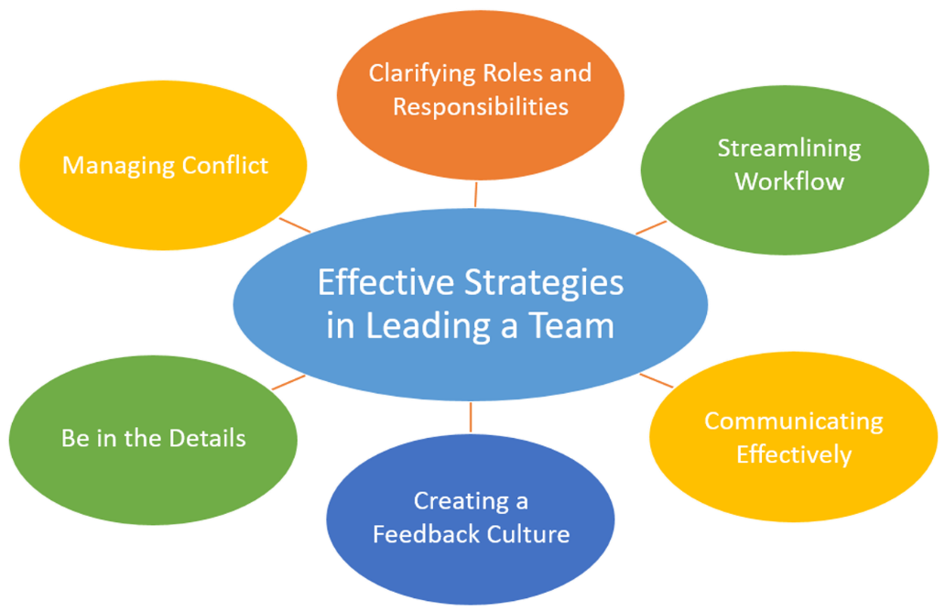

### Clarifying Roles and Responsibilities

Define the roles of your team. You need to understand who is ultimately responsible. Hyman G. Rickover, the “Father of the Nuclear Navy,” led a team to build the world’s first nuclear-powered submarine, the USS Nautilus. He had a deep understanding of responsibility. He said, “Responsibility is a unique concept... You may share it with others, but your portion is not diminished. You may delegate it, but it is still with you... If responsibility is rightfully yours, no evasion, or ignorance or passing the blame can shift the burden to someone else. Unless you can point your finger at the man who is responsible when something goes wrong, then you have never had anyone really responsible.” (United States Congress, 1965, p. 87). Although you may have delegated tasks, the shared successes and failures of your project are yours to bear.

### Additional Videos

* [Key Project Team Roles](https://youtu.be/KDbYzGY_QiE)

### Streamlining Workflow

Find bottlenecks. As a leader, you can’t fully delegate responsibility away for a project. So, if tasks aren’t happening, you need to ask, “Why?” You will need to find solutions. In the book, The Goal: A Process of Ongoing Improvement, the main character receives a critical insight from one of his professors, “What you have learned is that the capacity of the [project] is equal to the capacity of its bottlenecks” (Goldratt, 1992, p. 158). This capacity of any given bottleneck on your team or as part of your project affects the amount of work accomplished during a particular timeframe.

The speed of the project will depend on the number of bottlenecks. It would be best if you gave time and attention to improving those bottlenecks each day. The priority has to be what problems your team is having and helping them solve the issues quickly. These problems or bottlenecks will determine whether you will meet your deadline.

### Communicating Effectively

Don’t keep your people in the dark. As the project manager, you will need to develop strong communication channels with your team and stakeholders. B.G. Zulch discovered that “The single most significant factor affecting the success of a project is the communication ability of the project manager. If it seems true that everything rises and falls on communication and leadership, it stands to reason that leadership communication ability is the foundational skill that must be attained for a project manager to be effective…Communication is so important to project success that it has been referred to as the lifeblood of a project…” (2014, p. 1001).

Don’t allow blind spots to develop. The responsibility of communication does not rest solely on the project manager. The entire team needs to be communicating regularly with updates on progress. Without regular updates, blind spots will occur.

Have regular meetings with your team. Many meetings are considered boring and a waste of time because the leader conducting the meeting does not know how to have a productive meeting. From the book, Death by Meeting, Lencioni (2004) asserts two ideas for more productive meetings. First, meetings need more drama. The meetings need to be centered around conflict by addressing difficult questions. Let your people be passionate about what they do. Second, meetings need contextual structure. Not every meeting is the same type. Have the right kind of meeting that addresses your needs from a daily check-in to a monthly strategic meeting.

### Additional Videos

* [Improving Your Project Management Communication](https://www.youtube.com/watch?v=1RqnvRYfNyQ)
* [How to Run Team Meetings](https://youtu.be/xW0CjH95K3Q)

### Creating a Feedback Culture

Foster a culture of offering and receiving feedback. Feedback creates accountability. In the book, The Oz Principle, Connors et al. (2004) state, "You can gain great insight from frequent, regular, and ongoing feedback from other people. Although it can cause a great deal of pain and embarrassment at times, honest input helps create the accurate picture of reality that lies at the core of accountability" (p. 81). With any project, you need people to be accountable for their assigned tasks. With this loop of giving and receiving feedback, you, as the manager, can see the status of each part of the project. When you see epic failures with projects, many times, the lack of feedback is the underlying reason for it.

### Additional Videos

* [Managing Teams & Giving Feedback – Project Management](https://www.youtube.com/watch?v=ECFOMtS8zzg)

### Be in the Details

Spend the majority of your time in the details of the project. Admiral Rickover, the manager who led the team to build the world’s first nuclear-powered submarine, drove this point home by stating, "The man in charge must concern himself with details. If he does not consider them important, neither will his subordinates. Yet 'the devil is in the details.' It is hard and monotonous to pay attention to seemingly minor matters. In my work, I probably spend about ninety-nine percent of my time on what others may call petty details. Most managers would rather focus on lofty policy matters. But when the details are ignored, the project fails. No infusion of policy or lofty ideals can then correct the situation" (Rickover, 1982). Success is through the execution of small tasks.

### Managing Conflicts

Have crucial conversations. Anytime you are dealing with people under time and money constraints, you are going to have conflict. As a project manager, you will be required to have crucial conversations. From the book, Crucial Conversations, Patterson et al. (2002) define a crucial conversation as "a discussion between two or more people where stakes are high, opinions vary, and emotions run strong" (p. 3). When leading a crucial conversation, it is imperative to stay focused on the facts and issues. Prepare ahead of time so you can stay calm and not be distracted by strong feelings and emotional appeals. A leader who approaches these difficult conversations in a non-emotional way serves his people more effectively. You can create a safe environment for a crucial conversation by validating the other person’s position. Patterson et al. (2002) recommend the STATE method to manage conflict. The STATE method is an acronym of the tools you can use: Share your facts, Tell your story, Ask for others’ paths, Talk tentatively (or speaking gently and respectfully), and Encourage testing (or invite others to talk) (p. 124).

### Additional Videos

* [Conflict Management – Key Concepts in Project Management](https://youtu.be/wSwtbok3rv0)

### Application Exercises

* Identify the type of support you will need to give for each of the different teams with which you are interacting.
* Which strategies do you feel are the most important and how would you apply those strategies to your situation?

## Conclusion

In this chapter, we discussed that although you may be an instructional designer, you might often find yourself in the project manager role. We explored the four phases of the project management lifecycle: initiation, planning, execution, and closeout. We also studied how the project management triangle showed how the three constraints of scope, time, and cost can impact quality of a project. We reviewed the different teams you will work with on a project and provided effective strategies in leading a team.

Even if project management is new to you, becoming an effective project manager can be learned. As you master those skills, you will find yourself leading effective teams. A well-managed project will cause a positive outlook for everyone from your team down to the stakeholders and clients. Your finely-tuned project management skills will lead you to future success.

### Resources

* Project Management for Instructional Designers Textbook ([PM4ID](https://pm4id.org/))
* Project Management Institute – [pmi.org](https://www.pmi.org/)
* A Guide to the Project Management Body of Knowledge ( [PMBOK® Guide](https://www.pmi.org/pmbok-guide-standards))

## References

Connors, R., Smith, T., & Hickman, C. (2004). The Oz Principle: Getting results through individual and organizational accountability. New York, NY: Portfolio.

Covey, S. (2013). The 7 habits of highly effective people: Powerful lessons in personal change (25th anniversary edition). Retrieved from https://ebookcentral.proquest.com

Goldratt, E.M. & Cox, J. (1992). The Goal: A process of ongoing improvement (Second revised edition). Great Barrington, MA: North River Press.

Lencioni, P. (2004). Death by meeting : A leadership fable...about solving the most painful problem in business (Vol. 1st ed). San Francisco, CA: Jossey-Bass. Retrieved from https://ebookcentral.proquest.com

Patterson, K., Grenny, J., McMillan, R., Switzler, A. (2002). Crucial conversations. New York, NY: McGraw-Hill Professional Publishing.

Project Management Institute. (2017). A Guide to the Project Management Body of Knowledge (PMBOK® Guide)–Sixth Edition. Newtown Square, Pennsylvania: Project Management Institute.

Rath, T. (2007). Strengths Finder 2.0. New York, NY: Gallup Press.

Rickover, H. G. (1982). Doing a Job. Retrieved from [https://edtechbooks.org/-Nyt](https://govleaders.org/rickover.htm)

United States Congress. Joint Committee on Atomic Energy. (1965). Loss of the U.S.S. "Thresher.": Hearings, Eighty-eigth Congress, First and Second Sessions. Washington D. C.: U.S. Government Publishing Office

Wiley et al. (n.d.). Project management for instructional designers. Retrieved from http://pm4id.org/

Zulch, B. (2014). Communication: The foundation of project management. Procedia Technology, 16, 1000–1009. https://doi.org/10.1016/j.protcy.2014.10.054

Read this online at <https://edtechbooks.org/id/leading_project_team>