# Designing Instructional Text

Govender, S., Jaffer, T.

The term “instructional text” has been widely used to describe a wide range of textual objects, from whole texts (such as textbooks, manuals, guides and even narrative, reading scheme texts) to parts of a text. Historically, much of the research on instructional text has been in relation to the linguistic construction of texts (Tarasov et al., 2015) and document design (Misanchuk, 1992). In this chapter, we are going to narrow the focus substantially. This is not a chapter on how to write a didactic text, in other words, how to convey subject-specific information in print texts or online. Instead, this chapter will focus on the often overlooked “instructional text” that supports learning. Drawing on concepts from fields such as applied linguistics, graphic and multimedia design, and diversity studies, we’re going to focus our attention on the kind of textual features that work alongside subject-specific content to direct learners’ attention and action—instructional text.

## What Does Instructional Text Do?

Instructional text is commonly found hiding inside other texts: in classroom conversation, in textbooks and learner guides, in educator-produced material such as worksheets or assignment briefs, and on websites and course sites. We often do not really notice instructional text unless it is badly written and disrupts the flow of the learning. Instructional text can play a number of roles in face-to-face, print, and online learning contexts, including:

* contributing to creating a learning environment,
* outlining the structure of a learning experience,
* directing learners’ attention to specific areas,
* directing learners' actions and behaviours, and
* creating links between different parts of a learning experience.

Issitt (2004) noted that when we are constructing instructional text for print media, we should pay careful attention to the placement, construction, and design of these texts, and this is equally true for online and multimodal media, especially in asynchronous formats.

### Instructional Text: In the Classroom, in Print, and Online

While most educators pay careful attention to instructional text that conveys subject-specific content, less attention is given to instructional text that supports the learning of content.

In face-to-face spaces, instructional text often happens in direct response to learners’ actions. Moving into an online or multimodal context poses some new challenges and affordances for constructing instructional text. Poorly constructed instructional text in online and multimedia forms can be very confusing for learners but well-constructed instructional text can also open the door to a wonderful range of visual and verbal opportunities. So if you are an instructional designer, you need to think intentionally about the different spaces where instruction is needed.

## Towards a Theoretical Perspective

The Community of Inquiry (CoI) framework (Figure 1), developed almost 20 years ago, drew together the useful categories of Social Presence, Cognitive Presence, and Teaching Presence to describe the “dynamics of an online educational experience” in light of asynchronous, text-based group discussions (Garrison et al., 2010, p. 6).

**Figure 1**

Community of Inquiry (CoI) Framework

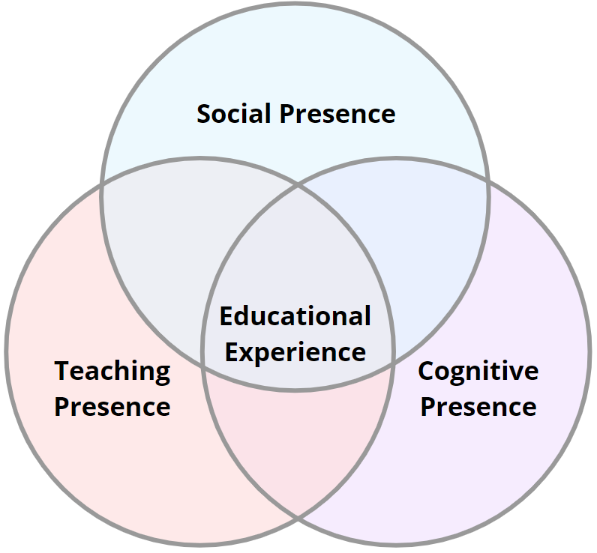

This model remains useful today, and can be used to think about instructional text in print media, online text, and multimodal media. While most educators’ focus tends to remain resolutely on cognitive presence, attention to social presence and teaching presence when constructing successful instructional text can enhance learner satisfaction and strengthen a sense of community. Social presence in an online learning experience can help participants to “identify with the community (e.g., course of study), communicate purposefully in a trusting environment, and develop interpersonal relationships by way of projecting their individual personalities” (Garrison, 2009, p. 352). The specific textual choices that an educator makes in constructing instructional text will either support the achievement of this aim or hamper it.

## Principles for Constructing Instructional Text

### Additional Information

* [Slides for Principles for constructing instructional text](https://docs.google.com/presentation/d/1I7KiitxTNkc23Xh7C_PSuS3XTDRiTqsk9NXTdhfgOQE/edit?usp=sharing)
* [Video for Principles for constructing instructional text](https://youtu.be/KybYGa6grbw)

Whether you are constructing instructional text for written, online, multimodal contexts, there are a number of key principles that you will need to bear in mind. These principles come from a wide variety of research fields, including perception studies in psychology, user experience research, multimodal studies, and applied linguistics.

### Principle 1: Simplify: Reduce Extraneous Load

Simplifying texts and producing ‘‘easy-to-read texts’’, or ‘‘plain language texts’’ is another way of thinking about reducing extraneous load to produce texts that align with readers’ ability levels (Arfe et al., 2017). Extraneous load or processing refers to any work that a learner might need to do that does not contribute to the learning goal or outcome (Mayer, 2019). Poorly written, excessively complicated instructional text, or instructions that are only issued verbally can contribute to extraneous cognitive load. Instructional text should

* be short and direct
* avoid jargon
* highlight key actions
* be easily “findable”
* hyperlink where appropriate

### Principle 2: Personalise: Connect Through Voice and Tone

Research suggests that belonging, achieved in part through affective connection, is a key predictor of learner success (Masika & Jones, 2016; Trujillo & Tanner, 2017). In face-to-face classroom contexts, successful educators instinctively use body language and tone of voice to create connection through conveying emotion. This is particularly true for minority learners (Meeuwisse et al., 2010; Rahman, 2013) and in online learning spaces (Delahunty et al., 2014).

Instructional text, in print, online text, or multimodal texts, often suffers from an absence of emotional connection between the writer and the reader (Issitt, 2004), failing to build belonging in support of learning. Instructional text is, however, an opportunity to connect with learners on levels beyond the purely cognitive, enhancing learning through building connection, belonging and trust (see Figure 2). The use of a human (as opposed to synthesized voice) and to “you” and “I” as opposed to third person pronouns or more formal language are ways of building connections (Ginns et al., 2013).

**Figure 2**

Exemplar Email Showing Tone and Personalising Practices for Instructional Text

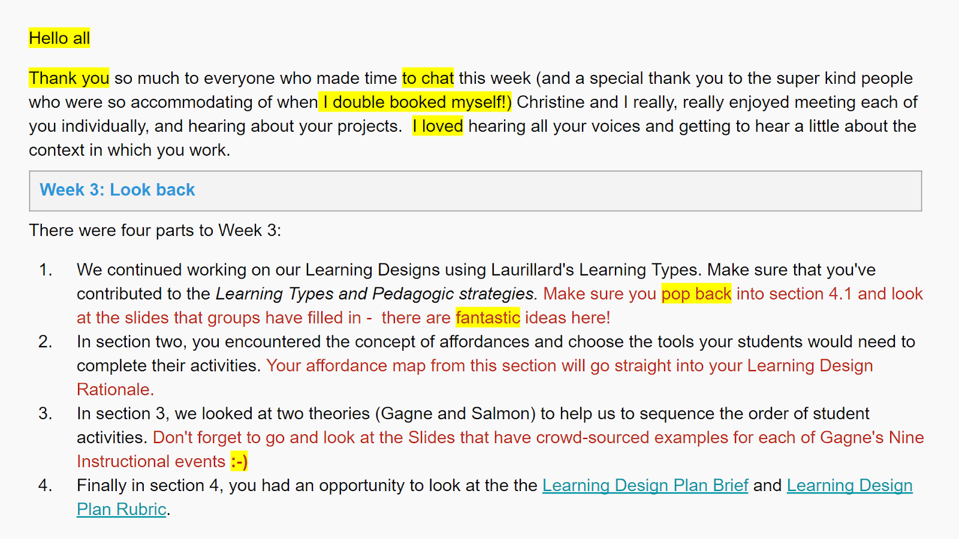

The text, highlighted in yellow above, points

to some of the language choices made in an instructional text to build connection and convey emotion

. Not everyone will do this in the same ways based on factors such as the personality of the instructor, the age of your learners, and the context in which you work; but for this educator, this is an authentic example of “voice” that seeks to promote connection. In certain contexts, the use of emoticons, gifs, and memes might be an authentic and approachable way to build connection.

The pervasiveness of recording devices in the form of cellphones, cameras, lecture recording, and live video conferencing contribute to educators across the educational sector feeling increasingly under surveillance. In the context from which we are writing, a research-intensive university in South Africa, staff are hyper-aware and often uncomfortable with being recorded. This can result in both teaching and learning interactions and instructional text that is hyper-correct, hyper-formal and devoid of personality and the opportunity for connection.

#### Consider Multimodal Instructional Text

Instructional texts in multimodal contexts can take advantage of the affordances of video and audio to improve clarity and strengthen connection. In blended contexts, making the instructional text available in both online and face-to-face modes can support learning in a seamless manner.

**Figure 3**

Example Showing the Complexity of Conveying Tone in Different Modalities

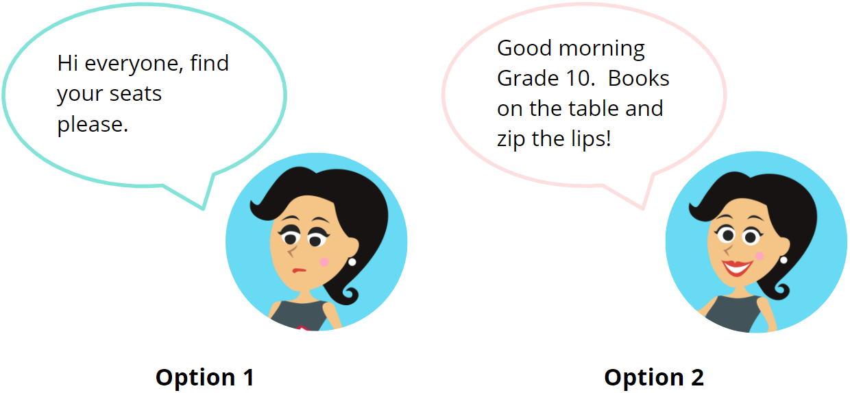

Note. Image adapted from macrovector_official - [freepik.com](https://www.freepik.com/free-vector/clever-office-girl-standing-set_4561579.htm#page=2&amp;query=happy+angry+woman&amp;position=28)

In written text on the page or screen, Option 1 seems much friendlier than Option 2. But what if we were in a live video conference call, and Option 1 was said in a monotone, and Option 2 was said with a cheery smile and a “zip the lips and throw away the key” gesture? The tone changes entirely. The same would be true of an audio recording, video or podcast—formal language, paired with welcoming tone and visuals can have a very different impact than just the text, and of course, text, audio and visuals that work in support of each other would be the most powerful.

### Principle 3: Communicate Regularly

The temptation with instructional text is sometimes to write or present long and complex screeds of instructions at the outset of a process. We would encourage you, however, to communicate regularly with learners and to offer instructional text in brief, just-in-time chunks. This is for a number of reasons. Instructional text is most likely to make sense to learners when it is directly related to what a learner needs to do immediately. While it is useful to tell learners at the beginning of the semester how it is that they will submit their final semester project, you really should be prepared to come back in the final weeks of semester and remind them. Instructional text is also a way of building a connection with learners across time. Knowing that a lecturer will email weekly with key submissions, key activities, and a summary of what went well in the previous week is something that learners, particularly in online contexts, value. Instructional communication over time is also an opportunity to acknowledge and encourage learners on an ongoing basis.

## Purpose and Placement of Instructional Text

There are many places where you should consider inserting instructional design text. Given the broad role instructional text plays, it is ubiquitous in course design and delivery. There are, however, some typical placements (see Figure 4) of instructional text.

**Figure 4**

Example Structure of an Online Course With Typical Instructional Text Placements

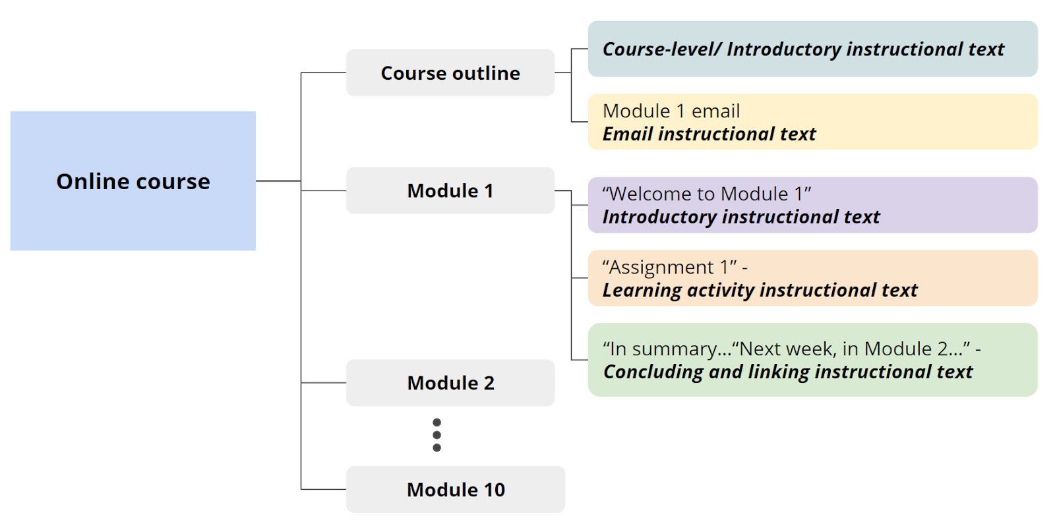

### Introductory, Linking, and Concluding Instructional Texts

Instructional text is often needed at the beginning of a unit or module in a course or textbook. In this location, instructional text will usually outline the shape of the text learning experience ahead of the learner by articulating learning outcomes and identifying key aspects of the learning activities. It might alert the learner to activities such as live sessions, expected time on tasks, or equipment required for that week. Figure 5 is an example of introductory instructional text.

**Figure 5**

Example Showing Introductory Instructional Text

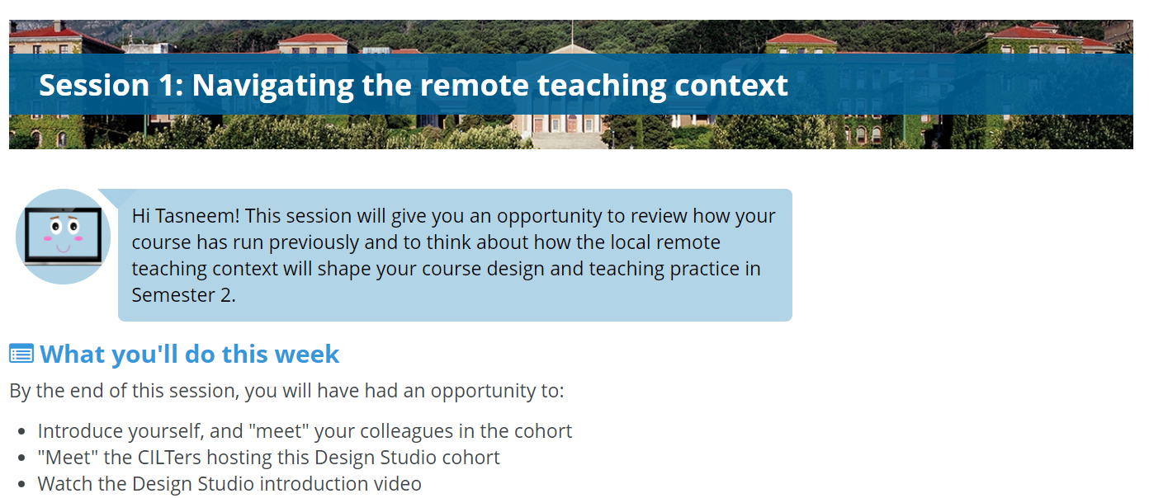

While the text above performs an introductory function, similar texts can perform linking functions between sections of text or activities, and to conclude learning “chunks.”

### Instructional Text to Support Navigation

Both print learning texts and online learning spaces have their own rules and norms. As an educator, you may be very aware that bold text or italicized text requires particular attention, or that text in a particular shade of blue with an underline is likely to be hyperlinked. However, the norms of texts and online spaces are not always immediately apparent to all learners, who may need some assistance navigating either the text or the space. Further, learners are almost always enrolled in multiple courses, each with its own structure, rules and norms. Figure 6 provides an example of instructional text with a navigation purpose.

**Figure 6**

Example Showing Navigation Techniques in a Learning Activity

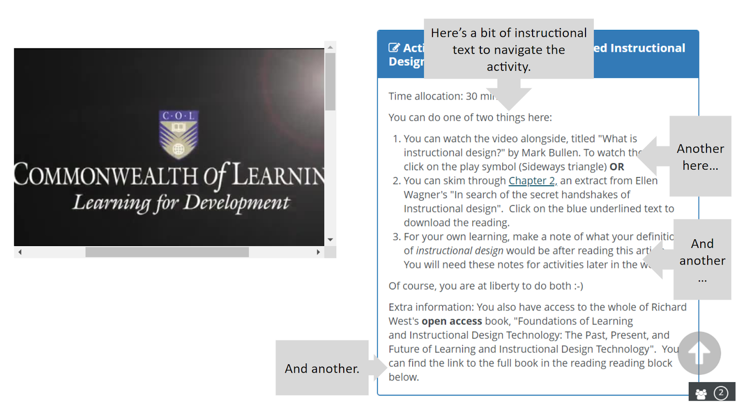

Being explicit about the structure, rules, and norms of your course can improve the learner experience by reducing extraneous cognitive load. That is, because of the way the content is presented, learners may have to do excessive analyzing that is not necessary to achieve the learning outcomes of the course (Mayer, 2019). It is our responsibility as instructors to limit this load, allowing learners to focus their attention and efforts on what we really want them to learn.

### Learning Activity Instructional Text

If you research older articles, you will often come across instructional text articles that refer to writing the instructions of an assignment or manual for print. Each assignment or assessment created for learners contains instruction—sometimes the instruction is minimal if it is an open-ended question or more intensive if it is a step-by-tutorial. Depending on the level of the learners, the level of instruction used for assessments may differ. Figure 7 is the instruction for a small activity on learner personas.

**Figure 7**

Example Showing Instructional Text in a Learning Activity

|  |
| --- |
|  |

### Email as Instructional Text

In an online setting, course announcements or emails are often used by the instructor to communicate with learners on a regular basis (see Figure 8). This type of instruction typically includes, but is not limited to reminders, deadlines, changes in course information, and feedback on assessment. While other forms of instruction may be pre-planned, emails are done with a short turnaround time and therefore contextual to what is currently happening in the class. If we, as instructors, are communicating sensitive or not-so-great information about learner grades, we want to pay particular attention to our tone. It is the little things that contribute to a successful email—like the usage of greetings.

**Figure 8**

Example of an Instructional Text in an Email

|  |
| --- |
| Example:  Hello everyone  We don't have any new work/input at the moment, so I hope you are all catching your breath and writing happily!  In this week's live session, we focused on the first two sections of the Learning Design Rationale. We talked about trigger problems in relation to the introduction and started to think about the "Thinking like a designer" section. We tried two short activities to get everyone to think about the goal of both these two sections.  Seema had a great question about how to use the feedback in the blogs. Do not use this feedback to rewrite your blogs—it's totally unnecessary. The blogs are, however, actually key parts of your LDR, so use this feedback to improve your final LDR.  Next week, we are using our two live sessions to continue strengthening the LDRs   * Monday (4:30pm) - Context section (Saadiq) * Wednesday (3pm) - Design and Develop sections (Sandiso, Widad)   Thanks to our volunteers for next week—we will have some examples to think about our work in relation to!  Also, check out the Commons tool in the left-hand menu! It's a great place for leaving messages or sharing questions and resources.  Stay strong!  Shanali |

## Visual Design of Instructional Text

While the content of the instructional text is central to its purpose of guiding the learner, there are many other factors that contribute to its success. An example is focusing on accessibility in the instructional text's visual design. When designing instructional text, we need to think about how it caters to the learner’s experience from a visual perspective, which affects the learner’s ability to find information (Lonsdale, 2016). These visual guidelines draw on the work of Hartley (1981), Universal Design for Learning (UDL), and the field of User Experience (UX) to name a few. Regardless of a physical or digital medium, these guidelines are important considerations for the design of your instructional text. Good instructional text will not always be noticeable to the learner, but poor instructional text or the absence of instructional text will be evident. When designing instructional text there are a few key areas that need to be considered.

### Headings

Headings improve the learner's ability to scan and navigate the content. At any point, a learner should know where they came from, where they are, and where they are going. Headings signal the topic, and in many cases give you an idea of whether the information under the heading will be relevant. Before lesson planning, it is a good idea to sit down and plan the structure including the headings and subheadings for one unit or lesson. This allows you to mimic the heading structure for future lessons, creating a consistent learning experience. For optimum accessibility, here you want to make use of the heading styles provided by Word, Google Docs, or any text editor.

### Numbering

Numbering aids in sequencing and organizing information. Furthermore, it is particularly valuable for referencing purposes (Hartley, 1981). Where possible, numbering is encouraged, as it provides opportunities to reference by number in announcements, emails, assignments, and other parts of the course (see Figure 9; e.g., "Please have a look at section 2.2 detailing how to use an empathy map.") If the course content changes regularly, you may want to be cautious about the upkeep of a numbering system. Numbering also provides learners with an easy reference method when emailing an instructor with queries.

**Figure 9**

Example Showing Content Structure Using Headings and Numbering

|  |
| --- |
| 1. Introduction to Online Learning Design 1.1 What is online learning design? 1.2 Knowing your context  2. Understanding your learners 2.1 Personas 2.2 Empathy maps |

### Bullets

Break up large chunks of text into smaller numbered or bulleted lists. For example, if there are five key points for a topic, it might be a good idea to outline this using bulleted lists (see Figure 10).

**Figure 10**

Example Showing a Before and After of Converting a Chunk of Text to a Bulleted List

|  |
| --- |
| **Tips for filming your online lectures**  Example: Large chunk of text (Before)  Script writing is an essential part of preparing to film your lecture for an online course. Here are five key tips you need to think about when filming. If writing a verbatim script, use short sentences, short paragraphs and simple syntax. Be clear and concise: aim to convey maximum information using minimum words. Check that your script flows, that you are explaining the links between paragraphs or sections. Storytelling is a useful device to keep learners engaged—try to mimic this in your videos. Don’t use abbreviations in the spoken form—e.g., say the United States instead of the US, University of Cape Town instead of UCT. |
| Example: Bulleted list (After)  Script writing is an essential part of preparing to film your lecture for an online course. Here are five key tips you need to think about when filming:   * Use short sentences, short paragraphs and simple syntax. * Be clear and concise: aim to convey maximum information using minimum words. * Check that your script flows, that you are explaining the links between paragraphs or sections. * Use storytelling in your videos to keep learners engaged. * Don’t use abbreviations in the spoken form—e.g., say the United States instead of the US, University of Cape Town instead of UCT. |

### Spacing

Designers talk about “white space”—which is the space around text and images like in this textbook. Golombisky and Hagen (2013) phrase it really well “Too much space, and visuals and type get lost or don’t talk to each other. Not enough space and they start to fight with each other”(p. 7). White space is necessary and appropriate when placing text and images, and it contributes to the readability of the instruction. Having white space around the most important information allows it to stand out from the rest of the text. Following the methodology of [chunking](https://www.nngroup.com/articles/chunking/) (see Figure 11), you should break up text into logical chunks which can provide the white space needed to maximize readability (Moran, 2016).

**Figure 11**

Example Showing How Groupings of Text May Appear to a Learner

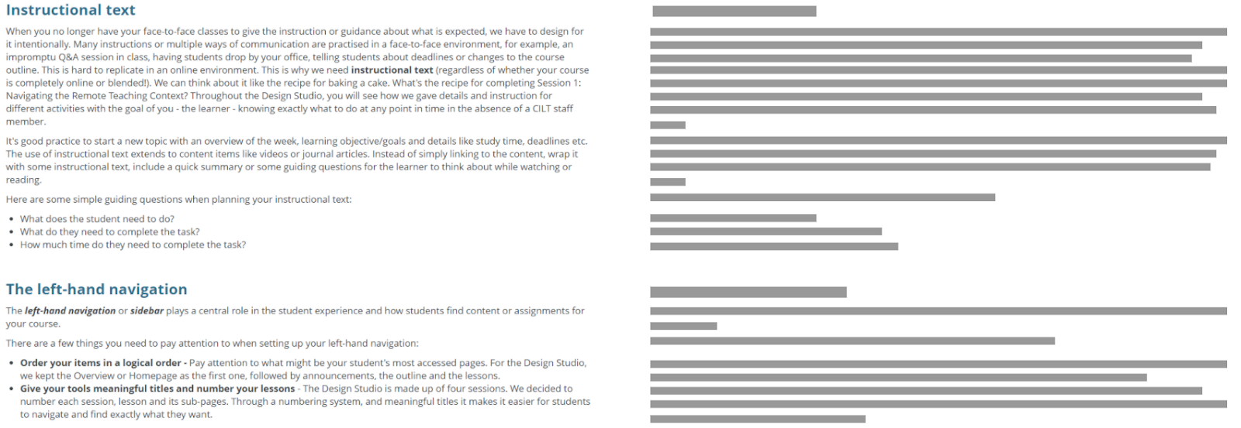

### Fonts

Font choice can impact the readability of the text. Opt for common, highly readable fonts like Arial, Tahoma, Verdana, or others and avoid decorative fonts that are difficult to read. Some font-families are considered more readable than others, with division among those who prefer sans-serif or serif fonts. A simple web search for the most accessible fonts will give a selection of suitable fonts. Limit text to one or a few select fonts—having too many will be distracting for the reader. Although they may seem boring, they are effective and easy on the eyes. Let’s leave the decorative fonts for the kids (see Figure 12).

**Figure 12**

Example Showing How Decorative Fonts May Not Be Easy on the Eye

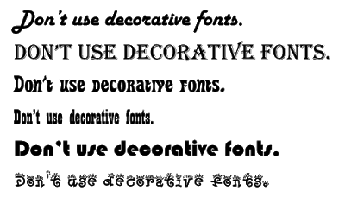

#### Font Size

Depending on the placement of the instructional text, it’s important to consider the font size. If important instructions are too small and illegible, they might be overlooked by the reader (see Figure 13).

**Figure 13**

Example Showing Readability of Different Font Sizes

|  |
| --- |
| This is 8px  This is 10px  This is 12px  This 14px  This is 18px |

#### Emphasis Using Text Effects

When communicating important information like deadlines, it is common to **bold**, underline, or italicize certain parts of the text to make it stand out to the learner. For example, the bolding on **this part of the sentence** signals that you should focus on it. Here it is important to be consistent in the style of emphasis you are going to be using throughout your course materials in order to not confuse learners.

#### Colors and Highlighting

If color is used to signal important text, you want a good contrast between the colors used. Poor color contrast may not be readable and particularly affect learners who are color-blind. Using an online contrast checker like [WebAIM](https://webaim.org/resources/contrastchecker/) will determine whether the text is well-contrasted (see Figure 14). As far as possible, color should not be the only way to show emphasis.

**Figure 14**

Example of a Contrast Checker Showing Inaccessible Color Usage

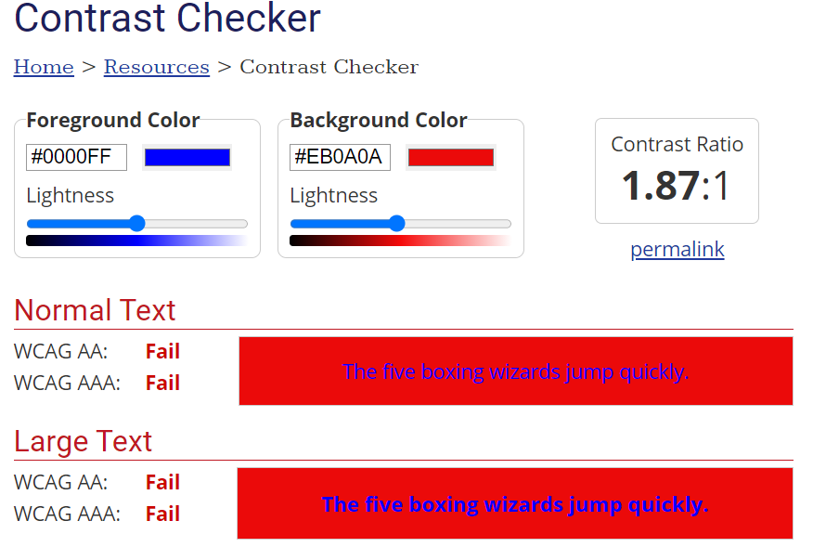

## Conclusion

In this chapter, we have limited our focus to the kind of instructional text that works between subject-specific material to support learning. While we hope that the principles suggested to you will continue to be useful over a period of time, factors such as mode (face to face, blended, or online) and ever-changing technological and digital contexts, mean that what learners find appealing and supportive will change. We encourage you to pay attention to the role of instructional text in learning, and to take steps to develop your capacity with constructing instructional text by, above all, listening to your learners.

### Application Exercises

#### Exercise 1

Refer to Figure 7: Example showing instructional text in a learning activity. Which principles for constructing instructional text do you see at work in this example? Compare your answers with a peer and see if you missed anything.

#### Exercise 2:

Here’s a version of the email announcement example we used earlier with some creative use of font and colour. Copy this email into a text editor, remove all the formatting and think about font colour, size and spacing to improve the read-ability.

Example:

Hello everyone. We don't have any new work/ input at the moment so I hope you are all catching your breath and writing happily! In this week's live session we focused on the first two sections of the LDR. We talked about trigger problems in relation to the introduction and started to think about the "Thinking like a designer section". We tried two short activities to get everyone to think about the goal of both these two sections. Seema had a great question about how to use the feedback in the blogs. Do not use this feedback to rewrite your blogs - it's totally unnecessary. The blogs are however, actually key parts of your LDR, so use this feedback to improve your final LDR. Next week, we are using our two live sessions to continue strengthening the LDRs - Monday (4:30pm) - Context section (Saadiq) and Wednesday (3pm) - Design and Develop sections (Sandiso, Widad). Thanks to our volunteers for next week - we will have some examples to think about our work in relation to! Also, check out the Commons tool in the left-hand menu! It's a great place for leaving messages or sharing questions and resources.

Kind regards

Shanali

#### Exercise 3:

Find an existing example of instructional text. This could be something you have written previously or an example from a textbook or online course. Using what you have learned in this chapter about principles for constructing and designing instructional text, edit the example you have found. Share your edits with a peer or a friend for feedback.

## References

Delahunty, J., Verenikina, I., & Jones, P. (2014). Socio-emotional connections: Identity, belonging and learning in online interactions. A literature review. Technology, Pedagogy and Education, 23(2), 243–265.

Garrison, D. R. (2009). Communities of inquiry in online learning. In Encyclopedia of Distance Learning, Second Edition (pp. 352-355). IGI Global.

Garrison, D. R., Anderson, T., & Archer, W. (2010). The first decade of the community of inquiry framework: A retrospective. The Internet and Higher Education, 13(1-2), 5–9.

Ginns, P., Martin, A. J., & Marsh, H. W. (2013). Designing instructional text in a conversational style: A meta-analysis. Educational Psychology Review, 25(4), 445–472.

Golombisky, K., & Hagen, R. (2013). White space is not your enemy: A beginner's guide to communicating visually through graphic, web & multimedia design. Taylor & Francis.

Hartley, J. (1981). Eighty ways of improving instructional text. IEEE Transactions on Professional Communication, 1, 17–27.

Issitt, J. (2004). Reflections on the study of textbooks. History of Education, 33(6), 683–696.

Lonsdale, M. D. S. (2016). Typographic features of text and their contribution to the legibility of academic reading materials: An empirical study. Visible Language, 50(1), 79-111.

Masika, R., & Jones, J. (2016). Building student belonging and engagement: Insights into higher education students’ experiences of participating and learning together. Teaching in Higher Education, 21(2), 138–150.

Mayer, R. E. (2019). Thirty years of research on online learning. Applied Cognitive Psychology, 33(2), 152–159.

Mayer, R. E., & Moreno, R. (2003). Nine ways to reduce cognitive load in multimedia learning. Educational Psychologist, 38(1), 43–52.

Meeuwisse, M., Severiens, S. E., & Born, M. P. (2010). Learning environment, interaction, sense of belonging and study success in ethnically diverse student groups. Research in Higher Education, 51(6), 528–545.

Misanchuk, E. R. (1992). Preparing instructional text: Document design using desktop publishing. Educational Technology.

Moran, K. (2016). How Chunking Helps Content Processing. www.nngroup.com/articles/chunking/

Rahman, K. (2013). Belonging and learning to belong in school: The implications of the hidden curriculum for indigenous students. Discourse: Studies in the Cultural Politics of Education, 34(5), 660–672.

Tarasov, D. A., Sergeev, A. P., & Filimonov, V. V. (2015). Legibility of textbooks: A literature review. Procedia-Social and Behavioral Sciences, 174, 1300–1308.

Trujillo, G., & Tanner, K. D. (2014). Considering the role of affect in learning: Monitoring students' self-efficacy, sense of belonging, and science identity. CBE—Life Sciences Education, 13(1), 6-15.

Read this online at <https://edtechbooks.org/id/designing_text>