# APA 7 Job Aid

Kimmons, R.

This job aid provides a brief guide to common APA 7 rules for academic writing along with tips on how to avoid common mistakes.

## Contents

Document Formatting

Font Selection

Headings

Citations

References

Indents

Page Breaks

Lists

Quotations

Commas

Semicolons

Colons

Em Dashes

Hyphens

Tables

Figures

Latin Abbreviations

## Document Formatting

Table 1

Document Setup Guidelines

|  |  |
| --- | --- |
| Element | Formatting |
| Margins | 1" on all sides |
| Line Spacing | Double-space (without extra line breaks between paragraphs and headings) |
| Paragraph Indentation | Indent the first line of every paragraph 0.5" (use the indentation feature rather than manual tabs or spaces) |
| Paragraph Alignment | Left-align |

## Font Selection

Fonts should use one of the group/size combinations in Table 2. Generally, manuscript text uses a serif font and tabular text uses a sans-serif font.

Table 2

Font Styles

|  |  |
| --- | --- |
| Style Group | Options |
| Serif | 12-point Times New Roman, 11-point Georgia, or 10-point Computer Modern |
| Sans-Serif | 12-point Calibri, 11-point Arial, or 10-point Lucida Sans Unicode |

## Headings

Table 3

Heading Levels

|  |  |
| --- | --- |
| Level | Formatting |
| 1 | **Centered, Bold, Title Case** |
| 2 | **Flush Left, Bold, Title Case, No Period at the End** |
| 3 | Flush Left, Bold, Italic, Title Case, No Period at the End |
| 4 | **Indented with Paragraph, Bold, Title Case, Ending with Period.** |
| 5 | Indented with Paragraph, Bold, Italic, Title Case, Ending with Period. |

Headings are best utilized by using your word processor's built-in style system. Here is [a simple Google Docs template](https://docs.google.com/document/d/1l2i_qV3AF7m7gPm_FwYyxxcvop4imrlL8NH1zc_Jxt4/copy) with the styles preset so that all you need to do is highlight your heading and apply the appropriate style to apply the proper formatting. Using styles is also preferable to manually formatting each heading because it allows the word processor to identify headings for the purpose of constructing outlines and tables of contents.

### Title Case

Title case is a type of capitalization that involves capitalizing all major words, which, according to APA 7, means, "nouns, verbs (including linking verbs), adjectives, adverbs, pronouns, and all words of four letters or more." Do not capitalize minor words, which includes, "short (i.e., three letters or fewer) conjunctions, short prepositions, and all articles."

The first words of titles and subtitles are also capitalized, as well as the first word after a colon, em dash, or end punctuation in a heading. Also  be sure to capitalize the second part of hyphenated words (e.g., "Self-Report," not "Self-report").

## Citations

Table 4

Parenthetical Citation Examples

|  |  |  |
| --- | --- | --- |
| Author Count | Parenthetical Citation | Narrative Citation |
| One | (Kimmons, 2020) | Kimmons (2020) found that... |
| Two | (Kimmons & Johnstun, 2019) | Kimmons and Johnstun (2019) argued that... |
| Three or more | (Kimmons et al., 2020) | Kimmons et al. (2020) suggested that... |

**Parenthetical citations** are used within paragraphs to cite the source of a claim. An example of this would be the following:

Current trends in educational technology reveal that exploring new technologies may be prioritized over addressing persistent educational problems (Kimmons, 2020).

**Narrative citations** are similar to parenthetical citations but are mainly used if the name of the author is important for adding gravity to the claim or for making clear that the claim is that of the cited author and not your own. An example of this would be the following:

Kimmons and Johnstun (2019) argue that the multihyphenate approach to navigating paradigms in educational technology is superior to alternatives.

Narrative citations referencing an article's title should place the title in quotes and apply sentence capitalization as follows:

Kimmons and Johnston explained in "Navigating paradigms in educational technology" (2019) that paradigms are deep and poorly understood.

Narrative citations referencing the title of a book or journal should italicize the title and apply title case capitalization as follows:

Kimmons et al.'s (2019) article in The International Review of Research in Open and Distributed Learning showed that scraping school websites nationwide to glean valuable information was a possibility.

## References

References are included at the end of your paper to provide full details for any parenthetical or narrative citations that were included. References should be formatted with a hanging indent of 0.5 inches. You can do this in most word processing programs using the ruler bar (see Figure 1). You can also view this page for how to make a hanging indent in Word and [this page](https://support.google.com/docs/thread/6177910/how-do-i-get-hanging-indents-in-google-docs?hl=en) for creating a hanging indent in Google Docs.

Figure 1

Hanging Indents May Be Set in Google Docs by Moving the Triangle and Bar in the Ruler to the Position Indicated

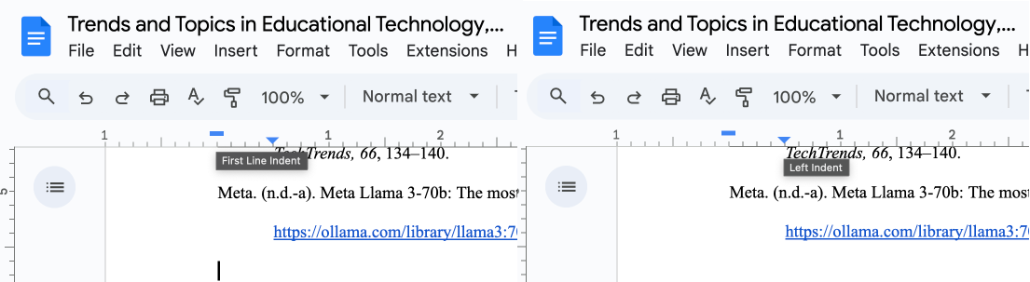

The following are several basic templates you can use for generating references for your most common kinds of referenced materials.

### Journal Article

Surname, F. M., & Surname, F. M. (2020). Journal article title goes here. Journal Title Goes Here, 1(2). https://doi.org/10.10.10/10.10.10

In this example, the number 1 is the journal volume number and the number 2 is the journal issue number. If there is no issue number, exclude the number and the parentheses.

If a DOI is available, always include it at the end of the reference as a complete URL.

### Book

Surname, F. M. (2020). Book title goes here. Publisher Name.

Please note that as of APA 7 no publisher location is required. This is a change from APA 6.

### Book Chapter from Edited Volume

AuthorSurname, F. M. (2020). Chapter title goes here. In F. M. EditorSurname & F. M. EditorSurname (Eds.), Book title (pp. 23-67). Publisher Name.

Here's an example of the chapter you're currently reading:

Kimmons, R. (2018). APA 7 job aid: Basic stylistic guidelines. In R. Kimmons & R. E. West (Eds.), Rapid Academic Writing. EdTech Books. https://edtechbooks.org/rapidwriting/apa_formatting_job_aid

### Authors

Table 5

Examples of Formatted Author Names

|  |  |
| --- | --- |
| Author Count | Example Reference (Journal Article) |
| 1 | Kimmons, R. (2020). Current trends in educational technology research and practice. TechTrends, 64(6). |
| 2 | Kimmons, R., & Johnstun, K. (2019). Navigating paradigms in educational technology.TechTrends, 63(5), 631-641. |
| 3-20 | Kimmons, R., Graham, C., & West, R. (2020). The PICRAT model for technology integration in teacher preparation. Contemporary Issues in Technology and Teacher Education, 20(1). |
| 21+ | One, O., Two, T., Three, T., Four, F., Five, F., Six, S., Seven, S., Eight, E., Nine, N., Ten, T., Eleven, E., Twelve, T., Thirteen, T., Fourteen, F., Fifteen, F., Sixteen, S., Seventeen, S., Eighteen, E., Nineteen, N., ... Last, L. (2020). The PICRAT model for technology integration in teacher preparation. Contemporary Issues in Technology and Teacher Education, 20(1). |

## Indents

When indentations are necessary, use 0.5" indentations, and use your word processor's built-in indentation tools. Do not use tabs or spaces in place of indentations, as this will create formatting issues later on. Especially do not artificially break a citation with returns to indent subsequent lines.

In Google Docs, you can adjust indents in the ruler bar or by going to Format > Align & Indent > Indentation Options.

## Page Breaks

If you need to move content down to a new page, do not hit enter/return a bunch of times to create empty paragraphs. Rather, use your word processor's page break feature. In Google Docs you can do this with ctrl+enter/cmd+enter or by clicking Insert > Break > Page break. This prevents formatting issues later, such as when you add more content above the break point that might move the content after the break around in unexpected ways.

## Lists

Lists can be helpful for grouping content or ideas together. Some general principles to follow when using lists include the following:

* Use unordered (bulleted) or alphabetic (a, b, c) lists instead of ordered/numeric lists (1, 2, 3) unless there is a reason for the order (such as in the steps for following a recipe or process).
* Use parallel structure in list items, such as starting each item with the same form of speech (like a verb or gerund).

### In-text Lists

In-text lists can be useful for clarifying breaks between ideas in long pieces of text. Here is an example:

Open education can (a) reduce costs to students, (b) improve teacher flexibility to revise content, and (c) encourage a culture of continuous improvement.

### Block Lists

Block lists are useful for lists with larger amounts of content. When creating lists, use your word processor's built-in list feature rather than manually typing the letters, numbers, or bullets. This will help prevent formatting problems and allow you to more easily adjust list content or list item order.

You can introduce a list with a sentence followed by a colon if the sentence is a complete sentence.

Elements of good design include the following: correctKnowing your user story;Focusing on user needs;Iteratively improving minimum viable products;...

Elements of good design include: incorrect...

## Quotations

Direct quotations should generally be used sparingly (relying instead on paraphrasing), but they are sometimes useful for preserving the exact wording used by a cited author or to ensure that you are not misrepresenting an author's claim (especially when you intend to argue against it).

### In-text Quotations

When including a direct quotation, you should encapsulate it in quotation marks and include the page number (p. XX) or paragraph number (para. XX) of the quote within the citation. An example of this would be the following:

The authors argued that paradigmatic plurality "may be a necessary reality of addressing complex educational problems" (Kimmons & Johnstun, 2019, p. 632).

### Block Quotations

Lengthy quotations of 40 words or more should not be encapsulated in quotation marks, however, and should represent their own block of text with a 0.5" indentation on the left. Include the citation after the final punctuation mark in the blockquote itself unless you have previously referenced the citation in an introductory sentence. An example of this would be the following:

The authors argued the following:Though the hard sciences may be more amenable to a single-paradigm model (e.g., the Earth and the Sun cannot both be the center of the universe), social sciences and endeavors like education will exhibit greater plurality as professionals harbor fundamental disagreements about morality, people, and the social world. Either way, we have not, as a field, adequately grappled with this plurality nor articulated intentional ways for professionals to navigate it. (Kimmons & Johnstun, 2019, p. 632)

## Commas

Commas are perhaps the most misused form of punctuation. Do not use them to merely show when you would take a breath or just because a sentence is getting long. Rather, you should generally only use them in the following situations provided in Table 6, and common examples of comma misuse are provided in Table 7.

Table 6

Correct Comma Usage

|  |  |  |
| --- | --- | --- |
| Situation | Example(s) | Note(s) |
| Between Seriated or Listed Elements | The student was sad, angry, and frustrated. correct I collected the data, analyzed the results, and reported on my findings. correct | Use the Oxford rule Use parallel structure |
| After an Introductory Phrase | First, I collected the data. correct After collecting the data, I ran the results. correct |  |
| To Set Off Parenthetical Clauses | Problem-based learning, which is now commonly used, involves giving students a problem to solve. correct | Usually denoted by "which" or "such as" but not "that" |
| To Separate Independent Clauses | We collected the data, and we analyzed the results. correct We found one result, but the other team found another. correct | Must use a conjunction, such as "and," "or," or "but" |

In lists, also be sure to use Oxford commas, which means placing a comma prior to the last conjunction. This is important because some items in a list might also use conjunctions. Consider the following incorrect example:

My favorite sandwiches are ham and cheese, grilled cheese and peanut butter and jelly. incorrect

Does this mean that I like "grilled cheese and peanut butter" sandwiches and also "jelly" sandwiches or "grilled cheese" sandwiches and also "peanut butter and jelly" sandwiches? Rewriting with an Oxford comma makes it clear that "grilled cheese" is its own sandwich and so is "peanut butter and jelly," as follows:

My favorite sandwiches are ham and cheese, grilled cheese, and peanut butter and jelly. correct

Table 7

Incorrect Comma Usage

|  |  |
| --- | --- |
| Situation | Example(s) |
| Before an Essential Clause | Games, that depict violence, are bad for children. incorrect Games that depict violence are bad for children. correct |
| Between Two Parts of a Compound Predicate | We collected the data, and analyzed the results. incorrect We collected the data and analyzed the results. correct |

## Semicolons

Semicolons may be used to join two independent clauses into a single compound sentence without using a conjunction, as in this example:

We shouldn't teach students what to think; we should teach them how to think. correct

## Colons

Colons may be used between an independent introductory clause and a final phrase or clause of illustration, as in this example:

The evidence is clear: Tutoring improves student test performance. correct

Do not use a colon after an incomplete sentence, as in this incorrect example:

According to the evidence: Tutoring improves student test performance. incorrect

If the text following the colon is a complete sentence, it should be capitalized.

## Em Dashes

An em dash may be used to set off an element that adds to or digresses from the main clause, as in this example:

Evidence shows that tutoring—direct, one-on-one communication with a more-knowledgeable other—improves student learning. correct

Do not use spaces around the em dash, and do not merely use a dash (-) or two dashes (--) in place of an em dash.

On a Mac, you can use option+shift+dash(-) to get an em dash. On Windows, you can use windows+period(.) to bring up the symbols panel or hit alt0151 if you have a keypad. You can also copy the em dash from here: —

## En Dashes

En dashes are primarily used to indicate a numerical ranges, such as page or date ranges, such as the following:

pp. 65–68

8/4/25–12/31/25

Generally you'll need to look up an en dash in the "Special Characters" feature of your word processor, however on a PC you can hit alt0150 if you have a keypad.

## Hyphens

Hyphens are used to join two words together into a compound word. They are generally used in situations where the meaning of the sentence might be unclear without them, as in this example:

High-achieving students from middle-class families are overrepresented at charter schools. correct

In this example, placing the first hyphen helps clarify that "high" refers to "achieving," while the second clarifies that "middle" applies to "class." One rule of thumb is that if a compound word is being used as an adjective modifying a noun (e.g., "high-achieving" is modifying "students"), then it should be hyphenated.

## Tables

Text is one-dimensional and linear (top-to-bottom). Tables, on the other hand, are two-dimensional and are better for representing information that is benefitted by two-dimensionality (like being able to cross-reference a value to its type, like n, M, or SD, and to another descriptor).

Tables should not be used for data that are one-dimensional, such as lists or paragraphs of texts. If a list will suffice, then you should use a list.

Tables should also be referenced from and described by the text, such as by writing "(see Table 1)".

Table formatting in APA 7 follows a few basic rules:

* Only use horizontal borders, not vertical borders.
* Only use horizontal borders at the top and bottom of the table and between sections of content, such as between a heading row and a content row.
* Do not bold or italicize headings unless they should be italicized for another reason (such as using a Greek symbol for a statistical value).
* Use a sans-serif font option to distinguish from prose.
* Top-align all cells vertically.
* Left-align text horizontally.
* Center-align numeric values and headings.
* Use commas to separate place values of large numbers at the thousandths level (e.g., 3000000 should be 3,000,000 and 4134 should be 4,134).
* Use consistent place values in decimal numbers (e.g., if you have .43 and .297 in the same table, report them as .430 and .297 or as .43 and .30).
* Do not put content into tables simply to reduce the word count of your prose.
* For headings prior to tables, in the first line type "Table X" where X is the order number of the table in the document, and in the second line, type a descriptive title in title case as shown in Figure 2:

Figure 2

Screenshot of an Example Table

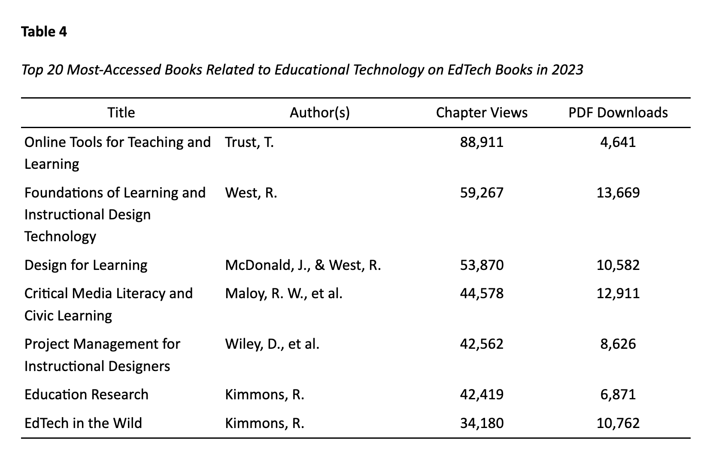

## Figures

Figures include images, icons, graphs, and any other visual material in your manuscript. Figures should use numbered headings like tables and should follow the same basic rules, as follows:

* Ensure sufficient contrast between text and background colors in images so that text is readable.
* Ensure that text in the image is large enough to read.
* Ensure that your image is high enough resolution to avoid fuzziness on different screens and when printing (generally 300dpi for print).
* Center-align images or have them fill the horizontal screen space.
* Include alternative text for the image that describes its contents to ensure readability for everyone.
* Do not use an image or figure if text will suffice.
* Do not simply use an image of text unless there is a clear reason to do so (e.g., to represent something that must be visualized).

Figure 3

An Example Figure for a Paper

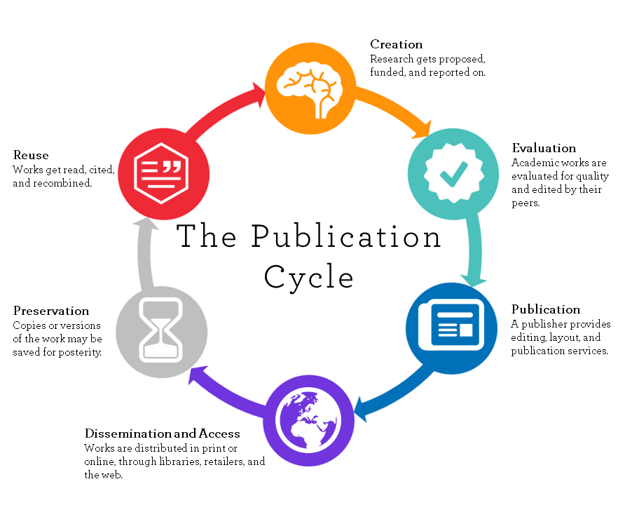

## Latin Abbreviations

### e.g.,

The abbreviation "e.g." is short for the Latin phrase "exempli gratia," translated as "for example." You may use it followed by a comma when providing a single example or a non-exhaustive list of examples, as in this example:

Teachers use many technologies (e.g., Google Docs, interactive whiteboards, and 3D printers) in their classrooms. correct

### i.e.,

The abbreviation "i.e." is short for the Latin phrase "id est," translated as "that is." You may use it followed by a comma to restate, define, or clarify something you have already said, as in this example:

Teachers now use interactive whiteboards (i.e., electronic whiteboards with features that allow for tactile interaction) to perform a variety of common tasks. correct

### cf.

The abbreviation "cf." is short for the Latin term "confer/conferatur," translated as "compare." You may use it to point your reader to another idea or source related to your statement, as in this example:

Thompson (2019) found that tutoring had little effect on student achievement, unlike previous studies (cf. Adams, 2011). correct

### etc.

Generally avoid using "etc." or "et cetera," and use "e.g." instead. Be sure not to use "e.g." and "etc." in the same list, because if you do, "e.g." means that you think it's important to provide some items in a list, but "etc." means that you don't think it's important to provide additional items in the list, which is unnecessary, because you're only providing the needed items to begin with.

Teachers use many technologies (e.g., Google Docs, interactive whiteboards, 3D printers, etc.) in their classrooms. incorrect

Read this online at <https://edtechbooks.org/rapidwriting/apa_formatting_job_aid>