# Virtually De-Centered and Radically Hopeful: Faculty Learning Communities

Török, J., Conley, M.

In Fall 2020, Pratt Institute's (US) Center for Teaching and Learning facilitated and participated in a Deep Dive Community on Feminist Pedagogies (FemPed Deep Dive Community). This fully online faculty development series used online platforms for collaborative research, conversations, community building and engagement. The program brought together a diverse faculty group from nine departments to examine readings on feminist pedagogy, apply critical lenses to classroom and administrative work, and set the task of enacting a Reflective Action Plan. The goal of the Plan was to both look back at the labor completed and its implications, and become part of a larger institutional tradition based in real action as individuals in our classroom practice and as a group in this Community, the first of its kind. Our chapter provides an experiential reflection on this virtual FemPed Deep Dive Community as our case study along with an exploration of practices that we have implemented in our community. We showcase how we put the pedagogical suggestions of “Don't Hate Me Because I'm Virtual” by Chick and Hassel (2009) into practice with colleagues as we gathered online. We reflect on the larger implications and what they mean for online teaching practices as well other feminist-pedagogy-inspired virtual faculty learning communities or groups.

Our chapter aims to frame our virtual FemPed Deep Dive Community through the concept of hope as a radical agent. We share both our successes and shortcomings through an experiential reflection on this virtual community, and through deep respect for the process and less emphasis on progress. We put the pedagogical suggestions of “Don't Hate Me Because I'm Virtual” by Chick and Hassel (2009) into practice with colleagues as we gathered over a period of four weeks. A de-centered collective community, where each participant is asked to be self-guided as well as responsible to the entire group, is quite out of the ordinary within the traditional system of higher education; it was also truly a difficult leap for some because of pandemic-related fatigue and social-upheaval traumas, among myriad other reasons.

We will discuss what it was like to both participate and facilitate the FemPed Deep Dive Community project, thus blurring the lines of traditional notions of teacher and student roles. We practiced through various activities and reflection prompts how we might de-center the "classroom," and make visible the often ignored emotional heavy-lifting that accompanies a caring-focused pedagogy, which needs constant attention and thought (McKenna, 1996). Inspired heavily by Crenshaw’s (1991) critical lens on intersectionality, we discussed the need for developing a language which is critical of the dominant view of teaching and educational institutions. The group explored how we can know that our community was truly building on the experiences of the participants, and that we were collectively moving on to seeing our “experiences in different lights and relating our experiences to other or new evidence” (Shrewsbury, 1997, p. 6-7). We will then reflect on the larger implications of our take-aways and what they mean for online teaching practices as well other feminist-pedagogy-inspired virtual faculty learning communities or groups.

## The Deep Dive Community

In planning Center of Teaching and Learning (CTL) programming, we try to offer a dynamic mix of faculty conversations to support teaching in online and hybrid modalities, technology platform-modeling sessions, and continuing our ongoing discussions about more theoretical aspects of art and design educational practices. We offer year-long Faculty Learning Communities that are a major contributor to the progress of the scholarship of teaching and learning efforts on our campus, but the entry points to these communities are infrequent and the yearly commitment required can seem daunting, inaccessible, or undoable to many. In an effort to combine faculty’s need for camaraderie and practices (modeled by our Faculty Learning Communities) but with only a small fraction of the commitment, we designed our month-long Deep Dive Communities. These Deep Dives are aimed to be cross disciplinary, reflective, action-oriented, and critical. Our main focus was on sharing theoretical pedagogical frameworks that colleagues could ultimately incorporate into their classroom and teaching practices. Based on some informal polling on possible topics, we decided that the first Deep Dive Community would focus on feminist pedagogies (FemPed, for short).

Remaining true to the centrality of a community, as established by best practices in our Faculty Learning Communities as well as the tenets of feminist pedagogies, our aim was to keep the structure of the Deep Dive Community very decentered. Aside from participation in synchronous sessions and a final reflective action plan, we had only a loose idea of the arc of the series; exactly how we enacted that loose plan was very much based on a group consensus.

### Selected prompts from our community-building activities:

**Framing Questions**

    •    What community guidelines do you want to propose for our group (if other than the CTL guidelines)?  
    •    How should we work together, what should we value most as a FemPed Deep Dive Community?  
    •    What are your individual questions (intentions/objective) you'd like to explore in this Deep Dive Community?  
    •    What should be our collective set of objectives/intentions to engage with during this series?

With ten faculty participants

—

five part-timers and five full-timers

—

we embarked on a series that would explore, critique, and reflect on feminist pedagogies for our art and design school. We promised to pay part-time faculty a small stipend for their investment of time and commitment to this work. Using a mix of Zoom for synchronous meetings and Milanote for our asynchronous work, our first task was collecting resources to read together and use as common texts. We settled on Chick and Hassel’s article “Don’t Hate Me Because I’m Virtual” (2009) and asked colleagues to add their own favorites that they thought might be good for the group to read.

### Some suggestions received from our reading board

* I’m Your Sister: Black Women Organizing Across Sexualities, by Audre Lorde
* On Intersectionality, by Kimberle Crenshaw
* What is Feminist Pedagogy?, by Carolyn Shrewsbury
* Teaching to Transgress: Education as the Practice of Freedom, by bell hooks
* Care the Core: Conversational Essays on Identity, Education and Power, by Sherri Spelic
* Transforming Higher Education with Distributed Open Collaborative Courses (DOCCs): Feminist Pedagogies and Networked Learning, by Balsamo and colleagues
* New Ways of Seeing podcast, by the BBC Radio 4

At the forefront of everyone’s mind in the Fall of 2020 was the recent and still shocking switch to almost-exclusive virtual teaching because of the covid-19 pandemic, thus taking the virtual aspects of FemPed into consideration would be important as Chick and Hassel state:

If the principles of feminist pedagogy can revise classroom spaces, learning activities, and modes of communication and knowledge construction in our F2F classes, then imagine their potential for the often quiet, distant, lonely, impersonal non spaces of online classes, where learning too easily slips into the one-way transfer of information in virtual independent study or correspondence courses. The potential is great, particularly because online classes are often full of characteristics antithetical to our ideal feminist classroom. (Chick and Hassel, 2009, p. 196)

Chick and Hassel continue to unpack the question, how to embed feminist values in learning environments, and suggest that we consider three key aspects: 1. Dynamics and Environment, 2. Definition of Knowledge and 3. Habits of Mind. Next, we demonstrate how we applied each aspect to our program design.

Dynamics and environment. Paying attention to power dynamics in a feminist virtual classroom is important for the learners to be able to use their voices authentically and care about themselves and each other as they contribute to the knowledge produced by the community. We intentionally designed our FemPed community and our asynchronous platforms to be open and inviting, with spaces for individual connections and personalities to shine through. We were also keenly aware of perceived hierarchies and power dynamics within our community from the start, and we hoped to create shared roles and responsibilities for us as facilitators, and for our faculty colleagues as participants.

Definition of knowledge. There is a need for a deliberate and reflective attention to forms, kinds and constructions of knowledge that occupy our classrooms. As virtual feminist teachers, we must embrace the complexities and ambiguities of our knowledge as a construct, therefore create opportunities for our learners through activities, assignments, course modules, and discussions to recognize that knowledge is beyond just individually processing data. It includes active learning, collaboration, interactions, hopeful inquiry–all of which were basic building blocks of our FemPed Deep Dive Community. We discussed various metaphors for learning and education (some suggested by the authors, others by our participants) to help us collectively clarify and create meaning. We utilized pair work and small group discussion strategies in our Zoom calls, as well as a fishbowl activity to explore topics in our community.

Habits of mind. As one of the most abstract yet central aspects of learning in a college classroom, this concept includes some higher order thinking and tasks, such as analyzing and synthesizing texts, evaluating arguments and demonstrating ownership of one’s education. From a feminist perspective, these habits need to also be shaped by reflections on gender, race, class, and culture as intersecting power structures. Awareness of intersectionality and “confluence” (Shaw & Lee, 2007, p. 62) were key topics in our FemPed discussions, as we took apart the complexities of teaching to diverse populations, while embracing multiple perspectives in our classrooms as feminist educators.

## Asynchronous Activities

Milanote (milanote.com) is a collective drafting platform aimed mostly at creatives as a means of brainstorming or organizing projects, either individually or as a group. It was suggested by a colleague and we found it very beneficial for our own idea development at CTL. We have been successfully using it with participants in our center events and series since we moved to function fully online in March 2020. It allows for a mapping of ideas using text and image, as well as the nesting of ideas within boards, which one can drag from a simple tool bar on the side of the platform in order to comment, annotate, organize, and map (see Image 1).

Image 1

Creative Milanote board with links to quotes, images, websites that participants felt like sharing across the series mostly on asynchronous time.

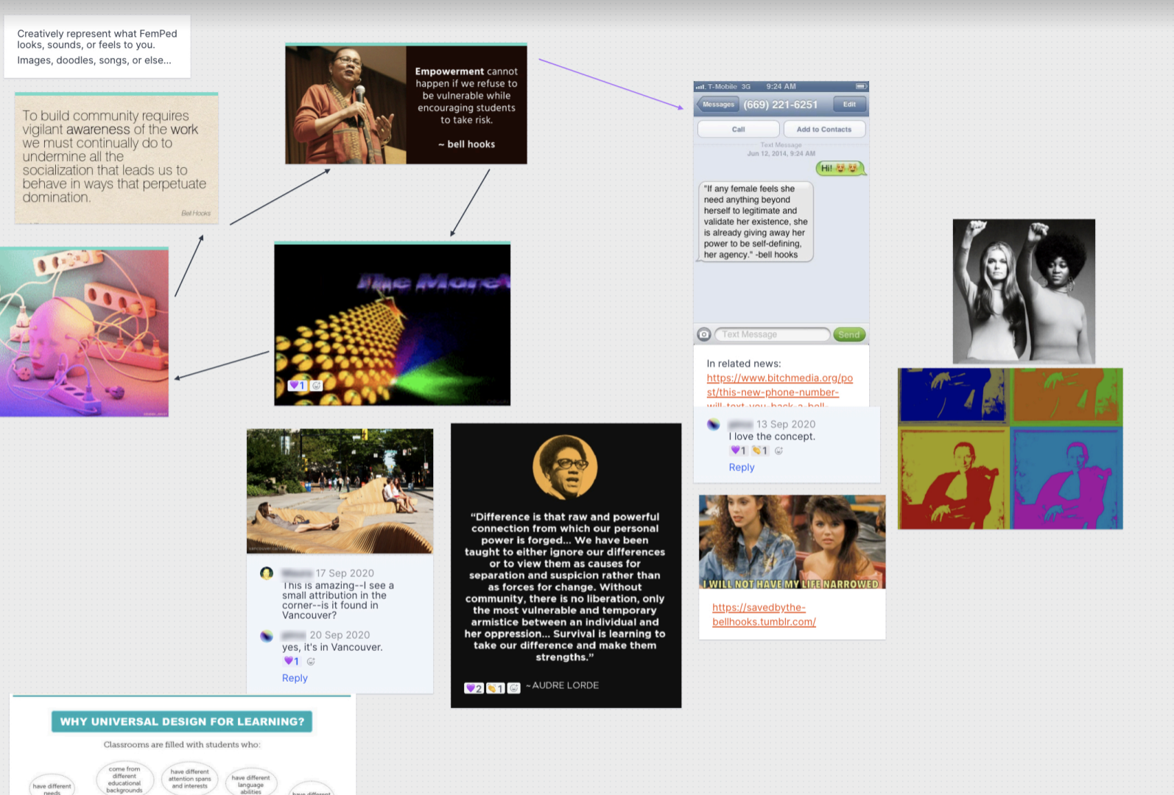

We began each new week of the FemPed series by adding a new Milanote board nested onto the main FemPed board. We listed potential tasks for our participants to engage in, a reading list to consider or contribute to, as well as some creative fun spaces that the group would collectively play in. Eventually at the end of Week 4 of the series, Milanote would host everyone’s reflective action plans. This platform appealed to us because of its extremely visual nature. This tool could accommodate all different formats, such as a PDF or an image file, and participants in the series could also add to a "questions board" with written notes and comments addressed to specific colleagues, visuals like GIFs or embedded hyperlinks to answer a query, an emoji to express an emotion, or even color-code their responses in order to facilitate the drawing of connections amongst ideas that drove much of our conversations, synchronously and asynchronously.

### Selected prompts from our asynchronous activities

**Exit Tickets**

**Week 1**

* Balancing our want for progress and an end goal, with our strong rejection of traditional ideas of production/productivity/labor—Where do we as a group want to be at the end of Week 1?
* How did your original intention change, morph, or solidify?
* What is your understanding of both your role within this community, as well as the larger role of the community itself?

**Week 2**

* What's the perfect recipe of practical—usable—decentered practice?
* Did today's synchronous Zoom activity get you/us any closer to your/our end goal? (or was it neutral, a set-back, any mixture thereof...)

**Week 4**

* One interesting thing that has been eye-opening for you?
* How do you think you will work with these discoveries?
* Can feminist pedagogy be a coherent practice in academic institutions as they are today?
* What’s next, what should come next?

As a teaching and learning center within an art and design school, a consideration we take seriously is to grow beyond the traditional text-heavy idea sharing, and Milanote seemed like the perfect blend of text and visual. All of this is to say, theoretically, Milanote is an ideal platform for a CTL situated within an art and design context, but when used within a faculty community we realized its shortcomings in practice.

### FemPed Milanote Weekly Board Set Ups

Week 1: Coming Together

* Readings Board
* Guide to FemPed
* Creative Fun
* Framing Questions
* Week 1 Exit Ticket

Week 2: Pulling Threads and Critical Lenses

* Readings Board
* Emerging Themes
* Pull Quotes
* Fish Bowl Notes
* Personal Reflections

Week 3: Individual Work

Week 4: Reflective Action

* Readings Board
* Reflective Actions
* Evaluation and Feedback
* Final Submissions

Reflecting back, there are some limitations to Milanote as our collective platform. Since the platform’s main draw is its visual nature, it moves beyond a linear understanding of how ideas link together and represents the otherwise text-heavy bullet pointed agenda in a more organic manner. Not everyone found this approach accessible. Because there were many different entry points, some participants voiced concerns about "making sense" of what was there, how the boards were linked or organized and joining the conversations hosted on the boards each week. One participant reflected at the end of the series that he failed to interact with the Milanote board much beyond the first week because he is a linear thinker and thus was unable to make sense of its visuality.

Collaboratively choosing a platform could have added another layer to the democratic process we were looking to establish in the FemPed Deep Dive Community, but since we wanted to "hit the ground running" in the first week of the series, we opted to make that decision as facilitators ahead of time, rather than as a group. Our sense is that because there is not one perfect platform (each has its own benefits in terms of linearity, visuality, clarity, or ADA-accessibility; also, each user has their own ideas about what is most important in a platform) there probably wouldn’t have been a consensus even if we had embedded choice of platform into the democratic nature of the Deep Dive Community.

The platform was not ADA compliant and in considering accessibility beyond just one small group of faculty, Milanote did not seem the logical choice. Additionally, we did not use the platform as fully as we might have for both the asynchronous and synchronous portions of the series, which could have served as an incentive for our reluctant users to engage with it, perhaps a little bit more. In hindsight, we speculate that there must be something that invites or brings people back to the Milanote board

—

during the sessions as well as in between

—

in order to really see it grow as a lively place of iteration and interaction for its users.

## Synchronous Activities

We organized weekly synchronous meetings for our participants in this series. During these Zoom sessions, we focused heavily on community building. We made sure to spend some time at the top of each session checking in with each other to build trust, as most participants hadn’t worked with one another before. The second task each week in the synchronous sessions was to begin to get participants thinking about their developing reflective action plans. Some of the synchronous activities and prompts that aided this process included Virtual Consult to Clarify, Virtual Fishbowl Activity, and weekly Exit Tickets.

### Selected prompts from our synchronous activities:

**Virtual Consult to Clarify** (adapted from Lipmanowicz and McCandless, 2014)

30 minutes, three rounds (each round 10 min.)

* Round 1 begins
* In groups of three, one person is the Participant and 2 are Consultants
* Participant shares their personal intention for an outcome as they take part in this FemPed Deep Dive Community (1 min., video on for all)
* Two Consultants - ask follow-up and clarification questions to better understand the Participant (2 min., video on for all)
* Participant turns off voice and video
* Two consultants discuss what they heard, the viability, their suggestion, perceived challenges (5 min., video on for Consultants only)
* Participant turns back on their voice and video
* All three debrief (2 min., video on for all)
* End of Round 1 - Round 2 begins
* Switch roles.

**Virtual Fishbowl Activity** (adapted from Chick and Hassel, 2009)

45 minutes, three rounds (each round 15 min.)

* Round 1 begins
* Divide the group into Fish (2 or 3 people) and Observers (rest of the group)
* Pose a question for the Fish
* Round 1 question: What themes are you seeing?
* Round 2 question: What is emerging for you so far?
* Round 3 question: What are you not seeing and is that problematic?
* Fish leave their voice and camera on, all other Observers turn camera off and mute themselves
* Designate a note-take (one of the Observers who is not a Fish in that round)
* Fish begin discussing the assigned question (10 min).
* When time is up all Observers turn voice and camera back on and share what they have heard as a whole group
* End of Round 1 - Round 2 begins
* Switch roles

Our participants found these synchronous events the most convenient way to take part in the series. Mostly, and it is worth reflecting on whether this is pandemic-specific, our faculty love participating in very open and honest conversations that we are able to host as part of our general Center for Teaching and Learning series, and this FemPed was no exception. Participants were engaged with the weekly conversations in our FemPed Zoom rooms, often citing it as the highlight of the series. Via our feedback form, one participant commented, “I think it worked best in real time with the conversations that were held. The real time discussions seemed to be the most engaged/worked best with the group.”

## Reflective Action Plan

As our culminating activity, we asked participants to complete a reflective action plan. Understanding that reflection is a best practice as well as the foundation for growth and development, we asked our FemPed Deep Dive Community group to incrementally write their reflections throughout our time together. We generated a few initial questions or guiding prompts to get the group thinking, which centered around the experiences of participants within the series, how they might continue to work with what they have come to understand, and concerns they might have about what comes next.

### The prompts for the reflective action plans included:

* One interesting thing that has been eye-opening for you (what you came here with, what you expected vs. what it turned out to be)
* How do you think you will work with these discoveries going forward? What will you do, specifically? Feel free to give a short description of a classroom exercise, or a practice.
* How would you explain to others what we have been talking about in this Deep Dive Community? What this FemPed Deep Dive Community is all about?
* How do we link the FemPed Deep Dive Community to other existing resources within and outside Pratt? Creating a collective resource as an ongoing process. What is one resource you would suggest for this resource to get it started?
* What is next, what should come next? What is exciting about what comes next? What concerns do you have about what is and what comes next?

The Reflection Action Board was great and engaging but within the meetings there was a noticeable lag in everyone's willingness to share. Because of the initial lack of traction with the reflective action plans and with a hope to catalyze this process, we decided to give it some air time in the last Zoom session and work on it synchronously as a group on a shared Milanote board. We introduced the prompts then gave people time to chat with each other and jot down initial thoughts. Watching it unfold in real time on the shared Milanote board (Image 2) was very exciting. Something about the board populating within the session did seem real and tangible in a way it hadn’t yet before.

Image 2

A generative use of our synchronous Zoom time together; gaining traction with participants on our Reflective Action shared Milanote Board.

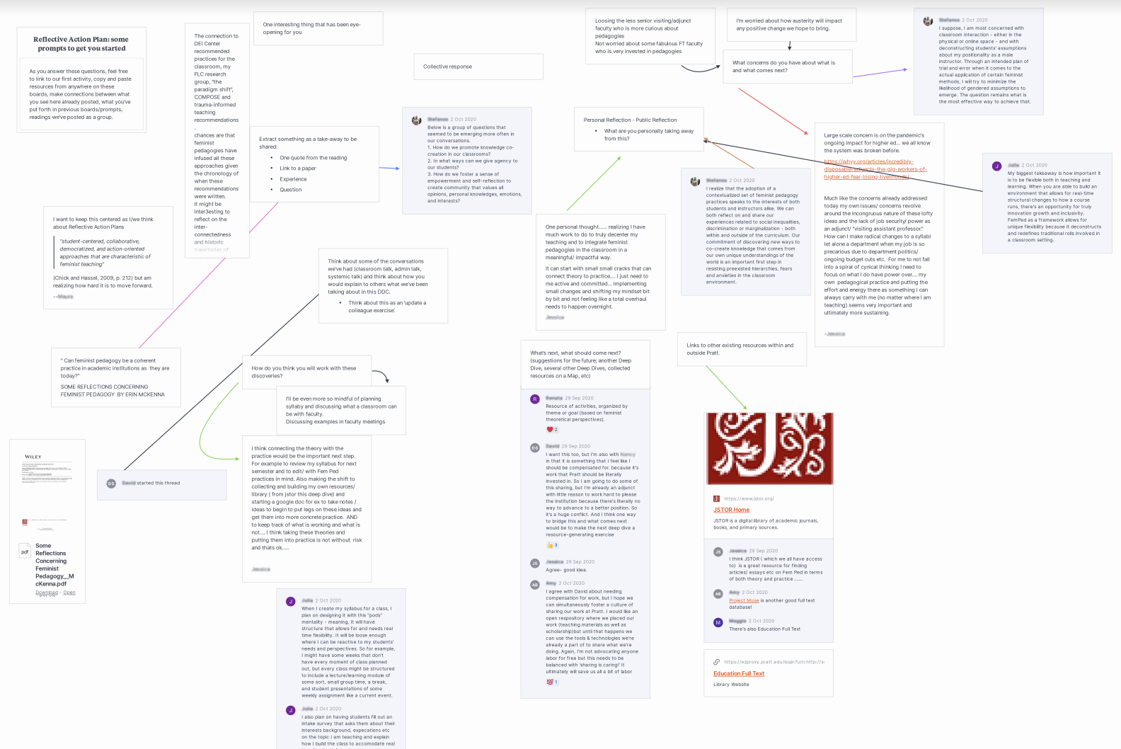

In thinking about the open structure of the reflective action plans, and given that this was the first time we had run such programming, we wonder if people were at a loss for what they wanted to do or write about, or maybe even what they thought we wanted from them. We had no model to share, nothing really to aim at, and so this could have added to the hesitancy. We know from the follow-up survey that of all who completed the survey, 100% were "Very Satisfied" and would "Definitely Recommend" this program to a colleague. Other feedback we received from the participants included comments, such as "the Deep Dive remained a lot on the discussion level and even though I loved those and I also see a lot of participation on the boards, I miss a conclusion of sorts that is maybe more about the collective than the individual takeaways."

There was confusion about what participants were committing to do versus what the role of this group was within the larger institute. In an effort to incorporate some of these habits of mind, we unpacked ideas as they exist within individual classrooms versus more systemic and institutional structures that bind. And while many of us found these questions useful for our praxis as teachers enacting any sort of feminist pedagogies with students and other colleagues, the ideas also gave breath to some of the larger institutional critiques looming over all the work we do in questioning and critiquing higher education. In hindsight, we could have leaned into this collective take-away a bit more.

## Reflections on FemPed for Online Teaching and Faculty Learning Communities

Something we found ourselves coming back to again and again throughout the series was the question of evaluation of this Deep Dive Community, that is: what would it look like if our FemPed worked? While this community focused on discussions around incorporating feminist pedagogies into our online classes (and departments), we were also interested in evaluating how these feminist values and practices were enacted in this small faculty community. Although there was a consensus amongst our participants that the attributes of feminist pedagogies were all quite valuable (i.e., ground-up work, harnessing differences, destabilizing traditional power dynamics) we did find that the group continuously looked towards our center for guidance and leadership. The participants largely felt uncomfortable with determining what course the community should take, and were hesitant to suggest structures, community activities or topics of discussion for the group. So this made us wonder: is this a failure of our enactment of the decentered dynamic lauded by a feminist pedagogy? Or perhaps it was the interference with other systemic structures, habits of mind and ways of being with each other within an academic setting that prevented the group to truly enact feminist values? Our gatherings each week were lively, inquisitive and inclusive. The topics and themes built on each other, and the flow of conversations and group orientation, was moving along together towards our set goals. Our conversations raised critical questions, and inspired the group to a commitment to enact some of these practices in their individual classes. Perhaps that is good in itself.

Traditional evaluative procedures don't work for non-traditional classroom and academic practices. Given the inherent power relationships and hierarchies that exist amongst part time and full time faculty, chairs and other administrators—and, of course, us as colleagues working in a teaching and learning center like ours—traditional educational evaluation processes don’t quite apply here. In the following, we would like to provide some of our tentative proposals for what structures could have impacted the flow and results of this FemPed community, in hopes that others who might wish to replicate a similar community could consider them in their planning.

## Larger Implications of FemPed within the Institution

One thing we couldn’t help but notice when we took stock of which of our participants submitted their final reflective action plans was the visible divide between part-time and full-time faculty’s completion of these reflections. While hardly noticeable in any other aspect of the Deep Dive Community, the divide was blaring in participants’ reflections. While all of the part-time participants completed their reflections (and thus were eligible for the stipend) only one full timer completed the reflective action plan. Paying a small stipend to part-time faculty is our way of acknowledging their time commitment in doing this work. It is an equity-inspired commitment we would like to stand by given the glaring inequities endured by part-time faculty within the US higher educational system. But as we reflect back on the institutional limitations between who can be paid for this work and who cannot, as well as our choice to make the reflective action plan a stipendable product for part-timers, we wonder if it inadvertently allowed our full-time colleagues not to complete the work because they weren’t aiming for the stipend, while part-time participants felt compelled because their stipends were at stake. Did we in fact exacerbate the divide? A piece of the conversations that stuck with us as we write this case study’s reflection is that there are parts of feminist pedagogy that are more applicable for our small communities, our classrooms, our most intimate of interactions, but not suitable or germane when applied to our entire institutions and educational structures.

On that note, the issue of labor was a popular and heated theme in our synchronous Zoom conversations and a prominent emergent topic on our collective Milanote reflection board. As one participant commented on "Vulnerability":

How can we both model these ideas/ theories without being dogmatic? How can we find a more nuanced approach to both traditional lecturing and modeling, while also allowing ourselves the space to ‘mess things up’ and recognizing our own intersecting identities? We should be putting ourselves in the seat of the students.

But even more, maybe it is impossible for FemPed (the way we imagined it) to work inside of an institution. Alongside the topics of vulnerability and the part-time/full-time divide, and the inequities those create, we reflected on how the current structures of higher education factor in to our efforts to practice feminist-inspired pedagogies in our classrooms and faculty communities. Again, a voice from one community participant:

Also how does the business model of education factor in, seeing our students as "products"? The hierarchies of education reinforce the domination. Many part-timers are considered expendable teachers with little job security and no benefits in a highly competitive market/workplace.

This all rings very true, as most of our center events are attended by part-timers. It is there we feel the most immediate implications of these structural vulnerabilities for our small community, and all this came to the forefront of our collective discourse, in this particular series. But the fact that these critical issues plaguing higher education do come up in the FemPed and beyond, and are shared and reflected on openly and honestly in a group of cross-departmental faculty, leaves us hopeful that these spaces are useful and needed within a larger institution, where such issues can be forgotten or even co-opted and assumed into the daily operations without careful consideration and critical inquiry.

Faculty look to us for leadership in holding spaces for difficult conversations. And being aware of our status as full-time employees with our own intersectional identities, linked to very particular routes of power, we must continuously consider and practice the decentering of our spaces and assuring collective leadership and voice to all participants. So to the question of what are feminist pedagogical tools and practices we should keep refining in the future, we are committing ourselves to interactive community-building practices. Perhaps it is not just theorizing but more importantly paying attention to nuances–how communities form and function, how members experience power and voice within those communities, how to build trust and connection, and how to be mindful of triggers and our own embodied responses to differences. And in the spirit of feminist values, we hope to collaborate and learn from and learn with others who are investigating these types of structures and communities.

We found the FemPed Deep Dive Community personally inspiring and professionally very valuable. As our group wrapped up the reflective action plans and our time together came to an end, there was a palpable positive energy about the group that the conversations we had seeded the ground for future initiatives at the Institute. Just as rare as the decentered nature of faculty development series in general is the sense of hope that results from an examination of grassroots possibilities within the academe. It is our belief that the framework used for our inaugural Deep Dive Community should be taken into consideration for future open learning initiatives, leaning heavily on hope as a radical agent for change in a de-centered faculty community.

## References

Chick, N. H., & Hassel, N. H. (2009). "Don't hate me because I'm virtual": Feminist pedagogy in the online classroom. Feminist Teacher, 19, 195-215.

Crenshaw, K. (1991). Mapping the margins: Intersectionality, identity politics, and violence against women of color. Stanford Law Review, 43(6), 1241.

Lipmanowicz, H., & McCandless, K. (2014). The surprising power of liberating structures: Simple rules to unleash a culture of innovation. Liberating Structures Press.

McKenna, E. (1996). Some reflections concerning feminist pedagogy. Metaphilosophy, 27, 178-183.

Shaw, S., & Lee, J. (2007). Women’s voices, feminist visions: Classic and contemporary readings. Boston: McGraw-Hill.

Shrewsbury, C. M. (1987). What is feminist pedagogy? Women’s Studies Quarterly, 15(3/4), 6-14.

Read this online at <https://edtechbooks.org/feminist_digital_ped/bydvmMMj>