# The Subquery in an UPDATE statement

### The Subquery in an UPDATE statement

* Subqueries may be used in an UPDATE statement
* Since it is possible to change many values at once with a subquery, take special care before running an UPDATE statement with a subquery. You might make a copy of the table and data you are trying to change to test with before running your statement on live data.
* It is also possible to run your UPDATE statement inside of a transaction block that allows you to ROLLBACK or undo a statement. We will address the topic of ROLLBACK in a future lesson.

Code Sample:

1    UPDATE country 2    SET GNPOld = 0.00 3    WHERE Code IN 4    (SELECT CountryCode FROM countrylanguage WHERE population = 0)

Results:

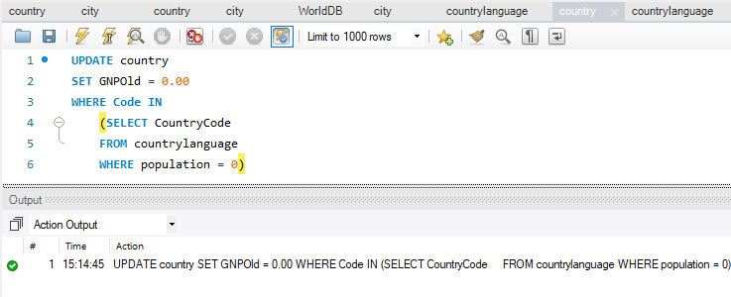

**UPDATE country**

* Update the country table

**SET GNPOld = 0.00**

* Set the value of the GNPOld table = 0.00.
* No quotes are required because the GNPOld column is a decimal datatype

**WHERE Code IN**

* Update only the rows where the Code column value is in the results list returned in the subquery show below.

**(SELECT CountryCode FROM countrylanguage WHERE population = 0)**

* Return a list of values from the CountryCode column from the countrylanguage table that has a population equal to zero.
* If these values match a code in the country table, the row is updated.

Read this online at <https://edtechbooks.org/learning_mysql/the_subquery_in_an_u>