# Create a Duplicate Table From An Existing Table

### Create a Duplicate Table from an Existing Table with a Select Statement

* It is often helpful to create a duplicate table from an existing table for testing purposes
* You can combine the CREATE TABLE command with a select statement to create a duplicate of a table structure as well as the data in the table.

Code Sample:

1    USE world; 2    CREATE TABLE city_bak AS SELECT * FROM city;

Results:

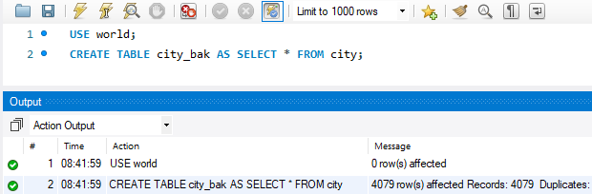

**USE world;**

* Select world as the default schema

**CREATE TABLE city_bak AS SELECT * FROM city;**

* Create a new table named city_bak with the exact same structure as the city table.
* Copy all of the data from the city table to the city_bak table

Read this online at <https://edtechbooks.org/learning_mysql/create_a_duplicate_t>