# How to Manually Add an Index to an Existing Table

* Right-click on the table
* Select ‘Alter Table’

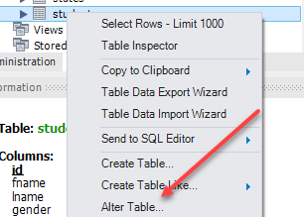

* Click on the ‘Indexes’ tab



* Type the name of the index in the ‘Index Name’ field
* Under ‘Type’ select ‘INDEX’
* Click on the column(s) that you want to index.
* Tab to a new line

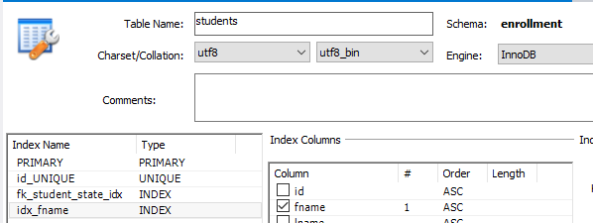

Read this online at <https://edtechbooks.org/learning_mysql/how_to_manually_add_>