# Performing Arts in the Early Childhood Classroom

## Dance in the Classroom

### "Before a child talks, they sing. Before they write, they draw. As soon as they stand, they dance. Art is fundamental to human expression."  - Phylicia Rashad

Movement in the classroom supports the academic, physical, social, and intellectual development of children in the elementary classroom. Some of the reasons educators integrate movement into their instructional activities are listed below.

* Support physical development and a healthy lifestyle.
* Promote social-emotional health and maturity.
* Integrate kinesthetic learning with conceptual understanding.
* Provide children with multiple perspectives.
* Nurture cognitive development and academic engagement.
* Help children develop literacy.
* Encourage social interaction and cooperation.
* Foster critical thinking and creative problem-solving skills.

### Movement vs. Dance

Dance is a rigorous academic, artistic, and social discipline with years of study, research, and influence on our society today. However, many educators and students carry preconceived ideas about what dance is, what dance looks like, and what dance means. These ideas are often narrow and limiting when it comes to the potential for movement to support learning in the classroom. Some educators choose to focus on the terminology "movement in the classroom" as opposed to "dance" to help themselves or their students feel more comfortable with physical expression in the classroom.

The most prominent images of what dance is and what dance looks like are presented in the forms of codified dance--ballet, modern dance, tap, and folk dances--that have a specific vocabulary and pattern for sequencing steps or movement. However, dance is used as a form of individual expression across the globe beyond these dance forms that dominate our Western society. Dance is a natural part of the human experience and can be used to express many ideas in the classroom.

### Elements of Dance

An understanding of the elements and concepts of dance is essential for a classroom teacher to design movement-integrated instructional events. The elements of dance are used to describe, guide, instruct, connect, and evaluate movement. The elements of dance are organized in many different frameworks. The "Dance is B.E.S.T" framework developed by Marilyn Berrett is described in the chart below.

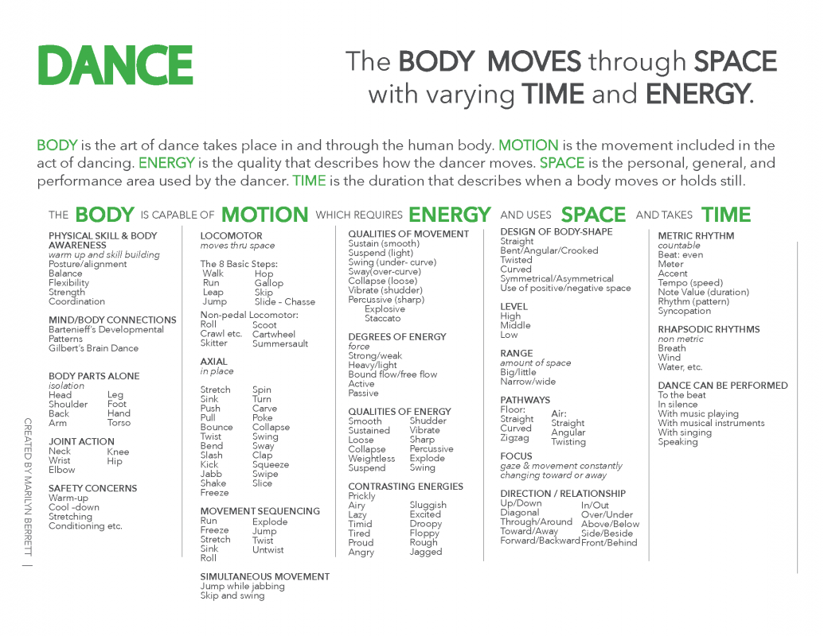

#### [Click here to download the "Dance is B.E.S.T" chart.](https://www.dropbox.com/s/qb059igr8dddzht/Dance%20Elements%20Chart.pdf?dl=0)

#### [Click here to download the dance poster and resources for using it as a word wall.](http://advancingartsleadership.com/node/89)

### Dance activities for the classroom

#### Brain Dance

Participants move through the eight fundamental movement patterns of Breath, Tactile, Core-Distal, Head-Tail, Upper-Lower, Body-Side, Cross-Lateral, and Vestibular. These patterns are introduced and integrated into the lesson as dance concepts (level, direction, size, pathway, focus, balance, and energy). Though usually performed standing, the Brain Dance can sometimes be done seated in a chair.

#### Group Mirror Warm-up

Teachers lead participants through balancing, stretching, and isolating body parts. Students reflect the movements of the teacher as if looking into a mirror. Be sure to change levels and travel through space but move slowly enough to have students stay in sync with the leader at all times.

#### Simon Says

Playing Simon Says moves various body parts in different ways and develops listening skills. ("Simon says to stretch your arms up way high." "Simon says to bounce in place." "Simon says to shake your hand.") When students make mistakes, teachers encourage continued participation in the warm-up.

#### Isolated Parts Warm-up

Warm-up with a body part dance. Teachers use a drum to create rhythm, naming a body part every time he or she starts drumming. Instruct students to dance with only that body part, keeping the other parts still. Ask questions: How many ways can you move that part? What are some new ways this part can move?

#### Head-to-Toe Warm-up

Begin by choosing a movement. Make it travel from your head to your toes and back again. Start with shaking: shake the head, then move the shaking from the head to the shoulders, arms, hands, torso, hips, knees, legs, feet, and back up through the body to the head. Try other movements like floating, stretching, pulling, twisting, and bending. Encourage suggestions. Use a drum or other movements (clapping, tapping, stamping) to accompany students' explorations.

#### Carousel Dance Warm-up

Display five to eight prompts at various locations around the room. Divide the class into groups and assign each a beginning station. Set a timer and give students one to two minutes to explore the movement prompt before signaling the transition to the next station. Repeat until students have completed the entire cycle. Coach them on the side to explore multiple solutions to each movement prompt.

### Integrating Dance with Core Subjects

Check out the following dance-integrated lesson plans designed by elementary classroom teachers and dance teaching artists for the BYU ARTS Partnership. These lesson plans represent excellent examples of using movement and dance to explore all subjects in the classroom.

* "[From Head to Toe by Eric Carle](https://education.byu.edu/arts/lessons/from-head-to-toe-by-eric-carle)" - Dance and English Language Arts for Grades K-1
* "[Every Dancer Counts!](https://education.byu.edu/arts/lessons/every-dancer-counts!)" - Dance and Mathematics (Place Value) for Grades K-2
* "[Heredity](https://education.byu.edu/arts/lessons/heredity)" - Dance, Science, and Social Studies for Grades 1-3
* "[Plants Can't Sit Still](https://education.byu.edu/arts/lessons/plants-can%E2%80%99t-sit-still)" - Dance and Science for K-3
* "[My Many Colored Days by Dr. Suess](https://education.byu.edu/arts/lessons/my-many-colored-days-by-dr.-seuss)" - Dance and English Language Arts for Grades K-3

Find more lesson plans at [www.education.byu.edu/arts/lessons](http://www.education.byu.edu/arts/lessons).

## 

## Drama in the Classroom

### "I regard the theatre as the greatest of all art forms, the most immediate way in which a human being can share with another the sense of what it is to be a human being." -Oscar Wilde

Guided classroom drama activities support the academic, physical, social, and intellectual development of children in the elementary classroom. Reasons educators integrate drama activities into their instructional activities are listed below.

* Provides a natural way for children to learn and explore.
* Encourages dispositions for teamwork and collaboration.
* Brings attention to the whole person, including physical, emotional, social, and intellectual aspects.
* Develops imagination, creativity, and critical thinking.
* Enhances the ability to express through movement and voice.
* Boosts confidence and builds 21st century skills.

#### [Click here to download the drama poster and resources for using it as a word wall.](http://advancingartsleadership.com/node/89)

### The Hallmarks of Guided Classroom Drama

While theatre is audience-centric and focuses primarily on students developing higher-level performance, design, writing, and tech skills, guided classroom drama is designed to benefit students' own understanding of themselves, help them develop a deeper understanding of ideas and issues, and encourage empathy for others. Storytelling, dramatic play, choral speaking, puppetry, pantomime, narrative mime, theatre games, mantle of the expert, improvisation, and teacher-in-role are examples of drama-based activities.

Guided classroom drama is easily integrated into other core curricula, is student-centric, incorporates the teacher as facilitator, and includes a non-formal audience and performing space. It is an appropriate method of teaching and learning for all grade levels. The culminating outcomes of guided classroom drama might include demonstrating understanding of concepts in other content areas, following directions, demonstrating more confidence when taking creative risks, improved group collaboration, speaking clearly, or using flexible and unique thinking to solve problems. These outcomes can vary in effective drama classrooms and may or may not be intended to become a final performance for an invited audience.

#### 1. Drama involves pretending, such as role-play and characterization.

Guided classroom drama is most often recognized as pretending. Guided classroom drama focuses on the use of an actor's tools: body, voice, and mind. Mind equals imagination and analysis, as well as creative problem solving. Pretending is fostered by open-ended questions with unlimited answers.

#### 2. Drama emphasizes the importance of relationships.

Often using design, sound, and movement to convey ideas, drama emphasizes the importance of relationships, can be communicated through speech and movement (sometimes using a script), and is expressed through an actor's body, voice, and mind. Guided classroom drama is focused on communicating content, including specific curricular content or more abstract ideas like emotion and empathy. Participating individuals and audience members will see, hear, understand, and feel the meaning of what learners and/or performers are expressing. In dramatic performance, showing is more powerful than telling. Ideas can be expressed through scenery, costumes, music, dance, blocking, stage business, puppetry, light, color, texture, mood, and energy.

#### 3. Drama is collaborative and encourages problem solving by highlighting conflict.

The facilitating teacher of a drama-based activity helps learners identify the main dramatic conflict, and then guides learners in finding ways to resolve the conflict. While tension may be uncomfortable, guided classroom drama capitalizes on conflict as an opportunity to practice resilience and problem solving in low stakes and lifelike situations.

### A Scaffold for Drama Work

Systematic approaches to learning about and through drama are many and varied. The elements of this scaffold represent just one method of ordering the work for guided classroom drama, and incorporates the hallmarks described above. The story element, with its inherent dramatic conflict, strong structure, and memorable characters, runs throughout this particular approach. Using various [21 red-hot guided classroom drama tools](http://advancingartsleadership.com/node/10#21redhotprocessdramatools) while practicing the elements described in this scaffold can provide students with more in-depth drama explorations.

* **Imagination:** Begin with IMAGINATION, concentrating on visualization, sensory work, and identifying creative choice. For example, after classroom read-aloud, teachers could encourage students to imagine and share a possible ending to the story, or imagine a particular scene differently.
* **Dramatic Play:** Engage children's natural dramatic play skills by inviting them to pretend, participate in role-play, and become characters, objects, or aspects of the setting or environment of the story. Encouraging students to act out a favorite memory is one way of practicing dramatic play.
* **Movement and Rhythm:** Adding movement and rhythm organizes the students' energy as they incorporate repeated patterns of gesture, sound, and percussion that support their exploration of character, conflict, and setting. The student's use of body, voice, and imagination to incorporate movement and rhythm helps deeply express emotions and experiences in a different manner than using only words or speech. For example, class members could use movement and rhythm to demonstrate the feelings and language in Lewis Carroll's "Jabberwocky."
* **Pantomime:** Next, try pantomime, or acting with no voice, though music can be added. Students' use of abstract movement and precise, natural movement in pantomime can illustrate an emotion or emphasize the sensory details of a story. Using characters from Charlie and the Chocolate Factory, students could take turns pantomiming each child's choices and consequences during the factory tour.
* **Improvisation:** Students can practice improvisation, which reflects a spontaneous, unrehearsed scene co-created with partner(s) without pen or paper. For example, one student might assume the role of a slave owner while another student acts as an abolitionist, meeting for the first time at a dinner party.
* **Playmaking/Storytelling:** Incorporate playmaking and storytelling for informal audiences, including puppetry and playwriting. Sets, props, costumes, sound, and lighting are design elements that can be added. Favorite books or stories can provide inspiration for these live, three-dimensional performances. Consider a winter-themed Bunraku puppet show of Snowmen at Night, or a fashion show to accompany the text of Today I Feel Silly, or a shadow puppet presentation to accompany a poem by Shel Silverstein.
* **Creating Theatre:** Intended for more formal audiences, theatre involves more advanced performance skills, rehearsal time, in-depth design development, and production work. Guided classroom drama is designed primarily for in-depth learning and expression. While guided drama may develop preparatory and foundational tools for a more advanced and formal theatre production at a future point, theatre production is not intended to be a primary focus or end goal of guided classroom drama. Additionally, as a general rule, formal theatre should not be a requirement of children before fourth grade, although interested children can certainly self-select into after-school drama groups, or participate in professional or community theatre.

### Getting Ready for Drama Work

Drama is social, communal, communicative, performative, and imaginative. Adequate development of these skills requires students to practice drama warm-ups. Essential for tuning awareness and personal temperament, the warm-ups exercises explained in this section allow students to easily call upon their voices, bodies, and imaginations to produce better quality drama work. (This preparatory step is as important to a theatre artist as it is to a musician, dancer, or an athlete.)

#### Become an Ensemble

Task students to become an ensemble within a created performing space. Specifically, this process might involve students setting up the classroom to be ready for a theatre game; moving tables to the side in order to create a community circle; clearing off desks and pushing in chairs to create individual acting spaces; walking down the hall to the gym in some specific way; and entering that prepared space ready to work. Directions include getting ready quickly, helping all to be included, and respecting one another’s personal space as well as the classroom environment.

Sample directions: “By the time I count to fifteen, let’s have our space cleared, and all students comfortably seated in a circle. And today, let’s try doing this with no vocals! You’re going to have to figure how to do this without words or noises! Ready? Begin."

#### Engage Creative Choice

Invite each student to engage their body, voice, and mind to make and perform creative choices. This could involve using a theatre game or other drama warm-up which clearly links to the focus of the drama lesson.

Sample directions:"Let’s play 'In the Manner of the Word.' I need one person to go out in the hall until we come get you. While you are gone, we will choose and agree on an adverb, such as 'quickly' or 'sadly' or 'sneakily.' When you come back in, you will stand in the circle and ask one of us to do an activity 'in the manner of the word.' Perhaps, 'Eat breakfast in the manner of the word' or 'Play piano in the manner of the word,' and so forth. You can ask a few different people, but you only have three guesses. Remember everyone, we're all working together to try to communicate the adverb clearly."

#### Side Coaching

Teachers can act as side coaches during the first and second tasks. Side coaching helps focus students on their ensemble work, emphasizes their communicative, performative and imaginative choices, and facilitates praising and challenging students until they are warmed up and ready to engage in drama-integrated learning.

Sample side-coaching sounds like: ”Wow, you all are clearing this room using no words, but I still hear some sounds! Let’s use gestures, and no verbal language!” “Josefina’s face seems to be inviting others to fill in this side of the circle! Let’s see you respond.” Or, “My word, they guessed our adverb 'sneakily' so quickly. Charlie, you really made a great choice to show us with your whole body what 'sneakily' really looked like. Even your fingers looked sneaky! Nice work!”

[Find the 21-Red-Hot-Process Drama Skills you can use in the classroom by clicking here.](http://advancingartsleadership.com/node/10#21redhotprocessdramatools)

### Integrating Drama with Core Subjects

Check out the following drama-integrated lesson plans designed by elementary classroom teachers and theatre teaching artists for the BYU ARTS Partnership. These lesson plans represent excellent examples of using process drama to explore all subjects in the classroom.

* "'[Catching' Tens and Ones](https://education.byu.edu/arts/lessons/'catching'-tens-and-ones)" - Drama and Mathematics for Grades K-2
* "[Penguin Place Value Emotions](https://education.byu.edu/arts/lessons/penguin-place-value-emotions)" - Drama, English Language Arts, and Mathematics for Grades K-2
* "[Goin' on a Bear Hunt](https://education.byu.edu/arts/lessons/goin'-on-a-bear-hunt)" - Drama, English Language Arts, and Science for Grades 2-3

Find more lesson plans at [www.education.byu.edu/arts/lessons](http://www.education.byu.edu/arts/lessons).

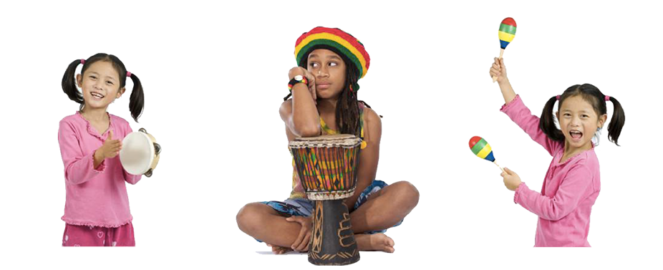

## Music in the Classroom

### "Music enhances the education of our children by helping them to make connections and broadening the depth with which they think and feel. If we are to hope for a society of culturally literate people, music must be a vital part of our children's education." - Yo-Yo Ma

Leveraging music activities in the classroom supports the academic, physical, social, and intellectual development of children in the elementary classroom. Reasons educators integrate music learning into their instructional activities are listed below.

* Impact student's academic achievement.
* Encourage social and emotional development.
* Strengthen memory and learning retention.
* Influence motor development and physical maturation.
* Enhance the connection between the body and mind.
* Boost confidence and acquire 21st century skills.

#### [Click here to download the music poster and resources for using it as a word wall.](http://advancingartsleadership.com/node/89)

### What Children Do With Music

#### Singing

* differentiate between singing voice and speaking voice
* explore range of high and low pitches
* sing on pitch and with good tone

#### Playing

* experience feeling and moving to a steady beat
* recognize the difference between strong and weak beats
* practice beat accuracy
* explore sound and silence in rhythmic patterns
* practice playing strong and weak beats in patterns of 2, 3, 4
* practice rhythmic patterns simultaneously with beat/rhythmic patterns of others
* build skill in playing rhythm patterns
* explore varying uses of tempo and dynamics
* perform with body percussion (clap, snap, pat, stomp)
* play on non-pitched and pitched instruments

#### Reading/Notating

* explore a variety of icons representing pitch, duration, and form
* understand the relationship between beat and rhythm
* use traditional and iconic notation as a means of reading and performing music
* use Curwen hand signs

#### Listening

* respond to patterns of same and different
* listen and identify how tempo (fast and slow), dynamics (loud and soft), and timbre (vocal, instrumental, environmental sounds) are used in a piece of music to express the composer's intent
* learn to listen carefully to others when participating in an ensemble
* recognize repeated or contrasting phrases
* identify the form of a piece of music
* analyze and identify the elements of music in a piece and how they are used to express the composer's intent
* connect music to personal, societal, and cultural context

#### Creating

* compose, improvise, and apply musical elements to create music
* create vocal characterizations as part of a story or song
* create new words and rhymes for favorite classroom songs
* create simple beat and rhythm patterns
* create simple iconic representation of beat, meter, rhythm, and pitch
* create simple rhythmic patterns to be played against a steady beat
* create variations in tempo, dynamics, and timbre for musical expression

### Beat and Rhythm

Focusing on beat and rhythm skills in the classroom can help students develop skills in fluency, pacing, timing, synchronicity, agility, and coordination. Try the following activities to engage students in understanding beat and rhythm:

* **Play the beat:** Show a steady underlying pulse in various ways as the students follow along: body percussion (patting, clapping, snapping, stomping), alternating hands right, left, right, left (RLRL), feet marching, on an instrument, tapping various parts of the body (head, heart, fingertips, tongue, and so on) as the children follow along.
* **Call-and-response:** Perform a certain number of beats and have the students repeat them. Change the tempo and volume of the beat, and see how well the students follow. Produce a rhythm while maintaining a steady beat and have the students repeat it, alternating back and forth in call-and-response style. Invite various students to be the leader.
* **Rhythm with words and phrases:** Use voice, body percussion, or instruments to produce the rhythm of student's names, a nursery rhyme or poem, or words to a familiar song. Divide into 2 or 3 groups and play different patterns simultaneously to the same steady beat.
* **Put the beat in your feet:** Play a steady drum beat and invite the students to walk with the beat. Instruct the students that when the drum starts they start, when the drum stops they stop. Vary the tempo by accelerating and decelerating. Vary the volume by playing loud or soft.
* **Drum circle:** Give each student a hand-held percussion instrument or have them clap. Play a steady beat in unison. Invite the students to improvise a rhythm while staying with the beat of the group.

### How to Teach a Song

#### The Basics

1. Connect the song to their own experiences, a culture, or something they are learning about.

2. Before singing the song, students hear the whole song (4-5 times) with directed listening, playing, or movement activities.

3. Students may sing part of the song every time it occurs.

4. Play singing games as students become familiar with the song.

5. Add body percussion and instruments.

6. Include movement.

7. Extend learning by having students identify or create form, discover patterns and sequences, count, group, read or write lyrics, make connections to other cultures or classroom subjects.

NOTE: "Whole song" refers to a simple song that includes a lot of repetition and a recurring, obvious form. For more complex songs, use the "whole song" method with just one section of the piece. It is not necessary to start at the beginning of a song. Begin where students will experience the most success. Adapt your teaching strategies to match the requirements of the song. The structure and demands of different songs might require different teaching strategies.

#### Use the whole-part-whole method

##### **WHOLE**

1. Let the children hear the song a few (or many!) times before they are called upon to sing the song.

2. With each hearing, direct students' listening or have them engage in some of the ideas listed on the "[What Can I Do with a Folk Song?](http://advancingartsleadership.com/node/16#basicmusicskills)" page.

3. After they have heard the song 4-5 times, the children sing the entire song if it is a short simple song, or join in singing one phrase, verse, or the refrain of the song whenever it occurs. It is not necessary to start teaching the beginning of the song. Teach just one main section or part of the song. Providing picture or word cues, lyrics, or sheet music can be helpful, but isn't necessary.

##### **PART**

4. Define vocabulary words, review difficult phrases, practice melodic intervals, strengthen insecure parts, and correct any sections where students are making errors.

5. If students have only learned one part of the song, teach the other parts of the song adding one part at a time until they know the entire song.

##### **WHOLE**

6. Sing it DIFFERENTLY every time by adding various elements such as body percussion, instruments, or movement. Vary dynamics and/or tempo. Add rhythmic ostinatos with non-pitched percussion or body percussion. Play harmonic accompaniments on boomwhackers, bells, Orff instruments, or ukuleles. Divide the song into sections and have a different group sing each section, line, verse, or part. Students may sit or stand. Teach them how to conduct the meter of the song as they sing. Be creative and have fun!

7. After experiencing the song many different ways, students may help determine how to most effectively perform it. When practicing to perform, concentrate on consistency in tempo, dynamics, conducting cues, breathing, pronunciation, etc. Emphasize in-tune singing and good vocal tone. The time to sing it the SAME way every time is when students are practicing to perform a song.

### Integrating Music with Core Subjects

Check out the following music-integrated lesson plans designed by elementary classroom teachers and music teaching artists for the BYU ARTS Partnership. These lesson plans represent excellent examples of using process music to explore all subjects in the classroom.

* "[Johnny Works with Place Value](https://education.byu.edu/arts/lessons/johnny-works-with-place-value)" - Music and Mathematics for Grades K-2
* "[Pie Rhythms](https://education.byu.edu/arts/lessons/pie-rhythms)" - Music and English Language Arts for Grades K-2
* "[Waddling Ones and Tabaggoning Tens](https://education.byu.edu/arts/lessons/waddling-ones-and-tobogganing-tens)" - Music, Dance and Math for Grades K-2
* "[Weather in the Seasons](https://education.byu.edu/arts/lessons/weather-in-the-seasons)" - Music, Dance, and Science for Grades K-2

Find more lesson plans at [www.education.byu.edu/arts/lessons](http://www.education.byu.edu/arts/lessons).

Read this online at <https://edtechbooks.org/advancingartsleadership/Performing_Arts>