# PICRAT

Kimmons, R., Draper, D., Backman, J.

PICRAT is a technology integration model for teacher education intended to assist teachers in improving their classroom practices. PICRAT (Kimmons et al., 2020; see Figure 1) has two parts representing two guiding questions: PIC and RAT. The PIC part responds to the question “What is the student’s relationship to the technology” with one of three responses: Passive, Interactive, or Creative. The

[RAT](https://edtechbooks.org/encyclopedia/rat)

(Hughes et al., 2006) part responds to the question “How is the use of technology influencing the teacher’s existing practice” with one of three responses: Replacement, Amplification, or Transformation. Answers to these two questions are organized into a 3x3 visual matrix (with PR on the bottom left and CT on the top-right; see Figure 1). Practices are interpreted hierarchically with more active, more effective, and better-justified classroom technology practices generally occurring at the top-right of the matrix.

Because technologies are always changing and educational contexts vary so greatly from one another, teacher educators and professional development providers need tools to train teachers that are simple, flexible, and practical while guiding educators in self-improvement through reflective practice. PICRAT is a framework to help teachers and teacher education students to be self-reflective in their technology integration practices and to engage in learning activities that are more interactive and creative for students while amplifying or transforming their own practices (Kimmons et al., 2020). The PIC part of the matrix loosely aligns with Bloom’s taxonomy of educational objectives for the cognitive domain (Bloom et al., 1956; see Figure 2), where passive learning activities might favor lower-level cognitive objectives like remembering, interactive activities might favor mid-level objectives like applying, and creative activities might favor higher-level objectives. The [RAT](https://edtechbooks.org/encyclopedia/rat) part of the matrix suggests that teacher practices with technologies exhibit differing levels of relative advantage to a teacher’s pedagogy (Hughes et al., 2006), with some practices being more pedagogically beneficial than others.

Figure 1

The PICRAT Matrix

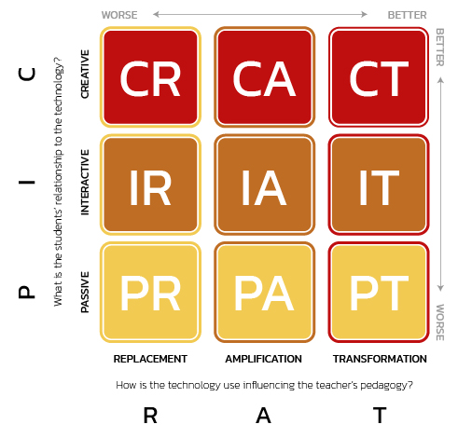

Figure 2

Alignment of PIC to Bloom’s Taxonomy

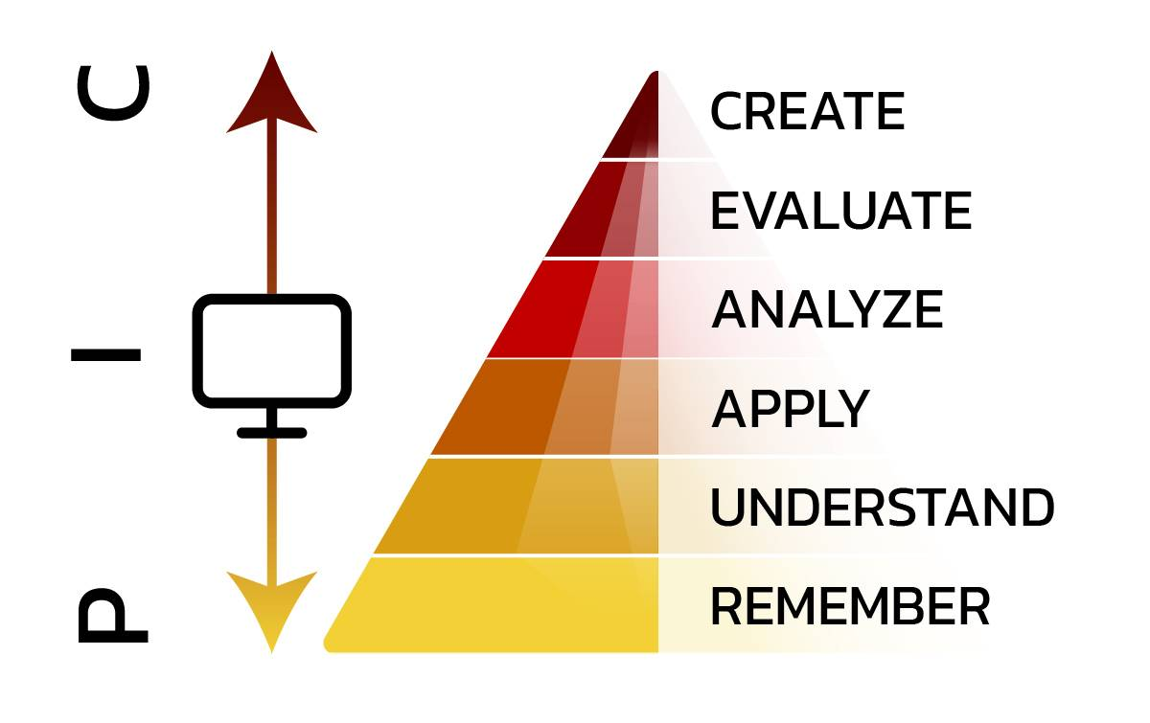

The PICRAT matrix can be particularly useful when teachers reflect upon their practice by analyzing existing or proposed learning activities according to the framework. Intended to assist teachers in ongoing improvement efforts, teachers using PICRAT consider how their past or potential future practices might make better use of technologies, thereby improving both student engagement and learning outcomes. Consider, for example, the teacher who might traditionally lecture from a PowerPoint presentation full of text (Passive Replacement or PR). Improved instructional experiences like the following could be considered:

* Students are provided a copy of the PowerPoint slides to peruse at their own pace and self-direction (I or Interactive).
* The teacher inserts rich media throughout the self-paced PowerPoint lesson, to improve comprehension of difficult concepts (A).
* The teacher uses Nearpod or Peardeck instead of PowerPoint, embedding Drag & Drop, Draw It, or other activities throughout the lesson, encouraging students to engage with the instructional material (IA).
* Students create their own presentation showcasing their knowledge (C).
* The entire class uses Lucid Spark to engage in a live, whole-class brainstorming session, allowing teachers and students to see the thought processes of others as they participate and generate knowledge together (CT).

One key insight of PICRAT is that any technology might be used in a variety of ways, with some practices being more educationally valuable than others. Consider, for example, the myriad ways that the Nearpod application might be used by a science teacher (see Table 1). Depending on the educational goal, teachers may elect to work within any cell of the framework, even when using the same tool. This means that the practices surrounding technology use are better indicators of educational merit than the technologies themselves (e.g., just because teachers are using Nearpod does not mean that they are doing things that are particularly valuable for their students or practice).

Table 1

Examples of Nearpod Classroom Activities within a Biology Classroom Revealing Different PICRAT Levels

|  |  |  |  |
| --- | --- | --- | --- |
| Creative | Teacher assigns each student a genetic term to define and has students present their terms to the class via Nearpod. | Teacher provides an ethical dilemma regarding genetic modification along with online resources for students to explore in Nearpod small groups; they then report their solution to the entire class. | Students engage with each other and the teacher using a Nearpod collaboration board to collect and thematically organize examples of current genetics research. |
| Interactive | Teacher begins the class session with a Nearpod quiz, covering the previous night’s homework on cellular structure. | Teacher embeds Draw It activities among Nearpod slides to encourage student participation. | Teacher embeds Drag and Drop activities among Nearpod slides to assess student understanding, making instructional adjustments on the fly. |
| Passive | Teacher shows Nearpod slides detailing cellular replication during a whole-class lecture. | Teacher embeds instructional videos in Nearpod slides to better explain difficult concepts. | Teacher uses Nearpod + Zoom integration to virtually host a geneticist from a research center to provide a guest lecture. |
|  | Replacement | Amplification | Transformation |

The more difficult parts of PICRAT for educators to understand and master in practice often include the Creative and Transformative levels. To clarify, by “Creative,” PICRAT authors mean knowledge artifact creation, similar to constructionism (cf., Kafai & Resnick, 1996), rather than artistic creativity. Additionally, whether technology can ever play a transformative role in education is a contested idea in itself (Clark, 1994; Kozma, 1994), and even if transformation exists, the line between Amplifying and Transformative practice may seem a bit ill-defined. PICRAT authors contend that some instances of technology integration in classrooms increase efficiencies or opportunities to such a degree that it no longer seems reasonable to treat them merely as amplifying or functional improvements, meaning that they should be treated as Transformative (Kimmons et al., 2020). Furthermore, by leaving the line between Amplification and Transformation a bit blurry, professionals are empowered to use their best judgment to grapple with this important issue in their own settings. Rational professionals can disagree on whether a particular instance of technology use is Amplifying or Transforming practice, but PICRAT authors contend that having such reflective discussions (either with colleagues or with oneself) is a valuable exercise, as it forces educators to constantly grapple with the effects technology applications have upon their practice.

In addition, one common concern with PICRAT is that its hierarchical structure might be viewed as delegitimizing some technology practices that are educationally valuable. For example, if a teacher shows a YouTube video to a class, this activity might be interpreted as poor practice, because the students are Passive, and the video might just consist of a talking head, thereby Replacing a lecture (PR). Rather than interpreting this to mean that teachers should never show YouTube videos to students, PICRAT should be used to consider (a) whether there are additional ways to have students engage in the learning process beyond watching the video (i.e., Interaction and Creation), (b) whether some videos might be better than others (i.e., those that provide Amplifying or Transformative learning opportunities), and (c) whether practices near the bottom-left are being done for their educational merit or due to lack of planning and reflection. Even the best classrooms using technology will likely exhibit some practices that fall near the bottom-left of PICRAT, and this is expected. However, if all practices with technology are of this type or if teachers are seeking ways to use technology to improve pedagogy or to make learning more active and engaged, then practices that would be classified more toward the top-right of the matrix should also be sought after.

## References

Amador, J., Kimmons, R., Miller, B., Desjardins, C. D., Hall, C. (2015). Preparing preservice teachers to become self-reflective of their technology integration practices. In M. L. Niess & H. Gillow-Wiles (Eds.), Handbook of Research on Teacher Education in the Digital Age (pp. 81-107). Hershey, PA: IGI Global.

Bloom, B. S., Englehart, M. D., Furst, E. J., Hill, W. H., & Krathwohl, D. R. (1956). Taxonomy of educational objectives. Handbook 1: Cognitive domain. New York: Longmans, Green.

Clark, R. E. (1994). Media will never influence learning. Educational Technology Research and Development, 42(2), 21-29.

Hughes, J., Thomas, R., & Scharber, C. (2006). Assessing technology integration: The RAT – Replacement, Amplification, and Transformation – framework. In Proceedings of SITE 2006: Society for Information Technology & Teacher Education International Conference (pp. 1616–1620). Chesapeake, VA: Association for the Advancement of Computing in Education.

Kafai, Y. B., & Resnick, M. (2012). Constructionism in practice: Designing, thinking, and learning in a digital world. Routledge.

Kimmons, R., Graham, C., & West, R. (2020). The PICRAT model for technology integration in teacher preparation. Contemporary Issues in Technology and Teacher Education, 20(1).

Kimmons, R., & Hall, C. (2016). Emerging technology integration models. In G. Veletsianos (Ed.), Emergence and innovation in digital learning: Foundations and applications. Edmonton, AB: Athabasca University Press.

Kimmons, R., & Hall, C. (2017). How useful are our models? Pre-service and practicing teacher evaluations of technology integration models. TechTrends, 62, 29-36. doi:10.1007/s11528-017-0227-8

Kimmons, R., Miller, B., Amador, J., Desjardins, C., & Hall, C. (2015). Technology integration coursework and finding meaning in pre-service teachers' reflective practice. Educational Technology Research and Development, 63(6), 809-829. doi:10.1007/s11423-015-9394-5

Kozma, R. B. (1994). Will media influence learning? Reframing the debate. Educational Technology Research and Development, 42(2), 7-19.

## Community Artifacts

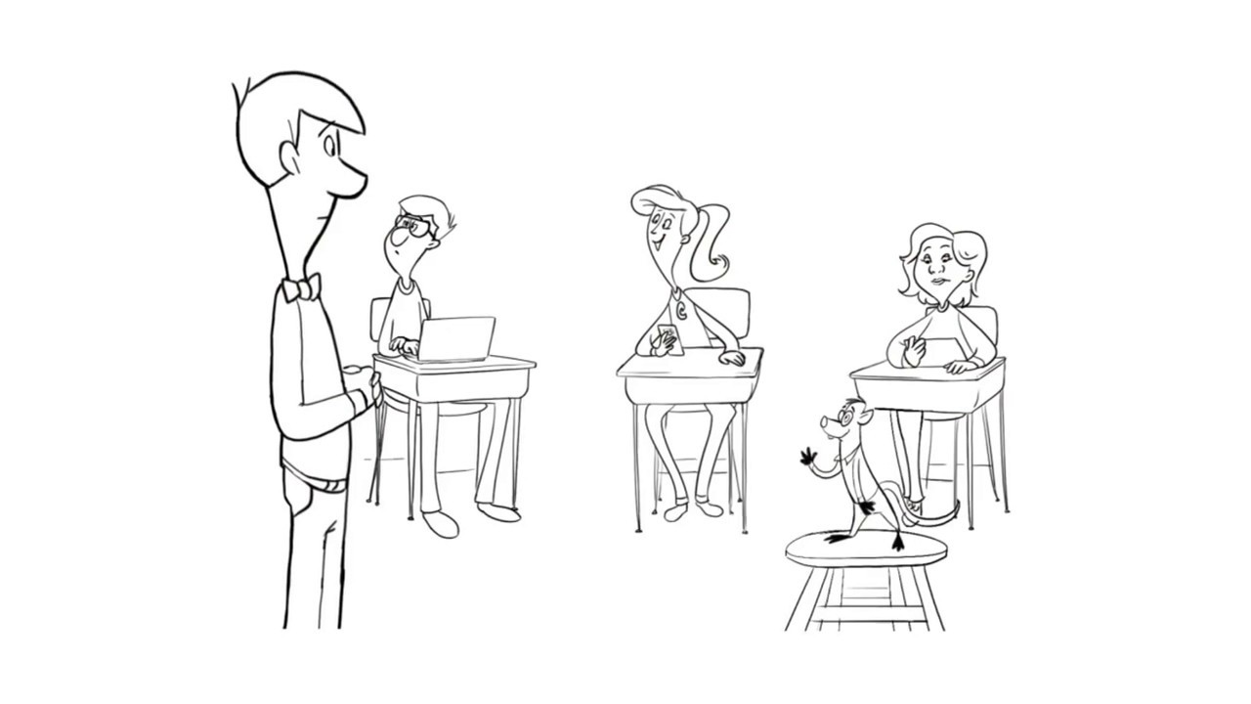

[Watch on YouTube](https://www.youtube.com/watch?v=bfvuG620Bto&amp;autoplay=1)

Biola, S. (n.d.). PICRAT Flow chart. <https://docs.google.com/drawings/d/1W4wuf5O3dAAU_2RBHRT1motXKmm5f35Le-4PvSAbBMA/edit>

Constantine, A., & Jung, K. G. (2019). Using digital science notebooks to support elementary student learning: Lessons and perspectives from a fifth-grade science classroom. Contemporary Issues in Technology and Teacher Education, 19(3), 373-412.

Heberer Jr, D. H. (2021). Teacher Perceptions & Practice of Technology Integration before and after PICRAT Matrix Professional Development Intervention (Doctoral dissertation, St. John's University, New York).

Kimmons, R. (2018). Technology Integration: Effectively Integrating Technology in Educational Settings. In A. Ottenbreit-Leftwich & R. Kimmons, The K-12 Educational Technology Handbook. EdTech Books. Retrieved from <https://edtechbooks.org/k12handbook/technology_integration>

Kimmons, R. (2018). K-12 Technology Frameworks. In R. E. West, Foundations of Learning and Instructional Design Technology: The Past, Present, and Future of Learning and Instructional Design Technology. EdTech Books. Retrieved from <https://edtechbooks.org/lidtfoundations/k12_tech_frameworks>

Il modello PIC RAT (Italian). Testo e realizzazione: Christian Biasco, Centro Risorse Didattiche e Digitali, Cantone Ticino. <https://edutich.sharepoint.com/:v:/s/O365Group_2052/EfQyRey02cxGq-eUE4EFRvoBr3dxIUl51YGgODetN8jn3g?e=q1v0RP>

Read this online at <https://edtechbooks.org/encyclopedia/picrat>