# Padlet

is a community-centered virtual bulletin board in which collaborators can simultaneously create and organize posts of any content type, whether it be text, documents, images, videos, audio, or links.

Padlet is a great tool to use for collaborative group projects, as it eliminates the need to schedule time in advance for the group members to meet face-to-face. Students are able to work freely on their group assignments at their own convenience while still observing every change or contribution made by group members as soon as they are made without scheduling conflicts and the constraints produced from limiting project work to specified times.

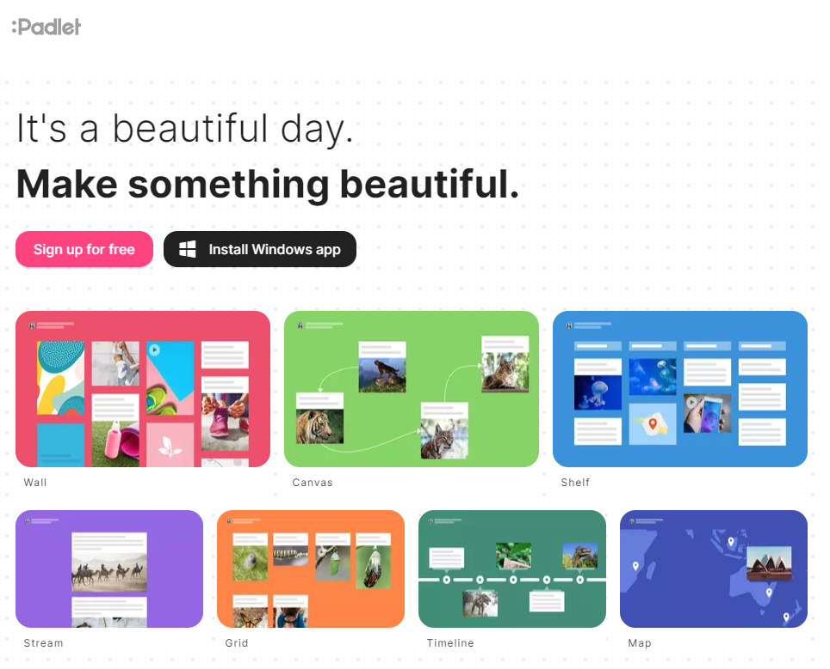

## Tool Snapshot

|  |  |
| --- | --- |
| Price | Free (limited);  [Upgraded memberships available](https://padlet.com/memberships) |
| Learning | Social constructivism, Connectivism |
| Ease of Use | ★★★★☆ |
| Privacy | ★★☆☆☆ |
| Accessibility | ★★★☆☆ |
| Class Size | Unlimited |
| [ISTE*S](http://www.iste.org/standards/standards/for-students-2016) | Knowledge Constructor, Creative Communicator, Global Collaborator |

## Padlet Tutorial for Teachers by New EdTech Classroom

## Padlet & the SAMR Model

* **Substitution:** Students create their own Padlet with text-based posts (rather than putting Post-it notes on a class bulletin board).
* **Augmentation:** Students continue to work on the Padlet outside of class over the next few weeks.
* **Modification:** The students then give one another’s posts feedback directly on the padlet.
* **Redefinition:** Students can collaboratively curate multimodal collections with peers and the broader global community.

## Learning Activities

### **History**

Create a timeline to illustrate related events in a particular period, perhaps a war or governmental change. Create a timeline narrating the key events throughout the life of an important historical figure.

### **Government / Politics**

Design a diagram depicting the organization, powers, and history of each branch of the U.S. government.

### **Geography**

Build a collage covering the different regions of a particular country including pictures and descriptions of local wildlife, terrain, climate, etc...

Design an interactive map using the [Padlet map feature](https://padlet.com/blog/map).

### **Literature**

Create a book report covering important events and characters, along with descriptions and their relationships to one another.

### **Social Studies**

Curate a collection of historical artifacts and primary source materials for a specific event, era, or person.

### **Biology**

Present a certain region’s food chain with images and labels of the animal species.

## Resources

* [Educational Ways to Use Padlet](https://padlet.com/lkarpiuk/iheartedtechpadlet)
* [32 Interesting Ways to Use Padlet in the Classroom](https://docs.google.com/presentation/d/102ajRlZ0bDby07MhC79NdxyTSMLHXuT-bZNJ4fpsYHw/edit?pli=1#slide=id.i14)
* [How to Use Padlet in the Classroom](http://www.coolcatteacher.com/how-to-use-padlet-fantastic-tool-teaching/)
* [Educational World: Five Ways to Use Padlet in Class](http://www.educationworld.com/a_tech/using-padlet-in-the-classroom.shtml)
* [Padlet Teaching Examples](http://teachinghistory.org/digital-classroom/tech-for-teachers/24636)
* [Teacher’s Guide to Using Padlet in Class](http://www.educatorstechnology.com/2014/07/teachers-guide-to-using-padlet-in-class.html)
* [Padlet Tutorial for Teachers](https://www.youtube.com/watch?v=f51WeQVLeVU)
* [Padlet’s Many Uses for the Classroom](https://www.youtube.com/watch?v=5c9vWCPn8ys)
* [Teacher Tutorial for Setting Up Padlet](https://www.youtube.com/watch?v=RCi6p6v79Bg)
* [How to Use Padlet in the Classroom](https://www.youtube.com/watch?v=KHWRi54nCn8)
* [20 Useful Ways to Use Padlet in Class](http://ditchthattextbook.com/2014/11/03/20-useful-ways-to-use-padlet-in-class-now/)

## How to Use Padlet

1. Go to [www.padlet.com](http://www.padlet.com).
2. Click “Sign up” and register if you would like to have your own account.
3. Click “Create a Padlet”.
4. Choose the design options of you padlet including your title, description, layout, wallpaper, icon etc. and click “Next” after you have chosen everything to your liking.
5. Select your padlet’s privacy setting and the privileges that other users with access will have on your padlet. Click “Next” once you are finished.
6. Now click “Start posting” and you are ready to begin. Click the “+” button or double click anywhere on the padlet to begin posting. You can also drag and drop files onto the padlet or paste from the clipboard.
7. You can hit the “Padlet” icon in the top left of the screen if you wish to return to the homepage or change padlets if you are signed into an account.

## Research

Deni, A. R. M., & Zainal, Z. I. (2018, October). [Padlet as an educational tool: Pedagogical considerations and lessons learnt](https://dl.acm.org/doi/abs/10.1145/3290511.3290512). In Proceedings of the 10th International Conference on Education Technology and Computers (pp. 156-162).

Dewitt, D., Alias, N., & Siraj, S. (2015). [Collaborative learning: Interactive debates using Padlet in a higher education institution](https://eprints.um.edu.my/13630/).

Fuchs, B. (2014). [The writing is on the wall: using Padlet for whole-class engagement](https://uknowledge.uky.edu/libraries_facpub/240/). Loex Quarterly, 40(4), 7.



Read this online at <https://edtechbooks.org/onlinetools/padlet-review>