# Thinglink

[**ThingLink**](https://www.thinglink.com/) is a tool for creating interactive images and videos by adding tags. Tags can link to websites, social media pages, videos, maps, images, and audio. Interactive Thinglink images can be shared on social networks, including Facebook, Twitter, and Pinterest. There is an option to embed the Thinglink image on other websites as well.

Another feature that Thinglink offers is 360 degrees tours with tags. Users can upload 360 degrees pictures and add audio and video tags for a 3D virtual reality experience. This feature is only available with a Professional or Premium subscription.

## Tool Snapshot

|  |  |
| --- | --- |
| [Price](https://www.thinglink.com/edu-options) | Free trial version. Professional Teacher License: $35/year. Premium & Academic Enterprise plans as well. |
| Learning | [Constructionism](http://edutechwiki.unige.ch/en/Constructionism) |
| Ease of Use | ★★★✩✩ |
| [Privacy](https://www.thinglink.com/en-us/privacy) | ★★★✩✩ |
| [Accessibility](https://support.thinglink.com/hc/en-us/articles/360035406914-ThingLink-Accessibility-statement) | ★★★★✩ |
| Class Size | 60 for professional teacher license plan; Unlimited for upgraded plans |
| [ISTE*S](http://www.iste.org/standards/standards/for-students-2016) | Knowledge Constructor, Creative Communicator, Global Collaborator |
| COPPA/FERPA | Requires teacher/school official to provide consent on behalf of parents. |

## ThingLink Overview Video

## ThingLink & the SAMR Model

Here is an example of how Thinglink might fit within the SAMR model:

* **Substitution:** Students can view a static image on Thinglink (as opposed to in a textbook).
* **Augmentation:** Students can view a multimodal, interactive image in Thinglink.
* **Modification:** Students can create their own interactive images.
* **Redefinition:** Students can design virtual 360 degree tours with embedded audio, video, and hyperlinks.

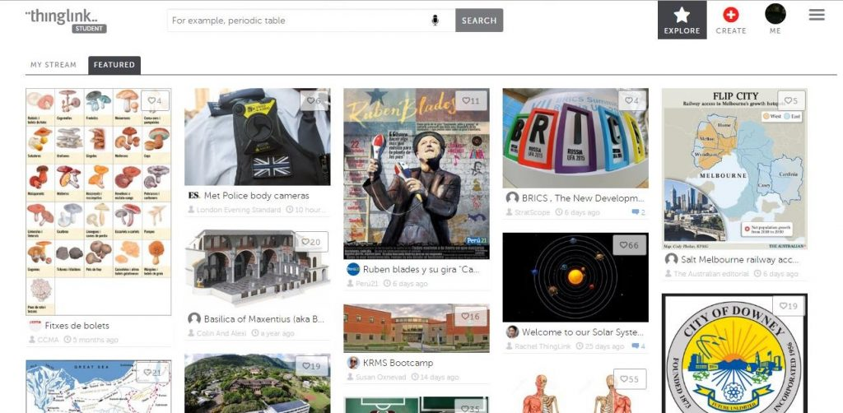

## Learning Activities

Thinglink can be especially useful for science, geography, history, language, and visual arts.

### **Science**

Students can create an interactive image to develop or demonstrate their knowledge about a scientific concept or topic.  Check out [this example](http://goo.gl/FzykNh) of the solar system:

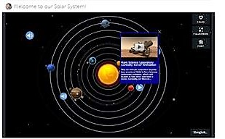

### **English/Language Arts**

Students can make their own vocabulary mind map and tag related words and images. Students can also annotate images of their favorite authors and texts. See [an example](https://www.thinglink.com/scene/647108069322391552) in which the image links to Edgar Allan Poe’s birthplace, major works, and related websites.

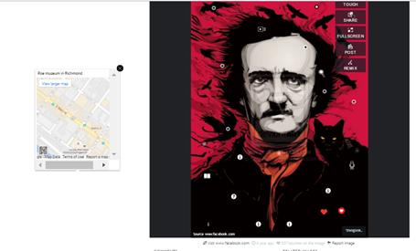

### **Geography**

Students can pinpoint the names of places and landmarks. They can also include definitions or annotate historical facts on maps.

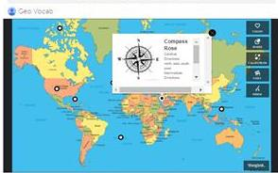

### **Arts**

Have you ever wanted to show your students a virtual tour to the Louvre? Better yet, your students can create one by tagging paintings to artists, times, and movements. See an example .

## How to Use ThingLink

1. Go to <https://www.thinglink.com/>.
2. Sign up by creating an account using an email or sign up using your Facebook, Twitter,  or Google account.
3. Explore or follow popular users or topics.
4. Upload an image from your hard drive, the Internet, or Facebook.
5. Select a position on the image and tag it to a website, video, or map.
6. Share your interactive image on Facebook, Twitter, or Gplus, or obtain a code to embed it in your website.

## Resources

More ideas for how to use ThingLink

* [Build Your ThingLink Classroom](http://thinglinkblog.com/2015/01/08/build-your-thinglink-classroom-3/)
* [Best Examples of ThingLink for Education](https://www.thinglink.com/channel/717857770820337666)

## Research

Appasamy, P. (2018). [Fostering Student Engagement With Digital Microscopic Images Using ThingLink, an Image Annotation Program](https://my.nsta.org/resource/?id=10.2505/4/jcst18_047_05_16). Journal of College Science Teaching, 47(5).

Nakatsuka, K. (2018). [Making history come to life: ThingLink virtual museums](https://www.proquest.com/docview/2344260092?pq-origsite=gscholar&amp;fromopenview=true). Social Studies Review, 57, 47-52.

Roslan, N. N. A., & Sahrir, M. S. (2020). [The Effectiveness of ThingLink in Teaching New Vocabulary to Non-Native Beginners of the Arabic Language](https://journals.iium.edu.my/ijes/index.php/iejs/article/view/274). IIUM Journal of Educational Studies, 8(1), 32-52.

## Image Sources

All images sourced from <https://www.thinglink.com/>

Read this online at <https://edtechbooks.org/onlinetools/thinglink>